**Results**

**Task 1**

Given an array of integers, find the pair of adjacent elements that has the largest product and return that product.

Example

For inputArray = [3, 6, -2, -5, 7, 3], the output should be

adjacentElementsProduct(inputArray) = 21.

7 and 3 produce the largest product.

function adjacentElementsProduct (inputArray) {

// your code...

}

For testing:

[-1, -2]

[5, 1, 2, 3, 1, 4]

[1, 2, 3, 0]

[9, 5, 10, 2, 24, -1, -48]

[-1, -2]

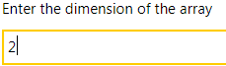 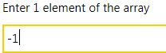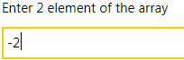 

[5, 1, 2, 3, 1, 4]



[1, 2, 3, 0]



[9, 5, 10, 2, 24, -1, -48]



**Task 2**

Tic-Tac-Toe, sometimes also known as Xs and Os, is a game for two players (X and O) who take turns marking the spaces in a 3X3 grid. The player who succeeds in placing three respective marks in a horizontal, vertical, or diagonal rows (NW-SE and NE-SW) wins the game.

But we will not be playing this game. You will be the referee for this games results. You are given a result of a game and you must determine if the game ends in a win or a draw as well as who will be the winner. Make sure to return "X" if the X-player wins and "O" if the O-player wins. If the game is a draw, return "D".

A game's result is presented as a list of strings, where "X" and "O" are players' marks and "." is the empty cell.

Input: A game result as a list of strings (unicode).

Output: "X", "O" or "D" as a string.

Precondition:

There is either one winner or a draw.

Do not use regular expressions!

function xoReferee(data) {

// Your code here

}

// Example

xoReferee([

"X.O",

"XX.",

"XOO"]) -> "X"

 