DHEMAJI ENGINEERING COLLEGE



DSA LAB REPORT

Submitted To: Submitted By:
Dhantu Buragohain Sir Name: Saranga Pani Dutta
Branch: COMPUTER
SCIENCE AND ENGINEERING
Semester: 3rd
Roll Number: 2481105745

Exercise 1 Date: 20-08-2025
Aim:
To write a C program to perform a Linear Search on an array of integers entered by the user.
Code:
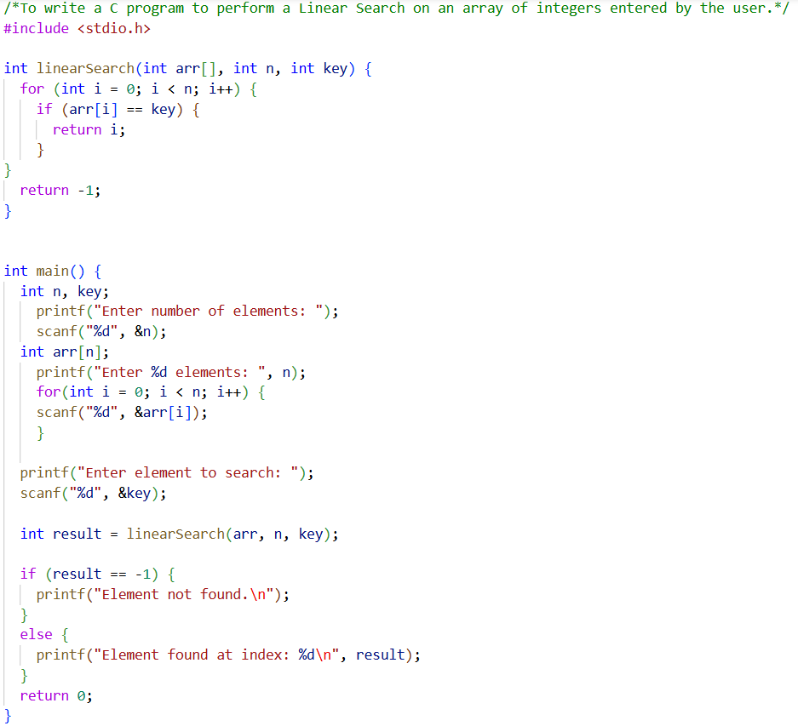

Output:
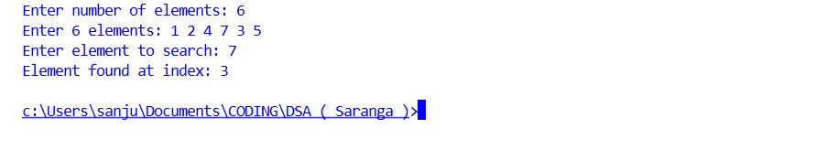
Observation:
This algorithm checks each element sequentially until it finds the desired element or reaches the end of the array. This program doesn't work for duplicate elements.
Exercise 2 Date: 20-08-2025
Aim:
To write a C program to perform a Linear Search in an array that may contain duplicate elements.
Code: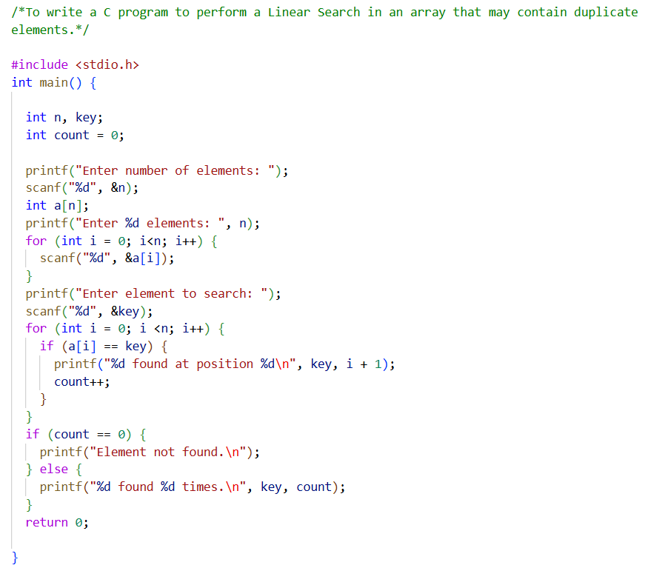
Output:
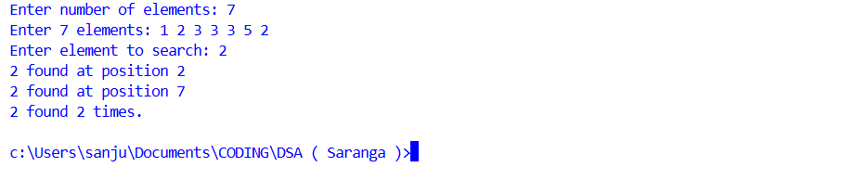
Observation:
This program checks all the numbers in the list and shows every position where the searched number appears, unlike the program in Exercise 1.

Exercise 3 Date: 20-08-2025
Aim:
To write a C program that performs a Binary Search on a sorted array entered by the user.
Code:
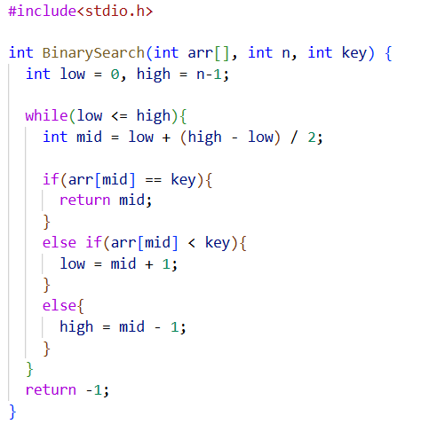
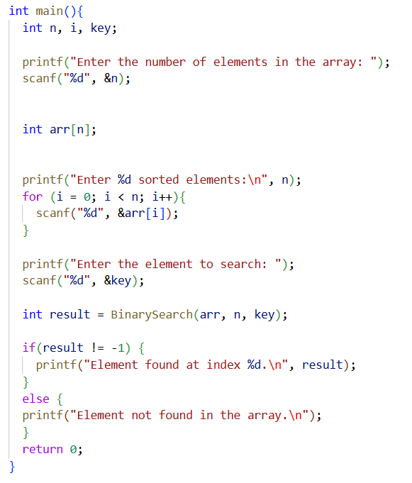

Output:

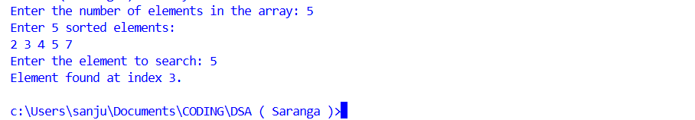

Observation:
This program only works when the list is already sorted in increasing order. It keeps dividing the list into halves to find the searched number. It doesn't work if any duplicate items are entered by the user.

Exercise 4 Date: 20-08-2025
Aim:
To write a C program that performs a Binary Search on a sorted array containing duplicate elements.
Code:

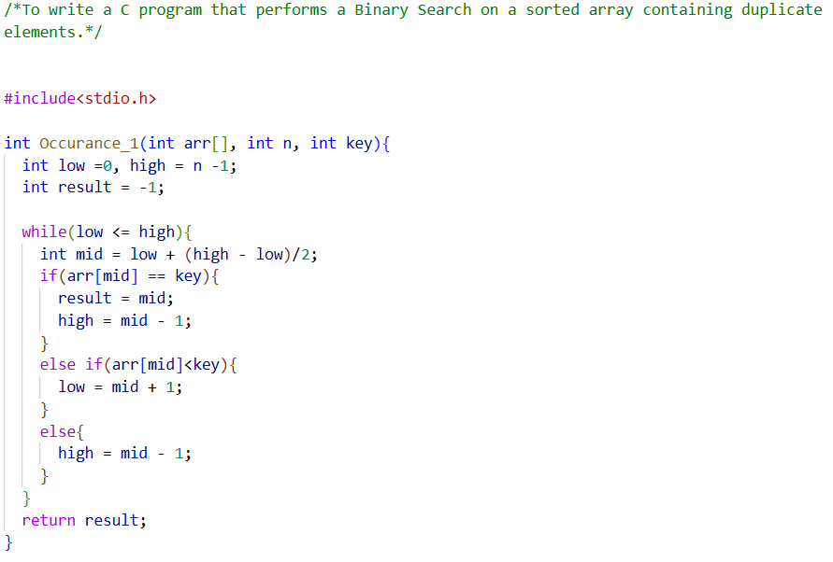
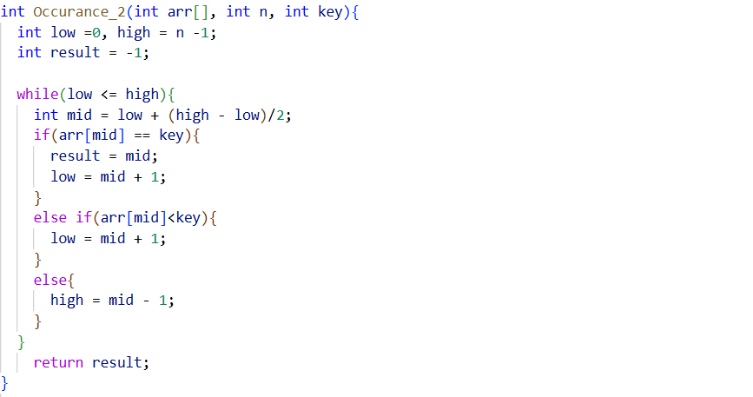
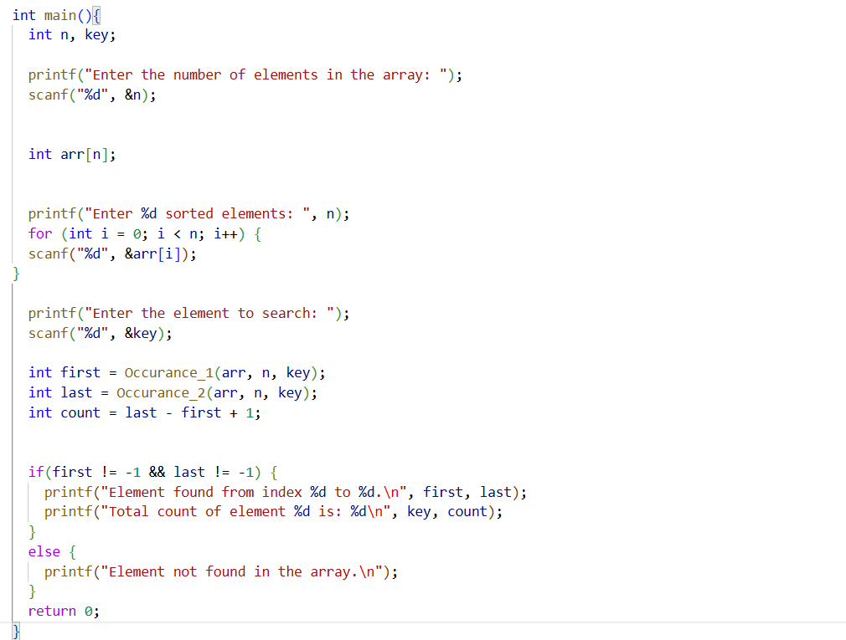
Output:

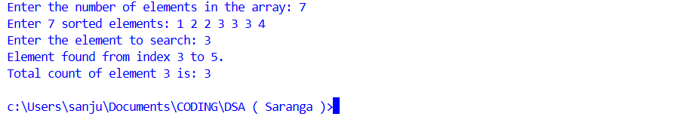
Observation:
This version (unlike the program in Exercise 3) finds the first and last position of a number if it appears multiple times in a sorted list.

Exercise 5 Date: 19-09-2025
Aim:
To write a C program to demonstrate a stack using an array, with push and pop functions.
Code:
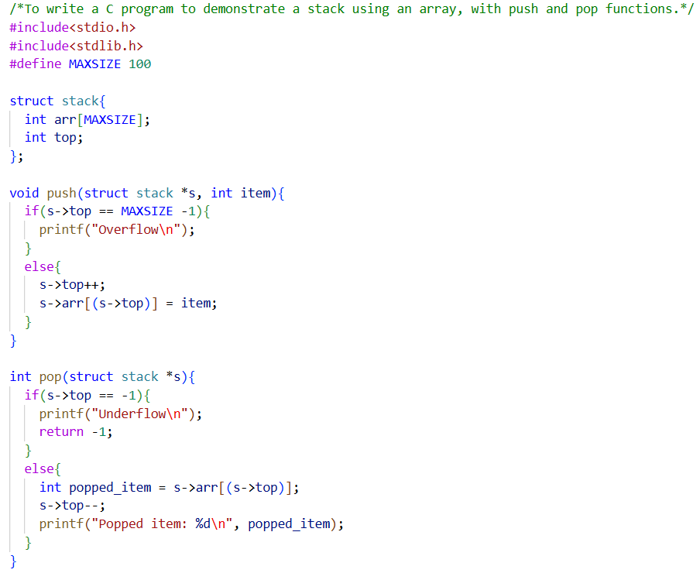
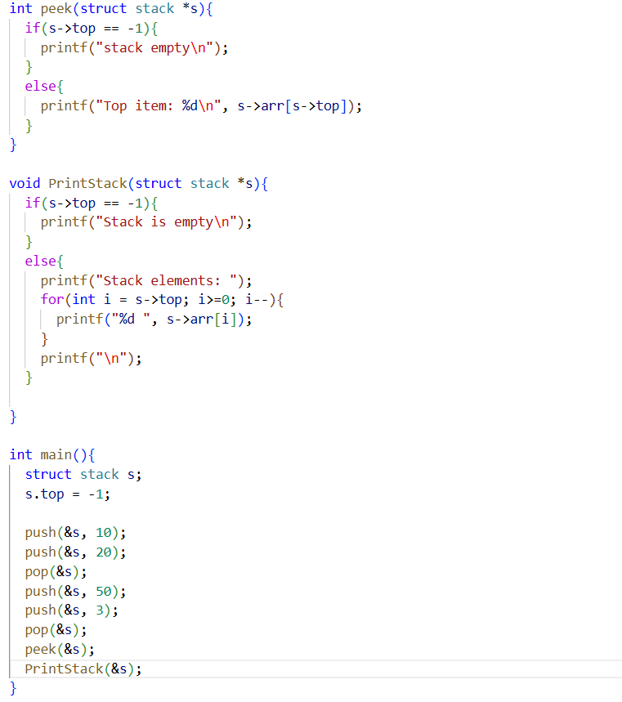

Output:
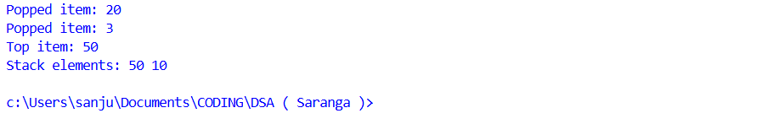
Observation:
The stack operates on a Last-In-First-Out (LIFO) principle. The last number put in the stack comes out first when popped. When we try to add/remove elements to/from the stack when the stack is full/empty it shows appropriate messages.

Exercise 6 Date: 24-09-2025
Aim:
To write a C program demonstrating the implementation of a Queue data structure with functions to enqueue (insert) and dequeue (remove) elements.

Code:
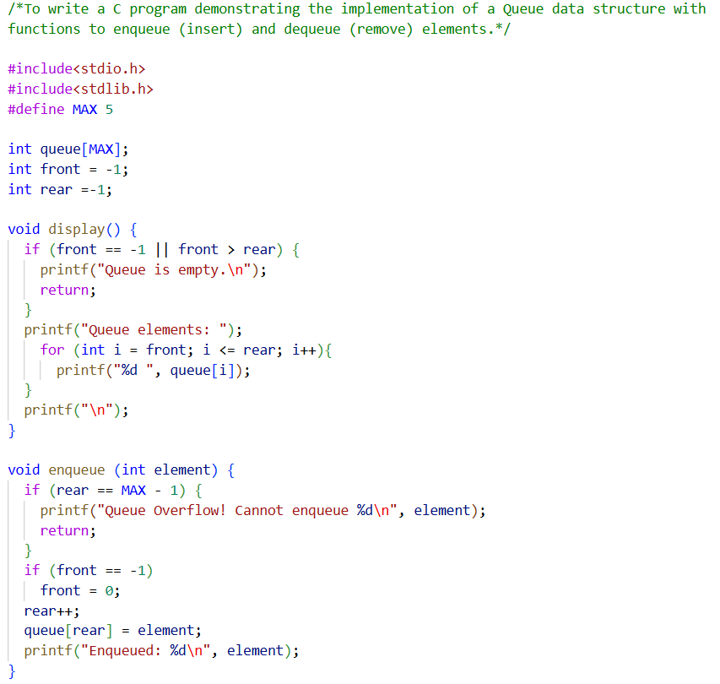
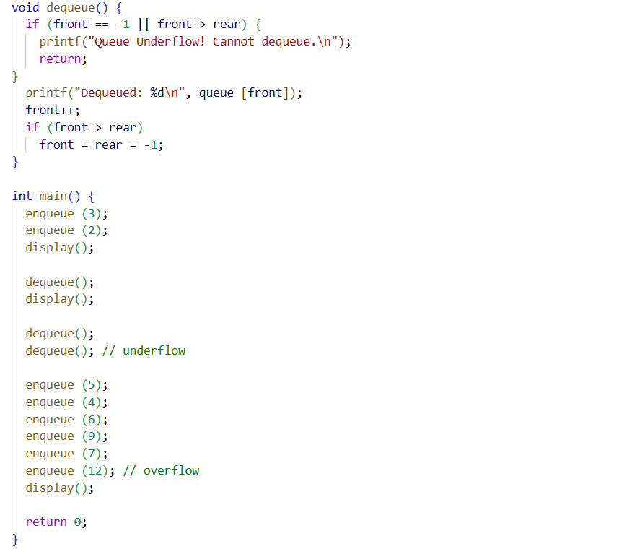

Output:
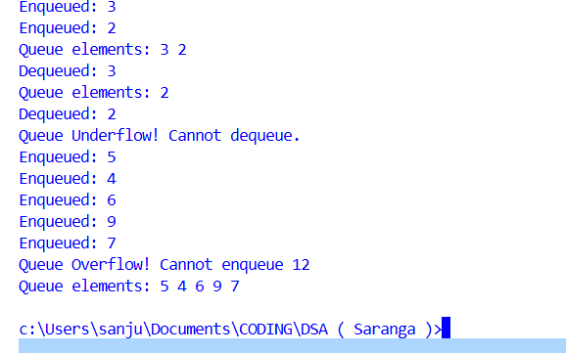
Observation:
The program uses a simple array-based queue with front and rear pointers to manage enqueue and dequeue operations. Underflow is displayed when attempting to dequeue from an empty queue, and overflow occurs when trying to enqueue beyond MAX.

Exercise 7 Date: 08-10-2025
Aim:
To write a C program to create a singly linked list and implement insertion operations at the beginning, end and at a specific position of the list.

Code:
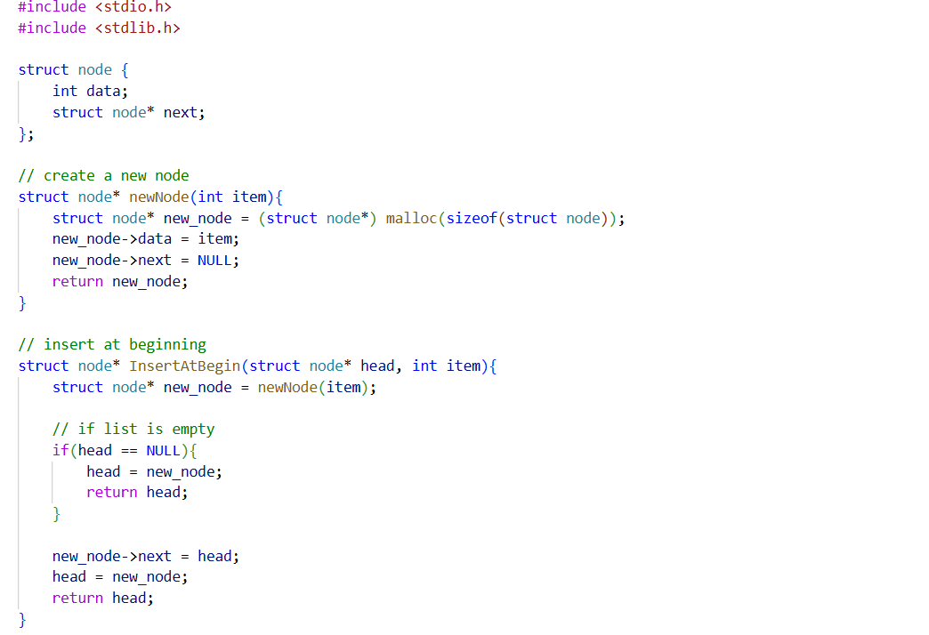
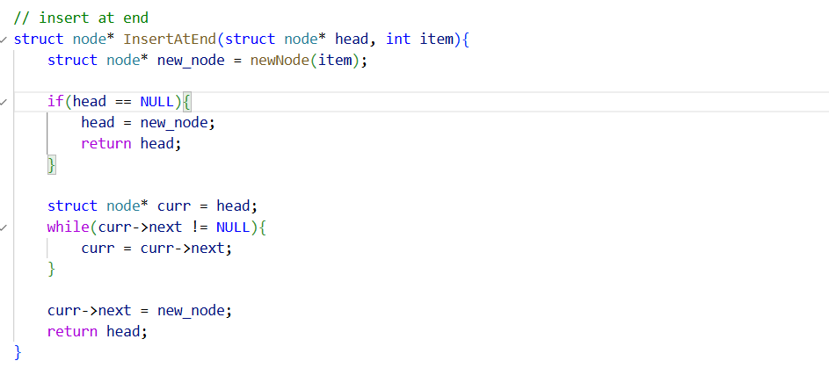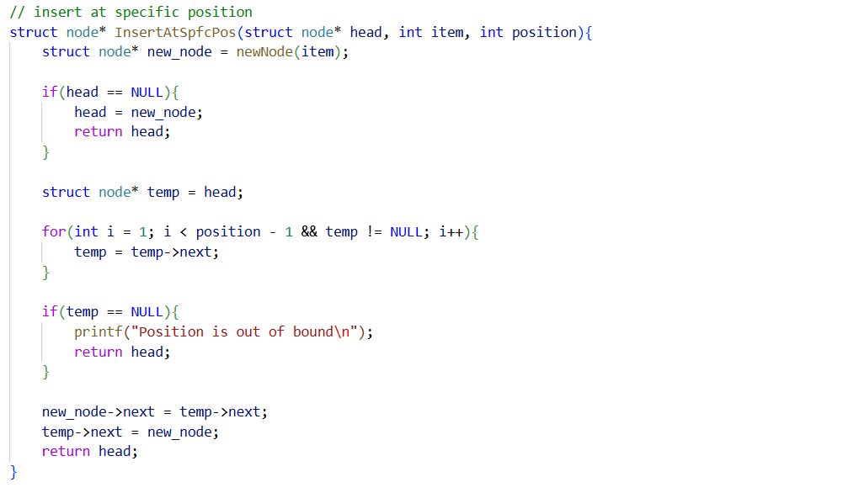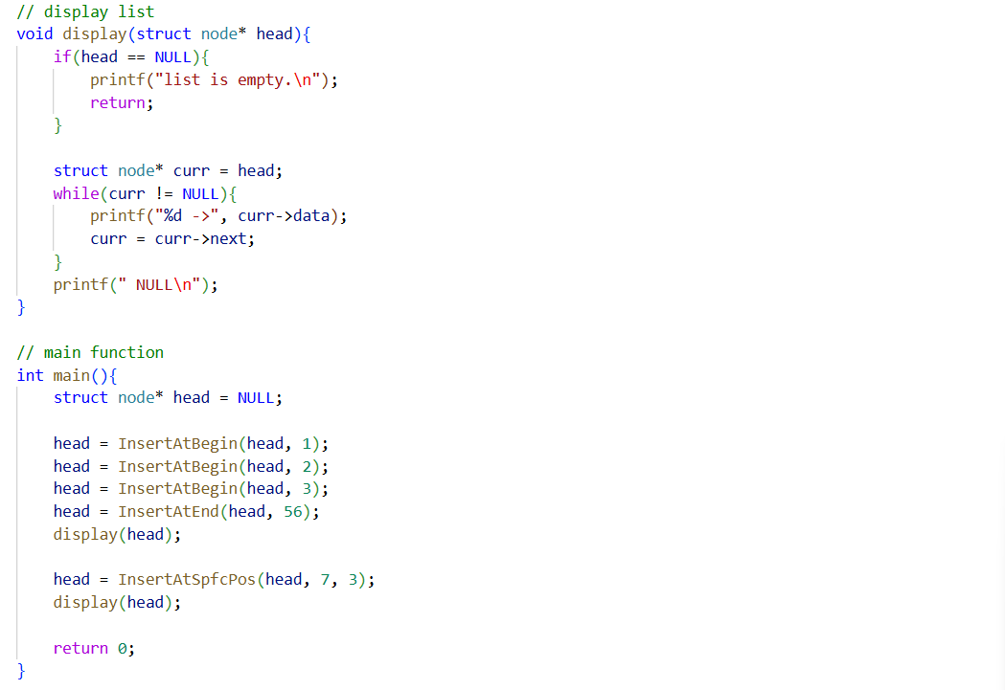

Output:
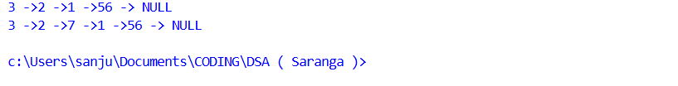
Observation:
The function insertAtBeginning() inserts a new node at the start of the list by changing the head pointer. The function insertAtEnd() traverses the linked list to the last node and adds the new node at the end.

Exercise 8 Date: 15-10-2025

Aim:
To write a C program to implement a singly linked list that supports the following operations: insertion at the beginning, insertion at the end, insertion at a specific position, deletion from the beginning, deletion from the end, and deletion from a specific position.

Code:
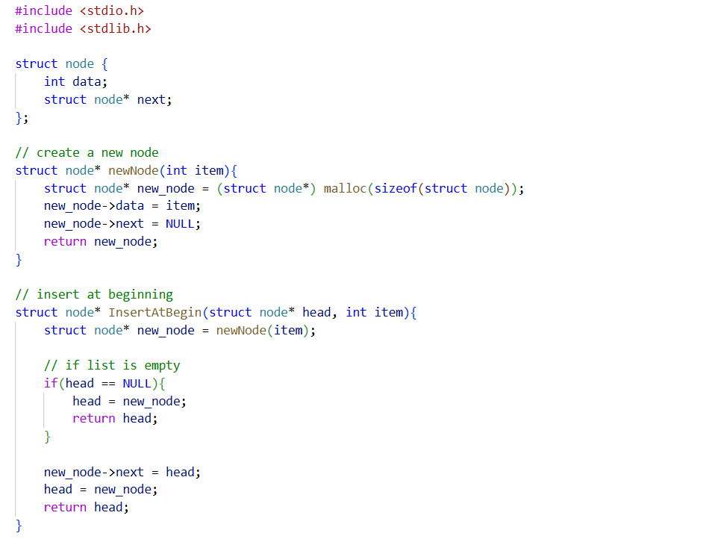
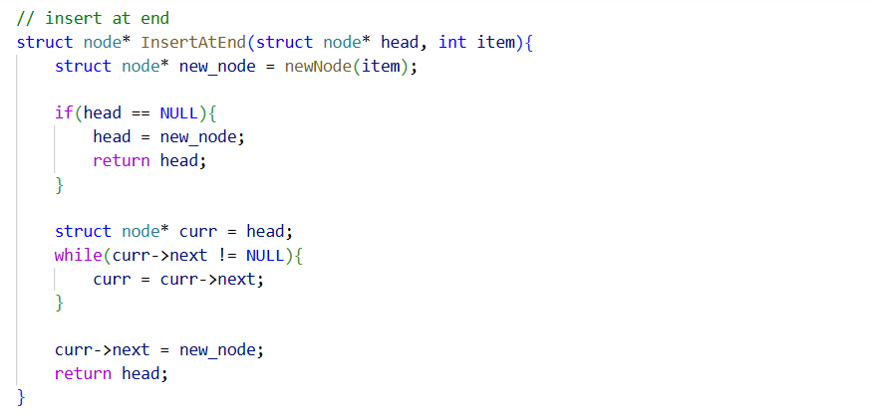
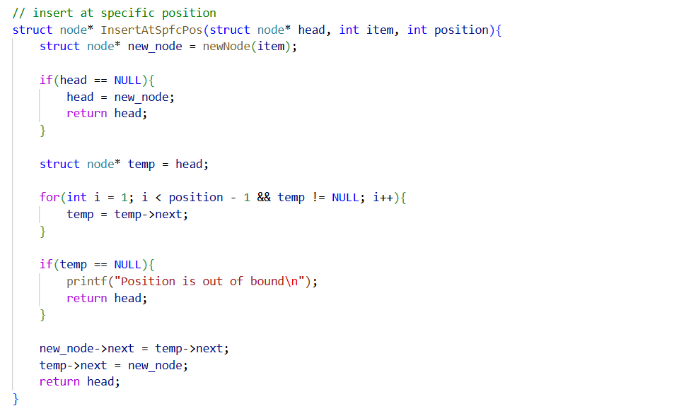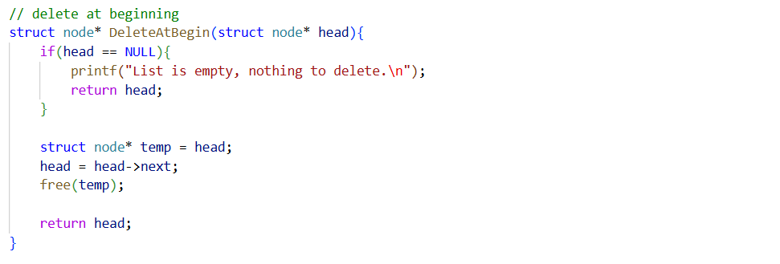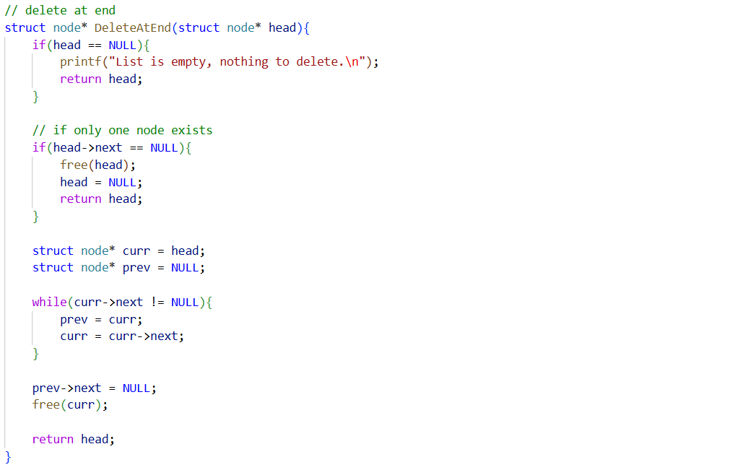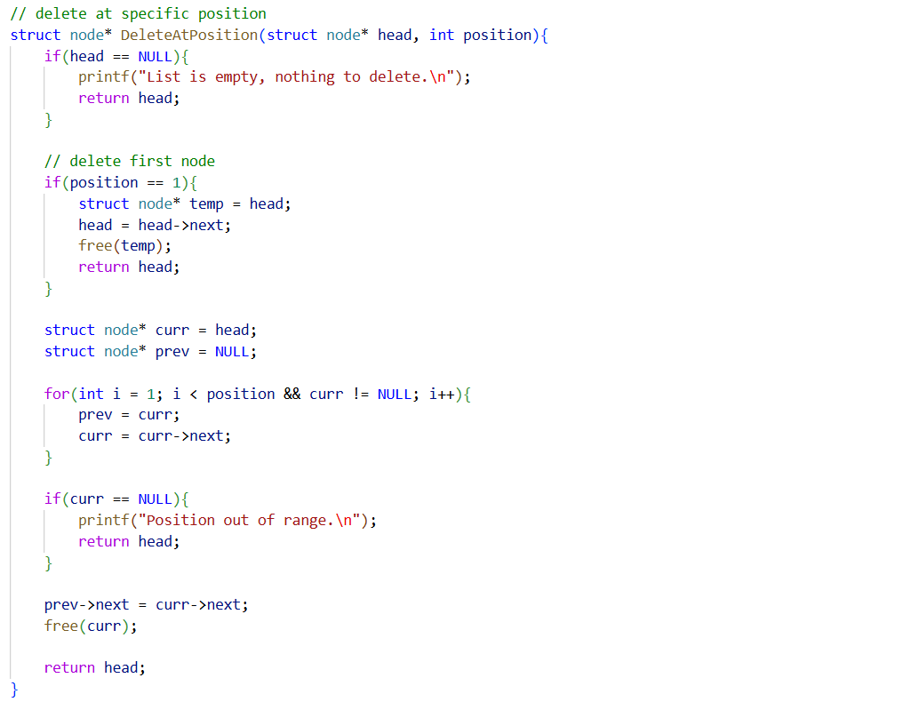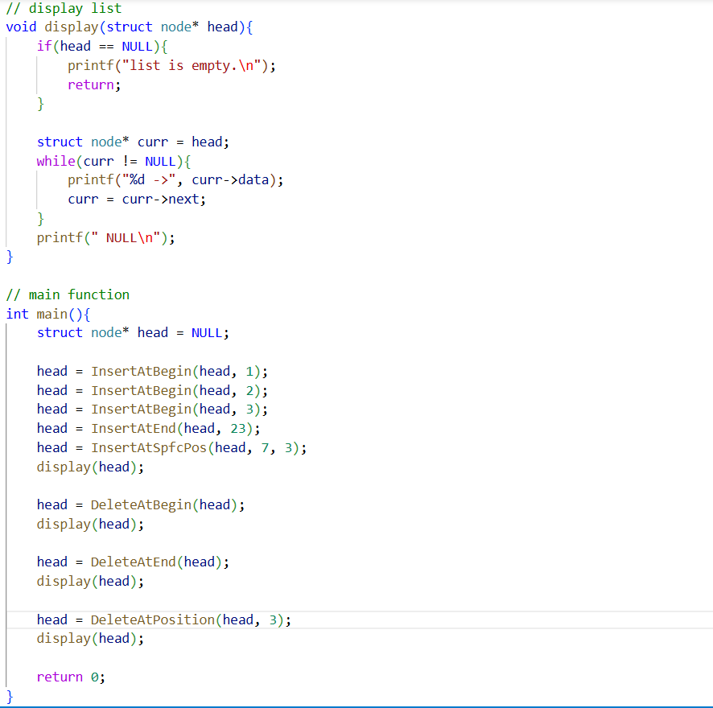

Output:
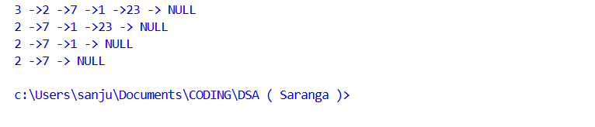
Observation:
To delete a node at a particular position, we have to go through the list one by one until we reach that position.

Exercise 9 Date: 17-10-2025

Aim:
To perform different traversals on a binary tree, use the diagram given below (Figure 1) and write the code to display the in-order, pre-order, and post-order traversal sequences. Also, implement a function to find and print the height of the tree.
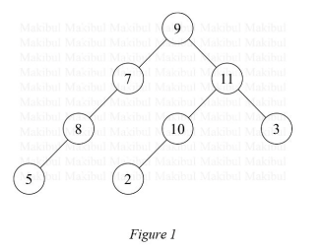
Code: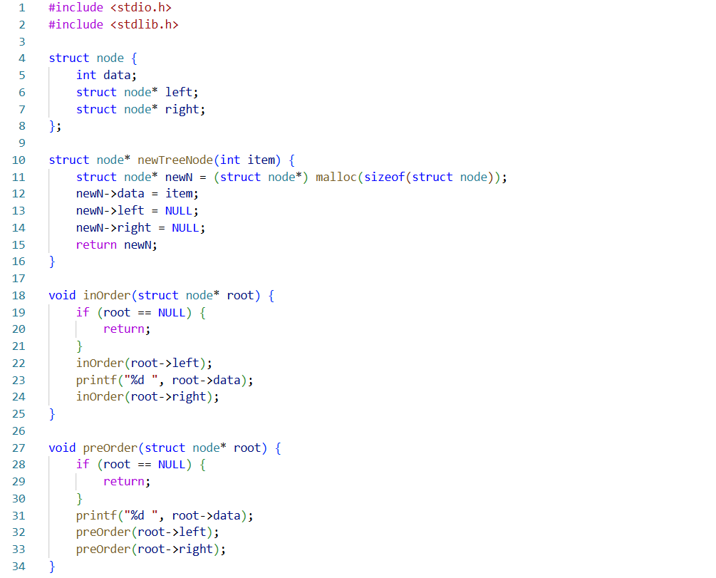
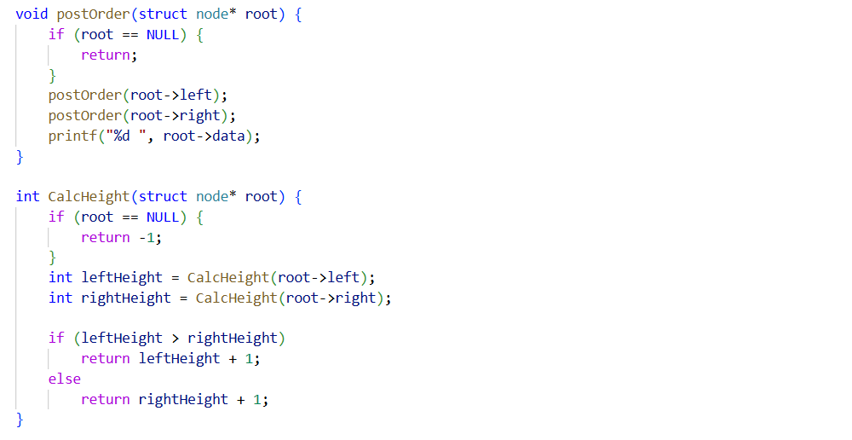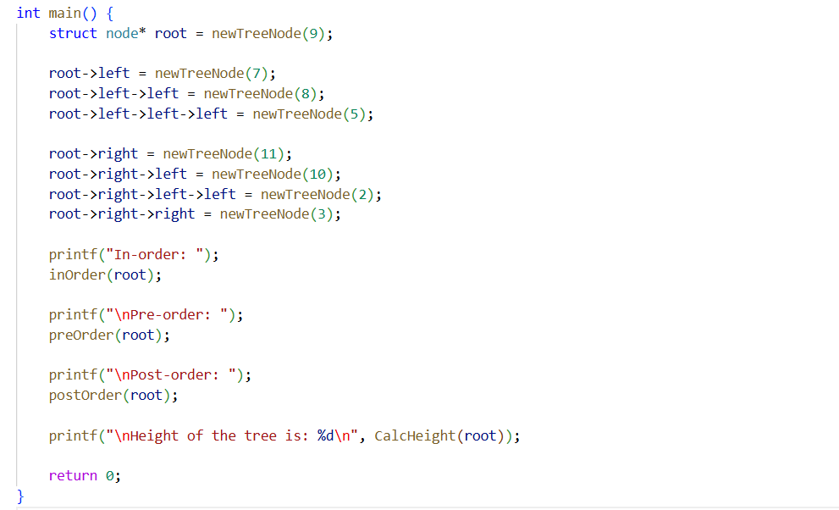

Output:
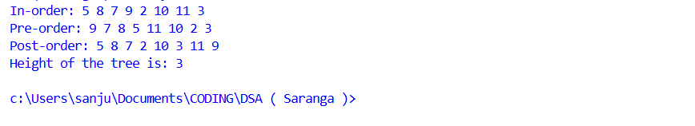
Observation:
This program builds a binary tree with several nodes and shows different ways to visit every node, called traversals (in-order, pre-order, post-order). The function getHeight calculates how many steps the longest path from the root to a leaf takes, which is called the height of the tree.

Exercise 10 Date: 24-10-2025

Aim:
To write a C program to create a binary search tree, display its nodes using in-order traversal, and provide an option for the user to search for a value in the tree.

Code:

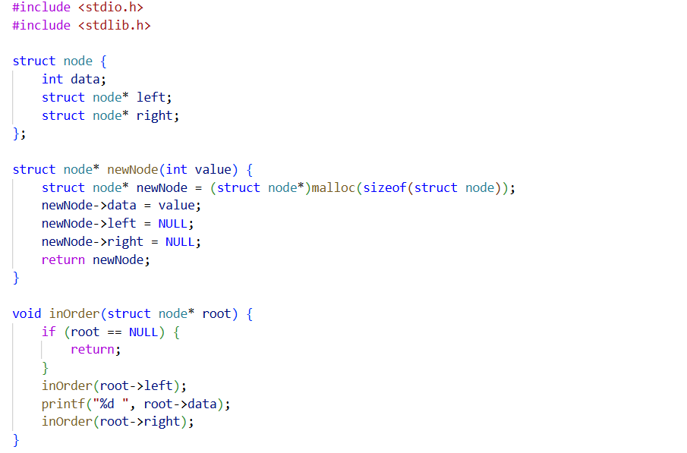
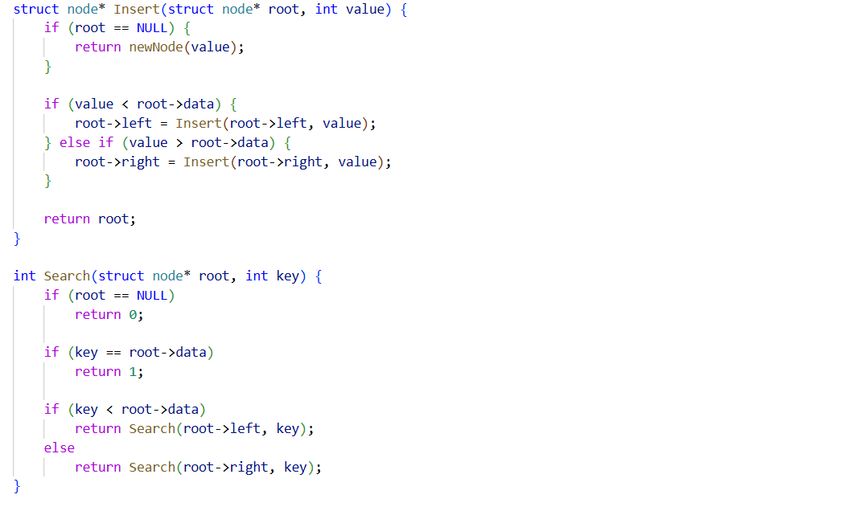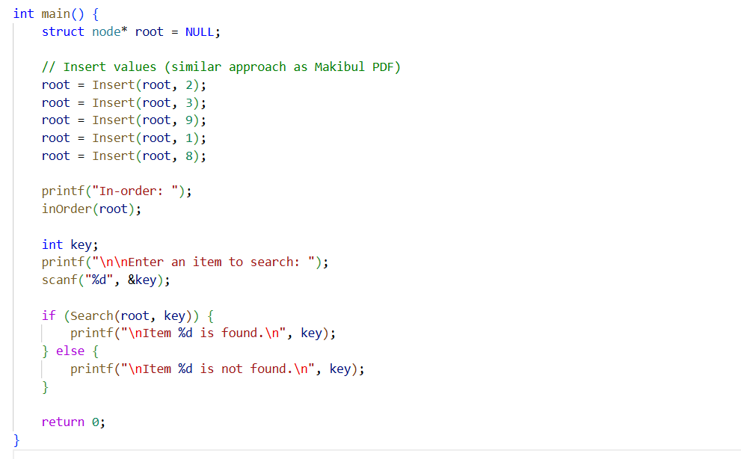

Output 1:
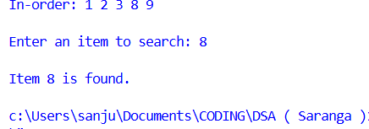

Output 2:
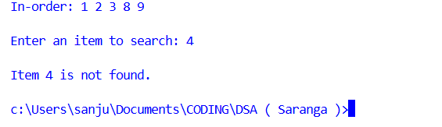

Observation:
In-order traversal is used to display the tree nodes, which ensures the output is sorted in ascending order. The search operation allows the user to check if a particular value exists within the tree.

Exercise 11 Date: 29-10-2025

Aim:
To write a C++ program for the Bubble Sort algorithm.

Code:
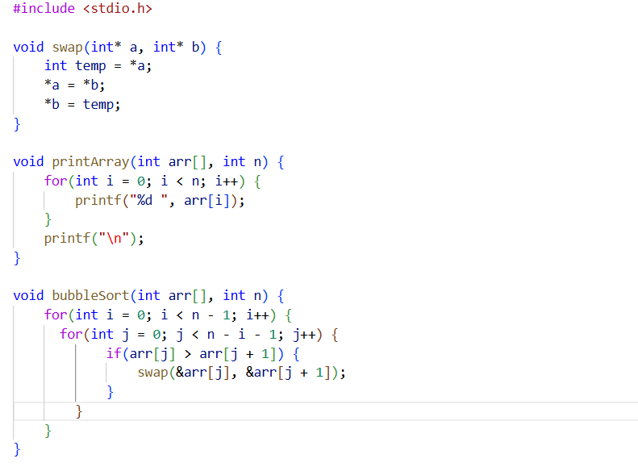
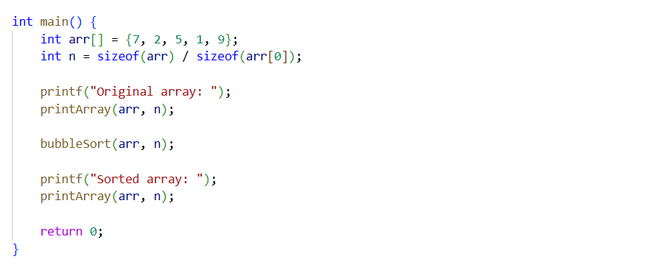

Output:

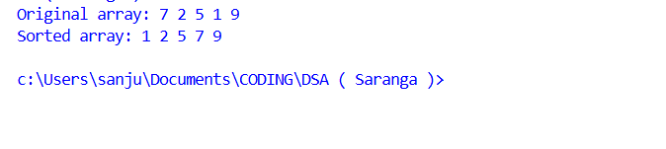
Observation:
The algorithm checks each pair of adjacent elements and swaps them if needed, thus pushing the largest element to the end in each pass. The use of the isSwap flag provides an optimization by terminating early if the array becomes sorted before completing all passes.

Exercise 12 Date: 29-10-2025

Aim:
To write a C++ function to implement the Selection Sort algorithm to sort an integer array.

Code:
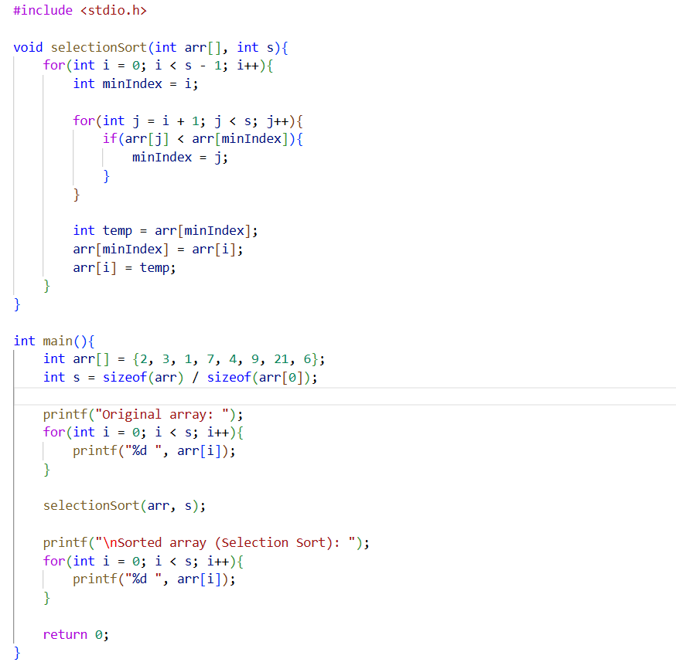
Output:
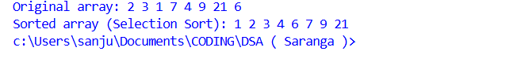
Observation:
The algorithm always finds the smallest element from the unsorted part and places it at the beginning.
Exercise 13 Date: 29-10-2025

Aim:
To implement the Insertion Sort algorithm in C++ to sort an integer array by sequentially inserting each element into its correct position.

Code:
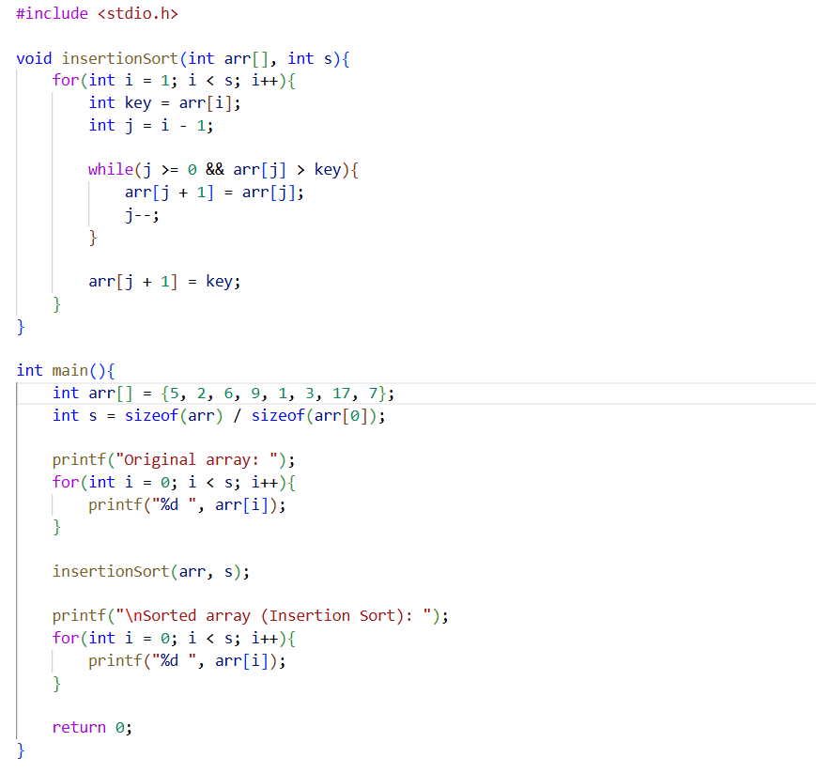
Output:
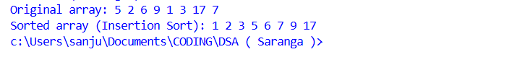
Observation:
The element is shifted until it reaches its sorted position in the left part of the array.

Exercise 14 Date: 31-10-2025

Aim:
To write a C program to implement the Quick Sort algorithm using the partition method and display the sorted array.

Code:
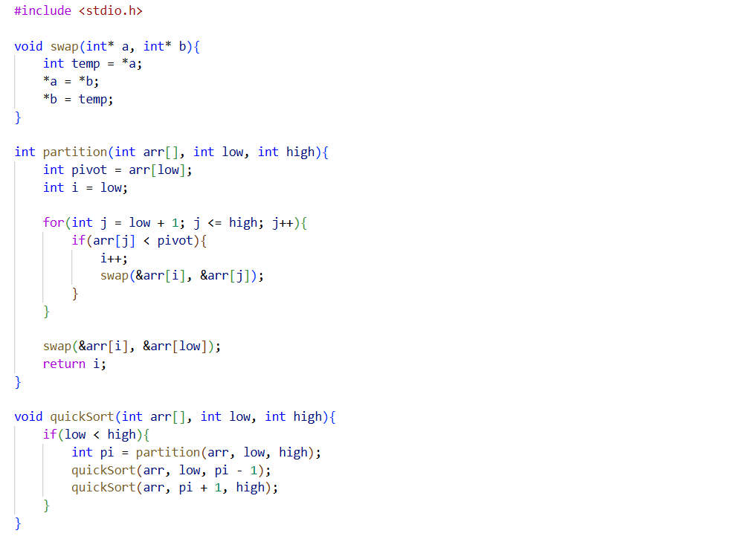
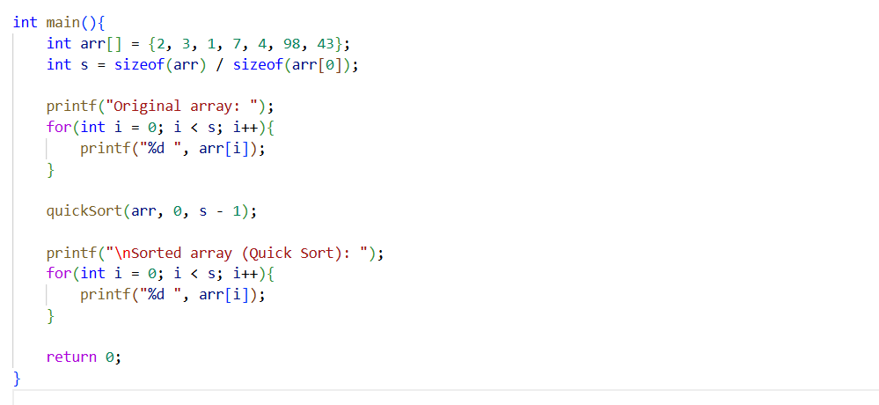

Output:
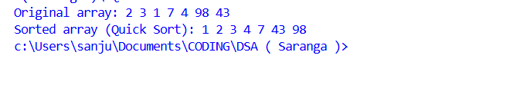
Observation:
The program uses the last element of the array as the pivot during partitioning. The QuickSort function applies recursion to sort the subarrays divided by the pivot index.

Exercise 15 Date: 07-11-2025

Aim:
To write a C program that creates the adjacency matrix of the graph shown in Figure 2 and displays the matrix after adding all edges as per the structure of the graph.
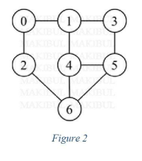
Code: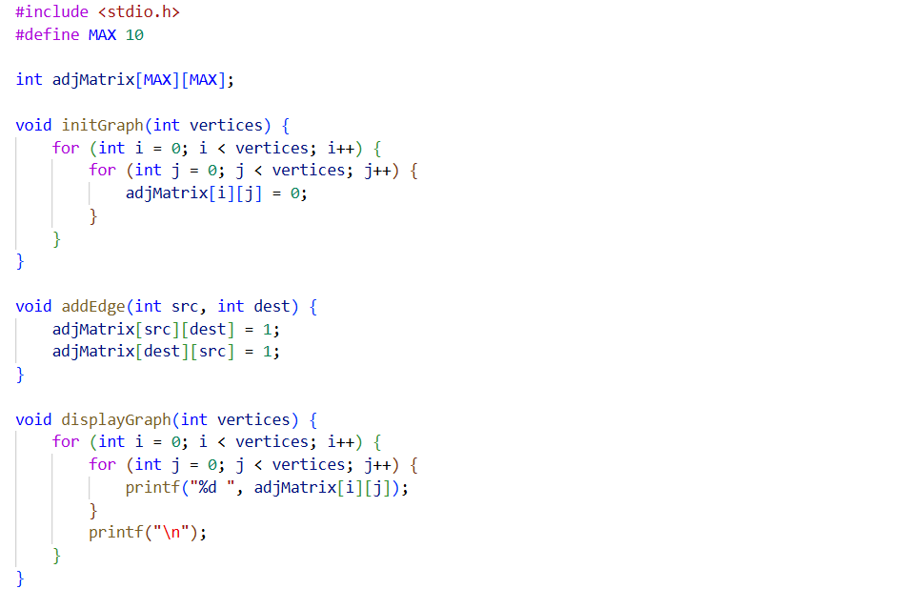
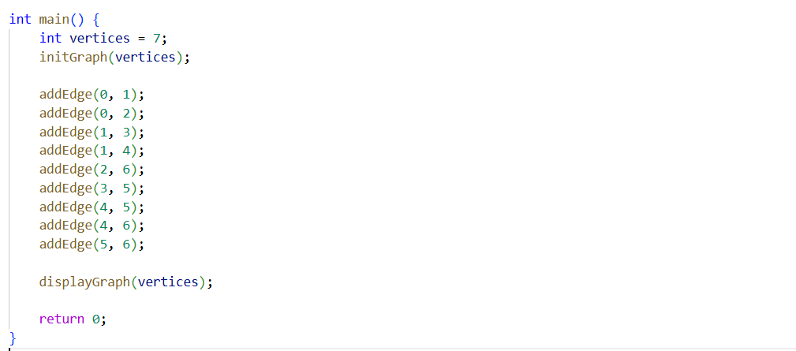
Output:
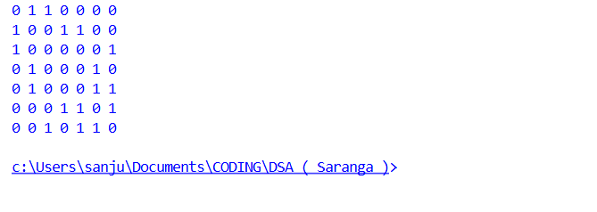
Observation:
The adjacency matrix represents the undirected graph in Figure 2, with each edge being reflected symmetrically in the matrix.

Exercise 16 Date: 07-11-2025

Aim:
To write a C program that creates the adjacency list of the graph shown in Figure 3 and prints the list representation after adding all edges as per the figure.
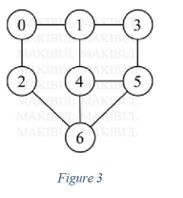

Code: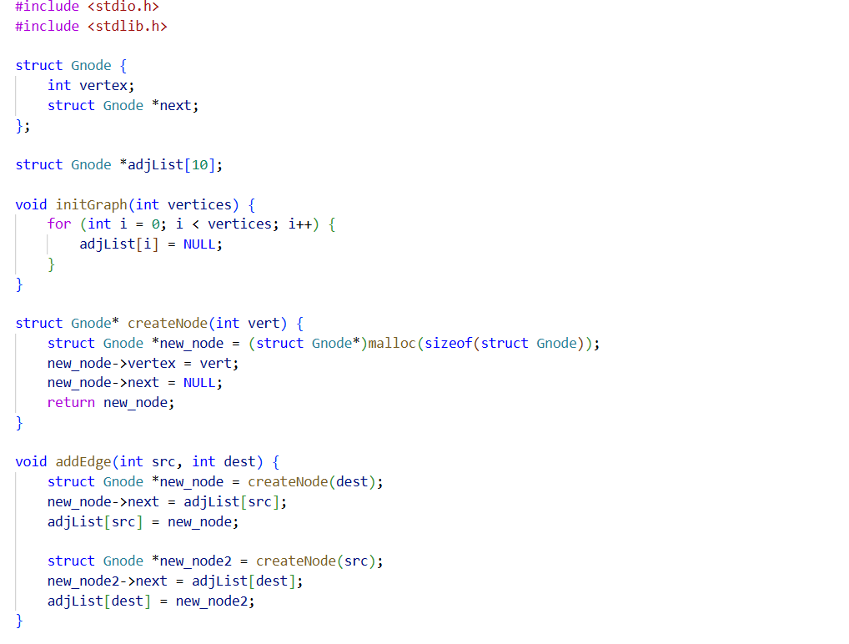
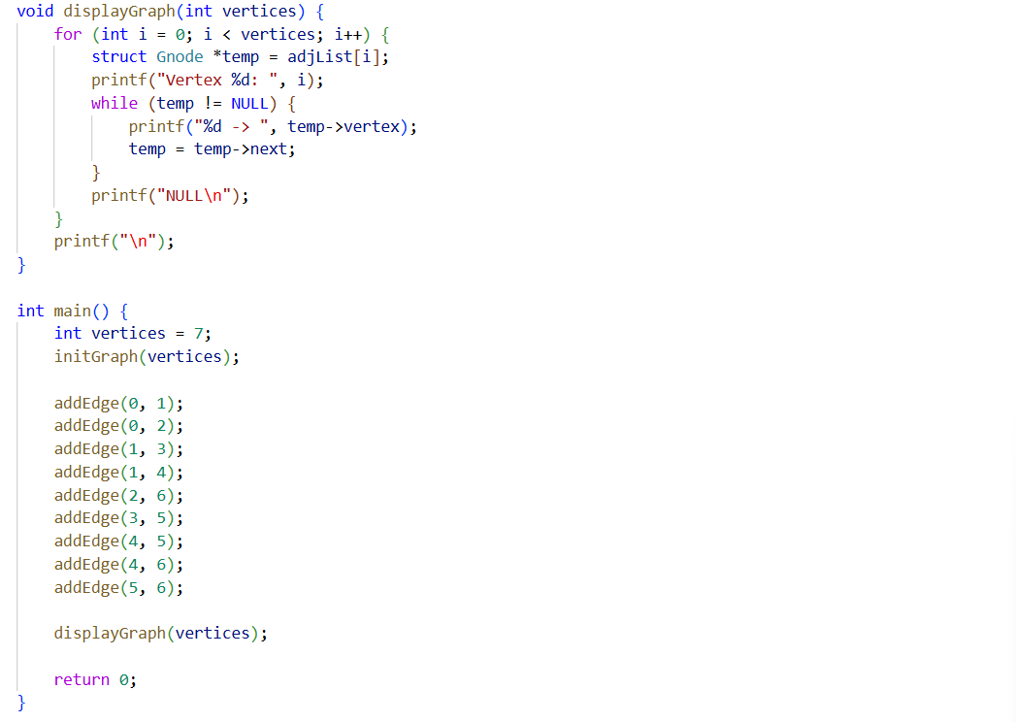

Output:
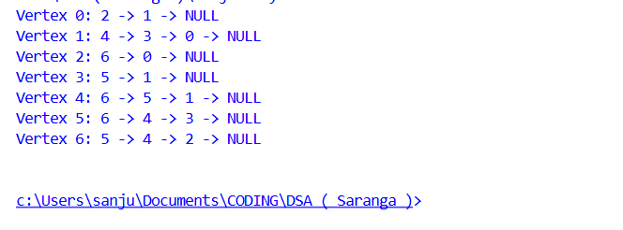
Observation:
Each undirected edge is stored twice: once for each direction, reflecting the structure of Figure 3.

Exercise 17 Date: 14-11-2025

Aim:
To write a C program to implement the Heap Sort using the heapify function. The program should sort an array in ascending order.

Code:

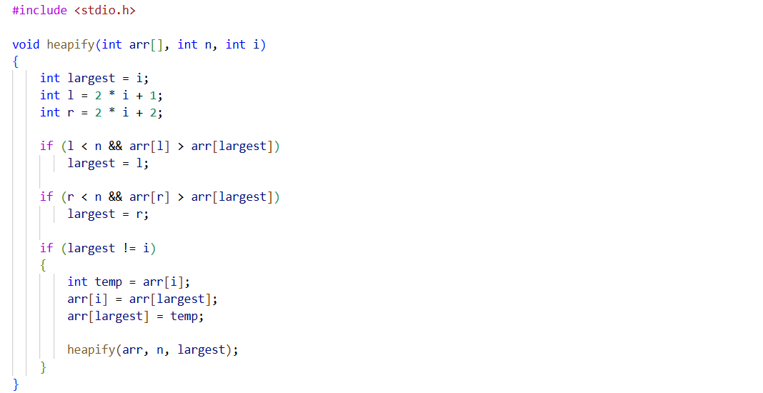
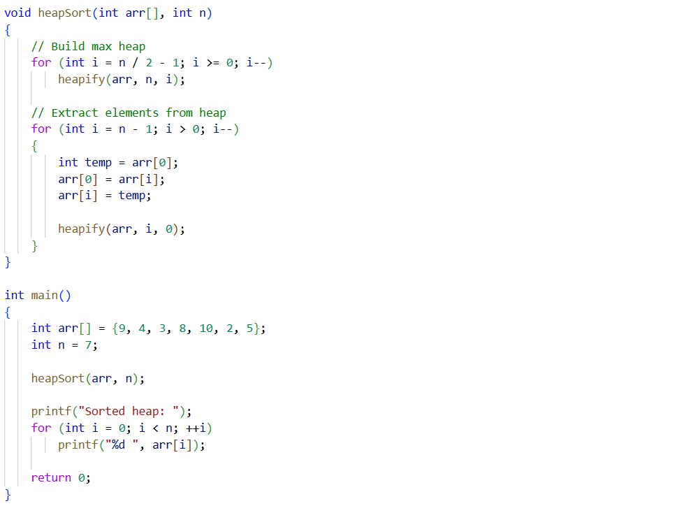

Output:

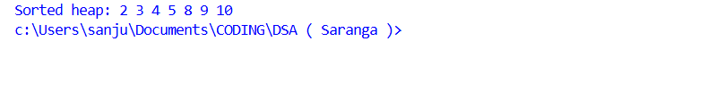
Observation:
The program builds a max heap from the given array and repeatedly applies heapify, resulting in the array being sorted in ascending order.

