Assignment Report: Student Management System

Subject: Object-Oriented Programming with C++

Date: September 22, 2025

This document provides a summary of the C++ Student Management System, outlining its program flow, key features, and sample usage.

1. Program Flow
The program is designed around a continuous, user-friendly menu system that runs inside a while loop. The flow is as follows:

Initialization: The program starts by creating a fixed-size array to store Student objects and initializes the count of students to zero.

Menu Display: A menu of options (Add, Display, Search, Modify, Delete, Report Card, and Exit) is displayed to the user on the console.

User Input: The program prompts the user to enter a choice. It includes robust input validation to ensure the user enters a valid number, preventing crashes or infinite loops from invalid text input.

Action Processing: A switch-case statement evaluates the user's choice and executes the corresponding functionality.
Each action (like searching or deleting) prompts the user for necessary information (e.g., a roll number).
The program iterates through the student array to find the relevant record and perform the requested action.
Feedback is provided to the user, such as "Record updated" or "No records found" or “Student not found”.

Loop Continuation: After an action is completed, the menu is displayed again, allowing the user to perform another task.

Termination: The while loop and the program terminate only when the user selects the "Exit" option (option 7) from the menu.

2. Features Implemented
The system provides a comprehensive set of functionalities for basic student record management:

Add Student (Option 1): Allows the user to enter details for a new student, including name, roll number, department, semester, and marks in five subjects.

Display All Students (Option 2): Lists the complete details of all students currently stored in the system.

Search Student (Option 3): Finds and displays the record of a specific student by searching for their roll number.

Modify Student Record (Option 4): Allows the user to update the details of an existing student by re-entering all their information.

Delete Student Record (Option 5): Removes a student's record from the system. The array is adjusted to fill the gap left by the deleted record.

Generate Report Card (Option 6): Displays a neatly formatted report card for a specific student, which includes all their details, total marks, percentage, and final grade.

Exit (Option 7): Safely terminates the program.

3. Sample Input/output
Below are samples demonstrating the program's interaction with a user:

Sample Output1:(Option 1)
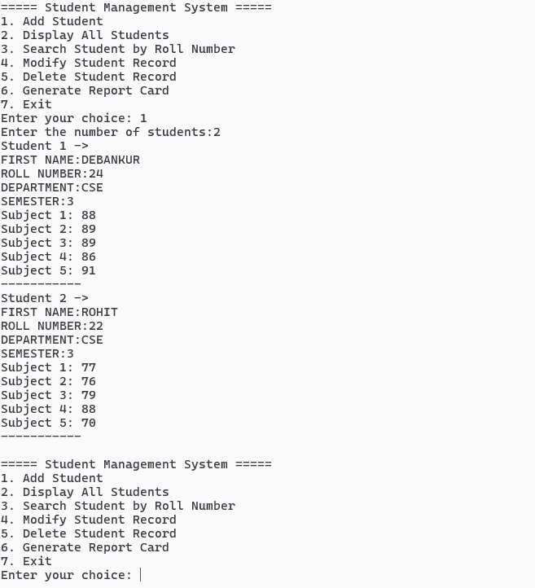

Sample Output 2 :( Option 2)
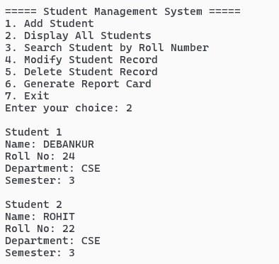

Sample Output 3 :( Option 3)
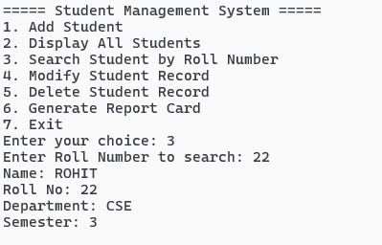

Sample Output 4 : ( Option 4 )
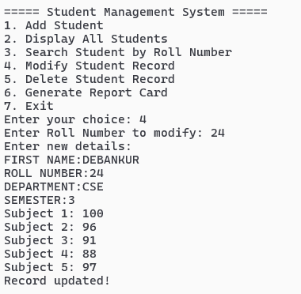
Sample Output 5 : ( Option 5 )
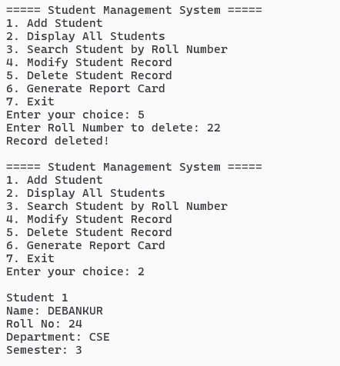

Sample Output 6 : ( Option 6 )
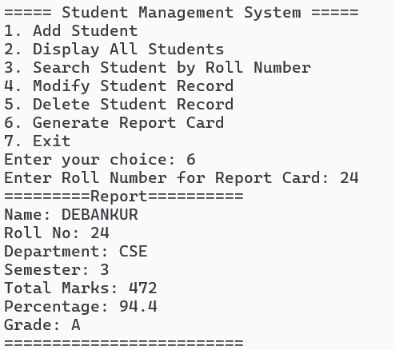

Sample Output 7 : ( Option 7 )

