没做图形界面，代码风格也是渣的不行，好多函数都是写完，又拆开，又复制了好几份，十分乱套，还没来得及整理。。。小伙伴们先凑合着用那个人人对弈的图形界面程序搭配着玩一下吧，根据坐标手动落子😂。。。

先输入0/1确定先手（1电脑先手），然后电脑落子会输出x,y格式的数据，根据数据在图形界面上手动落子，然后玩家落子之后手动输入坐标，格式：x y(x空格y回车)，就酱。。

－－－－－－－－－－－－

已知BUG（或者说是有些功能太费事还没做😉）：

先手开局不能把握优势，不会隔空位落子（甚至会因此错失必胜机会）：算法对空位没有纳入考量

某些较好落点的价值并不很高：公式不完善，可调整公式中的一些常量，增加预落子系统及局面评估系统

中间有点能凑成活四会被放过：算法对空位没有纳入考量（已通过增加函数对其特殊处理解决）

－－－－－－－－－－－－

对空位的忽视造成以下结果：很明显[9][6]（40）应作为必胜点（价值为10^3数量级）处理，然而其价值还没有[10][5]（45）高，至于[10][5]价值咋那么高。。。我也不造。。。

(int [15][15]) ::valueboard = {

[0] = ([0] = 1, [1] = 1, [2] = 1, [3] = 1, [4] = 37, [5] = 2, [6] = 5, [7] = 1, [8] = 1, [9] = 1, [10] = 1, [11] = 1, [12] = 1, [13] = 1, [14] = 1)

[1] = ([0] = 1, [1] = 1, [2] = 1, [3] = 1, [4] = 9, [5] = 0, [6] = 29, [7] = 9, [8] = 5, [9] = 1, [10] = 1, [11] = 1, [12] = 1, [13] = 1, [14] = 1)

[2] = ([0] = 1, [1] = 1, [2] = 1, [3] = 5, [4] = 29, [5] = 0, [6] = 0, [7] = 0, [8] = 6, [9] = 1, [10] = 1, [11] = 1, [12] = 1, [13] = 1, [14] = 1)

[3] = ([0] = 1, [1] = 1, [2] = 1, [3] = 41, [4] = 0, [5] = 0, [6] = 0, [7] = 0, [8] = 17, [9] = 5, [10] = 1, [11] = 1, [12] = 1, [13] = 1, [14] = 1)

[4] = ([0] = 1, [1] = 1, [2] = 1, [3] = 38, [4] = 0, [5] = 0, [6] = 0, [7] = 0, [8] = 0, [9] = 6, [10] = 1, [11] = 1, [12] = 1, [13] = 1, [14] = 1)

[5] = ([0] = 1, [1] = 1, [2] = 1, [3] = 9, [4] = 27, [5] = 0, [6] = 0, [7] = 0, [8] = 0, [9] = 14, [10] = 5, [11] = 1, [12] = 1, [13] = 1, [14] = 1)

[6] = ([0] = 1, [1] = 1, [2] = 1, [3] = 5, [4] = 0, [5] = 0, [6] = 0, [7] = 0, [8] = 0, [9] = 0, [10] = 22, [11] = 5, [12] = 1, [13] = 1, [14] = 1)

[7] = ([0] = 1, [1] = 1, [2] = 1, [3] = 10, [4] = 14, [5] = 0, [6] = 0, [7] = 0, [8] = 25, [9] = 0, [10] = 0, [11] = 21, [12] = 1, [13] = 1, [14] = 1)

[8] = ([0] = 1, [1] = 1, [2] = 1, [3] = 1, [4] = 6, [5] = 0, [6] = 0, [7] = 0, [8] = 0, [9] = 0, [10] = 0, [11] = 3, [12] = 1, [13] = 1, [14] = 1)

[9] = ([0] = 1, [1] = 1, [2] = 1, [3] = 1, [4] = 10, [5] = 10, [6] = 40, [7] = 0, [8] = 0, [9] = 27, [10] = 37, [11] = 10, [12] = 1, [13] = 1, [14] = 1)

[10] = ([0] = 1, [1] = 1, [2] = 1, [3] = 1, [4] = 5, [5] = 45, [6] = 0, [7] = 0, [8] = 0, [9] = 0, [10] = 6, [11] = 1, [12] = 1, [13] = 1, [14] = 1)

[11] = ([0] = 1, [1] = 1, [2] = 1, [3] = 5, [4] = 25, [5] = 0, [6] = 0, [7] = 0, [8] = 0, [9] = 0, [10] = 11, [11] = 1, [12] = 1, [13] = 1, [14] = 1)

[12] = ([0] = 1, [1] = 1, [2] = 1, [3] = 17, [4] = 0, [5] = 0, [6] = 38, [7] = 22, [8] = 7, [9] = 18, [10] = 2, [11] = 1, [12] = 1, [13] = 1, [14] = 1)

[13] = ([0] = 1, [1] = 1, [2] = 1, [3] = 2, [4] = 6, [5] = 6, [6] = 5, [7] = 1, [8] = 1, [9] = 1, [10] = 1, [11] = 1, [12] = 1, [13] = 1, [14] = 1)

[14] = ([0] = 1, [1] = 1, [2] = 1, [3] = 1, [4] = 1, [5] = 1, [6] = 1, [7] = 1, [8] = 1, [9] = 1, [10] = 1, [11] = 1, [12] = 1, [13] = 1, [14] = 1)

}

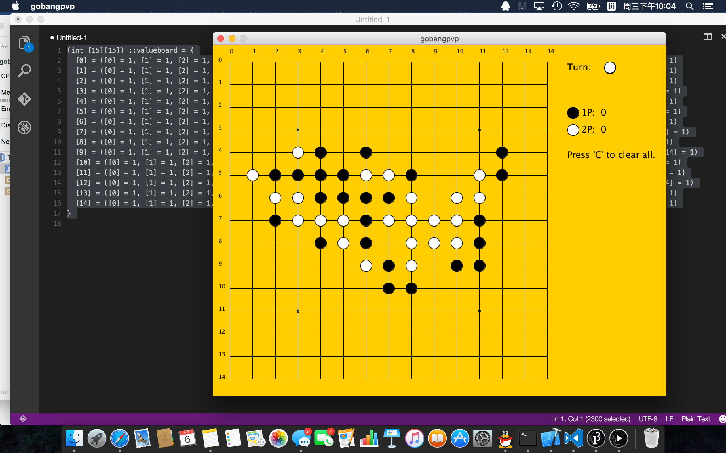

还有就是，会错失下图[7][6]这样的点，同时对方有这样的点电脑也会GG

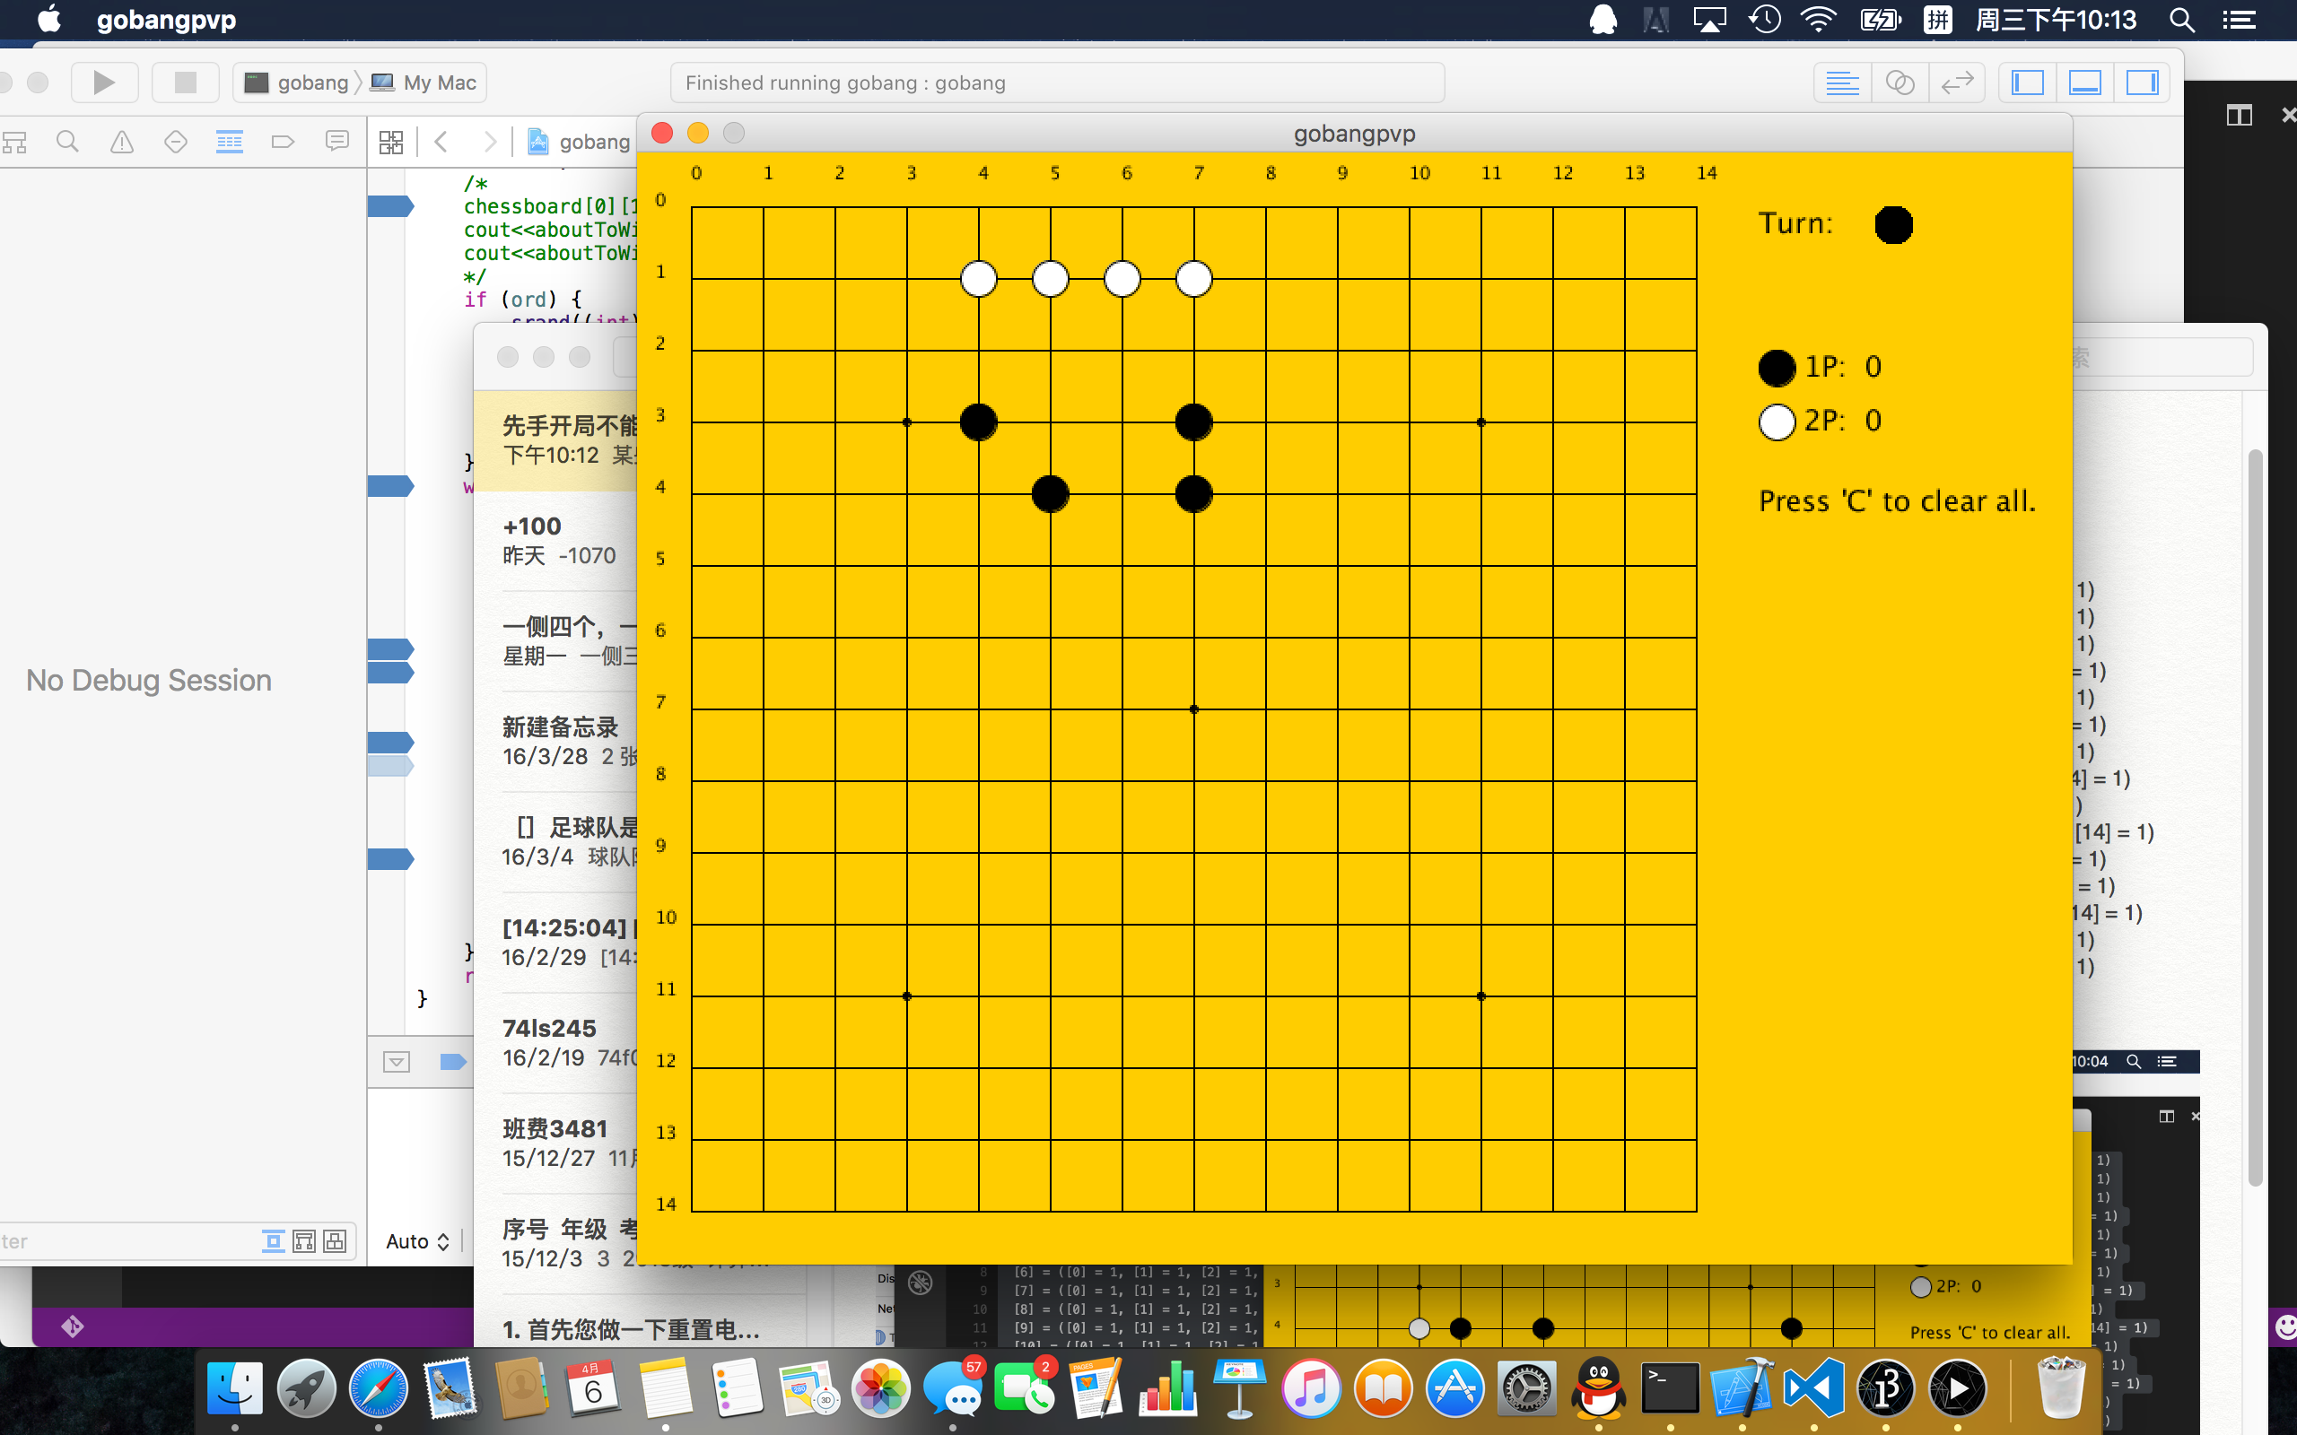

还有更多bug等待大家去发现哦。。。欢迎大家一起调戏傻的乎的五子棋君。。。