

**INTRODUCTION TO C PROGRAMMING**

Individual Assignment ICP

| **Lecturer : Ms. MARY THING** | | | **Class Code: CT018-3-1-ICP** | |
| --- | --- | --- | --- | --- |
| **Submission Date** | **14-04-2022** | **Due Date:** | **22-06-2022** | |
| **Student Full Name**  **(Indicate Student ID)** | **PEDRO FABIAN OWONO ONDO MANGUE**  **(TP063251)** | | | |
| **Total number of pages including this cover page.** | | | |  |

**TABLE OF CONTENTS**

INTRODUCTION AND ASSUMPTION………………………………..…………………………………………………1

PSEUDOCODE………………………………………………………………………………………………………………….2-5

FLOWCHART……………………………………………………………………………………………………………..…..6-12

SOURCE CODES………………………………………………………………………………………………………………7-15

MICROCONTROLLER PIC………………………………………………………………………………………………….15

CONCLUSION…………………………………………………………………………………………………………………….9

REFERENCES…………………………………………………………………………………………………………………….10

1. **INTRODUCTION AND ASSUMPTIONS**

In this C programming project, I have designed a model of a Hydroponic System for tomatoes. Said Hydroponic System allows the user to get into different information such as Ph level, temperature, humidity, and nutritional needs or elements so that it is effective and works in the best possible way. Basically, according to the requirements of the hydroponic system for tomatoes regarding Ph level. It establishes that Ph level should be regulated from 5.5 to 6.5 to maintain the growth and the state of the Hydroponic System. However, it is an additional requirement that contributes to the tomato Hydroponic System. On the other hand, I have to point out the importance of the light and dark time period that should be set at 16 to 18 hours while the darkness should be set at 8 hours. Therefore, the next and penultimate requirements are humidity and temperatures. These two factors play an important role since first you should be very careful and pay attention to the temperature and humidity. The humidity is regulated from 65% to 75% during the night while during the day it is between 80% to 90%. On the other hand, the temperature during the day is around 21 to 26 degrees Celsius while it is from 13 to 18 degrees Celsius. Finally, it is advisable to mention the last feature that I added in my system which is nutritional needs for the system that are Nitrogen, Phosphorus, and Potassium.

1. **PSEUDOCODE**

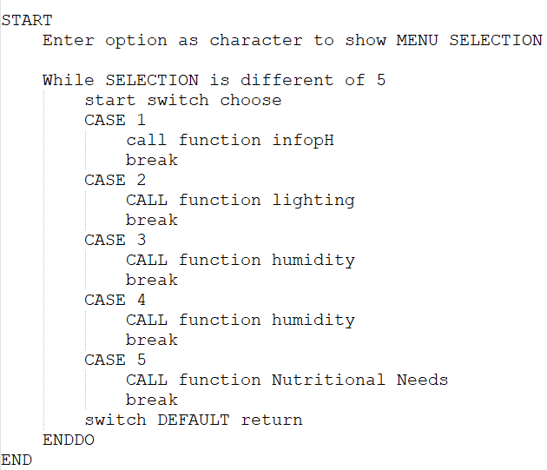

diagram 1.11

In diagram 1.11 the function int main can be reflected. From there you can call different functions according to the case that it is been chosen.

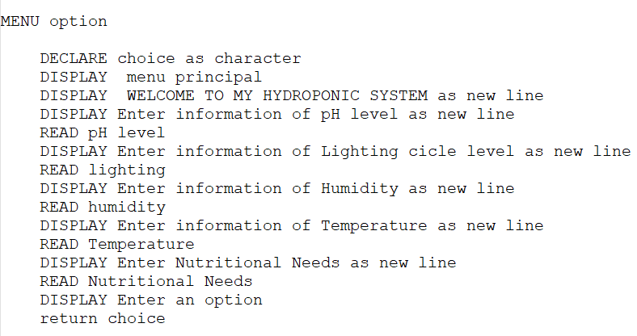

diagram 1.12

diagram 1.13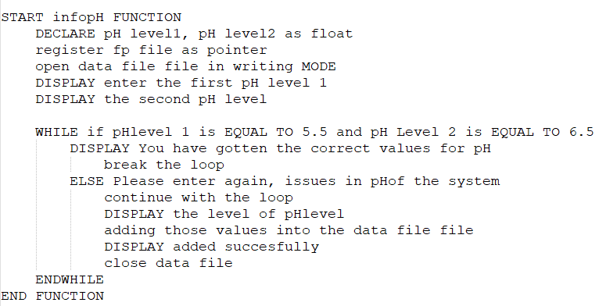

diagram 1.14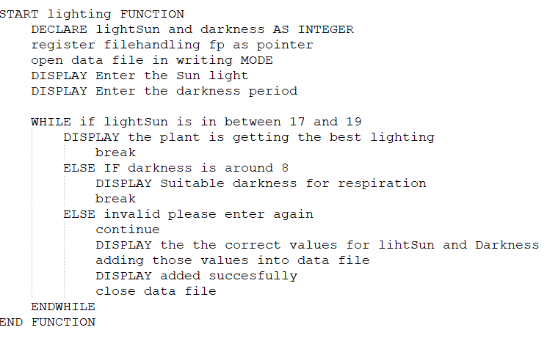

diagram 1.15

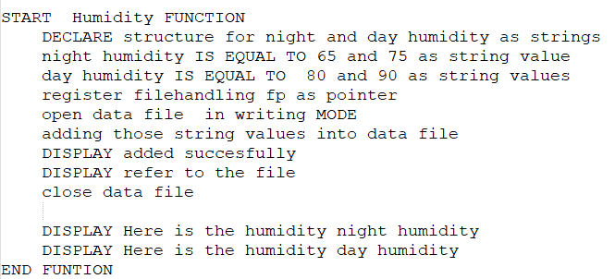

diagram 1.16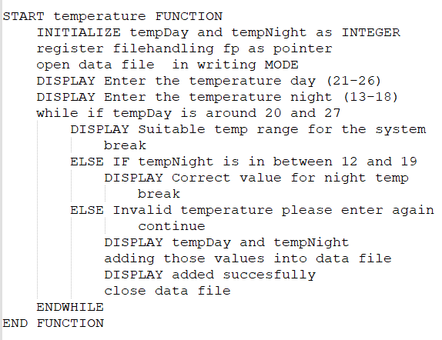

diagram 1.17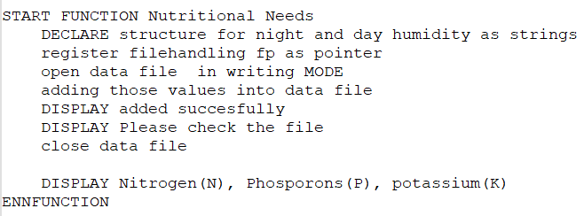

1. **FLOWCHART**

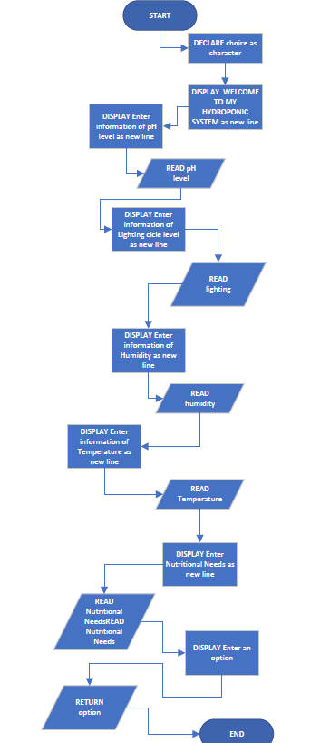

figure 2.11

figure 2.11 menu function

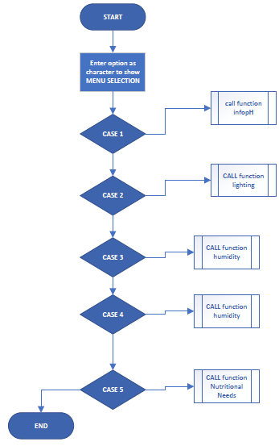

figure 2.12

figure 2.12 int main

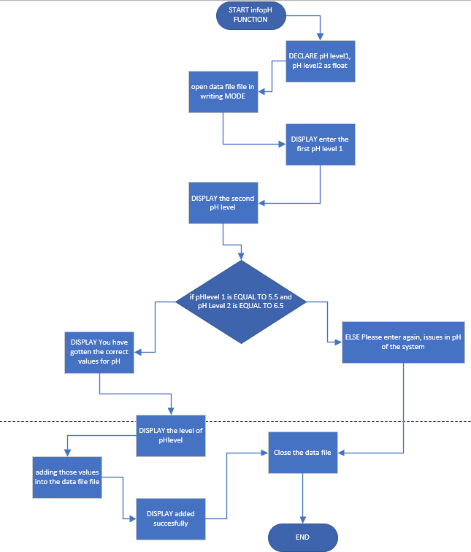

figure 2.13

figure 2.13 function pH

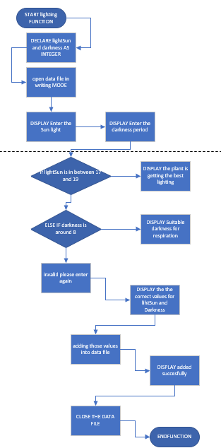

figure 2.14

figure 2.14 lighting function

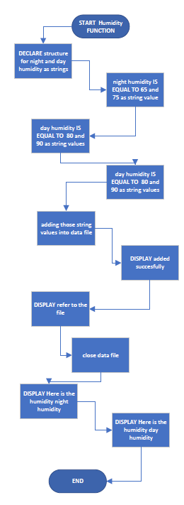

figure 2.15

figure 2.15 humidity function

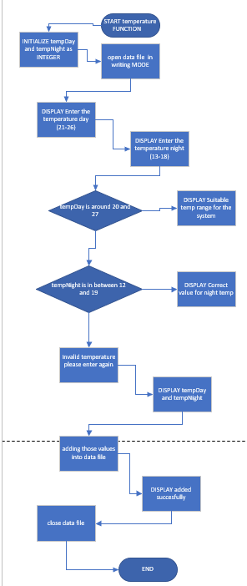

figure 2.16

figure 2.16 temperature function

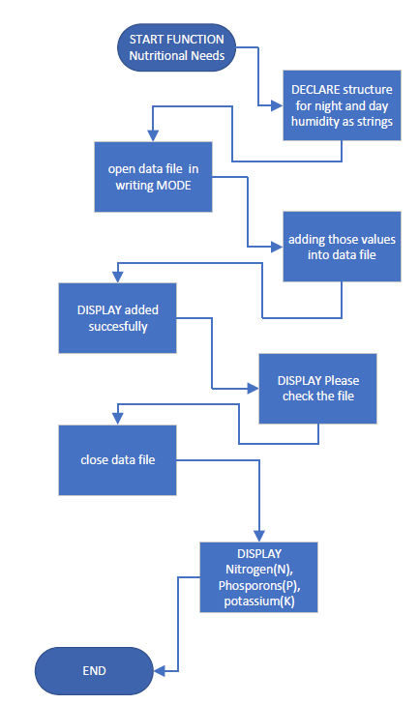

figure 2.17

figure 2.17 Nutritional needs function

1. **SOURCE CODES**

Libraries:

#include <stdio.h>

#include<string.h>

diagram 3.11

In diagram 3.11 you can see the menu of the hydroponic system with different functionalities such as information for pH, temperature, etc., you only have to select a number to access a specific function for the system.

diagram 3.12

In diagram 3.12 the pH level information has been accessed and basically it is necessary to enter 5.5 and 6.5 as these represent the pH required for the tomato. In case you enter something different the system will reject it until you enter the correct values for pH, and those values will be stored in a file.

diagram 3.13

In diagram 3.13 the user asks us the period to provide light to the system and the necessary time it should take in the dark. The times are indicated, and these values will be stored directly in a file.

diagram 3.14

In the diagram 3.14 the information is already displayed in the structures and is going directly into the file.

diagram 3.15

In diagram 3.15 we are getting input of temperature considering that the correct temperature values are visible from the input. In case you enter a different one, the system will ask you to enter again until you put the correct values which are shown in the input.

diagram 3.16

Unlike the humidity, the elements of nutritional needs in diagram 3.16 are displayed from the structures and it goes directly to the file where you can find them as NPK, but in the output screen you can see them clearly.