Statistical Arbitrage in Cryptocurrencies
Momentum and Reversal Research on Live Market Data - Version 2
Wall Street Quants - Bootcamp Project
Survivorship-free universe of 39 coins | data 2021-01-01 to 2026-10-08
October 2026

Contents
Executive Summary 3
0. Changes in Version 2 3
1. Introduction 4
2. Literature Review 4
3. Data 4
3.1 A survivorship-free universe 4
3.2 Prices and sources 5
3.3 Investment themes 6
4. Backtest Methodology 6
4.1 Unconstrained backtest 6
4.2 Costs 6
4.3 Metrics 6
4.4 Pre-registered protocol 6
5. Momentum Research (Research Period) 7
5.1 Time horizon 7
5.2 New information and activity 8
5.3 Seasonality 8
5.4 Investment themes 9
5.5 Technical plays: front-running the US session 9
6. Reversal Research (Research Period) 10
6.1 Time horizon 10
6.2 Correlation: residual baskets and cointegrated pairs 10
6.3 Macro: volatility and dislocation 11
7. Mechanical Strategy Selection 11
8. Execution 12
9. Weighting 12
10. Performance Evaluation 13
11. Discussion 15
11.1 Version 1 versus version 2 15
11.2 What the research shows 16
11.3 Limitations 16
11.4 Next steps 16
12. Conclusion 16
Appendix A. Reproducibility 16
References 17

Executive Summary
This is version 2 of the project. It answers the class brief - research momentum and reversal strategies in crypto, test them with unconstrained backtests at 20 bps (market orders) and 7 bps (limit orders), combine them with a weighting scheme and report returns, volatility, Sharpe, drawdown and alpha / beta - and it corrects five issues in version 1 (Section 0).
Headline: the hold-out result
All research and every design decision used only 2021-07 to 2023-12. On the untouched hold-out (2024-01-01 to 2026-10-08) the combined momentum + reversal portfolio earned a net Sharpe of 0.20, an annualised alpha of 2.8% with a t-statistic of only 0.52, a beta to Bitcoin of -0.03 and a correlation to Bitcoin of -0.12. In the research period the same portfolio had a Sharpe of 0.93 and an alpha t-statistic of 1.64. The edge did not survive out of sample at a statistically meaningful level.
Table 1. Combined portfolio, net of costs. Hold-out first.
Combined portfolio | Sharpe | Ann. return | Ann. vol | Max DD | Alpha | Alpha t | Beta | Corr BTC
Hold-out 2024-2026 | 0.20 | 2.1% | 10.3% | -26.7% | 2.8% | 0.52 | -0.03 | -0.12
Research 2021-2023 | 0.93 | 9.4% | 10.1% | -13.3% | 9.6% | 1.64 | -0.03 | -0.15
Full backtest | 0.50 | 5.2% | 10.2% | -26.7% | 5.7% | 1.42 | -0.03 | -0.13
Buy & hold BTC, hold-out | 0.61 | 24.1% | 39.4% | -53.1% | 0.0% | 0.33 | 1.00 | 1.00
* Momentum book at 20 bps (market orders), reversal book at 7 bps (limit orders). Sharpe = mean / std x sqrt(252); return, volatility and alpha annualised with 252 days. Alpha, beta and correlation vs daily Bitcoin returns; alpha t uses Newey-West (5-lag) errors.
Key findings
- Horizon. With 39 coins chosen by market cap at the start of 2021, research-period data show cross-sectional reversal at 1-5 days (1-day gross Sharpe -0.85) and at 21-120 days, and time-series momentum at 1-4 week horizons (0.45 at 30 days).
- Costs. Short-horizon reversal is real in gross terms but its turnover makes it lose money even with 7 bps limit orders; only slow signals survive the brief's costs.
- What survived. Time-series momentum with an implied-volatility (DVOL) filter is the one component that held up: research net Sharpe 0.55, hold-out 0.62 at 20 bps. Theme momentum and the slow reversal signals that looked best in 2021-2023 decayed.
- Version 1 vs version 2. Version 1 reported a Sharpe of 1.02 using sqrt(365). On the class sqrt(252) scale that is 0.85 (full) and 0.46 (hold-out). Removing survivorship bias and hold-out contamination takes the hold-out Sharpe from 0.46 to 0.20.

0. Changes in Version 2
Table 2. Changes from version 1 to version 2.
V1 | V2 | Effect
Sharpe annualised with sqrt(365) | All Sharpe ratios = mean / std x sqrt(252); returns, volatility and alpha annualised with 252 days (sa_core.ANN = 252) | V1 combined Sharpe 1.02 -> 0.85 (full), 0.55 -> 0.46 (hold-out)
Exploration ran on the full 2021-2026 sample, so the hold-out was not untouched (the 60/90-day reversal only appears in 2024-2026) | Pre-registered mechanical protocol: every signal's direction, every candidate, the execution rule and the weighting are chosen on 2021-07 to 2023-12 only (Section 4.4) | The hold-out is now a true out-of-sample test; the combined hold-out Sharpe is 0.20
Full-sample results reported first; no correlation to BTC (hold-out alpha t was 0.90 vs 2.19 full sample) | Hold-out reported first everywhere (summary, tables, README, deck); correlation to BTC added to every table | Hold-out alpha t = 0.52; correlation to BTC = -0.12
16 coins that survived to 2026 (survivorship bias) | Top 40 coins by market cap on 2021-01-03 (stablecoins and wrapped tokens excluded); 39 have free data. Coins that collapsed or were delisted (FTT, EOS, MKR) are kept until their prices end | Removes survivorship bias; the universe includes the FTX collapse and other failures
No standalone rebuild or methodology guide | src/minimal_backtest.py rebuilds a strategy in ~60 lines and checks it against the engine; a separate methodology explainer covers every choice and likely interview questions | Engine and minimal backtest agree to machine precision

1. Introduction
Statistical arbitrage looks for price-volume patterns that predict returns. The brief highlights momentum (recent winners keep winning) and reversal (recent moves undo themselves), and gives a research outline for each: time horizon, new information and activity, seasonality, investment themes and technical plays for momentum; time horizon, uninformed trading, correlation and macro dislocation for reversal. It then asks for unconstrained backtests, realistic execution costs, a weighting scheme and standard performance metrics.
Version 2 keeps the research outline of version 1 but changes how conclusions are drawn. The universe is fixed by market cap at the start of the sample, so it includes coins that later failed. All exploration and selection uses the 2021-2023 research period, through a mechanical rule set written down before the hold-out is examined. The research question is unchanged: which momentum and reversal patterns exist in crypto, which survive realistic costs, and how should they be combined?

2. Literature Review
Cross-sectional momentum (Jegadeesh & Titman, 1993), time-series momentum (Moskowitz, Ooi & Pedersen, 2012) and industry momentum (Moskowitz & Grinblatt, 1999) are robust across asset classes, but momentum crashes in high-volatility rebounds (Daniel & Moskowitz, 2016) and benefits from volatility scaling (Barroso & Santa-Clara, 2015). Short-term reversal (Lehmann, 1990) is a reward for supplying liquidity: low-volume moves reverse more (Campbell, Grossman & Wang, 1993) and reversal profits rise with market volatility (Nagel, 2012). Long-horizon reversal reflects overreaction (De Bondt & Thaler, 1985). In crypto, Liu and Tsyvinski (2021) and Liu, Tsyvinski and Wu (2022) document a momentum factor, Han, Kang and Ryu (2024) find time-series momentum more robust than cross-sectional momentum after costs, and Fil and Kristoufek (2020) find pairs relationships unstable. Garleanu and Pedersen (2013) motivate partial trading toward targets; DeMiguel, Garlappi and Uppal (2009) show that simple weights are hard to beat. Harvey, Liu and Zhu (2016) and Bailey and Lopez de Prado (2014) warn that testing many strategies inflates backtest Sharpe ratios - the reason for version 2's protocol. Survivorship bias, the reason for version 2's universe, is a standard concern in any backtest that conditions on assets that still exist at the end of the sample.

3. Data

3.1 A survivorship-free universe
Version 1 traded 16 coins that were still liquid on Coinbase in 2026, which quietly excludes every coin that failed. Version 2 fixes the universe at the start of the sample: the 40 largest coins by market capitalisation in the CoinMarketCap historical snapshot of 2021-01-03, after removing stablecoins (USDT, USDC, DAI, BUSD) and wrapped tokens (WBTC). Membership never changes with hindsight. A coin leaves the cross-section only when its price history ends. Of the 40, 39 have free price history; Revain (REV) has none and is the only drop.
Table 3. Universe: top 40 non-stablecoin coins by market cap on 2021-01-03.
Rank | Coin | Name | Source | First price | Last price | Status
1 | BTC | Bitcoin | coinbase | 2021-01-01 | 2026-10-08 | active
2 | ETH | Ethereum | coinbase | 2021-01-01 | 2026-10-08 | active
4 | LTC | Litecoin | coinbase | 2021-01-01 | 2026-10-08 | active
5 | XRP | XRP | kucoin | 2021-01-01 | 2026-10-08 | active
6 | DOT | Polkadot | kucoin | 2021-01-01 | 2026-10-08 | active
7 | BCH | Bitcoin Cash | coinbase | 2021-01-01 | 2026-10-08 | active
8 | ADA | Cardano | kucoin | 2021-01-01 | 2026-10-08 | active
9 | BNB | Binance Coin | gate | 2021-01-01 | 2026-10-08 | active
10 | LINK | Chainlink | coinbase | 2021-01-01 | 2026-10-08 | active
13 | BSV | Bitcoin SV | kucoin | 2021-01-01 | 2026-10-08 | active
14 | XLM | Stellar | coinbase | 2021-01-01 | 2026-10-08 | active
15 | EOS | EOS | bitfinex | 2021-01-01 | 2026-07-03 | history ends (delisted / collapsed)
16 | XMR | Monero | bitfinex | 2021-01-01 | 2026-10-08 | active
17 | THETA | THETA | gate | 2021-01-01 | 2026-10-08 | active
18 | TRX | TRON | gate | 2021-01-01 | 2026-10-08 | active
19 | XEM | NEM | gate | 2021-01-01 | 2026-10-08 | active
20 | VET | VeChain | kucoin | 2021-01-01 | 2026-10-08 | active
21 | XTZ | Tezos | coinbase | 2021-01-01 | 2026-10-08 | active
22 | CEL | Celsius | gate | 2021-04-09 | 2026-10-08 | active
23 | UNI | Uniswap | coinbase | 2021-01-01 | 2026-10-08 | active
24 | LEO | UNUS SED LEO | bitfinex | 2021-01-01 | 2026-10-08 | active
25 | CRO | Crypto.com Coin | kucoin | 2021-01-01 | 2026-10-08 | active
26 | DOGE | Dogecoin | gate | 2021-01-01 | 2026-10-08 | active
27 | ATOM | Cosmos | coinbase | 2021-01-01 | 2026-10-08 | active
30 | NEO | Neo | kucoin | 2021-01-01 | 2026-10-08 | active
31 | AAVE | Aave | coinbase | 2021-01-01 | 2026-10-08 | active
32 | SNX | Synthetix | coinbase | 2021-01-01 | 2026-10-08 | active
33 | REV | Revain | - | - | - | no free price history found
34 | HT | Huobi Token | gate | 2021-01-01 | 2026-10-08 | active
35 | FIL | Filecoin | gate | 2021-01-01 | 2026-10-08 | active
36 | DASH | Dash | coinbase | 2021-01-01 | 2026-10-08 | active
37 | IOTA | IOTA | bitfinex | 2021-01-01 | 2026-10-08 | active
38 | ETC | Ethereum Classic | gate | 2021-01-01 | 2026-10-08 | active
39 | ZIL | Zilliqa | gate | 2021-01-01 | 2026-10-08 | active
40 | YFI | yearn.finance | coinbase | 2021-01-01 | 2026-10-08 | active
41 | MKR | Maker | coinbase | 2021-01-01 | 2026-01-12 | history ends (delisted / collapsed)
42 | FTT | FTX Token | bitfinex | 2021-01-01 | 2022-11-29 | history ends (delisted / collapsed)
43 | COMP | Compound | coinbase | 2021-01-01 | 2026-10-08 | active
44 | ZEC | Zcash | coinbase | 2021-01-01 | 2026-10-08 | active
45 | SUSHI | SushiSwap | gate | 2021-01-01 | 2026-10-08 | active

3.2 Prices and sources
For each coin, daily candles were requested from three free public APIs - Coinbase Exchange (USD), KuCoin and Gate.io (USDT) and Bitfinex (USD) - and the source with the most complete history from January 2021 was used, breaking ties by dollar volume. The same source supplies hourly candles where available. USDT is treated as USD. Binance is geo-restricted from the research environment (HTTP 451). Bitfinex keeps the history of delisted pairs, which is how FTX Token (FTT, collapsed November 2022) enters the sample. Implied volatility is the Deribit DVOL index.
Several coins trade thinly at their chosen venue (median daily dollar volume below $100,000 for XEM, CEL and FTT). Their prices are real but noisy, and a fund could not trade them at size; Section 11.3 discusses this. Prices are aligned to a daily calendar, gaps of up to three days are forward-filled, and simple close-to-close returns are used.

3.3 Investment themes
Table 4. Themes, assigned from each project's function rather than from returns.
Theme | Coins
Payments & Privacy | BTC, LTC, BCH, BSV, XRP, XLM, DOGE, DASH, ZEC, XMR, XEM
Smart-Contract Platforms | ETH, ADA, DOT, EOS, TRX, XTZ, ATOM, NEO, ETC, ZIL
DeFi & Oracle | UNI, AAVE, SNX, YFI, MKR, COMP, SUSHI, LINK
Exchange & CeFi Tokens | BNB, LEO, CRO, HT, FTT, CEL
Data, IoT & Media | THETA, FIL, VET, IOTA

4. Backtest Methodology

4.1 Unconstrained backtest
Each day a signal is turned into weights using information up to that day's close; the weights earn the next day's return, so there is no look-ahead. Gross exposure (sum of absolute weights) is one. Cross-sectional strategies are dollar-neutral, with weights proportional to each coin's demeaned rank. Time-series strategies hold each coin long or short on its own signal, scaled by the inverse of its 30-day volatility. src/minimal_backtest.py reproduces this in about 60 lines and checks itself against the engine.

4.2 Costs
Costs follow the brief: 20 bps per unit of turnover for market orders and 7 bps for limit orders. Momentum-direction strategies are charged 20 bps because they chase price and need immediate fills. Reversal-direction strategies are charged 7 bps because they buy what has fallen and sell what has risen, supplying liquidity, and they trade slowly enough to work passive orders. Every result is also shown with all trades at 20 bps.

4.3 Metrics
Following the class convention, Sharpe = mean / standard deviation x sqrt(252) on daily returns, and annual return, volatility and alpha use 252 days. Crypto trades 365 days a year, so these are a common yardstick across projects rather than calendar-year figures (multiply by sqrt(365/252) = 1.20 for the calendar Sharpe). Alpha, beta and correlation come from daily returns against Bitcoin; the alpha t-statistic uses Newey-West (5-lag) standard errors. Maximum drawdown and CAGR use actual compounded returns.

4.4 Pre-registered protocol
The research period is 2021-07-01 to 2023-12-31; the hold-out is 2024-01-01 onward. The protocol, written before the hold-out was examined, makes every decision mechanically from research-period data:
- Signals: 51 signal variants across seven families - cross-sectional return (1-120 days, with and without a 14-day skip and volume weighting), time-series return (with and without a DVOL filter), theme return, residual versus the market, residual versus the coin's theme, short-term reversal in high-volatility regimes, and cointegrated pairs.
- Direction: each signal's direction - follow it (momentum) or fade it (reversal) - is the sign of its research-period gross Sharpe. Nothing about direction is chosen by hand.
- Candidates: every signal is crossed with a grid of holding periods, giving 167 candidates, each charged its book's cost.
- Books: in each book (momentum, reversal) the best variant of each family is kept if its research-period net Sharpe is positive; the book is an equal-weight ensemble of the top three families.
- Execution and weighting: the execution rule (holding period or no-trade band) for each book and the weighting method for combining the books are chosen by research-period Sharpe.
Exploration tables in Sections 5-6 show both periods for transparency, but only the research-period columns feed any decision. One caveat remains: version 1 results on a different 16-coin universe were seen before this protocol was written, and the protocol's ingredients (for example the DVOL filter and skip-period signals) were informed by that work. Because version 2 selects among them mechanically on 2021-2023 data, that influence is limited to which ingredients were available, not which were chosen.

5. Momentum Research (Research Period)

5.1 Time horizon
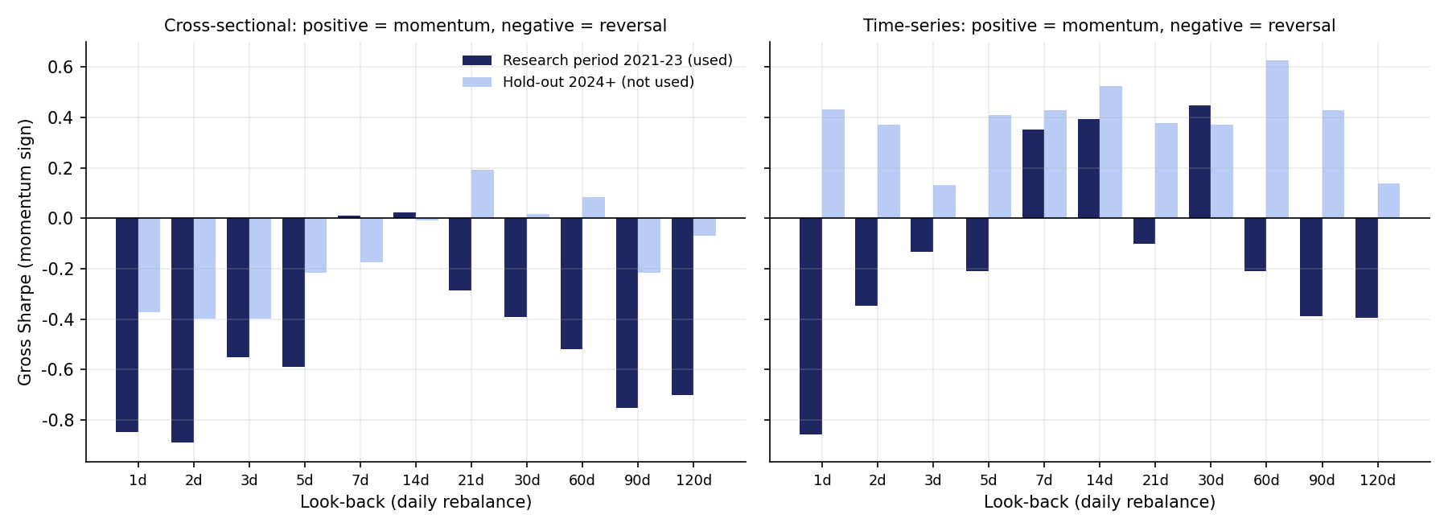
Figure 1. Gross Sharpe of momentum-sign strategies by look-back. Dark bars (research period) drive decisions; light bars (hold-out) are shown only for transparency.
In the research period the cross-sectional signal is reversal at 1-5 days (gross Sharpe -0.85 at 1 day, -0.59 at 5 days), flat at 7-14 days, and reversal again at 21-120 days (-0.75 at 90 days). Time-series momentum is positive at 7, 14 and 30 days (0.35 at 7 days, 0.39 at 14, 0.45 at 30; 21 days is slightly negative at -0.10) and turns to reversal at 60-120 days. With a broad survivorship-free universe, the brief's equity intuition - reversal at short horizons, momentum at medium ones - holds for the cross-section in crypto too, unlike the 16-coin result in version 1.
Table 5. Horizon scan (momentum sign; negative = reversal). IS = research period, OOS = hold-out.
Look-back | CS gross IS | CS gross OOS | CS net 7 IS | TS gross IS | TS gross OOS | TS net 20 IS | CS turnover
1 d | -0.85 | -0.37 | -2.36 | -0.86 | 0.43 | -2.12 | 1.33
3 d | -0.55 | -0.40 | -1.42 | -0.13 | 0.13 | -0.84 | 0.77
7 d | 0.01 | -0.17 | -0.56 | 0.35 | 0.43 | -0.12 | 0.51
14 d | 0.02 | -0.01 | -0.39 | 0.39 | 0.52 | 0.07 | 0.37
30 d | -0.39 | 0.02 | -0.67 | 0.45 | 0.37 | 0.23 | 0.26
60 d | -0.52 | 0.08 | -0.73 | -0.21 | 0.63 | -0.39 | 0.19
90 d | -0.75 | -0.21 | -0.94 | -0.39 | 0.43 | -0.53 | 0.16
120 d | -0.70 | -0.07 | -0.87 | -0.39 | 0.14 | -0.52 | 0.13

5.2 New information and activity
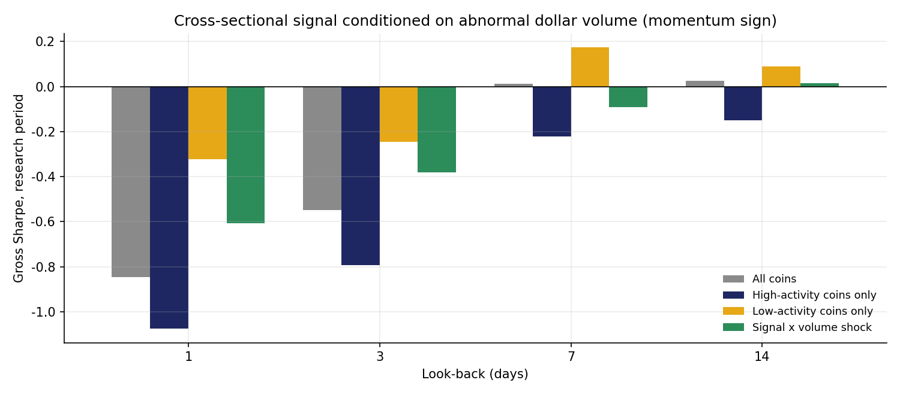
Figure 2. Cross-sectional signal conditioned on abnormal dollar volume, research period.
The brief suggests activity strengthens momentum and that uninformed (low-activity) moves reverse more. At 1-3 days the data show the reverse of the uninformed-trading story: reversal is stronger among high-activity coins (-1.07 at 1 day) than low-activity coins (-0.32). Volume shocks in this universe often mark liquidity-driven spikes in small coins that then retrace. Weighting by volume shock moves the signal toward momentum (1 day: -0.85 to -0.61), consistent with the brief's momentum hypothesis, but not enough to make a positive momentum signal.

5.3 Seasonality
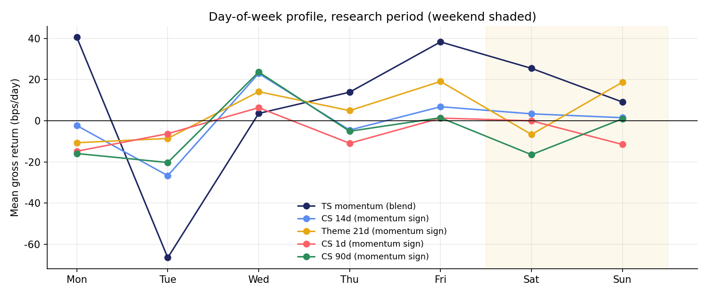
Figure 3. Day-of-week profile of strategy returns, research period (weekend shaded).
Time-series momentum is much stronger on weekends (gross Sharpe 1.37) than on weekdays (0.32), as in version 1: trends set by retail flow persist when institutions are away. Tuesday is consistently the worst day for trend-following.
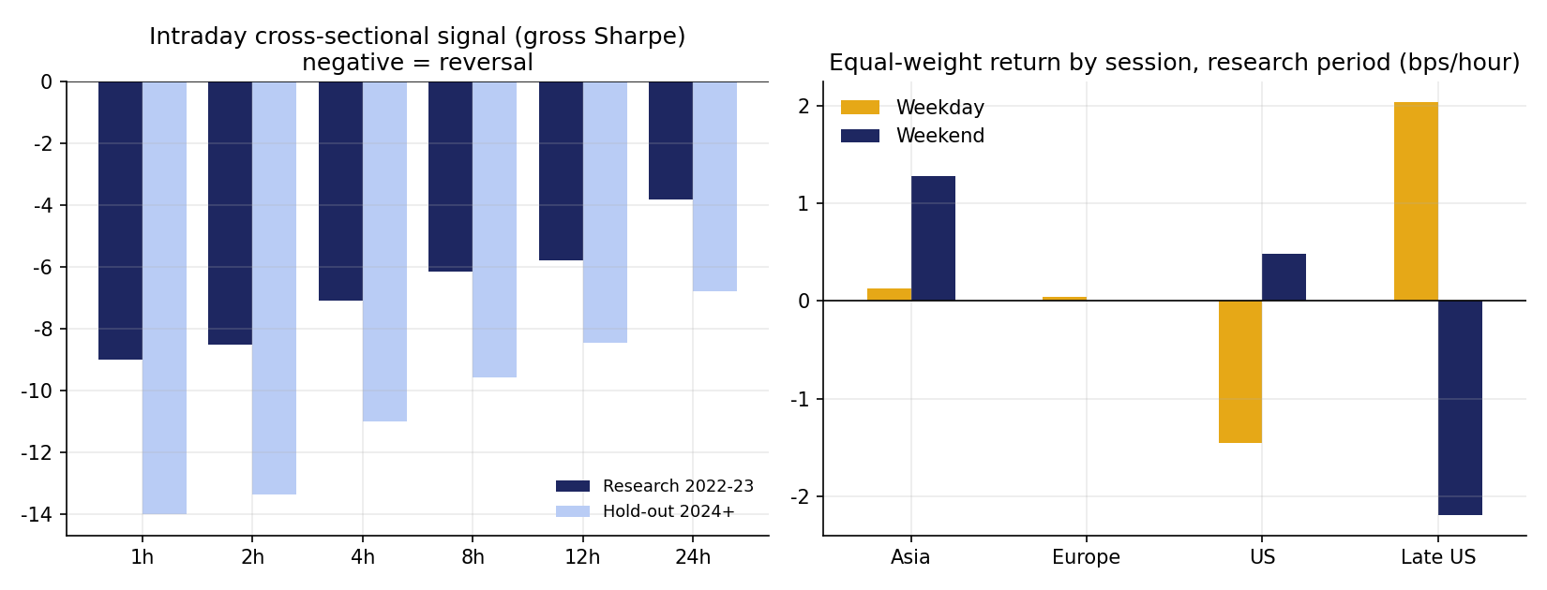
Figure 4. Left: intraday cross-sectional signal. Right: mean return by session.
Hourly data show the session pattern: on research-period weekdays the US session averaged -1.45 bps per hour and the late-US hours 2.04 bps per hour.

5.4 Investment themes
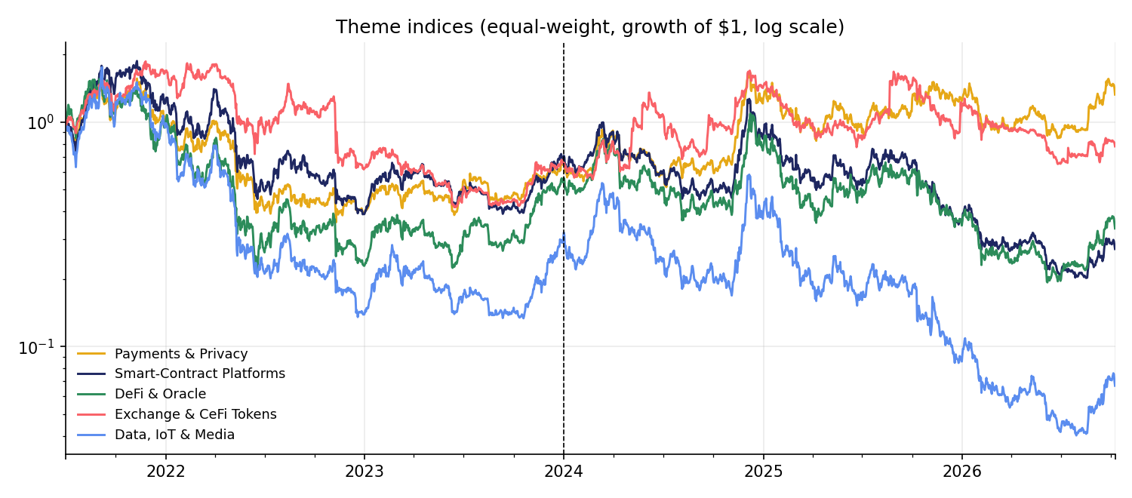
Figure 5. Equal-weight theme indices (growth of $1, log scale). Dashed line: hold-out start.
Theme momentum is positive at every look-back in the research period, best at 14 days (gross Sharpe 1.10 with a 7-day hold, net 0.57 at 20 bps). It was the top momentum candidate but decayed in the hold-out (gross 0.10).

5.5 Technical plays: front-running the US session
Table 6. Session-based front-running tests (hourly data, 2022 onward).
Test | Type | Gross bps/day | Gross IS | Gross OOS | Net at 7 bps | t-stat
Pre-US return -> US session | Time-series | -3.87 | -0.96 | 0.07 | -1.69 | -0.93
Pre-US return -> US session | Cross-sectional | -2.98 | -0.71 | -0.67 | -3.89 | -1.73
Prior-day US session -> today's US session | Time-series | -5.70 | -1.12 | -0.09 | -1.77 | -1.39
Prior-day US session -> today's US session | Cross-sectional | 0.14 | 0.09 | -0.01 | -3.17 | 0.09
US session -> late-US hours | Time-series | -1.12 | 0.36 | -0.62 | -2.46 | -0.49
US session -> late-US hours | Cross-sectional | -4.96 | -1.44 | -2.35 | -7.57 | -5.10

Each session strategy opens and closes a full position every day, so even with limit orders the round trip costs 14 bps a day - far more than any of these effects earn. Front-running institutional hours is not profitable at the brief's costs.

6. Reversal Research (Research Period)

6.1 Time horizon
Daily cross-sectional reversal is strongest at 1-2 days (gross Sharpe 0.85 and 0.89 as reversal), but the 1-day version turns over 1.33x its capital a day and loses money even at 7 bps (net Sharpe -2.36). Slow reversal at 60-120 days trades a tenth as much.
Table 7. Intraday cross-sectional signal (momentum sign; negative = reversal), hourly rebalance.
Look-back | Gross IS | Gross OOS | Gross bps/hour | Turnover/hour | Net at 7 bps
1 h | -8.99 | -14.00 | -3.43 | 1.36 | -43.6
2 h | -8.52 | -13.36 | -3.28 | 0.96 | -34.1
4 h | -7.09 | -11.02 | -2.72 | 0.70 | -26.2
8 h | -6.15 | -9.58 | -2.34 | 0.52 | -20.8
12 h | -5.80 | -8.46 | -2.11 | 0.43 | -17.9
24 h | -3.81 | -6.78 | -1.62 | 0.32 | -13.3

Intraday, reversal is the dominant pattern in both periods, but two warnings apply. First, much of it is probably bid-ask bounce: in thinly traded coins the hourly close alternates between bid and ask prices, which looks like reversal but cannot be captured. Second, turnover of more than one times capital per hour puts it far out of reach at 7-20 bps. It is reported as evidence for the brief's horizon hypothesis, not as a strategy.

6.2 Correlation: residual baskets and cointegrated pairs
Table 8. Correlation-based signals. Negative gross = the residual reverses.
Strategy (momentum sign) | Gross IS | Gross OOS | Net 7 IS | Turnover
Residual vs market L=1d | -0.83 | -0.55 | -2.48 | 1.327
Residual vs theme L=1d | -1.19 | -0.52 | -2.87 | 1.337
Residual vs market L=3d | -0.70 | -0.03 | -1.70 | 0.765
Residual vs theme L=3d | -1.01 | -0.10 | -1.97 | 0.767
Residual vs market L=7d | -0.36 | 0.09 | -1.01 | 0.513
Residual vs theme L=7d | -0.40 | -0.14 | -1.04 | 0.510
Residual vs market L=14d | -0.34 | 0.22 | -0.83 | 0.370
Residual vs theme L=14d | -0.54 | -0.01 | -1.01 | 0.368
Residual vs market L=30d | -0.67 | 0.06 | -0.99 | 0.255
Residual vs theme L=30d | -0.78 | 0.04 | -1.09 | 0.254
Residual vs market L=60d | -0.55 | 0.18 | -0.78 | 0.181
Residual vs theme L=60d | -0.76 | -0.15 | -1.00 | 0.185
Cointegrated pairs (Kalman, walk-forward) | -0.46 | 1.10 | -0.58 | 0.038

'Security A minus something correlated to it' reverses at every horizon in the research period, against the market and even more against the coin's own theme (60-day theme residual -0.76 in momentum sign, i.e. 0.76 as reversal). Cointegrated pairs, traded with a Kalman-filter hedge ratio and monthly re-selection across 430 pairs, lost money in the research period (gross -0.46) and so were not selected - although they did well in the hold-out (1.10), a reminder of how unstable these relationships are.

6.3 Macro: volatility and dislocation
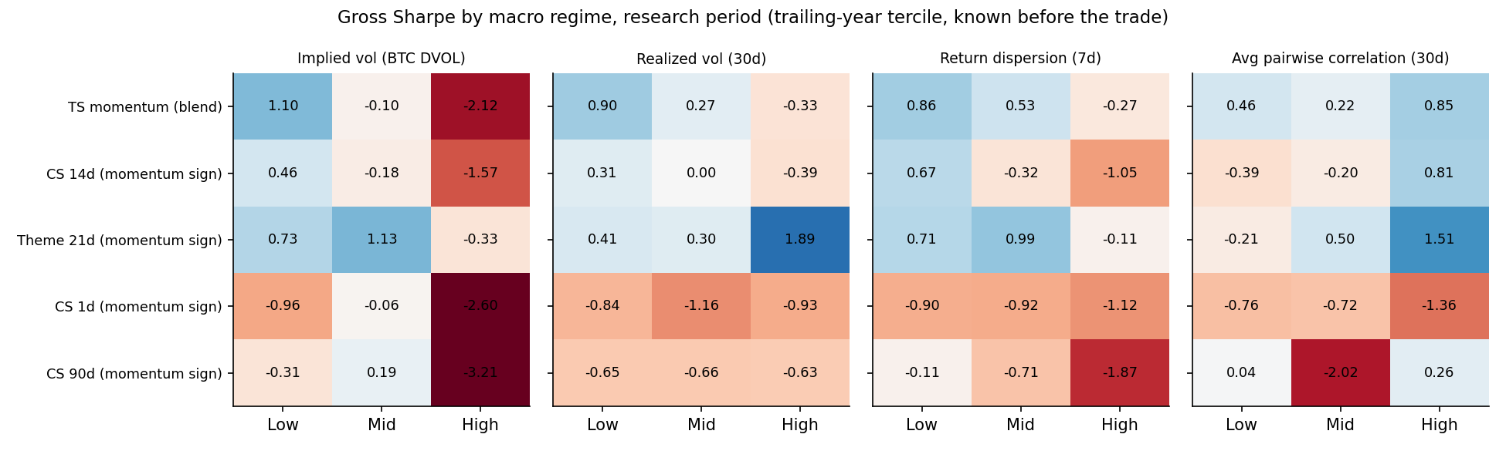
Figure 6. Gross Sharpe by macro regime, research period.
The clearest macro result is for momentum: time-series momentum earns 1.10 when implied volatility is low and -2.12 when it is high (the pattern repeats in the hold-out), which is why the DVOL filter is part of the selected strategy. For reversal, 1-day reversal is strongest when implied volatility is high (momentum-sign Sharpe -2.60) and when average correlation is high (-1.36), in line with the brief and Nagel (2012).

7. Mechanical Strategy Selection
Of the 51 signal variants, the research period assigned 17 to the momentum direction and 34 to reversal. After crossing with holding periods, the best candidate per family was:
Table 9. Family winners (research-period net Sharpe at the book's cost).
Best candidate in family | Book | Net Sharpe IS (selection) | Hold-out net 20 | Hold-out net 7 | Turnover
Theme look-back 14 momentum, hold 7 | Momentum | 0.57 | -0.45 | -0.09 | 0.17
TS look-back 7/14/28 blend + DVOL filter momentum, hold 1 | Momentum | 0.55 | 0.62 | 0.90 | 0.24
CS look-back 14 momentum, hold 3 | Momentum | -0.56 | -0.20 | 0.23 | 0.23
Residual vs theme look-back 60 reversal, hold 7 | Reversal | 0.81 | -0.09 | 0.05 | 0.07
CS look-back 120 reversal, hold 7 | Reversal | 0.67 | -0.16 | -0.07 | 0.05
Residual vs market look-back 60 reversal, hold 7 | Reversal | 0.65 | -0.40 | -0.26 | 0.07
TS look-back 90 reversal, hold 1 | Reversal | 0.34 | -0.58 | -0.48 | 0.12
Short-term (1d) in high-vol regime reversal, hold 2 | Reversal | 0.29 | -1.76 | -0.66 | 0.27
Cointegrated pairs REV | Reversal | -0.58 | 0.64 | 0.94 | 0.04

Selected books (families with positive research-period net Sharpe, top three per book):
- Momentum: Theme look-back 14 momentum, hold 7
- Momentum: TS look-back 7/14/28 blend + DVOL filter momentum, hold 1
- Reversal: Residual vs theme look-back 60 reversal, hold 7
- Reversal: CS look-back 120 reversal, hold 7
- Reversal: Residual vs market look-back 60 reversal, hold 7
Cross-sectional momentum has no variant with a positive net Sharpe after 20 bps, so the momentum book has two members.

8. Execution
Table 10. Execution variants (book cost: momentum 20 bps, reversal 7 bps; 'other' swaps them).
Book | Execution | Turnover/day | Gross Sharpe | IS at book cost | Full at book cost | Full at other cost
Momentum | Daily rebalance | 0.206 | 0.98 | 0.65 | 0.48 | 0.81
Momentum | Hold 3d (overlapping) | 0.180 | 0.81 | 0.46 | 0.39 | 0.66
Momentum | Hold 7d (overlapping) | 0.146 | 0.64 | 0.25 | 0.32 | 0.53
Momentum | No-trade band 2% | 0.163 | 0.95 | 0.75 | 0.54 | 0.81
Momentum | No-trade band 5% | 0.043 | -0.11 | -0.40 | -0.30 | -0.18
Reversal | Daily rebalance | 0.063 | 0.38 | 0.80 | 0.30 | 0.15
Reversal | Hold 3d (overlapping) | 0.057 | 0.41 | 0.84 | 0.33 | 0.20
Reversal | Hold 7d (overlapping) | 0.050 | 0.42 | 0.82 | 0.35 | 0.23
Reversal | No-trade band 2% | 0.029 | 0.45 | 0.80 | 0.40 | 0.33
Reversal | No-trade band 5% | 0.010 | 0.23 | 0.77 | 0.21 | 0.18

The research period selected 'No-trade band 2%' for momentum and 'Hold 3d (overlapping)' for reversal. A 2% band cuts momentum turnover without diluting the signal; wider bands or longer holds lose too much signal. The cost sweep below shows the combined portfolio reaches zero Sharpe between 20 and 30 bps in the hold-out (Sharpe 0.11 at 20 bps).
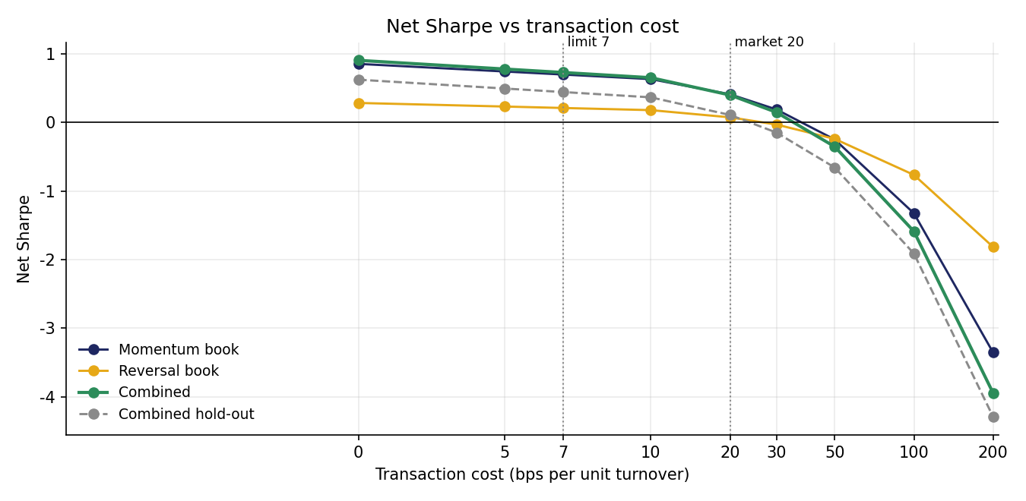
Figure 7. Net Sharpe versus transaction cost (0-200 bps).

9. Weighting
The two books are slightly negatively correlated (daily correlation -0.11). Four schemes were tested, all re-estimated every 21 days on the trailing 180 days only.
Table 11. Weighting methods (selection on the research-period Sharpe).
Method | Avg weight momentum | Avg weight reversal | Sharpe IS | Sharpe OOS | Sharpe full
Equal weight | 50% | 50% | 0.86 | 0.20 | 0.49
Inverse volatility | 43% | 57% | 0.93 | 0.20 | 0.50
Risk parity (ERC) | 43% | 57% | 0.93 | 0.20 | 0.50
Mean-variance (shrunk) | 47% | 53% | 0.60 | -0.01 | 0.22

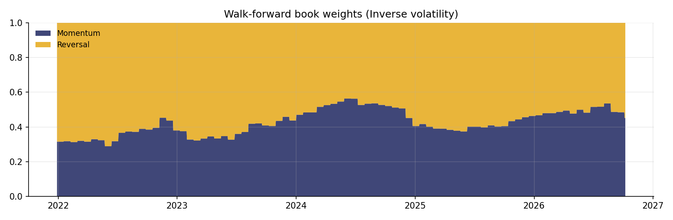
Figure 8. Walk-forward book weights (inverse volatility).
Table 12. Ensemble versus single best strategy.
Construction | Mom. IS | Mom. OOS | Rev. IS | Rev. OOS | Combined IS | Combined OOS
Final: top-3 family ensembles | 0.54 | 0.30 | 0.66 | -0.07 | 0.93 | 0.20
Single IS-best strategy per book | 0.54 | -0.30 | 0.70 | 0.08 | 0.98 | -0.24

Picking only the single best research-period strategy in each book would have given a hold-out Sharpe of -0.24; the three-family ensembles gave 0.20. Diversifying across families reduces, but does not remove, selection risk.

10. Performance Evaluation
Table 13. Hold-out, 2024-01-01 to 2026-10-08 (never used for any decision).
Strategy | Ann. return | Ann. vol | Sharpe | Max DD | Alpha | Beta | Alpha t | Corr BTC
Combined portfolio * | 2.1% | 10.3% | 0.20 | -26.7% | 2.8% | -0.03 | 0.52 | -0.12
Combined (all trades at 20 bps) | 1.1% | 10.3% | 0.11 | -27.7% | 1.9% | -0.03 | 0.34 | -0.12
Momentum book (20 bps) | 5.2% | 17.3% | 0.30 | -24.8% | 7.2% | -0.08 | 0.80 | -0.18
Momentum book (7 bps) | 10.6% | 17.3% | 0.61 | -18.6% | 12.5% | -0.08 | 1.40 | -0.18
Reversal book (7 bps) | -1.0% | 14.4% | -0.07 | -35.4% | -1.2% | 0.01 | -0.16 | 0.03
Reversal book (20 bps) | -2.8% | 14.4% | -0.19 | -38.2% | -3.0% | 0.01 | -0.40 | 0.03
Cointegrated pairs (20 bps) | 2.7% | 4.3% | 0.64 | -5.6% | 2.6% | 0.01 | 1.20 | 0.06
Equal-weight crypto | 10.1% | 52.5% | 0.19 | -74.4% | -15.2% | 1.05 | -0.92 | 0.79
Buy & hold BTC | 24.1% | 39.4% | 0.61 | -53.1% | 0.0% | 1.00 | 0.33 | 1.00
* Momentum book at 20 bps (market orders), reversal book at 7 bps (limit orders). Sharpe = mean / std x sqrt(252); return, volatility and alpha annualised with 252 days. Alpha, beta and correlation vs daily Bitcoin returns; alpha t uses Newey-West (5-lag) errors.
Table 14. Research period, 2021-12-28 to 2023-12-31 (all decisions made here).
Strategy | Ann. return | Ann. vol | Sharpe | Max DD | Alpha | Beta | Alpha t | Corr BTC
Combined portfolio * | 9.4% | 10.1% | 0.93 | -13.3% | 9.6% | -0.03 | 1.64 | -0.15
Combined (all trades at 20 bps) | 8.2% | 10.1% | 0.81 | -14.1% | 8.3% | -0.03 | 1.43 | -0.15
Momentum book (20 bps) | 11.2% | 20.6% | 0.54 | -17.1% | 11.7% | -0.12 | 1.08 | -0.28
Momentum book (7 bps) | 16.6% | 20.6% | 0.81 | -14.9% | 17.1% | -0.12 | 1.59 | -0.28
Reversal book (7 bps) | 8.2% | 12.5% | 0.66 | -16.5% | 8.2% | 0.01 | 1.18 | 0.04
Reversal book (20 bps) | 6.3% | 12.5% | 0.50 | -17.8% | 6.2% | 0.01 | 0.90 | 0.04
Cointegrated pairs (20 bps) | -5.3% | 5.9% | -0.90 | -14.9% | -5.4% | 0.01 | -1.68 | 0.09
Equal-weight crypto | -7.2% | 55.8% | -0.13 | -71.2% | -11.7% | 1.05 | -0.68 | 0.86
Buy & hold BTC | 4.3% | 45.8% | 0.09 | -67.0% | 0.0% | 1.00 | 3.65 | 1.00

Table 15. Full backtest, 2021-12-28 to 2026-10-08.
Strategy | Ann. return | Ann. vol | Sharpe | Max DD | Alpha | Beta | Alpha t | Corr BTC
Combined portfolio * | 5.2% | 10.2% | 0.50 | -26.7% | 5.7% | -0.03 | 1.42 | -0.13
Combined (all trades at 20 bps) | 4.1% | 10.2% | 0.40 | -27.7% | 4.6% | -0.03 | 1.15 | -0.13
Momentum book (20 bps) | 7.7% | 18.8% | 0.41 | -24.8% | 9.3% | -0.10 | 1.34 | -0.23
Momentum book (7 bps) | 13.1% | 18.7% | 0.70 | -18.6% | 14.7% | -0.10 | 2.12 | -0.23
Reversal book (7 bps) | 2.9% | 13.6% | 0.21 | -36.1% | 2.7% | 0.01 | 0.52 | 0.03
Reversal book (20 bps) | 1.0% | 13.6% | 0.08 | -40.2% | 0.9% | 0.01 | 0.16 | 0.03
Cointegrated pairs (20 bps) | -0.7% | 5.0% | -0.13 | -19.8% | -0.8% | 0.01 | -0.43 | 0.08
Equal-weight crypto | 2.8% | 53.9% | 0.05 | -74.4% | -13.8% | 1.05 | -1.15 | 0.82
Buy & hold BTC | 15.8% | 42.2% | 0.37 | -67.0% | 0.0% | 1.00 | -1.36 | 1.00

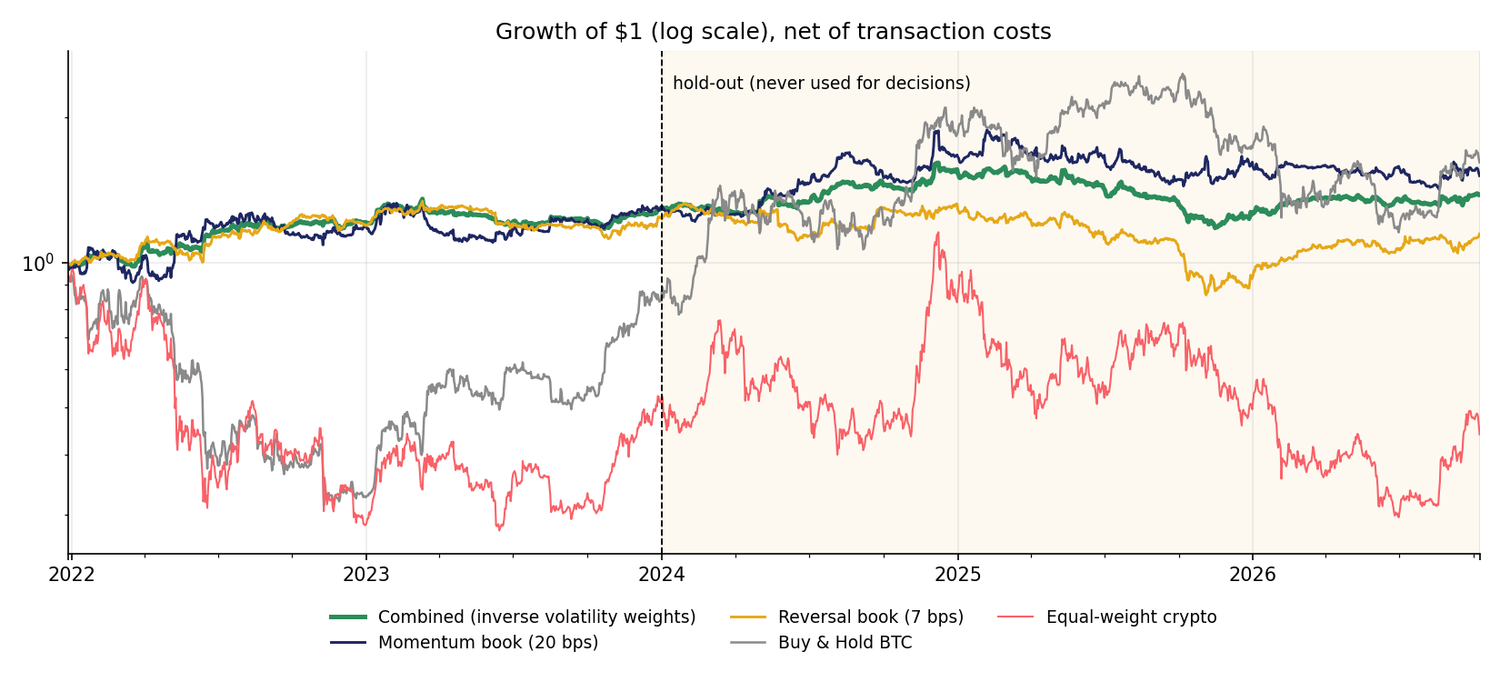
Figure 9. Growth of $1, net of costs (log scale). Shaded: hold-out.
In the hold-out the combined portfolio returned 2.1% a year at 10.3% volatility (Sharpe 0.20), with a maximum drawdown of -26.7% against -53.1% for Bitcoin. It is genuinely market-neutral - beta -0.03, correlation -0.12 - but its alpha (2.8%, t = 0.52) is not statistically distinguishable from zero. The momentum book held up (hold-out Sharpe 0.30 at 20 bps, 0.61 at 7 bps); the reversal book did not (-0.07).
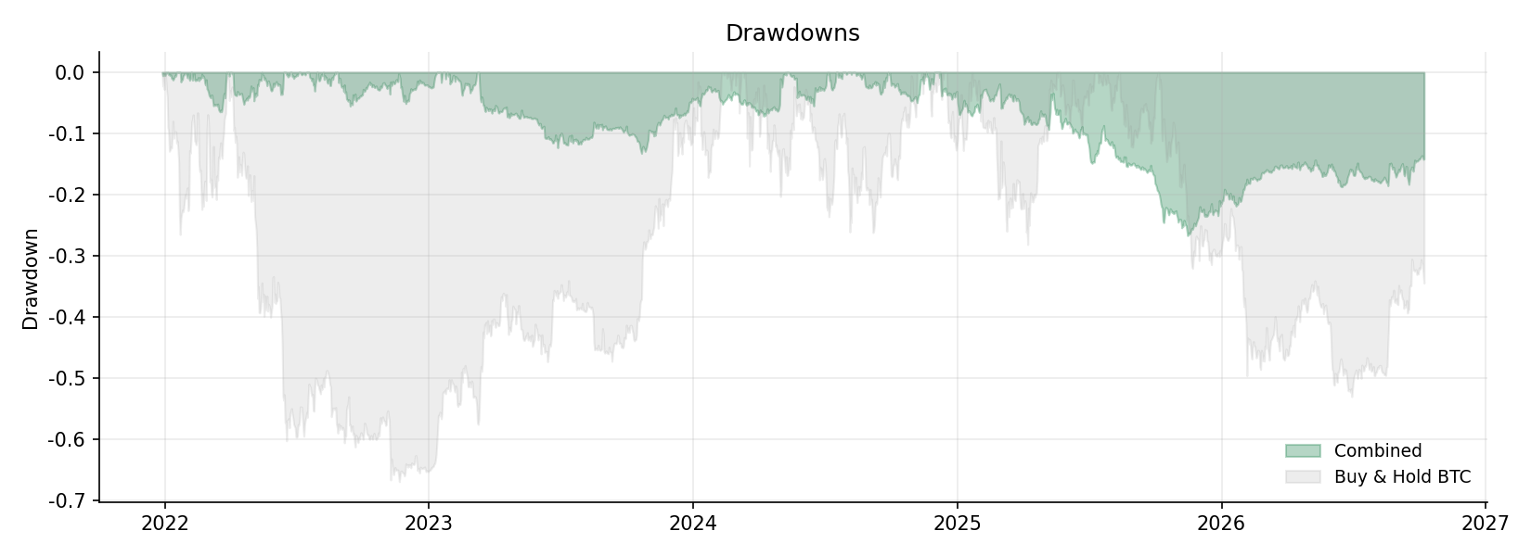
Figure 10. Drawdowns of the combined portfolio and Bitcoin.
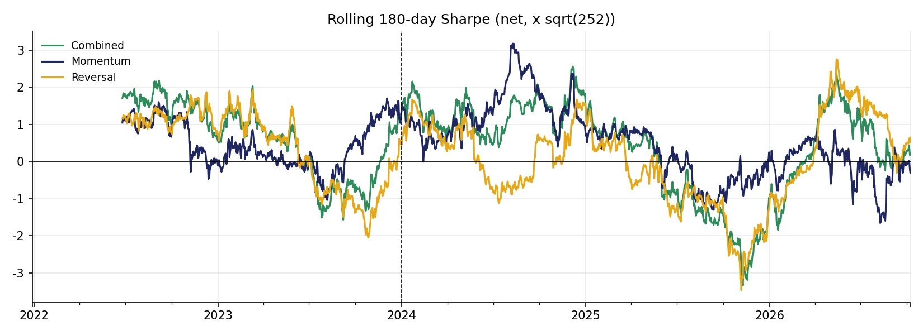
Figure 11. Rolling 180-day Sharpe ratio (net, x sqrt(252)). Dashed line: hold-out start.

11. Discussion

11.1 Version 1 versus version 2
Table 16. What the version 2 corrections did to the headline numbers.
 | Version 1 | Version 1 at sqrt(252) | Version 2
Universe | 16 coins alive in 2026 | 16 coins alive in 2026 | 39 coins by market cap, Jan-2021
Decisions made on | Full sample (exploration) | Full sample (exploration) | 2021-2023 only, mechanical
Combined Sharpe, full | 1.02 | 0.85 | 0.50
Combined Sharpe, hold-out | 0.55 | 0.46 | 0.20
Alpha t, hold-out | 0.90 | 0.90 | 0.52
Correlation to BTC, full | -0.05 | -0.05 | -0.13

The sqrt(252) convention alone lowers every Sharpe by 17%. The larger change comes from the universe and the protocol: version 1's long-horizon reversal book was chosen partly because it worked in 2024-2026, and its 16 survivors excluded the coins whose collapses make cross-sectional strategies harder. Version 2's lower number is the more credible one.

11.2 What the research shows
- Horizon. Cross-sectional crypto returns reverse at short and long horizons; time-series returns trend at 1-4 weeks. Only the slower signals survive realistic costs.
- The robust finding. Time-series momentum with a DVOL filter was selected purely on 2021-2023 data and kept working in 2024-2026. It is the one finding that passed a genuine out-of-sample test.
- Instability. Theme momentum and slow residual reversal looked strong in 2021-2023 and faded. Pairs did the opposite. Relationships in crypto are unstable.
- Bottom line. The final portfolio is market-neutral and diversifying (correlation to BTC near zero), but its hold-out alpha is not statistically significant. It is a research result, not a deployable strategy.

11.3 Limitations
- Shorting. Short positions assume coins can be borrowed or shorted through perpetual futures; funding is not modelled.
- Liquidity. Several coins are thinly traded at their data venue; costs are linear and limit-order fills are assumed, which is optimistic for small coins and large capital.
- Data. Prices come from four venues (Coinbase, KuCoin, Gate.io, Bitfinex); venue differences add noise, and Revain is missing.
- Multiple testing. 167 candidates were compared; the research-period Sharpe of the winners is biased upward, which is why the hold-out leads.
- Intraday coverage. Hourly data are complete for 35 of 39 coins; CEL, HT and XEM have hourly prices only from September 2025 and FTT's hourly series is sparse, so the intraday cross-section is slightly smaller in 2022-2023.

11.4 Next steps
- Paper-trade the time-series momentum book with the DVOL filter on live data.
- Add perpetual-futures funding costs and a liquidity screen (minimum dollar volume) to the universe.
- Re-run the protocol each year as the hold-out grows, without changing its rules.

12. Conclusion
Applying the version 2 corrections - the sqrt(252) convention, a survivorship-free universe of 39 coins and a research protocol that never touches the hold-out - turns version 1's strong result into a modest one. Crypto shows reversal across the cross-section and momentum in individual coins' own trends, and the brief's conditioning variables (activity, seasonality, themes and especially implied volatility) all leave visible marks. But after costs, the combined portfolio's hold-out Sharpe is 0.20 with an alpha t-statistic of 0.52. The one component that survived a genuine out-of-sample test is time-series momentum switched off when implied volatility is high. The main lesson is methodological: how a strategy is selected matters as much as what it is.

Appendix A. Reproducibility
- python3 src/fetch_data.py - universe, daily, hourly and DVOL data
- python3 src/statarb.py - cointegrated pairs engine
- python3 src/research.py - research blocks, mechanical selection, weighting, performance
- python3 src/minimal_backtest.py - 60-line rebuild of one strategy, checked against the engine
- python3 src/make_report.py, build_explainer.py, build_pptx.py, build_excel.py, build_notebook.py

References
Bailey, D. H., & Lopez de Prado, M. (2014). The deflated Sharpe ratio: Correcting for selection bias, backtest overfitting and non-normality. Journal of Portfolio Management, 40(5), 94-107.
Barroso, P., & Santa-Clara, P. (2015). Momentum has its moments. Journal of Financial Economics, 116(1), 111-120.
Campbell, J. Y., Grossman, S. J., & Wang, J. (1993). Trading volume and serial correlation in stock returns. Quarterly Journal of Economics, 108(4), 905-939.
Daniel, K., & Moskowitz, T. J. (2016). Momentum crashes. Journal of Financial Economics, 122(2), 221-247.
De Bondt, W. F. M., & Thaler, R. (1985). Does the stock market overreact? Journal of Finance, 40(3), 793-805.
DeMiguel, V., Garlappi, L., & Uppal, R. (2009). Optimal versus naive diversification: How inefficient is the 1/N portfolio strategy? Review of Financial Studies, 22(5), 1915-1953.
Fil, M., & Kristoufek, L. (2020). Pairs trading in cryptocurrency markets. IEEE Access, 8, 172644-172651.
Garleanu, N., & Pedersen, L. H. (2013). Dynamic trading with predictable returns and transaction costs. Journal of Finance, 68(6), 2309-2340.
Han, H., Kang, J., & Ryu, D. (2024). Time-series and cross-sectional momentum in the cryptocurrency market: A comprehensive analysis under realistic assumptions (SSRN Working Paper No. 4675565).
Harvey, C. R., Liu, Y., & Zhu, H. (2016). ... and the cross-section of expected returns. Review of Financial Studies, 29(1), 5-68.
Jegadeesh, N., & Titman, S. (1993). Returns to buying winners and selling losers: Implications for stock market efficiency. Journal of Finance, 48(1), 65-91.
Lehmann, B. N. (1990). Fads, martingales, and market efficiency. Quarterly Journal of Economics, 105(1), 1-28.
Liu, Y., & Tsyvinski, A. (2021). Risks and returns of cryptocurrency. Review of Financial Studies, 34(6), 2689-2727.
Liu, Y., Tsyvinski, A., & Wu, X. (2022). Common risk factors in cryptocurrency. Journal of Finance, 77(2), 1133-1177.
Moskowitz, T. J., & Grinblatt, M. (1999). Do industries explain momentum? Journal of Finance, 54(4), 1249-1290.
Moskowitz, T. J., Ooi, Y. H., & Pedersen, L. H. (2012). Time series momentum. Journal of Financial Economics, 104(2), 228-250.
Nagel, S. (2012). Evaporating liquidity. Review of Financial Studies, 25(7), 2005-2039.
Wall Street Quants. (2025). Statistical arbitrage in cryptocurrencies: Course project brief [Class handout].

