Statistical Arbitrage in Cryptocurrencies
Momentum and Reversal Research on Live Market Data
Wall Street Quants - Bootcamp Project
Data: Coinbase Exchange (daily and hourly OHLCV) and Deribit DVOL, 2021-01-01 to 2026-10-08
Report rebuilt on live data, October 2026

Contents
Executive Summary 3
1. Introduction 3
2. Literature Review 4
2.1 Momentum 4
2.2 Reversal 4
2.3 Relative value and pairs 4
2.4 Intraday patterns, execution and weighting 4
3. Data 5
3.1 Sources 5
3.2 Universe and themes 5
3.3 Cleaning 5
4. Backtest Methodology 5
4.1 Unconstrained backtest 5
4.2 Execution costs 6
4.3 Metrics 6
4.4 Research discipline 6
5. Momentum Research 6
5.1 Time horizon 6
5.2 New information and activity 7
5.3 Seasonality: weekdays vs weekends, day vs night 8
5.4 Investment themes 9
5.5 Technical plays: front-running institutional hours 9
6. Reversal Research 10
6.1 Time horizon: intraday and long-horizon reversal 10
6.2 Uninformed trading 10
6.3 Correlation: residual baskets and cointegrated pairs 11
6.4 Macro: volatility and dislocation 11
7. Execution 12
8. Strategy Selection 13
9. Weighting 14
9.1 Robustness of the selection 14
10. Performance Evaluation 15
11. Discussion 17
11.1 What the research shows 17
11.2 Comparison with the July version 17
11.3 Limitations 17
11.4 Next steps 18
12. Conclusion 18
Appendix A. Reproducibility 18
References 18

Executive Summary
This report answers the Wall Street Quants class project brief: research profitable momentum and/or reversal strategies in cryptocurrencies, test them with unconstrained backtests under the brief's execution costs (20 bps for market orders, 7 bps for limit orders), combine the strategies with a weighting scheme, and report returns, volatility, Sharpe ratios, maximum drawdowns and alpha / beta. The study uses live market data through 2026-10-08: daily and hourly prices for 16 liquid coins from the Coinbase Exchange API and the Deribit DVOL implied-volatility index. Every item in the brief's research outline is tested: time horizon, new information / activity, seasonality, investment themes, technical plays, uninformed trading, correlation, and macro dislocation. All parameters were chosen on a research period (2021-07 to 2023-12) and the strategies were then run untouched over a hold-out period (2024-01-01 to 2026-10-08).
Key findings
- Horizon decides the sign. Daily horizons from 1 to 30 days show momentum, not reversal. Cross-sectional momentum peaks at a 14-day look-back (gross Sharpe 1.09). Reversal appears only at the extremes: intraday (1-24 hour) horizons and long (60-90 day) horizons. This matches crypto-specific evidence and is the opposite of the equity intuition in the brief.
- Intraday reversal is strong but untradeable. A 1-hour cross-sectional reversal earns a gross Sharpe of 4.91, but it trades 1.34x its capital per hour, so even 7 bps limit orders turn it into a large loss. Short-horizon reversal is real but not investable at the brief's costs.
- Activity, seasonality, themes and macro all matter. Volume shocks strengthen short-horizon momentum, momentum is far stronger on weekends than on weekdays, theme (sector) momentum is the strongest gross signal in the research period, and time-series momentum breaks down when implied volatility is high.
- The combined strategy is market-neutral and positive after costs. The final strategy pairs a momentum ensemble (time-series, theme and cross-sectional momentum) with a long-horizon reversal book, weighted by mean-variance (shrunk). Over 2021-12-28 to 2026-10-08 it earns 20.2% a year at 19.7% volatility: Sharpe 1.02, max drawdown -28.1%, alpha 20.6% a year (t = 2.19) and beta to Bitcoin of -0.02.
- Out-of-sample decay is real. In the hold-out period the combined Sharpe is 0.55 (vs 1.71 in the research period). Reversal held up (1.00) while momentum decayed (0.22). Picking the single best momentum strategy from the research period would have failed (-0.61 hold-out Sharpe), which is why the final design diversifies across momentum families.
Table 1. Headline performance, 2021-12-28 to 2026-10-08 (net of costs).
Strategy | Ann. return | Ann. vol | Sharpe | Max DD | Alpha (ann.) | Beta (BTC) | Alpha t
Combined portfolio * | 20.2% | 19.7% | 1.02 | -28.1% | 20.6% | -0.02 | 2.19
Combined (all trades at 20 bps) | 17.3% | 19.8% | 0.88 | -28.6% | 17.8% | -0.02 | 1.88
Momentum ensemble (20 bps market) | 22.3% | 33.3% | 0.67 | -31.1% | 25.2% | -0.13 | 1.68
Reversal (7 bps limit) | 18.7% | 19.6% | 0.95 | -33.7% | 18.7% | 0.00 | 2.01
Buy & hold BTC | 22.9% | 50.8% | 0.45 | -67.0% | 0.0% | 1.00 | -1.36
* Momentum traded with market orders (20 bps), reversal with limit orders (7 bps). Alpha and beta are from a daily regression on Bitcoin returns with Newey-West standard errors. Returns are arithmetic annualised means (365-day year).

1. Introduction
Statistical arbitrage looks for price-volume patterns that predict returns. The two patterns the brief highlights are momentum (recent winners keep winning) and reversal (recent moves undo themselves). Crypto markets are young, open all day every day, dominated by retail flow and lightly arbitraged, so they are a natural place to look for both.
The brief gives a research outline for each pattern. For momentum: longer time horizons, periods of new information and activity, seasonality (weekdays vs weekends, day vs night), investment themes, and technical plays such as front-running institutional trading hours. For reversal: shorter time horizons, uninformed (liquidity-driven) trading, correlated pairs or baskets, and macro periods of high volatility and dislocation. It then asks for unconstrained backtests, realistic execution costs, a weighting scheme to combine strategies, and a standard set of performance metrics.
This report follows that outline section by section. Section 2 reviews the literature, Section 3 describes the data, and Section 4 sets out the backtest method. Sections 5 and 6 cover the momentum and reversal research. Section 7 covers execution, Section 8 strategy selection, Section 9 weighting, and Section 10 performance. Sections 11 and 12 discuss the results and conclude.
The research question is: which momentum and reversal patterns exist in crypto, which survive realistic trading costs, and how should they be combined into a single portfolio?

2. Literature Review

2.1 Momentum
Cross-sectional momentum (Jegadeesh & Titman, 1993) and time-series momentum (Moskowitz, Ooi & Pedersen, 2012) are among the most robust anomalies across asset classes, and Moskowitz and Grinblatt (1999) show that much of stock momentum is industry (theme) momentum. Momentum is prone to crashes in high-volatility rebounds (Daniel & Moskowitz, 2016), and scaling positions by recent volatility improves its risk-adjusted return (Barroso & Santa-Clara, 2015). In crypto, Liu and Tsyvinski (2021) and Liu, Tsyvinski and Wu (2022) document a strong momentum factor, while Han, Kang and Ryu (2024) find that time-series momentum is more robust than cross-sectional momentum once realistic costs are applied.

2.2 Reversal
Short-term reversal in stocks (Lehmann, 1990) is linked to liquidity provision: Campbell, Grossman and Wang (1993) show that price moves on high volume tend to reverse less, because they carry information, while moves on low volume reflect liquidity demand and reverse more. Nagel (2012) shows that reversal profits rise sharply when market volatility is high, because liquidity providers demand more compensation. Long-horizon reversal (De Bondt & Thaler, 1985) reflects overreaction. In crypto, Dobrynskaya finds momentum at short horizons and reversal at longer horizons, the opposite of the equity pattern.

2.3 Relative value and pairs
Pairs trading (Gatev, Goetzmann & Rouwenhorst, 2006) and cointegration (Engle & Granger, 1987; Vidyamurthy, 2004) trade the spread between related assets; Elliott, van der Hoek and Malcolm (2005) and Chan (2013) estimate the hedge ratio with a Kalman filter. Do and Faff (2010, 2012) and Krauss (2017) document declining, cost-sensitive pairs profits, and Fil and Kristoufek (2020) find crypto cointegration particularly unstable.

2.4 Intraday patterns, execution and weighting
Heston, Korajczyk and Sadka (2010) document intraday return periodicity tied to recurring trading schedules. Garleanu and Pedersen (2013) show that, with costs, the optimal policy trades only part of the way toward the target portfolio, which motivates holding periods and no-trade bands. DeMiguel, Garlappi and Uppal (2009) show that naive equal weighting is hard to beat out of sample. Harvey, Liu and Zhu (2016) and Bailey and Lopez de Prado (2014) warn that testing many strategies inflates backtest Sharpe ratios, which motivates the research / hold-out split used here.

3. Data

3.1 Sources
- Daily prices: daily OHLCV from the Coinbase Exchange public API, January 2021 onward (Binance is geo-restricted from the research environment, HTTP 451, so Coinbase is used).
- Hourly prices: hourly OHLCV from Coinbase for the same coins, January 2022 onward, used for the intraday horizon, session and front-running tests.
- Implied volatility: the Deribit DVOL index (30-day implied volatility of Bitcoin options), the crypto equivalent of the VIX, used as the implied-volatility macro indicator.
The data were downloaded on 2026-10-09 and run through 2026-10-08 (the last complete daily bar). Re-running src/fetch_data.py refreshes everything to the latest date.

3.2 Universe and themes
The universe is 16 liquid USD-quoted coins: BTC, ETH, SOL, ADA, DOGE, AVAX, LINK, LTC, DOT, ATOM, UNI, BCH, XLM, ALGO, AAVE and COMP. XRP is excluded because of a long Coinbase listing gap during 2021-2023, and MKR because it stopped trading in January 2026 after migrating to SKY. Coins that listed after January 2021 enter when their history begins. For the theme test, coins are grouped into four investment themes:
Table 2. Investment themes.
Theme | Coins | Rationale
Payments & Meme | BTC, LTC, BCH, XLM, DOGE | Store-of-value and payment coins; retail-driven
Large Smart-Contract L1 | ETH, SOL, AVAX | Leading smart-contract platforms
Alt L1 | ADA, DOT, ATOM, ALGO | Second-tier layer-1 platforms
DeFi & Oracle | UNI, AAVE, COMP, LINK | Decentralised-finance protocols and oracle

3.3 Cleaning
Prices are aligned to a common calendar (crypto trades every day). Gaps of up to three days are forward-filled; longer gaps are left missing so the coin simply drops out of the cross-section. Daily returns are simple close-to-close returns. Dollar volume (price x volume) is the activity measure.

4. Backtest Methodology

4.1 Unconstrained backtest
Following the brief, all strategies are first tested with the unconstrained backtest taught in class. Each day a signal is turned into portfolio weights using information up to that day's close; the weights earn the next day's return, so there is no look-ahead. Weights are scaled so that gross exposure (the sum of absolute weights) equals one. Cross-sectional strategies are dollar-neutral: weights are proportional to each coin's demeaned rank on the signal. Time-series strategies take each coin long or short on the sign of its own signal, scaled by the inverse of its 30-day volatility.

4.2 Execution costs
Costs follow the brief: 20 bps per unit of turnover for market orders (7 bps commission plus 13 bps slippage) and 7 bps for limit orders. Turnover is the sum of absolute weight changes. The momentum book is charged 20 bps because it chases prices and needs immediate fills. The reversal book is charged 7 bps because it trades slowly (positions are held about two weeks) and supplies liquidity, so it can be worked with passive limit orders; results with 20 bps are reported alongside so the assumption can be judged. A cost sweep from 0 to 200 bps covers everything in between.

4.3 Metrics
As the brief requires, each strategy is reported with annualised return, annualised volatility, Sharpe ratio, maximum drawdown, and alpha / beta. Alpha and beta come from regressing daily strategy returns on daily Bitcoin returns, with Newey-West (5-lag) standard errors; alpha is annualised. Sortino, Calmar, hit rate, turnover and Newey-West t-statistics are reported in the workbook. Annualisation uses 365 days.

4.4 Research discipline
The sample is split into a research period (2021-07-01 to 2023-12-31) and a hold-out period (2024-01-01 to 2026-10-08). Every parameter choice - which strategies to keep, look-backs, holding periods, execution rules and the weighting method - is made on the research period only. The hold-out is reported but never used for selection. In total 44 candidate strategies entered the final selection step, so the research-period Sharpe of the winners is biased upward; the hold-out is the honest measure.

5. Momentum Research

5.1 Time horizon
The brief expects momentum at longer horizons and reversal at shorter ones. Figure 1 tests this by trading the trailing return over look-backs from 1 to 120 days, rebalanced daily. A positive bar means momentum and a negative bar means reversal.
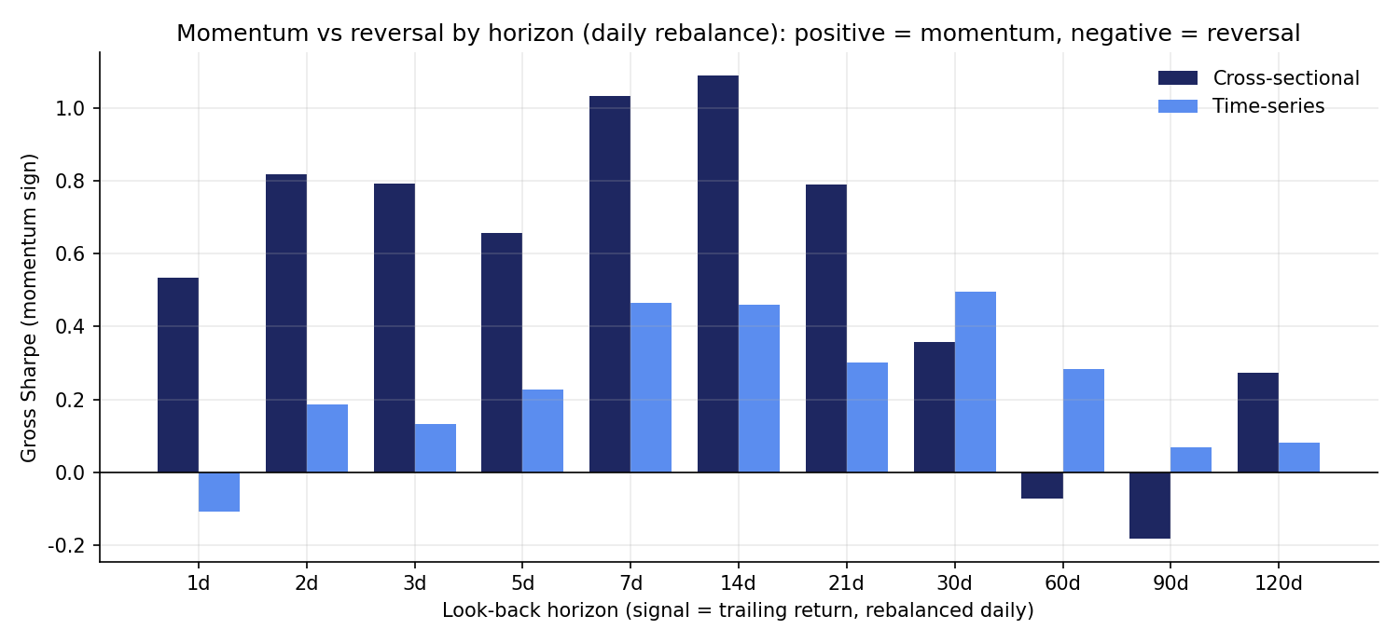
Figure 1. Gross Sharpe of momentum-sign strategies by look-back. Positive = momentum, negative = reversal.
Cross-sectional momentum is positive at every horizon from 1 to 30 days, rising from 0.53 at one day to a peak of 1.09 at 14 days. It turns negative (reversal) at 60 days (-0.07) and 90 days (-0.18). Time-series momentum is weaker but positive from 2 days onward and best at about 30 days (0.50). So crypto shows momentum at short-to-medium daily horizons and reversal only at long horizons, the reverse of the equity pattern in the brief and consistent with Dobrynskaya. Section 6.1 shows that the brief's short-horizon reversal does exist, but only intraday.
Costs matter a great deal. The 1-day strategy trades about 1.3x its capital per day, so 20 bps of cost costs roughly 95% a year and turns a positive gross Sharpe into a heavily negative net one. Longer look-backs trade far less, which is why the tradable momentum strategies in Section 8 use 7 to 30 day signals.
Table 3. Horizon scan, full sample (daily rebalance).
Look-back | CS gross Sharpe | CS net 20 bps | CS net 7 bps | TS gross Sharpe | TS net 20 bps | CS turnover/day
1 d | 0.53 | -3.96 | -1.08 | -0.11 | -1.46 | 1.32
3 d | 0.79 | -1.97 | -0.19 | 0.13 | -0.63 | 0.77
7 d | 1.03 | -0.78 | 0.39 | 0.47 | -0.03 | 0.51
14 d | 1.09 | -0.23 | 0.62 | 0.46 | 0.11 | 0.37
30 d | 0.36 | -0.59 | 0.03 | 0.50 | 0.25 | 0.26
60 d | -0.07 | -0.76 | -0.32 | 0.28 | 0.11 | 0.19
90 d | -0.18 | -0.76 | -0.38 | 0.07 | -0.07 | 0.16

5.2 New information and activity
The brief suggests momentum is stronger when activity and new information are high. Activity is measured by abnormal dollar volume, today's dollar volume divided by its trailing 30-day average. Social media data are not freely available historically, so volume is the activity proxy. Figure 2 compares cross-sectional momentum on all coins, on only the high- or low-activity half of coins each day, and with the signal multiplied by each coin's volume-shock rank.
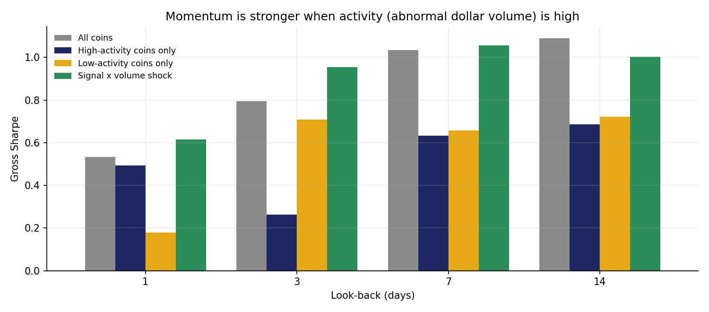
Figure 2. Cross-sectional momentum conditioned on abnormal dollar volume.
At the shortest horizons, activity strengthens momentum as the brief predicts. One-day momentum has a gross Sharpe of 0.49 among high-activity coins against 0.18 among low-activity coins. Weighting the signal by volume shock lifts the 1-day Sharpe from 0.53 to 0.61 and the 3-day Sharpe from 0.79 to 0.95, and the improvement holds in the hold-out period (0.63 to 1.01 at 3 days). At 7 to 14 days the effect fades. Restricting to half the coins hurts in both halves because the portfolio is less diversified, so the volume-weighted version is the useful one.

5.3 Seasonality: weekdays vs weekends, day vs night
Institutions mostly trade on weekdays during working hours, while retail trades around the clock. Figure 3 shows the day-of-week profile of the main strategies.
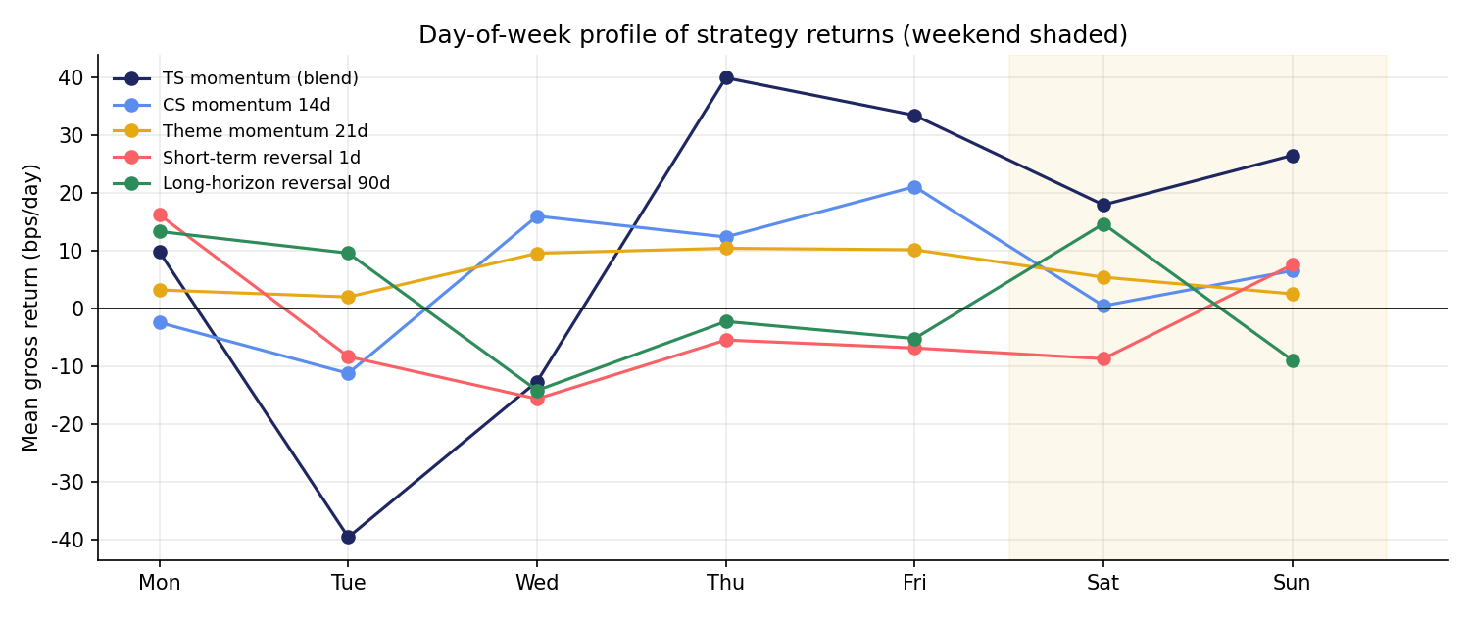
Figure 3. Mean gross daily return of each strategy by day of week (weekend shaded).
Time-series momentum is much stronger on weekends: gross Sharpe 1.77 on Saturdays and Sundays against 0.39 on weekdays. When institutions are away, retail-driven trends persist; on weekdays (especially Tuesday and Wednesday) institutional flow tends to interrupt them. Cross-sectional and theme momentum show the opposite tilt and earn more on weekdays. A weekend-only time-series momentum book has a higher research-period gross Sharpe (1.32) than the all-days version (0.93), but opening and closing every weekend adds turnover, so it does not beat the all-days book after 20 bps costs.
Using hourly data, Figure 4 (right) splits the equal-weight crypto return by trading session. On weekdays the US session (13:00-21:00 UTC) has a negative average return (-1.11 bps per hour) while the late-US / early-Asia hours earn the most (2.21 bps per hour). Crypto gains have accrued outside US working hours, a 'night effect' consistent with institutional selling pressure during the US day and retail buying outside it.
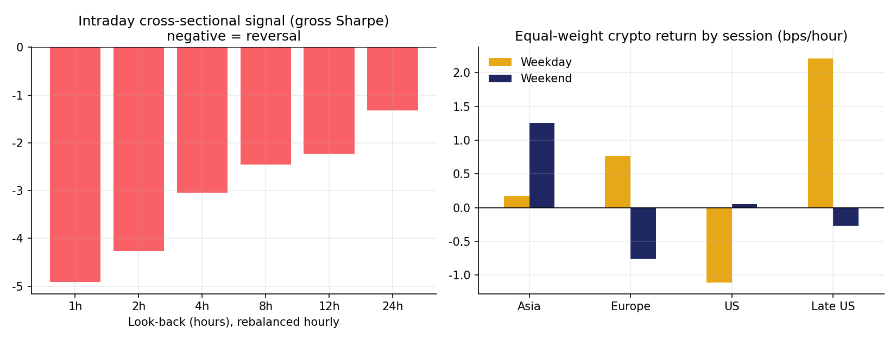
Figure 4. Left: intraday cross-sectional signal by look-back (negative = reversal). Right: mean return by session.

5.4 Investment themes
Theme momentum ranks the four theme indices on their trailing return, goes long the best themes and short the worst, and spreads each theme's weight equally across its coins.
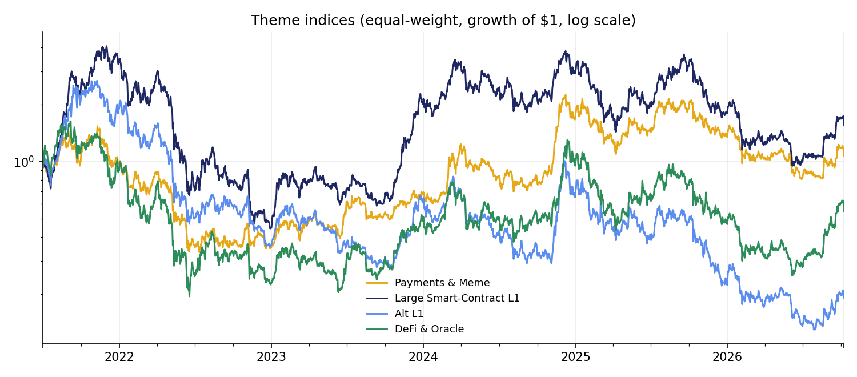
Figure 5. Equal-weight theme indices (growth of $1, log scale).
Theme momentum is the strongest gross signal in the research period: with a 14-day look-back it earns a gross Sharpe of 2.02 in 2021-2023 and 1.36 over the full sample. Themes rotate slowly, so turnover is modest. However, the signal weakened sharply in the hold-out period (gross Sharpe 0.66). Theme moves in 2024-2026 came in short, sharp bursts that then reversed - the payments & meme theme rose about 150% in 2024 and fell about 36% from January 2025 - so trailing theme returns stopped predicting the following weeks. Table 4 shows the grid.
Table 4. Theme momentum grid (look-back and holding period).
Look-back | Hold | Gross IS | Gross OOS | Net 20 bps (full) | Net 7 bps (full) | Turnover
7d | 1d | 1.31 | 0.46 | -0.89 | 0.25 | 0.46
7d | 7d | 1.30 | 0.41 | -0.10 | 0.53 | 0.26
14d | 1d | 2.02 | 0.66 | 0.15 | 0.93 | 0.31
14d | 7d | 1.73 | 0.12 | 0.36 | 0.76 | 0.16
21d | 1d | 1.99 | 0.30 | 0.21 | 0.84 | 0.25
21d | 7d | 1.51 | 0.47 | 0.51 | 0.84 | 0.13
30d | 1d | 1.76 | 0.33 | 0.23 | 0.78 | 0.22
30d | 7d | 1.34 | -0.13 | 0.23 | 0.50 | 0.11
60d | 1d | 0.93 | 0.50 | 0.16 | 0.52 | 0.14
60d | 7d | 0.80 | -0.05 | 0.08 | 0.28 | 0.08

5.5 Technical plays: front-running institutional hours
If institutions trade predictably during US hours, the moves before the US open, or the previous US session, might predict the coming US session. Three tests use hourly data: (i) the pre-US return (00:00-13:00 UTC) predicting the US session; (ii) yesterday's US session predicting today's (same-session persistence, in the spirit of Heston, Korajczyk & Sadka, 2010); and (iii) the US session predicting the following late-US hours.
Table 5. Front-running the US session (hourly data, 2022 onward).
Test | Type | Gross bps/day | Gross Sharpe | IS | OOS | Net 7 bps | t-stat
Pre-US return -> US session (TS, each coin) | Time-series | -4.67 | -0.47 | -1.34 | 0.16 | -1.87 | -0.99
Pre-US return -> US session (TS, each coin) | Cross-sectional | 0.32 | 0.10 | -0.78 | 0.68 | -4.30 | 0.21
Prior-day US session -> today's US session | Time-series | -3.87 | -0.36 | -1.10 | 0.14 | -1.68 | -0.83
Prior-day US session -> today's US session | Cross-sectional | 1.63 | 0.53 | 0.40 | 0.63 | -4.04 | 1.17
US session -> late-US / overnight | Time-series | 0.37 | 0.07 | 0.65 | -0.40 | -2.45 | 0.15
US session -> late-US / overnight | Cross-sectional | -1.92 | -1.13 | -1.59 | -0.79 | -9.36 | -2.38

The most promising effect is same-session persistence across coins: coins that outperformed in yesterday's US session tend to outperform again today (gross 1.63 bps per day, Sharpe 0.53). But no test is statistically strong, and because each strategy opens and closes a full position every day, even 7 bps limit orders wipe out the edge. Front-running institutional hours is not profitable at the brief's costs with daily session granularity.

6. Reversal Research

6.1 Time horizon: intraday and long-horizon reversal
The brief expects reversal at shorter horizons. Daily data showed none, so the test was repeated on hourly data (Figure 4, left, and Table 6). Here reversal is very strong.
Table 6. Intraday cross-sectional signal (negative Sharpe = reversal), rebalanced hourly.
Look-back | Gross Sharpe | IS | OOS | Gross bps/hour | Turnover/hour | Cost bps/hour at 7 | Net Sharpe at 7 bps
1 h | -4.91 | -5.08 | -4.79 | -1.13 | 1.34 | 9.38 | -43.2
2 h | -4.27 | -5.33 | -3.47 | -0.98 | 0.95 | 6.66 | -32.0
4 h | -3.05 | -4.27 | -2.16 | -0.70 | 0.69 | 4.86 | -23.6
8 h | -2.46 | -3.84 | -1.45 | -0.56 | 0.51 | 3.57 | -17.7
12 h | -2.23 | -3.63 | -1.21 | -0.52 | 0.43 | 2.98 | -14.8
24 h | -1.33 | -1.90 | -0.91 | -0.31 | 0.31 | 2.17 | -10.5

A 1-hour cross-sectional reversal (buy the coins that fell most in the last hour, sell those that rose) has a gross Sharpe of 4.91, and it holds in both the research and hold-out periods. It confirms the brief's view that shorter horizons lead to reversal. But the strategy earns about 1.13 bps per hour while turning over 1.34x its capital, which costs 9.38 bps per hour even with limit orders. Intraday reversal is an edge for market makers paid to provide liquidity, not for a strategy that pays 7-20 bps.
At the other end, long-horizon reversal works and is cheap to trade. Selling the coins with the best 60-day return and buying the worst, skipping the most recent 14 days (which still carry momentum) and holding each portfolio 14 days, earns a gross Sharpe of 1.02 with turnover of only 0.06 per day. This is the overreaction pattern of De Bondt and Thaler (1985), compressed into weeks rather than years in crypto.

6.2 Uninformed trading
The brief suggests that uninformed, liquidity-driven moves reverse more. The activity results in Section 5.2 point the same way: low-activity moves show weaker 1-day momentum (0.18) than high-activity moves (0.49), consistent with Campbell, Grossman and Wang (1993). The intraday reversal is also the uninformed-trading channel: hour-to-hour moves are mostly liquidity noise, and they reverse. At the daily horizon, however, even low-volume moves do not reverse outright in this large-cap universe.

6.3 Correlation: residual baskets and cointegrated pairs
The brief suggests that 'Security A minus something correlated to it' is more mean-reverting. Three versions are tested: (i) each coin's return minus its beta-adjusted market return; (ii) each coin's return minus its theme index; and (iii) cointegrated pairs traded with a Kalman-filter hedge ratio and a walk-forward monthly re-selection (the engine from the July version of this project, now run at 20 bps).
Table 7. Correlation-based reversal.
Strategy | Gross IS | Gross OOS | Gross full | Net 20 bps | Net 7 bps | Turnover
Market-residual reversal L=1d | -0.49 | -0.69 | -0.59 | -5.53 | -2.28 | 1.32
Theme-residual reversal L=1d | 0.19 | -0.08 | 0.06 | -5.54 | -1.85 | 1.32
Market-residual reversal L=3d | -0.86 | -1.07 | -0.96 | -3.90 | -1.98 | 0.76
Theme-residual reversal L=3d | 0.05 | 0.12 | 0.09 | -3.07 | -1.00 | 0.77
Market-residual reversal L=7d | -1.03 | -0.99 | -1.01 | -2.88 | -1.66 | 0.51
Theme-residual reversal L=7d | -0.92 | -0.06 | -0.47 | -2.55 | -1.19 | 0.52
Market-residual reversal L=30d | -0.98 | 0.26 | -0.36 | -1.32 | -0.70 | 0.26
Theme-residual reversal L=30d | 0.07 | 1.26 | 0.67 | -0.44 | 0.29 | 0.26
Market-residual reversal L=60d | -0.27 | 0.19 | -0.04 | -0.73 | -0.28 | 0.19
Theme-residual reversal L=60d | 0.81 | 0.75 | 0.78 | -0.05 | 0.49 | 0.20
Cointegration pairs (Kalman, walk-forward) | 0.55 | -0.01 | 0.24 | -0.11 | 0.12 | 0.03

Residuals against the whole market do not reverse; they trend (7-day Sharpe of the reversal -1.01), so coin-specific moves carry information. Residuals against the coin's own theme do reverse at 1-2 month horizons (60-day gross Sharpe 0.78, positive in both periods): a coin that runs ahead of its closest peers tends to give it back. Cointegrated pairs are genuinely market-neutral and trade very little (turnover 0.033 per day), but their gross edge (0.24) is too small to survive costs. Across 83 monthly windows the engine traded 120 different pairs, most often LTC-AVAX, XLM-ADA, COMP-LTC, ETH-BTC.

6.4 Macro: volatility and dislocation
The brief expects more reversal when volatility and dislocation are high. Four indicators are tested, as discussed in class: implied volatility (Deribit DVOL), realized volatility of the market, cross-sectional return dispersion, and average pairwise correlation. Each day is placed in the low, middle or high tercile of the indicator's trailing one-year range, using only data available before the trade.
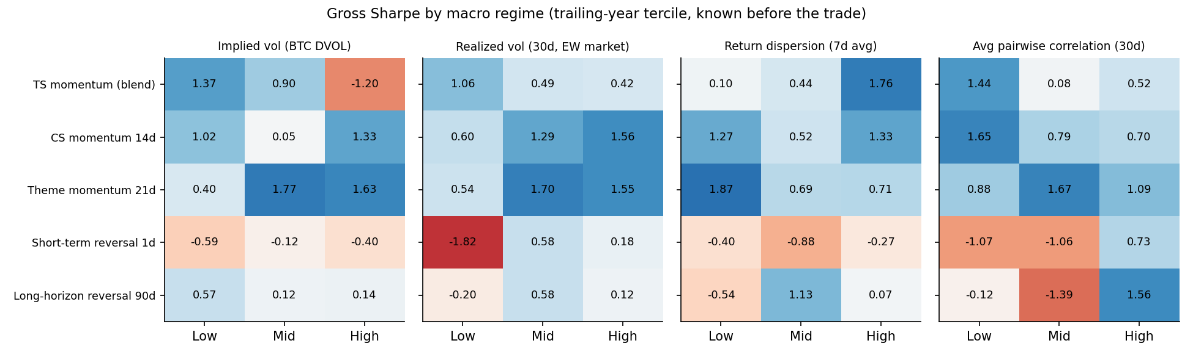
Figure 6. Gross Sharpe of each strategy by macro regime.
Short-term (1-day) reversal behaves as the brief predicts: it loses heavily when realized volatility is low (Sharpe -1.82) and turns positive when volatility is middling or high, and it is positive only when average correlation is high (0.73). That matches Nagel (2012): liquidity providers earn more when markets are stressed. The effect is not strong enough to make daily reversal tradable after costs (Section 8), but it is a clean confirmation of the macro hypothesis.
The more useful macro result is for momentum. Time-series momentum earns a Sharpe of 1.37 when implied volatility is low but -1.20 when it is high: trends break when option markets price large moves, the crypto version of the momentum crashes in Daniel and Moskowitz (2016). Switching time-series momentum off when DVOL is in its top tercile is therefore built into the candidate set, and it was selected on the research period.

7. Execution
Execution decides most of these results. Three tools reduce cost: (i) limit orders (7 bps instead of 20) for slow strategies; (ii) overlapping holding periods, which average the last few days' target portfolios and so trade more slowly; and (iii) a no-trade band, which leaves a position alone unless it is more than 2% or 5% away from target (Garleanu & Pedersen, 2013). Table 8 applies them to the two final books.
Table 8. Execution variants for the final momentum and reversal books.
Book | Execution | Turnover/day | Gross Sharpe | Net 7 bps | Net 20 bps | Cost drag/yr at 20
Momentum | Daily rebalance | 0.237 | 1.26 | 1.08 | 0.75 | 17.3%
Momentum | Hold 3d (overlapping) | 0.172 | 0.95 | 0.82 | 0.57 | 12.6%
Momentum | Hold 7d (overlapping) | 0.137 | 0.69 | 0.58 | 0.39 | 10.0%
Momentum | No-trade band 2% | 0.197 | 1.26 | 1.11 | 0.83 | 14.4%
Momentum | No-trade band 5% | 0.137 | 0.95 | 0.84 | 0.63 | 10.0%
Reversal | Daily rebalance | 0.062 | 1.02 | 0.94 | 0.80 | 4.5%
Reversal | Hold 3d (overlapping) | 0.059 | 1.04 | 0.96 | 0.83 | 4.3%
Reversal | Hold 7d (overlapping) | 0.056 | 1.04 | 0.97 | 0.84 | 4.1%
Reversal | No-trade band 2% | 0.048 | 1.00 | 0.93 | 0.82 | 3.5%
Reversal | No-trade band 5% | 0.037 | 0.92 | 0.87 | 0.78 | 2.7%

For the momentum ensemble the research period selected 'No-trade band 2%': turnover goes from 0.237 to 0.197 per day and the 20 bps Sharpe from 0.75 to 0.83, while the gross Sharpe is essentially unchanged (1.26 vs 1.26). Longer holding periods cut turnover too, but they dilute the momentum signal faster than they save cost. The reversal book already trades slowly; 'Hold 3d (overlapping)' was selected for it. Moving from market to limit orders is worth about 0.28 of Sharpe for momentum, so if part of the momentum book can be executed passively the gain is large.
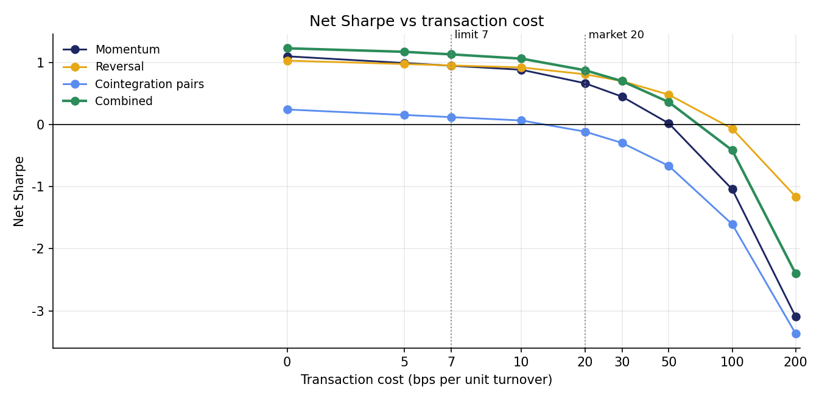
Figure 7. Net Sharpe of the final books versus transaction cost (0-200 bps).
The combined portfolio stays profitable up to about 50 bps (Sharpe 0.36) and breaks down near 100 bps (-0.41). The reversal book is the most cost-robust sleeve because of its low turnover; the momentum sleeve breaks even near 50 bps.

8. Strategy Selection
The research blocks above produced a pre-specified grid of 44 candidates. Momentum candidates are time-series momentum (holding period, with or without the DVOL filter), theme momentum (look-back and holding period) and cross-sectional momentum (look-back, holding period, with or without volume weighting). Reversal candidates are short-term reversal restricted to high-volatility regimes, long-horizon reversal (look-back, skip, holding period) and cointegrated pairs. Each candidate is ranked by its research-period net Sharpe at its execution cost (20 bps for momentum, 7 bps for reversal).
Table 9. Top candidates by research-period net Sharpe.
Candidate | Family | Selection Sharpe (IS) | Hold-out net 20 | Hold-out net 7 | Turnover
Theme momentum L=14 H=7 | Momentum | 1.20 | -0.61 | -0.14 | 0.16
Theme momentum L=21 H=3 | Momentum | 1.13 | -0.58 | -0.05 | 0.19
Theme momentum L=30 H=3 | Momentum | 1.12 | -0.86 | -0.41 | 0.16
Theme momentum L=21 H=1 | Momentum | 1.12 | -0.77 | -0.08 | 0.25
Theme momentum L=21 H=7 | Momentum | 1.06 | -0.11 | 0.27 | 0.13
Theme momentum L=14 H=3 | Momentum | 1.02 | -0.73 | -0.07 | 0.23
Long-horizon reversal L=60 skip=14 H=14 | Reversal | 0.90 | 0.84 | 0.98 | 0.06
Long-horizon reversal L=60 skip=14 H=7 | Reversal | 0.81 | 0.63 | 0.82 | 0.08
Cointegration pairs (Kalman) | Reversal | 0.38 | -0.37 | -0.13 | 0.03
Long-horizon reversal L=60 skip=0 H=14 | Reversal | 0.20 | 0.64 | 0.77 | 0.05
Long-horizon reversal L=90 skip=14 H=14 | Reversal | 0.18 | 0.86 | 0.97 | 0.05
Full list in the workbook (sheet 'Candidate Selection').
The momentum ranking is dominated by theme momentum, but those variants are close relatives of one another and all of them decayed in the hold-out. Rather than bet on one winner, the final momentum book is an ensemble of the research-period best variant from each momentum family:
- TS momentum blend H=1 + DVOL filter (hold-out net Sharpe at 20 bps: 0.67)
- Theme momentum L=14 H=7 (hold-out net Sharpe at 20 bps: -0.61)
- CS momentum L=14 H=7 (hold-out net Sharpe at 20 bps: -0.45)
The reversal book is the research-period best reversal candidate, Long-horizon reversal L=60 skip=14 H=14. Short-term reversal, even restricted to high-volatility regimes, loses money after costs and was rejected.

9. Weighting
The momentum and reversal books are almost uncorrelated (daily correlation 0.08), and neither is correlated with Bitcoin, so combining them should cut risk substantially. Four weighting schemes from the course were tested, all re-estimated monthly on the trailing 180 days only: equal weight, inverse volatility, risk parity (equal risk contribution) and a shrunk mean-variance optimiser (means shrunk 50% toward zero, covariance shrunk toward its diagonal, no shorting of sleeves).
Table 10. Weighting methods for combining momentum and reversal.
Method | Avg weight momentum | Avg weight reversal | Sharpe IS | Sharpe OOS | Sharpe full
Equal weight | 50% | 50% | 1.44 | 0.70 | 1.02
Inverse volatility | 38% | 62% | 1.54 | 0.80 | 1.10
Risk parity (ERC) | 38% | 62% | 1.54 | 0.80 | 1.10
Mean-variance (shrunk) | 33% | 67% | 1.71 | 0.55 | 1.02

Mean-variance (shrunk) had the best research-period Sharpe and was selected. With only two sleeves, inverse volatility and risk parity give nearly identical weights. All four methods beat either sleeve on its own, which is the main benefit of combining uncorrelated strategies. In the hold-out the simpler schemes did slightly better than mean-variance, consistent with DeMiguel, Garlappi and Uppal (2009): estimated means are noisy, so a plain risk-based weighting is a sound default going forward.
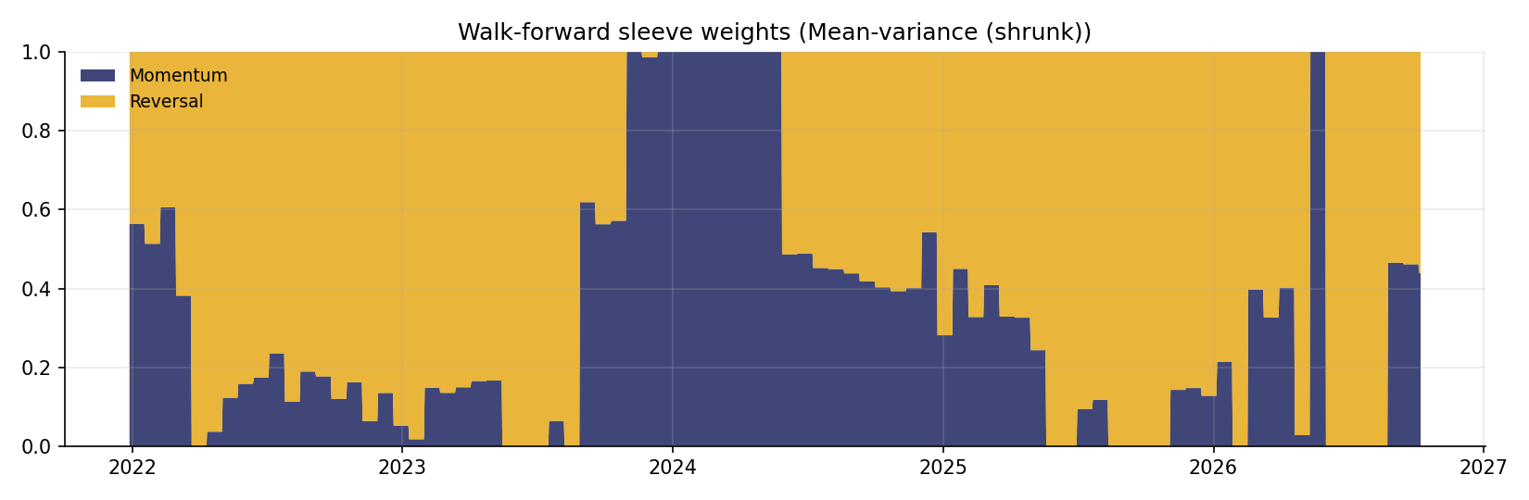
Figure 8. Walk-forward sleeve weights (mean-variance (shrunk)).

9.1 Robustness of the selection
Table 11. How the result depends on the momentum choice.
Momentum sleeve | Mom. Sharpe IS | Mom. Sharpe OOS | Combined IS | Combined OOS | Combined full
Final: momentum ensemble (best TS + theme + CS) | 1.19 | 0.22 | 1.71 | 0.55 | 1.02
Single IS-best momentum (Theme momentum L=14 H=7) | 1.22 | -0.61 | 1.84 | 0.09 | 0.81
TS momentum only (TS momentum blend H=1 + DVOL filter) | 0.75 | 0.67 | 1.37 | 0.68 | 0.90

Had the single best research-period momentum strategy been used, the combined portfolio's hold-out Sharpe would have been only 0.09. The ensemble and the time-series-only versions hold up better (0.55 and 0.68). This table is the clearest illustration of selection risk in the project. Transparency note: the ensemble design was adopted after seeing that single-strategy selection was fragile, so its hold-out figure is partly informed by the hold-out and should be read with that in mind.

10. Performance Evaluation
Tables 12-14 report the metrics required by the brief for the full backtest window, the research period and the hold-out period. The combined portfolio is the recommended strategy; its components and the passive benchmarks are shown for comparison.
Table 12. Full backtest, 2021-12-28 to 2026-10-08.
Strategy | Ann. return | Ann. vol | Sharpe | Max DD | Alpha (ann.) | Beta (BTC) | Alpha t
Combined portfolio * | 20.2% | 19.7% | 1.02 | -28.1% | 20.6% | -0.02 | 2.19
Combined (all trades at 20 bps) | 17.3% | 19.8% | 0.88 | -28.6% | 17.8% | -0.02 | 1.88
Momentum ensemble (20 bps market) | 22.3% | 33.3% | 0.67 | -31.1% | 25.2% | -0.13 | 1.68
Momentum ensemble (7 bps limit) | 31.6% | 33.3% | 0.95 | -25.1% | 34.6% | -0.13 | 2.31
Reversal (7 bps limit) | 18.7% | 19.6% | 0.95 | -33.7% | 18.7% | 0.00 | 2.01
Reversal (20 bps market) | 15.9% | 19.6% | 0.81 | -35.6% | 15.9% | 0.00 | 1.71
Cointegration pairs (20 bps) | -0.7% | 6.6% | -0.11 | -12.9% | -0.9% | 0.01 | -0.32
Equal-weight crypto (buy & hold) | 9.3% | 70.1% | 0.13 | -77.4% | -17.4% | 1.17 | -1.00
Buy & hold BTC | 22.9% | 50.8% | 0.45 | -67.0% | 0.0% | 1.00 | -1.36
* Momentum at 20 bps (market orders), reversal at 7 bps (limit orders).
Table 13. Research period, 2021-12-28 to 2023-12-31.
Strategy | Ann. return | Ann. vol | Sharpe | Max DD | Alpha (ann.) | Beta (BTC) | Alpha t
Combined portfolio * | 32.9% | 19.2% | 1.71 | -12.6% | 33.0% | -0.02 | 2.42
Combined (all trades at 20 bps) | 30.9% | 19.4% | 1.59 | -13.5% | 31.0% | -0.02 | 2.25
Momentum ensemble (20 bps market) | 43.7% | 36.7% | 1.19 | -28.0% | 44.5% | -0.14 | 1.76
Momentum ensemble (7 bps limit) | 52.7% | 36.7% | 1.44 | -25.1% | 53.6% | -0.14 | 2.13
Reversal (7 bps limit) | 15.6% | 17.7% | 0.89 | -26.1% | 15.6% | 0.00 | 1.24
Reversal (20 bps market) | 12.8% | 17.7% | 0.73 | -26.4% | 12.8% | 0.00 | 1.02
Cointegration pairs (20 bps) | 1.3% | 7.2% | 0.19 | -6.0% | 1.3% | 0.01 | 0.29
Equal-weight crypto (buy & hold) | -6.7% | 72.7% | -0.09 | -77.4% | -13.8% | 1.14 | -0.52
Buy & hold BTC | 6.2% | 55.1% | 0.11 | -67.0% | 0.0% | 1.00 | 3.65
* Momentum at 20 bps (market orders), reversal at 7 bps (limit orders).
Table 14. Hold-out period, 2024-01-01 to 2026-10-08.
Strategy | Ann. return | Ann. vol | Sharpe | Max DD | Alpha (ann.) | Beta (BTC) | Alpha t
Combined portfolio * | 11.1% | 20.1% | 0.55 | -23.5% | 11.6% | -0.01 | 0.90
Combined (all trades at 20 bps) | 7.5% | 20.0% | 0.38 | -24.0% | 8.1% | -0.02 | 0.63
Momentum ensemble (20 bps market) | 6.8% | 30.6% | 0.22 | -26.7% | 11.0% | -0.12 | 0.61
Momentum ensemble (7 bps limit) | 16.3% | 30.6% | 0.53 | -21.2% | 20.5% | -0.12 | 1.15
Reversal (7 bps limit) | 21.0% | 21.0% | 1.00 | -22.0% | 20.9% | 0.00 | 1.59
Reversal (20 bps market) | 18.2% | 21.0% | 0.87 | -23.8% | 18.1% | 0.00 | 1.38
Cointegration pairs (20 bps) | -2.2% | 6.1% | -0.37 | -11.7% | -2.2% | 0.00 | -0.69
Equal-weight crypto (buy & hold) | 20.9% | 68.3% | 0.31 | -75.2% | -20.8% | 1.19 | -0.90
Buy & hold BTC | 34.9% | 47.4% | 0.74 | -53.1% | 0.0% | 1.00 | 0.33
* Momentum at 20 bps (market orders), reversal at 7 bps (limit orders).
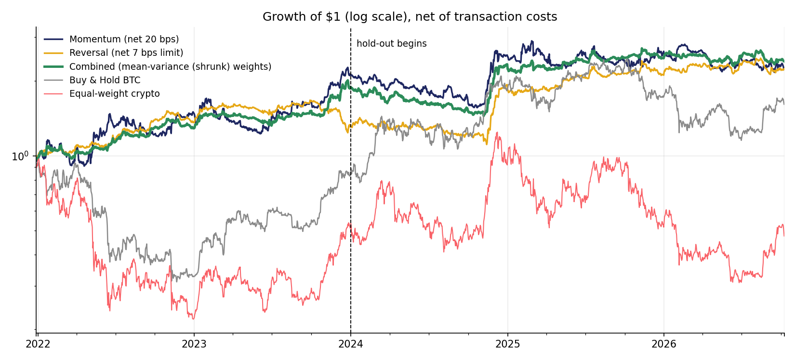
Figure 9. Growth of $1, net of costs (log scale). Dashed line: start of hold-out.
Over the full window the combined portfolio earns 20.2% a year at 19.7% volatility, a Sharpe of 1.02, against 0.45 for holding Bitcoin. Its beta to Bitcoin is -0.02, so almost all of its return is alpha: 20.6% a year with a t-statistic of 2.19. Its worst drawdown is -28.1%, against -67.0% for Bitcoin and -77.4% for an equal-weight crypto basket. Even with every trade charged 20 bps, the Sharpe is 0.88.
The hold-out is weaker. The combined Sharpe falls to 0.55, with alpha 11.6% a year (t = 0.90), because the momentum ensemble's Sharpe fell from 1.19 to 0.22. Bitcoin itself had a strong hold-out (Sharpe 0.74) after spot ETF approval, but with a -53.1% drawdown and full market risk. The reversal book was the steadiest component, with a hold-out Sharpe of 1.00 at 7 bps and 0.87 at 20 bps.
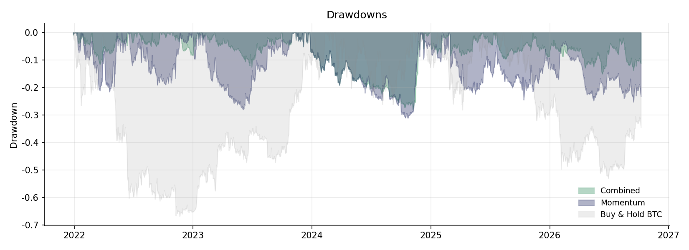
Figure 10. Drawdowns of the combined portfolio, the momentum book and Bitcoin.
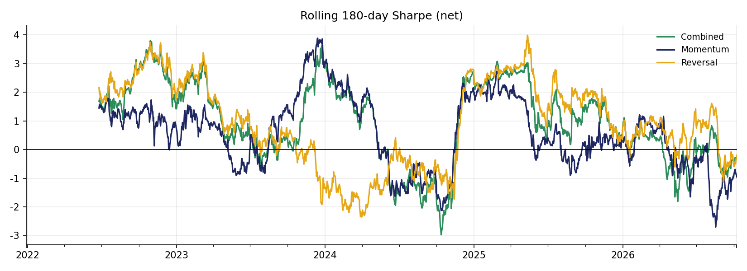
Figure 11. Rolling 180-day Sharpe ratio (net).

11. Discussion

11.1 What the research shows
- Momentum and reversal live at different horizons. At daily horizons crypto is a momentum market. The brief's short-horizon reversal exists, but only intraday, where costs make it unreachable; long-horizon (2-month) reversal is the tradable reversal.
- The brief's conditioning variables work. Volume shocks, weekends, theme rotation and calm option markets all strengthen momentum; high volatility and high correlation strengthen reversal. Each confirms a hypothesis in the brief.
- Execution is the binding constraint. Turnover, not signal discovery, separates profitable from unprofitable strategies. Bands, slower signals and limit orders matter as much as the signal itself.
- Combining is where the value is. Momentum and reversal are nearly uncorrelated, so a simple risk-based combination produces a market-neutral portfolio with a higher Sharpe and a smaller drawdown than either part.

11.2 Comparison with the July version
The July 2026 version compared vol-scaled time-series momentum with cointegration pairs at 10 bps and found time-series momentum best. This rebuild extends the sample by three months, applies the brief's 20 / 7 bps costs instead of 10 bps, adds alpha, tests every item in the research outline, adds a reversal strategy that works, and combines momentum and reversal with explicit weighting. Time-series momentum remains the most robust single momentum family; cointegration pairs remain market-neutral but unprofitable after costs.

11.3 Limitations
- Shorting. Short legs assume coins can be borrowed or shorted through perpetual futures; funding costs are not modelled. A long-only implementation would capture only part of the long-short edge.
- Survivorship. The universe is 16 large coins that survived to 2026; failed or delisted coins are absent, which flatters the sample (survivorship bias).
- Costs and capacity. Costs are linear. Real slippage rises with trade size and in stressed markets, and limit orders may not fill, so the 7 bps reversal assumption is optimistic for large capital.
- Multiple testing. 44 candidates were compared. Even with the research / hold-out split, a deflated Sharpe ratio (Bailey & Lopez de Prado, 2014) would be lower than the reported one.
- Activity data. Social-media and on-chain activity data were not used because free historical data are not available; volume is the only activity proxy.

11.4 Next steps
- Paper-trade the combined portfolio forward on live data to build a genuine out-of-sample record.
- Execute the momentum book partly with limit orders and measure fill rates.
- Add theme-residual reversal (Section 6.3) as a third sleeve and test it on new data.
- Model perpetual-futures funding and borrow costs for the short legs.

12. Conclusion
On live data through October 2026, crypto shows momentum at horizons of a few days to a month and reversal at the extremes - within the hour and over two months. The patterns the brief points to are present: activity strengthens momentum, weekends favour it, themes rotate, implied volatility predicts momentum crashes, and stressed markets favour reversal. Most of these edges are too small or trade too often to survive 20 bps costs, so execution design is as important as signal discovery.
A market-neutral portfolio that combines a diversified momentum ensemble with long-horizon reversal, weighted by mean-variance (shrunk), earns a net Sharpe of 1.02 with alpha of 20.6% a year, a beta to Bitcoin of -0.02 and a maximum drawdown of -28.1%. Its hold-out Sharpe of 0.55 is lower, which is the realistic expectation for a newly deployed strategy. The strongest lesson of the project is that diversification across signals, and discipline about what is chosen on which data, matter more than any single backtest result.

Appendix A. Reproducibility
All results are reproduced by the notebook crypto_stat_arb_project.ipynb, or from the command line in this order:
- python3 src/fetch_data.py - download daily, hourly and DVOL data to the latest date
- python3 src/statarb.py - cointegration pairs engine (walk-forward, Kalman)
- python3 src/research.py - all research blocks, selection, weighting and performance
- python3 src/build_report.py, build_pptx.py, build_excel.py, build_notebook.py - deliverables
Every table in this report is read from data/research/*.csv, and the workbook crypto_stat_arb_data.xlsx contains every dataset and result.

References
Bailey, D. H., & Lopez de Prado, M. (2014). The deflated Sharpe ratio: Correcting for selection bias, backtest overfitting and non-normality. Journal of Portfolio Management, 40(5), 94-107.
Barroso, P., & Santa-Clara, P. (2015). Momentum has its moments. Journal of Financial Economics, 116(1), 111-120.
Campbell, J. Y., Grossman, S. J., & Wang, J. (1993). Trading volume and serial correlation in stock returns. Quarterly Journal of Economics, 108(4), 905-939.
Chan, E. P. (2013). Algorithmic trading: Winning strategies and their rationale. Wiley.
Daniel, K., & Moskowitz, T. J. (2016). Momentum crashes. Journal of Financial Economics, 122(2), 221-247.
De Bondt, W. F. M., & Thaler, R. (1985). Does the stock market overreact? Journal of Finance, 40(3), 793-805.
DeMiguel, V., Garlappi, L., & Uppal, R. (2009). Optimal versus naive diversification: How inefficient is the 1/N portfolio strategy? Review of Financial Studies, 22(5), 1915-1953.
Do, B., & Faff, R. (2010). Does simple pairs trading still work? Financial Analysts Journal, 66(4), 83-95.
Do, B., & Faff, R. (2012). Are pairs trading profits robust to trading costs? Journal of Financial Research, 35(2), 261-287.
Dobrynskaya, V. (n.d.). Cryptocurrency momentum and reversal [Working paper]. HSE University.
Elliott, R. J., van der Hoek, J., & Malcolm, W. P. (2005). Pairs trading. Quantitative Finance, 5(3), 271-276.
Engle, R. F., & Granger, C. W. J. (1987). Co-integration and error correction: Representation, estimation, and testing. Econometrica, 55(2), 251-276.
Fil, M., & Kristoufek, L. (2020). Pairs trading in cryptocurrency markets. IEEE Access, 8, 172644-172651.
Garleanu, N., & Pedersen, L. H. (2013). Dynamic trading with predictable returns and transaction costs. Journal of Finance, 68(6), 2309-2340.
Gatev, E., Goetzmann, W. N., & Rouwenhorst, K. G. (2006). Pairs trading: Performance of a relative-value arbitrage rule. Review of Financial Studies, 19(3), 797-827.
Han, H., Kang, J., & Ryu, D. (2024). Time-series and cross-sectional momentum in the cryptocurrency market: A comprehensive analysis under realistic assumptions (SSRN Working Paper No. 4675565).
Harvey, C. R., Liu, Y., & Zhu, H. (2016). ... and the cross-section of expected returns. Review of Financial Studies, 29(1), 5-68.
Heston, S. L., Korajczyk, R. A., & Sadka, R. (2010). Intraday patterns in the cross-section of stock returns. Journal of Finance, 65(4), 1369-1407.
Jegadeesh, N., & Titman, S. (1993). Returns to buying winners and selling losers: Implications for stock market efficiency. Journal of Finance, 48(1), 65-91.
Krauss, C. (2017). Statistical arbitrage pairs trading strategies: Review and outlook. Journal of Economic Surveys, 31(2), 513-545.
Lehmann, B. N. (1990). Fads, martingales, and market efficiency. Quarterly Journal of Economics, 105(1), 1-28.
Liu, Y., & Tsyvinski, A. (2021). Risks and returns of cryptocurrency. Review of Financial Studies, 34(6), 2689-2727.
Liu, Y., Tsyvinski, A., & Wu, X. (2022). Common risk factors in cryptocurrency. Journal of Finance, 77(2), 1133-1177.
Moskowitz, T. J., & Grinblatt, M. (1999). Do industries explain momentum? Journal of Finance, 54(4), 1249-1290.
Moskowitz, T. J., Ooi, Y. H., & Pedersen, L. H. (2012). Time series momentum. Journal of Financial Economics, 104(2), 228-250.
Nagel, S. (2012). Evaporating liquidity. Review of Financial Studies, 25(7), 2005-2039.
Vidyamurthy, G. (2004). Pairs trading: Quantitative methods and analysis. Wiley.
Wall Street Quants. (2025). Statistical arbitrage in cryptocurrencies: Course project brief [Class handout].

