Assignment 2
Question 1 (ChatGPT used to get summary of metrics)

CPU time counter: 244961671265950 ns
CPU time diff: 13431 ns

CPU time counter: 244967181549590 ns
CPU time diff: 14295 ns

CPU time counter: 244967861422340 ns
CPU time diff: 14469 ns

CPU time counter: 244968344014779 ns
CPU time diff: 18917 ns

CPU time counter: 244968828767847 ns
CPU time diff: 13741 ns

CPU time counter: 244969303910903 ns
CPU time diff: 14595 ns

CPU time counter: 244969831947710 ns
CPU time diff: 18396 ns

CPU time counter: 244970333487404 ns
CPU time diff: 15043 ns

CPU time counter: 244972469651637 ns
CPU time diff: 14314 ns

CPU time counter: 244972847876839 ns
CPU time diff: 19957 ns
CPU time diff metrics are:

Metric | Value
Count | 10
Mean (average) | 15,715.8 ns
Median | 14,532 ns
Minimum | 13,431 ns
Maximum | 19,957 ns
Range | 6,526 ns
Q1 (25th percentile) | 14,295 ns
Q3 (75th percentile) | 18,396 ns
Interquartile Range (IQR) | 4,101 ns
Population Std. Dev. | ≈ 2,276 ns
Sample Std. Dev. | ≈ 2,399 ns

Question 2
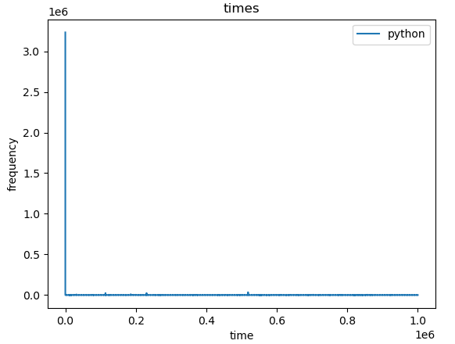
Question 3 (ChatGPT used to get summary of metrics)

Output:
Minimum consecutive TSC diff: 286 cycles Approximate time: 357.50 ns
Minimum consecutive TSC diff: 284 cycles Approximate time: 355.00 ns
Minimum consecutive TSC diff: 296 cycles Approximate time: 370.00 ns
Minimum consecutive TSC diff: 286 cycles Approximate time: 357.50 ns
Minimum consecutive TSC diff: 266 cycles Approximate time: 332.50 ns
Minimum consecutive TSC diff: 282 cycles Approximate time: 352.50 ns
Minimum consecutive TSC diff: 294 cycles Approximate time: 367.50 ns
Minimum consecutive TSC diff: 258 cycles Approximate time: 302.91 ns
Minimum consecutive TSC diff: 260 cycles Approximate time: 325.00 ns
Minimum consecutive TSC diff: 290 cycles Approximate time: 362.50 ns

CPU diff. Time metrics are:

Metric | Value
Count | 10
Mean | 348.29 ns
Median | 356.25 ns
Minimum | 302.91 ns
Maximum | 370.00 ns
Range | 67.09 ns
Q1 | 332.50 ns
Q3 | 362.50 ns
IQR | 30.00 ns
Population Std. Dev. | ≈ 21.0 ns
Sample Std. Dev. | ≈ 22.2 ns

Question 4
Output:
Minimum consecutive TSC diff: 62 cycles Approximate time: 17.22 ns
Minimum consecutive TSC diff: 62 cycles Approximate time: 17.22 ns
Minimum consecutive TSC diff: 64 cycles Approximate time: 17.78 ns
Minimum consecutive TSC diff: 64 cycles Approximate time: 17.78 ns
Minimum consecutive TSC diff: 64 cycles Approximate time: 17.78 ns
Minimum consecutive TSC diff: 64 cycles Approximate time: 17.78 ns
Minimum consecutive TSC diff: 50 cycles Approximate time: 62.50 ns
Minimum consecutive TSC diff: 62 cycles Approximate time: 77.50 ns
Minimum consecutive TSC diff: 64 cycles Approximate time: 17.78 ns
Minimum consecutive TSC diff: 62 cycles Approximate time: 17.22 ns

Metric | Value
Count | 10
Mean | 28.86 ns
Median | 17.78 ns
Minimum | 17.22 ns
Maximum | 77.50 ns
Range | 60.28 ns
Q1 | 17.22 ns
Q3 | 17.78 ns
IQR | 0.56 ns
Population Std. Dev. | ≈ 20.62 ns
Sample Std. Dev. | ≈ 21.74 ns

Performance is significantly improved.

Question 5
Output:
Minimum consecutive TSC diff: 44 cycles
Approximate time: 12.22 ns
