Assignment 3
Question 1
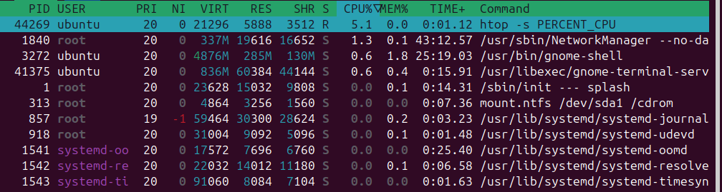
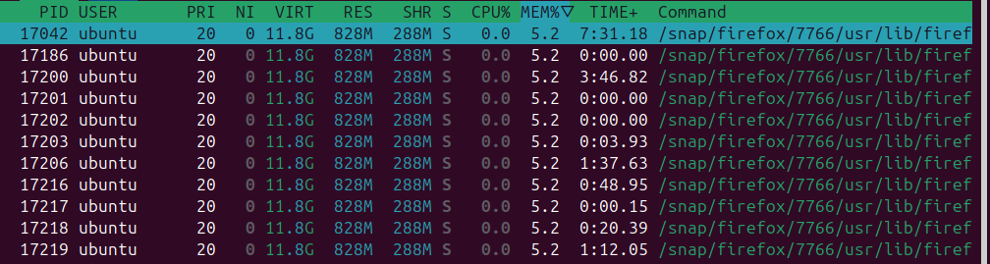
Terminal is the highest user of CPU at the moment.
Firefox is the higheset memory user

For CPU, I could run a computationally expensive program locally, while for memory, I could run a program that requires a lot of dynamic memory. These are both achievable by playing a locally run, high performance game, like Minecraft.

Question 2
CPU utilisation seems to be at about 5%, and therefore it should be idle about 95% of the time.

Question 3
Yes there are some minor fluctuations that occur over time. This is possibly because of background processes (e.g. memory allocation activities) turning on and off which are considered part of baseline.

Question 4

Note that the columns at the top correspond to:
usy%,Bzy_MHz,PkgWatt,CorWatt,PkgTmp,CoreTmp
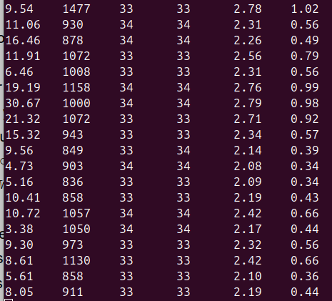
The busy percentage is much higher than the previously measured one using htop. This tool therefore probably grants more insights into the nature of fluctuations of baseline CPU use, and actual absolute values of baseline CPU use over time. This is in contrast to the previous one which only measured and displayed CPU use in a single instant at any point in time.

Question 5
Output:
LHS: Pkg%pc2,Pkg%pc3,Pkg%pc6,Pkg%pc7,Pkg%pc8,CPU%c1,CPU%c3,CPU%c6,CPU%c7
RHS: usy%,Bzy_MHz,PkgWatt,CorWatt,PkgTmp,CoreTmp

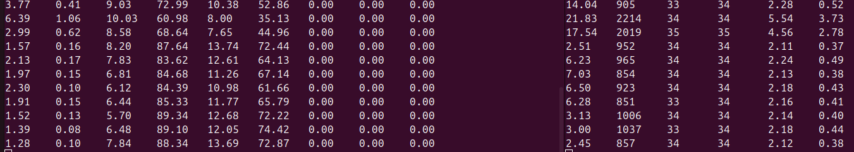
Question 6
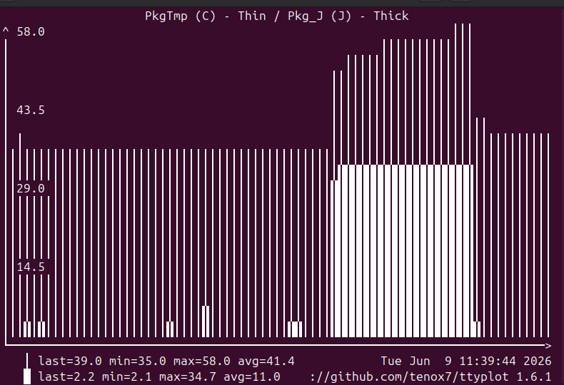

Baseline energy is small but non-negligible relative to that consumed during stress testing. However, since they are non-negligible, if the lab machines sit idle for most of the day, overall energy efficiency is likely to be adversely impacted, since energy will be consumed for no good reason.

Question 7
For matmul_slow.py:
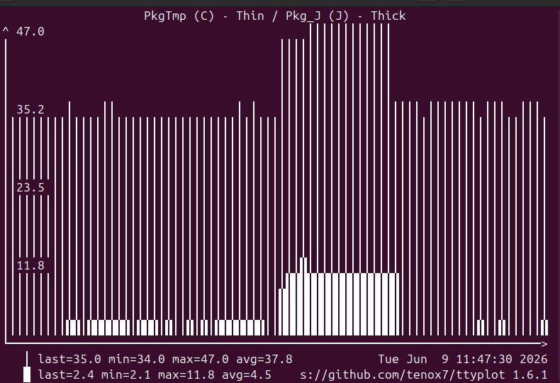

for matmul_fast.py:
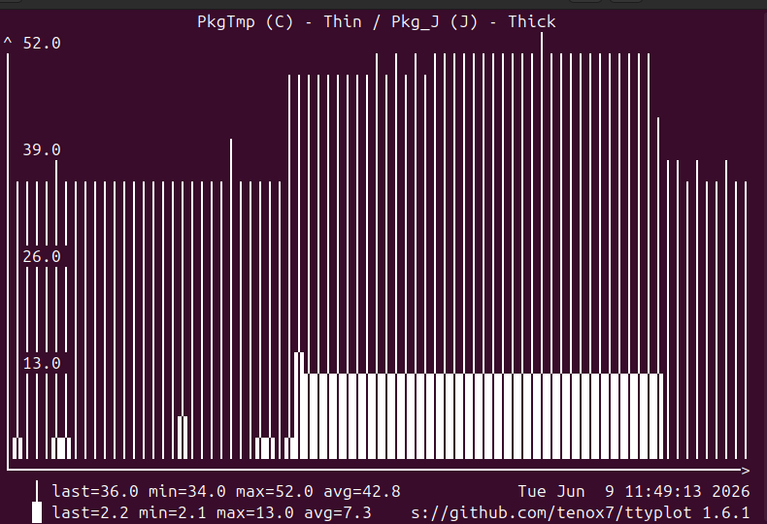

Note that the code for matmul_fast.py has been modified for testing of all 3 matmul_fast algorithms, leading to the seemingly longer program runtime.

The fast version led to mildly higher energy efficiency, as although it took slightly more power to run, it ran for much less time. This sort of matched my intuition as I had expected it to do so, as the underlying actions within the program itself were not significantly more complex than those in matmul_slow, and previous experiments had shown that matmul_fast was significantly faster than matmul_slow.

Question 8
No. Deeper sleep states might take longer to awaken, which may be problematic for operations where system reaction times are important, like those governing defence or energy systems.

Question 9
If seeking to maximise utilisation, data centres might be incentivised to scale down a little, as long as their core offerings are not too significantly impacted. They might alternatively be designed to allow for a variety of sleep states, to enable optimal utilisation and power consumption while providing quick starts to clients.

Thermals probably limit scale, while design probably caps this, leading to incentives for superior thermal management, or roll-outs in locations where this can be more easily achieved (e.g. where cooling costs are lower, like colder regions).

Question 10
a. 8 seconds (1 byte=8 bits)
b. 2.4J to 80J
c. Each machine probably adds 2.4J to 80J in the best case. Transmission network costs would also add to this value, as would cache fetches, which would increase the total energy required for the first machine since it would have to spend energy retrieving the file before sending it. Furthermore, costs associated with route-finding would need to be added in the event that the network path is not perfectly direct and known to be so. Therefore, additional information relating to cache-retrieval, machine-machine transmission, and route-finding costs would be needed.

Question 11
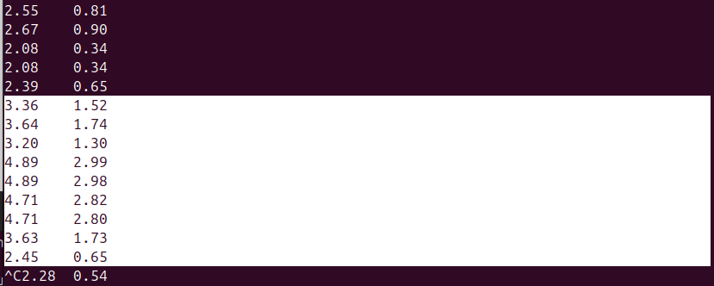
Highlighted cells are for PkgWatt and CoreWatt for when the file was being downloaded. The highlighted PkgWatt values add to 35.48J. They are similar, as this falls within previously mentioned range.

Question 12
Power consumption for 144p, 480p, and 720p.
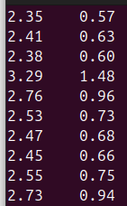
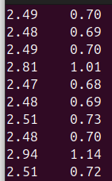
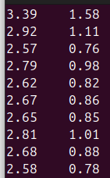

The first took 25.92J, the second 25.66, the third 27.68, with resolutions in the order mentioned above. Therefore, video streaming is quite energy efficient, since power consumed rose relatively little for an increase in resolution.

Question 13
Using North Korea on 090626 at 1230, with 308gCO2/kWh, and
Singapore on 080626 at 1515, with 494gCO2/kWh,
since matmul_slow.py and matmul_fast.py took 197.9J and 152.9J respectively,

In North Korea the carbon footprints would be 0.0169gCO2 and 0.013gCO2 respectively, while
in Singapore the carbon footprints would be 0.0272gCO2 and 0.0210gCO2 respectively. These are quite stark differences.

Savings at scale in any region from program optimisations are therefore probably incredibly significant, especially for AI inference use cases. Since the code necessarily consumes large amounts of energy, it should be run in places with more renewable energy like the UK as opposed to Singapore, at times when the share of renewables are highest like in the day when solar power is most abundant.

Question 14
Doing the math yields,
per day: 0.85GWh
per month: 25.5 Gwh
per year: 310.25 Gwh (roughly 30 000 households in developed countries)

From ChatGPT, training costs are:
Model | Estimated training energy
GPT-3 (2020) | ~1–5 GWh
GPT-4 (2023) | ~20–60 GWh
Frontier models around GPT-4.5/GPT-5 scale | ~50–500+ GWh (very uncertain)

From https://www.cevalogistics.com/en/glossary/gigawatt-hour, 1GWh powers 220 households for a year in a developed country, letting 1 Hy denote the power needed for 1 household a year,

From https://www.ema.gov.sg/resources/singapore-energy-statistics/chapter3
Singapore consumed 58TWh in 2024. Letting 58TWh=1 SGPy,

ChatGPT footprint for inference becomes:
per day: 187Hy
per month: 5610Hy
per year: 68255Hy
while for training it becomes:
GPT-3: 1100Hy
GPT-4: 13200 Hy
Frontier: 0.1SGPy

