Assignment 1
Question 1:

Output:
n=128 reps=2 checksum=107389.290000

real 0m0.229s
user 0m0.216s
sys 0m0.013s

Real seems to be the sum of user and sys times. Sys time is significantly shorter than user time.

Question 2:
n=128 reps=2 checksum=107389.290000
0.22
n=128 reps=2 checksum=107389.290000
0.22
n=128 reps=2 checksum=107389.290000
0.22
n=128 reps=2 checksum=107389.290000
0.23
n=128 reps=2 checksum=107389.290000
0.22

Time elapsed seems to be quite stable at 0.22.

I would report mean time, because it would contain information from all the runs, including both max and min times, which the two other metrics do not account for.

Question 3
Output:
n=128 reps=2 checksum=107389.290000

Performance counter stats for 'python3 matmul_slow.py':

796783128 cycles
2300307768 instructions # 2.89 insn per cycle

0.224159868 seconds time elapsed

0.215265000 seconds user
0.008047000 seconds sys

Question 4 <<<<<<<<<<<<<<<<<<<<<<<<<<<<<<<<<<<<<<<<<
n=128 reps=2 checksum=107389.290000
n=128 reps=2 checksum=107389.290000
n=128 reps=2 checksum=107389.290000
n=128 reps=2 checksum=107389.290000
n=128 reps=2 checksum=107389.290000

Performance counter stats for 'python3 matmul_slow.py' (5 runs):

802482569 cycles ( +- 0.77% )
2295997757 instructions # 2.86 insn per cycle ( +- 0.04% )
551516 cache-misses ( +- 3.43% )

0.22472 +- 0.00200 seconds time elapsed ( +- 0.89% )

There are 2.86 instructions per cycle, which implies that 2.86 program instructions are done per computer tick. This implies that each instruction takes very little time to execute, and therefore that the program is really efficient.

The ratio of cache misses to instructions is roughly 2-3%. This means that caching is done very efficiently, and therefore that the system does not need to access main memory too often to retrieve information. This is important in reducing the computational cost incurred linked to such processes.

Question 5
Output:
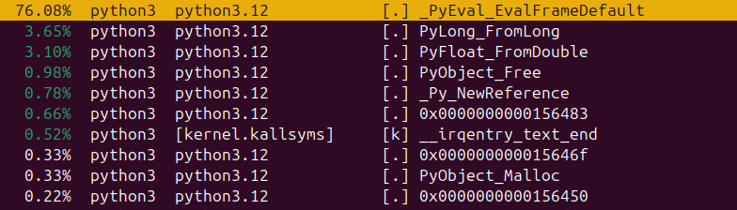

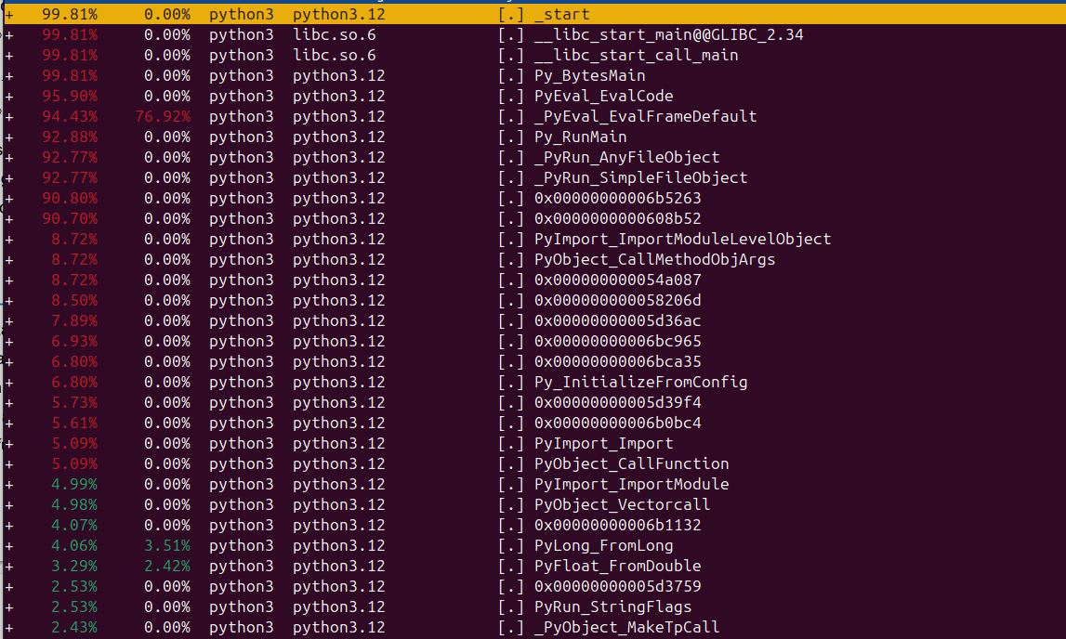
Of those which are not parent start frames, the function FromLong and FromDouble seem to be hogging the samples

Question 6
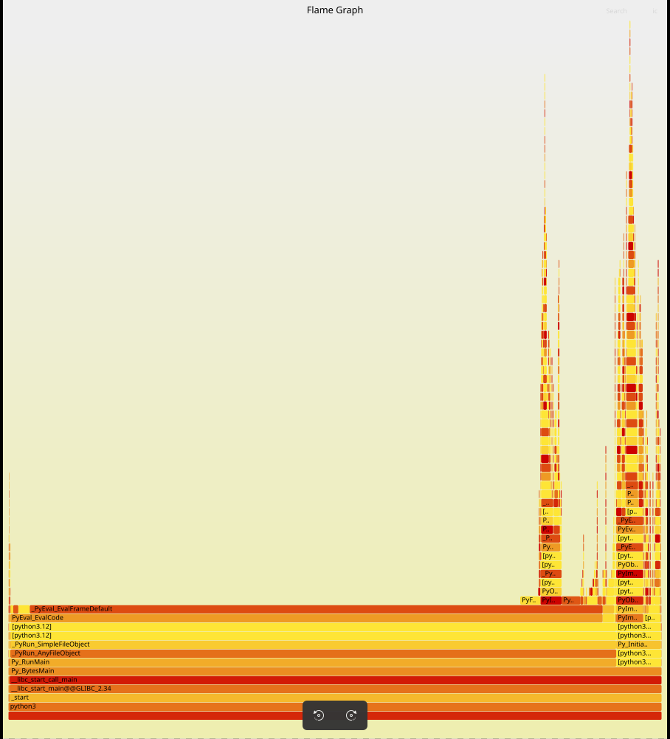
Of those which are not parent start frames, the function FromLong and FromDouble seem to be dominating the runtine. (This assumes that EvalFrameDefault is a parent start frame).

Therefore, likely bottlenecks probably relate to the time taken for individual datatype conversions.

Question 7
Output of performance commands used for Q5:
