PES1UG24CS180

#include <stdio.h>

int sum_array(int *p, int s) {
int sum = 0;
int *ptr = p;

for (int i = 0; i < s; i++) {
sum += *(ptr + i);
}

return sum;
}

int main() {
int p[] = {10,20,30,40,50};
int s = sizeof(p) / sizeof(p[0]);

printf("Sum of array elements: %d\n", sum_array(p, s));

return 0;
}

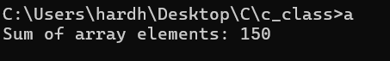

#include <stdio.h>

int compare_arrays(int *a1, int *a2, int size) {
for (int i = 0; i < size; i++) {
if (*(a1 + i) != *(a2 + i)) {
return 0;
}
}
return 1;
}

int main() {
int a1[] = {10,21,30,40,50};
int a2[] = {10,20,30,40,50};

int size = sizeof(a1) / sizeof(a1[0]);

int result = compare_arrays(a1, a2, size);

printf("Result: %d\n", result);

return 0;
}

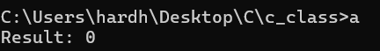

#include <stdio.h>

int main(){
int a;
printf("Enter the number");
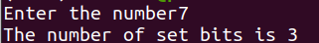
scanf("%d",&a);
int count = 0;
while(a>=1){
if (a%2!=0 || a==1){
count += 1;
}
a=a>>1;
}
printf("The number of set bits is %d\n",count);
return 0;
}

#include <stdio.h>

int main(){
int n;

printf("Enter size");
scanf("%d",&n);
int a[n] ;
for (int i = 0;i<n;i++){
printf("Enter number");
scanf("%d",&a[i]);
}
int largest;
int slargest;
largest = a[0];
slargest = a[0];
for (int i = 0;i<n;i++){
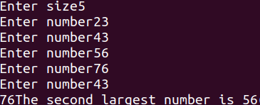
if (a[i]>largest){
largest = a[i];
}
}
printf("%d",largest);
for (int i = 0;i<n;i++){
if (a[i]>slargest && a[i]<largest){
slargest = a[i];
}
}
printf("The second largest number is %d",slargest);
return 0;
}

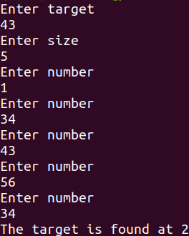
#include <stdio.h>

int main(){
int n;
int target;
printf("Enter target\n");
scanf("%d",&target);

printf("Enter size\n");
scanf("%d",&n);
int a[n] ;
for (int i = 0;i<n;i++){
printf("Enter number\n");
scanf("%d",&a[i]);
}
for (int i = 0;i<n;i++){
if (target == a[i]){
printf("The target is found at %d",i);
}
}
return 0;
}

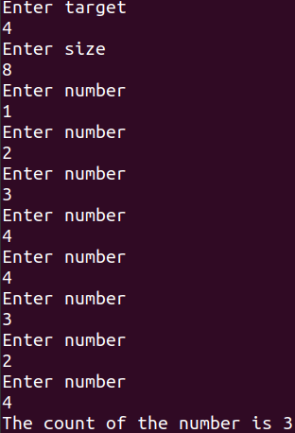
#include <stdio.h>
int counter(int a[],int target,int size){
int count = 0;
for (int i=0;i<size;i++){
if (a[i]==target){
count += 1;
}
}
return count;
}
int main(){
int target;
int n;
printf("Enter target\n");
scanf("%d",&target);

printf("Enter size\n");
scanf("%d",&n);
int a[n] ;
for (int i = 0;i<n;i++){
printf("Enter number\n");
scanf("%d",&a[i]);
}
printf("The count of the number is %d",counter(a,target,n));
return 0;
}

