Name: HARSH PATNAIK SRN:PES1UG24EC085

#include <stdio.h>

struct Point {
int x;
int y;
};

void printpoint(struct Point p) {
printf("(x,y) = (%d, %d)\n", p.x, p.y);
}

int main() {
struct Point p1 = {10, 20};
printpoint(p1);
return 0;
}

#include <stdio.h>

struct dob {
int day;
int month;
int year;
};

struct Student {
char name[50];
struct dob dob;
};

int main()
{
struct Student s;
printf("Enter name: ");
scanf("%s", s.name);
printf("date of birth: ");
scanf("%d %d %d", &s.dob.day, &s.dob.month, &s.dob.year);

printf("\nName: %s\n", s.name);
printf("D.O.B: %d/%d/%d\n", s.dob.day, s.dob.month, s.dob.year);
return 0;
}
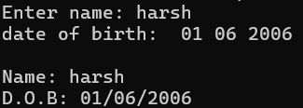

#include <stdio.h>

struct Complex {
float real;
float imag;
};

struct Complex addComplex(struct Complex c1, struct Complex c2) {
struct Complex result;
result.real = c1.real + c2.real;
result.imag = c1.imag + c2.imag;
return result;
}

int main() {
struct Complex a, b, sum;

printf("Enter first complex number (real and imaginary): ");
scanf("%f %f", &a.real, &a.imag);

printf("Enter second complex number (real and imaginary): ");
scanf("%f %f", &b.real, &b.imag);

sum = addComplex(a, b);

printf("Sum: %.2f + %.2fi\n", sum.real, sum.imag);
return 0;
}

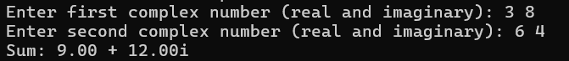

#include <stdio.h>
#include <math.h>

struct Point {
float x;
float y;
};

float distance(struct Point p1, struct Point p2) {
return sqrt(pow(p2.x - p1.x, 2) + pow(p2.y - p1.y, 2));
}

int main() {
struct Point pts[3];

printf("Enter coordinates for 3 points (x y):\n");
for (int i = 0; i < 3; i++) {
printf("Point %d: ", i + 1);
scanf("%f %f", &pts[i].x, &pts[i].y);
}

float d = distance(pts[0], pts[1]);
printf("Distance between first and second point: %.2f\n", d);

return 0;
}
