作者初次投稿：

/upload

input:

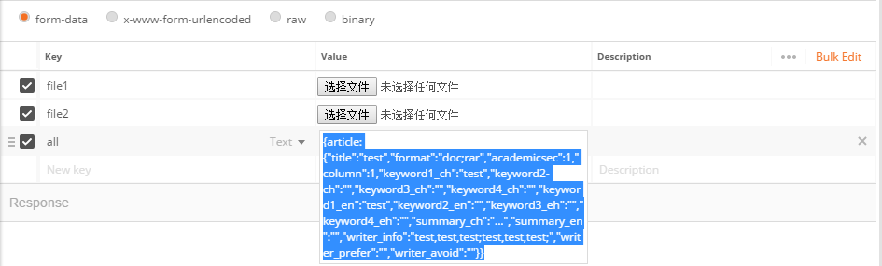

{article:{"title":"test","format":".doc;.rar","academicsec":1,"column":1,"keyword1_ch":"test","keyword2-ch":"","keyword3_ch":"","keyword4_ch":"","keyword1_en":"test","keyword2_en":"","keyword3_eh":"","keyword4_eh":"","summary_ch":"...","summary_en":"","writer_info":"test,test,test;test,test,test;","writer_prefer":"","writer_avoid":""}}

output:

{

"result": 1,

"data": ""

}

资源获取：

/task/resource

input:

{

"resource":

{

"func":"type_column"

}

}

output:

任务列表拉取：

/task

input:

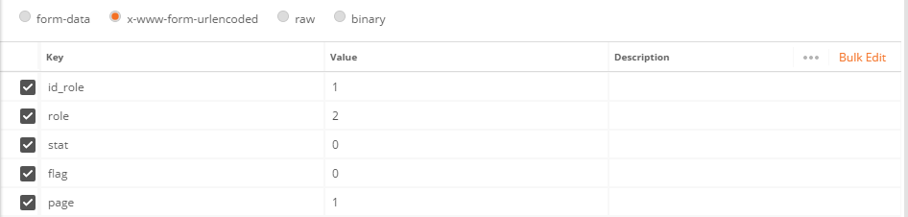

output:

{

"result": 1,

"data": {

"professor": [],

"total": 1,

"task": [

{

"id": 3,

"id_article": 4,

"id_role": 1,

"content": null,

"stat": 0,

"role": 2,

"flag": 0,

"date": "2018-04-24T06:40:29.000+0000"

},

{

"id": 4,

"id_article": 5,

"id_role": 1,

"content": null,

"stat": 0,

"role": 2,

"flag": 0,

"date": "2018-04-24T06:49:47.000+0000"

},

{

"id": 5,

"id_article": 6,

"id_role": 1,

"content": null,

"stat": 0,

"role": 2,

"flag": 0,

"date": "2018-04-24T12:05:29.000+0000"

}

],

"invoice": [],

"article": [

{

"id": 4,

"title": "test",

"format": "doc;rar",

"academicsec": 1,

"column": 1,

"keyword1_ch": "test",

"keyword2_ch": "",

"keyword3_ch": "",

"keyword4_ch": "",

"keyword1_en": "test",

"keyword2_en": "",

"keyword3_en": "",

"keyword4_en": "",

"summary_ch": "...",

"summary_en": "",

"writer_id": 1,

"writers_info": "",

"writer_prefer": "",

"writer_avoid": "",

"date_pub": null

},

{

"id": 5,

"title": "1",

"format": "docx;rar",

"academicsec": 1,

"column": 1,

"keyword1_ch": "哈",

"keyword2_ch": "",

"keyword3_ch": "",

"keyword4_ch": "",

"keyword1_en": "E",

"keyword2_en": "",

"keyword3_en": "",

"keyword4_en": "",

"summary_ch": "111",

"summary_en": "",

"writer_id": 1,

"writers_info": "1,;1,;1@qq.com",

"writer_prefer": ";;",

"writer_avoid": ";;",

"date_pub": null

},

{

"id": 6,

"title": "test",

"format": "doc;rar",

"academicsec": 1,

"column": 1,

"keyword1_ch": "test",

"keyword2_ch": "",

"keyword3_ch": "",

"keyword4_ch": "",

"keyword1_en": "test",

"keyword2_en": "",

"keyword3_en": "",

"keyword4_en": "",

"summary_ch": "...",

"summary_en": "",

"writer_id": 1,

"writers_info": "",

"writer_prefer": "",

"writer_avoid": "",

"date_pub": null

}

]

}

}

主编分配稿件：

/task/allocate

input：

{

"task":

{

"id": 3,

"id_article": 4,

"id_role": 1,

"content": null,

"stat": 0,

"role": 2,

"flag": 0

},

"id_role":[1]

}

output：

{

"result": 1,

"data": ""

}

编辑初审：

/task/judge

input:

{

"task":

{

"id": 6,

"id_article": 4,

"id_role": 1,

"content": null,

"stat": 0,

"role": 3,

"flag": 0

}

}

output:

{

"result": 1,

"data": null

}

编辑审稿费管理：

/task/manage

input:

{

"task":

{

"id": 7,

"id_article": 4,

"id_role": 1,

"content": null,

"stat": 4,

"role": 3,

"flag": 0

},

"invoice":

{

"id_article":4,

"flag":null,

"receipt_title":null,

"receipt_num":null,

"address":null,

"receiver":null,

"type":1,

"expense":60

}

}

output:

{

"result": 1,

"data": ""

}

作者审稿费缴费信息填写及确认：

/task/fill

input:  
{

"task":

{

"id": 8,

"id_article": 4,

"id_role": 1,

"content": null,

"stat": 6,

"role": 1,

"flag": 0

},

"invoice":

{

"id": 15,

"id_article": 4,

"flag": 0,

"receipt_title": "测试",

"receipt_num": 1234567890,

"address": "测试",

"receiver": "测试",

"type": 1,

"expense": 60

}

}

output:

{

"result": 1,

"data": ""

}

编辑审稿费审核：

/task/check

input:

{

"task":

{

"id": 8,

"id_article": 4,

"id_role": 1,

"content": null,

"stat": 6,

"role": 3,

"flag": 0

}

}

output:

{

"result": 1,

"data": ""

}

编辑稿件分配：

/task/judge

input:

{

"task":

{

"id": 9,

"id_article": 4,

"id_role": 1,

"content": null,

"stat": 1,

"role": 3,

"flag": 0

},

"id_role":[1,2,3]

}

output:

{

"result": 1,

"data": null

}

审稿人审核：

/task/judge

input:  
{

"task":

{

"id": 11,

"id_article": 4,

"id_role": 1,

"content": "测试",

"stat": 2,

"role": 4,

"flag": 0

}

}

output:

{

"result": 1,

"data": ""

}

编辑意见汇总分析：

/task/analyze

input:

{

"task":

{

"id": 23,

"id_article": 4,

"id_role": 1,

"content": "修改",

"stat": 3,

"role": 3,

"flag": 0

}

}

output:

{

"result": 1,

"data": ""

}

作者重新上传：

/upload

input:



{"task": {"id": 29,"id_article": 4,"id_role": 1,"content": "修改","stat": 3,"role": 1,"flag": 0}}

output:

{

"result": 1,

"data": ""

}

编辑重审：

/task/judge

input:

{

"task":

{

"id": 30,

"id_article": 4,

"id_role": 1,

"content": null,

"stat": 7,

"role": 3,

"flag": 0

},

"id_role":[1,2,3]

}

output:

{

"result": 1,

"data": null

}

审稿人重新审核：

/task/judge

input:  
{

"task":

{

"id": 31,

"id_article": 4,

"id_role": 1,

"content": "测试",

"stat": 7,

"role": 4,

"flag": 0

}

}

output:

{

"result": 1,

"data": null

}

编辑重审意见汇总分析：

/task/analyze

input:

{

"task":

{

"id": 35,

"id_article": 4,

"id_role": 1,

"content": "通过",

"stat": 5,

"role": 3,

"flag": 0

}

}

output:

{

"result": 1,

"data": ""

}

编辑格式修改：

/task/design

input:



{task:{"id": 62,"id_article": 8,"id_role": 1,"content": "通过","stat": 5,"role": 3,"flag": 0}}

output:

{

"result": 1,

"data": ""

}

作者修改确认：

/notice

input:

{

"task":

{

"id": 36,

"id_article": 4,

"id_role": 1,

"content": "通过",

"stat": 5,

"role": 1,

"flag": 0

}

}

output:

{

"result": 1,

"data": ""

}

编辑版面费管理：

/task/manage

input:

{

"task":

{

"id": 38,

"id_article": 4,

"id_role": 1,

"content": "通过",

"stat": 4,

"role": 3,

"flag": 0

},

"invoice":

{

"id_article":4,

"flag":null,

"receipt_title":null,

"receipt_num":null,

"address":null,

"receiver":null,

"type":2,

"expense":120

}

}

output:

{

"result": 1,

"data": ""

}

作者版面费缴费信息填写及确认：

/task/fill

input:

{

"task":

{

"id": 39,

"id_article": 4,

"id_role": 1,

"content": "通过",

"stat": 6,

"role": 1,

"flag": 0

},

"invoice":

{

"id": 16,

"id_article": 4,

"flag": 1,

"receipt_title": "测试2",

"receipt_num": 987654321,

"address": "测试2",

"receiver": "测试2",

"type": 2,

"expense": 120

}

}

output:

{

"result": 1,

"data": ""

}

编辑版面费审核：

/task/check

input:

{

"task":

{

"id": 39,

"id_article": 4,

"id_role": 1,

"content": "通过",

"stat": 6,

"role": 3,

"flag": 0

}

}

output:

{

"result": 1,

"data": ""

}

主编排版排期：

/task/schedule

input:

{

"task":

{

"id": 40,

"id_article": 4,

"id_role": 1,

"content": "通过",

"stat": 6,

"role": 2,

"flag": 0

}

}

output:

{

"result": 1,

"data": ""

}