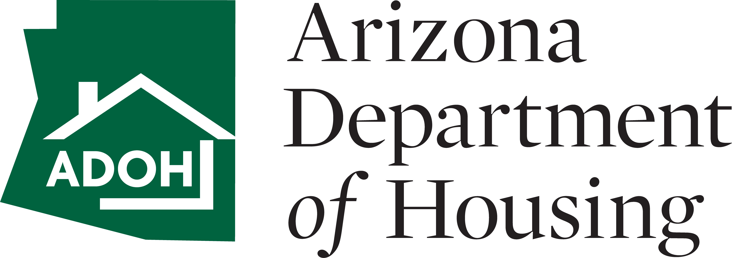Arizona Department of Housing - Weatherization Assistance Program

**PRINT FORM**

# QUALITY CONTROL INSPECTION (QCI) CHECKLIST

Client Name: Date:

Subgrantee: ADOH WAP Database #:

Choose One

Address:

AZ

City:

State:

Zip:

Contact Phone #:

Client File Checklist: Check which of the following items are included in the client file

**Part 1: Client File**

|  |  |  |  |
| --- | --- | --- | --- |
| A1. | Client file checklist | A11. | H&S Evaluation Forms (client & auditor) |
| A2. | Eligibility determination and client information | A12. | Hazard Disclosure Form (Lead; Mold; Radon) |
| A3. | Proof of ownership or signed rental agreement | A13. | Residential Diagnostic Evaluation Form (Audits) |
| A4. | No previous weatherization checklist | A14. | Scope of work (signed off by client) |
| A5. | Certification of Zero Income Form (if applicable) | A15. | Before and After Photos of Appliances/HVAC |
| A6. | Progress Form | A16. | Vendor Bids, Invoices & Change Order(s) (if applicable) |
| A7. | Client Rights and Responsibilities | A17. | Invoices/PO for materials installed |
| A8. | Household Action Plan | A18. | ASHRAE Ventilation Calculator |
| A9. | Priority checklist or copy of REM/H&S Waiver | A19. | Manual J; D; S |
| A10. | Notice to proceed | A20. | Utility Release Form |

## Comments on A1-A20 (for any unchecked items above, explain here):

Client File Review

* 1. Does the initial audit justify the scope of work? Yes No
  2. Do the invoices match up to the scope of work? Yes No
  3. Are there pre and post photos of all replaced appliances (if applicable)? Yes  No N/A
  4. Is there pre and post documentation of the serial and model #'s of appliances? Yes  No
  5. Is the insulation certificate present in the client file (if applicable)? Yes  No N/A

1.6A. Are there any client complaints on file?  Yes  No

1.6B. If yes, were the complaints handled? Note in comment section.

 Yes No N/A

* 1. Is the combustion safety diagnostic testing results within WAP guidelines?  Yes  No
  2. Do DOE expenses/measures match the input on the Work Performed page of the State's database?  Yes  No
  3. Are there any instances where work completed does not match DOE funding requirements? (Note in comment section)

Yes No

* 1. Does homeowner meet income eligibility requirements?  Yes No

## Comments on #1.1-#1.10:

**Part 2: In-Progress Inspections**:

Was in-progress inspection completed? (not required) **NOTE:** In-progress questions are hidden until 'Yes' is checked.  Yes  No

Final Site Inspection

**Part 3: In Field - Visual/Sensory Inspections**

* 1. Perform exterior and interior walk around of home: Does the home appear to qualify for weatherization per WAP standards?

Yes No

* 1. Were any concerns found during the walk around? (If so, detail in comments section)  Yes  No
  2. Were there any discrepancies seen during visit, compared to the client file?  Yes  No
  3. Verify installed measures: A. Were measures done to field guide standards?  Yes  No

3.4B. Were the measures allowable through weatherization?  Yes  No

* 1. Were there any missed opportunities and/or audit discrepancies?

 Yes  No

* 1. Was there any damage done by contractors/workers? Yes  No
  2. Was any non-conformance or exceptional work documented with camera?  Yes  No  N/A
  3. Generate a punch list off of failed measures and concerns in note section.

## Comments on #3.1-#3.8:



In Field (Post-Work Diagnostic Inspections): Conduct Health and Safety Tests

3.9. Perform combustion tests (heating systems, domestic water heater, ovens, stoves, fireplaces, etc.): N/A

**Indoor Ambiant Air:**

Furnace or Space Heater Room: Water Heater Room:

In Kitchen (after 5 minutes):

Near Supply Air Registers: Other:

Reported:

QCI Testing:

PPM

PPM PPM PPM PPM

PPM

PPM PPM PPM PPM

**Undiluted Flue:**

Furnace or Space Heater Room: Water Heater:

Oven Vent:

Other:

Reported:

QCI Testing:

PPM

PPM PPM PPM

PPM

PPM PPM PPM

* 1. Conduct visual moisture evaluations (Note concerns, if any):
  2. Conduct visual electrical safety tests (Note concerns, if any):

## Additional Comments on #3.9-#3.11:

In Field: Conduct Diagnostic Tests

* 1. Perform blower door tests:

Flow Ring House Pressure Fan Pressure Flow (CFM50)

Final Reported Whole House

QCI Whole House

Pa Pa

Pa Pa

* 1. Perform pressure pan test:

Register Location:

1.

2.

Reported Pressure:

QCI

Pressure:

6.

7.

Register Location:

Reported Pressure:

QCI

Pressure:

11.

12

Register Location:

Reported Pressure:

QCI

Pressure:

3. 8. 13

4. 9. 14

5. 10. 15.

Notes:

* 1. Conduct zonal pressure tests:

Supply: Choose One

Reported: QCI Testing:

Pa Pa

* 1. Perform fan flow tests:

Return: Choose One

Pa Pa

Reported CFM

Reported Pascals

Reported Opening Used:

QCI CFM QCI Pascals

QCI-Opening Used:

Location:

CFM Pa

CFM Pa

Location:

CFM Pa

CFM Pa

Location:

CFM Pa

CFM Pa

Notes:

* 1. Conduct CAZ Testing

Appliance:

Reported CAZ

QCI CAZ

Appliance:

Appliance:

* 1. Domestic water heater temperature Degrees

3.18. Room Pressure

Reported Room Pressure

QCI Room Pressure

Room:

Pa

Pa

Room:

Pa

Pa

Room:

Pa

Pa

Room:

Pa

Pa

Room:

Pa

Pa

## Comments on #3.12-#3.18:

In Field: Identify Work Problems

* 1. Review the results of all tests. Compare results against pre-test data. Were any discrepancies found?  Yes  No
  2. Do the results meet WAP field guide standards?  Yes  No
  3. Were there any missed opportunities identified after diagnostic testing?

 Yes  No

* 1. Were any deficiencies found during diagnostic testing that would require corrective actions?  Yes  No
  2. Generate a punch list in comment section of diagnostic results from above that did not meet WAP standards.

## Comments on #3.19-#3.23:

**Client Questionnaire**

*(Questions to ask the client concerning work performed)*

**Part 4: Client Satisfaction**

* 1. Client's overall satisfaction of work performed:
  2. Were the workers courteous and friendly?
  3. Did all workers clean up after themselves each day?
  4. Did you hear any of the workers using foul language on the job?
  5. Did the workers move any personal belongings, without permission?
  6. Did the crew leader call you in advance to inform you of the day and time that they would arrive on the job?
  7. If the workers did not show up on a scheduled day, did someone call you in advance to let you know?
  8. Did the workers ever block your driveway with their vehicle or park in your driveway, without permission?
  9. Would you call this contractor back to do other work that is not connected in any way to the Weatherization Assistance Program?
  10. Since the work has been completed, have you noticed a change in the comfort level of your home?

## Comments on #4.1-4.10

**Part 5: Verify Separation of Work & Required Signatures**

* The initial audit and QCI can be performed by the same entity, all other jobs performed must be completed by different individuals.

Initial Inspector:

* 1. Name of Initial Auditor:
  2. Company of Initial Auditor:
  3. Date of Initial Audit:

Crew Foreman:

* 1. Name of Crew Foreman
  2. Company of Crew Forman

Final Inspector:

* 1. Name of Final Inspector
  2. Company of Final Inspector
  3. Date of Final Inspection

QCI Inspector:

* 1. Name of QCI Inspector
  2. BPI QCI Certification Number of QCI Inspector
  3. Company of QCI Inspector
  4. Date of Final QCI Inspection
  5. Signature of QCI Inspector

**Any Further Comments:**

# Part 6: Results

PASS FAIL

Notes: If QCI failed list reason(s) why. What are the next steps?

**PRINT FORM**

**FORM INSTRUCTIONS**:

1. This form is mandatory and must be present every completed client file that that had DOE funding used on the project.
2. There are objects that are not visible until certain other items are checked and visibility is necessary.

*Please be sure to fill out each section in it's entirety to ensure that all necessary items appear and are completed.*

1. List both recorded final numbers and new QCI numbers for comparison.
2. Be sure that all dates are entered as well as who performed each process.