Chapter 5: UI/UX Design

Introduction
The design of a user-facing system is as critical as its underlying technical architecture. In the context of SCAN-GO — a smart, autonomous self-checkout system embedded within a supermarket trolley — the graphical interface serves as the primary point of interaction between the shopper and the entire ecosystem of hardware and software that powers the solution. Unlike conventional retail applications designed for use in a static, controlled environment, the SCAN-GO interface must operate under uniquely demanding conditions: it is mounted on a moving cart, operated by users with varying levels of technological familiarity, used in brightly lit public spaces, and must complete entire transactional journeys — from authentication to payment to exit — with maximum speed and minimum friction.
This chapter presents a comprehensive account of the User Interface (UI) and User Experience (UX) design decisions that shape the SCAN-GO system. It begins with a foundational discussion of what UI and UX mean within this context, before examining the specific visual design language, layout strategies, interaction patterns, and user flows that were implemented. The chapter further explores the Information Architecture (IA) underpinning the application, the rationale behind key design choices related to privacy and accessibility, and a detailed screen-by-screen breakdown of the interface as it guides a shopper from initial authentication through to a seamless, queue-free store exit.

UI/UX Design
User Interface and User Experience design, while closely related, represent two distinct yet deeply intertwined disciplines. Together, they determine not only how a system looks, but how it feels and functions from the perspective of the end user. In product development, and particularly in systems designed for public-facing retail environments, a thoughtful integration of both UI and UX is essential to achieving adoption, efficiency, and trust.

UI/UX design is the multidisciplinary practice of planning, prototyping, and refining the visual layout and interactive behaviour of a digital product. It draws upon cognitive psychology, visual design theory, human factors engineering, and iterative user research to produce interfaces that are intuitive, efficient, and satisfying to use. For SCAN-GO, the UI/UX design process was guided by a core set of principles: clarity over complexity, speed of interaction, accessibility in a dynamic public environment, and unwavering attention to user privacy.
The SCAN-GO interface was designed using Figma, a professional, cloud-based design and prototyping tool widely adopted in the industry. Figma allowed for the creation of high-fidelity mockups and interactive prototypes that simulate the real-world behaviour of the application. It also enabled the team to define a cohesive design system — covering colour, typography, spacing, and component styles — that ensures visual consistency across every screen of the application.

User Interface (UI)
The User Interface is the visual and interactive layer through which the user communicates with the system. It encompasses every element the user can see and touch: buttons, text labels, icons, images, colour schemes, typographic choices, and the spatial arrangement of all these components on screen. A well-designed UI reduces the mental burden placed on the user by making the path to each action immediately obvious and visually rewarding.
For SCAN-GO, the UI is rendered on a landscape-oriented tablet screen physically mounted on the shopping cart. This hardware context has a profound influence on every design decision made.
Colour Palette: The primary brand colour chosen for SCAN-GO is a vibrant, saturated emerald green (approximately #3DAA7E to #4CAF88). This colour carries strong cultural associations with action, confirmation, commerce, and trust — all of which are entirely appropriate for a checkout application. It is used consistently across interactive elements such as primary action buttons, progress indicators, success states, and highlighted product information. The background palette transitions between a pure white (#FFFFFF) for information-dense areas such as the cart panel and payment screens, and a rich dark charcoal (#0D1B2A to #1A2332) for the camera viewfinder panel. This

high-contrast dark background maximises the visibility of the glowing green scanning frame and camera UI elements, even under the bright fluorescent lighting typical of supermarket environments. Text is rendered in near-black (#1A1A2E, #2D2D2D) for body content and bold dark grey for secondary labels, ensuring WCAG-compliant readability at all times.
Typography: The entire interface uses a clean, geometric sans-serif typeface that prioritises legibility at a glance. Display headings — such as the "Welcome to SCAN-GO" onboarding title and the "Payment Successful!" confirmation header — are set at large sizes (36–40pt equivalents) with bold weight to command immediate attention. Product names, prices, and cart line items use a moderately large medium-weight style (18–22pt equivalents) to remain readable from a natural standing distance. Supporting labels, metadata, and secondary information are rendered at smaller sizes but always with sufficient contrast to avoid eye strain. Critically, no body text is set below the functional readability threshold, as the interface must be usable by shoppers of all ages, including elderly users who may have reduced visual acuity.
Touch Targets and Fitts's Law: The tablet is operated by touch while the user is standing beside or pushing a moving cart, which introduces a degree of physical instability not present when using a stationary device. To accommodate this, all interactive elements in the SCAN-GO interface are generously sized, adhering to Fitts's Law — the ergonomic principle that the time required to move to a target is a function of the target's size and distance. Primary action buttons, such as 'Tap to Scan Product', 'Add to Cart', 'Checkout', and 'Confirm Payment', span nearly the full width of the screen and carry a minimum height of approximately 56–64dp. This large target area makes them easy to tap accurately even when in motion, with gloved hands, or when distracted by the surrounding shopping environment. Interactive elements are also spaced well apart to prevent accidental taps on adjacent controls.
Icon Design: Icons are used sparingly and purposefully throughout the interface. A shopping cart icon, a camera icon, a trash/delete icon, and a WiFi/NFC icon each carry self-evident meaning that reinforces the adjacent text label without requiring the user to memorise symbol meanings. This icon-plus-label pattern is a UX best practice that improves learnability for first-time users while maintaining speed for repeat shoppers.

User Experience (UX)

User Experience design is concerned with the holistic journey a person undertakes when engaging with a product or system. Where UI design asks 'How does this look?', UX design asks 'How does this feel, and how effectively does it serve the user's real-world goal?' A positive UX is not merely the absence of frustration; it is the presence of clarity, efficiency, and — where appropriate — even delight.
The central UX challenge of SCAN-GO is that it must compress what is traditionally a multi-step, multi-location supermarket checkout process — selecting a lane, unloading items, interacting with a cashier or self-checkout terminal, bagging goods, and processing payment — into a single, continuous, in-cart experience that requires no behavioural change in how the shopper physically picks up and places items. The goal is radical convenience: the cart itself becomes the checkout, and the exit gate becomes the final confirmation.
Cognitive Load Reduction: The SCAN-GO interface is deliberately minimalist in its information density at any given moment. Rather than presenting the user with all possible actions or data simultaneously, it surfaces only the content and controls relevant to the current step in the shopping journey. The onboarding screen shows only a face scan prompt. The main dashboard shows only the camera and the cart. The payment screen focuses the user on selecting a single method. This progressive disclosure of information prevents cognitive overload and allows the user to navigate the system through sequential, low-effort decisions rather than complex multi-choice reasoning.
Frictionless Flow: Every screen transition in SCAN-GO is designed to feel inevitable and natural. Authentication leads directly to the shopping dashboard without intermediary steps. A successful product scan surfaces a contextual overlay rather than redirecting to a new page, preserving the user's spatial context. Adding an item closes the overlay and updates the cart in real time.
Payment confirmation leads directly to the exit QR code without requiring any further user action. This 'always forward' flow philosophy eliminates dead ends, back navigation requirements, and decision paralysis.
Privacy-Centred Design: A critical UX decision in SCAN-GO is the intentional elimination of PIN pad entry on the public tablet. In a traditional self-checkout environment, users must type their card PIN on a shared, visible keypad — exposing themselves to 'shoulder surfing', where nearby individuals observe and record PIN entry. SCAN-GO eliminates this vulnerability entirely. For NFC payments, the user simply taps their card or device against the back of the

screen — a gesture that reveals no secret information. For e-wallet payments, a dynamic QR code is generated on the tablet screen, which the user then scans with their personal smartphone. All sensitive authentication and PIN entry takes place on the user's own, private device — completely shielded from public view. This design choice is not merely a feature; it is a foundational UX principle that places user security and dignity at the centre of the checkout experience.

Difference Between UI and UX
Although the terms UI and UX are frequently used interchangeably in everyday discourse, they describe fundamentally different aspects of product design.
Understanding their distinction is important in evaluating the design rigour of any digital system, including SCAN-GO.
User Interface (UI) design is primarily concerned with the visual and interactive presentation of a system. It is, in essence, the craft of deciding what a screen looks like: the colours, the fonts, the button shapes, the spacing, the iconography, and the overall aesthetic sensibility. In the context of SCAN-GO, the UI encompasses choices such as the emerald-green primary button colour, the dark-charcoal camera panel background, the large white bold typeface used for product names, the rounded corners on card and modal components, and the placement of the cart list on the right pane of the main dashboard.
These are deliberate visual decisions that contribute to brand recognition, emotional tone, and ease of visual parsing.
User Experience (UX) design, by contrast, operates at a higher level of abstraction. It is concerned with the quality of the end-to-end journey a user undertakes — including moments that precede and follow the direct interaction with the interface itself. UX encompasses questions such as: Does the biometric login feel secure and instantaneous? Is the transition from scanning a product to reviewing the cart summary cognitively smooth? Does the user feel confident that their payment information is private? Does the exit pass QR code feel like a satisfying conclusion to the shopping journey, or does it feel like an additional bureaucratic step? In SCAN-GO, UX-level thinking produced decisions such as the privacy-preserving QR payment modal, the
real-time weight validation step that silently confirms item authenticity, and the 29-second countdown timer on the exit pass screen that gently signals the system will reset for the next user.

The simplest way to contextualise the distinction is this: the UI is what the user sees; the UX is what the user feels. In SCAN-GO, both have been treated with equal seriousness, with the recognition that an interface that is visually attractive but confusing to navigate, or one that is logically structured but visually stressful, will fail to meet the product's core objective of making supermarket shopping faster, safer, and more pleasant.

Target Audience
SCAN-GO is designed to serve two primary stakeholder groups, each with distinct goals, contexts, and technical expectations.
Supermarket Shoppers (End Users): The primary target audience for the SCAN-GO tablet interface is the general supermarket-going public. This is a highly heterogeneous group spanning all age brackets, from digitally native young adults to elderly shoppers who may have limited experience with touchscreen technology. It includes individuals of varying literacy levels, those with visual or motor impairments, and users operating under time pressure or with children in tow. The UI/UX design accounts for this diversity through large text sizes, high colour contrast, simple sequential navigation, and physical affordances such as oversized touch targets. The interface explicitly avoids jargon, minimises required reading, and provides immediate visual and textual feedback for every action. The face-scan onboarding further removes the cognitive overhead of remembering passwords or loyalty card numbers, creating a barrier-free entry point accessible to essentially all shoppers.
Supermarket Retailers (Institutional Clients): The second audience for SCAN-GO consists of supermarket operators, procurement managers, and IT administrators who adopt the system at an institutional level. While these stakeholders do not directly interact with the cart-mounted tablet in the same way as shoppers, they are the decision-makers who evaluate the system against criteria such as operational efficiency gains, fraud prevention capabilities, integration with existing point-of-sale infrastructure, and compliance with financial data security standards. The design of SCAN-GO addresses their concerns through the load cell weight verification mechanism (which provides a technical deterrent to product theft), the dynamic exit pass QR system (which integrates with smart gate hardware to close the physical checkout loop), and the privacy-preserving payment flow (which reduces the retailer's liability for card security incidents at the point of sale).

User Flow Description
The SCAN-GO user flow is a carefully sequenced series of interactions that guides the shopper from the moment they approach the cart to the moment they exit the store. Each step in the flow has been designed to be self-explanatory, reversible where appropriate, and resilient to common user errors. The complete flow is illustrated in the User Flow Diagram below.

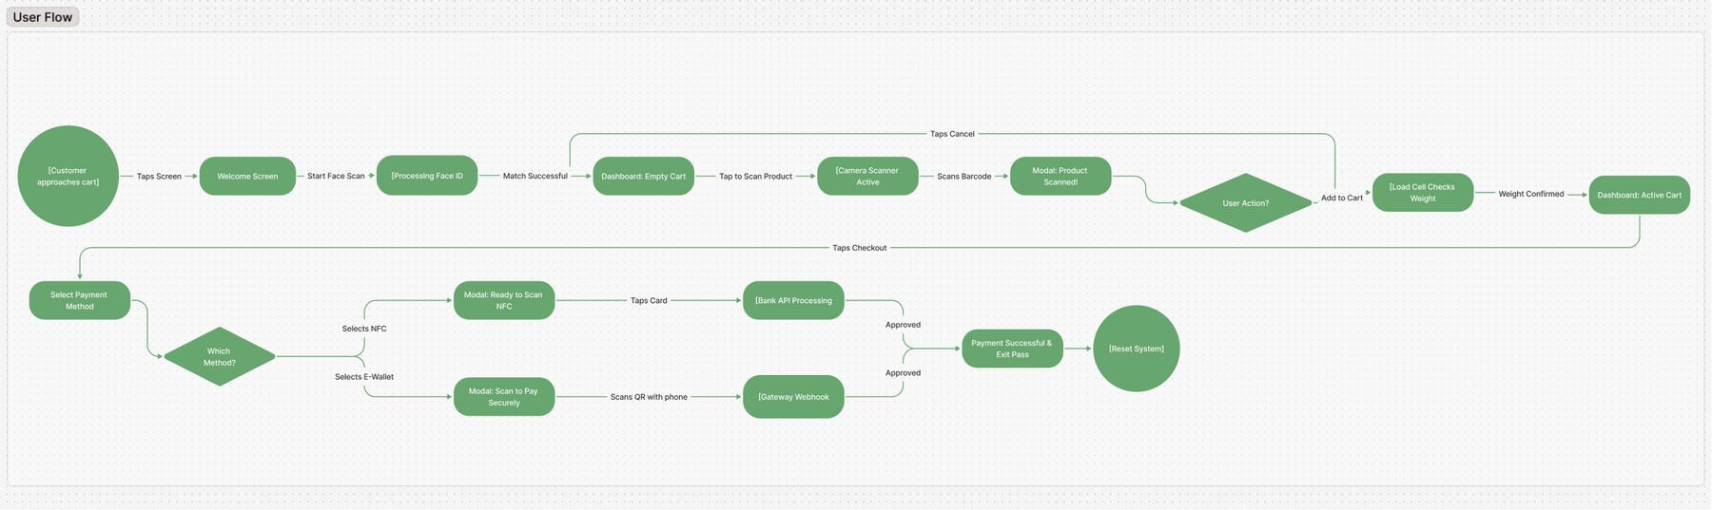
Figure 5.1 – SCAN-GO User Flow Diagram

The flow proceeds through the following stages:
Stage 1 — Approach and Activation: The shopping journey begins when the customer physically approaches the SCAN-GO-equipped cart. The tablet screen displays the splash/onboarding screen featuring the SCAN-GO branding, the tagline "Smart Shopping Made Easy", and a clear call-to-action button: "Tap to Start Shopping". This initial screen serves as both a brand introduction and an idle-state indicator that the system is ready for a new session.
Stage 2 — Biometric Authentication: Upon tapping the activation button, the system transitions to the Biometric Login screen. The screen presents a face-scanning graphic and a "Start Face Scan" button. The user looks directly at the tablet camera. The system processes the facial scan in real time — indicated by a scanning animation with a horizontal sweep line across the face graphic and the button text changing to "Scanning...". Upon a successful match against the registered account, the system automatically proceeds to the Main Dashboard without any further input required from the user.

Stage 3 — Main Shopping Dashboard (Empty Cart): The Main Dashboard is a split-screen layout. The left pane displays the live camera viewfinder framed by a glowing green scanning rectangle. The right pane displays the active digital cart, which initially shows an empty state with the message "Your cart is empty
- Scan products to add them". A running total of $0.00 is displayed, along with a greyed-out (inactive) "Checkout" button. The "Tap to Scan Product" button is prominently displayed at the base of the left pane.
Stage 4 — Product Scanning: When the user taps "Tap to Scan Product", the camera activates and begins actively reading barcodes. The user holds the product barcode in front of the camera. Upon a successful barcode read, a "Product Scanned!" overlay modal appears at the bottom of the screen, presenting: the product image, the product name, the price, the production date, and the expiry date. The user is then presented with two choices: "Cancel" (dismiss the modal and continue scanning) or "Add to Cart" (proceed to add the item).
Stage 5 — Weight Verification (Hardware Integration): When the user physically places the scanned item into the cart after tapping "Add to Cart", the load cell (weight sensor) embedded in the cart base registers the new weight. The system cross-references this measured weight against the expected weight stored in the product database for the scanned barcode. If the weights match within an acceptable tolerance, the item is confirmed and added to the digital cart, and the cart count and total update in real time. If there is a discrepancy
- for example, if a different or additional item was placed in the cart — the system flags an alert. This step is entirely invisible to honest shoppers but serves as a powerful anti-theft mechanism.
Stage 6 — Continued Shopping and Cart Management: The user can repeat the scanning process for each item in their physical basket. The right pane of the dashboard updates in real time to reflect every added item, showing the item name, unit price, and a quantity adjustment control with plus and minus buttons. The running subtotal updates with each addition. Items can be removed by pressing the red trash icon adjacent to each cart line. This stage loops until the user is satisfied with their selection.
Stage 7 — Checkout Initiation: When the user has finished shopping, they tap the "Checkout" button, which becomes active once at least one item is in the cart. The interface transitions to the Checkout Screen.

Stage 8 — Payment Method Selection: The Checkout Screen presents a full Order Summary on the right pane (itemised list, subtotal, tax at 15%, and grand total) alongside a left pane listing the available payment methods: (a) Tap to Pay via NFC — highlighted as the recommended option; (b) E-Wallet / Mobile Pay, supporting InstaPay, Vodafone Cash, and Orange Cash; (c) a saved Visa card ending in 4242; and (d) an option to add a new card. The user selects their preferred method.
Stage 9a — NFC Payment: If the user selects "Tap to Pay (NFC)", a modal appears instructing them to tap their card or device against the back of the tablet screen. A pulsing NFC icon provides visual feedback as the system waits for the card tap. The payment is processed via the bank API. No PIN is entered on the public screen.
Stage 9b — E-Wallet / QR Payment: If the user selects "E-Wallet / Mobile Pay", a secure QR code modal is generated. The total amount due is displayed clearly. A countdown timer (e.g., 4:59) shows the QR code expiry. The user scans this QR code with their personal smartphone and completes authorisation within their own banking or e-wallet application. The SCAN-GO system awaits a webhook callback from the payment gateway confirming approval. No sensitive data is entered on the shared tablet at any point.
Stage 10 — Payment Successful and Exit Pass: Upon payment approval, the interface transitions to the Payment Successful screen. A large green checkmark animation confirms the transaction. A digital receipt shows the amount paid, transaction ID, and timestamp. A personalised note informs the user of the time saved (e.g., "You saved 5 minutes with SCAN-GO today!"). On the right side of the screen, a dynamically generated Exit Pass QR code is displayed, uniquely tied to this transaction. A 29-second countdown timer indicates how long the code will remain active. The user scans this QR code at the store's smart exit gate, which is powered by a Raspberry Pi, triggering the physical barrier to open and grant exit. The system then automatically resets for the next user.

Information Architecture
Information Architecture (IA) refers to the structural organisation of a digital system's content and functionality — the blueprint that determines what information exists, where it lives, how it is grouped, and in what sequence it

becomes accessible to the user. A well-conceived IA is the invisible foundation that makes a complex system feel simple, because it ensures that users always know where they are, what they can do from their current position, and how to reach what they need.
In the case of SCAN-GO, the IA is intentionally linear rather than hierarchical. Unlike multi-page web applications or feature-rich mobile apps where users might navigate freely between sections, SCAN-GO is a purpose-built transaction system with a defined start point, a defined end point, and a highly predictable sequence of interactions between them. The IA reflects this by organising the system into four primary screen zones, each with a clearly delineated set of content and functional components. The structural layout is illustrated in the Information Architecture Diagram below.

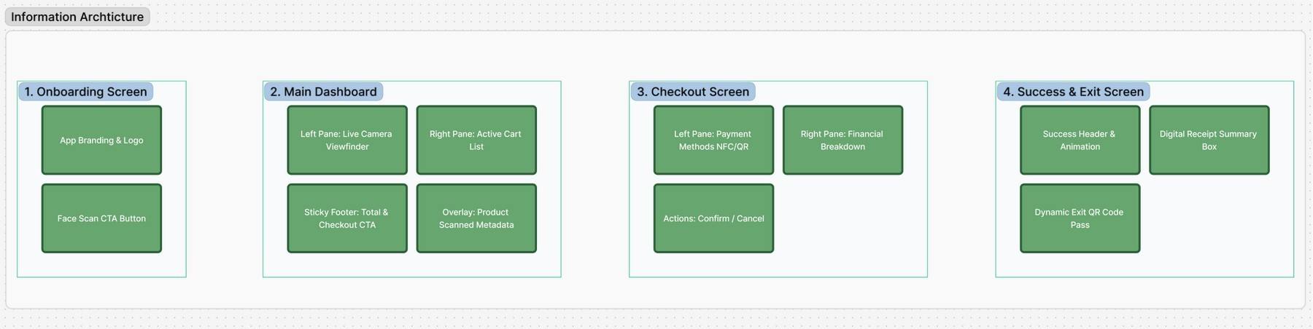
Figure 5.2 – SCAN-GO Information Architecture Diagram

Zone 1 — Onboarding Screen: This zone encompasses the splash screen and the biometric login screen. Its content components are the App Branding & Logo (the SCAN-GO wordmark and icon, establishing visual identity and building trust) and the Face Scan CTA Button (the single interactive element that initiates the authentication process). By limiting Zone 1 to these two components, the IA ensures that the entry point to the system is as low-friction and clear as possible.
Zone 2 — Main Dashboard: This is the core operational zone of the application, where the majority of the shopping session takes place. It is structurally divided into three functional areas: the Left Pane, which houses the Live Camera Viewfinder and the active scanning frame; the Right Pane, which displays the Active Cart List — a real-time, scrollable register of scanned items with quantity controls and individual prices; the Sticky Footer, which contains the running Total and the Checkout CTA button, always visible regardless of

cart length; and the Overlay, which is a contextual panel that surfaces Product Scanned Metadata (name, price, production date, expiry date, product image) as a floating layer above the main dashboard without navigating away from it.
Zone 3 — Checkout Screen: This zone is activated when the user initiates the checkout process. Its left pane presents the Payment Methods (NFC, E-Wallet/QR, saved cards, and new card entry) in a scannable list format. The right pane provides the Financial Breakdown (subtotal, tax, and grand total), keeping the financial context visible throughout the payment selection process. The Actions area at the bottom of the right pane contains the Confirm Payment button and the Cancel Order & Start Over option.
Zone 4 — Success & Exit Screen: The final zone is reached upon payment confirmation. It is composed of the Success Header & Animation (the green checkmark, transaction confirmation message, and savings notification), the Digital Receipt Summary Box (amount paid, transaction ID, date and time), and the Dynamic Exit Pass QR Code — the unique, time-limited code that interfaces with the physical Raspberry Pi-powered exit gate to grant the shopper egress from the store.

User Interface Screens
The following subsections provide a detailed description of each screen and interactive state within the SCAN-GO interface, accompanied by the corresponding UI design mockups produced in Figma. Each screen has been designed to fulfil a specific role within the overall user flow while maintaining visual consistency with the overarching SCAN-GO design language.

Welcome / Onboarding Screen
The Welcome Screen is the first point of visual contact between the shopper and the SCAN-GO system. It is intentionally minimal: a teal-green background bearing the SCAN-GO logo (a shopping cart within a scanner frame), the brand tagline "Smart Shopping Made Easy", and a single, high-contrast call-to-action button reading "Tap to Start Shopping". The choice of a rich, single-colour background rather than a busy graphic design is deliberate — it ensures that the interface is immediately legible under the variable and often harsh lighting conditions of a supermarket floor, and it signals to the approaching shopper

that this is an active, ready-to-use kiosk rather than a powered-off or out-of-order device.
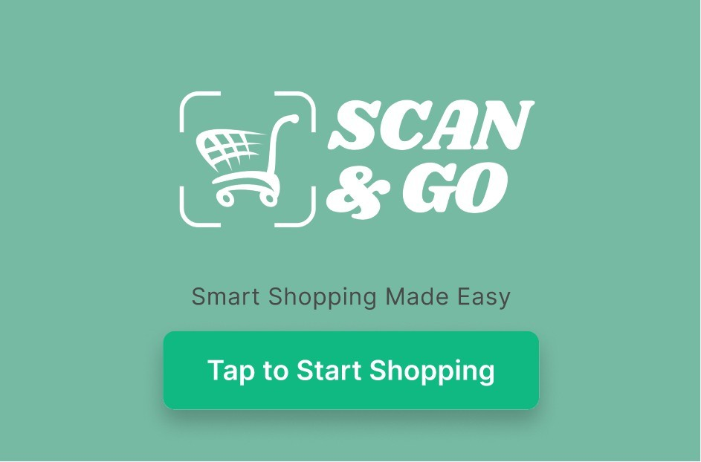
Figure 5.3 – Welcome / Onboarding Screen

Upon tapping the CTA button, the system transitions to the Biometric Login screen. This screen maintains the clean white aesthetic that will persist through most of the authenticated experience. The header identifies the screen context ("SCAN-GO | Biometric Login") and the main title instructs the user: "Welcome to SCAN-GO — Look at the camera for instant, secure login." A stylised face-scanning graphic (bracket corners, eyes, nose bridge, and a smile curve in outline form) occupies the central visual space, immediately communicating the nature of the action required. The "Start Face Scan" button initiates the process.

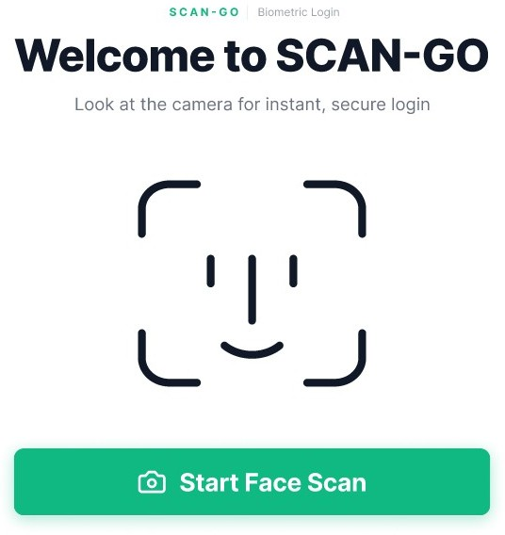
Figure 5.4 – Biometric Login Screen (Ready State)

During active scanning, the face graphic acquires a soft mint-green background fill, a horizontal sweep line animates across the face to indicate active sensor processing, and the button label changes to "Scanning..." — providing clear visual feedback that the system is working. A progress bar beneath the face graphic advances as the scan processes. This animated state prevents user uncertainty about whether the system has received the tap input.

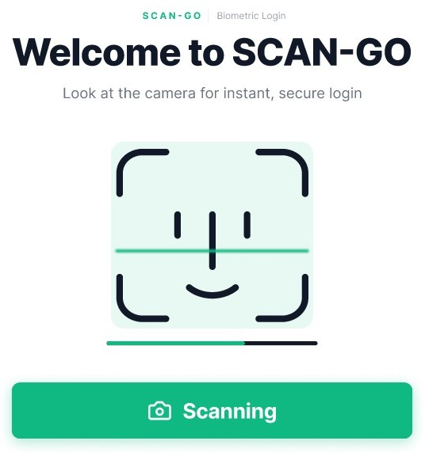
Figure 5.5 – Biometric Login Screen (Scanning State)

Main Dashboard
The Main Dashboard is the operational heart of the SCAN-GO experience. It occupies the full landscape width of the tablet and is divided into two clearly delineated panes by a visual split. The left pane, rendered against the dark charcoal background, houses the live camera viewfinder framed within a glowing green rounded rectangle — the scanning target zone. A camera icon in the centre of the inactive viewfinder provides a visual affordance indicating that this area activates the camera. The "Tap to Scan Product" button, rendered in the primary SCAN-GO green, spans the base of the left pane and is the sole interactive element in this area.
The right pane of the Main Dashboard, rendered on a white background, displays the active cart. In its initial empty state, it shows a ghost cart icon, the message "Your cart is empty — Scan products to add them", and a total of
$0.00. The red "Cancel" button in the top-right corner of the right pane allows the user to abandon the session and reset the system if needed. As items are added, the right pane dynamically updates to reflect each item with its name, price, quantity controls (plus and minus buttons), and individual line-item total.

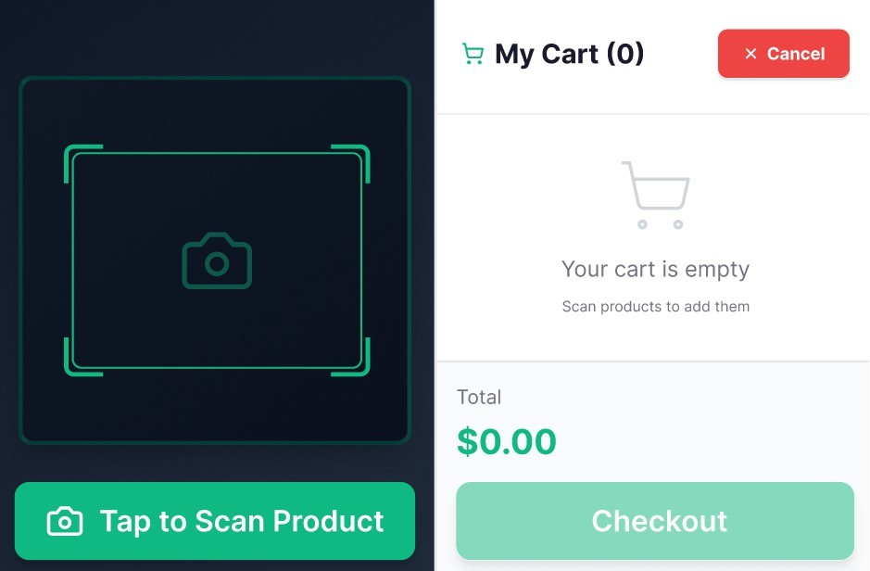
Figure 5.6 – Main Dashboard (Empty Cart State)

Product Scanned Overlay
When a barcode is successfully read by the camera, the system surfaces a Product Scanned overlay at the bottom of the screen, visually anchored as a bottom sheet. This overlay displays: a product thumbnail image on the left; the product name (e.g., "Fresh Milk 1L") in bold with a green verified checkmark; the price in a prominent green typeface (e.g., "$5.49"); a Production Date field showing the manufacture date (e.g., "Apr 25, 2026") with a calendar icon; and an Expiry Date field showing the use-by date (e.g., "May 10, 2026") with a clock icon. This expiry date information is a distinctive and consumer-beneficial feature of SCAN-GO, allowing shoppers to verify freshness at the point of scanning rather than discovering expired items at home.
Two action buttons appear at the right of the overlay: a red-outlined "Cancel" button to dismiss the scan result and continue, and a filled green "Add to Cart" button to confirm the addition. This clear binary choice — with colour-coding reinforcing the desired primary action — allows the user to make a rapid decision without reading button labels in detail.

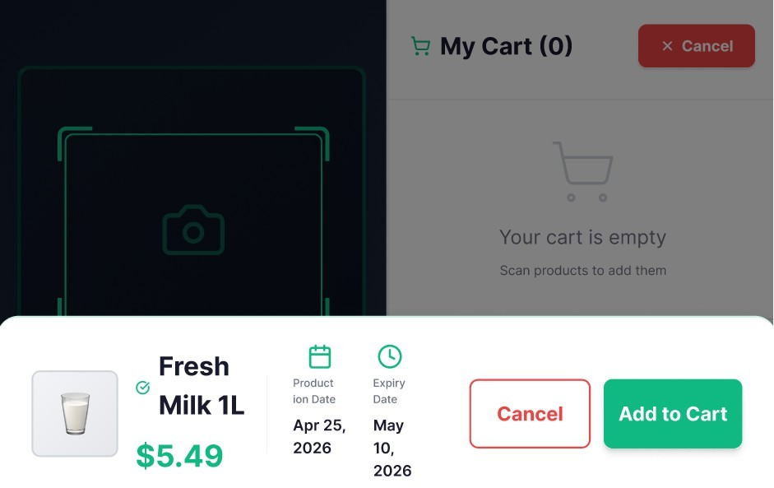

Figure 5.7 – Product Scanned Overlay Modal

Following confirmation, the overlay dismisses and the cart panel on the right updates immediately to reflect the newly added item. The cart item row includes the product thumbnail, name, unit price in green, quantity controls (a green minus button, the quantity count, and a green plus button), the line-item extended total, and a red trash-can icon for removal. The grand total at the base of the right pane updates accordingly, and the "Checkout" button transitions from greyed-out to fully active green.

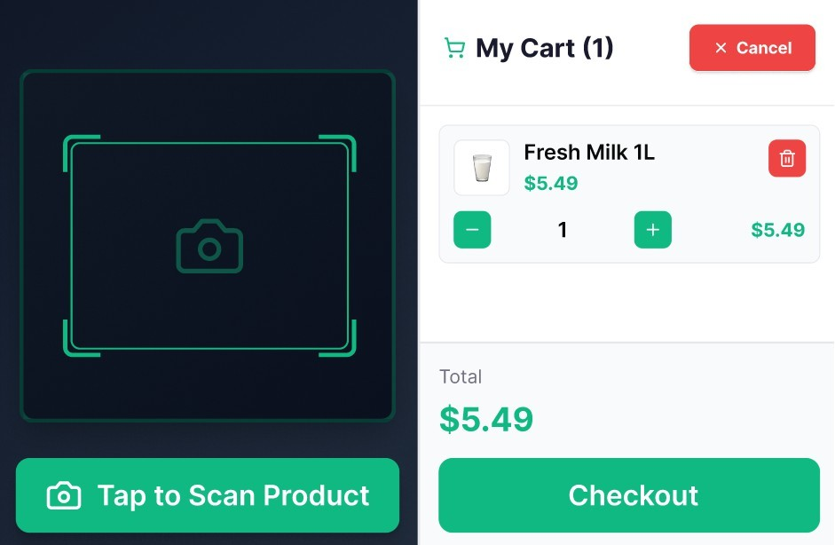
Figure 5.8 – Main Dashboard (Active Cart State, Item Added)

Select Payment Method Screen
The Payment Method Selection screen is reached when the user taps "Checkout". It presents a two-column layout. The left column lists the available payment methods in a vertically scrollable card list: "Tap to Pay (NFC)" — marked with a green "RECOMMENDED" badge and a green WiFi-signal icon on a green square background; "E-Wallet / Mobile Pay" — with an orange device icon and a descriptor listing supported platforms (InstaPay · Vodafone Cash · Orange Cash); "Visa •••• 4242" — with a blue card icon and an expiry date; and "Add New Card" — with a purple card icon and a descriptor of accepted networks.
The right column presents the Order Summary: an itemised list of purchased products with quantities and prices, a subtotal, tax (calculated at 15%), the grand total in large green text, and the green "Confirm Payment" button. A red text link at the bottom of the right column reads "Cancel Order & Start Over", providing an emergency exit from the checkout flow. The payment method rows are touch-selectable, with a green border appearing around the active selection to provide visual confirmation of the chosen method before the user taps "Confirm Payment".

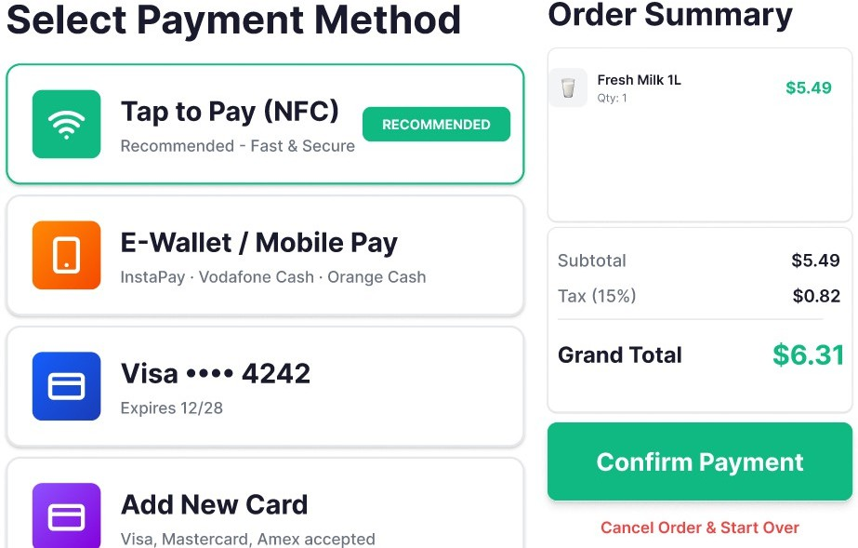
Figure 5.9 – Payment Method Selection (NFC Selected)
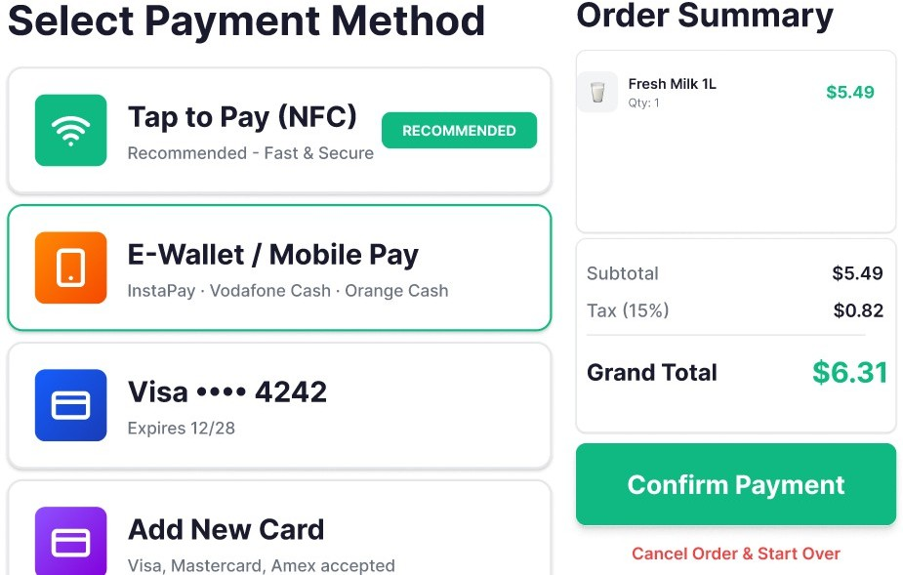
Figure 5.10 – Payment Method Selection (E-Wallet Selected)

Secure Payment Modals

The secure payment modals are the pivotal point in the SCAN-GO UX where the privacy architecture manifests most tangibly. Two distinct modals exist depending on the selected payment method.
NFC Payment Modal: When the user selects "Tap to Pay (NFC)" and confirms, a white card modal appears over the payment screen. It features a large circular NFC/WiFi icon in mint green, the headline "Ready to Scan...", and the instruction "Please tap your card or device on the back of this screen." Three animated dots indicate that the system is actively listening for an NFC signal. A status message reads "Processing your payment...". At no point does the user enter a PIN, passcode, or any identifying information on the shared tablet screen. The payment authentication occurs through the cryptographic handshake between the card/device and the NFC reader embedded behind the tablet screen, handled entirely by the bank's API processing layer.
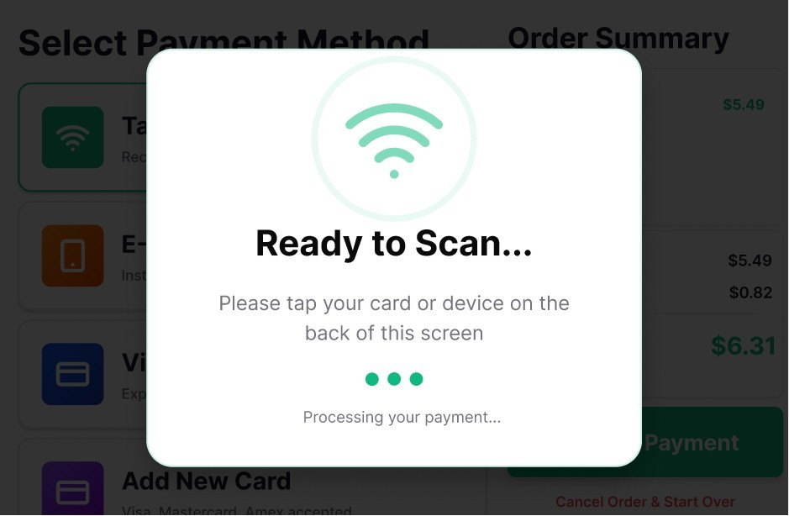
Figure 5.11 – NFC Payment Modal (Ready to Scan)

E-Wallet / QR Payment Modal: When the user selects "E-Wallet / Mobile Pay" and confirms, a modal titled "Scan to Pay Securely" appears. It presents a dynamically generated QR code — unique to this transaction and session — that encodes the payment instruction for the specified amount. The total amount due is displayed beneath the QR code in large green text. A QR expiry countdown timer (e.g., "4:59") provides transparency about the validity

window. A status indicator reads "Waiting for payment confirmation.." with an animated spinner. A "Cancel & Choose Another Method" button allows the user to return to the payment method list. The small footer note reads "Payment processed on your personal device · No data entered here", explicitly affirming the privacy guarantee to the user. The shopper opens their own banking or e-wallet app on their personal smartphone, scans the QR code, and completes the authorisation on their private screen. The SCAN-GO system receives confirmation via a secure gateway webhook.
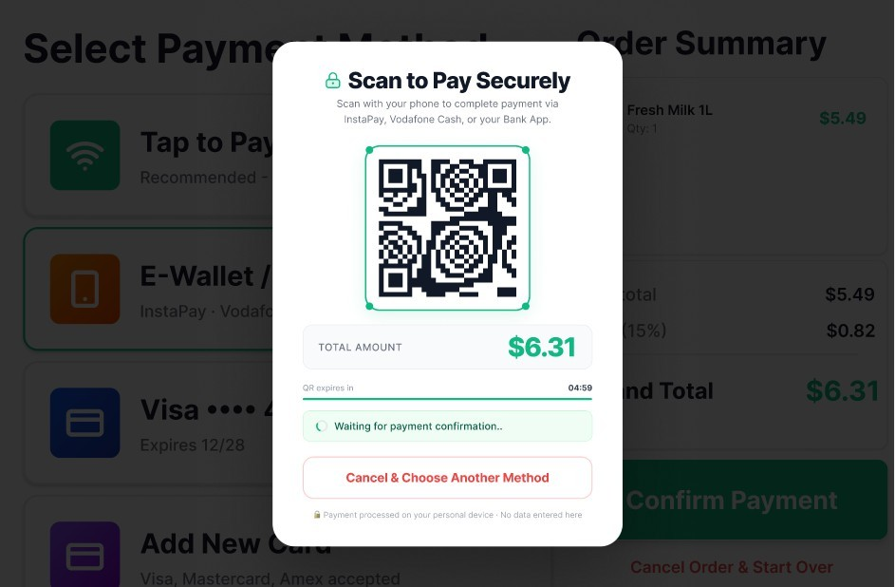
Figure 5.12 – E-Wallet QR Payment Modal (Awaiting Scan)

Payment Successful and Exit Pass Screen
The final screen of the SCAN-GO user journey is the Payment Successful and Exit Pass screen — a two-panel display that simultaneously confirms the completed transaction and enables the physical exit from the store. This screen is designed to feel celebratory and reassuring, offering the user a clear signal that their shopping session has been successfully completed and that they are free to leave.
The left panel features a large green filled circle containing a white bold checkmark — a universally recognised success symbol — followed by the headline "Payment Successful!" in bold black text. Below this, the text "Thank

you for shopping with SCAN-GO" provides a warm, personalised closing note. A summary receipt card displays the amount paid (in green), the unique transaction ID (prefixed with #SG-), and the date and time of the transaction. A mint-green highlighted banner at the bottom of the left panel celebrates the time saved by using SCAN-GO (e.g., "You saved 5 minutes with SCAN-GO today!"), leveraging the behavioural psychology of positive reinforcement to encourage repeat use of the system.
The right panel is dominated by the Exit Pass QR Code — a large, clearly rendered QR code unique to this transaction, accompanied by the transaction reference below it. The "EXIT PASS READY" label in green at the top of the right panel clearly indicates the purpose of this code. The instruction reads "Scan the QR code below at the smart exit gate to open the barrier." A green progress bar beneath the QR code counts down a 29-second active window, communicating to the user both urgency and the system's automatic reset behaviour. A prominent "Done & Exit" button provides an explicit action for users who are ready to proceed. The note "Or automatically resets in 29 seconds" manages expectations about system behaviour without requiring the user to take any further action.
At the physical level, the SCAN-GO smart exit gate — controlled by a Raspberry Pi single-board computer equipped with a QR scanner — reads this exit pass when the user presents the tablet screen or a secondary device. Upon verification, the barrier opens, confirming that payment has been completed and allowing the shopper to exit the store. This integration of digital interface with physical hardware infrastructure represents the complete closure of the SCAN-GO transaction loop.

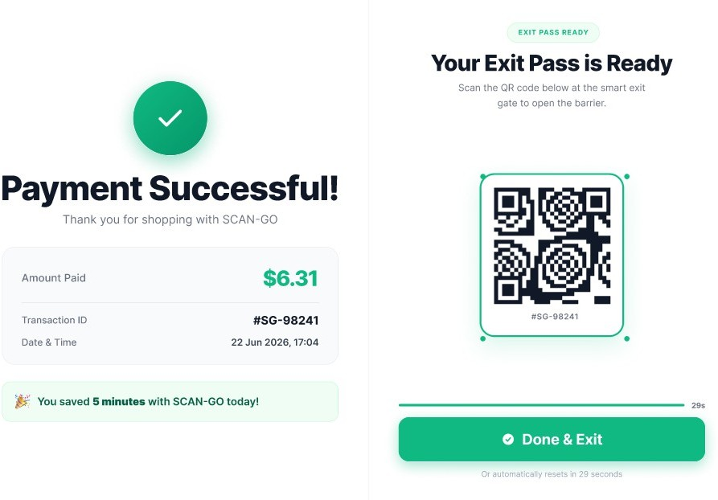
Figure 5.13 – Payment Successful and Exit Pass Screen

