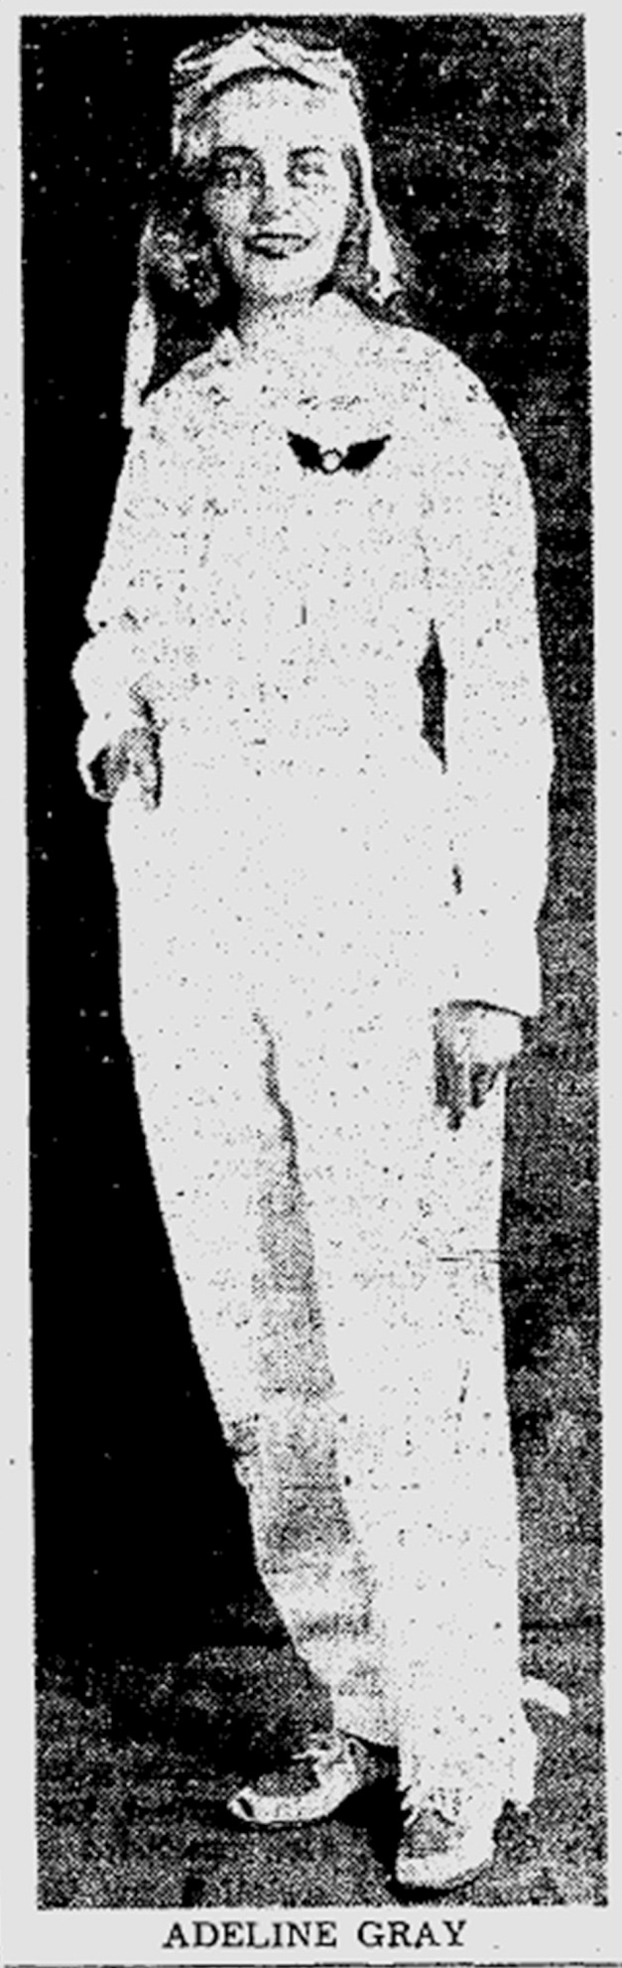

**From the Cleveland Plain Dealer,**

**August 20, 1939**

**They'll Gamble with**

**Death Daily in Sky Here**

Parachute jumpers will be out in force to provide plenty of the suspense that hangs on each jump before the white silk blossoms out to slow the jumper's meteoric fall.

Joseph J. (Flying Dutchman) Dunkel, who handles the parachute events expects that Miss Adeline Gray, only woman to file a parachute entry, will provide competition for the 34 male jumpers in the spot landing contest that takes place each of the three days of the races.

Miss Gray, 21, has trusted her 112 pounds to a parachute 25 times and carries the first and so far the only parachute license issued to a woman by the state of Connecticut.

Contestants in the daily parachute race will be Earl Stone of Fostoria, O; Buddy Batzel of Pittsburgh, Merle Aucker of Medina, O., and Johnny Becker of Detroit.

Chosen for skill and experience, these four will "bail out" at 10,000 feet and delay opening their parachutes to the last possible moment in an effort to be the first to reach the ground.

Thirty jumpers will participate each day in the mass jump, in which three transport planes are used to carry the jumpers into the sky where they spill out of the planes en masse for one of the most spectacular events of the races.