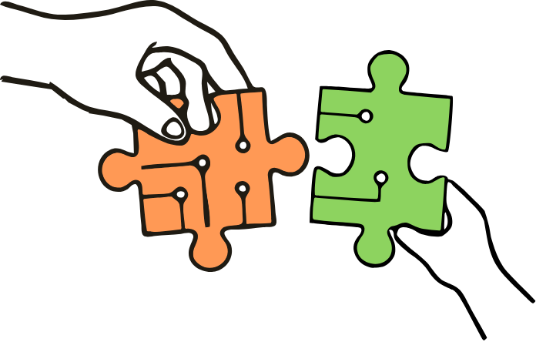
CAMCAD Workshop Report
Child-Centred AI-Mediated Collaborative Agency by Design
CHI 2026 — Thursday, 16 April 2026

Overview
The Child-Centred AI-Mediated Collaborative Agency by Design (CAMCAD) workshop was held on Thursday, 16 April 2026, 14:15–18:00 CEST, as part of the ACM CHI 2026 conference in Barcelona, Spain.
This workshop brought together researchers, designers, educators, and practitioners to explore how AI applications can be designed to support children and young people in making informed decisions and enacting them meaningfully.
This year's central theme was collaborative agency. Through this lens, we explored how children and young people can be supported in making and acting on decisions not just as individuals, but in collaboration with others, such as peers, teachers, and parents.
CAMCAD 2026 built on a series of Child-Centred AI workshops at CHI 2023 (Child-Centred AI Design: Definition, Operation, and Considerations) and CHI 2024 (The Second Workshop on Child-Centered AI Design (CCAI)), deepening the community's engagement with questions of child-centred design in the age of increasingly ubiquitous AI systems.

Organisers
The workshop was organised by a cross-institutional team of ten researchers:
- Vidminas Vizgirda, University of Oxford & University College London
- Isobel Voysey, University of Oxford
- Zaki Pauzi, University College London
- Najme Babai, University of Oulu
- Eva Durall Gazulla, University of Oulu
- Jane Waite, Raspberry Pi Foundation
- Ayça Atabey, University of Edinburgh
- Sarah Turner, University College London
- Manolis Mavrikis, University College London
- Jun Zhao, University of Oxford

Attendees
The workshop was attended by two organisers, six invited talk presenters, eight workshop participants who presented posters and pictorials, three guests, and two contributors who were unable to attend in person but submitted work that was presented and discussed:
Organisers: Vidminas Vizgirda (University of Oxford & University College London), Isobel Voysey (University of Oxford)
Invited presenters: Netta Iivari (University of Oulu), Hawra Rabaan (University of Maryland), Diana Sarai Hernandez Manzo (Robert Gordon University), Keyu Mao (Zhejiang Normal University), Mennatullah Hendawy (University of California Santa Cruz), Yui Kondo (University of Oxford)
Participants: Jianing Wang (CUHK Shenzhen), Sohyun Park (KAIST), Khadija El Aadmi-Laamech (Universitat Pompeu Fabra), Giuseppe Sanseverino (TU Chemnitz), Silvia Ferrando (University of Genoa), Ylva Fernaeus (Umeå Institute of Design & KTH), Martin Jonsson (Södertörn University), Christina Detsika (Fraunhofer FKIE)
Guests: Annie Strickland Fisher (independent), Boyd Branch (University of Southampton), Ann-Kristin Lieberknecht (Goethe University Frankfurt)
Contributors: Nora Hille (Universität Siegen), Nomisha Kurian (University of Warwick)
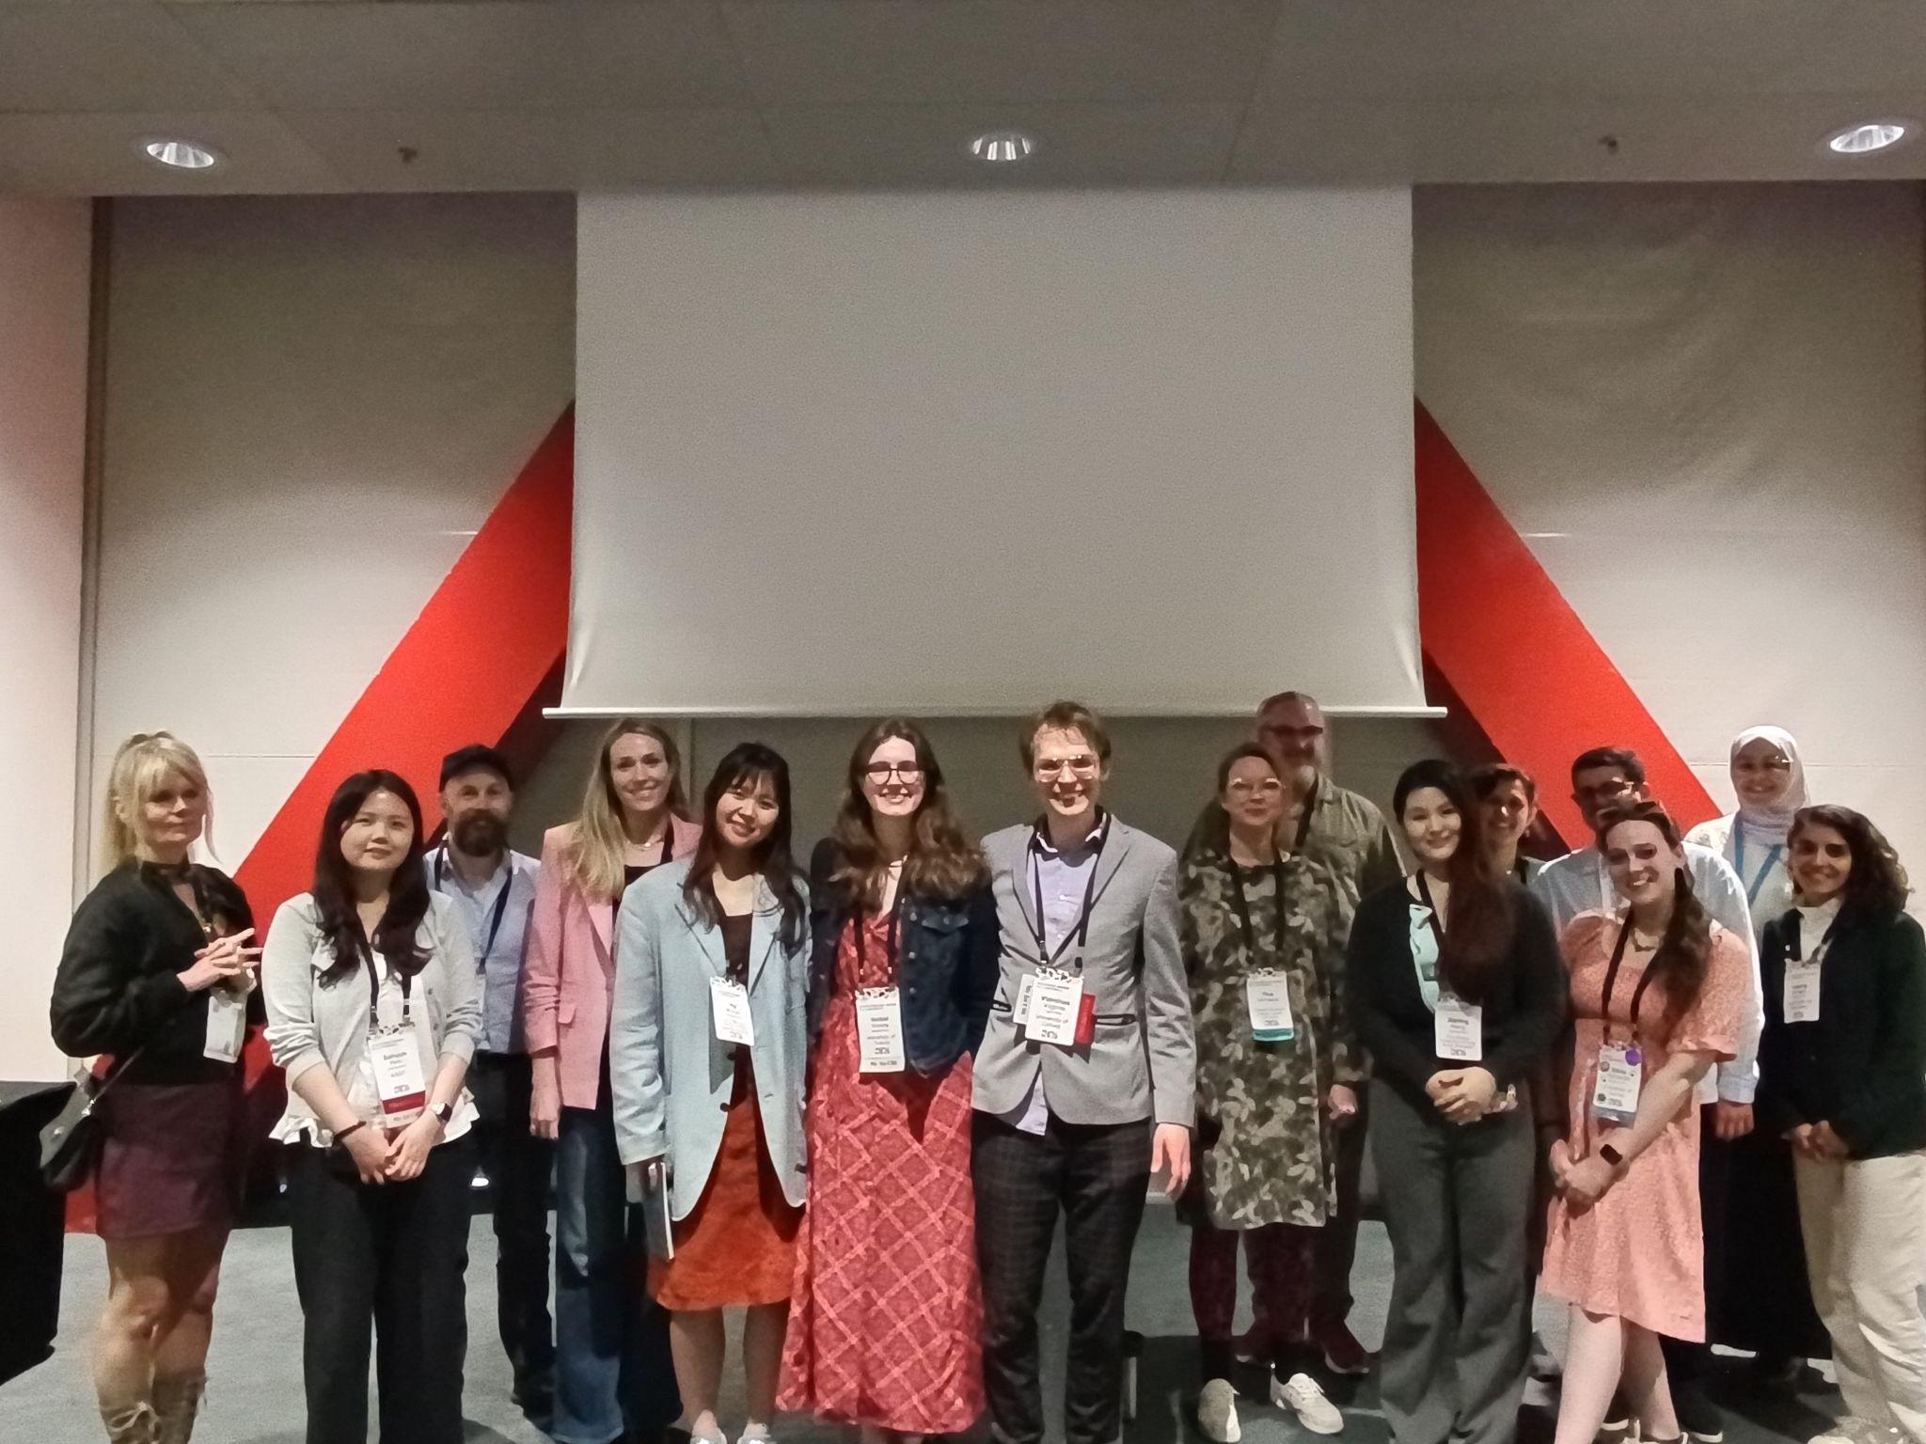

Acknowledgements
This workshop was supported by the UK Research and Innovation (UKRI) Cross Research Council Responsive Mode projects CHAILD - Children’s Agency In the age of AI: Leveraging InterDisciplinarity (MR/Z505882/1) and GRASPING DATA: Co-creating Physicalizations to Empower Young Children to Interact with, Understand, and Benefit from Their Personal Data (MR/Z505602/1) and the Research Council of Finland funded project Critical DataLit: Cultivating justice-oriented data literacies among GenZ (Grant #354445).
The Microsoft CMT service was used for managing the peer-reviewing process for this conference. This service was provided for free by Microsoft and they bore all expenses, including costs for Azure cloud services as well as for software development and support.

Workshop Programme

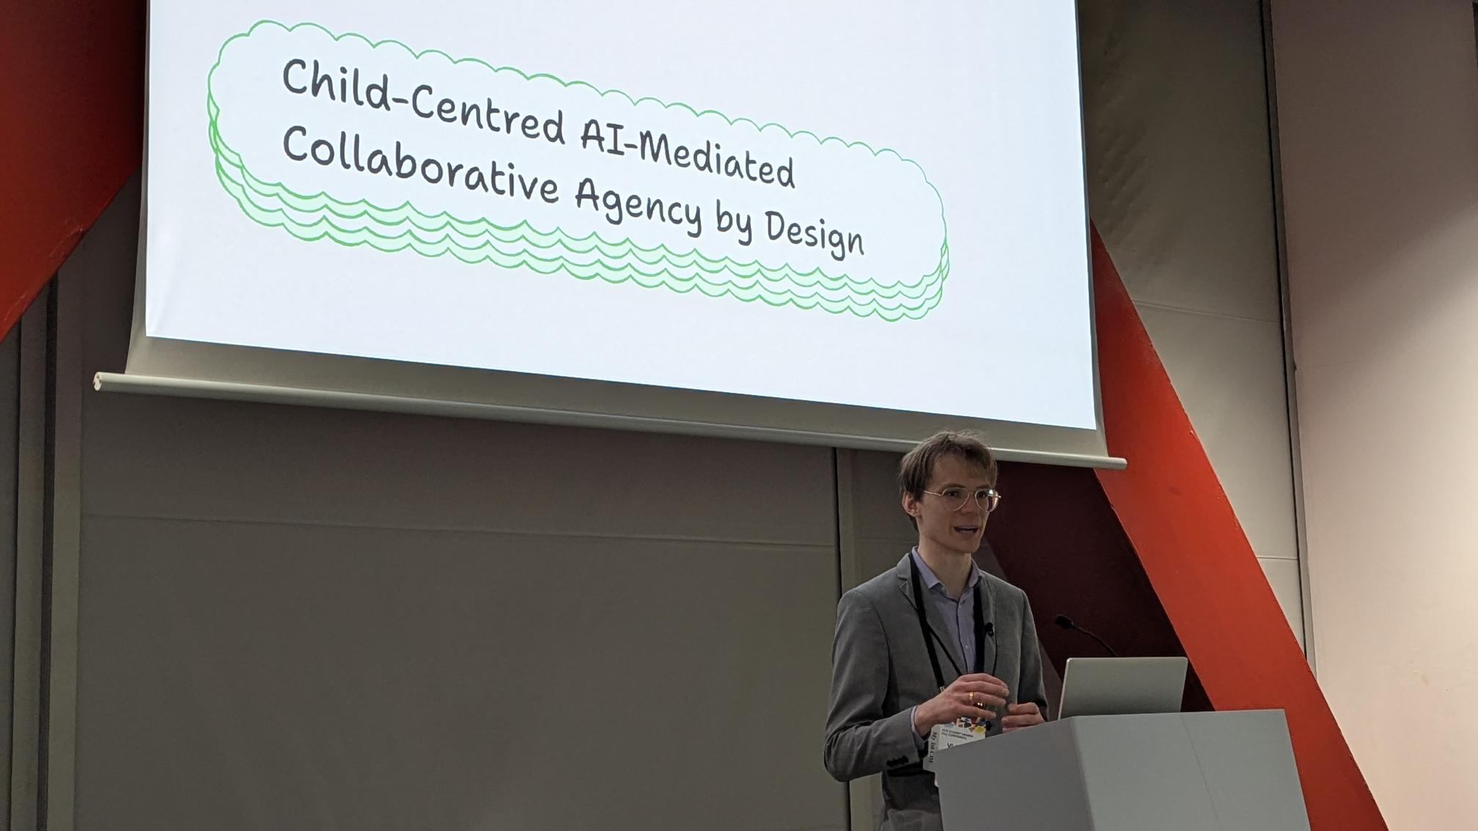
Session 1: Whole-group activities (14:15–15:45)
- 14:15–14:30 Introduction and overview of themes from accepted submissions — Dr Vidminas Vizgirda (University of Oxford / UCL)
- 14:30–14:55 Keynote: "Fostering transformative agency of children in the age of AI" — Professor Netta Iivari (University of Oulu)
- 14:55–15:45 Invited presentations:
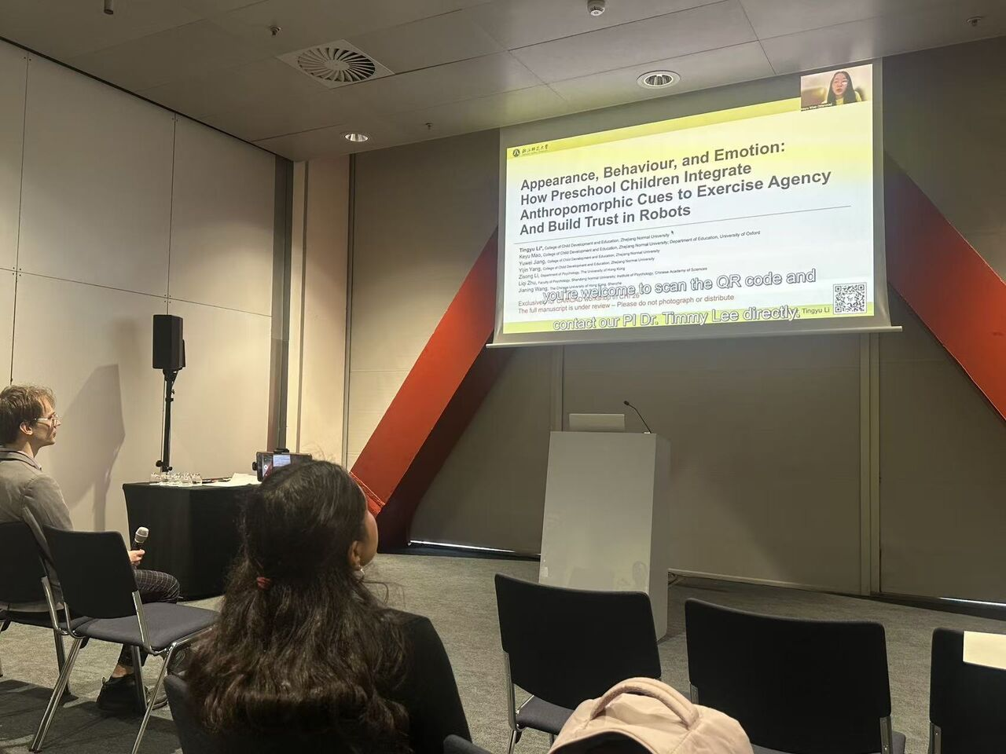
  - Dr Hawra Rabaan (University of Maryland) — Enacting Collaborative Agency through Critical AI Literacy
  - Diana Sarai Hernandez Manzo (Robert Gordon University) — Virtual Heritage VR Escape Room with AI Agents
  - Keyu Mao (Zhejiang Normal University) — Child-Robot Trust
  - Mennatullah Hendawy (University of California Santa Cruz) — AI-Enabled Child Online Safety: From Control to Co-Agency
  - Yui Kondo (University of Oxford) — Algorithmic Mirror

Break and Poster Session (15:45–16:30)
During the break between workshop activities, we had a poster session, with refreshments and informal discussion. Fourteen accepted posters and pictorials were presented.
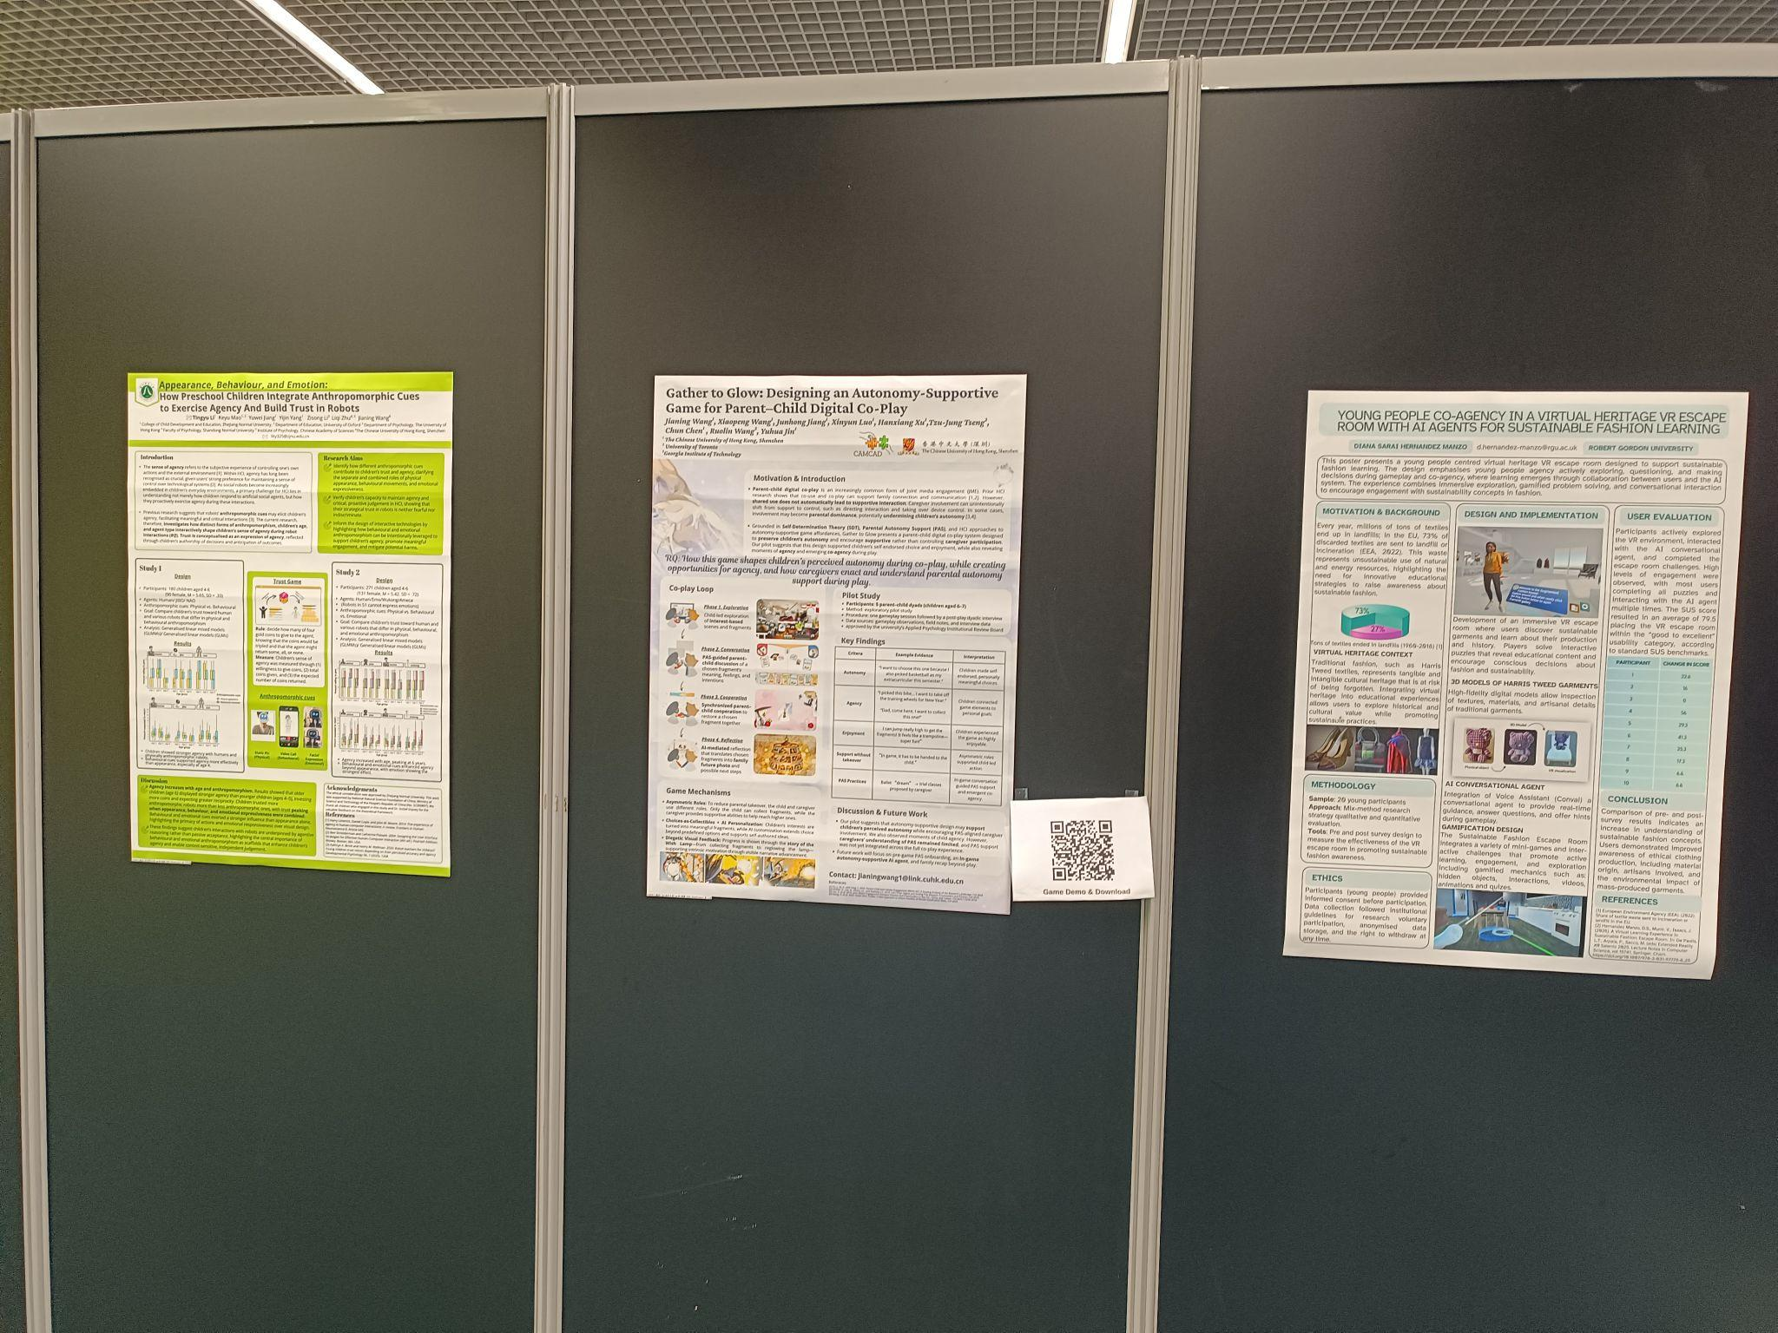
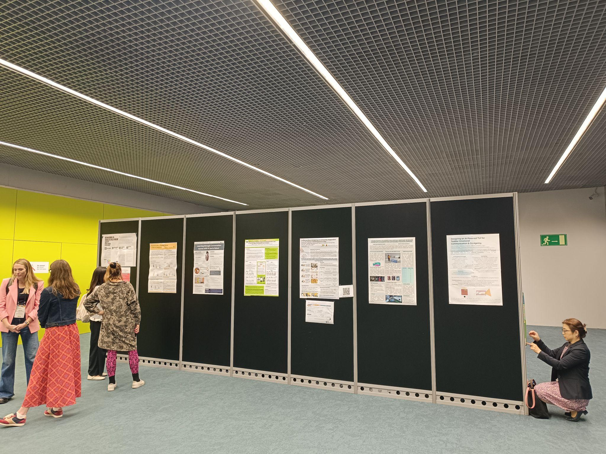
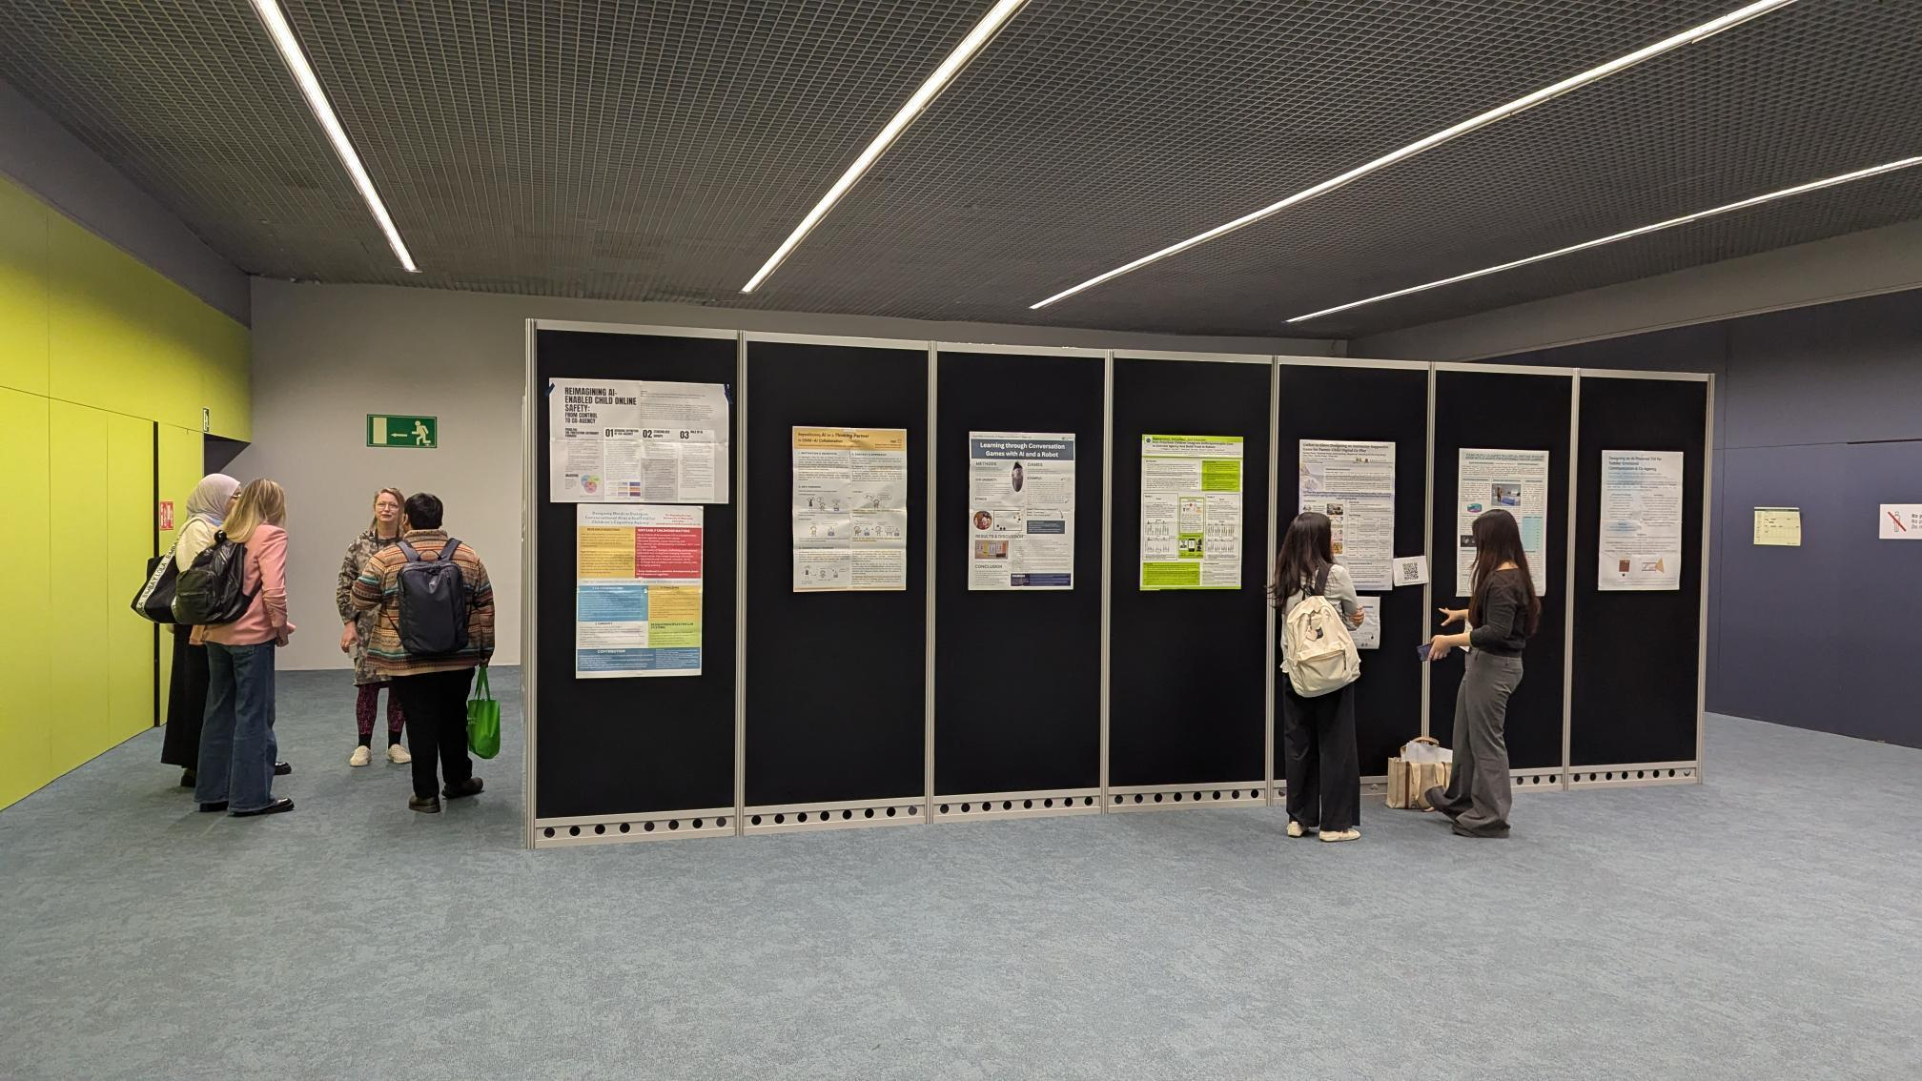

Session 2: Breakout group activities (16:30–18:00)
- 16:30–17:00 Group task: translating research insights on co-agency into implications for practice
- 17:00–17:30 Group rotation and peer feedback
- 17:30–17:50 Whole-group review and documentation of outputs
- 17:50–18:00 Workshop recap and next steps

Workshop Talks

Introduction: Vidminas Vizgirda (University of Oxford & UCL)
Dr Vizgirda opened by framing CAMCAD as a workshop not just about children using AI tools, but about “AI-mediated experiences” more broadly: situations in which AI shapes children’s lives directly or indirectly, whether through a child’s own interaction with an AI system, an adult intermediary, or AI systems being part of a surrounding environment.
He also used the introduction to clarify some shared vocabulary. “Agency” has multiple valid definitions and the organisers had intentionally asked submission authors to define it in their own terms. In the workshop submissions, agency was understood as the capacity to:
- critically examine AI systems, make informed decisions, and enact decisions (Rabaan & Erete, 2026);
- control own actions and shape one’s environment (Li et al., 2026);
- generate ideas, reflect, revise them, and act on them (Kurian, 2026);
- initiate, interpret, and shape activity (Wang et al., 2026);
- take an active part in research and product development (Hille, 2026);
- make choices and decisions without undue external influence (El Aadmi-Laamech et al., 2026).
While the workshop topic was initially inspired by the OECD Education 2030 Learning Compass concept note on student agency and the “sun model of co-agency”, workshop submissions expanded on the idea of collaborative agency considering different actors in a variety of contexts. In workshop submissions, collaborative agency was framed as:
- Shared decision making and active engagement
  - For example, in peer-and-AI collaboration within a VR sustainable fashion escape room (Hernandez Manzo, 2026)
- Asymmetric, role-differentiated partnerships
  - For example: in AI-supported bouldering coaching (Sanseverino et al., 2026) and in structured role-differentiated dialogue (Park & Lee, 2026)
- Joint understanding, influence, and regulation
  - For example: shared online safety decisions (Hendawy & Seif el Nasr, 2026)
- Working with others on a shared problem
  - For example: tackling algorithmic profiling opacity (Kondo et al., 2026)
- Interactive, mutually supportive relationships that help learners progress towards goals
  - For example: collaborative drawing with AI emotion feedback (Ferrando & Ceccaldi, 2026) and in a child-parent-AI voice interface (Detsika et al., 2026);
- Shared production of action and meaning
  - For example, in children's play with robotic toys, where meaning emerges from physical interaction and imagined robot narratives (Fernaeus et al., 2026)
This year’s workshop also focused on child-centred design by “decentring children” (or more accurately, “zooming out” to the bigger picture of children’s interconnected lives)—that is, by asking how parents, teachers, peers, designers, and institutions enable or constrain children’s agency. This framing set up the rest of the session as a conversation about agency as relational, distributed, and designed rather than purely individual.
Vizgirda noted that the workshop title was chosen deliberately to foreground the question of how we might support collaborative agency by design. This was the main workshop topic.

Keynote: Netta Iivari (University of Oulu)
"Fostering Transformative Agency of Children in the Age of AI"
Prof Iivari’s keynote expanded on transformative agency, grounding the concept in Cultural-Historical Activity Theory. In the talk, she described transformative agency as something that “does not only refer to one’s capacity to act” but to people’s “initiative [and] commitment to transform the world”. In Iivari’s account, this includes resisting and criticising injustice, explicating the need for change, envisioning alternatives, committing to action, and acting collectively toward social good. Importantly, she stressed that this is “rather seen as a collective process than an individual feature” and that it resides in relationships and interactions, not just within a single child.
The keynote connected this theory to long-running design work with children on issues such as bullying, discrimination, animal testing, and other matters they care deeply about. Iivari repeatedly emphasised that the goal is not classroom performance for its own sake, but to “learn for life” and to move beyond “toy activities in a classroom” toward efforts that matter outside school. Her talk also sharpened the design challenge: criticality is necessary, but mere criticising doesn’t really help unless children are also supported to propose alternatives, imagine better futures, and take action together. At the end of the talk, she distilled the implication for designers: “If you’re designing for agency, I would say you should be designing for collectives”.
The keynote gave the workshop a theoretical grounding and a normative challenge: ask how we might support children to recognise injustice in their AI-mediated experiences, imagine change, and act with others to pursue it.

Hawra Rabaan (University of Maryland)
"Enacting Collaborative Agency through Critical AI Literacy"
Dr Rabaan presented a case study of a two-week, community-based critical AI literacy programme, co-designed over ten months with a local nonprofit organisation. She situated the work in the context of AI harms disproportionately affecting communities of colour and explained that the programme was designed to involve those most affected not only as learners, but as co-authors of critique and redesign. The team’s community-based approach was to “have the community tell us what they need”.
Eighteen Black and Latinx middle school girls and their families engaged in identity grounding, sociotechnical critique, community inquiry, and creative redesign. In the talk, Rabaan described collaborative agency as being enacted through an ecology of youth, families, community partners, near-peer mentors, and guest speakers. The researchers organised the curriculum around identity, technical understanding, and advocacy, and summarised one of the central reflective prompts as: “Who am I and who are we as a collective and then what must we change?” This programme went beyond learning how AI works and included building confidence, surfacing values, and linking technical critique to issues participants cared about in everyday life. Rabaan described how co-agency emerged through “collectively experimenting with the technology”, building a shared understanding of bias, and then moving into community interviews and a shared knowledge production process involving parents, grandparents, and other community members. Her closing emphasis on intergenerational dialogue showcases how the project treated collaborative agency as distributed authorship across youth, families, educators, and communities.

Diana Sarai Hernandez Manzo (Robert Gordon University)
"Virtual Heritage VR Escape Room with AI Agents"
Hernandez Manzo presented the design and evaluation of a young-people-centred virtual heritage VR escape room for sustainable fashion learning that combines immersive exploration with an AI conversational agent to support collaborative learning. This project was sponsored by the Harris Tweed brand, who focus on sustainable fashion. In the escape room, participants moved through a familiar domestic environment, searching for hidden information about materials, water usage, plastics, and garment production. As the presenter explained, the design intentionally avoided over-direction: “you just need to go around the house and then try to get the information hiding objects”, allowing participants to explore, discover facts, and interpret them at their own pace within a playful space.
The AI system was described as a real-time voice assistant that participants could use when they got stuck on the questions needed to complete the escape room. Hernandez Manzo emphasised that the assistant “is not going to give you the exact response but some kind of hint”, thus making it a scaffold that supports learners’ agency. She also noted practical design concerns, including the importance of keeping the experience “as fun as possible” while minimising motion sickness for first-time VR users.
Her evaluation with 20 young participants combined open-ended responses and Likert-scale measures. She reported an average usability score of 79.5, placing the system in a “good to excellent” range in system usability score benchmarks, alongside improvements in understanding sustainable fashion, as well as in awareness, interest, and engagement.
This talk positioned the VR escape room experience as a concrete example of AI-mediated learner agency in an immersive learning environment with an AI agent guiding but not answering for participants.

Keyu Mao (Zhejiang Normal University)
"Child-Robot Trust"
Mao presented research investigating how preschool children integrate anthropomorphic cues — physical appearance, behavioural dynamics, and emotional expressiveness — to form trust judgements in robot interactions. Mao framed trust as both an affective preference and as evidence that children are evaluating, anticipating, and deciding—in other words, acting as agentic participants rather than passive recipients of robot behaviour.
The study used a trust game in which children allocated coins to different agents and formed expectations about what would be returned. Mao described this as capturing not just behavioural outcomes but “agentic reasoning”. Across two studies, the work compared how children responded to robots with different physical appearance, movement/behaviour, and emotional expression. The central result from the first study was that robot actions matter more than appearance. In the second study, emotional expression emerged as the strongest cue of all. Mao summarised the findings in four points: agency increased with age, children trusted more anthropomorphic robots, behaviour and emotion mattered more than appearance, and trust peaked when all three cues converged.

Mennatullah Hendawy (University of California Santa Cruz)
"AI-Enabled Child Online Safety: From Control to Co-Agency"
Hendawy argued that child online safety tools still treat children as objects of surveillance rather than partners in safety. She characterised the field’s central dilemma as a “protection autonomy paradox”: how far parents and caregivers should control children’s digital environments while still allowing room for autonomy, resilience, and development. She argued that existing responses are often inadequate because “control heavy fixes often lag behind change” and can push risk into less visible spaces while also eroding trust and communication within families.
Hendawy argued for redesigning safety as “a developmental and relational practice” rather than a regime of surveillance and blocking. In her formulation, safety becomes “a shared practice distributed across children, caregivers, technologists, platforms and government actors”. In this case, digital co-agency is enacted when children, caregivers, and AI jointly shape safety decisions over time through shared decision-making. In this model, AI is repositioned from a "digital policeman" to a "digital mentor" that adds reflective friction, explains why content or behaviour is flagged, and supports self-regulated learning while preserving privacy and contestability.
The talk closed with a proposed shift from the question “how do we minimise risk with more control” to “how do we maximize autonomy while keeping children safe”.

Yui Kondo (University of Oxford / Oxford Internet Institute)
"Algorithmic Mirror"
Kondo presented Algorithmic Mirror, an interactive visualisation tool that transforms opaque profiling practices of social media recommender systems into explorable landscapes of personal data, drawing on adolescents' real digital footprints across TikTok, YouTube, and Netflix.
The project was motivated by the questions: “How do platforms see me? What do they remember about me? What might be shared between platforms? And can I change how the internet sees me?” Kondo used the image of the mirror to argue that mirrors help us not only identify ourselves but also reflect on how we present ourselves across contexts. Online, however, this self-recognition becomes difficult because data is dispersed across platforms and processed through opaque systems.
Algorithmic Mirror responds to this design gap by turning adolescents’ TikTok, YouTube, and Netflix histories into explorable visualisations of inferred interests and identities over time. The team evaluated this tool through a study with 27 participants aged 12–16, who engaged with their own data.
The application enabled adolescents to uncover the scale and persistence of data collection, recognise cross-platform profiling, and critically reflect on algorithmic categorisations of their interests. Select quotes include an adolescent who said, “It’s scary to realize that I’m watching things without awareness”, while another said the system made them reflect on how their interests are distributed across platforms “as if different personalities exist within each platform”. Kondo also reported that participants began to think about disclosure and control in much more nuanced terms, describing it as “the balance [of] how much you want them to know about you and how much you don’t want them to know about you”. The study found that personal identity is a powerful motivator for reflecting on datafication, highlighting the need for platforms to ensure young people have transparency and control over their algorithmic profiles.

Accepted Submissions
Fourteen posters and pictorials were accepted and presented during the workshop's poster session.

Citations
- Christina Detsika, Marie Matters, and Matthew Smith. 2026. Children's Perception on LLM-driven Voice User Interfaces. In Child-Centred AI-Mediated Collaborative Agency by Design Workshop at CHI 2026 (Barcelona, Spain, April 16, 2026). https://oxfordhcc.github.io/CAMCAD/submissions/#detsika-childrens-interfaces
- Khadija El Aadmi-Laamech, Patricia Santos, and Xènia Fàbrega. 2026. AI-Mediated Scaffolding for Student Agency and Peer Collaboration. In Child-Centred AI-Mediated Collaborative Agency by Design Workshop at CHI 2026 (Barcelona, Spain, April 16, 2026). https://oxfordhcc.github.io/CAMCAD/submissions/#aadmi-laamech-ai-collaboration
- Ylva Fernaeus, Sara Ljungblad, Martin Jonsson, and Loove Broms. 2026. It's a Scam: On Being Truthful when Involving Children in Robotics Research. In Child-Centred AI-Mediated Collaborative Agency by Design Workshop at CHI 2026 (Barcelona, Spain, April 16, 2026). https://oxfordhcc.github.io/CAMCAD/submissions/#fernaeus-scam-research
- Silvia Ferrando and Eleonora Ceccaldi. 2026. Toddlers and Emotion: A TUI for Emotional Communication. In Child-Centred AI-Mediated Collaborative Agency by Design Workshop at CHI 2026 (Barcelona, Spain, April 16, 2026). https://oxfordhcc.github.io/CAMCAD/submissions/#ferrando-toddlers-communication
- Mennatullah Hendawy and Magy Seif el Nasr. 2026. Reimagining AI-Enabled Child Online Safety: From Control to Co-Agency. In Child-Centred AI-Mediated Collaborative Agency by Design Workshop at CHI 2026 (Barcelona, Spain, April 16, 2026). https://oxfordhcc.github.io/CAMCAD/submissions/#hendawy-reimagining-co-agency
- Diana Hernandez Manzo. 2026. Young People Co-Agency in a Virtual Heritage VR Escape Room with AI Agents for Sustainable Fashion Learning. In Child-Centred AI-Mediated Collaborative Agency by Design Workshop at CHI 2026 (Barcelona, Spain, April 16, 2026). https://oxfordhcc.github.io/CAMCAD/submissions/#hernandez-young-learning
- Nora Hille. 2026. Learning through Conversation Games with AI and a Robot. In Child-Centred AI-Mediated Collaborative Agency by Design Workshop at CHI 2026 (Barcelona, Spain, April 16, 2026). https://oxfordhcc.github.io/CAMCAD/submissions/#hille-learning-robot
- Yui Kondo, Kevin Dunnell, Isobel Voysey, Qing Hu, Victoria Paesano, Qing Xiao, Jun Zhao, and Luc Rocher. 2026. Algorithmic Mirror: Helping Adolescents See and Shape Their Algorithmic Selves. In Child-Centred AI-Mediated Collaborative Agency by Design Workshop at CHI 2026 (Barcelona, Spain, April 16, 2026). https://oxfordhcc.github.io/CAMCAD/submissions/#kondo-algorithmic-selves
- Nomisha Kurian. 2026. Designing Minds in Dialogue: Conversational AI as a Scaffold for Children's Cognitive Agency. In Child-Centred AI-Mediated Collaborative Agency by Design Workshop at CHI 2026 (Barcelona, Spain, April 16, 2026). https://oxfordhcc.github.io/CAMCAD/submissions/#kurian-designing-agency
- Tingyu Li, Keyu Mao, Yuwei Jiang, Yijin Yang, Zisong Li, Liqi Zhu, and Jianing Wang. 2026. Appearance, Behaviour, and Emotion: How Preschool Children Integrate Anthropomorphic Cues to Exercise Agency And Build Trust in Robots. In Child-Centred AI-Mediated Collaborative Agency by Design Workshop at CHI 2026 (Barcelona, Spain, April 16, 2026). https://oxfordhcc.github.io/CAMCAD/submissions/#li-appearance-robots
- Sohyun Park and Woohun Lee. 2026. Repositioning AI as a Thinking Partner in Child–AI Collaboration: Interview-grounded insights for role-differentiated child–AI collaboration. In Child-Centred AI-Mediated Collaborative Agency by Design Workshop at CHI 2026 (Barcelona, Spain, April 16, 2026). https://oxfordhcc.github.io/CAMCAD/submissions/#park-repositioning-collaboration
- Hawra Rabaan and Sheena Erete. 2026. Enacting Collaborative Agency through Critical AI Literacy: A Community-Based Program with Black and Brown Middle School Girls and Their Families. In Child-Centred AI-Mediated Collaborative Agency by Design Workshop at CHI 2026 (Barcelona, Spain, April 16, 2026). https://oxfordhcc.github.io/CAMCAD/submissions/#rabaan-enacting-families
- Giuseppe Sanseverino, Lena Marcella Nischwitz, Dominik Krumm, and Lewis Chuang. 2026. AI as a Partner for Children's Bouldering. In Child-Centred AI-Mediated Collaborative Agency by Design Workshop at CHI 2026 (Barcelona, Spain, April 16, 2026). https://oxfordhcc.github.io/CAMCAD/submissions/#sanseverino-ai-bouldering
- Jianing Wang, Xiaopeng Wang, Junhong Jiang, Xinyun Luo, Hanxiang Xu, Tzu-Jung Tseng, Chun Chen, Ruolin Wang, and Yuhua Jin. 2026. Gather to Glow: Designing an Autonomy-Supportive Game for Parent–Child Digital Co-Play. In Child-Centred AI-Mediated Collaborative Agency by Design Workshop at CHI 2026 (Barcelona, Spain, April 16, 2026). https://oxfordhcc.github.io/CAMCAD/submissions/#wang-gather-co-play

Group Discussions
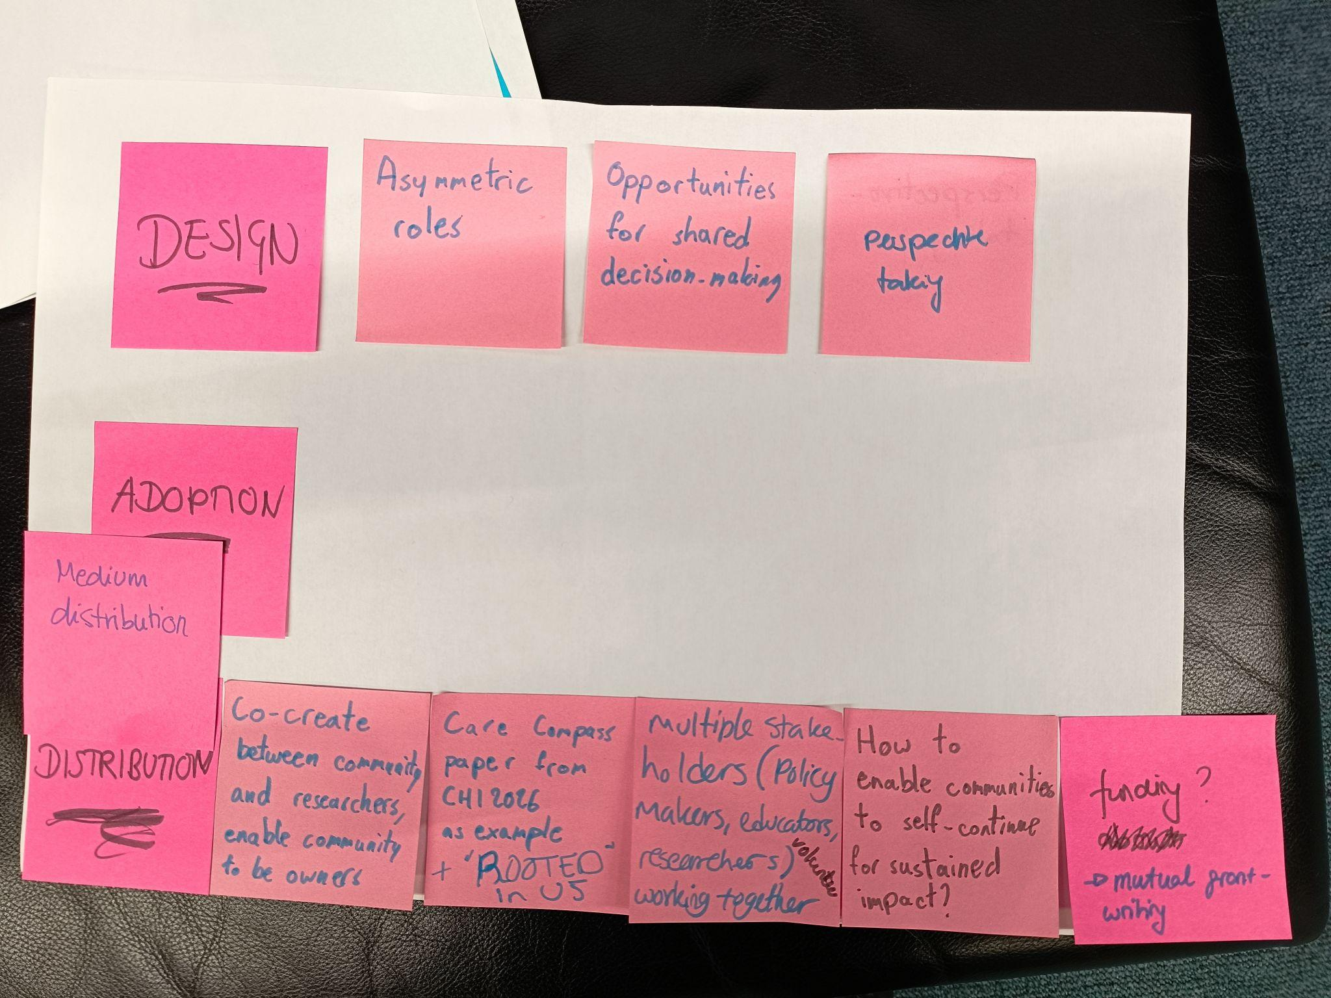
notes read "DESIGN", "Asymmetric roles", "Opportunities for shared decision-making", and "perspective taking". Further notes include "ADOPTION", "Medium distribution", and "DISTRIBUTION". The remaining sequence of notes states "Co-create between community and researchers, enable community to be owners", "Care Compass paper from CHI 2026 as example + 'ROOTED' in US", "multiple stakeholders (policy makers, educators, researchers) volunteers working together", "How to enable communities to self-continue for sustained impact?", and "funding? -> mutual grant-writing".

In this group we discussed the Gather to Glow submission, which is a cooperative game for children and parents, with asymmetric player roles that put children in the lead. We discussed that asymmetric roles are useful in preventing adults from dominating and not leaving room for children to exercise agency. In relation to collaborative agency, specifically designed opportunities for shared decision-making foster this. We discussed that the game could be extended to encourage perspective-taking, e.g., the child reflecting on what the parent should do and vice versa.
We also reflected on how technical solutions are not simply introduced, but must be meaningfully distributed, adopted, and sustained within communities. A central concern was how to move beyond short-term interventions toward longer-term impact. In the context of Enacting Collaborative Agency through Critical AI Literacy: A Community-Based Program with Black and Brown Middle School Girls and Their Families, this meant prioritizing co-creation as a core design principle. Rather than positioning community members as passive recipients of an intervention, the program was developed in partnership with them, aiming for the knowledge, practices, and structures needed to continue the work remain embedded within the community beyond the formal research period.
Sustained impact, however, requires more than initial co-design. We discussed the importance of building pathways for continuity, particularly through shared ownership of resources and future planning. One approach we identified was engaging in mutual grant writing between community partners and researchers. This shifts funding from something externally controlled by researchers to a collaborative process in which community organizations actively shape and lead future directions.
Additionally, involving a broader ecosystem of stakeholders, including policymakers, educators, researchers, and community volunteers, can distribute responsibility and capacity across multiple actors. This not only reduces reliance on any single funding source or institution, but also increases the likelihood that aspects of the program can be adapted, taken up, and sustained in different contexts.
We briefly mentioned two other examples from this year’s CHI that have explored equitable and sustainable ways to do community-based work:
- CaseCompass: Designing Sustainable, Community-Led Socio-Technical Systems for Gender-Based Violence Support Work
- ROOTED in Us: A Framework for Cultivating Community Ecosystems through Relationships and Data | Proceedings of the 2026 CHI Conference on Human Factors in Computing Systems

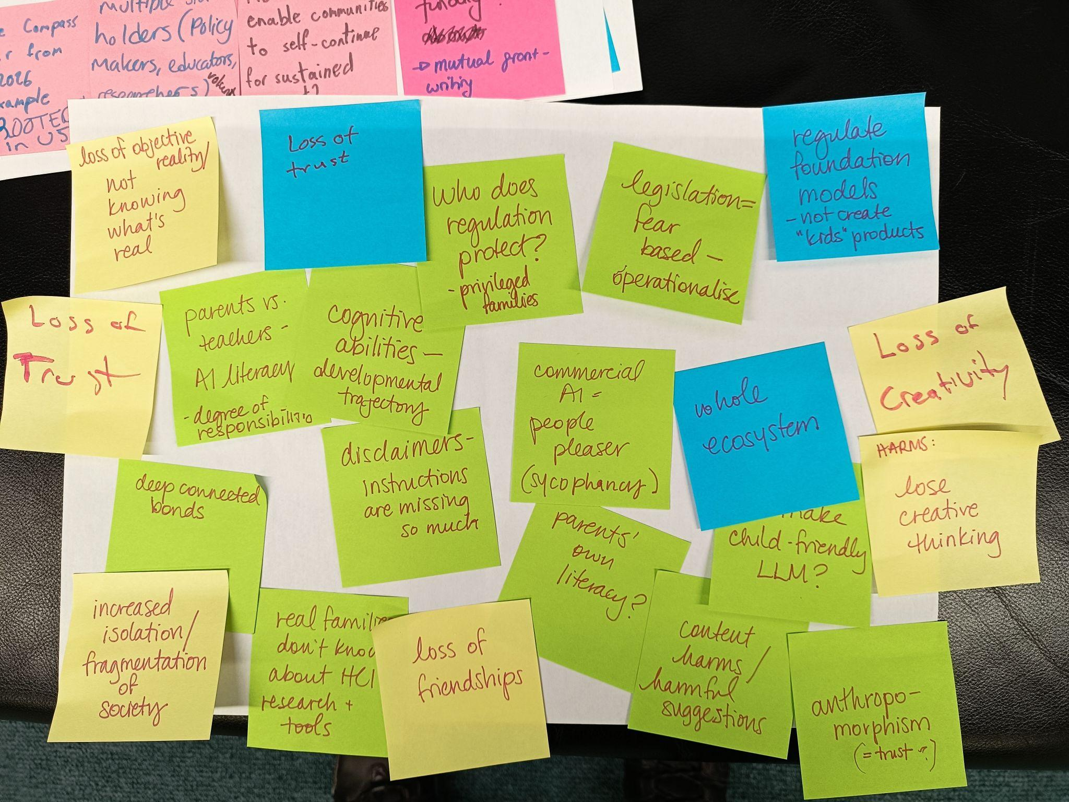
notes read "loss of objective reality / not knowing what's real", "Loss of trust", "Who does regulation protect? - privileged families", "legislation = fear based - operationalise", and "regulate foundation models - not create "kids" products". Further notes state "Loss of Trust", "parents vs. teachers - AI literacy - degree of responsibility", "cognitive abilities - developmental trajectory", "commercial AI - people pleaser (sycophancy)", "whole ecosystem", and "Loss of Creativity". The remaining notes read "deep connected bonds", "disclaimers - instructions are missing so much", "parents' own literacy?", "make child-friendly LLM?", "HARMS: lose creative thinking", "increased isolation / fragmentation of society", "real families don't know about HCI research + tools", "loss of friendships", "content harms / harmful suggestions", and "anthropomorphism (= trust?)"

This group discussion centred on the risks that AI tools pose to children’s agency and how those risks might be addressed. Participants grouped the concerns into two broad categories. The epistemic risks focused on a growing confusion about what is real, as deepfakes and synthetic content get more realistic. The social risks included the potential loss of human friendships and a wider erosion of trust in human relationships, driven by the way commercial AI systems are designed to please users - exhibiting sycophancy, unconditional positive regard, and constant availability that real relationships cannot match. Closely related were concerns about anthropomorphism and whether encouraging children to trust AI in this way is good design practice, given that a child's developmental stage may leave them unable to recognise the lack of genuine reciprocity in such interactions. Participants also raised broader worries about increased isolation and the fragmentation of society, a loss of creativity and creative thinking, and direct content harms such as harmful suggestions.

The discussion then turned to possible solutions, none of which the group found wholly satisfactory. The idea of building “child-friendly LLMs” was questioned on the grounds that children access general-purpose technologies regardless of restrictions, and that most "child-friendly" products sit downstream of foundation models, where the core problems remain. Regulating foundation models directly, for example by requiring content filters and disclaimers at the training stage, was likewise seen as limited, since disclaimers "are missing so much" and cannot compensate for a child's still-developing capacity for critical evaluation. A counter-argument held that legislation tends to be fear-based, hard to operationalise, and liable to protect only privileged families while leaving more vulnerable populations exposed. Participants discussed that a whole-ecosystem approach centred on AI literacy education is needed. This raised the question of whether parents or teachers should take primary responsibility for that education. Some noted parental literacy gaps and the mental overload many parents already carry. One participant observed that "real families don't know about HCI research and tools."

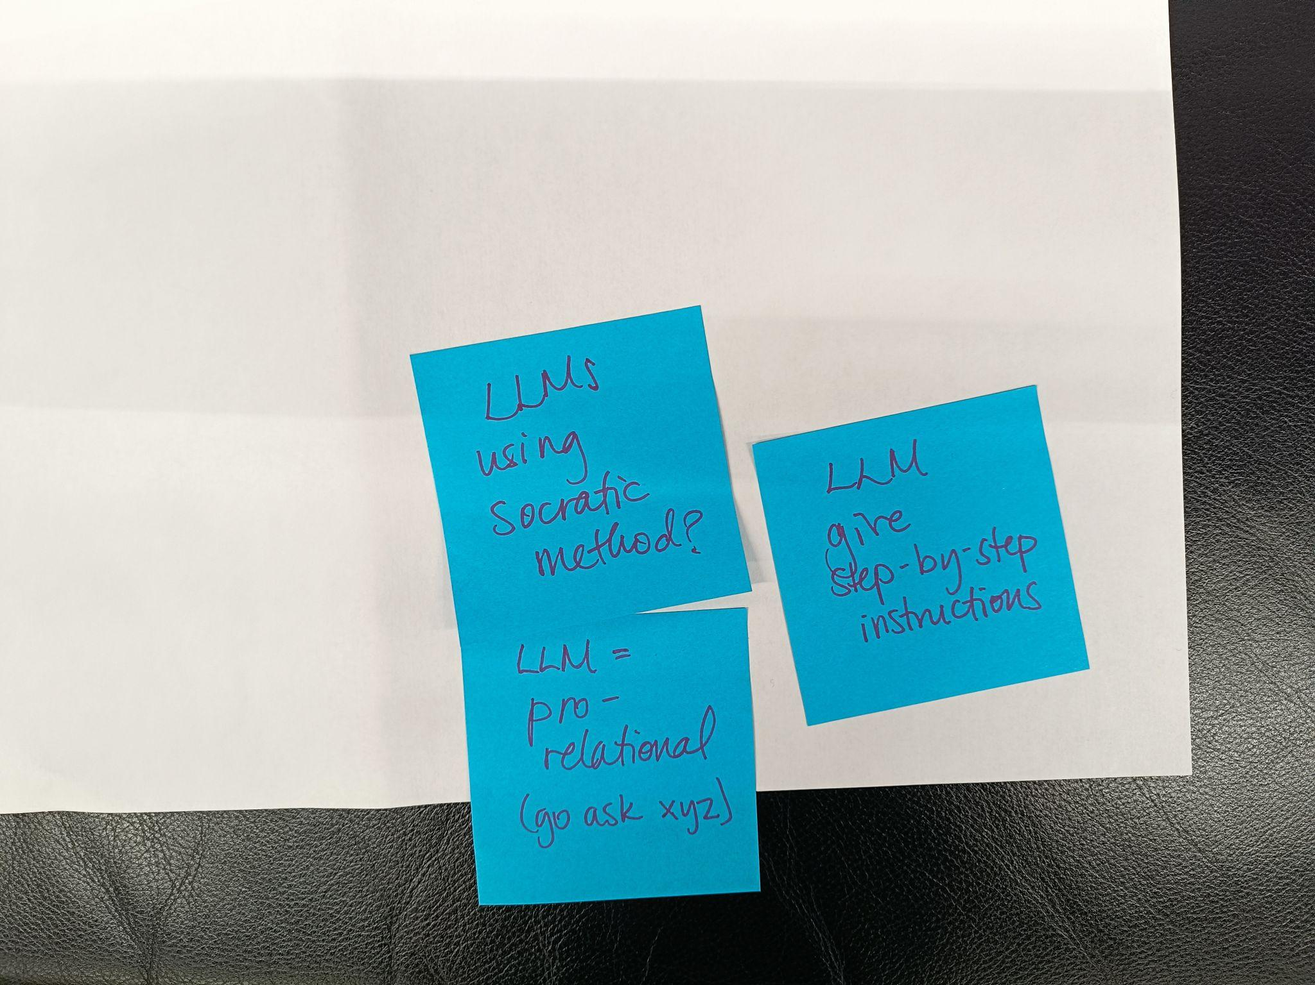
Notes read, "LLMs using Socratic method?", "LLM = pro-relational (go ask xyz)", "LLM give step-by-step instructions"

These notes go with the other post-its above. These were the culmination of the conversation - where the group landed when the time-boxed activity ended.
Rather than producing finished outputs on a child's behalf, an LLM could be configured to draw on the Socratic method, asking questions that prompt the child to think through a problem, and to offer step-by-step guidance that walks them through accomplishing a task themselves. The emphasis throughout was on keeping decision-making with the child: the system would help break a task down and clarify what the child actually wants help with, but leave the choices and the work to them. To guard against AI replacing human relationships, participants proposed a "pro-relational" LLM design in which the LLM would direct the child to consult a specific adult (e.g., teacher, parent, librarian, peer) for additional perspective on a situation or problem before offering its own “read”.

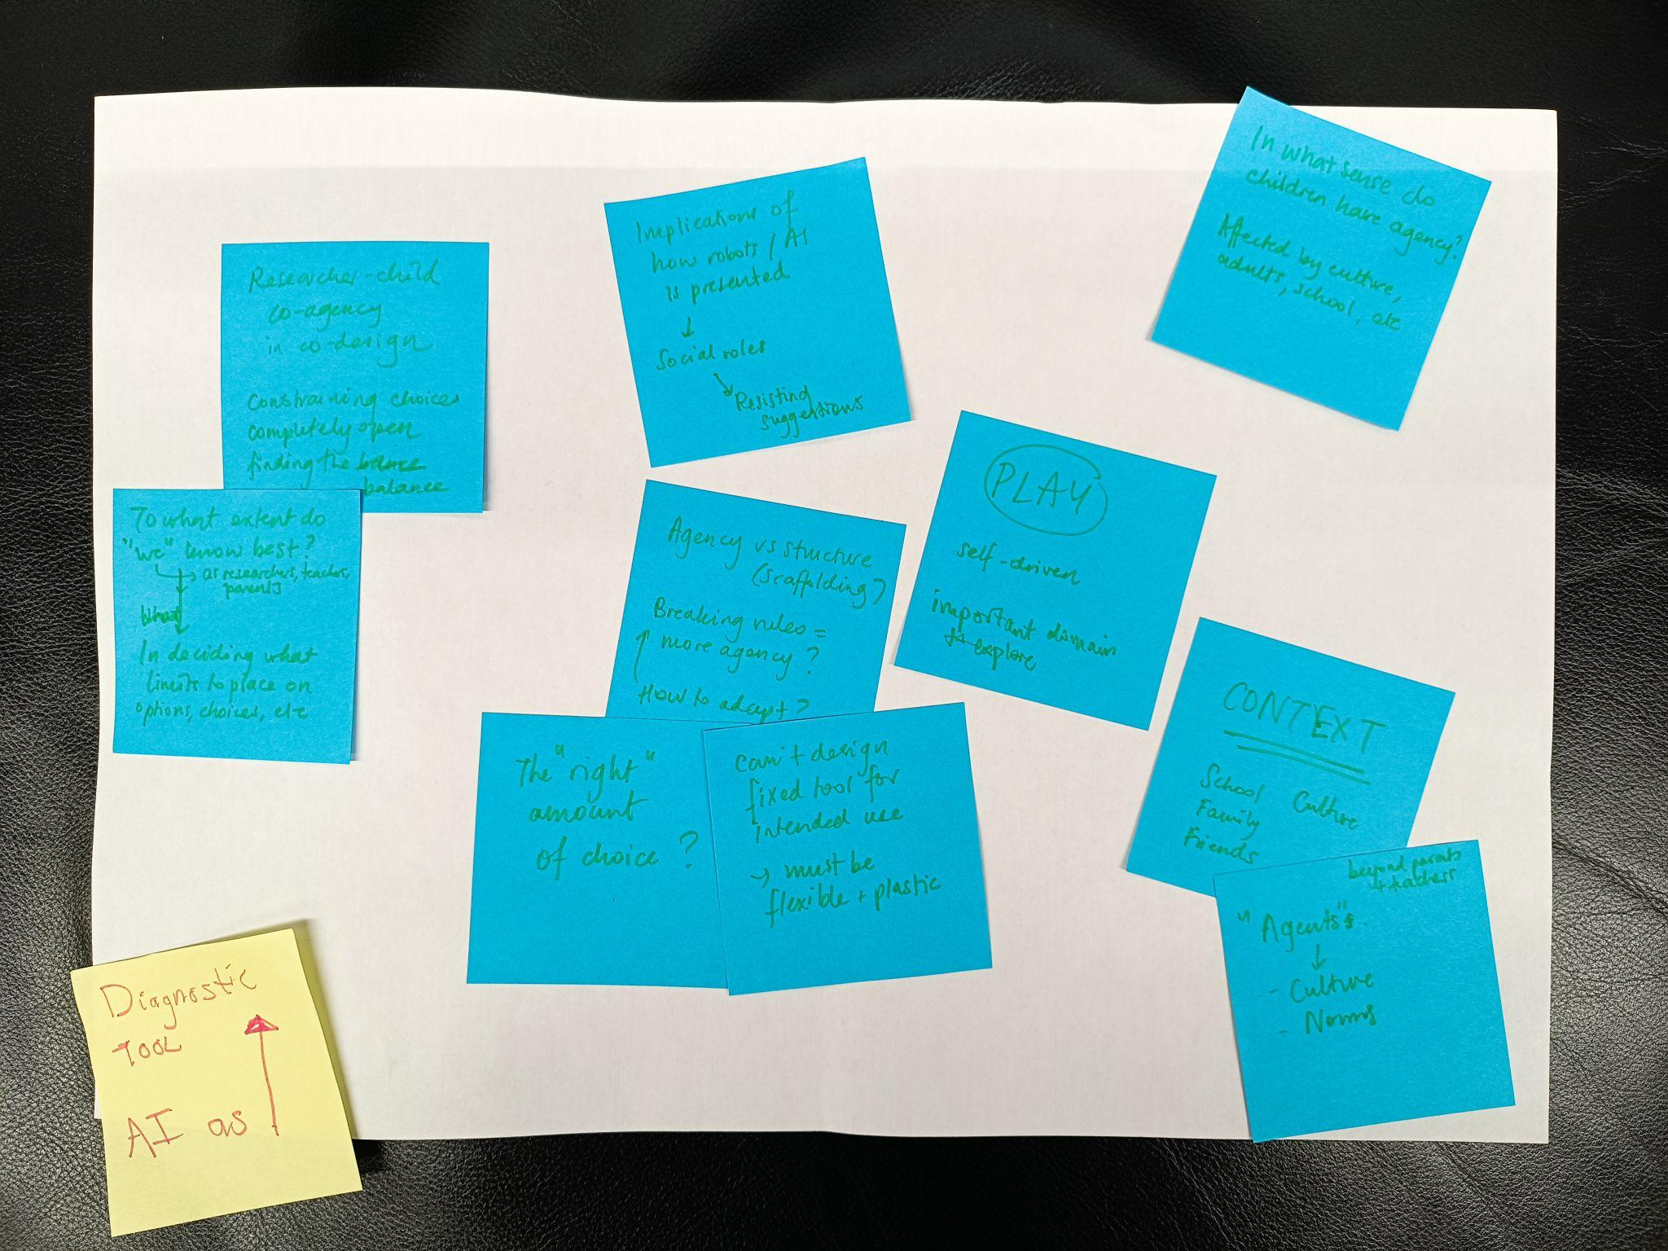
The single yellow note reads "Diagnostic TOOL AI as" alongside an upward-pointing arrow. The text on the blue notes includes "Researcher-child co-agency in co-design constraining choices completely open finding the sweet balance" and "To what extent do "we" (HCI researchers, teachers, parents) know best? in deciding what limits to place on options choices etc". Additional blue notes state "Implications of how robot / AI is presented -> Social voice -> Resisting suggestions", "Agency vs structure (scaffolding?) Breaking rules = more agency? How to adapt?", and "The "right" amount of choice?". The remaining notes read "Can't design fixed tool for intended use -> must be flexible + plastic", "In what sense do children have agency? Affected by culture, adults, school, etc", "(PLAY) self-driven important domain to explore", "CONTEXT School Culture Family Friends", and "beyond parents + teachers "Agents"? -> Culture - Norms".

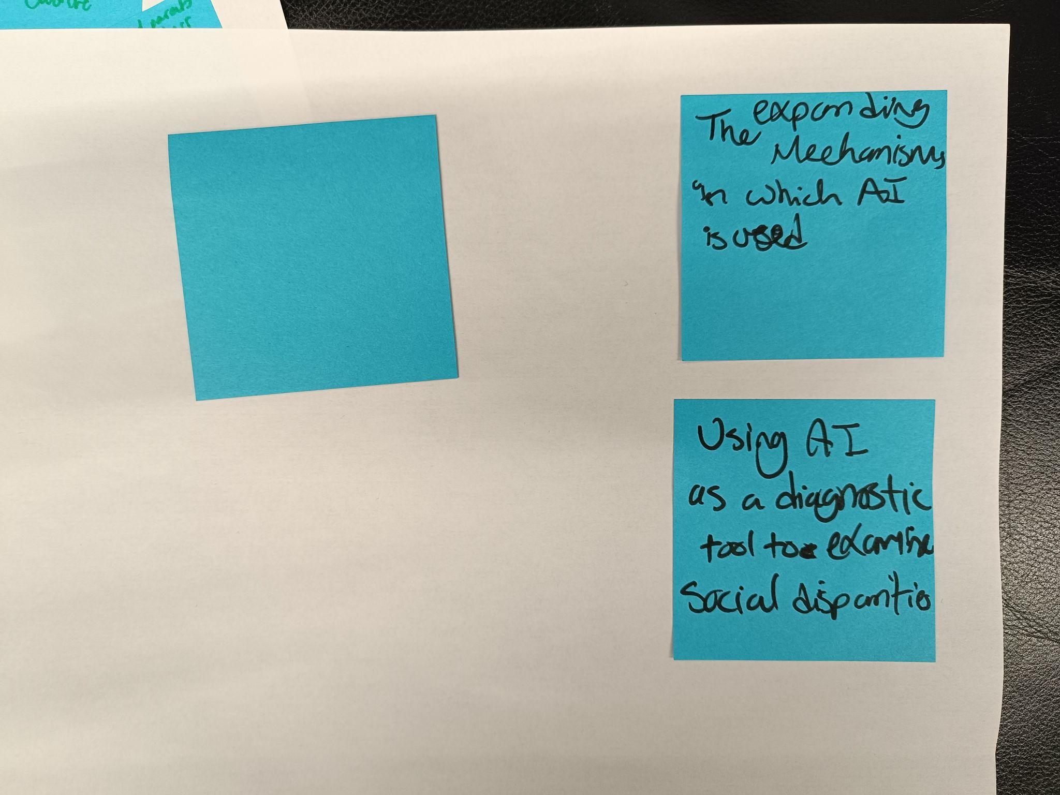
"The expanding Mechanisms in which AI is used"
"Using AI as a diagnostic tool to examine social disparities"

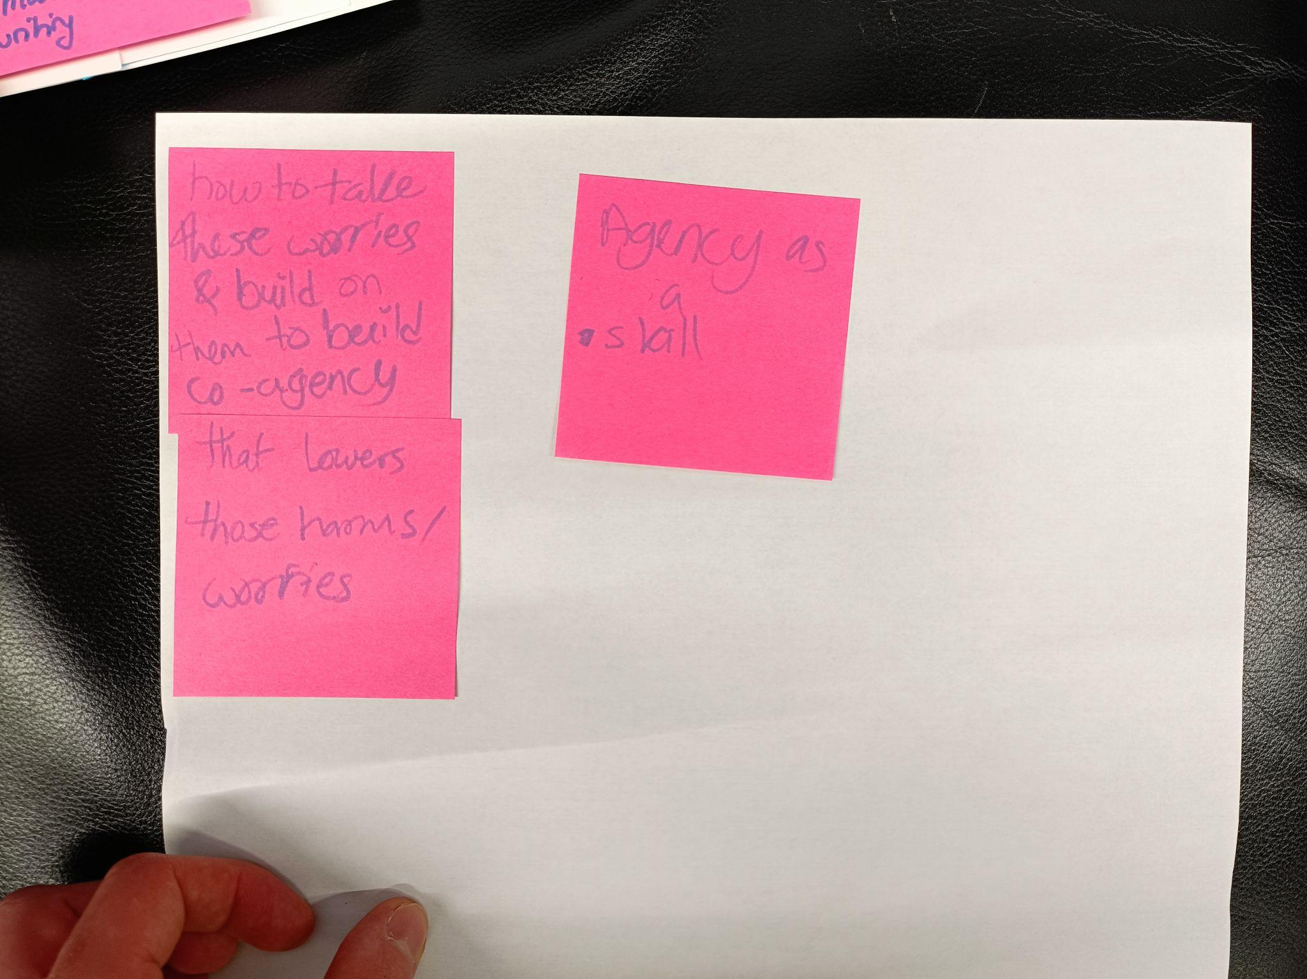
"how to take these worries & build on them to build co-agency"
"that lowers those harms/ worries"
"Agency as a skill"

Following the discussion of potential harms like erosion of trust and loss of creativity, we discussed what solutions might be. Education and experience surfaced as two top themes. We discussed learning critical AI literacy and information literacy, which allows learners to better know what information to trust and where to find reliable information. We also touched on agency being a skill that improves through practice, and thus the conjecture that making and enacting decisions helps people become better at this.

Outcomes and Next Steps

Workshop Resources
- Extended abstract: Child-Centred AI-Mediated Collaborative Agency by Design | Proceedings of the Extended Abstracts of the 2026 CHI Conference on Human Factors in Computing Systems
- All the submissions
- Workshop website (with accepted submissions and talk recordings): https://oxfordhcc.github.io/CAMCAD/
- Community Discord server: https://discord.gg/6kuHZdetEJ

Special Issue: Agency in Child-AI Interaction
Following the workshop, a Call for Papers has been launched for a special issue on Agency in Child-AI Interaction in the International Journal of Child-Computer Interaction. The special issue builds on the themes explored at CAMCAD 2026 and beyond; it covers agency more broadly – not just collaborative agency, and invites submissions from researchers and practitioners working at the intersection of child-computer interaction, AI design, and agency.
Submissions are open at: International Journal of Child-Computer Interaction | ScienceDirect.com by Elsevier

Relevant workshops at IDC 2026
There will be several relevant workshops at the IDC conference in June 2026. Some of the organisers and participants are planning to attend.
Workshop schedule: https://idc.acm.org/2026/attending/accepted-workshops/
Relevant workshops:
- C3AI: Where Do Trust, Design, and Evaluation Meet in Child–AI Interaction?
- Designing ethical and rights-respecting child-centred AI for learning
- Growing Up with Al: Approaches to Community-centered Al Literacy
- Frameworks in the Field: Considering Real Life Tensions When Designing AI for Children’s Wellbeing

Report contributors
- Vidminas Vizgirda, University of Oxford & University College London
- Hawra Rabaan, University of Maryland, College Park
- Jianing Wang, The Chinese University of Hong Kong, Shenzhen
- Khadija El Aadmi Laamech, Universitat Pompeu Fabra, Spain
- Christina Detsika, Fraunhofer FKIE, Germany

STUDENT AGENCY FOR 2030 | OECD Future of Education and Skills 2030

