Visibility data for verification of Gridding algorithms

# Introduction

This document very briefly summaries the inputs used to generate a first set of test visibilities for verification of gridding algorithms.

# Telescope model

These simulations made use of the SKA1 mid-combined telescope layout found in the SKA ECP register (https://skaoffice.atlassian.net/wiki/display/EP/ECP+Register). This telescope model has 254 antennas and a maximum baseline of approximately 200km. The antenna layout is plotted below.

Macintosh HD:Users:bmort:peter_bramm_scripts:verification:SKA1_mid_combined.eps

# Sky model

As these simulations are aimed at verification of gridding algorithms, a simple sky model of 7 sources arranged was chosen. This consists of:

* 1 source at the observation phase centre.
* 4 sources of the same Right Ascension as the phase centre, but with Declinations of +0.3, +0.6, +0.9, +1.9, and +2.9 degrees from the phase centre.
* 2 sources at the same Declination as the phase centre but with Right Ascensions of +0.2, and +0.4 from the phase centre.

# Observation settings

Two pointing directions were chosen for fictitious observation targets, which satisfy the condition of allowing a symmetric 6-hour observation of the target while staying at reasonably high elevation throughout. These are given in the table below.

|  |  |  |
| --- | --- | --- |
| Pointing ID | RA [deg] | Dec [deg] |
| 0 | -90.355 | -8.571 |
| 1 | -38.246 | -45.639 |

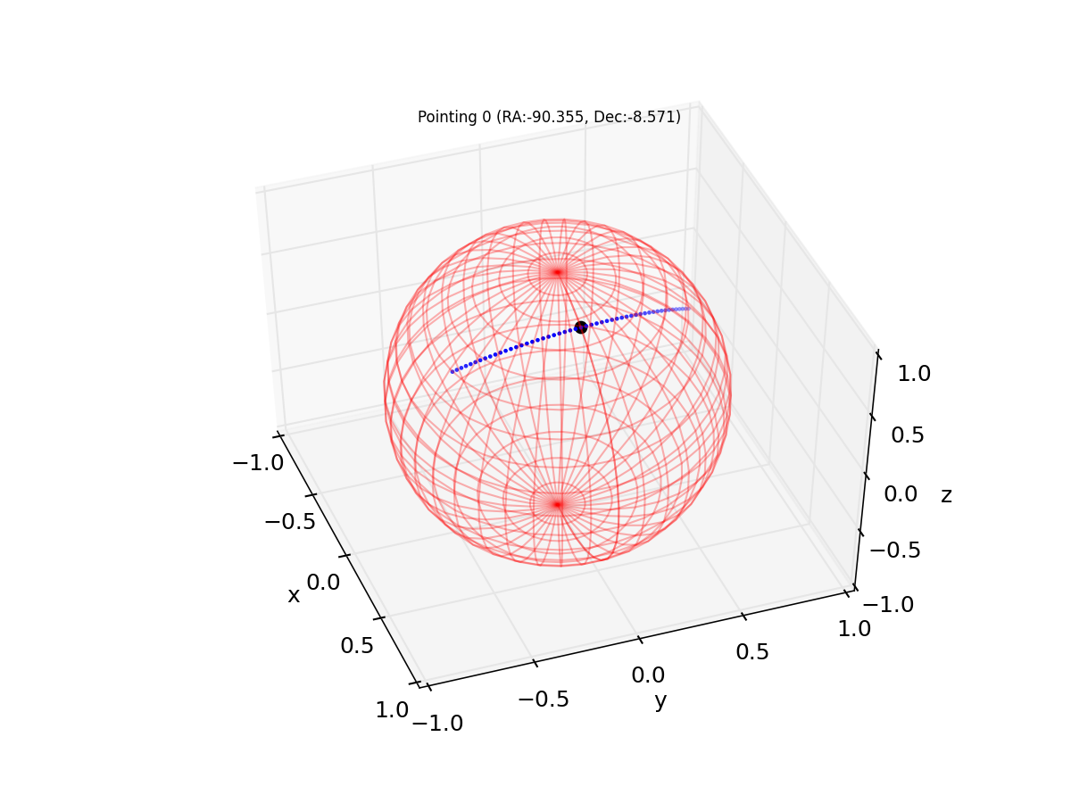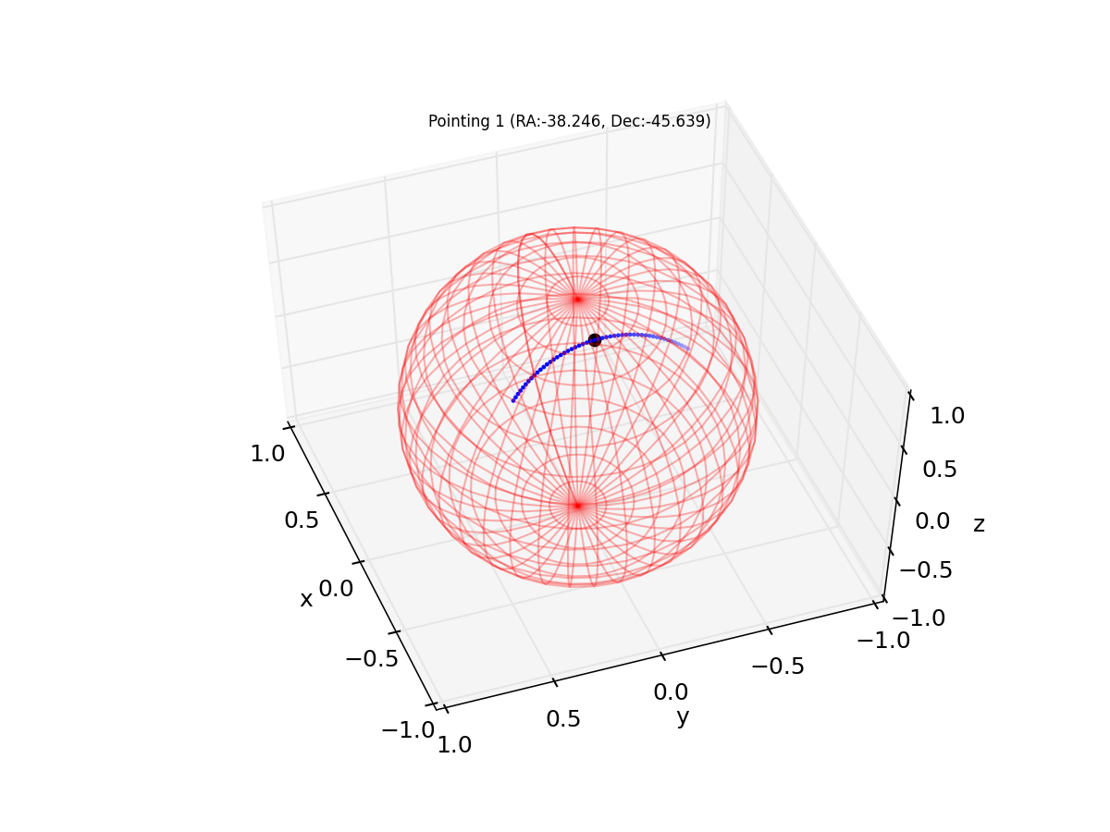

Figure 1: Locus of points representing a 6-h observation for the two pointings (right: pointing ID 0, left: pointing ID 1) described in the table above. Plots are in the Azimuth, Elevation co-ordinates. The black point represents the centre time for the observation.

In order to obtain a representative range of uvw-coordinates, three 16 second ‘snapshot’ observations where generated for each of the two pointings. These snapshot observations each consist of 200 0.08 second correlator dumps.

The three snapshots were taken and different sections of 6 hour observations to give an idea of the full range of uvw coordinates one might expect in snapshots from these type of observation.

* Snapshot 1 is at the start of the 6 hour observation where the source is low on the horizon.
* Snapshot 2 is 1.5 hours into the observation.
* Snapshot 3 is 3 hours into the observation at the point when the source is at its highest on the horizon.

The three tables below, give the start time, azimuth and elevation of the phase centre for three snapshots for each of the two pointing directions.

### Snapshot 1: Start of the 6 hour observation

|  |  |  |  |
| --- | --- | --- | --- |
| Pointing ID | Time [MJD UTC] | Az. [deg] | El. [deg] |
| 0 | 57086.113194 | 72.1 | 42.6 |
| 1 | 57086.257639 | 126.2 | 52.0 |

### Snapshot 2: 1.5 hours into the observation

|  |  |  |  |
| --- | --- | --- | --- |
| Pointing ID | Time[MJD UTC] | Az. [deg] | El. [deg] |
| 0 | 57086.175694 | 48.5 | 59.5 |
| 1 | 57086.320139 | 136.8 | 66.9 |

### Snapshot 3: 3 hours into the observation

|  |  |  |  |
| --- | --- | --- | --- |
| Pointing ID | Time[MJD UTC] | Az. [deg] | El. [deg] |
| 0 | 57086.238194 | 0.0 | 68.0 |
| 1 | 57086.382639 | 180.0 | 75.0 |

## Frequencies.

Two observation frequencies have been chosen, to be near each end of band-1 of the SKA-combined mid as described in the SKA baseline design document. These frequencies are:

1. 0.6 GHz
2. 1.0 GHz

# Visibility data files

Visibility data files generated are named using the following pattern:

test\_p<**pointing ID**>\_s<**snapshot ID**>\_f<**freq ID**>.<**extension**>

Where

* **Pointing ID** (either 00 or 01) and corresponds to the pointings in table in section **Error! Reference source not found.**.
* **Snapshot ID** (either 00, 01, or 02) corresponds to the observation snapshots described in sections 4.1.1, 4.1.2, and 4.1.3.
* **Frequency ID** is either 00 for the channel at 0.6 GHz, or 01 for the channel at 1.0 GHz
* **Extension** is either ‘**ms’** for Measurement Set format or **‘vis’** for OSKAR binary visibility block format.

The format of visibility binary files is something we may want to discuss in the very near future. The OSKAR binary format (\*.vis files) are in a new block format which will be officially available with oskar-2.6.x (to be released in a few weeks). Until then I would probably recommend using the Measurement Set format, which can be read with the casacore C++ library or with the CASA MeasurementSet or Table tools from Python. If you have major problems with that format let me know and I’ll see if I come up with a easy way for you to read the OSKAR binary data files from C or python.