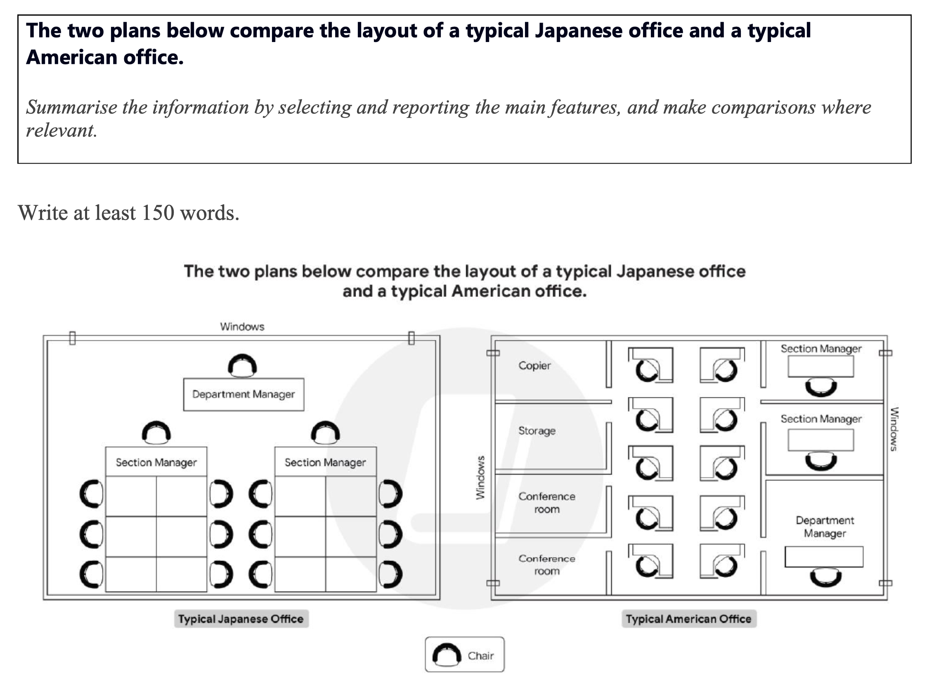
The diagrams compare the layouts of a typical Japanese office and a typical American office.
Overall, the Japanese office adopts an open and group-oriented layout that emphasizes teamwork, while the American office features a more compartmentalized structure, highlighting individual working spaces and functional zones.
In the Japanese office, employees are seated in clusters of desks arranged in two large rectangular groups, each supervised by a section manager who sits at one end of the group. The department manager sits separately at the front of the room, facing all staff members. This layout promotes visual supervision and encourages collaboration among team members.
By contrast, the American office is divided into small cubicles, with each employee having a personal workspace. Section managers and the department manager are located along one wall near the windows, away from the general working area. Additionally, the American office includes extra functional rooms such as two conference rooms, a storage area, and a printer/copier section, which are absent in the Japanese design.

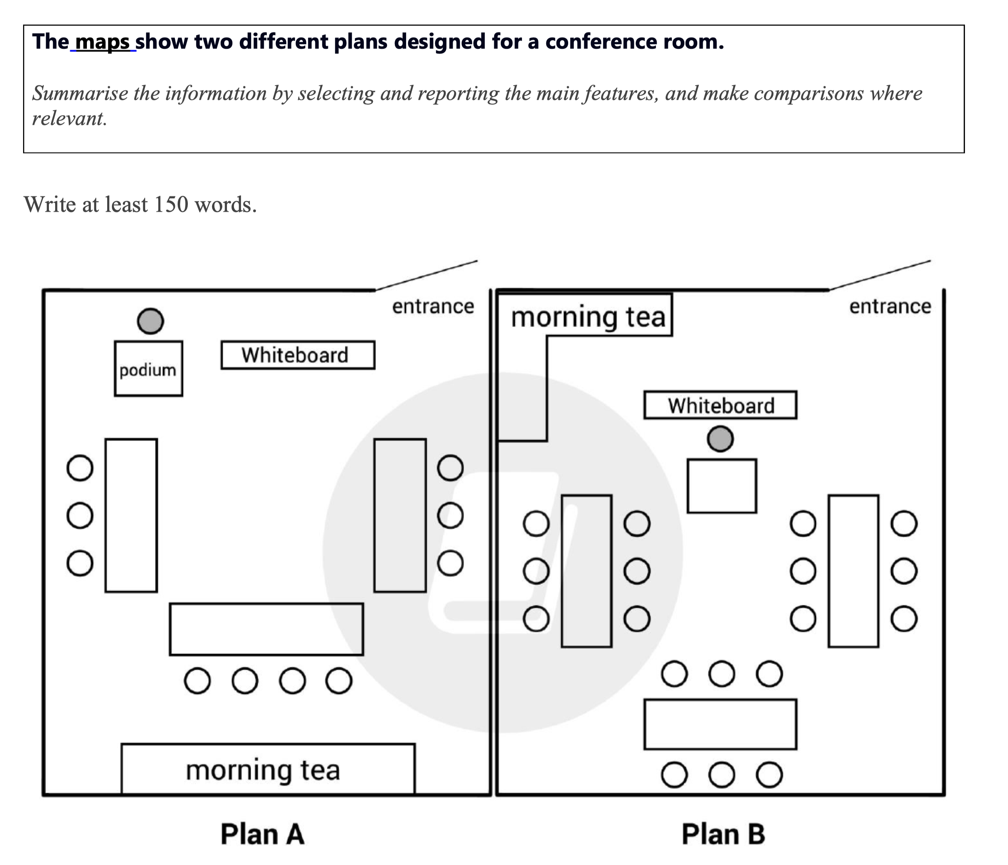

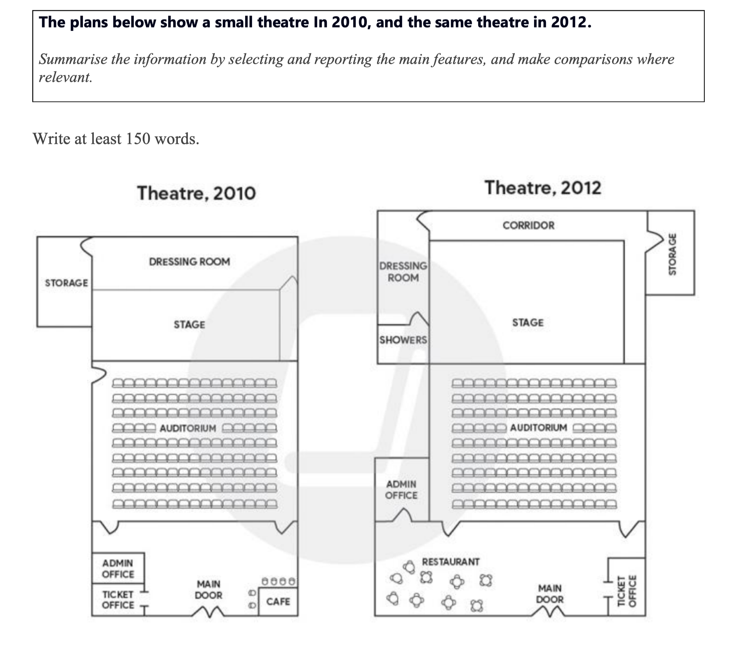
The two plans illustrate the layout of a small theatre in 2010 and the changes made to it by 2012.
Overall, several notable changes were made to the theatre over the two-year period, including the addition of new facilities and a rearrangement of some existing spaces, aimed at improving convenience and functionality.
In 2010, the theatre featured a stage and auditorium at its core, with a dressing room and storage area located behind the stage. The front section contained an admin office, a ticket office, and a small café to the right of the main entrance.
By 2012, the theatre underwent several modifications. The most significant change was the replacement of the café with a larger restaurant containing multiple tables. Additionally, a corridor was built behind the stage, creating better access to the storage area, which was relocated to the far right. A shower room was also added between the dressing room and stage, offering improved backstage facilities.
Despite these changes, the auditorium and main structural layout remained the same, indicating a focus on enhancing supporting amenities rather than altering the performance area itself.
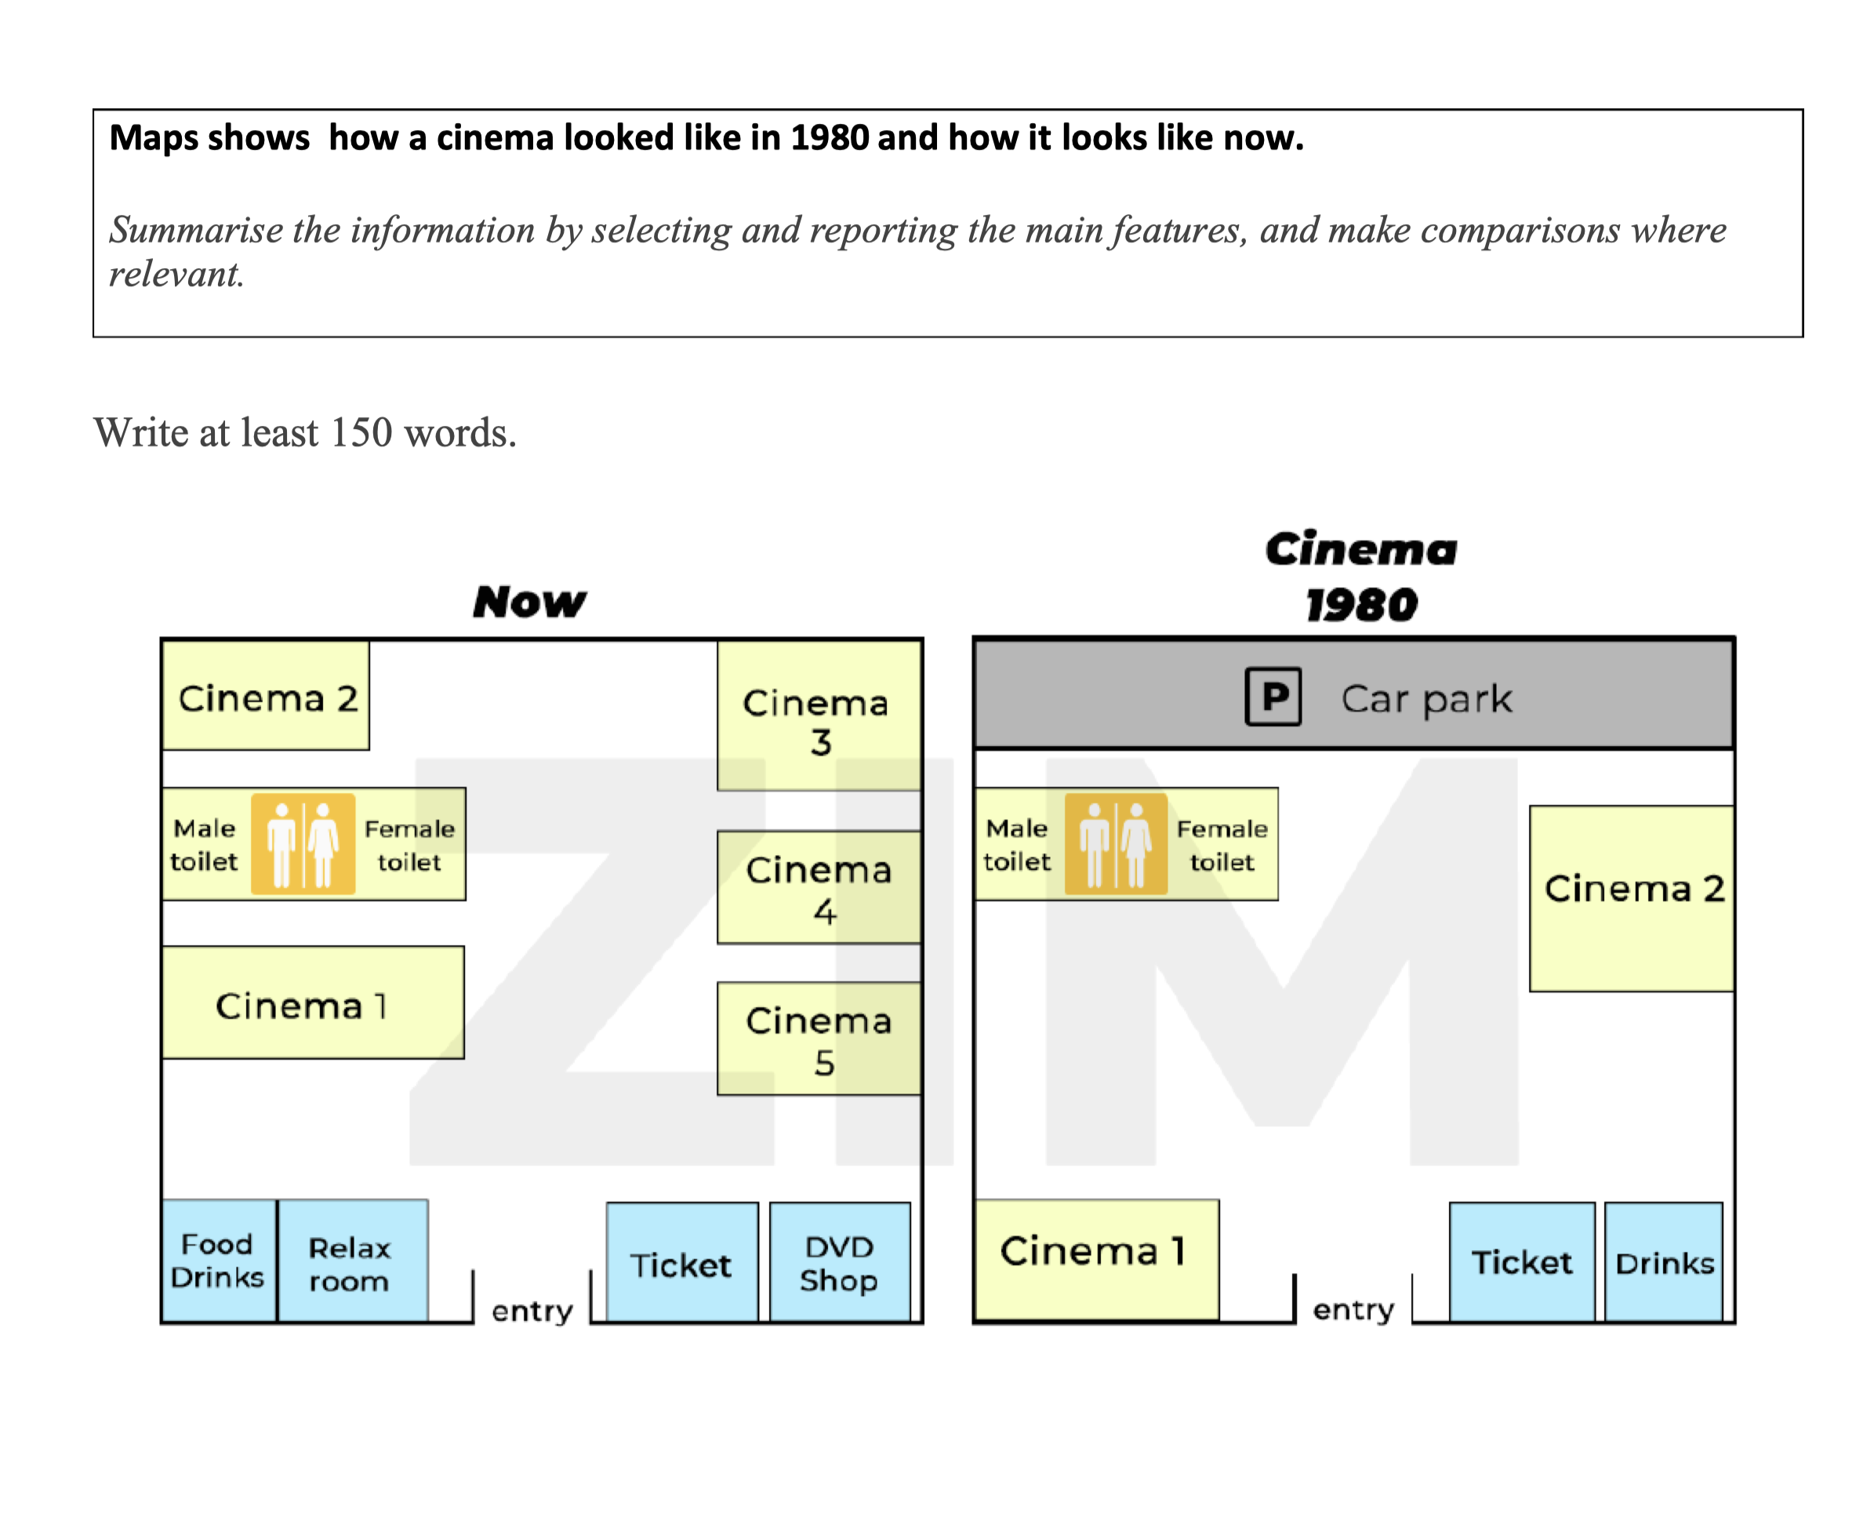
The two maps compare the layout of a cinema in 1980 with its current design.
Overall, the cinema has undergone significant development, with major changes including the removal of the car park, the addition of new cinema rooms, and a broader range of facilities for customers.
In 1980, the cinema had a relatively simple layout. There were only two screening rooms (Cinema 1 and 2), a ticket booth and drinks area located near the entrance, and a car park at the top of the map. Male and female toilets were positioned between the two cinema halls.
Currently, the car park has been removed and replaced by three additional screening rooms, bringing the total number of cinemas to five. The toilets have been relocated to the top-left corner. The drinks area has been expanded into a food and drinks section on the left side of the entrance, and a new relax room has been added next to it. Additionally, a DVD shop has replaced the old drinks area on the right-hand side of the entrance.

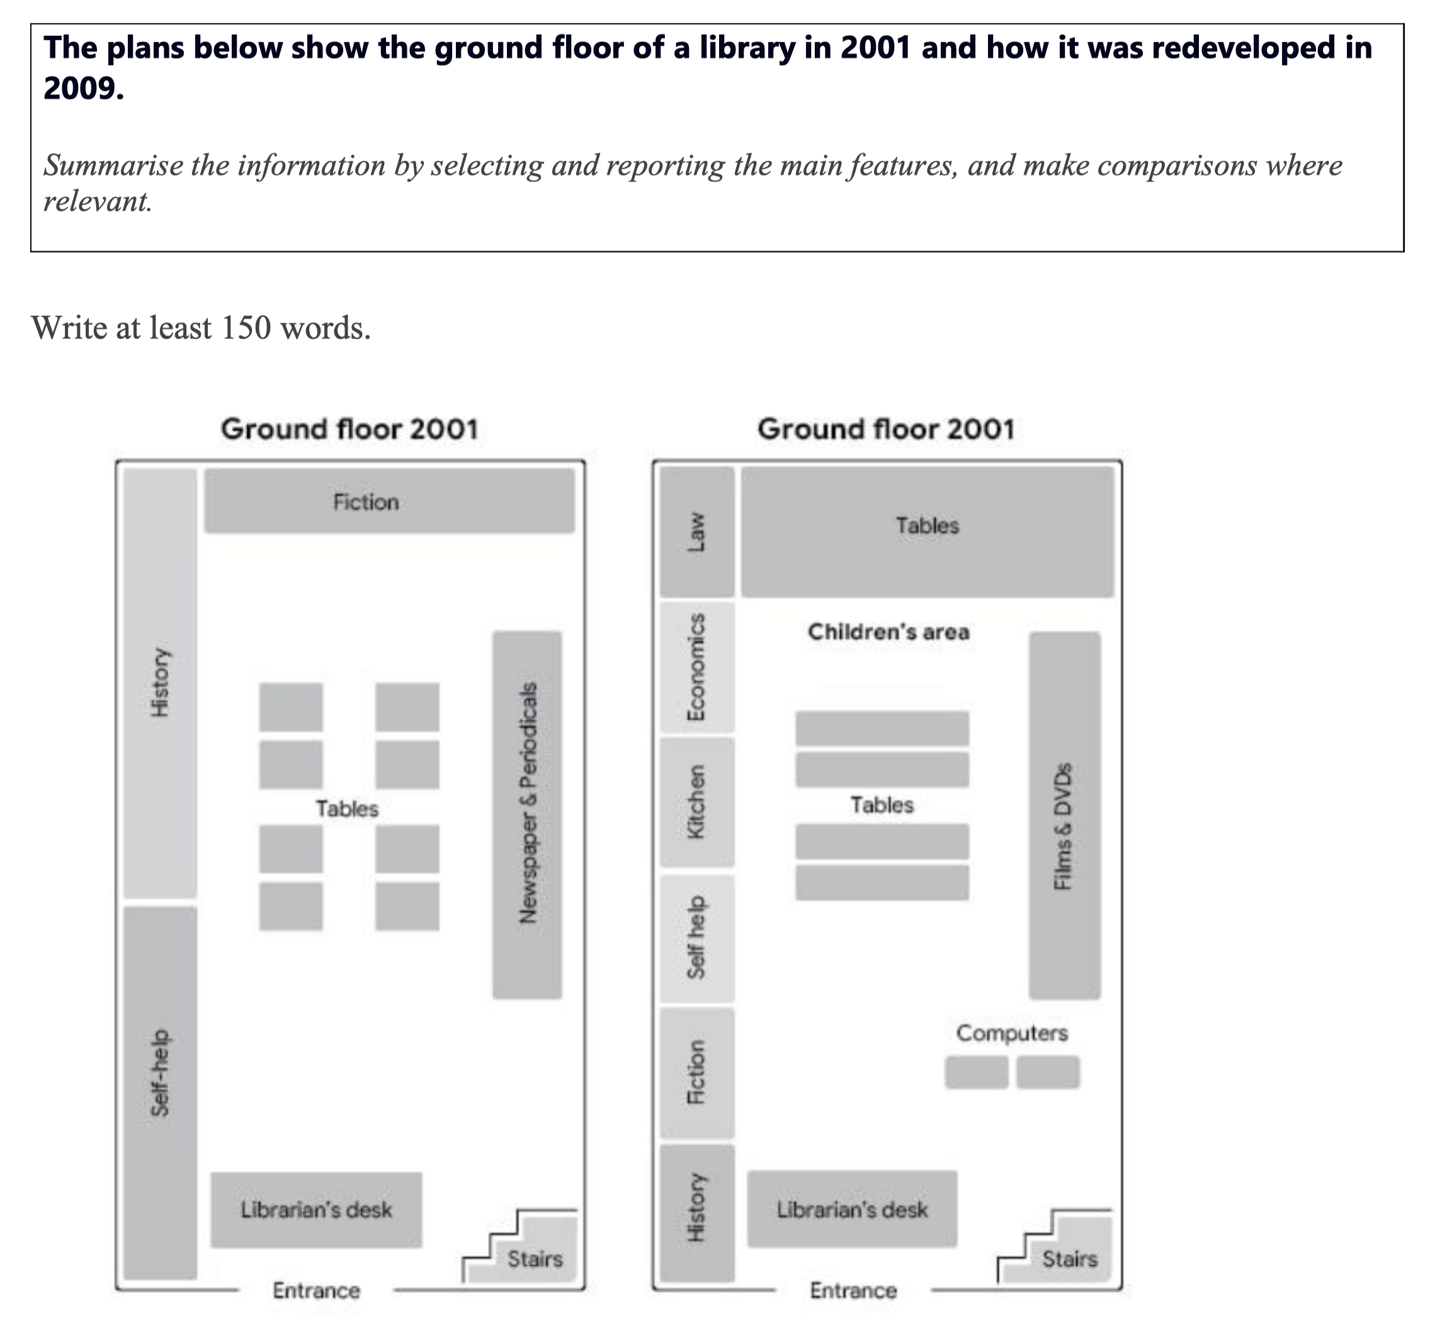

The two floor plans compare how the ground floor of a library was arranged in 2001 and the changes that were made by 2009.
Overall, the library underwent a significant transformation over the eight-year period, with the introduction of new sections such as a children’s area, computers, and a kitchen, while some original areas were relocated or replaced.
In 2001, the library had a relatively simple layout. The fiction section was located at the top, while history and self-help books lined the left wall. On the right side, there was a section for newspapers and periodicals. Four sets of tables occupied the central area, and the librarian’s desk was near the entrance. The stairs were in the bottom-right corner.
By 2009, the layout had become more diversified. The newspaper and periodicals area was replaced by a films and DVDs section, and computers were added next to it. The central tables were rearranged into three longer ones, with a new children’s area placed nearby. Several new book sections were introduced along the left side, including law, economics, and kitchen-related materials, while fiction and history were moved to the bottom. The self-help section remained but was relocated.

