
OKLAHOMA CHRISTIAN UNIVERSITY
CMSC 5713 · ARTIFICIAL INTELLIGENCE
REAL-TIME STYLE TRANSFER

SECTION 01

WHAT THE PROJECT DOES

This project turns any photo, or a live webcam feed, into a painting in the style of a famous artist. You give it a picture of your dog, then pick Van Gogh's The Starry Night, and shortly after, the image of your dog is regenerated in the style you chose, and how strong you chose it to affect the original photo.
It knows four styles, all widely known and able for me to use.
PAINTING | ARTIST | YEAR | WHAT IT LOOKS LIKE
The Starry Night | Vincent van Gogh | 1889 | Thick swirls, deep blue and gold
The Great Wave off Kanagawa | Katsushika Hokusai | 1831 | Woodblock print, curling lines, blue and cream
The Scream | Edvard Munch | 1893 | Wavy, uneasy strokes in orange and dark blue
Composition VII | Wassily Kandinsky | 1913 | Bright, chaotic, abstract color shapes

THIS IS NOT A BASIC MODEL!!!!
● One network, four styles. A single trained network paints all four styles and can blend any two of them with a slider, for example 70% Van Gogh and 30% Hokusai.
● Fast enough for live video. The pretraining happened on my GPU for 2 hours. After that, painting a new picture is one quick pass through the network.
● A real application. The finished model runs inside a simple web page with photo upload, webcam, style pickers and sliders.

SECTION 02

FIRST STEPS AND WHY

Before writing any model code, we made sure the computer could do the work and gathered the three ingredients the model learns from.

STEP 1: CHECK THE GRAPHICS CARD
Training a neural network means billions of small multiplications. A graphics card (GPU) does these way better than a CPU, because it can do them in parallel. Our machine has an NVIDIA RTX 5080.
I wrote scripts/check_gpu.py to make sure you don’t crash your computer. It does not just ask "is there a GPU?"; it runs a calculation on the graphics card, ours passed with a 3.2 millisecond per calculation time.

STEP 2: DOWNLOAD VGG16
VGG16 is an image-recognition network published in 2014 by Oxford University's Visual Geometry Group (that is where "VGG" comes from). The "16" is its number of learned layers. It was trained on ImageNet, a collection of about 1.2 million labeled photos in 1,000 categories, to answer "what is in this picture?"
To get good at that, its layers learned to spot visual features in stages: early layers react to edges and colors, middle layers to textures and patterns like brush strokes, and deeper layers to object parts like eyes or wheels. That ladder of features is exactly what we need to compare a painting to a photo.

WHERE WE FOUND IT
VGG16 comes built into torchvision, PyTorch's official image library. Its trained weights (vgg16-397923af.pth) download automatically from PyTorch.

WHY WE USED IT
● VGG judges our generations. VGG16 never changes during our project. It only measures how close an image is to the photo and to the painting. Reusing a network trained for another job like this is called transfer learning. (Flashback to week 1 of our class)
● It is good at texture. Its middle layers capture brush strokes and patterns well. Newer networks such as ResNet are better at naming objects but are known to work worse as style judges.
● It is free to train. Since VGG16 is already trained, we skipped weeks of training and only train our own, much smaller painter network.

STEP 3: THE OTHER TWO INGREDIENTS
● Four paintings. Downloaded our paintings we used from Wikimedia Commons.
● 5,000 everyday photos from COCO. The practice material, explained in the next section.
SECTION 03

FIRST MODEL TRAINING

WHAT COCO IS
COCO stands for "Common Objects in Context." It is a free, widely used collection of everyday photos, released in 2014 by a research team led by Microsoft: people, food, streets, animals and rooms, shot by ordinary photographers. We used its 2017 validation set of 5,000 photos.
Why everyday photos? The “painter” (our model) will work on anything a user might upload, so it practices on a wide mix of real scenes. We kept 4,800 photos for practice and set 200 aside, never shown during training, so we can later test the model on pictures it has never seen.

WHAT THE JUDGE DOES
For every attempt the painter makes, the judge (VGG16) looks at three images: the original photo, the painter's attempt, and the painting. It gives the attempt three scores, and lower is better for each:
SCORE | QUESTION IT ANSWERS | HOW IT IS MEASURED
Content | Is it still the same picture? | Compares VGG16's mid-level features of the attempt and the photo
Style | Does it look like the original downloaded painting? | Compares which textures appear together at four VGG16 layers
Smoothness | Is it free of pixel noise? | Penalizes big jumps between neighboring pixels

The three scores are added into one total using weights from the settings file. The painter is then nudged in whichever direction lowers that total.
The style score uses Gram matrix, another topic we learned recently. It remembers features that show up TOGETHER like “blue and swirly” for the Tsunami painting. It doesn’t record WHERE they appear, though, so we’re not just applying a filter to a photo, we’re actually generating it in its own style.

HOW WE BUILT THE PAINTER
The painter (TransformNet, in model.py) is a network of about 1.69 million adjustable numbers. It works in three stages:
01 Shrink. Three layers squeeze the photo down to a quarter of its width and height, keeping its main shapes.
02 Repaint. Five "residual blocks" restyle that compact version. Most of the painting happens here.
03 Grow back. Two layers enlarge it to full size and a final layer turns it back into colors.

THE 1-MINUTE TRAINING
Before committing hours of GPU time, I ran a short trial of 1,000 practice rounds of 8 photos each, on all four styles. It confirmed:
- The whole pipelines runs
- The score weights are sort of balanced by default
- The output is neither barely changed or a random smear
MEASURE | ROUND 100 | ROUND 1,000
Content score | 924,558 | 687,914
Style score | 3,050,682 | 433,510
Speed (photos per second) | 47 | 131

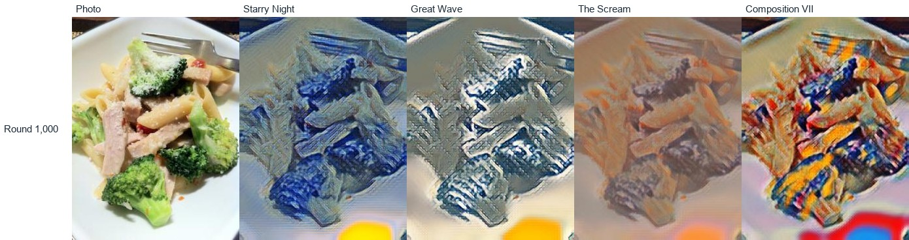

The trial finished and both scores dropped quickly, and after only 1,000 rounds each style already had its own palette while the pasta and broccoli stayed recognizable. That showed the starting weights (content 1e5, style 1e10, from PyTorch's reference example) were sensible, so we kept them. Speed rose from 47 to 131 photos per second as the GPU warmed up, which let us predict that a full run of 40,000 passes would take about 3 hours.

MAKING IT REPEATABLE ON ANOTHER COMPUTER
Anyone with an NVIDIA graphics card should be able to clone the repository and get the same kind of result. That is handled by:
● Step-by-step setup in the README: install PyTorch, install requirements.txt, run check_gpu.py.
● One command for the photos: scripts/download_coco.py downloads and unpacks the 5,000 photos, and is safe to run twice. VGG16 downloads itself. The paintings ship inside the repository.
● One settings file: every number lives in configs/default.yaml, including a fixed random seed (42), so the photo order and starting values are the same on every run.
● Settings saved with results: each run writes a copy of its exact settings next to its trained model, so any result can be traced back and rerun.
● Tests: running pytest confirms the scoring math and the painter behave correctly on the new machine.
SECTION 04

FULL MODEL TRAINING

WHY WE RAN IT
The full run did 40,000 rounds. At 8 photos per round, that is 320,000 practice paintings, or about 67 passes through the 4,800 practice photos, with each pass using different random crops and a different random style for each photo.

WHAT WAS HAPPENING DURING THE 30 MINUTES
The GPU repeated this same loop 40,000 times:
01 Take 8 practice photos and cut a random 256 x 256 square from each.
02 Give each photo a random style, so every round practices all four styles a little.
03 The painter paints all 8.
04 The judge scores each painting for content, style and smoothness.
05 Work out how each of the 1.69 million numbers in the painter should change to lower the scores (this is called backpropagation), and adjust them slightly.

Along the way, the script saved the scores every 100 rounds (log.csv), painted one held-out photo in all four styles every 1,000 rounds (the 40 images in samples/), and saved the model every 5,000 rounds so a crash would not lose everything.

WHAT THE SCORES DID
Average scores over a window of rounds (lower is better):
ROUNDS | CONTENT SCORE | STYLE SCORE | TOTAL
100 – 1,000 | 744,567 | 978,311 | 1,722,878
9,000 – 11,000 | 427,503 | 177,725 | 605,229
19,000 – 21,000 | 375,941 | 151,790 | 527,732
21,000 – 23,000 | 377,791 | 148,377 | 526,168
23,000 – 25,000 | 358,056 | 139,544 | 497,600
29,000 – 31,000 | 358,909 | 137,004 | 495,913
38,000 – 40,000 | 373,619 | 140,913 | 514,532

Most of the learning happened early: the total fell about 65% in the first 10,000 rounds. After that the painter kept refining, with one more noticeable step down around rounds 23,000 to 25,000, and then the scores levelled off. The small rise at the very end is normal and not the model getting worse.

WHAT WE SAW AROUND ROUND 23,000
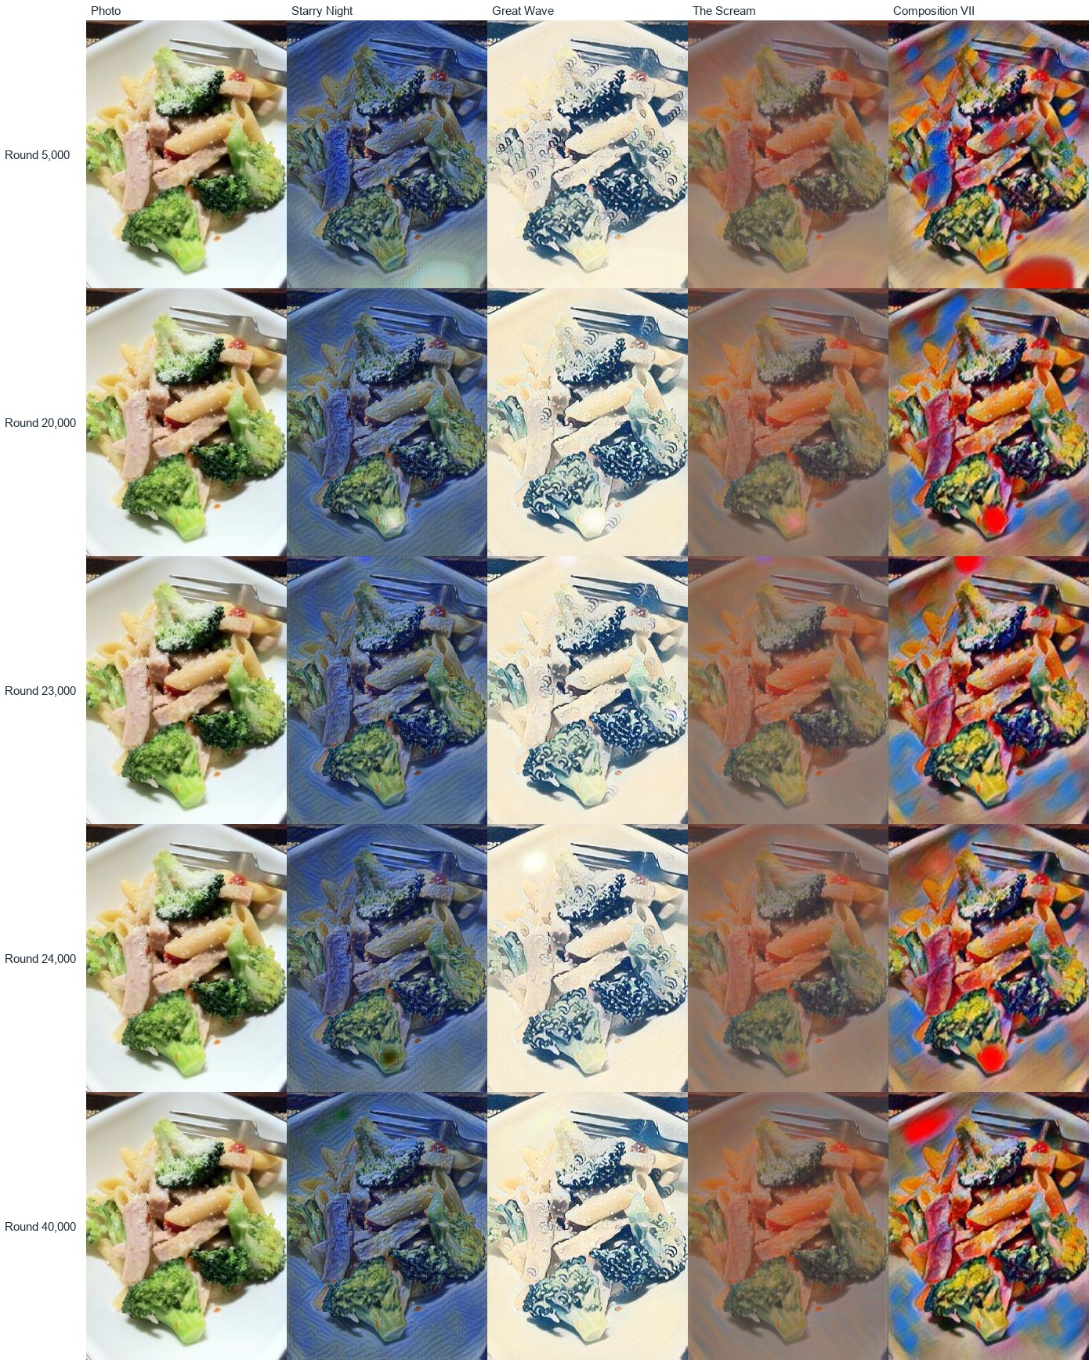
Watching the sample images, we noticed that around round 23,000 the random white "hot spots" faded and each painting's own character came through more clearly, specifically the curls of the waves on the broccoli (the third image in the row)
The round-23,000 sample is the cleanest so far: the Starry Night, Great Wave and Scream frames have no spots, and the scores show their last real drop between rounds 23,000 and 25,000.
But the spots did not go away for good. A light spot appears in Great Wave, and a dark spot appears in starry night, around 24,000 iteratrions. There are also red blobs throughout the Kandinsky paintings.
The spots happen due to normalization. We shrunk the photo, and during resizing, the layers are scaled by its own average brightness, and the network can learn to make a bright spot to steer the whole image towards its ideal total brightness. The AI world calls them droplet artifacts.

WHY THE RESULT WAS SIGNIFICANT
● One 6.8 MB network learned all four styles in a short timeframe on a single home graphics card.
● All four styles came out clearly different, and the content stayed recognizable in every one.
● It proved the whole approach works end to end, so everything after this is improvement, not rescue.
Its one weakness: the styles were mild. Starry Night had the right blues but almost none of its signature swirls.

MULTISTYLE VS. STYLE3E10 EXPERIMENTATION
We ran these tests through multistyle and Style3e10. Style3e10 has 3 times stronger weights than multistyle, as shown in the chart below.
The only setting that changed is the style weight, which controls how much the judge's style score counts compared with the content score.
 | MULTISTYLE_40K | STYLE3E10_40K
Style weight | 1e10 (the default) | 3e10 (3 times stronger)
Rounds, time | 40,000, 32.1 min | 40,000, about 32 min
Content score, last 2,000 rounds | 373,619 | 528,494 (photo changed more)
Style match, before weighting | 140,913 | 74,207 (about twice as close)
Look | Clean, mild, photo-like | Clearly painted, still recognizable

The scores cannot be compared directly, because the 3e10 run multiplies its style score by 3. Dividing that back out shows the stronger model matches the paintings about twice as closely, and pays for it by changing the photo more. That trade-off is exactly what the setting is supposed to do.
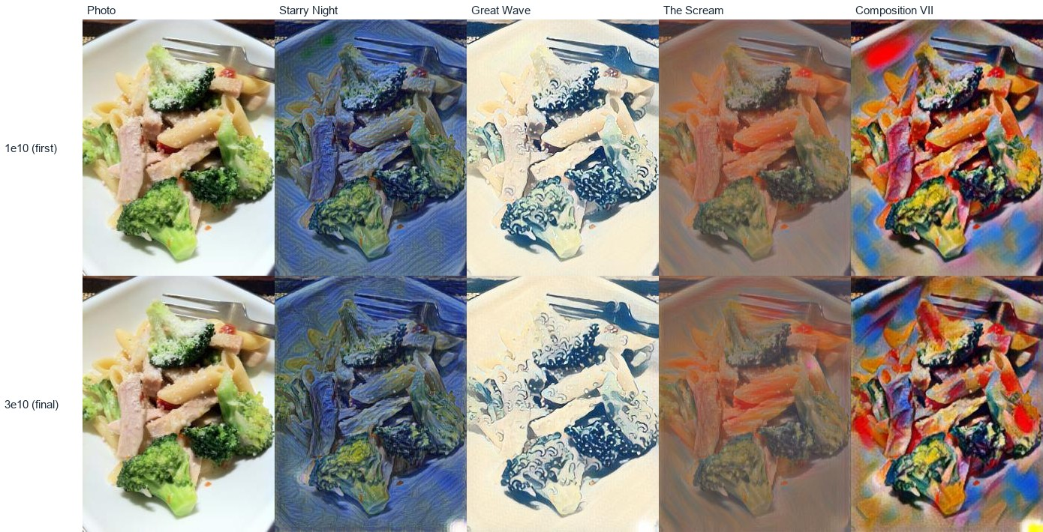

WHY WE CHOSE STYLE3E10
- It looks more like the paintings
- The original image looks the same
  - The pasta, broccoli and fork are all still easy to recognize.
- It is the safer choice for the app.
  - The app's strength slider can always tone a strong style down, but it cannot add style the model never learned.
The 3e10 model was copied to weights/final.pth (6.8 MB), the one model file the repository is set up to publish. It still shows an occasional small bright spot, so that remains on the improvement list.
SECTION 05

WHERE THINGS STAND

Done: environment check, the three ingredients, the judge, the painter, two full training runs, the final model choice, the slow Gatys comparison method, and the inference code that paints and blends images.
Next: the evaluation script for official speed and quality numbers and report figures, the web app with webcam, and the report and demo recording.

Every number in this log comes from a saved run in the runs/ folder. Thank you for reading carefully.

