1) Table PATIENT has columns PATIENT_ID, FNAME, and LNAME. Write a query that will identify duplicate PATIENT_IDs in the table PATIENT. The query should return all three columns and include all rows where the PATIENT_ID shows up more than once in the table.

Answer: USED MSSQL SERVER

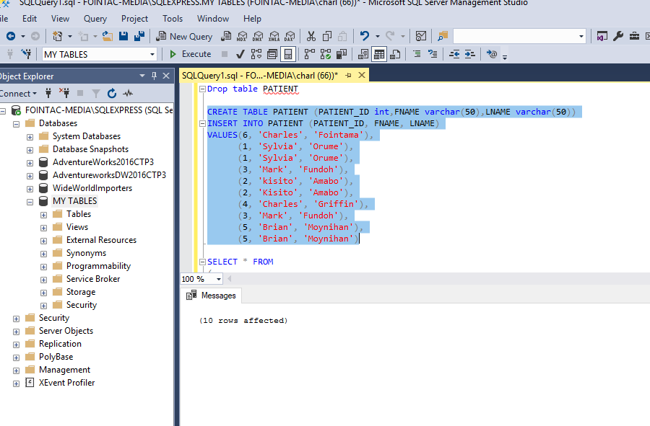

Mine:

select patient_id, FNAME, LNAME --, count (patient_ID)

from PATIENT

group by patient_ID,FNAME,LNAME

having count(patient_ID) > 1

CREATE TABLE PATIENT (PATIENT_ID int,FNAME varchar(50),LNAME varchar(50))

INSERT INTO PATIENT (PATIENT_ID, FNAME, LNAME)

VALUES(6, 'Charles', 'Fointama'),

(1, 'Sylvia', 'Orume'),

(1, 'Sylvia', 'Orume'),

(3, 'Mark', 'Fundoh'),

(2, 'kisito', 'Amabo'),

(2, 'Kisito', 'Amabo'),

(4, 'Charles', 'Griffin'),

(3, 'Mark', 'Fundoh'),

(5, 'Brian', 'Moynihan'),

(5, 'Brian', 'Moynihan')

SELECT * FROM

(

SELECT *,

COUNT(*)OVER(PARTITION BY (PATIENT_ID )) AS DUPLICATE_COUNT

FROM PATIENT

) AS MAIN

WHERE MAIN.DUPLICATE_COUNT > 1

/* OR */

SELECT DISTINCT * FROM PATIENT

WHERE PATIENT_ID IN

(

SELECT PATIENT_ID FROM PATIENT

GROUP BY PATIENT_ID

HAVING COUNT(1) > 1

)

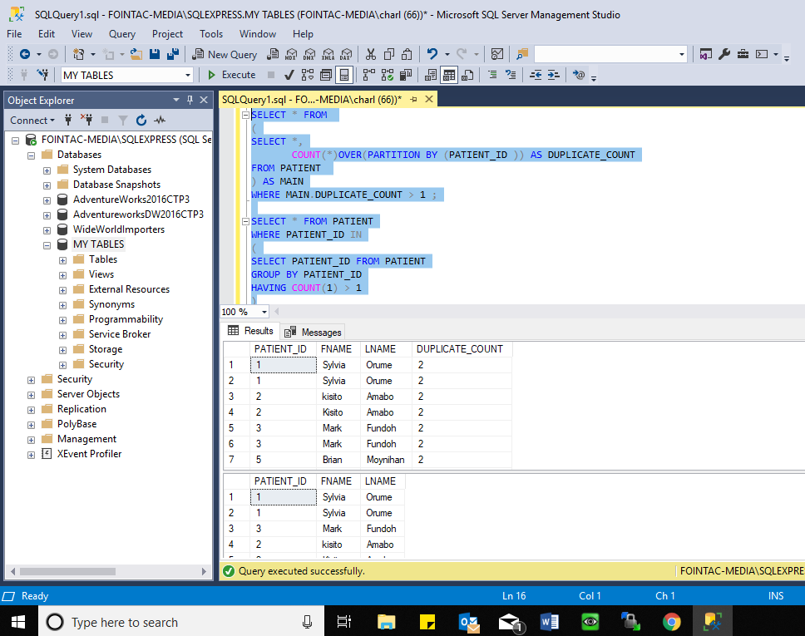

2) Write a delete statement to remove the duplicates on PATIENT_ID. It does not matter which duplicates are deleted but the table must be unique on PATIENT_ID after the delete statement.

Answer:

Mine:

begin tran aaa; (эта транзакция бужет тут начата)

with newtable as (

select *,

row_number() over(partition by patient_ID order by patient_ID ) as row#

from patient)

delete from newtable

where row#>1

rollback tran aaa (эта транзакция откатана назадю Тюею результат тебе показан, но изменения не были внесены)

WITH CTE AS

(

SELECT *,

RN = ROW_NUMBER()OVER(PARTITION BY PATIENT_ID ORDER BY PATIENT_ID)

FROM PATIENT

)

DELETE FROM CTE WHERE RN > 1

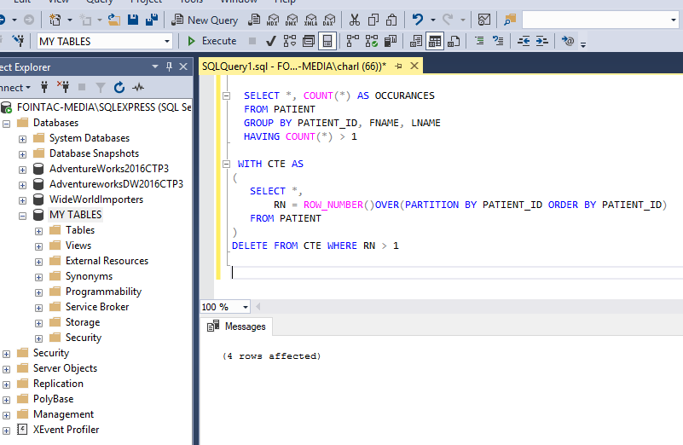

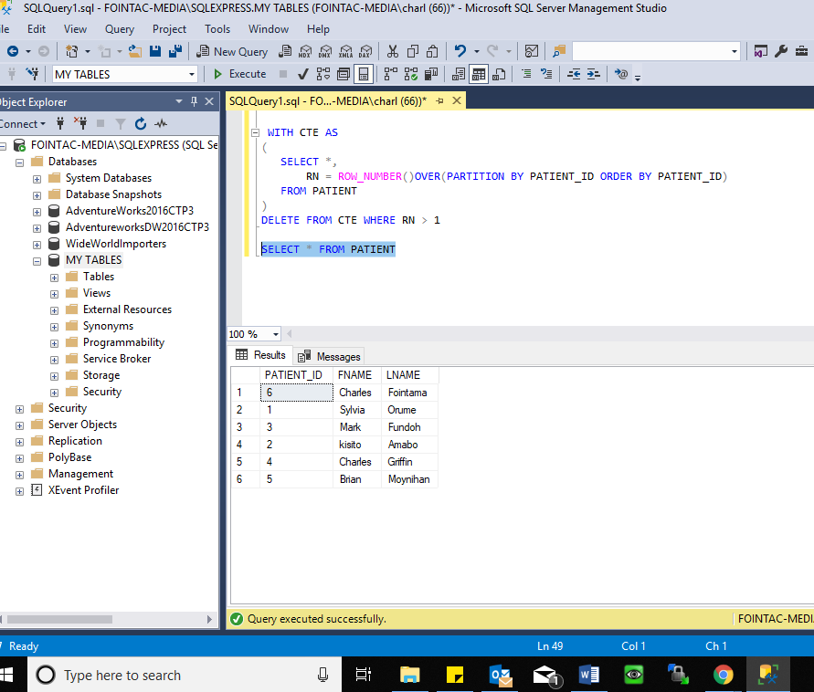

3) Read the below SQL Select * from patient, orders Where patient.patient_id = orders.patient_id (+) And orders.order_type = 705

What type of join is in the above query?

This looks like a very old sql statement but looking at the properties and since we have to return only a matching row, this will be an **INNER JOIN**

4) Two tables, TABLE_A and TABLE_B have the same structure. There are no constraints on either of the tables. How can you verify that TABLE_A and TABLE_B contain the same data.

Answer:

Mine:

Count * table A, count * table B, Должны быть равны.

Затем делаем union (по факту это вертикальное объединение без дублированияю Затем в Union table считаем count – оно должно быть такое же, как и в изначальной таблице.

count(Table_A) = (Count Table_B) = Count(Table_A Union Table_B)

I Will first perform a select distinct count for both tables to check if they have same numbers of rows. If True, I will join the two tables using the union operation and perform a count on the union table. If the tables are same, we should have the same count number .

ie count(Table_A) = (Count Table_B) = Count(Table_A Union Table_B)

select * from Table_A

UNION

SELECT * FROM Table_B

Note: Union will bring up only distinct values so no duplicate. So to perform a lengthy verification, use the union all operator. It will duplicate the table.

