Group IDs

Logan Westwood - 740039554  
Jacob Evans - 740048598  
Xuanjin Qu - 740020891  
Sam Harries - 730039610  
Yanbin Huang - 730061231

ECM1414 – Lift elevator control system specification

Sam Harries, Logan Westwood, Jacob Evans, Xuanjin Qu, Yanbin Huang

Introduction

Background

In modern multi-story buildings, efficient lift systems play a crucial role in ensuring a seamless user experience while optimising energy consumption. They operate on control systems which manage requests and schedule trips in the most efficient and fast way. Mis designed systems lead to large wait times, increased energy consumption and higher operating costs. In a world of buildings hundreds of meters tall, designing smart and adaptable control systems becomes a necessity to avoid the aforementioned risks.

Purpose of the Project

The main objective of this project is to develop an intelligent and adaptable lift control system that manages passenger requests whilst optimizing life movement – in an efficient and effective manner. The system is designed to accommodate a configurable number of floors and passenger requests, ensuring low wait times and good efficiency in it’s scheduling process – leading to lower energy consumption and costs to the operator. Using the SCAN and LOOK algorithms as well as data structures (e.g. queues and priority queues), we are aiming to enhance the overall responsiveness and performance of lift operations.

Overview  
This report is structured as follows:

* **Objectives:** Discusses the key goals of the project, including request handling, algorithm implementation and performance simulation.
* **System Overview:** Provides a description of the system and it’s key features.
* **Specification:** Details the data structures used, algorithm specifications and implementation details
* **Results:** Presents a description of simulation scenarios, performance metrics and algorithm comparisons.
* **Discussion:** Interprets the results, highlights system limitations and suggests future improvements.

Objectives

The goal of this project is to develop a lift control system that efficiently manages requests from passengers, implements optimized scheduling algorithms, and conducts performance simulations to evaluate its effectiveness. The system must dynamically handle multiple passenger requests while minimising wait times and unnecessary lift movement.

A key objective is to ensure the system can handle incoming requests from passengers waiting to go up or down. The implementation must support concurrent requests, ensuring that all calls are processed in an optimised manner. To achieve this, the lift control system will utilise scheduling algorithms to determine the most efficient sequence of operations, minimising travel time and improving response efficiency.

Prioritisation is also a critical component of the system. Requests must be handled based on direction of travel, proximity to the lift, and wait times to ensure fairness and prevent delays.

To check the system’s effectiveness, a simulation of real-world scenarios will be implemented using real-world constraints such as capacity limits, and the time taken to move between floors. Statistics will be collected and charts generated to visualise the data.

System Overview

**High-Level Description**

The system is designed to efficiently manage passenger requests in a multi-story building while optimising movement to minimise wait times and energy consumption. The system dynamically processes lift requests, schedules stops using algorithms, and simulates real world constraints such as capacity and travel time. Using data structures such as queues and priority queues alongside scheduling algorithms SCAN and LOOK ensure the system creates smooth lift movements despite varying patterns of demand. The key components of the system are:

1. Request Handler – Collects and processes lift requests from passengers, determining their desired destination and current floor.
2. Scheduler – Uses algorithms SCAN and LOOK to decide the most efficient sequence for handling requests
3. Lift Controller – Executes the movement of the lift based on scheduler decision, ensuring stops align with prioritised requests.
4. Simulation Module – Runs test scenarios with different building configurations and passenger demand levels, generating performance statistics.

Key Features:

1. Dynamic Request Handling – Processes multiple lift requests in real time, allowing for continuous operation and adaptive scheduling.
2. Efficient Scheduling Algorithms – Implements the SCAN and LOOK algorithms, reducing unneeded movement and optimising response times.
3. Scalability – Supports an adjustable number of floors and passengers, enabling the system to work for both small and large buildings
4. Simulation Performance Testing – Evaluates system performance under different traffic patterns and demand conditions, providing data on efficiency which can be used to iterate on and improve the system.
5. Prioritisation Mechanism – Determines which requests to serve first based on proximity, direction and time already waited by passengers.

Diagram  
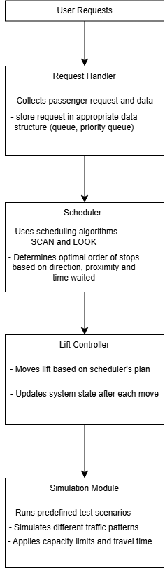

Specification

Results

Discussion