Data Analytics engineering Mentoring program AU25



Contents
1.1 Business background 3
1.2 Problems. Current Situation 3
1.3 the Benefits of implementing a database. Project Vision 3
2.1 Definitions & Acronyms 3
2.2 Logical Scheme 4
2.3 Objects 4
2.4 Implementing constraints 10
2.5 View, Functions and read-only role. 12

Business Description

Business background

Problems. Current Situation
The modeled system represents a retail sales workflow for household appliances. The core business process includes maintaining product inventory, managing suppliers, processing customer orders, and tracking final sales results.

the Benefits of implementing a database. Project Vision
This database ensures operational continuity by providing full traceability from supplier delivery to customer purchase. It is designed to support reporting and auditing requirements by enabling aggregated revenue analysis, product-level turnover tracking, and quarterly performance monitoring.
The data model supports the following key business needs:
- Managing product catalog with category-level segmentation
- Maintaining supplier relationships and delivery prices
- Recording sales transactions with employee involvement
- Producing analytics on orders, product quantities, and pricing
- Enabling traceable linking between customer purchases and supplied inventory

Model description

Definitions & Acronyms
The model consists of 8 core entities:

Entity | Purpose
Product | Stores household appliances with brand, model, category, and retail pricing
Category | Defines classification of products (e.g., kitchen appliances, cleaning appliances)
Supplier | Represents providers delivering goods to the company.
Product_supplier | Junction table linking product and supplier with agreed supply price
Customer | Represents buyers who place orders
Order | Header-level sales order containing customer, employee, and order date
Order_item | Line-level details including quantity, unit retail price, and product level
Employee | Represents company employees responsible for registering and processing customer orders

Step-by-Step Approach to Modeling
Step 1: Requirement Analysis
Initial business requirements were interpreted from the sales workflow:
- Products must have categories.
- Products can be sourced from multiple suppliers.
- Orders must allow multiple products per purchase.
- Sales must be traceable to the employee processing the sale.

Logical Scheme
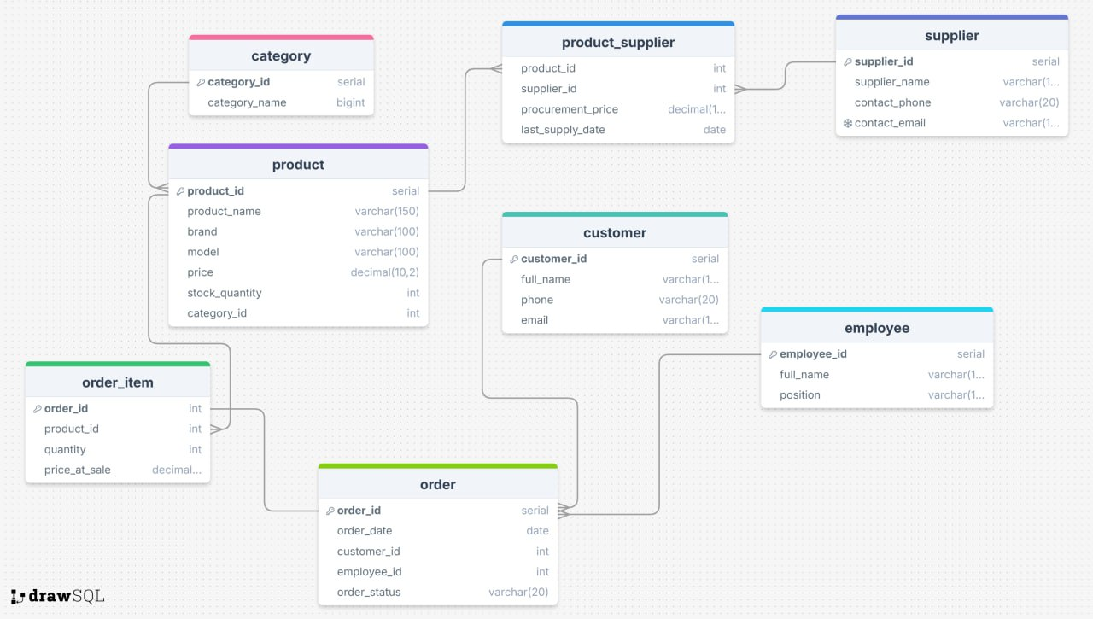

Objects

Table detailed description

Table Name | Field name | Field Description | Data Type
Product | product_id | Surrogate primary key of the product | Integer (pk, serial)
 | Product_name | Name of the household appliance (commercial name shown to the customer) | Varchar (150), not null
 | Brand | Brand or manufacturer of the product | Varchar (100)
 | Price | Standart retail price at which the product is sold to the customers (per unit) | Decimal (10,2)
 | Stock_quantity |  | Datetime (nullable)
 | Category_id | References category.category_id. Determines which category this product belongs to | Integer (fk not null)
category ↔ product: one category - many products → 1:N.
Product ↔ product_supplier: one product - many supplier records (different suppliers and delivery prices) → 1:N (via product_supplier)
product ↔ order_item: one product can appear in many order items → 1:N.

Table Name | Field name | Field Description | Data Type
Category | Category_id | Surrogate primary key of the category. Unique identifier of each product category. | Ineteger (pk, serial)
 | Category_name | Business name of the category (e.g., ‘Kitchen appliances’). | Varchar (100), not null
 | Description | Optional free-text description of the category. | Text, nullable
Category ↔ product: One category can have many products, but each product belongs to exactly one category → 1:N

Table Name | Field name | Field Description | Data Type
Supplier | Supplier_id | Surrogate primary key of the supplier | Integer (pk, serial)
 | Supplier_name | Legal or commercial name of the supplier organization | Varchar (150), not null
 | Contact_phone | Main phone number used to contact the supplier | Varchar (50), nullable
 | Contact_email | Contact e-mail address; assumed to be unique per supplier | Varchar (150), nullable, unique
supplier ↔ product_supplier: one supplier can provide many products, each with its own record in product_supplier → 1:N.

Table -Name | Field name | Field Description | Data Type
Product_supplier | Product_id | References product.product_id. Indicates which product is supplied | Integer (fk), not null
 | Supplier_id | References supplier.supplier_id. Indicates which supplier delivers the product | Integer (fk), not null
 | Procurement_price | Price per unit for this product under this specific supplier contract | Numeric (10, 2), not null
 | Last_supply_date | Date when the supply agreement or last price revision came into effect. | Date, nullable
Product ↔ product_supplier: one product - many supplier agreements → 1:N
Supplier ↔ product_supplier: one supplier - many supplied products → 1:N
This table resolves the many-to-many relationship between products and suppliers

Table Name | Field name | Field Description | Data Type
Customer | Customer_id | Surrogate primary key of the customer. | Integer (pk, serial)
 | Full_name | Customer’s full name (individual or company contact). | Varchar (150), not null
 | Phone | Customer’s contact phone number. | Varchar (50), nullable
 | Email | Customer’s e-mail address. | Varchar (150), nullable
customer ↔ order: one customer can have many placed orders, but each order is placed by exactly one customer → 1:N

Table Name | Field name | Field Description | Data Type
Employee | Employee_id | Surrogate primary key of the employee. | Integer (pk, serial)
 | Full_name | Employee’s full name. | Varchar (150), not null
 | Position | Employee’s job title or role (e.g., ‘Sales assistant’, ‘Store manager’) | Varchar (100), not null
Employee ↔ order: one employee can create or process many orders, but each order is associated with exactly on responsible employee → 1:N

Table Name | Field name | Field Description | Data Type
Order | Order_id | Surrogate primary key of the order (order header). | Integer (pk, serial)
 | Order_date | Date when the order was confirmed. | Date or timestamp, not null
 | Customer_id | References customer.customer_id. Identifies which customer placed the order | Integer (fk), not null
 | Employee_id | Refernces employee.employee_id, Identifies the employee who processed the order. | Integer (fk), not null
 | Order_status
Customer ↔ order: one customer - many orders → 1:N
Employee ↔ order: one employee - many processed orders → 1:N.
Order ↔ order_item: one order consists of many order items → 1:N.

Table Name | Field name | Field Description | Data Type
Order_item | Order_id | References order.order_id. Identifies which order this line belongs to. Part of composite primary key. | Integer (fk), not null
 | Product_id | References product.product_id. Identifies which product is sold in this line. Part of composite primary key. | Integer (fk), not null
 | Quantity | Quantity of the product sold in this order line | Integer, not null, check (quantity > 0)
 | Price_at_sale | Unit price charged to the customer for this product. | Numeric (10, 2, not null
Order ↔ order_item: one order - many order items → 1:N.
Product ↔ order_item: one order - many order items → 1:N.
If (order_id, product_id) is defined as a composite primary key, each product can appear at most per order; quantity reflects how many units were purchased.

Implementing constraints
Database constraints have been applied to ensure referential integrity, data consistency, and business rule enforcement across all entities. The objective is to support accurate transaction processing while preventing invalid data states within the retail appliance model.
Primary Keys
Each table contains a surrogate primary key (…_id) generated automatically.
The primary key guarantees row-level uniqueness and supports stable referencing across relationships, even if business attributes change.
Examples:
category_id uniquely identifies each product category.
order_id uniquely identifies each sales order.
product_supplier_id uniquely represents a supplier–product supply contract, preventing duplicates for the same supplier and product on the same terms.
Impact on data integrity:
Primary keys eliminate ambiguity in entity referencing and ensure durability of relational links across time.
Foreign Keys with ON DELETE restrictions
Foreign key constraints are used to maintain relational consistency between entities. Each foreign key establishes dependency on a parent row and restricts inappropriate deletions.
Key examples:
product.category_id → category.category_id
order.customer_id → customer.customer_id
order.employee_id → employee.employee_id
order_item.product_id → product.product_id
order_item.order_id → order.order_id
product_supplier.product_id → product.product_id
product_supplier.supplier_id → supplier.supplier_id
ON DELETE Policy: RESTRICT / NO ACTION
For all business-critical relationships, ON DELETE RESTRICT (or default NO ACTION) has been applied to prevent accidental cascading deletion of historical business data.
Rationale:
Orders cannot be removed by deleting customers or employees.
Products cannot be deleted while still referenced in order history.
Supplier records cannot be removed if historical supply transactions exist.
This preserves audit trails and ensures compliance with business reporting obligations.
CHECK Constraints
Check constraints have been implemented primarily to enforce valid numeric ranges and business logic.
Examples:
quantity > 0 ensures that order items must reflect a sold amount greater than zero.
delivery_price > 0 prevents storing invalid free or negative procurement cost.
price_at_sale > 0 guarantees monetized sales recording.
Business justification:
These constraints eliminate logically impossible transactions, strengthen data validity, and prevent calculation anomalies in subsequent analytics, particularly for revenue and margin assessment.
UNIQUE Constraints
A unique constraint is applied to supplier contact emails to prevent duplication of supplier entities under different identifiers.
Example:
supplier.contact_email must remain unique system-wide.
Business justification:
Suppliers are business partners with contractual commitments, and uniqueness prevents duplicate account creation, erroneous payment allocation, and scattering of supplier records across reporting.

View, Functions and read-only role.
As part of the functional and analytical extension of the database, two stored functions, one analytical view, and a restricted read-only role were created. The first function enables controlled updates of specific column values in existing records, ensuring data integrity and preventing unintended bulk modifications. The second function standardizes the insertion of new transactional data, automating order and order-item creation while validating all required business attributes. Additionally, a quarterly analytics view was implemented to present sales performance for the most recently completed period, excluding surrogate keys and returning only meaningful business fields for managerial interpretation. To ensure secure access, a dedicated read-only role was introduced, granting SELECT-only privileges and preventing any modification of operational data

Conclusion

The implemented database accurately models a retail household appliance distribution and sales platform. It fulfills the complete life cycle—from supplier acquisition, inventory management, customer interaction, point-of-sale recording, through high-level quarterly reporting. The schema supports both operational processing and analytical intelligence securely and in compliance with data normalization standards.

