**NAME: OYEDAYO OYELOWO STUDENT NUMBER: 014717208 DATE: 22/09/2017**

Exercise 3: Canopy height model (CHM) generation and change detection

Workflow (CHM generation):

1) Read TEXAS_lidar.txt to R

2) Select only first and single echoes of 2010 data

3) Create a raster using the cell size of 0.5 meters

4) Create CHM by adding maximum height for each raster cell

5) Fill NA-cells with focal-filter (only NA cells!)

6) Test different filtering parameters

Workflow (Change detection):

7) Generate another CHM based on 2006 data

8) Calculate the difference of CHM 2006 and CHM 2010, and plot the changes

9) Classify field data as damaged and undamaged trees

(Damage_class 0 = No damage; Damage_classes 1, 2 and 3 = Damaged)

10) Plot the reclassified field data over the CHM changes

Questions:

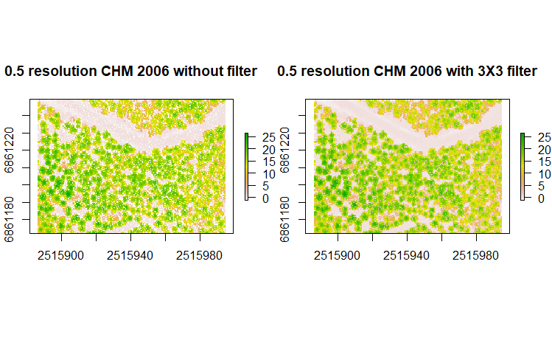

3D view of the filtered(3 X 3) chm for 2006:  
  
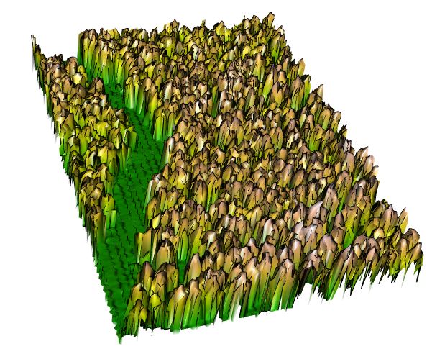

Canopy height model for 2010 without filtering

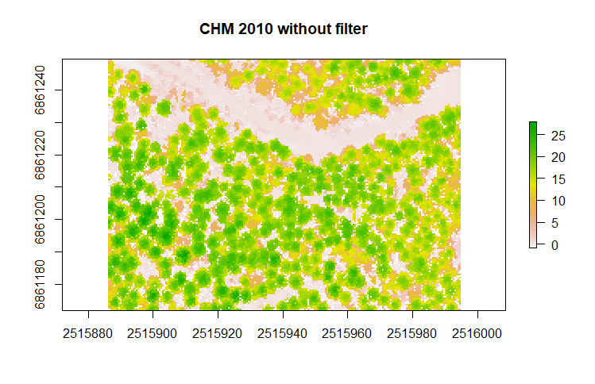

Canopy height model 3D for 2010 with filtering 3X3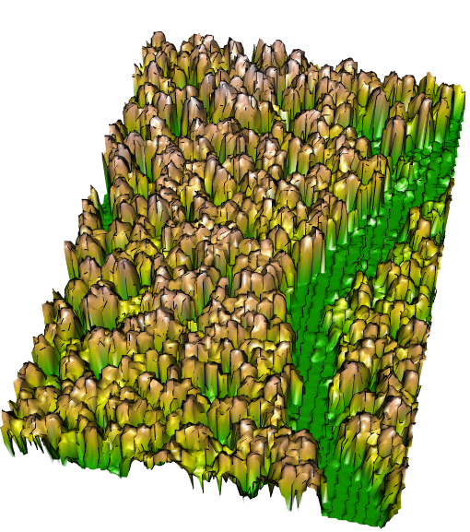  
canopy height model for 2010 with various printings  
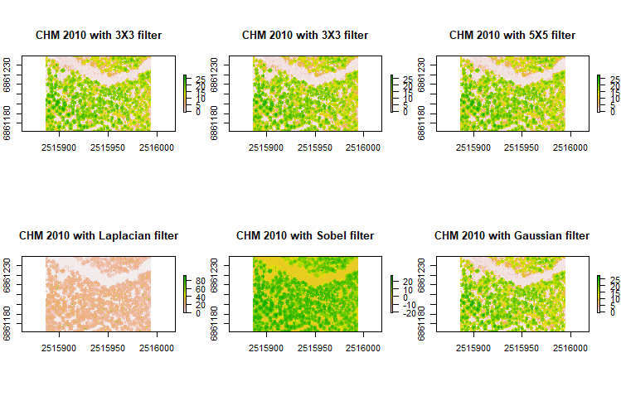



1. Find the areas where CHM 2006 is higher than CHM 2010. What might have happened?

The trees might have been damaged or cut down. They are the areas with negative values with light brown colour and white.

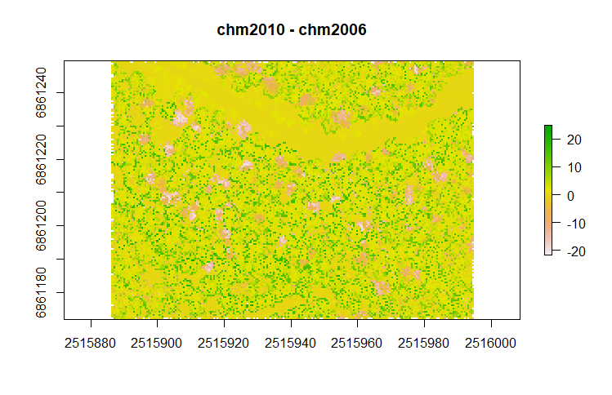

I made another visualisation in another way here I did the reverse by subtracting chm of 2010 from that of 2006. Therefore, the damaed areas are positive here and are the areas in green patches, below:  
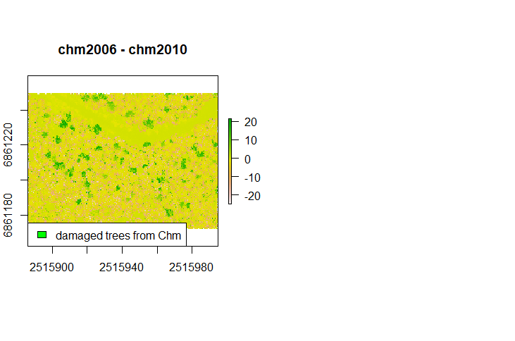

1. Does the observed damages in the field data correspond with those areas?

yes, they do, to a very large extent.

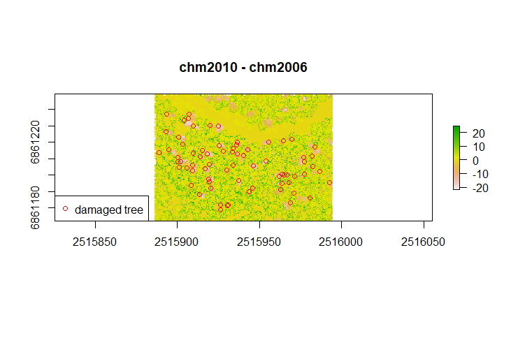

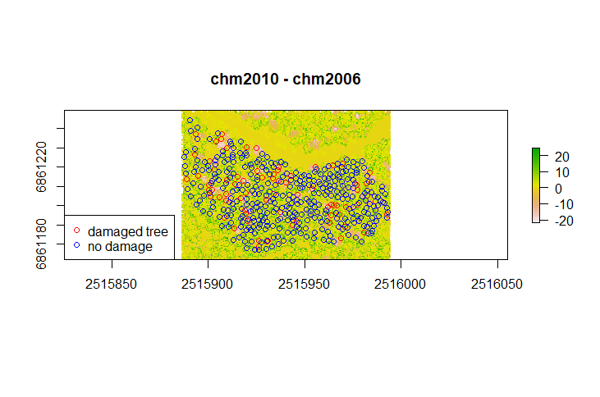

1. What is the mean difference of CHMs 2006 and 2010 (estimate for tree height growth)?

The average growth average tree height growth was 2.326743m

1. Calculate vertical canopy cover (CHM ≥ 1.3 meters) estimates for years 2006 and 2010?

For 2006:

Min. 1st Qu. Median Mean 3rd Qu. Max.

1.30 11.21 14.70 13.47 17.16 26.59

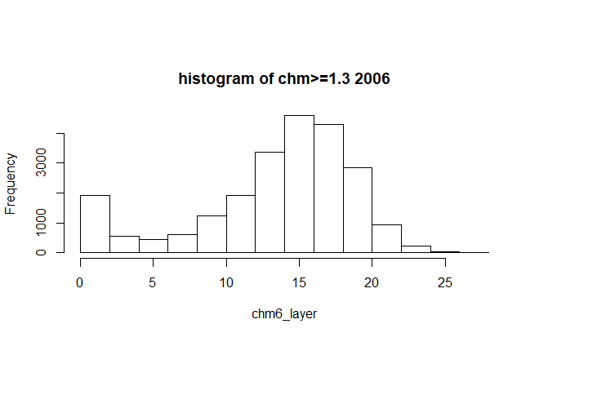

**For 2010:**

Min. 1st Qu. Median Mean 3rd Qu. Max.

1.30 12.55 16.25 15.24 18.89 27.95

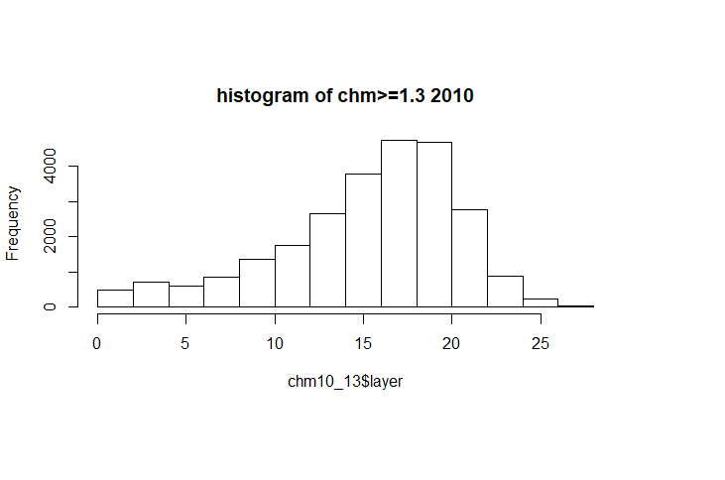

From my observation by projecting the negative areas after comparing the CHMs for 2006 and 2010, I deduced that the projected areas in the image below were the areas where trees were damaged.

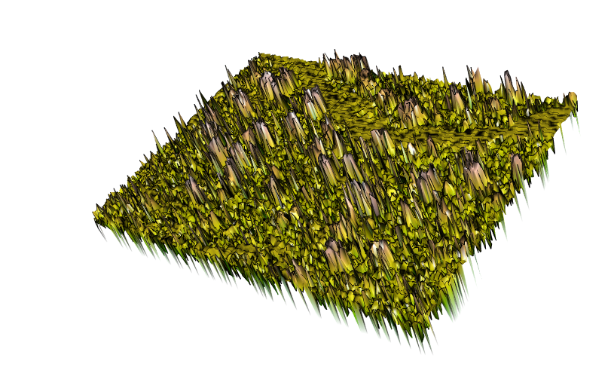

**I had fun doing this exercise. Thank you!**

Return a pdf-document including your answers and maps