**NAME: OYEDAYO OYELOWO STUDENT NUMBER: 014717208 DATE: 29/09/2017**

**EXERCISE 4: INDIVIDUAL TREE DETECTION**

1. Open chm2010.asc in ArcMap

2) Make a model for individual tree detection (Model Builder)

3) Smooth the surface few times (Spatial Analyst Tools –> Neighbourhood –> Filter)

4) Negate the surface (Spatial Analyst Tools –> Math)

5) Generate flow direction map (Spatial Analyst Tools –> Hydrology)

6) Generate basin map

7) Remove ground from the segments (Create reclassified CHM raster for this purpose)

• Test different ground thresholds (“cutting” heights)

8) Generate crown segments (Raster to polygon)

9) Compare crown segmentation and CHM’

Test 2-3 different surface smoothing and 2-3 different ground thresholds, and analyse your results visually. Return a pdf document including your conclusions, the generated model and the maps of 4-6 different segmentations.

**SOLUTION:**

I tried the low filter 2-3 times for each threshold I used. I tried three different thresholds: 1.3m, 2m and 0.5m thresholds. This means that I assumed that anything above this is a tree which has canopy. After deriving the basin, I converted to vector by using ***“raster to polygon”*** arctoolbox. I could have included this in my model too. Below are screenshots of my models built in model builder in ArcGIS:

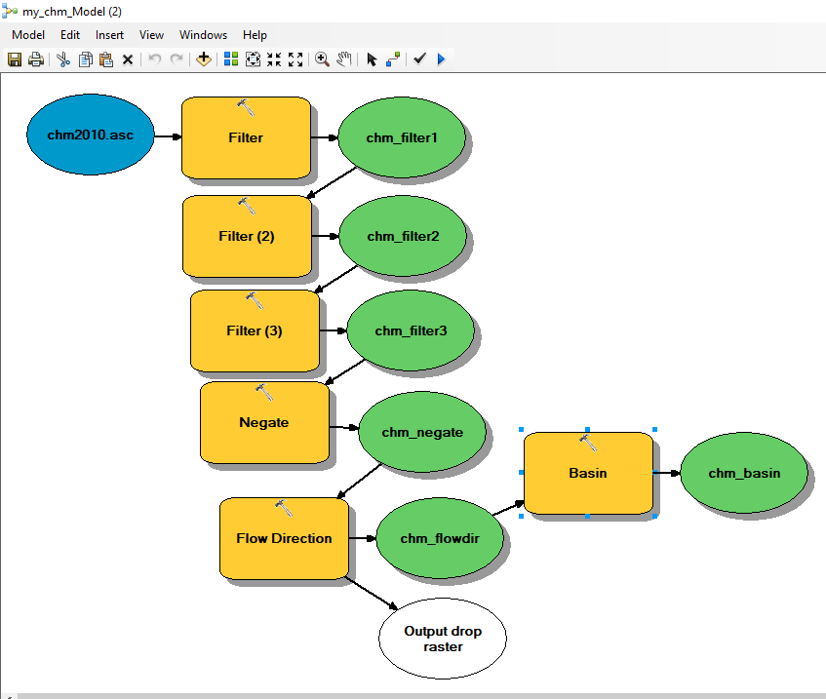

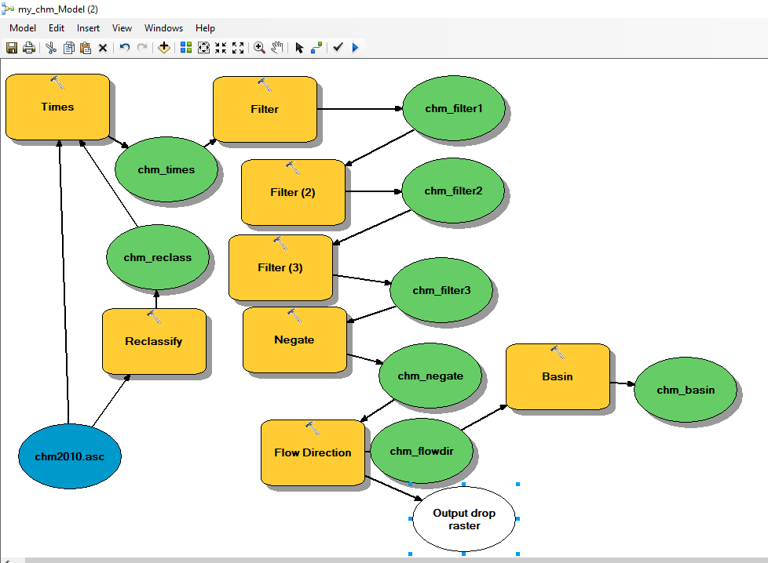

**Without filter, without threshold:**

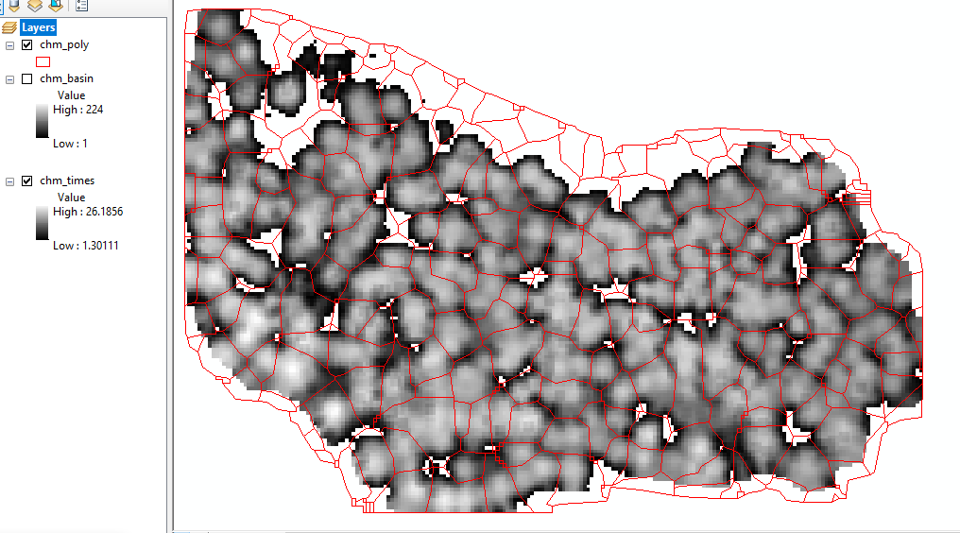

**1.3m Threshold, no filter:**

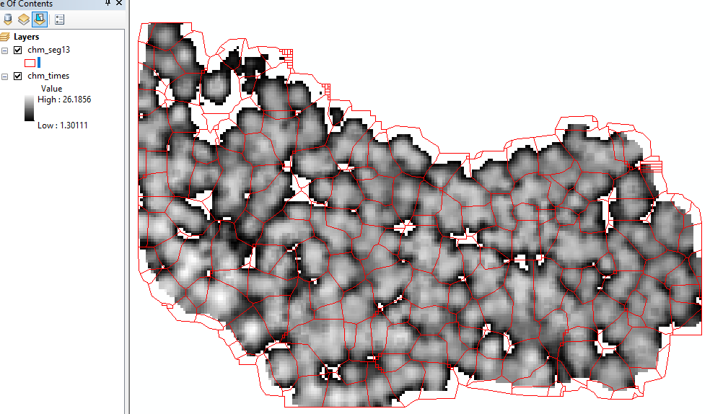

**1.3m threshold, filter: low 2X :**

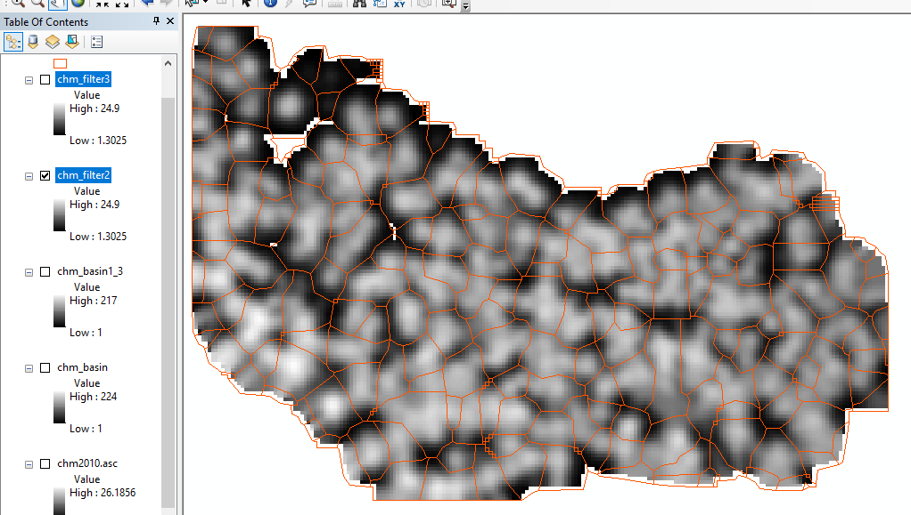

**1.3 threshold with low filter 3 times:**

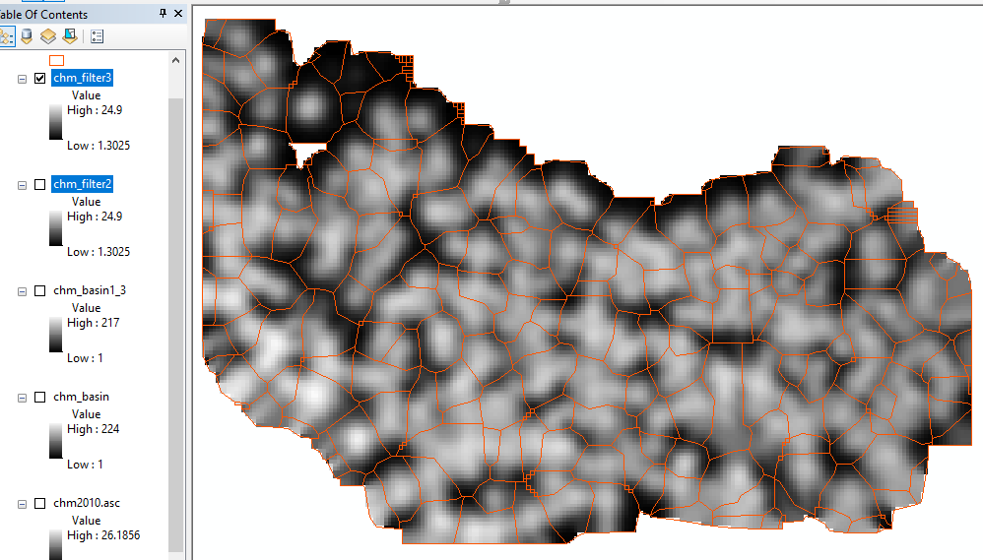  
  
  
**2m threshold with low filter 2 times:**

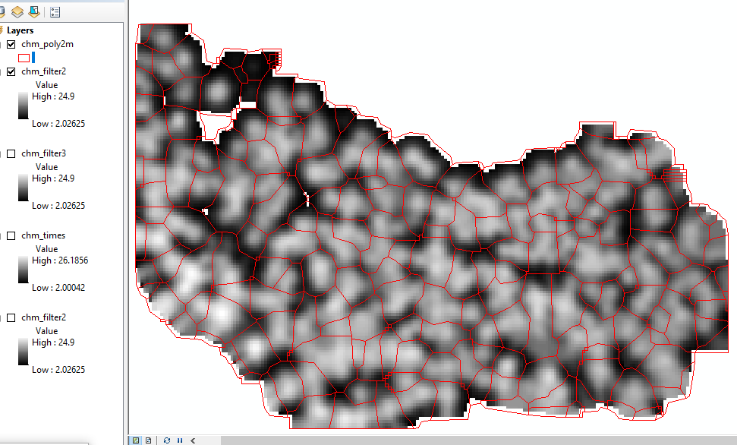

**2m threshold with low filter 3 times:**

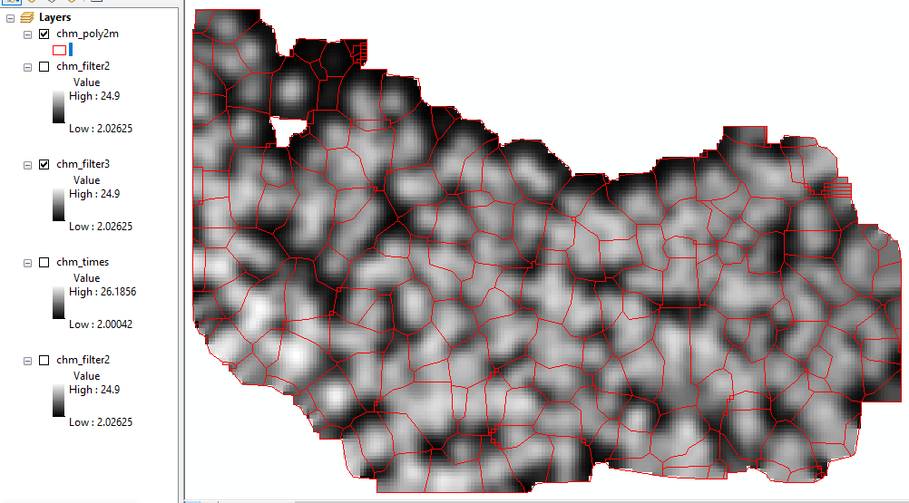

**2m thrshold with no filter:**

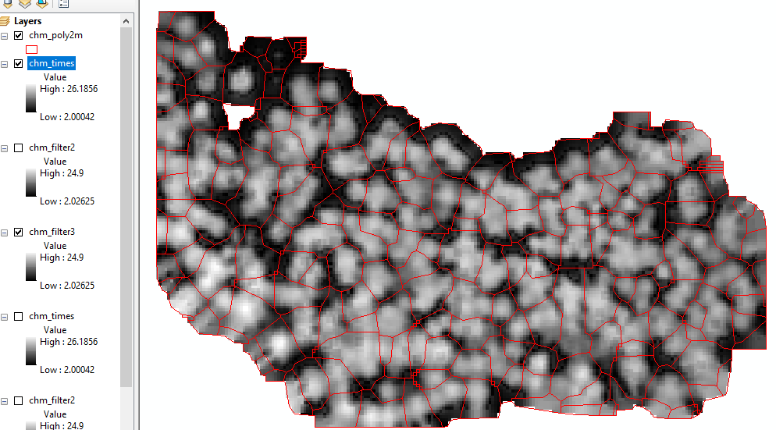

**0.5 threshold with low filter 2 times:**

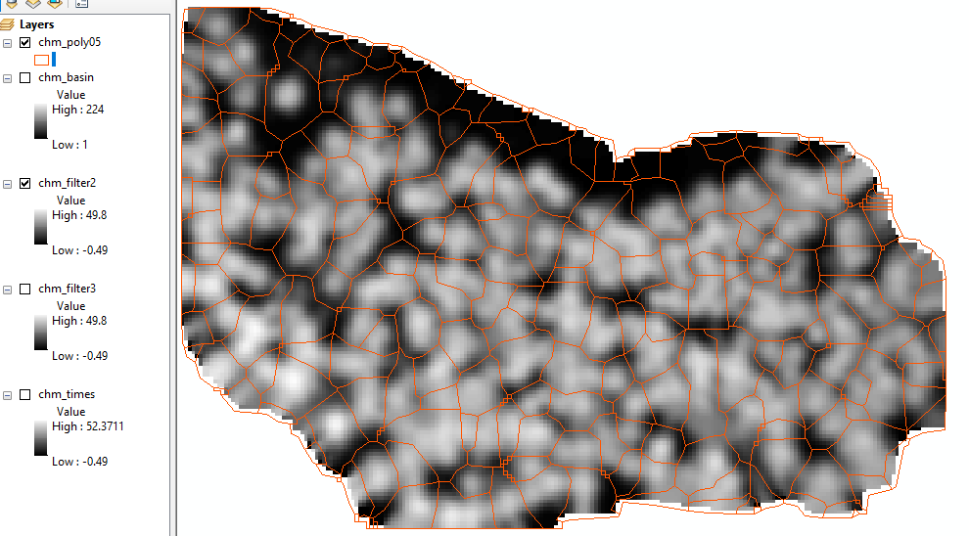

**0.5m threshold with low filter 3 times:**

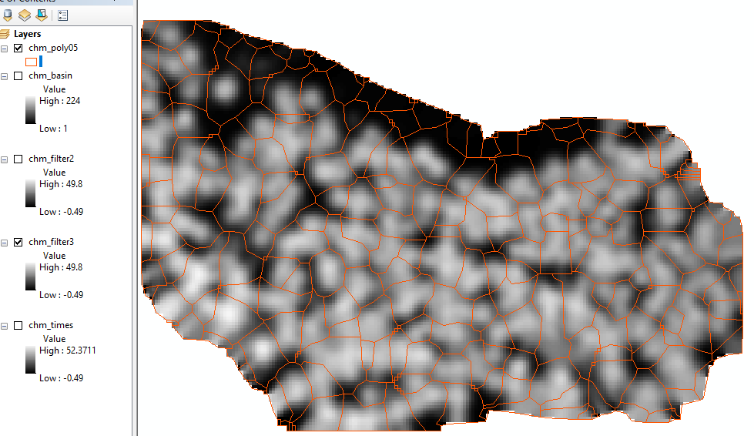

**0.5m threshold with no filter:**

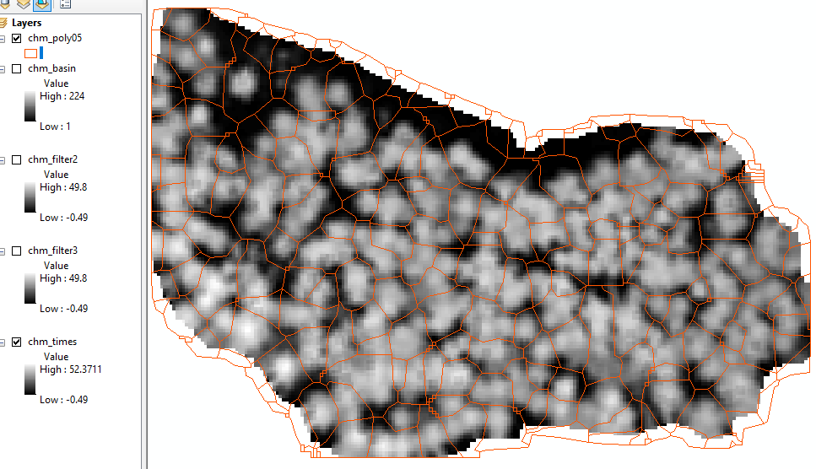

Conclusion:

I think the low filter is all right, if applied twice and 1.3m might be optimal. However, this is highly subjective and depends on the situation and requirements. By this, I mean, how much error, the analyst is willing to accept. Very high threshold might increase the omission error, as many canopies might go undetected but if the analyst is willing to leave many canopies undetected, then, a slightly higher threshold might be okay, but if he/she desires to have as many as possible detected, then, a lower threshold would be applicable. All in all, the threshold should not be too high or too low.

This exercise exposed me to canopy segmentation and especially how to execute this in ArcGIS environment. I also rejuvenated my knowledge of model builder in ArcGIS. With this model built, I can more easily, build a workflow to carry out similar task in other software and programs such as QGIS, R and Python which are open source and are more flexible and easier to reproduce.

I find it especially interesting how concept developed mainly for hydrology (flow direction, basin etc.) was adopted to do something completely different in canopy segmentation and the concept is very logical and useful. Negating the filtered canopy height model was also thoughtful, as water would only be able to feel the hollow or depressed places, which the trees become when negated/reversed, and as such, basin can be developed from this. The highest point is then able to separate the canopies.