assignment 5

Oyedayo Oyelowo

2 November 2017

#clear memory  
rm(list = ls())  
setwd("C:/Users/oyeda/Desktop/R_COURSE/assignment5")  
#load the data  
data<-read.table("puudata.txt", header = T, sep = "\t")

## Exercise 1

* **a) Plot the height of living crown (ELAVALARAJA) as a function of height (PITUUS). Try using dots and lines. Which one is better?**

plot(data$ELAVALARAJA~data$PITUUS, type = "p")

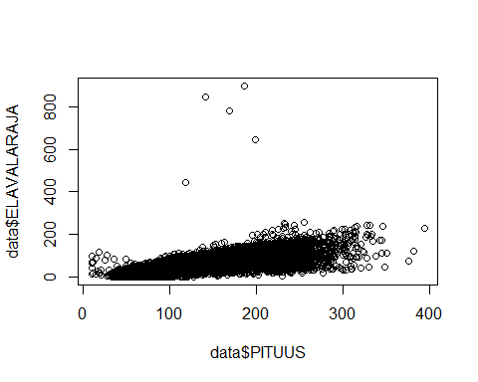

plot(data$ELAVALARAJA~data$PITUUS, type = "l")

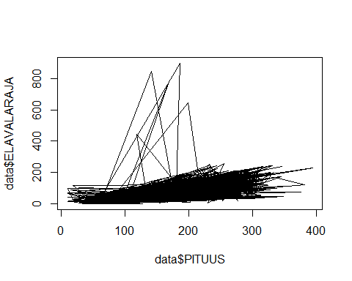

* ** Answer: The dots plot is better.**
* **b) Exclude the incorrect data entries (height of living crown over 40 meters) out of the picture by changing limits of x- and y-axis.**
* **c) Give proper names for both of the axes**
* **d) Add a line x = y to the picture. How would you describe the observation on the line? What about on top of the line?**

#b) Exclude the incorrect data entries (height of living crown   
#over 40 meters) out of the picture by changing limits of x- and y-axis.  
#?plot  
plot(data$ELAVALARAJA~data$PITUUS, type = "p", ylim = c(0,400))

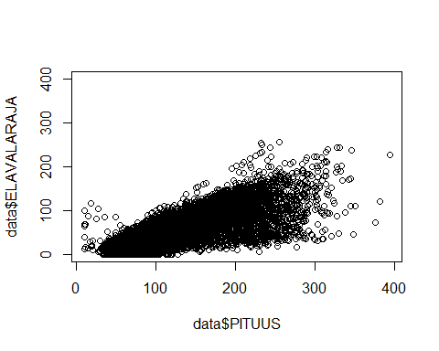

plot(ELAVALARAJA~PITUUS , data=data, ylim=c(0,400),  
 xlab = "Height", ylab = "Height Living Crown")  
#?~  
  
#c) Give proper names for both of the axes  
plot(ELAVALARAJA~PITUUS, data=data, type = "p", ylim = c(0,400),   
 xlab = "Height", ylab = "Height Living Crown")  
fit <- lm(ELAVALARAJA~PITUUS, data = data)  
abline(fit, col="red", lwd=2)

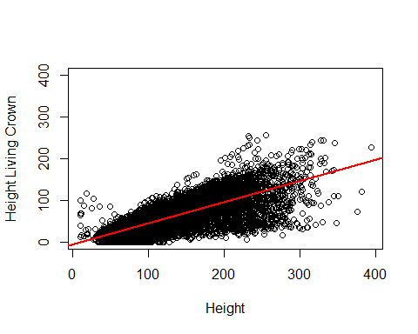

**The observations on the line are those where the predictions with zero vertical deviation and fit with the prediction while those on top are the positive residuals**

### Exercise 2

* **a) Plot height of the birches (PUULAJI=3) in the first canopy coverlayer as a function of the tree diameter.**

p1<-subset(data, PUULAJI==3 & LATVKERROS==1)  
plot(p1$LPM, p1$PITUUS, col="red")

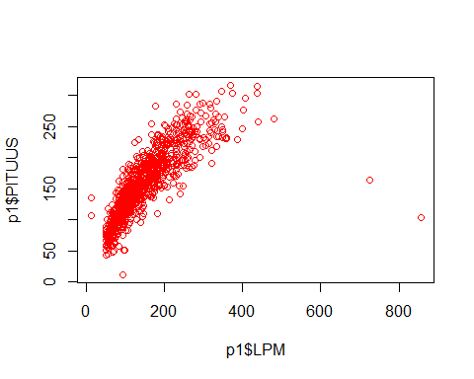

#or  
#plot(p1$PITUUS~p1$LPM, col="green")  
#or  
#plot(PITUUS~LPM, p1)

* **b) Change the picture so that the observations are drawn as green circles with black border.**

plot(p1$LPM, p1$PITUUS,pch= 21,col="black",type= "p", bg= "green")

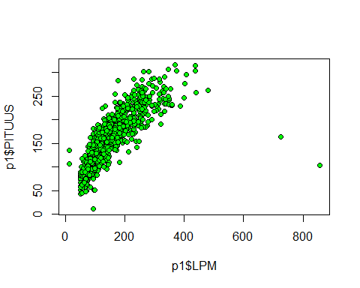

* **c) Change the style of the two differing observations as red triangles with black border (form a new subset and draw it with points function)**

plot(p1$LPM, p1$PITUUS,pch= 21,col="black",type= "p", bg= "green")  
p2<-p1[p1["LPM"]>600,]  
points(p2$LPM, p2$PITUUS, pch = 24, col ="black", bg = "red")

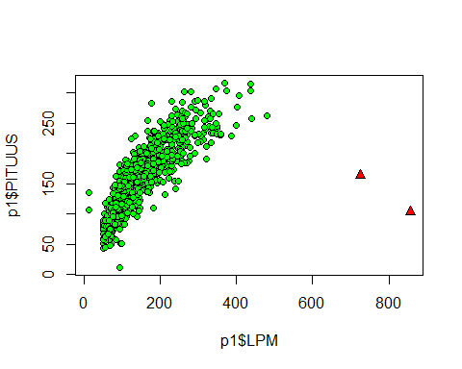

## Exercise 3 Exercise 2 continues.

* 1. Add line y=250 to the picture.
  2. Determine the color as red and the line width as 2.
  3. Add a line that travels through origin (point (0,0))and has slope value of 1.1. Use dashed line type and choose some nice color (available colors can be found with command colors()).
  4. Add a text into the formed rectangle (on lower right corner) that says "Erroneous observations".

plot(p1$LPM, p1$PITUUS,pch= 21,col="black",type= "p", bg= "green")  
p2<-p1[p1["LPM"]>600,]  
#points(p2$LPM, p2$PITUUS, pch = 24, col ="black", bg = "red")  
points(p2$LPM, p2$PITUUS, ylab = "Height",xlab = "DBH", pch = 24, col ="black", bg = "red")  
#abline(h=250, v=0,lwd=2,col="red")  
abline(h=250,lwd=2,col="red")  
  
#?abline  
#b) Add line x=550 to the picture and use the same styles.  
abline(v=550,lwd=2,col="red")  
abline(b=1.1, lwd=2, col="green", lm(PITUUS ~LPM, data = p2))  
abline(h=0, v=0,b=1.1, col = "yellow")  
abline(h = 0, lty = 2)  
  
# Add text  
# Add text using the following Corner_text function:  
  
#create function to add text  
text_corner <- function(text, position="bottomright"){  
 legend(position,legend=text, bty ="n", pch=NA)   
}  
  
#use the function to add the legend.  
#NOTE: I can do this directly, Just trying my hands on using   
#functions  
text_corner(text="Erroneous observations", position= "bottomright")

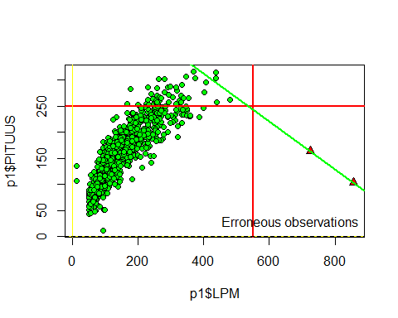

### Exercise 4

* Plot the heights of the pines growing in the first
* Add the pines in the second canopy layer to the same graph. Choose such styles and colors that the figure is easy to interpret. What can be easily deduced from the graph?

#canopy cover layer as a function of stem diameter.  
pines_canopy1 <- subset(data, data$PUULAJI==1 & data$LATVKERROS==1)  
pines_canopy2 <- subset(data, data$PUULAJI==1 & data$LATVKERROS==2)  
  
#plot height as a function of stem diameter  
{plot(PITUUS ~ LPM, pines_canopy1, xlab="Stem diameter", ylab="Height",  
 main="Height vs Stem diameter",col="blue")  
  
   
#alternatives  
#plot(data$LPM, data$PITUUS)  
#plot(data$PITUUS ~ data$LPM)  
  
par(new=T)  
plot(PITUUS ~ LPM, pines_canopy2, xlim=c(min(pines_canopy1$LPM),  
 max(pines_canopy1$LPM)), xlab=NA, ylab=NA,   
 ylim=c(min(pines_canopy1$PITUUS),max(pines_canopy1$PITUUS)),  
 col="red")  
  
legend("bottomright", legend=c("Pines in Canopy 1", "Pines in Canopy 2"),  
 col=c("blue", "red"), pch = 1, cex=0.8)  
#instead of using bottomright, a coordinate for the legend can  
#also be used. e,g 410, 190  
  
}

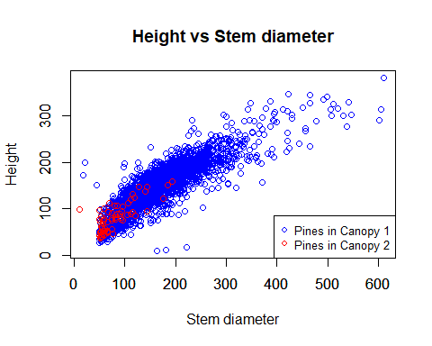

#alternatively, this can be done by plotting for the first,  
#and basically adding points from the second data  
  
#{plot(PITUUS ~ LPM, pines_canopy1, xlab="Stem diameter", ylab="Height",  
# main="Height vs Stem diameter",col="blue")  
  
#points(pines_canopy2$LPM, pines_canopy2$PITUUS, pch=1, col="red")  
# Add a legend  
#legend("bottomright", legend=c("Pines in Canopy 1", "Pines in Canopy 2"),  
# col=c("blue", "red"), pch = 1, cex=0.8)  
#}

***From the plot, it can be deduced that the first canopy of the Pines Species account mostly for the height- Stem diameter relationship.***