ASSIGNMENT 7

Oyedayo Oyelowo

1 November 2017

# Exercise 1

rm(list = ls())  
setwd("C:/Users/oyeda/Desktop/R_COURSE/assignment7")  
#load the data  
data <- read.table("puudata.txt", header = T, sep = "\t")

* *Write an if-statement that compares numbers x and y.*
* *if x is bigger, R prints out for example "x was bigger"*
* *if x and y are equal, R prints: "x and y are equal"*
* *if y is bigger, R prints "y is bigger than x"*

x <- 33  
y <- 11  
{  
 if (x > y) {  
 print("x was bigger")  
 } else if (x == y) {  
 print("x and y are equal")  
 } else  
 print("y is bigger than x")  
}

## [1] "x was bigger"

# Exercise 2

-Generate two vectors from normal distribution -(function rnorm()) which both contain hundred entries.

a = c(rnorm(100))  
b = c(rnorm(100))  
#Sort both vectors with sort() function.  
sorted_a <- sort(a, decreasing = F)  
sorted_b <- sort(b, decreasing = F)  
#- Plot the vectors (first vector as x-value and second as y-value)  
  
#- Define colors so that negative y-values are drawn as red and  
#positive values are drawn as  
#green (use for- and if statements inside the plot() function)  
plot(sorted_a, sorted_b, col = ifelse(sorted_b < 0, "red", "green"))

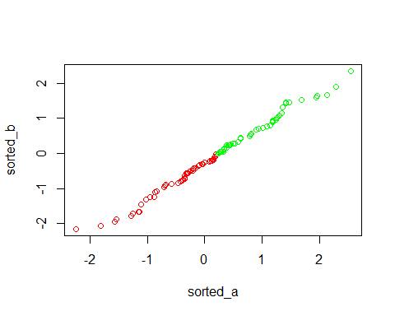

#?ifelse

# Exercise 3

* Plot the height of all downy birches (PUULAJI=4) that have
* a diameter over 30 cm (x=height,
* y=diameter). Use while() and if() statements.

#METHOD 1  
{  
 h <- d <- c()  
 i <- 0  
 while (i < nrow(data)) {  
 i = i + 1  
 if (data$PUULAJI[i] == 4 & data$LPM[i] > 30) {  
 h <- append(h, data$PITUUS[i])  
 d <- append(d, data$LPM[i])  
   
 }  
   
 }  
 plot(h,  
 d,  
 col = "red",  
 ylab = "Diameter",  
 xlab = "Height")  
}

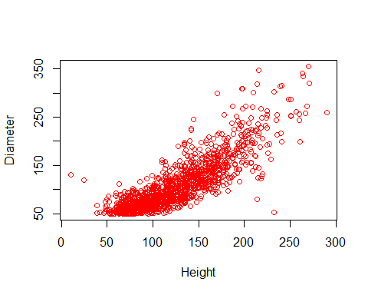

#par(new = T)  
  
#METHOD2  
{  
 h <- d <- c()  
 for (i in 1:nrow(data)) {  
 if (data$PUULAJI[i] == 4 & data$LPM[i] > 30) {  
 h <- append(h, data$PITUUS[i])  
 d <- append(d, data$LPM[i])  
 }  
   
 }  
 plot(h,  
 d,  
 col = "green",  
 ylab = "Diameter",  
 xlab = "Height")  
}

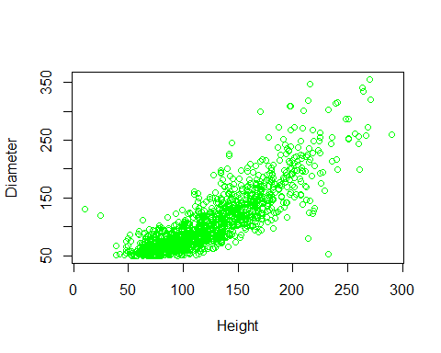

#dim(data)  
#levels(data$PUULAJI)  
  
  
#METHOD 3  
#another way of subsetting  
dbirch30 = data[data$PUULAJI == 4 & data$LPM > 30, ]  
plot(dbirch30$PITUUS, dbirch30$LPM, col = "blue",   
 ylab = "Diameter", xlab = "Height")

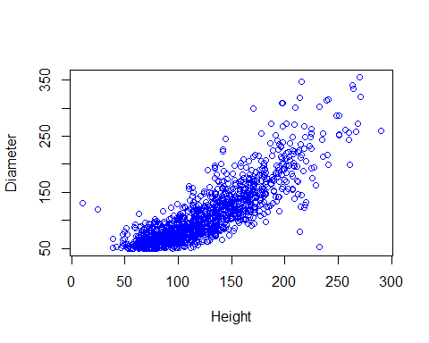

# Exercise 4

* Collect (into a vector) the numbers of those plots that have
* aspen (PUULAJI=5) growing on them.

aspen <- c(data[data$PUULAJI == 5, "TUNNISTE"])  
length(aspen)

## [1] 190

#it can also be done as below:  
sdd<- subset(data, data$PUULAJI==5)[,"TUNNISTE"]

### Exercise 5

* Determine tree-wise basal areas (in cm2) of pines (PUULAJI=1)
* in the puudata. Use for- and -ifstatements. Place the results in a new column.
* Some help:
* Diameter is given in millimeters
* Basal area can be calculated (pi*d^2)/4
* First create an empty vector: for example ba<- c()
* Add the calculated values to the vector with -append() function (check R-help for help)

pines <- data[data$PUULAJI == 1,]  
#pines_ <- subset(data, data$PUULAJI==1)  
  
#create a new column and convert the basal area into it  
#notice that the 0.1 is meant to convert mm to cm  
#finally, round off to 2dp  
pines$ba <- round((pi * ((pines$LPM * 0.1) ^ 2)) / 4, 2)  
  
  
#ANOTHER METHOD  
{  
ba<-c()  
for (i in 1:nrow(data)) {  
 if (data$PUULAJI[i] == 1) {  
 ba <- append(ba, round((((data$LPM[i]*0.1)^2)*pi)/4,2))  
   
 }  
}  
pines1 <- data[data$PUULAJI == 1,]  
pines_ba <- cbind2(pines1, ba)  
}  
  
  
#ANOTHER METHOD USING THE WHILE STATEMENT  
{ba2 <- c()  
i<-0  
while(i<nrow(data)){  
 i=i+1  
 if (data$PUULAJI[i]==1){  
 ba2<- append(ba2, round((((data$LPM[i]*0.1)^2)*pi)/4,2))  
 }  
}  
pines2 <- data[data$PUULAJI == 1,]  
pines_ba2 <- cbind2(pines2, ba2)  
}  
  
pines[1:3,]

## TUNNISTE KOEALA PUUNRO SUUNTA ETAISYYS PUULAJI LATVKERROS LPM PITUUS  
## 22 22 764 8 87 976 1 1 225 194  
## 23 23 764 9 100 198 1 1 196 165  
## 26 26 764 12 117 948 1 1 201 209  
## ELAVALARAJA LATVUSLEV ba  
## 22 129 22 397.61  
## 23 121 20 301.72  
## 26 119 20 317.31

pines_ba[1:3,]

## TUNNISTE KOEALA PUUNRO SUUNTA ETAISYYS PUULAJI LATVKERROS LPM PITUUS  
## 22 22 764 8 87 976 1 1 225 194  
## 23 23 764 9 100 198 1 1 196 165  
## 26 26 764 12 117 948 1 1 201 209  
## ELAVALARAJA LATVUSLEV y  
## 22 129 22 397.61  
## 23 121 20 301.72  
## 26 119 20 317.31

pines_ba2[1:3,]

## TUNNISTE KOEALA PUUNRO SUUNTA ETAISYYS PUULAJI LATVKERROS LPM PITUUS  
## 22 22 764 8 87 976 1 1 225 194  
## 23 23 764 9 100 198 1 1 196 165  
## 26 26 764 12 117 948 1 1 201 209  
## ELAVALARAJA LATVUSLEV y  
## 22 129 22 397.61  
## 23 121 20 301.72  
## 26 119 20 317.31