**Homework for a traineeship**

Attached you’ll find Boutique Shampoo Ltd’s data about their sales and investments in various marketing efforts / channels. The CEO of the company would like to better understand how their marketing efforts have contributed to sales in the past.

Your task is to help the CEO. To help you out with what types of questions the CEO is interested in, he has compiled a list of questions he’s hoping to get answers to:

**Part 1: Analysis**

1. What general findings can you draw from the data?

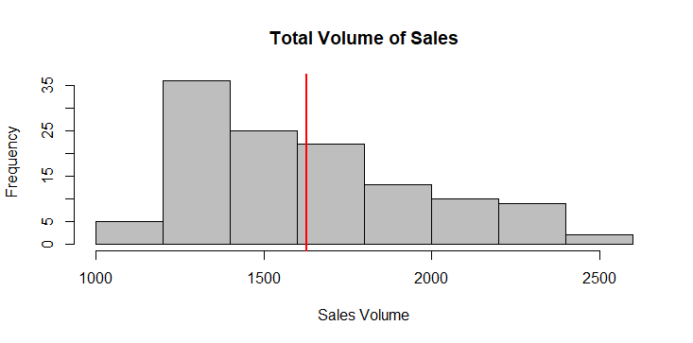

2.       How much do various marketing efforts / channels contribute to sales? I.e.

a.       based on the data, how much sales would they still get if they cut off all marketing for a while (baseline sales)?

b.       What portion of sales can be attributed to TV campaigns, radio and other marketing activities? Please quantify the contribution by channel

3.       How certain are you about the results of your analysis?

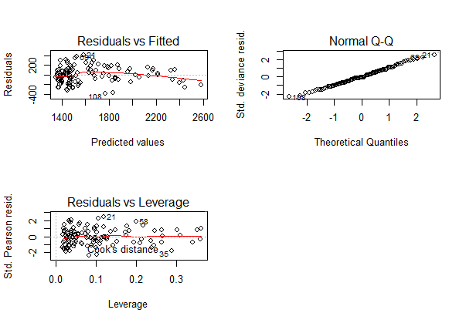

Coefficient of determination is 75%

4.       What other data you might want to incorporate in your analysis if you were to do it again to better explain the composition of factors affecting their sales?

Please be prepared to explain the analysis methods you’ve used to come to the conclusions in person, however you don’t need to go into too much detail in the presentation. Remember that the CEO is not a math expert - he likes simple explanations and visual representations such as bar graphs that are easy to understand.

**Part 2: Conclusions, recommendations, additional findings**

5.       What conclusions would you draw from the data?

6.       What recommendations would you give to the CEO of Boutique Shampoo regarding their marketing efforts?

Your answer / presentation should be no longer than 10 slides. Please provide your answers in English and explain what you’ve done and why. Please avoid math jargon as much as possible since the CEO is not a math expert.

Please return your findings by 10 am on Tuesday Jan 30th to [arto.hasu@dentsuaegis.com](mailto:arto.hasu@dentsuaegis.com) .

Call:

glm(formula = Total.Volume.Sales ~ Weighted.Average.Price + Price.Promotion.1 +

Rebrand + TV + Outdoor, family = "gaussian", data = data)

Deviance Residuals:

Min 1Q Median 3Q Max

-389.45 -111.03 -19.63 115.04 412.66

Coefficients:

Estimate Std. Error t value Pr(>|t|)

(Intercept) 4522.081 318.673 14.190 < 2e-16 ***

Weighted.Average.Price -1244.168 131.218 -9.482 3.89e-16 ***

Price.Promotion.1 228.802 79.184 2.889 0.004606 **

Rebrand 420.719 66.257 6.350 4.35e-09 ***

TV 3.208 0.350 9.167 2.12e-15 ***

Outdoor 2.717 0.762 3.566 0.000527 ***

---

Signif. codes: 0 ‘***’ 0.001 ‘**’ 0.01 ‘*’ 0.05 ‘.’ 0.1 ‘ ’ 1

(Dispersion parameter for gaussian family taken to be 29117.35)

Null deviance: 13628625 on 121 degrees of freedom

Residual deviance: 3377612 on 116 degrees of freedom

AIC: 1608.1

Number of Fisher Scoring iterations: 2