Hello,

You are welcome to the Power BI Developer (Projects/Internship) program.

This program is designed to provide you with an opportunity to use Power BI to solve real life Reporting and Analytics problems.

There will be several levels involved. And while completing lower levels are accomplishments of their own, completing lower levels are also pre-requisites to the higher levels.

Wishing you a successful learning experience as you complete your tasks and the project.

Here is an overview of what it may look like from one level to the other (more levels are currently being developed):

**Level 1:**

Warm up by building a Power BI report with data coming from Excel/Csv files

Get and prepare data from Excel Source

Create a Data Model

Create Row Level Security

Create Simple - Intermediate Output Measures

Build Reports with interactive functionality.

Publish Report to Power BI Service

Set up a Dashboard & Alert

**Level 2:**

Change your Data Sources to SQL Server and SharePoint

Create Parameters in PowerQuery

Edit (M) Script to change Data Sources to SQL and SharePoint

Create Intermediate - Advanced Output Measures

Create New Report Pages

Create and Administer a Power BI Workspace

Publish Report to Power BI Workspace

Set up a Report Subscription

If you have questions or contributions (Interns / project handlers usually have questions and contributions 😁), use the Discussion feature on the appropriate section.

You have seen the reporting requirements. I guess you will go back to read it again.

Now, use to you to create a mockup of what your reports will look like.

This will typically be drawn on whiteboard, or a piece of paper. On the drawing, you will show the layout of what each of your reports will look like, including a representation of the types of charts to use with titles. Please note that this does not have to be drawn with straight hands as it should be mere representation of your output design.

When you complete this, take a picture/screenshot of what you have and upload.

Check out the attached Mockup drawn with Microsoft Whiteboard.

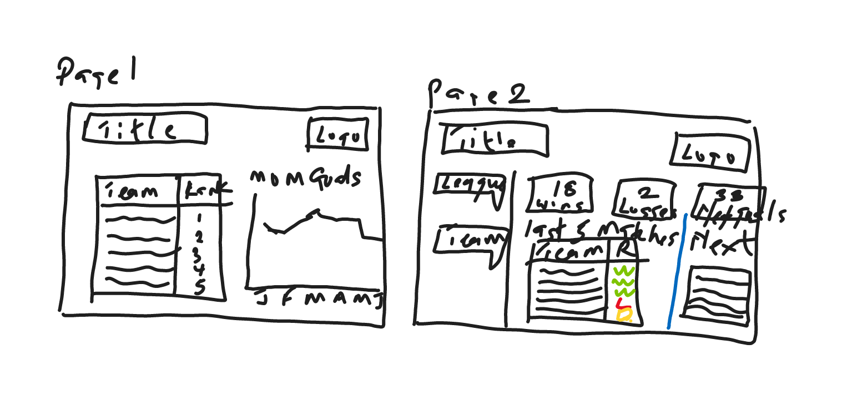**Background**

Forggith Pharmaceuticals (Forggith) is a Pharmaceutical Manufacturing company based in Germany. As a Manufacturing company, they produce medical drugs which get to the consumers through their Distributors.

Forggith provided a template for their distributors to capture records of their sales which are then sent to Forggith on a monthly basis. This data is then used for reporting and analysis by Forggith to achieve their goals Sales and Marketing objectives through tracking and monitoring of KPIs.

In their efforts to maximise growth, Forggith works with a team of Sales and Marketing pros who ensure retailers are able to get their products through the distributors. That is, Forggith does not sell directly to retailers or end-users, they sell to Distributors. But they maintain interaction with retailers, through their Sales and Marketing pros.

**Power BI Reporting Requirement.**

Forggith is looking to create some Power BI Reports to assist in guiding their strategies, tactics and operations as a company. For a start, they have identified a couple of numbers they will like to report from their data as reports.

**Sales Performance Overview (Sliced by: Year, Month, Quarter, Team)**

1. Total  Revenue
2. Total Revenue Year To Date (YTD)
3. Total Revenue Previous Year YTD
4. Total Revenue Same Period Last Year (SPLY)
5. Total Target
6. Total TargetYTD
7. Actual Revenue Performance Previous Year YTD vs Target Previous Year YTD
8. Actual Revenue Performance YTD vs Target YTD
9. Revenue Month on Month Percentage Change
10. Revenue Distribution by Location
11. Revenue by Channel
12. Revenue by Product Class

**Marketing Performance (Slice by Year, Quarter, Month, Product Category and Team)**

1. Revenue Achieved vs Revenue Target
2. Volume Achieved vs Volume Target
3. Actual Revenue by Sales Representative
4. Target Revenue Achievement% by Sales Representative
5. Actual Volume by Sales Representative
6. Target Volume Achievement by Sales Representative
7. Actual Revenue Achievement by Sales Team
8. Revenue and Volume Achievement by Product.

**Here are ideas of how these reports will be used:**

The Sales Representative can track their performances through-out the periods to plan their marketing activities.

The Team Managers can track their teams' performances through-out the periods to plan their teams' activities.

Executive team can track Revenue numbers to monitor alignment with the set targets to influence medium to long term strategies.

**Note:** You are to use the company's standard colors across your reports. You will find the Logo and Color guides in the Assets Folder you can download in the next lesson.

Using Microsoft Word or Excel (Excel should be better), create a simple description of your understanding of the dataset as it relates to the business.

You can typically list out all the columns in each table, then use a new column to describe the original data columns as simply as possible. For example, ***Date:*** *The Month the transaction took place;* ***Distributor***: *The Distributor the transaction counts for*.

**Submit your assignment**

You may only submit one file with maximum 100 MB in size