**Methodology**

**Block Diagram:**

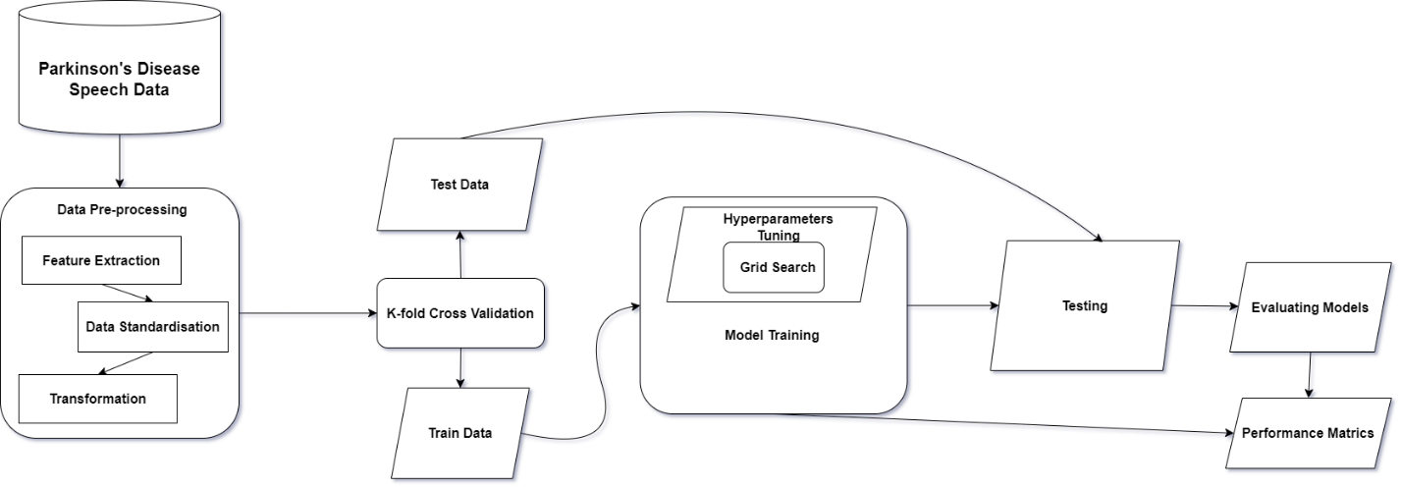

**Data standardization** is a technique that prevents attributes with large values from having more precedence over attributes with smaller values. Z- score is a standardization technique that transforms attribute values to standard scores such that the mean and the variance of the attributes become 0 and 1, respectively.

**K-fold Cross Validation** Splitting the dataset into k groups to train and test data each time.

**Model Training**, the project is trained on different classification models like SVM, Logistic Regression, KNN etc.

**Performance Metrics,** the model will be evaluated using different metrics accuracy, recall, validation accuracy etc.