1. Check if a String is a Palindrome
Write a function to determine if a given string is a palindrome. A palindrome is a string that reads the same forward and backward (ignoring spaces, punctuation, and case).
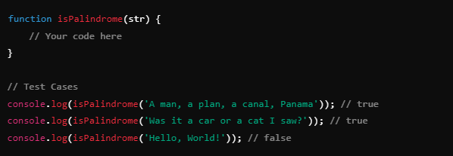

2. Reverse a String
Write a function to reverse a given string.

3. Find the Longest Palindromic Substring
Write a function to find the longest palindromic substring in a given string.
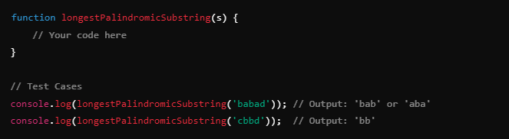

4. Check if Two Strings are Anagrams
Write a function to check if two given strings are anagrams of each other. Two strings are anagrams if they contain the same characters in the same frequency but in different orders.
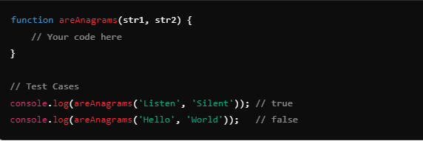
5. Remove Duplicates from a String
Write a function to remove duplicate characters from a string while preserving the order of the first appearance of each character.
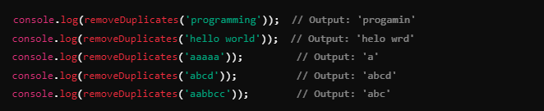

6. Count Palindromes in a String
Write a function to count how many distinct palindromes are in a given string. A palindrome is considered distinct based on its start and end position in the string.
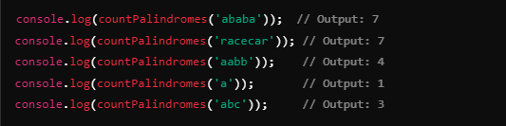

7. Longest Common Prefix
Write a function to find the longest common prefix string amongst an array of strings. If there is no common prefix, return an empty string.
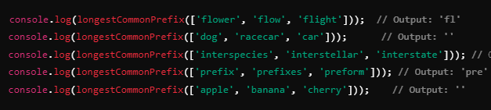

8. Case Insensitive Palindrome
Modify the palindrome function to be case insensitive, meaning it should ignore upper and lower case differences when checking for a palindrome.
