

INSTITUTO POLITÉCNICO NACIONAL
ESCUELA SUPERIOR DE COMPUTO

Mult8bit
Practica 10
Materia:
Arquitectura de computadoras
Profesor:
Castillo Cabrera Gelacio
Alumno:
Cortés Piña Oziel
Grupo:

3CM12

Simulación en GHDL y GTLWAVE
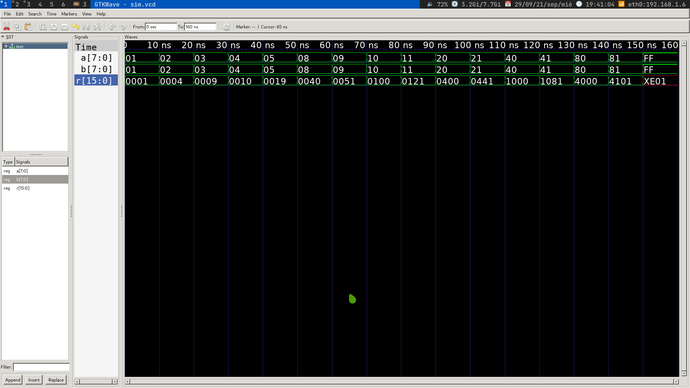
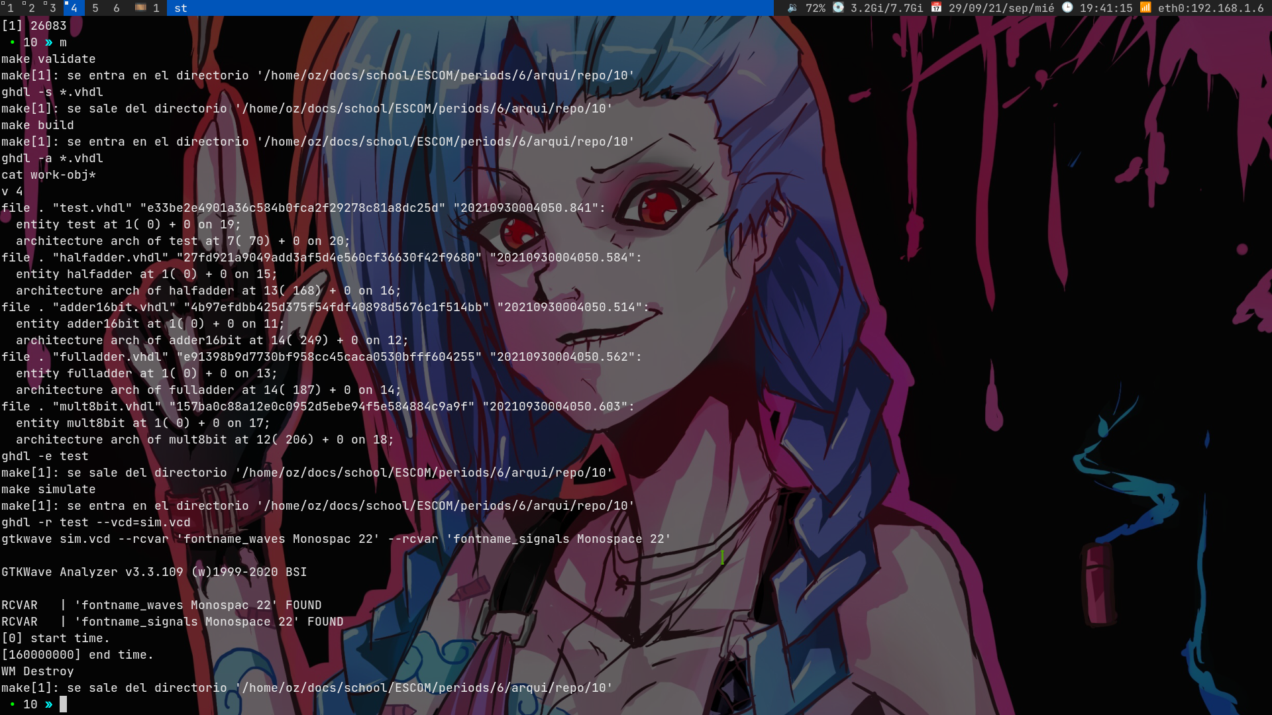

Código VHDL

Halfadder
library ieee;
use ieee.std_logic_1164.all;

entity halfadder is
port(
a: in std_logic;
b: in std_logic;
s: out std_logic;
c: out std_logic
);
end halfadder;

architecture arch of halfadder is
begin
s <= a xor b;
c <= a and b;
end arch;

Fulladder
library ieee;
use ieee.std_logic_1164.all;

entity fulladder is
port(
a: in std_logic;
b: in std_logic;
e: in std_logic;
s: out std_logic;
c: out std_logic
);
end fulladder;

architecture arch of fulladder is
component halfadder is
port(
a: in std_logic;
b: in std_logic;
s: out std_logic;
c: out std_logic
);
end component;
signal sum, carryA, carryB: std_logic;
begin
first: halfadder port map( a => a, b => b, s => sum, c => carryA );
second: halfadder port map( a => e, b => sum, s => s, c => carryB );
c <= carryA or carryB;
end arch;

Adder16bit
library ieee;
use ieee.std_logic_1164.all;

entity adder16bit is
port(
a: in std_logic_vector(15 downto 0);
b: in std_logic_vector(15 downto 0);
e: in std_logic;
s: out std_logic_vector(15 downto 0);
c: out std_logic
);
end adder16bit;

architecture arch of adder16bit is
component fulladder is
port(
a: in std_logic;
b: in std_logic;
e: in std_logic;
s: out std_logic;
c: out std_logic
);
end component;
signal carry: std_logic_vector(14 downto 0);
begin
s00: fulladder port map( a => a(0), b => b(0), e => e, s => s(0), c => carry(0) );
s01: fulladder port map( a => a(1), b => b(1), e => carry(0), s => s(1), c => carry(1) );
s02: fulladder port map( a => a(2), b => b(2), e => carry(1), s => s(2), c => carry(2) );
s03: fulladder port map( a => a(3), b => b(3), e => carry(2), s => s(3), c => carry(3) );
s04: fulladder port map( a => a(4), b => b(4), e => carry(3), s => s(4), c => carry(4) );
s05: fulladder port map( a => a(5), b => b(5), e => carry(4), s => s(5), c => carry(5) );
s06: fulladder port map( a => a(6), b => b(6), e => carry(5), s => s(6), c => carry(6) );
s07: fulladder port map( a => a(7), b => b(7), e => carry(6), s => s(7), c => carry(7) );
s08: fulladder port map( a => a(8), b => b(8), e => carry(7), s => s(8), c => carry(8) );
s09: fulladder port map( a => a(9), b => b(9), e => carry(8), s => s(9), c => carry(9) );
s10: fulladder port map( a => a(10), b => b(10), e => carry(9), s => s(10), c => carry(10) );
s11: fulladder port map( a => a(11), b => b(11), e => carry(10), s => s(11), c => carry(11) );
s12: fulladder port map( a => a(12), b => b(12), e => carry(11), s => s(12), c => carry(12) );
s13: fulladder port map( a => a(13), b => b(13), e => carry(12), s => s(13), c => carry(13) );
s14: fulladder port map( a => a(14), b => b(14), e => carry(13), s => s(14), c => carry(14) );
s15: fulladder port map( a => a(15), b => b(15), e => carry(14), s => s(15), c => c );
end arch;

Mult8bit
library ieee;
use ieee.std_logic_1164.all;

entity mult8bit is
port(
a: in std_logic_vector(7 downto 0);
b: in std_logic_vector(7 downto 0);
r: out std_logic_vector(15 downto 0)
);
end mult8bit;

architecture arch of mult8bit is
component adder16bit is
port(
a: in std_logic_vector(15 downto 0);
b: in std_logic_vector(15 downto 0);
e: in std_logic;
s: out std_logic_vector(15 downto 0);
c: out std_logic
);
end component;
signal p0, p1, p2, p3, p4, p5, p6, p7: std_logic_vector(15 downto 0);
signal s0, s1, s2, s3, s4, s5: std_logic_vector(15 downto 0);
signal carry: std_logic_vector(5 downto 0);
begin

p0(00) <= b(0) and a(0);
p0(01) <= b(1) and a(0);
p0(02) <= b(2) and a(0);
p0(03) <= b(3) and a(0);
p0(04) <= b(4) and a(0);
p0(05) <= b(5) and a(0);
p0(06) <= b(6) and a(0);
p0(07) <= b(7) and a(0);
p0(08) <= '0';
p0(09) <= '0';
p0(10) <= '0';
p0(11) <= '0';
p0(12) <= '0';
p0(13) <= '0';
p0(14) <= '0';
p0(15) <= '0';

p1(00) <= '0';
p1(01) <= b(0) and a(1);
p1(02) <= b(1) and a(1);
p1(03) <= b(2) and a(1);
p1(04) <= b(3) and a(1);
p1(05) <= b(4) and a(1);
p1(06) <= b(5) and a(1);
p1(07) <= b(6) and a(1);
p1(08) <= b(7) and a(1);
p1(09) <= '0';
p1(10) <= '0';
p1(11) <= '0';
p1(12) <= '0';
p1(13) <= '0';
p1(14) <= '0';
p1(15) <= '0';

p2(00) <= '0';
p2(01) <= '0';
p2(02) <= b(0) and a(2);
p2(03) <= b(1) and a(2);
p2(04) <= b(2) and a(2);
p2(05) <= b(3) and a(2);
p2(06) <= b(4) and a(2);
p2(07) <= b(5) and a(2);
p2(08) <= b(6) and a(2);
p2(09) <= b(7) and a(2);
p2(10) <= '0';
p2(11) <= '0';
p2(12) <= '0';
p2(13) <= '0';
p2(14) <= '0';
p2(15) <= '0';

p3(00) <= '0';
p3(01) <= '0';
p3(02) <= '0';
p3(03) <= b(0) and a(3);
p3(04) <= b(1) and a(3);
p3(05) <= b(2) and a(3);
p3(06) <= b(3) and a(3);
p3(07) <= b(4) and a(3);
p3(08) <= b(5) and a(3);
p3(09) <= b(6) and a(3);
p3(10) <= b(7) and a(3);
p3(11) <= '0';
p3(12) <= '0';
p3(13) <= '0';
p3(14) <= '0';
p3(15) <= '0';

p4(00) <= '0';
p4(01) <= '0';
p4(02) <= '0';
p4(03) <= '0';
p4(04) <= b(0) and a(4);
p4(05) <= b(1) and a(4);
p4(06) <= b(2) and a(4);
p4(07) <= b(3) and a(4);
p4(08) <= b(4) and a(4);
p4(09) <= b(5) and a(4);
p4(10) <= b(6) and a(4);
p4(11) <= b(7) and a(4);
p4(12) <= '0';
p4(13) <= '0';
p4(14) <= '0';
p4(15) <= '0';

p5(00) <= '0';
p5(01) <= '0';
p5(02) <= '0';
p5(03) <= '0';
p5(04) <= '0';
p5(05) <= b(0) and a(5);
p5(06) <= b(1) and a(5);
p5(07) <= b(2) and a(5);
p5(08) <= b(3) and a(5);
p5(09) <= b(4) and a(5);
p5(10) <= b(5) and a(5);
p5(11) <= b(6) and a(5);
p5(12) <= b(7) and a(5);
p5(13) <= '0';
p5(14) <= '0';
p5(15) <= '0';

p6(00) <= '0';
p6(01) <= '0';
p6(02) <= '0';
p6(03) <= '0';
p6(04) <= '0';
p6(05) <= '0';
p6(06) <= b(0) and a(6);
p6(07) <= b(1) and a(6);
p6(08) <= b(2) and a(6);
p6(09) <= b(3) and a(6);
p6(10) <= b(4) and a(6);
p6(11) <= b(5) and a(6);
p6(12) <= b(6) and a(6);
p6(13) <= b(7) and a(6);
p6(14) <= '0';
p6(15) <= '0';

p7(00) <= '0';
p7(01) <= '0';
p7(02) <= '0';
p7(03) <= '0';
p7(04) <= '0';
p7(05) <= '0';
p7(06) <= '0';
p7(07) <= b(0) and a(7);
p7(08) <= b(1) and a(7);
p7(09) <= b(2) and a(7);
p7(10) <= b(3) and a(7);
p7(11) <= b(4) and a(7);
p7(12) <= b(5) and a(7);
p7(13) <= b(6) and a(7);
p7(14) <= b(7) and a(7);
p7(15) <= '0';

r0: adder16bit port map( a => p0, b => p1, e => '0', s => s0, c => carry(0) );
r1: adder16bit port map( a => s0, b => p2, e => carry(0), s => s1, c => carry(1) );
r2: adder16bit port map( a => s1, b => p3, e => carry(1), s => s2, c => carry(2) );
r3: adder16bit port map( a => s2, b => p4, e => carry(2), s => s3, c => carry(3) );
r4: adder16bit port map( a => s3, b => p5, e => carry(3), s => s4, c => carry(4) );
r5: adder16bit port map( a => s4, b => p6, e => carry(4), s => s5, c => carry(5) );
r6: adder16bit port map( a => s5, b => p7, e => carry(5), s => r, c => r(15) );
end arch;

Test
library ieee;
use ieee.std_logic_1164.all;

entity test is
end test;

architecture arch of test is
component mult8bit is
port(
a: in std_logic_vector(7 downto 0);
b: in std_logic_vector(7 downto 0);
r: out std_logic_vector(15 downto 0)
);
end component;
signal a: std_logic_vector(7 downto 0);
signal b: std_logic_vector(7 downto 0);
signal r: std_logic_vector(15 downto 0);
begin
conn: mult8bit port map( a => a, b => b, r => r );
process begin
a <= "00000001";
b <= "00000001";
wait for 10 ns;
a <= "00000010";
b <= "00000010";
wait for 10 ns;
a <= "00000011";
b <= "00000011";
wait for 10 ns;
a <= "00000100";
b <= "00000100";
wait for 10 ns;
a <= "00000101";
b <= "00000101";
wait for 10 ns;
a <= "00001000";
b <= "00001000";
wait for 10 ns;
a <= "00001001";
b <= "00001001";
wait for 10 ns;
a <= "00010000";
b <= "00010000";
wait for 10 ns;
a <= "00010001";
b <= "00010001";
wait for 10 ns;
a <= "00100000";
b <= "00100000";
wait for 10 ns;
a <= "00100001";
b <= "00100001";
wait for 10 ns;
a <= "01000000";
b <= "01000000";
wait for 10 ns;
a <= "01000001";
b <= "01000001";
wait for 10 ns;
a <= "10000000";
b <= "10000000";
wait for 10 ns;
a <= "10000001";
b <= "10000001";
wait for 10 ns;
a <= "11111111";
b <= "11111111";
wait for 10 ns;
wait;
end process;
end arch;

Análisis de vectores

Vectores de entrada
A |  | B
Binario | Hexadecimal | Binario | Hexadecimal
00000001 | 01 | 00000001 | 01
00000010 | 02 | 00000010 | 02
00000011 | 03 | 00000011 | 03
00000100 | 04 | 00000100 | 04
00000101 | 05 | 00000101 | 05
00001000 | 08 | 00001000 | 08
00001001 | 09 | 00001001 | 09
00010000 | 10 | 00010000 | 10
00010001 | 11 | 00010001 | 11
00100000 | 20 | 00100000 | 20
00100001 | 21 | 00100001 | 21
01000000 | 40 | 01000000 | 40
01000001 | 41 | 01000001 | 41
10000000 | 80 | 10000000 | 80
10000001 | 81 | 10000001 | 81
11111111 | FF | 11111111 | FF

Valores de salida
Binario | Hexadecimal
0000 0000 0000 0001 | 0001
0000 0000 0000 0100 | 0004
0000 0000 0000 1001 | 0009
0000 0000 0001 0000 | 0010
0000 0000 0001 1001 | 0019
0000 0000 0100 0000 | 0040
0000 0000 0101 0001 | 0051
0000 0001 0000 0000 | 0100
0000 0001 0010 0001 | 0121
0000 0100 0000 0000 | 0400
0000 0100 0100 0001 | 0441
0001 0000 0000 0000 | 1000
0001 0000 1000 0001 | 1081
0100 0000 0000 0000 | 4000
0100 0001 0000 0001 | 4101
XXXX 1110 0000 0001 | XE01

Conclusión
A pesar de que de cierta manera el diseño del circuito es elegante el inocente tamaño lo vuelve complejo por que usar circuitos auxiliares ayudan pero al usar un sumador positivo corrompe los resultados a escalas grandes por lo que no es conveniente este diseño en el cual me apoyo de circuitos anteriores aunque más rápido de elaborar. Los desbordes al momento de multiplicar números grandes sigue siendo un problema.`

