

INSTITUTO POLITÉCNICO NACIONAL
ESCUELA SUPERIOR DE COMPUTO

Sumador de 8 bits
Practica 6
Materia:
Arquitectura de computadoras
Profesor:
Castillo Cabrera Gelacio
Alumno:
Cortés Piña Oziel
Grupo:

3CM12

Simulación en GHDL y GTLWAVE
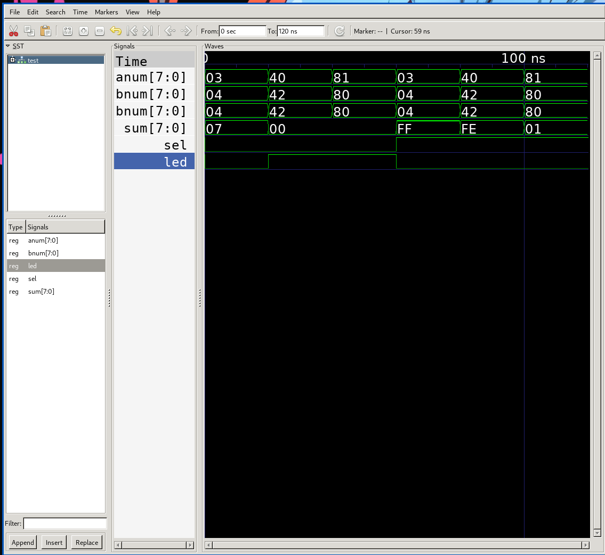

Código VHDL

Logicand
library ieee;
use ieee.std_logic_1164.all;

entity logicand is
port(
a: in std_logic;
b: in std_logic;
o: out std_logic
);
end logicand;

architecture logicand of logicand is
begin
o <= a and b;
end logicand;

Logicor
library ieee;
use ieee.std_logic_1164.all;

entity logicor is
port(
a: in std_logic;
b: in std_logic;
o: out std_logic
);
end logicor;

architecture logicor of logicor is
begin
o <= a or b;
end logicor;

Logicxor
library ieee;
use ieee.std_logic_1164.all;

entity logicxor is
port(
a: in std_logic;
b: in std_logic;
o: out std_logic
);
end logicxor;

architecture logicxor of logicxor is
begin
o <= a xor b;
end logicxor;

Logicxnor
library ieee;
use ieee.std_logic_1164.all;

entity logicxnor is
port(
a: in std_logic;
b: in std_logic;
o: out std_logic
);
end logicxnor;

architecture logicxnor_arch of logicxnor is
begin
o <= a xnor b;
end logicxnor_arch;

Halfadder
library ieee;
use ieee.std_logic_1164.all;

entity halfadder is
port(
a: in std_logic;
b: in std_logic;
o: out std_logic;
c: out std_logic
);
end halfadder;

architecture halfadder_arch of halfadder is
component logicand is
port(
a: in std_logic;
b: in std_logic;
o: out std_logic
);
end component;
component logicxor is
port(
a: in std_logic;
b: in std_logic;
o: out std_logic
);
end component;
begin
sum: logicxor port map( a => a, b => b, o => o );
carry: logicand port map( a => a, b => b, o => c );
end halfadder_arch;

Fullader
library ieee;
use ieee.std_logic_1164.all;

entity fulladder is
port(
anum: in std_logic;
bnum: in std_logic;
cin: in std_logic;
sum: out std_logic;
cout: out std_logic
);
end fulladder;

architecture fulladder_arch of fulladder is
component halfadder is
port(
a: in std_logic;
b: in std_logic;
o: out std_logic;
c: out std_logic
);
end component;
component logicor is
port(
a: in std_logic;
b: in std_logic;
o: out std_logic
);
end component;
signal carryA, carryB, sumPass : std_logic;
begin
firtsum: halfadder port map( a => anum, b => bnum, o => sumPass, c => carryB );
secondsum: halfadder port map( a => cin, b => sumPass, o => sum, c => carryA );
handlec: logicor port map( a => carryA, b => carryB, o => cout );
end fulladder_arch;

Adder8bit
library ieee;
use ieee.std_logic_1164.all;

entity adder8bit is
port(
sel: in std_logic;
anum: in std_logic_vector(7 downto 0);
bnum: in std_logic_vector(7 downto 0);
led: out std_logic;
sum: out std_logic_vector(7 downto 0)
);
end adder8bit;

architecture adder8bit_arch of adder8bit is
component fulladder is
port(
anum: in std_logic;
bnum: in std_logic;
cin: in std_logic;
sum: out std_logic;
cout: out std_logic
);
end component;
component logicxor is
port(
a: in std_logic;
b: in std_logic;
o: out std_logic
);
end component;
component logicxnor is
port(
a: in std_logic;
b: in std_logic;
o: out std_logic
);
end component;
component logicand is
port(
a: in std_logic;
b: in std_logic;
o: out std_logic
);
end component;
signal carry: std_logic_vector(7 downto 0);
signal bneg: std_logic_vector(7 downto 0);
signal sneg: std_logic_vector(7 downto 0);
signal cend: std_logic;
begin
rest0: logicxor port map( a => sel, b => bnum(0), o => bneg(0) );
rest1: logicxor port map( a => sel, b => bnum(1), o => bneg(1) );
rest2: logicxor port map( a => sel, b => bnum(2), o => bneg(2) );
rest3: logicxor port map( a => sel, b => bnum(3), o => bneg(3) );
rest4: logicxor port map( a => sel, b => bnum(4), o => bneg(4) );
rest5: logicxor port map( a => sel, b => bnum(5), o => bneg(5) );
rest6: logicxor port map( a => sel, b => bnum(6), o => bneg(6) );
rest7: logicxor port map( a => sel, b => bnum(7), o => bneg(7) );
sneg0: fulladder port map(anum => anum(0), bnum => bneg(0), cin => sel, cout => carry(0), sum => sneg(0) );
sneg1: fulladder port map(anum => anum(1), bnum => bneg(1), cin => carry(0), cout => carry(1), sum => sneg(1) );
sneg2: fulladder port map(anum => anum(2), bnum => bneg(2), cin => carry(1), cout => carry(2), sum => sneg(2) );
sneg3: fulladder port map(anum => anum(3), bnum => bneg(3), cin => carry(2), cout => carry(3), sum => sneg(3) );
sneg4: fulladder port map(anum => anum(4), bnum => bneg(4), cin => carry(3), cout => carry(4), sum => sneg(4) );
sneg5: fulladder port map(anum => anum(5), bnum => bneg(5), cin => carry(4), cout => carry(5), sum => sneg(5) );
sneg6: fulladder port map(anum => anum(6), bnum => bneg(6), cin => carry(5), cout => carry(6), sum => sneg(6) );
sneg7: fulladder port map(anum => anum(7), bnum => bneg(7), cin => carry(6), cout => carry(7), sum => sneg(7) );
ledh: logicxor port map( a => carry(7), b => carry(6), o => led );
idkw: logicxnor port map( a => carry(7), b => carry(6), o => cend );
sum0: logicand port map( a => cend, b => sneg(0), o => sum(0) );
sum1: logicand port map( a => cend, b => sneg(1), o => sum(1) );
sum2: logicand port map( a => cend, b => sneg(2), o => sum(2) );
sum3: logicand port map( a => cend, b => sneg(3), o => sum(3) );
sum4: logicand port map( a => cend, b => sneg(4), o => sum(4) );
sum5: logicand port map( a => cend, b => sneg(5), o => sum(5) );
sum6: logicand port map( a => cend, b => sneg(6), o => sum(6) );
sum7: logicand port map( a => cend, b => sneg(7), o => sum(7) );
end adder8bit_arch;

Test
library ieee;
use ieee.std_logic_1164.all;

entity test is
end test;

architecture test of test is
component adder8bit is
port(
sel: in std_logic;
anum: in std_logic_vector(7 downto 0);
bnum: in std_logic_vector(7 downto 0);
led: out std_logic;
sum: out std_logic_vector(7 downto 0)
);
end component;
signal anum, bnum, sum: std_logic_vector(7 downto 0);
signal sel, led: std_logic;
begin
conecctions : adder8bit port map( anum => anum, bnum => bnum, sel => sel, sum => sum, led => led );
process begin
sel <= '0';
anum <= "00000011";
bnum <= "00000100";
wait for 20 ns;
anum <= "01000000";
bnum <= "01000010";
wait for 20 ns;
anum <= "10000001";
bnum <= "10000000";
wait for 20 ns;
sel <= '1';
anum <= "00000011";
bnum <= "00000100";
wait for 20 ns;
anum <= "01000000";
bnum <= "01000010";
wait for 20 ns;
anum <= "10000001";
bnum <= "10000000";
wait for 20 ns;
wait;
end process;
end test;

Análisis de vectores

Vectores de entrada
A |  | B
Binario | Hexadecimal | Binario | Hexadecimal
00000011 | 3 | 00000100 | 4
01000000 | 40 | 01000010 | 42
10000001 | 81 | 10000000 | 80

Valores de salida
A |  | B |  | Selector
Binario | Hexa | Binario | Hexa | Binario | Binario | Hexa
00000011 | 3 | 00000100 | 4 | 0 | 00000111 | 7
01000000 | 40 | 01000010 | 42 | 0 | 00000000 | 0
10000001 | 81 | 10000000 | 80 | 0 | 00000000 | 0
00000011 | 3 | 00000100 | 4 | 1 | 11111111 | FF
01000000 | 40 | 01000010 | 42 | 1 | 11111110 | FE
10000001 | 81 | 10000000 | 80 | 1 | 00000001 | 1

Conclusión
Los circuitos para sumar en los procesadores buscan ser eficientes en su tarea, a pesar de que hacen uso repetitivo de módulos buscando la simplificación del problema a resolver hacen uso de las propiedades de los número en su base binario para añadir muy pocos componentes para convertir el sumador en un restador que de haber hecho uso de un circuito distinto pudo haber sido perjudicial para el uso de recursos que supondría.

