

INSTITUTO POLITÉCNICO NACIONAL
ESCUELA SUPERIOR DE COMPUTO

Std Logic Arith & Unsigned
Practica 7
Materia:
Arquitectura de computadoras
Profesor:
Castillo Cabrera Gelacio
Alumno:
Cortés Piña Oziel
Grupo:

3CM12

Simulación en GHDL y GTLWAVE
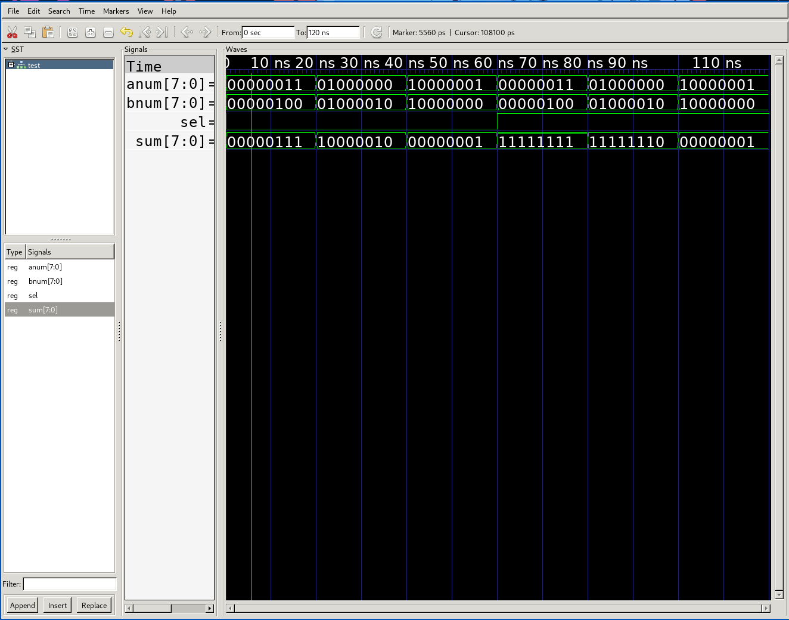
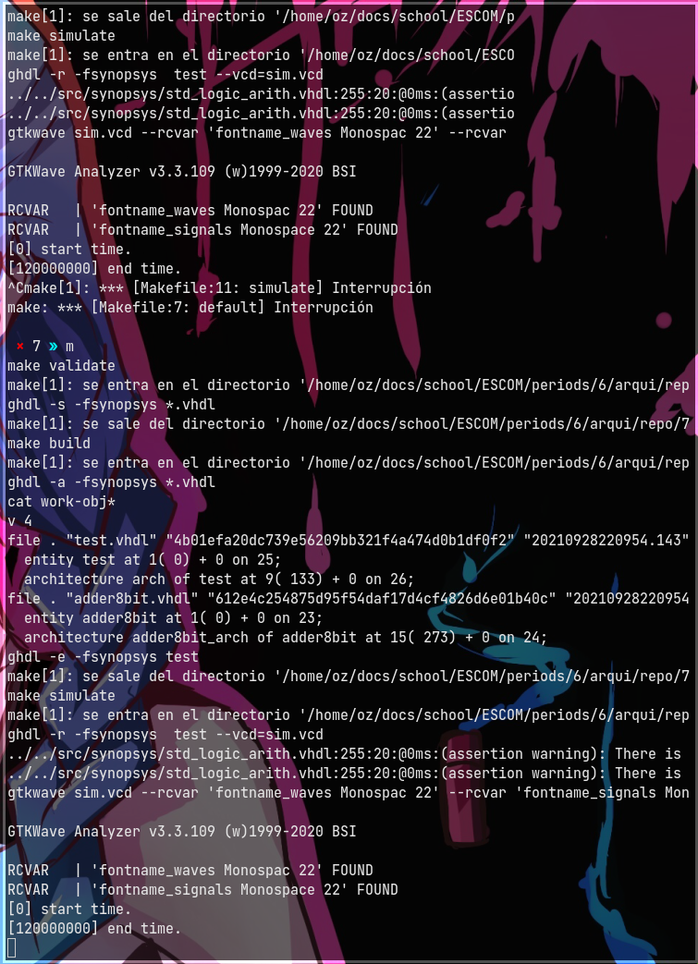

Código VHDL

Adder8bit
library ieee;
use ieee.std_logic_1164.all;
use ieee.std_logic_arith.all;
use ieee.std_logic_unsigned.all;

entity adder8bit is
port(
sel: in std_logic;
anum: in unsigned(7 downto 0);
bnum: in unsigned(7 downto 0);
sum: out unsigned(7 downto 0)
);
end adder8bit;

architecture adder8bit_arch of adder8bit is
begin
sum <= anum + bnum when sel = '0'
else anum - bnum;
end adder8bit_arch;

Test
library ieee;
use ieee.std_logic_1164.all;
use ieee.std_logic_arith.all;
use ieee.std_logic_unsigned.all;

entity test is
end test;

architecture arch of test is
component adder8bit is
port(
sel: in std_logic;
anum: in unsigned(7 downto 0);
bnum: in unsigned(7 downto 0);
sum: out unsigned(7 downto 0)
);
end component;
signal sel: std_logic;
signal anum: unsigned(7 downto 0);
signal bnum: unsigned(7 downto 0);
signal sum: unsigned(7 downto 0);
begin
adder: adder8bit port map( sel => sel, anum => anum, bnum => bnum, sum => sum );
process begin
sel <= '0';
anum <= "00000011";
bnum <= "00000100";
wait for 20 ns;
anum <= "01000000";
bnum <= "01000010";
wait for 20 ns;
anum <= "10000001";
bnum <= "10000000";
wait for 20 ns;
sel <= '1';
anum <= "00000011";
bnum <= "00000100";
wait for 20 ns;
anum <= "01000000";
bnum <= "01000010";
wait for 20 ns;
anum <= "10000001";
bnum <= "10000000";
wait for 20 ns;
wait;
end process;
end arch;

Análisis de vectores

Practica 6

Vectores de entrada
A |  | B
Binario | Hexadecimal | Binario | Hexadecimal
00000011 | 3 | 00000100 | 4
01000000 | 40 | 01000010 | 42
10000001 | 81 | 10000000 | 80

Valores de salida
A |  | B |  | Selector
Binario | Hexa | Binario | Hexa | Binario | Binario | Hexa
00000011 | 3 | 00000100 | 4 | 0 | 00000111 | 7
01000000 | 40 | 01000010 | 42 | 0 | 00000000 | 0
10000001 | 81 | 10000000 | 80 | 0 | 00000000 | 0
00000011 | 3 | 00000100 | 4 | 1 | 11111111 | FF
01000000 | 40 | 01000010 | 42 | 1 | 11111110 | FE
10000001 | 81 | 10000000 | 80 | 1 | 00000001 | 1

Practica 7

Vectores de entrada
A |  | B
Binario | Hexadecimal | Binario | Hexadecimal
00000011 | 3 | 00000100 | 4
01000000 | 40 | 01000010 | 42
10000001 | 81 | 10000000 | 80

Valores de salida
A |  | B |  | Selector
Binario | Hexa | Binario | Hexa | Binario | Binario | Hexa
00000011 | 3 | 00000100 | 4 | 0 | 00000111 | 7
01000000 | 40 | 01000010 | 42 | 0 | 00000000 | 82
10000001 | 81 | 10000000 | 80 | 0 | 00000000 | 01
00000011 | 3 | 00000100 | 4 | 1 | 11111111 | FF
01000000 | 40 | 01000010 | 42 | 1 | 11111110 | FE
10000001 | 81 | 10000000 | 80 | 1 | 00000001 | 1

Conclusión
La biblioteca de arith en VHDL permite realizar circuitos más fáciles y ahorra mucho tiempo más sin en-cambio arroja valores distintos al momento de realizar las operaciones de suma y resta haciendo que se aproveche el número a sumarse y restarte a diferencia del circuito anterior en el que teníamos desbordes. Pareciera que usa los positivos y negativos a su favor del número para representarlo.

