

INSTITUTO POLITÉCNICO NACIONAL
ESCUELA SUPERIOR DE COMPUTO

Mult4bit
Practica 9
Materia:
Arquitectura de computadoras
Profesor:
Castillo Cabrera Gelacio
Alumno:
Cortés Piña Oziel
Grupo:

3CM12

Simulación en GHDL y GTLWAVE
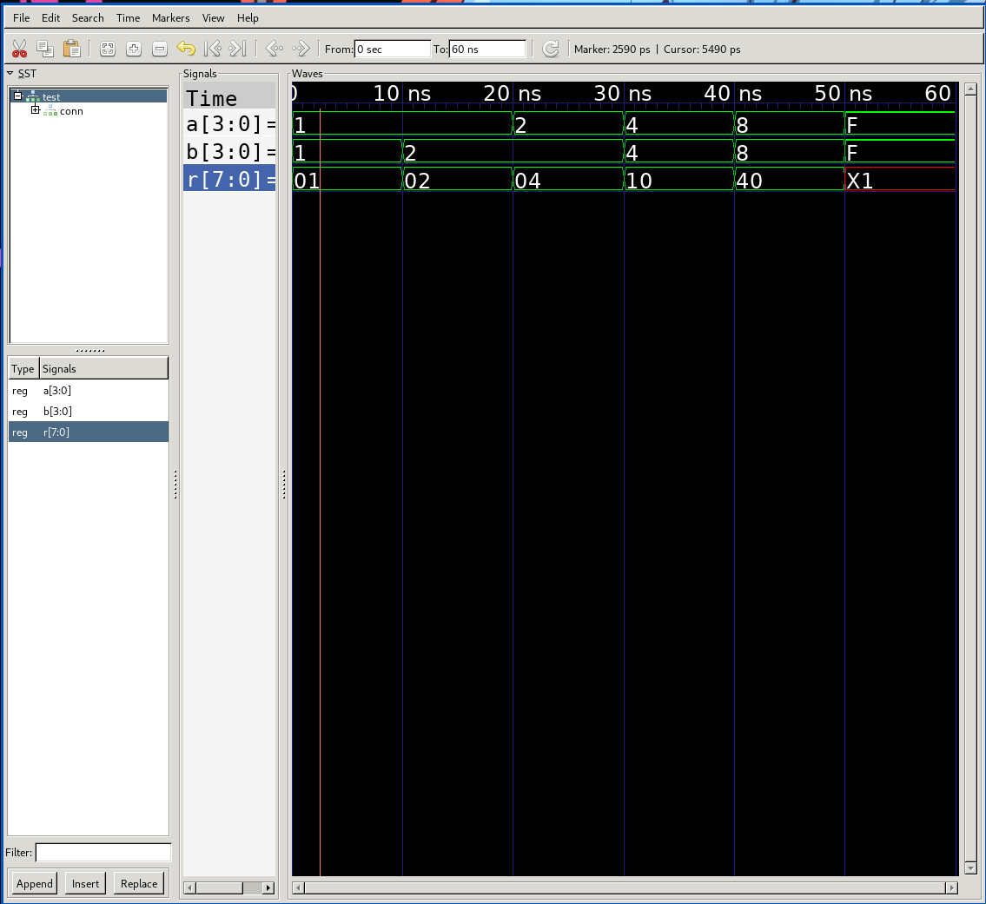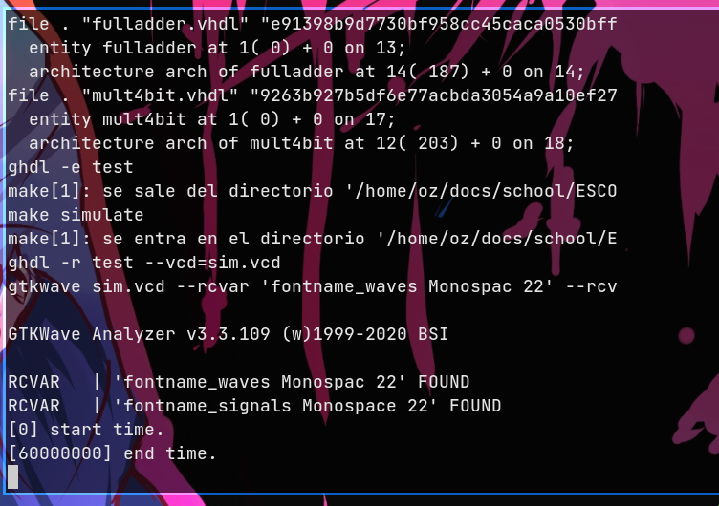

Código VHDL

Halfadder
library ieee;
use ieee.std_logic_1164.all;

entity halfadder is
port(
a: in std_logic;
b: in std_logic;
s: out std_logic;
c: out std_logic
);
end halfadder;

architecture arch of halfadder is
begin
s <= a xor b;
c <= a and b;
end arch;

Fulladder
library ieee;
use ieee.std_logic_1164.all;

entity fulladder is
port(
a: in std_logic;
b: in std_logic;
e: in std_logic;
s: out std_logic;
c: out std_logic
);
end fulladder;

architecture arch of fulladder is
component halfadder is
port(
a: in std_logic;
b: in std_logic;
s: out std_logic;
c: out std_logic
);
end component;
signal sum, carryA, carryB: std_logic;
begin
first: halfadder port map( a => a, b => b, s => sum, c => carryA );
second: halfadder port map( a => e, b => sum, s => s, c => carryB );
c <= carryA or carryB;
end arch;

Adder8bit
library ieee;
use ieee.std_logic_1164.all;

entity adder8bit is
port(
a: in std_logic_vector(7 downto 0);
b: in std_logic_vector(7 downto 0);
e: in std_logic;
s: out std_logic_vector(7 downto 0);
c: out std_logic
);
end adder8bit;

architecture arch of adder8bit is
component fulladder is
port(
a: in std_logic;
b: in std_logic;
e: in std_logic;
s: out std_logic;
c: out std_logic
);
end component;
signal carry: std_logic_vector(6 downto 0);
begin
s0: fulladder port map( a => a(0), b => b(0), e => e, s => s(0), c => carry(0) );
s1: fulladder port map( a => a(1), b => b(1), e => carry(0), s => s(1), c => carry(1) );
s2: fulladder port map( a => a(2), b => b(2), e => carry(1), s => s(2), c => carry(2) );
s3: fulladder port map( a => a(3), b => b(3), e => carry(2), s => s(3), c => carry(3) );
s4: fulladder port map( a => a(4), b => b(4), e => carry(3), s => s(4), c => carry(4) );
s5: fulladder port map( a => a(5), b => b(5), e => carry(4), s => s(5), c => carry(5) );
s6: fulladder port map( a => a(6), b => b(6), e => carry(5), s => s(6), c => carry(6) );
s7: fulladder port map( a => a(7), b => b(7), e => carry(6), s => s(7), c => c );
end arch;

Mult4bit
library ieee;
use ieee.std_logic_1164.all;

entity mult4bit is
port(
a: in std_logic_vector(3 downto 0);
b: in std_logic_vector(3 downto 0);
r: out std_logic_vector(7 downto 0)
);
end mult4bit;

architecture arch of mult4bit is
component adder8bit is
port(
a: in std_logic_vector(7 downto 0);
b: in std_logic_vector(7 downto 0);
e: in std_logic;
s: out std_logic_vector(7 downto 0);
c: out std_logic
);
end component;
signal p0, p1, p2, p3: std_logic_vector(7 downto 0);
signal s0, s1: std_logic_vector(7 downto 0);
signal carry: std_logic_vector(1 downto 0);
begin

p0(0) <= b(0) and a(0);
p0(1) <= b(1) and a(0);
p0(2) <= b(2) and a(0);
p0(3) <= b(3) and a(0);
p0(4) <= '0';
p0(5) <= '0';
p0(6) <= '0';
p0(7) <= '0';

p1(0) <= '0';
p1(1) <= b(0) and a(1);
p1(2) <= b(1) and a(1);
p1(3) <= b(2) and a(1);
p1(4) <= b(3) and a(1);
p1(5) <= '0';
p1(6) <= '0';
p1(7) <= '0';

p2(0) <= '0';
p2(1) <= '0';
p2(2) <= b(0) and a(2);
p2(3) <= b(1) and a(2);
p2(4) <= b(2) and a(2);
p2(5) <= b(3) and a(2);
p2(6) <= '0';
p2(7) <= '0';

p3(0) <= '0';
p3(1) <= '0';
p3(2) <= '0';
p3(3) <= b(0) and a(3);
p3(4) <= b(1) and a(3);
p3(5) <= b(2) and a(3);
p3(6) <= b(3) and a(3);
p3(7) <= '0';

r0: adder8bit port map( a => p0, b => p1, e => '0', s => s0, c => carry(0) );
r1: adder8bit port map( a => s0, b => p2, e => carry(0), s => s1, c => carry(1) );
s2: adder8bit port map( a => s1, b => p3, e => carry(1), s => r, c => r(7) );
end arch;

Test
library ieee;
use ieee.std_logic_1164.all;

entity test is
end test;

architecture arch of test is
component mult4bit is
port(
a: in std_logic_vector(3 downto 0);
b: in std_logic_vector(3 downto 0);
r: out std_logic_vector(7 downto 0)
);
end component;
signal a: std_logic_vector(3 downto 0);
signal b: std_logic_vector(3 downto 0);
signal r: std_logic_vector(7 downto 0);
begin
conn: mult4bit port map( a => a, b => b, r => r );
process begin
a <= "0001";
b <= "0001";
wait for 10 ns;
a <= "0001";
b <= "0010";
wait for 10 ns;
a <= "0010";
b <= "0010";
wait for 10 ns;
a <= "0100";
b <= "0100";
wait for 10 ns;
a <= "1000";
b <= "1000";
wait for 10 ns;
a <= "1111";
b <= "1111";
wait for 10 ns;
wait;
end process;
end arch;

Análisis de vectores

Vectores de entrada
A |  | B
Binario | Hexadecimal | Binario | Hexadecimal
0001 | 1 | 0001 | 1
0001 | 1 | 0010 | 2
0010 | 2 | 0010 | 2
0100 | 4 | 0100 | 4
1000 | 8 | 1000 | 8
1111 | F | 1111 | F

Valores de salida
Binario | Hexadecimal
00000001 | 01
00000010 | 02
00000100 | 04
00010000 | 10
00100000 | 40
x1100001 | X1

Conclusión
A pesar de que de cierta manera el diseño del circuito es elegante el inocente tamaño lo vuelve complejo por que usar circuitos auxiliares ayudan pero al usar un sumador positivo corrompe los resultados a escalas grandes por lo que no es conveniente este diseño en el cual me apoyo de circuitos anteriores aunque más rápido de elaborar.

