Task: Cache simulator (Block-set-associative / LRU)

Site page [Cache Simulator (westsomething.pythonanywhere.com)](https://westsomething.pythonanywhere.com/?fbclid=IwZXh0bgNhZW0CMTEAAR34wVzdGyrHP7QU0xHZGLJb3n9rYaX7E9gIB9b8v1vswrZ4KIUE8zyKwrs_aem_hEq3jG4jk04tVnACd_XvSg)  
How to use: Fill in necessary inputs only int; Put spaces between each input in Program Flow  
Set Memory/Cache/Program Flow Size from word or block

Code:

Test Cases:   
Test case 1

(small scale block & set size = 2 memory & cache size = 10 set all to blocks Program Flow: 1 2 3 4 5 6)

Results:

Site:

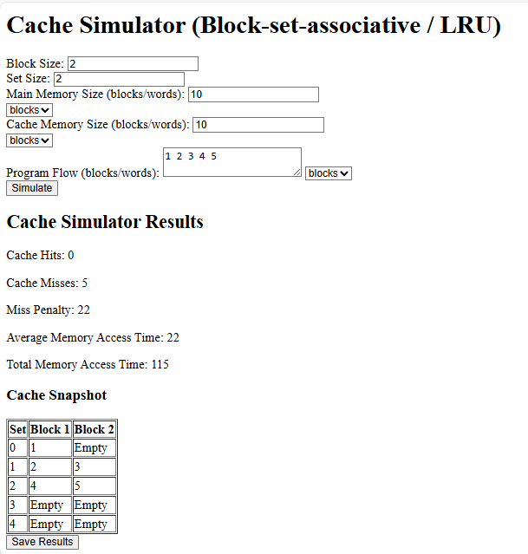

Txt file:

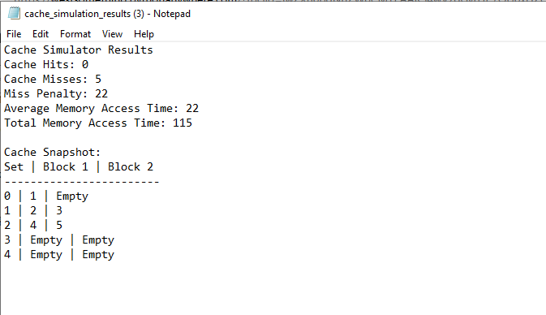

Test case 2

(Larger Scale block size = 100 set size = 50 memory = 10k cache = 1k set all to blocks Program Flow: 0 100 200 300 400 500 600 700 800)

Results:

Site:

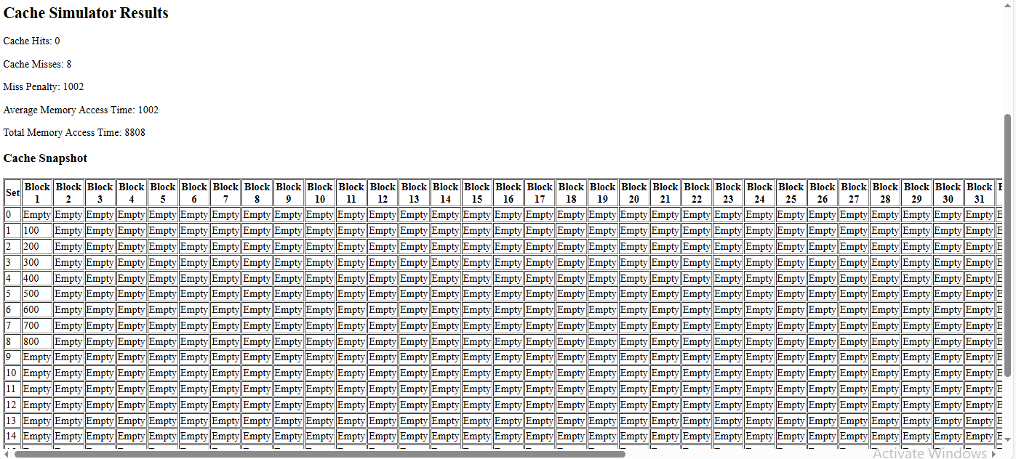

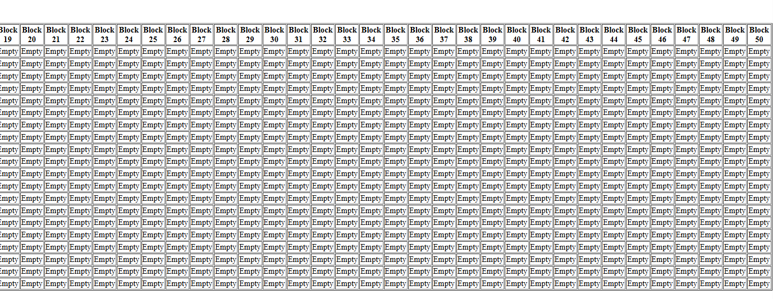

Txt file:

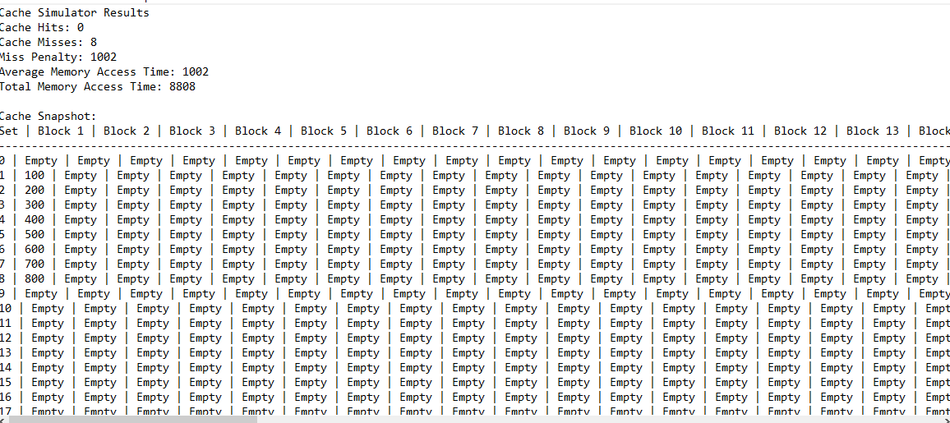

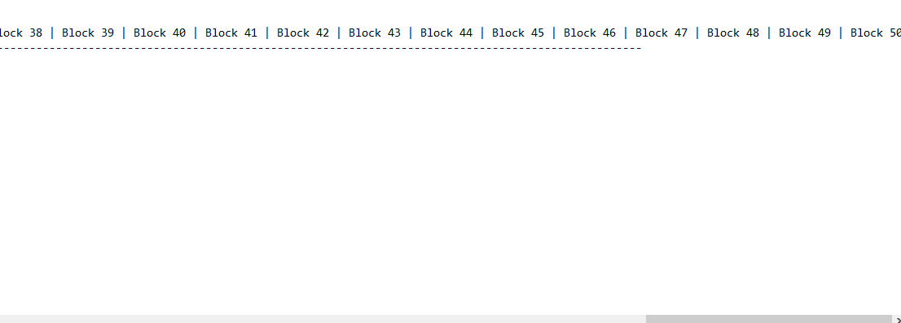

Test case 3

(small scale w/ repeats block & set size = 2 memory & cache size = 10 set all to blocks Program Flow: 1 1 2 2 3 3 4 4 5 5)

Results:

Site:

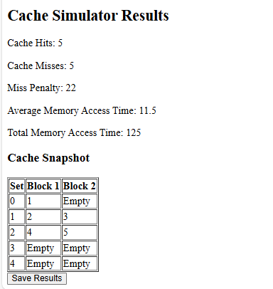

Txt file:

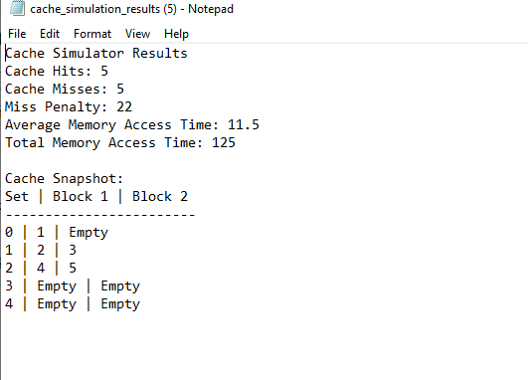

Test case 4

(small scale w/ repeats block & set size = 2 memory & cache size = 100 set both to words Program Flow: 1 1 2 2 3 3 4 4 5 5)

Results:

Site:

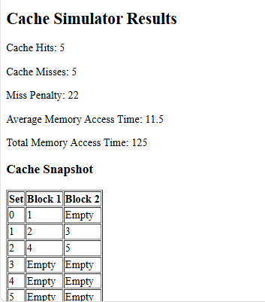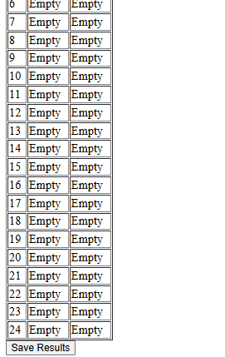

Txt file:

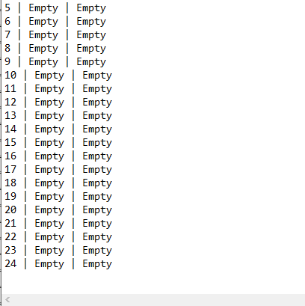

Test Case 5

(Incorrect Flow Block & Set size = 2 Memory & Cache Size = 100 words Flow: a b c d e 1 2 3 4)

Results: No Output

