T.C.
İSTANBUL KÜLTÜR UNIVERSITY
FACULTY OF ENGINEERING
DEPARTMENT OF
ELECTRICAL & ELCTRONICS ENGINEERING

OZAN EMRE TUNCA

Effi-Home: Smart Energy Optimization
Smart Home and Energy Management System Project Report

Introduction
The increasing global demand for energy necessitates innovative approaches to manage and optimize household energy consumption. This project focuses on implementing a Smart Home and Energy Management (SH&EM) system designed to enhance energy efficiency and reduce costs. The system uses a smart algorithm to prioritize electrical loads, shift high consumption periods, and visualize load profiles for efficient energy usage.
The primary objectives of this project include:
1. Categorizing household appliances based on their energy usage.
2. Preserving household comfort while shifting energy loads during peak hours.
3. Analyzing energy consumption for typical winter and summer days.
4. Comparing energy costs with and without load shifting using a three-tiered tariff structure.
Implemented using Python, this system offers clear data analysis, visualization, and effective cost-saving solutions for smart home energy management.
Additionally, the project contributes to sustainability by demonstrating the potential to optimize energy costs. By prioritizing device groups and employing innovative algorithms, it reduces the load on energy grids while creating long-term savings for households.

Methodology
Step 1: Categorizing Household Appliances and Data
Household appliances were classified into five priority levels based on importance and energy consumption:
- Priority 1 (High Priority): Devices requiring continuous operation (e.g., Refrigerator, Internet Modem).
- Priority 2 (Medium Priority): Devices with moderate flexibility (e.g., Oven, Coffee Machine).
- Priority 3 (Low Priority): Devices with minimal urgency (e.g., Game Console, Computer).
Step 2: Defining Usage Hours
Each device’s operating hours were determined based on typical winter day usage patterns, considering user habits and operational requirements. An Excel table was created to list these usage patterns and hourly energy consumption.
Additionally, detailed insights into the impact of device groups on energy efficiency were drawn. This analysis integrates load-shifting algorithms to reduce grid load during peak hours.

Step 3: Establishing Threshold Values
To optimize energy consumption, a threshold of 7500W was set as the maximum allowable power during peak hours. Any consumption exceeding this limit was redistributed through load-shifting techniques. This optimization considered individual devices and overall consumption patterns.

Step 4: SH&EM Algorithm
Our SH&EM algorithm is designed to optimize home energy management and reduce energy costs. Developed in Python, it incorporates the following steps:
1. Defining Threshold Values: Establishing a threshold (7500W) based on daily energy consumption profiles.
2. Analyzing Peak Hours: Identifying time intervals where total energy consumption exceeds the threshold.
3. Shifting Prioritized Loads: Relocating low-priority loads to off-peak hours while maintaining user comfort. This involves rescheduling devices based on energy tariffs.
4. Recalculating Consumption and Costs: Reassessing energy consumption and costs for original and shifted load profiles. Tariffs are applied to calculate total savings.
5. Optimization and Visualization: Graphically visualizing the new load profiles to demonstrate their impact on the grid and cost savings.

Sample Data

Step 5: Visualization and Comparison
We created a sample data to observe the working principle of this algorithm:
The following graphical outputs were generated:
1. Original Load Profile: Illustrates energy consumption without load shifting.
2. Shifted Load Profile: Displays optimized consumption after applying the load shifting algorithm.
3. Comparison Graph: Highlights savings achieved through load shifting.

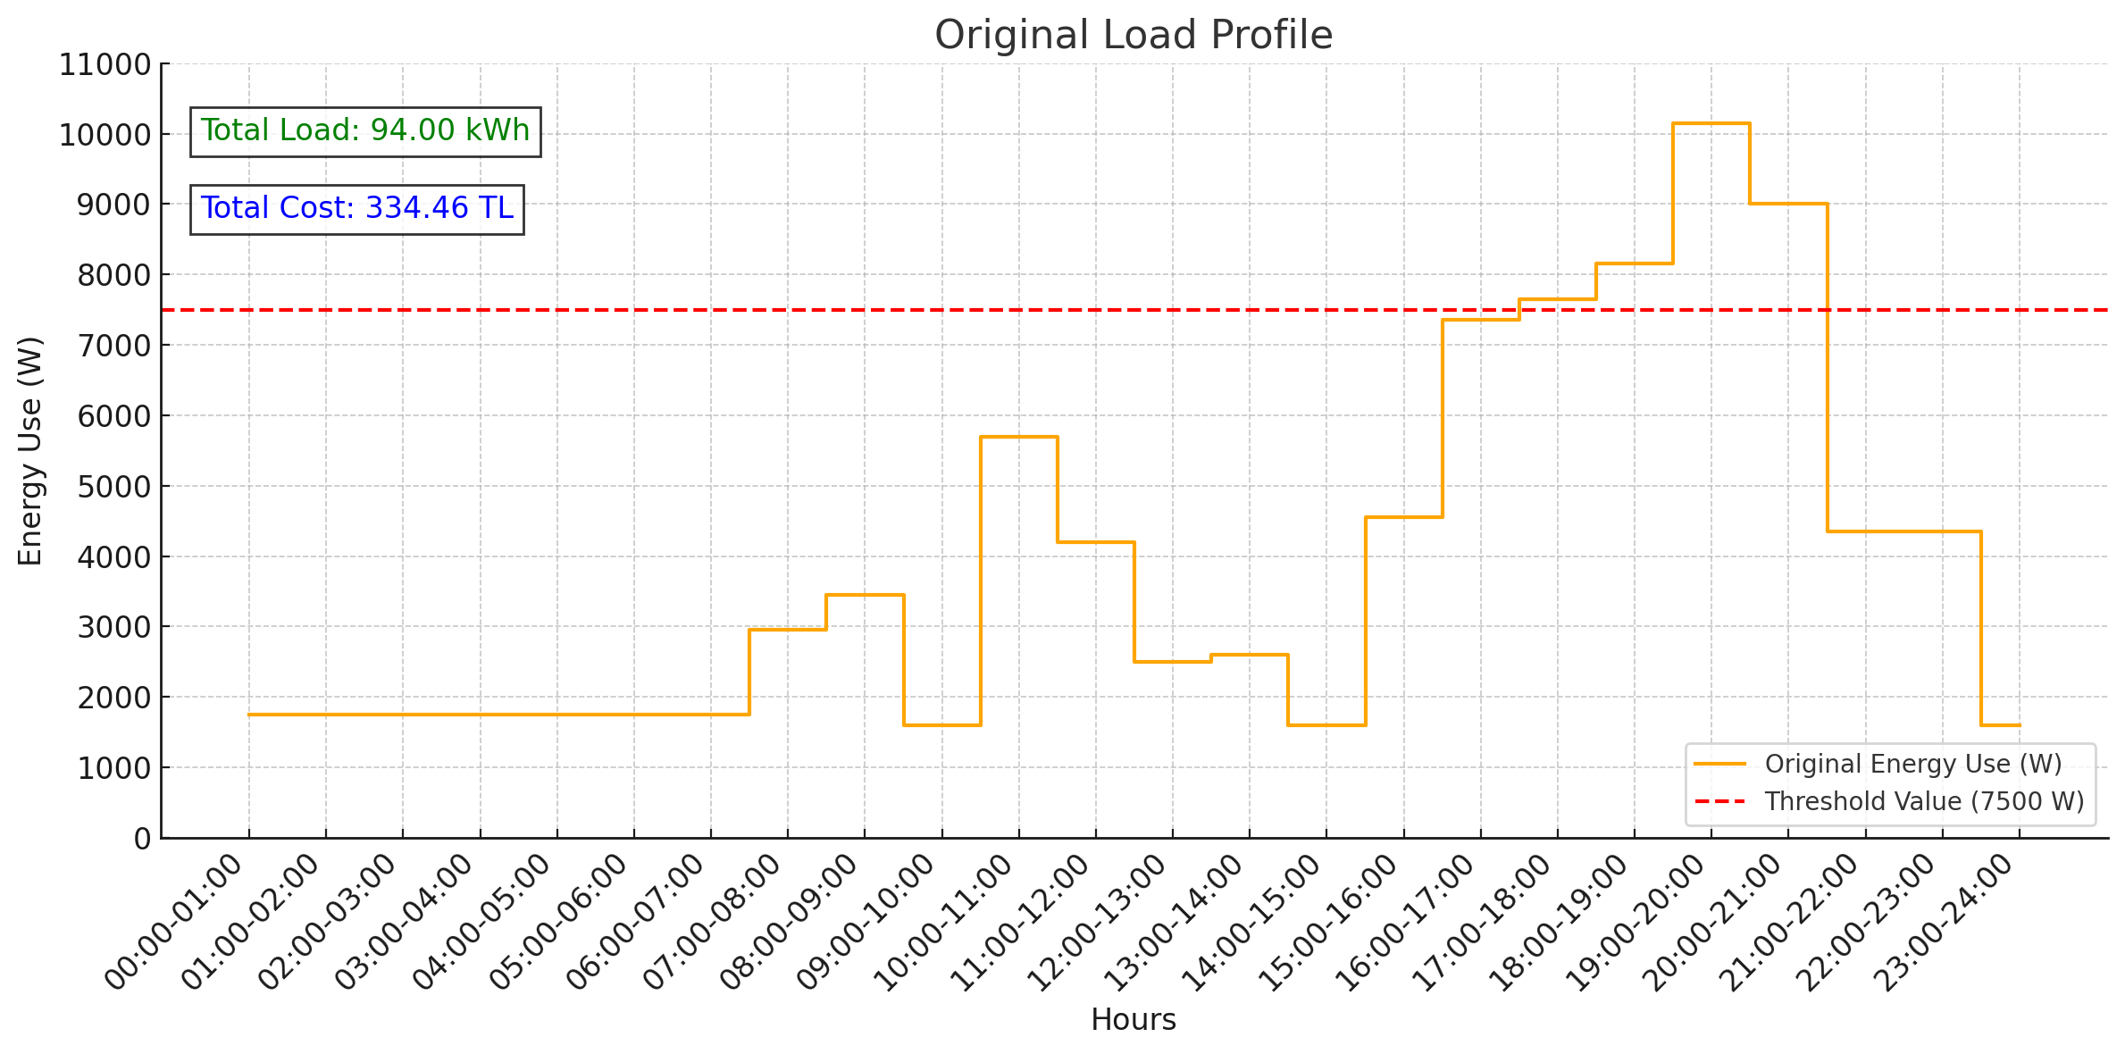
Original Load Profile

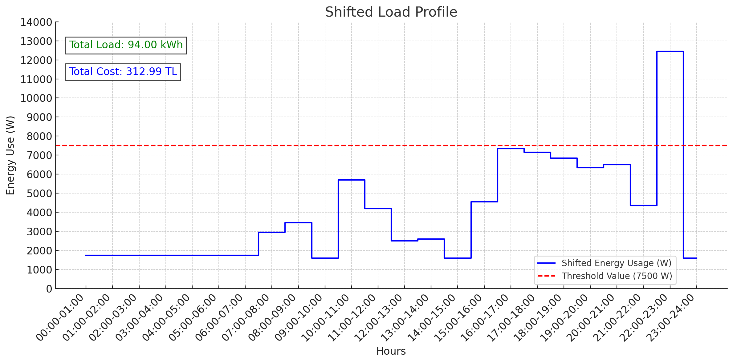
Shifted Load Profile

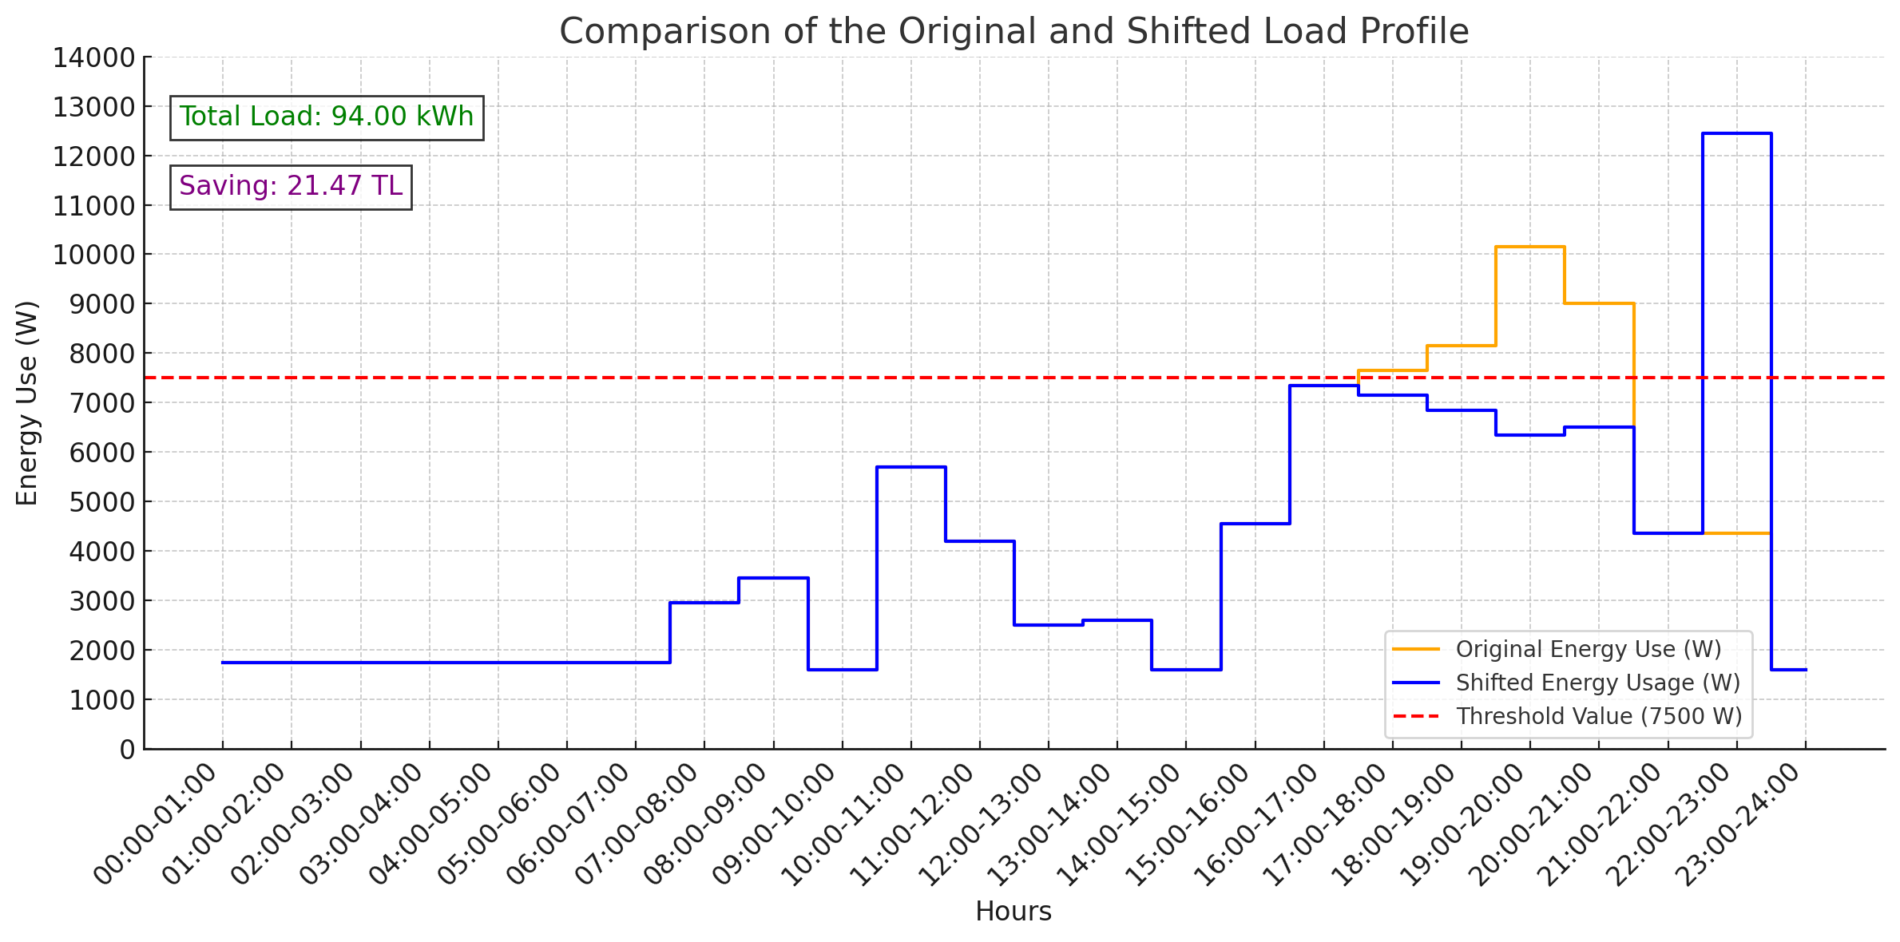
Comparison Graph
These graphs reveal the substantial impact of the optimization process, aligning with the threshold values for grid efficiency.
Step 6: Calculating Energy Costs
Energy costs for both scenarios were calculated using a three-tiered tariff system:
Original Scenario: Higher consumption during peak hours resulted in higher costs.
Shifted Scenario: Load shifting reduced peak-hour consumption, leading to cost savings.
For example, the average monthly household energy consumption is 430 kWh, costing approximately 1000 TL. With this system, annual savings of 1266,55 TL can be achieved based on daily savings of 3,47 TL.

Detailed Calculation of Energy Costs:

Monthly Energy Consumption:
The average monthly energy consumption is 2820 kWh. (For Project Data)
Daily Savings from Load Shifting:
Load shifting results in 21.47 TL savings per day

Monthly Savings:
If 21,47 TL is saved each day, the total monthly savings can be calculated as:
21,47 TL/day × 30 days = 641,1 TL/month

Annual Savings:
Based on daily savings of 21.47 TL, the annual savings would be:
21,47 TL/day × 365 days = 7836,55 TL/year

Energy Cost Comparison:
Energy Cost Without Load Shifting: 334,46 TL
Energy Cost With Load Shifting: 312,99 TL
The daily savings from load shifting can be calculated as:
334,46 TL – 312,99 TL = 21,47 TL/day
Results and Analysis
Key Observations
- Total Load: Remains constant at 94,00 kWh for both scenarios.
- Energy Cost Without Load Shifting: 334,46 TL.
- Energy Cost With Load Shifting: 312,99 TL.
- Daily Savings: 21,47 TL.
- Annual Savings Potential: Approximately 7836,55 TL, based on daily savings.

Graphical Analysis
1. Original Load Profile: Shows peak-hour surges exceeding the 7500W threshold.
2. Shifted Load Profile: Balanced energy consumption eliminates threshold breaches.
3. Comparison Graph: Demonstrates significant improvements in energy distribution and cost reductions.
The graphs highlight the dual benefits of cost reductions and reduced grid load.

Insights
The load-shifting algorithm effectively reduces energy costs while preserving household comfort. Priority-based scheduling ensures uninterrupted operation of critical devices. Furthermore, the seasonal differences in usage patterns provide valuable insights for future optimization efforts.

Conclusion
The Smart Home and Energy Management System demonstrates significant energy-saving potential through intelligent load management. Key benefits include:
1. Reducing energy consumption during peak hours.
2. Enhancing cost efficiency with minimal disruption to user comfort.
3. Scalability to accommodate seasonal changes (e.g., summer analysis forthcoming).
Future improvements may involve integrating renewable energy sources and real-time user feedback for enhanced optimization. This project highlights the practical application of Python in addressing real-world energy management challenges, offering scalable and user-friendly solutions for modern smart homes.

References
https://www.tedas.gov.tr/A/1/elektrik-tarifeleri/RoutePage/63c65a04d27de36b22f9cf1f
Enerji Piyasası Düzenleme Kurumu (EPDK). (2024). "Elektrik Tarifeleri ve Maliyet Analizi.”https://epdk.gov.tr/Detay/Icerik/3-0-1-3/elektriktarifeler
Python Software Foundation. (2024). Python Language Reference, version 3.10. https://www.python.org
Kluyver, T., et al. (2016). "Jupyter Notebooks - A Publishing Format for Reproducible Computational Workflows." In F. Loizides and B. Schmidt (Eds.), Positioning and Power in Academic Publishing: Players, Agents and Agendas (pp. 87-90). IOS Press. https://jupyter.org

