SPPU MBA
HUMAN RESOURCE MANAGEMENT
203 GC-09 | 2019 Pattern | Semester II

UNIT-WISE TOPPER NOTES
PYQ trend analysis (2022, 2023, 2024 and 2025) • Exam-ready definitions • Flowcharts • Comparisons • Applied examples • Model 5-mark and 10-mark answers

Prepared for SPPU MBA examination revision
Coverage: Units 1 to 5

Important Course Clarification
The official 2019-pattern syllabus places 203 GC-09 Human Resource Management in MBA First Year, Semester II. These notes follow that exact paper and unit structure, even though the request referred to “MBA second year.”

Study smart: definition + diagram + headings + example + conclusion

How to Use These Notes
These notes are designed around the wording and recurring themes of the four annual SPPU papers from 2022 to 2025. They are not a substitute for classroom teaching; they are an exam-writing framework that helps you convert concepts into structured, high-scoring answers.

Topper Answer Architecture
Question Type | Recommended Structure | Target Presentation
2 marks | One precise definition + two distinguishing points or one example. | 4-6 lines; underline keywords.
5 marks | Definition + mini diagram/table + five explained points + brief example. | About 1.5-2 pages in handwriting.
10 marks | Introduction + process/model diagram + 7-9 headings + example/case link + critical note + conclusion. | About 3.5-4.5 pages in handwriting.
Case study | State issue + apply relevant model + alternatives + recommendation + implementation controls. | Use facts from case; avoid generic theory dump.

Topper Tip
Start every long answer with a two-line definition or context. Draw a clean diagram within the first page. Use numbered headings, underline technical words, add one realistic example and close with a one-line conclusion linked to organisational performance.

Syllabus-to-Exam Priority Map
Unit | Official Unit Theme | 2022-2025 Recurrence | Priority
1 | HRM concept, challenges and Strategic HRM | Strategic role, HRM-HRD, challenges, evolution, HRM-SHRM | ★★★★☆
2 | HR acquisition and retention | HRP, job analysis, recruitment, selection, career/succession, JD-JS | ★★★★★
3 | Performance and training | Appraisal, performance management, training process/methods, Kirkpatrick | ★★★★★
4 | Compensation management | Pay components, incentives, equity, separation and grievance | ★★★★☆
5 | Emerging trends | HRIS every year; audit and accounting also repeated | ★★★★☆

Four-Year PYQ Heat Map
Theme | 2022 | 2023 | 2024 | 2025 | Revision Signal
Strategic HRM / changing HR role | Yes | Yes | Yes | Yes | Prepare one complete 10-mark answer.
HRP / manpower inventory | Yes | Yes | Yes | Indirect | Know process, barriers and gap actions.
Job analysis / JD / JS | Yes | Yes | Yes | Yes | Very high probability across question types.
Recruitment / selection | Yes | Yes | Yes | Yes | Processes + differences + case application.
Performance appraisal / management | Yes | Yes | Yes | Yes | Methods, process and comparison are essential.
Training / development / Kirkpatrick | Yes | Yes | Yes | Yes | Prepare process and evaluation answers.
Compensation / incentives | Yes | Yes | Yes | Yes | Components + equity + team incentives.
HRIS | Yes | Yes | Yes | Yes | Most stable Unit 5 topic.
HR audit / accounting | Yes | Yes | Limited | Limited | Useful alternate long-answer preparation.

Memory Key
Highest-return sequence for last-day revision: Unit 2 → Unit 3 → HRIS → Compensation → Strategic HRM → HR Audit/Accounting.

UNIT 1 - Human Resource Management: Concept and Challenges
Unit Scope
Introduction, objectives, scope, features, role, importance, policies and practices, functions and challenges of HRM; meaning, nature and importance of Strategic HRM; Harvard Model; Matching Model.

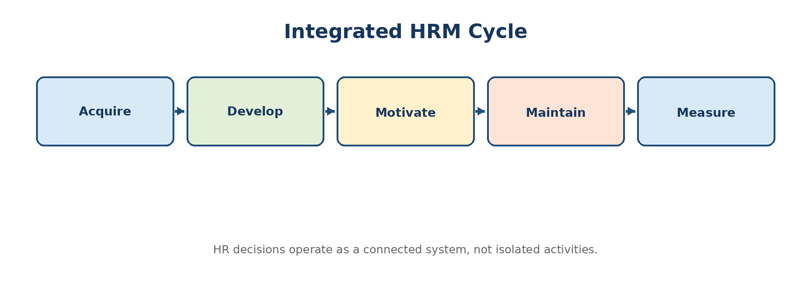
Diagram 1.1: HRM as an integrated organisational cycle

1. Meaning and Nature of HRM
Definition: Human Resource Management (HRM)
HRM is the systematic and strategic process of acquiring, developing, motivating, maintaining and effectively utilising people so that individual and organisational objectives are achieved.

People-centred: Employees are treated as valuable contributors with knowledge, skills, attitudes and aspirations.
Pervasive: Every manager performs HR responsibilities, while the HR department provides specialist systems and support.
Continuous: Planning, staffing, development, performance, reward and employee relations continue throughout the employee life cycle.
Development-oriented: HRM improves present capability and prepares employees for future roles.
Integrative: It balances employee expectations, organisational goals and societal requirements.
Strategic: People-related decisions are aligned with business direction and competitive priorities.
Contingency-based: Good HR practices vary according to strategy, technology, culture, workforce and environment.

2. Objectives, Scope and Importance
Dimension | Key Points | Exam Illustration
Organisational | Right people, productivity, quality, adaptability and goal achievement. | A logistics firm forecasts warehouse staffing before peak season.
Functional | Maintain HR contribution at an appropriate and cost-effective level. | Automate routine payroll while retaining human review.
Individual | Job satisfaction, growth, fair treatment, security and work-life quality. | Career paths reduce exits among high-potential analysts.
Societal | Legal compliance, inclusion, ethical employment and social responsibility. | Equal opportunity and safe working conditions.
Scope | HRP, job analysis, staffing, induction, training, appraisal, compensation, relations, welfare, records, separation and HR analytics. | Employee life cycle from entry to exit.

3. Functions of HRM
Managerial Functions | Operative Functions
Planning: forecast people and skill needs. | Procurement: job analysis, recruitment, selection and placement.
Organising: assign HR roles, authority and coordination. | Development: training, career, management development and succession.
Directing: leadership, communication and motivation. | Compensation: wages, incentives, benefits and recognition.
Controlling: compare HR results with plans and correct deviations. | Integration and maintenance: engagement, safety, welfare, relations and retention.
 | Separation and records: retirement, resignation, termination, HRIS and audit.

4. HR Policies and HR Practices
An HR policy is a broad guide for consistent decisions; an HR practice is the actual method or programme used to implement that policy.
Basis | HR Policy | HR Practice
Meaning | General principle or decision rule. | Specific action, procedure or programme.
Example | “Recruitment will be merit-based and inclusive.” | Structured interviews, scoring rubrics and diverse panels.
Time horizon | Relatively stable. | Can change with technology and operating needs.
Purpose | Consistency, fairness and direction. | Execution and measurable results.

5. HRM, HRD and Personnel Management
Basis | HRM | HRD | Personnel Management
Core focus | Total management of people for organisational performance. | Learning, capability, career and organisational development. | Administrative employment and labour matters.
Orientation | Strategic and integrated. | Developmental. | Operational and compliance-focused.
Responsibility | Line managers plus HR specialists. | HRD specialists, managers and learners. | Personnel department.
Typical outputs | Staffing, performance, rewards, engagement and retention. | Competence, learning culture and future readiness. | Records, wage administration and industrial relations.
Relationship | Umbrella concept. | A major subsystem of HRM. | Earlier/traditional approach that evolved into HRM.

6. Strategic Human Resource Management (SHRM)
Definition: Strategic HRM
SHRM is the planned pattern of HR deployment and activities intended to enable an organisation to achieve its long-term strategic objectives.

Vertical fit: HR strategy supports business strategy; for example, innovation strategy requires creative talent, autonomy and learning.
Horizontal fit: Recruitment, appraisal, rewards and development reinforce one another rather than sending conflicting signals.
Long-term orientation: Focus shifts from filling today’s vacancy to building tomorrow’s capabilities.
Evidence-based decisions: Workforce data and business outcomes are linked to improve decisions.
Strategic partnership: HR participates in planning, change, culture, restructuring and capability-building.
Basis | Traditional HRM | Strategic HRM
Focus | Operational efficiency and employee administration. | Long-term organisational capability and competitive advantage.
Planning | Often reactive. | Proactive and integrated with business planning.
Time horizon | Short to medium term. | Long term.
Success measures | Activities completed, cost, compliance. | Productivity, capability, retention, agility and business results.
Role of HR | Service provider / administrator. | Strategic partner, change agent and people architect.

7. Harvard Model and Matching Model
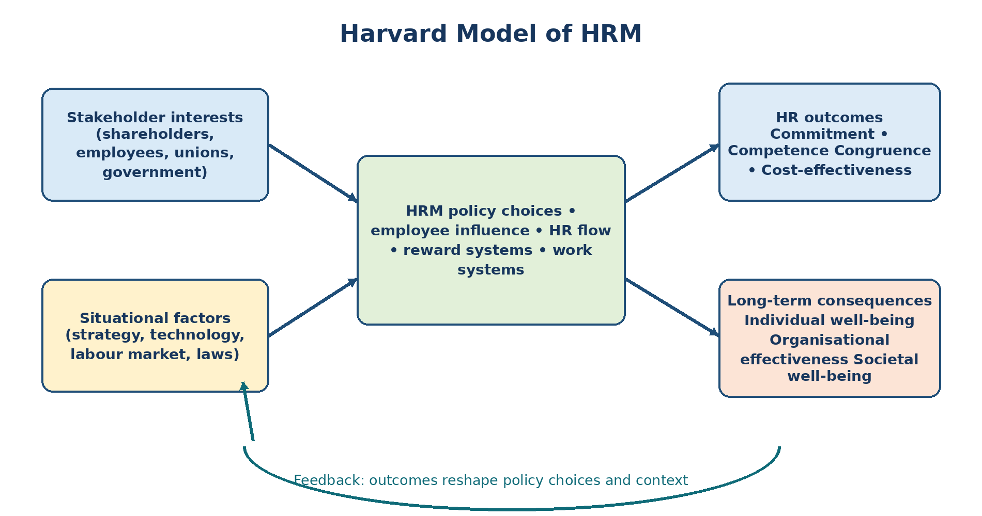
Diagram 1.2: Harvard Model - stakeholder and contextual approach
The Harvard Model is a “soft” or stakeholder-oriented model. It recognises that HR choices are shaped by multiple interests and situational factors. Its four desired HR outcomes are commitment, competence, congruence and cost-effectiveness. These outcomes create long-term consequences for individuals, the organisation and society.
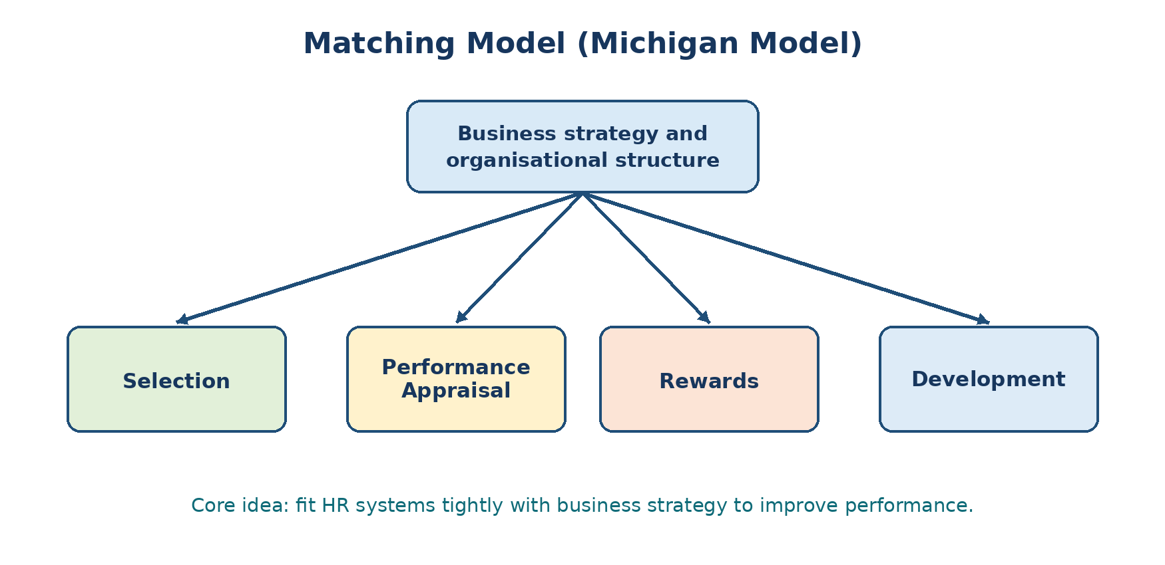
Diagram 1.3: Matching Model - strategic fit of HR systems
The Matching Model is a “hard” strategic fit model. It stresses that selection, appraisal, rewards and development must be designed to support business strategy and organisational structure. Its strength is clarity of alignment; its limitation is that employee interests may receive less emphasis.

8. Major Challenges before HRM
1. Technology and automation: Redesign jobs, reskill employees, manage digital adoption and protect data.
2. Talent scarcity and skill obsolescence: Build pipelines, use workforce planning and create continuous learning.
3. Workforce diversity: Ensure inclusion, remove bias and manage different generations and expectations.
4. Globalisation: Handle cross-cultural teams, mobility, varied labour markets and global standards.
5. Employee engagement and retention: Create meaningful work, capable managers, recognition and career opportunities.
6. Flexible and distributed work: Set output-based goals, collaboration norms, trust and well-being support.
7. Ethics and employee voice: Provide grievance, whistleblowing and fair investigation mechanisms.
8. Cost pressure with fairness: Balance productivity and affordability with internal equity and employee security.
9. Strategic credibility: Demonstrate how HR initiatives influence capability, productivity and business risk.
Applied Example
A software company facing rapid skill obsolescence can combine skill inventory, internal learning academies, project-based deployment, mentoring and targeted hiring. This is stronger than solving every skill gap through external recruitment.

PYQ-Focused Question Bank
Year | Question / Theme | Likely Marks | Priority
2022 | Importance of SHRM; HRM versus HRD; changes in 21st-century HRM. | 2/5 | High
2023 | Evolution and functions of HRM; challenges of HRM; strategic HR policies in emerging economies. | 5/10 | Very High
2024 | HRM versus SHRM. | 2 | Medium
2025 | Strategic transformation of the HR function from administrator to strategic contributor. | 10 | Very High

Model Answer (10 Marks - PYQ 2025 Theme): Explain why the HR function must transform from an administrative role to a strategic contributor.

Introduction
The administrative role of HR focuses on transactions such as attendance, payroll, records and compliance. These activities remain necessary, but competitive organisations require HR to shape workforce capability, culture and change. Therefore, HR must move from activity execution to business contribution.
Why strategic transformation is necessary
1. People are a source of advantage: Technology and capital can often be copied; organisation-specific skills, culture and leadership are harder to imitate.
2. Strategy requires capabilities: Growth, innovation, cost leadership or customer intimacy each require different talent and behaviour.
3. Environmental uncertainty: Workforce planning helps the organisation respond to demand changes, new technology and skill shortages.
4. Change success depends on employees: HR supports communication, role redesign, reskilling, leadership alignment and resistance management.
5. Talent risk affects continuity: Succession planning, retention and leadership development reduce dependence on a few individuals.
6. Data improves decisions: HR analytics can connect turnover, skill, performance and engagement patterns with operating outcomes.
7. Employee experience affects execution: Fair systems, competent managers and meaningful work improve commitment and service quality.
8. Governance and ethics: Strategic HR anticipates legal, conduct, safety and reputational risks rather than reacting after damage occurs.
How HR can make the shift
Automate and standardise routine transactions through HRIS and shared services.
Build HR business partner capability and business understanding.
Translate strategy into workforce, skill and leadership requirements.
Integrate staffing, appraisal, rewards and development.
Use a balanced HR scorecard covering efficiency, capability, employee outcomes and business impact.
Applied Example
For a hotel appointing a non-family CEO, strategic HR clarifies the capability profile, creates a rigorous selection and governance process, designs performance measures and plans stakeholder transition. Administrative HR would only issue the appointment letter.

Conclusion: HR creates strategic value when it converts business direction into capable people, aligned behaviour and a resilient organisation, while efficient administration becomes the foundation rather than the final objective.
Model Answer (10 Marks - PYQ 2023 Theme): Discuss major challenges of HRM and suggest suitable responses.

HRM operates at the intersection of business strategy, employee expectations, technology and law. Modern challenges are interconnected; hence isolated policies are insufficient.
Challenge | HR Response
Skill shortages and obsolescence | Strategic workforce planning, build-buy-borrow decisions, reskilling and internal mobility.
Technology disruption | Job redesign, change communication, digital learning and ethical data governance.
Diversity and inclusion | Bias-resistant selection, equal opportunity, inclusive leadership and accessible grievance channels.
Engagement and retention | Career visibility, quality supervision, recognition, fair pay and meaningful work.
Global / flexible workforce | Common values with local adaptation, output-based performance and collaboration norms.
Cost and productivity pressure | Workforce analytics, process redesign, variable pay and fair redeployment.
Ethics and trust | Codes of conduct, whistleblower protection, impartial investigations and transparent decisions.
Well-being and burnout | Workload review, manager support, employee assistance and realistic staffing.

Conclusion: Effective HRM does not merely solve employee problems; it builds systems that anticipate workforce risks and sustain performance with fairness.

Exam-Ready 5-Mark Notes
Model Answer (5 Marks): Differentiate HRM and HRD.

HRM is the broader system for managing people, while HRD is the developmental subsystem concerned with increasing capability and growth.
Basis | HRM | HRD
Scope | Staffing, performance, compensation, relations, welfare, separation and development. | Training, career development, potential, organisational learning and development.
Objective | Effective utilisation of human resources. | Improvement of competencies and future readiness.
Orientation | Managerial and strategic. | Learning and development.
Time focus | Present and future workforce needs. | Mostly future capability.
Relationship | Umbrella function. | Subsystem of HRM.

Model Answer (5 Marks): State the importance of Strategic HRM.

1. Strategic alignment: Ensures people systems support business priorities.
2. Capability-building: Develops skills and leadership required for future competition.
3. Integrated HR systems: Creates consistency among selection, appraisal, rewards and development.
4. Proactive risk management: Anticipates shortages, succession gaps and change needs.
5. Sustainable performance: Balances productivity, commitment, adaptability and ethical employment.

Rapid 2-Mark Answers
Q. What is an HR policy? A broad principle that guides consistent people-related decisions, such as a merit-based promotion policy.
Q. What is SHRM? The planned alignment of HR deployment and practices with long-term organisational strategy.
Q. Name the four HR outcomes in the Harvard Model. Commitment, competence, congruence and cost-effectiveness.
Q. What is vertical fit? Alignment between HR strategy and business strategy.
Q. What is horizontal fit? Internal consistency among different HR policies and practices.

UNIT 2 - HR Acquisition and Retention
Unit Scope
Human Resource Planning; job analysis, job description and job specification; job design, enlargement and enrichment; recruitment and selection; induction; career and succession planning; transfer, promotion and retention.

1. Human Resource Planning (HRP)
Definition: Human Resource Planning
HRP is the process of forecasting an organisation’s future demand for people and competencies, assessing internal and external supply, and developing actions to close the gap.

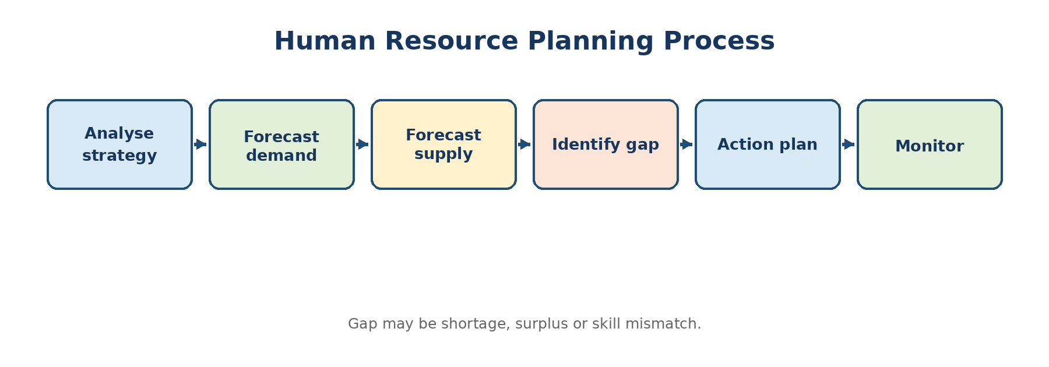
Diagram 2.1: Human Resource Planning process

Objectives and Importance of HRP
Provide the right number and quality of employees at the right time and place.
Prevent both shortage and surplus of labour.
Support expansion, technology change, restructuring and succession.
Estimate recruitment, training and compensation budgets.
Improve utilisation through redeployment and internal mobility.
Reduce disruption caused by unexpected resignations or retirements.

Demand and Supply Forecasting
Area | Techniques / Evidence | Example
Demand forecast | Managerial judgement, ratio-trend analysis, workload analysis, productivity ratios, scenario planning. | Orders per planner or calls per service executive.
Internal supply | Skills inventory, replacement chart, succession data, turnover and promotion patterns. | Employees ready now / ready in one year.
External supply | Labour-market data, educational pipelines, competitor demand, migration and location attractiveness. | Availability of data engineers in Pune.
Gap action | Recruit, train, redeploy, retain, automate, outsource, reduce overtime, freeze hiring or separate. | Reskill operations staff before system automation.

Barriers to Effective HRP
Uncertain business forecasts and rapid environmental change.
Poor HR data and outdated job/skill information.
Lack of coordination between line managers, finance and HR.
Overemphasis on headcount while ignoring competencies.
Resistance to declaring surplus or moving employees.
Short-term pressure that weakens long-term planning.

2. Job Analysis, JD and JS
Definition: Job Analysis
A systematic study of a job to identify its duties, responsibilities, working conditions, performance standards and the competencies required to perform it.

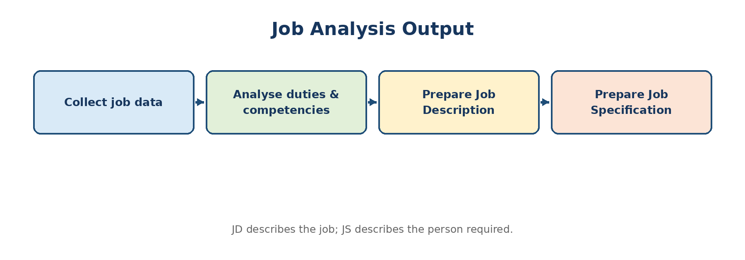
Diagram 2.2: Job analysis and its two major outputs

Methods of Job Analysis
Method | Best Use | Advantage | Limitation
Observation | Visible, repetitive and manual work. | Direct and realistic. | Weak for mental or infrequent tasks.
Interview | Managerial, technical or varied jobs. | Rich explanations and context. | Time-consuming; may involve exaggeration.
Questionnaire | Large number of similar jobs. | Standardised and economical. | May miss nuance; depends on respondent quality.
Diary / log | Jobs with changing activities over time. | Captures sequence and frequency. | Employees may omit or over-record tasks.
Critical incident | Jobs where effective/ineffective behaviours matter. | Useful for competencies and appraisal. | Does not provide complete job coverage.
Work records / documents | Established jobs and process-based work. | Quick supporting evidence. | Documents may be outdated.

Uses of Job Analysis
Workforce planning and organisation design.
Recruitment criteria and realistic job information.
Selection tests and interview questions.
Training need identification.
Performance standards and appraisal criteria.
Job evaluation, pay structure and legal defensibility.
Safety, workload and job redesign.
Basis | Job Description (JD) | Job Specification (JS)
Meaning | Written statement of job duties, authority, reporting and conditions. | Statement of qualifications and competencies required from job holder.
Focus | The job. | The person.
Typical contents | Title, purpose, duties, reporting, authority, KPIs, location and conditions. | Education, experience, technical skills, behavioural competencies and physical requirements.
Use | Clarifies responsibilities and standards. | Guides recruitment, screening and selection.
Example | “Conduct monthly payroll reconciliation.” | “Graduate with payroll-system knowledge and high accuracy.”

Topper Tip
For any JD/JS case, first state the organisational context, then write job title, reporting line, job purpose, 6-8 key duties, KPIs and authority. Follow with essential and desirable person specifications. This directly answers applied 10-mark questions.

3. Job Design, Enlargement and Enrichment
Job design determines how tasks, responsibilities, methods and relationships are combined into a job. Good design seeks efficiency, motivation, safety and flexibility.
Basis | Job Enlargement | Job Enrichment
Meaning | Adding more tasks of similar difficulty. | Adding greater responsibility, autonomy, planning and control.
Direction | Horizontal loading. | Vertical loading.
Main purpose | Reduce monotony and broaden task variety. | Increase meaningfulness, ownership and motivation.
Example | A service clerk handles billing plus dispatch documentation. | The clerk also resolves exceptions, plans priorities and reviews quality.
Risk | More work without greater authority. | Employee may need training and managerial support.

Factors in job design: technology, workflow, employee capability, ergonomics, safety, customer contact, autonomy, team dependence and legal requirements.
Common approaches: job rotation, enlargement, enrichment, autonomous teams and flexible work design.

4. Recruitment
Definition: Recruitment
The process of identifying and attracting a pool of potentially suitable candidates to apply for organisational vacancies.

Internal sources: promotion, transfer, internal job posting, succession pool, employee referrals and rehiring former employees.
External sources: campus, employment exchanges, consultants, online portals, social media, professional bodies, walk-ins and direct sourcing.
Source | Merits | Demerits
Internal | Lower cost, faster, known performance, motivation and career opportunity. | Limited choice, possible inbreeding, internal rivalry and another vacancy.
External | Fresh ideas, wider and specialised talent pool, supports growth/diversity. | Higher cost/time, uncertain fit, longer adjustment and possible demotivation internally.

Recruitment Process
1. Vacancy and requisition: Confirm genuine need, budget and approval.
2. Job analysis: Clarify duties, outcomes and person profile.
3. Recruitment strategy: Choose source, message, timeline, ownership and diversity controls.
4. Attraction: Publish a realistic and persuasive employer proposition.
5. Application management: Receive, acknowledge, track and protect candidate data.
6. Evaluate source effectiveness: Measure qualified applicants, time, cost, diversity, offer acceptance and quality of hire.

5. Selection
Definition: Selection
The process of choosing the most suitable candidate from the applicant pool through job-related assessment and decision stages.

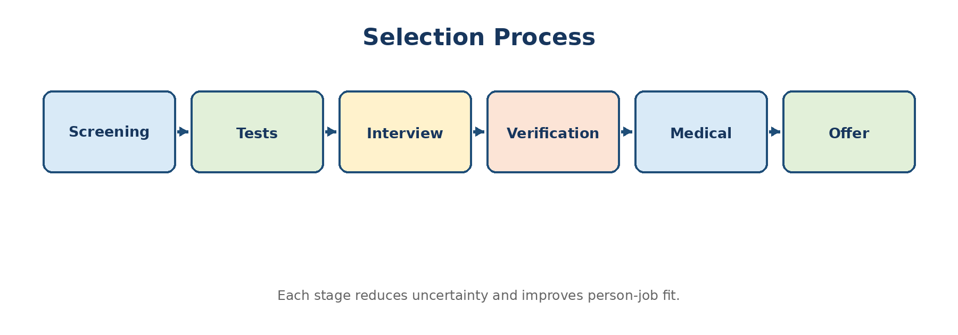
Diagram 2.3: Typical selection funnel
Basis | Recruitment | Selection
Purpose | Attract applicants. | Choose the best-suited candidate.
Nature | Positive process - expands the pool. | Screening process - narrows the pool.
Sequence | Precedes selection. | Follows recruitment.
Methods | Sourcing, advertising, referrals, campus and employer branding. | Tests, interviews, verification, assessment centre and medical examination.
Outcome | Applications. | Appointment / rejection decision.

Interview Types
Structured and unstructured interviews.
Behavioural and situational interviews.
Technical and competency-based interviews.
Panel, sequential and stress interviews.
Telephone/video and face-to-face interviews.
Topper Tip
A strong selection answer should mention validity, reliability, standardisation, multiple assessors, job-related criteria, documentation, candidate experience and legal fairness.

6. Induction and Orientation
Induction introduces the new employee to the organisation, job, team, policies and expected behaviour. Orientation may be viewed as the broader adjustment process during the early employment period.
Reduces anxiety and time to competence.
Clarifies role, performance standards and reporting.
Communicates culture, values, policies, safety and benefits.
Builds early relationships and belonging.
Reduces avoidable errors and early turnover.
Applied Example
A structured 30-60-90-day plan for a new warehouse manager can include safety certification, system access, process shadowing, stakeholder meetings, first-month KPIs and review checkpoints.

7. Career Planning, Succession, Transfer and Promotion
Definition: Career Planning
A process through which employees identify career goals and development needs while the organisation provides information, opportunities and support.

Definition: Succession Planning
A systematic process of identifying critical positions and developing a pool of employees who can fill them when required.

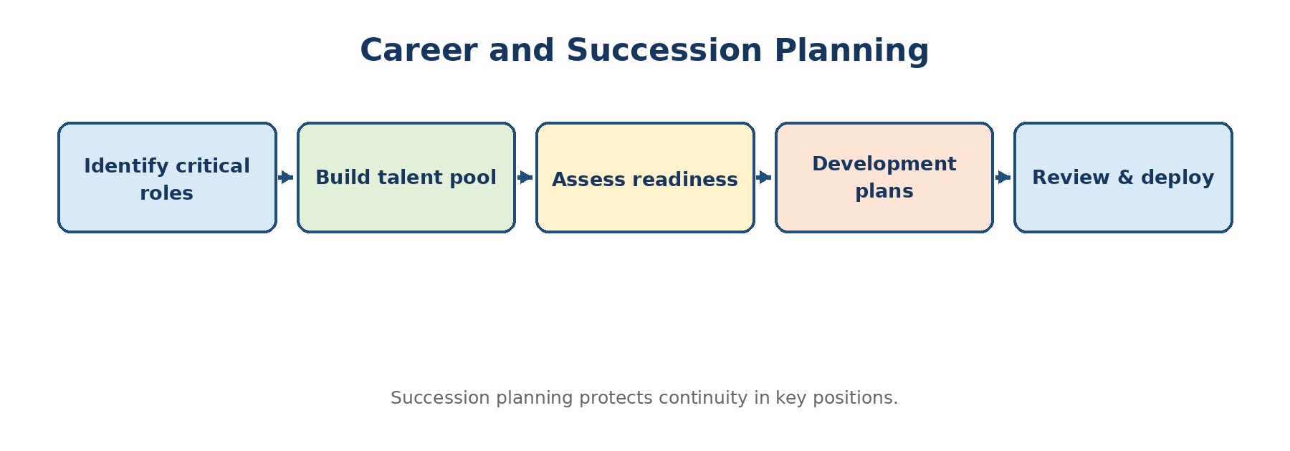
Diagram 2.4: Career and succession pipeline
Concept | Meaning | Typical Types / Tools
Transfer | Movement to another job at similar level/pay, usually without major status change. | Production, replacement, remedial, shift, inter-location.
Promotion | Upward movement with higher responsibility, authority, status and normally pay. | Merit, seniority, merit-cum-seniority; vertical/dry promotion.
Career development | Organisational actions that build employee readiness. | Assessment, mentoring, rotations, projects, education and career counselling.
Succession planning | Continuity plan for critical roles. | Talent pools, nine-box grid, readiness levels, development plans and emergency cover.

8. Employee Retention
Retention is the organisation’s ability to keep valued employees for an appropriate period. The aim is not zero turnover; it is to reduce regrettable and preventable turnover while maintaining performance standards.
Competitive and internally fair rewards.
Quality of supervision and respectful treatment.
Career growth, learning and internal mobility.
Meaningful work, autonomy and recognition.
Workload, well-being and flexibility.
Employee voice and fair grievance handling.
Stay interviews and targeted action for critical talent.
Evidence-based analysis of turnover patterns and costs.

PYQ-Focused Question Bank
Year | Question / Theme | Likely Marks | Priority
2022 | HRP and environmental factors; recruitment sources; JD/JS contents; selection process for logistics marketing manager. | 2/10 | Very High
2023 | Job-analysis uses; internal recruitment; internal mobility; enlargement vs enrichment; HRP process; JD vs JS; induction. | 2/5 | Very High
2024 | Recruitment process; selection; manpower inventory; succession planning; JD/JS for healthcare HR executive. | 2/5/10 | Very High
2025 | Recruitment and selection; promotion; job analysis features/methods; internal sources; CEO recruitment case; career planning. | 2/5/10 | Very High

Model Answer (10 Marks): Explain the Human Resource Planning process and discuss barriers to effective HRP.

HRP links business plans with workforce availability. It answers three questions: What people will be needed? What people will be available? What action will close the gap?

Use this diagram early in the answer
1. Analyse organisational plans: Study strategy, budgets, expansion, technology, product mix and productivity assumptions.
2. Prepare current workforce inventory: Map headcount, skills, age, performance, potential, locations, turnover and critical positions.
3. Forecast demand: Estimate future number and competencies by function, level and time using judgement and quantitative techniques.
4. Forecast supply: Assess internal movement and external labour-market availability.
5. Identify gaps: Classify shortage, surplus, location gap or competency gap.
6. Develop action plans: Recruit, train, redeploy, retain, outsource, automate, redesign jobs or manage separation.
7. Implement with responsibility and budget: Assign owners, schedule actions and coordinate line managers.
8. Monitor and revise: Track assumptions, staffing outcomes, productivity and business changes.
Barriers
Uncertain forecasts; weak HR data; poor coordination; lack of top-management support; focus only on numbers; rapid technology changes; employee resistance to movement; and failure to review plans.
Applied Example
For a logistics company entering two new cities, HRP should forecast drivers, sales staff, warehouse supervisors and digital skills; assess transferable employees; calculate the external gap; and phase recruitment and training before launch.

Conclusion: HRP is effective when it is continuous, competency-based and closely linked to operating assumptions rather than being an annual headcount exercise.
Model Answer (10 Marks - PYQ 2022 Theme): Design a selection process for a Marketing Manager in a logistics company.

The objective is to identify a candidate who can grow business, understand logistics economics, manage key accounts and coordinate operations without creating unrealistic commitments.
1. Job analysis and success profile: Define revenue responsibility, segment knowledge, pricing discipline, CRM usage, negotiation and cross-functional collaboration.
2. Recruitment channels: Use internal talent, industry networks, professional platforms, consultants and targeted competitor mapping.
3. Application screening: Apply essential criteria; verify relevant B2B/logistics experience and achievement evidence.
4. Work sample: Ask candidates to analyse a sample route/customer portfolio and prepare a 90-day market plan.
5. Structured competency interview: Use common questions and anchored scoring for customer orientation, negotiation, ethics and teamwork.
6. Technical-commercial panel: Assess freight economics, service feasibility, credit risk and contract basics.
7. Reference and background checks: Verify employment, performance claims, integrity and conflicts of interest with consent.
8. Final fit and offer: Clarify targets, variable pay, territory, authority and realistic job preview.
9. Post-selection validity: Review early performance, offer acceptance, joining and quality of hire to improve the process.
Applied Example
A candidate promising aggressive discounts should be assessed on contribution margin and operational feasibility, not only sales volume.

Conclusion: The process combines job-related evidence, multiple assessors and realistic business simulation, thereby improving validity and reducing bias.
Model Answer (10 Marks - PYQ 2024 Theme): Prepare a Job Description and Job Specification for an HR Executive in a healthcare organisation.

Job Description
Item | Illustrative Content
Job title / reporting | HR Executive; reports to HR Manager / Hospital Administrator.
Job purpose | Support timely staffing, employee records, attendance, onboarding, training coordination and employee service while maintaining confidentiality and compliance.
Key duties | Recruit clinical/support roles; coordinate joining and credential documents; maintain HRIS; attendance/payroll inputs; induction; training records; grievance support; exit formalities; HR reports.
Authority | Access approved HR records; coordinate interviews; issue standard letters after approval; escalate policy or conduct issues.
KPIs | Time to fill, joining ratio, record accuracy, payroll-input errors, induction completion, employee-query closure and audit observations.
Working conditions | Hospital environment, confidential records, occasional shift or urgent staffing support.

Job Specification
Category | Essential / Desirable Requirement
Education | Graduate; MBA/PG in HR preferred.
Experience | 1-3 years in HR operations; healthcare experience desirable.
Knowledge | Recruitment, HR documentation, attendance/payroll inputs, HRIS, basic employment compliance and confidentiality.
Skills | Communication, interviewing, Excel/HRIS, coordination, accuracy and report preparation.
Behavioural competencies | Empathy, integrity, service orientation, calmness, follow-through and ability to work with clinical and non-clinical teams.

Conclusion: The JD clarifies organisational expectations, while the JS creates objective recruitment and selection criteria.
Model Answer (10 Marks - PYQ 2025 Theme): Explain career planning and the roles of employee, manager and organisation.

Career planning aligns an employee’s aspirations and strengths with likely organisational opportunities. It is a shared responsibility rather than a promise of automatic promotion.
Stakeholder | Major Responsibilities
Employee | Self-assessment; career goals; seek feedback; build skills; take assignments; maintain performance; remain open to realistic alternatives.
Manager | Discuss aspirations; provide honest feedback; identify experiences; coach; recommend development; avoid hoarding talent.
HR / Organisation | Publish career paths; competency frameworks; assessments; learning resources; internal job market; mentoring; succession process; fairness monitoring.
Top management | Create opportunities, model talent mobility and hold leaders accountable for development.

1. Self-assessment: Interests, values, strengths, limitations and life priorities.
2. Opportunity analysis: Career families, future skills and likely vacancies.
3. Goal setting: Specific short- and long-term career objectives.
4. Development planning: Learning, projects, rotations, mentoring and qualifications.
5. Implementation: Perform, learn and seek visible evidence of readiness.
6. Review: Update goals as business and personal circumstances change.
Conclusion: Well-governed career planning improves employability, engagement and internal supply, but it must be transparent and based on capability and opportunity.

Exam-Ready 5-Mark Notes
Model Answer (5 Marks): Explain internal sources of recruitment with merits and demerits.

Sources: promotion, transfer, internal job posting, succession pool, employee referral and recall/rehire.
Merits: faster, cheaper, known performance, lower adjustment risk, motivates careers and protects organisational knowledge.
Demerits: limited choice, internal politics, possible inbreeding, disappointment among unsuccessful employees and a replacement vacancy.
Applied Example
An internal posting for a branch manager can reveal overlooked talent, but the organisation should use transparent eligibility and scoring criteria.

Model Answer (5 Marks): Differentiate job enlargement and job enrichment.

Basis | Job Enlargement | Job Enrichment
Loading | Horizontal. | Vertical.
Change | More similar tasks. | More autonomy and responsibility.
Motivation effect | Reduces monotony mainly through variety. | Improves meaning, achievement and ownership.
Skill need | Usually moderate. | Often requires higher skill and support.
Example | Add dispatch documentation to billing. | Allow planning, exception handling and quality review.

Rapid 2-Mark Answers
Q. What is manpower inventory? A systematic record of current employees, including number, skills, experience, age, performance, potential and location.
Q. Define recruitment. The process of attracting a pool of suitable applicants for vacancies.
Q. Define selection. The process of choosing the best-suited candidate from applicants through job-related assessment.
Q. What is induction? A planned introduction of a new employee to the organisation, job, team, rules and culture.
Q. Define promotion. Upward movement to a position with greater responsibility, authority, status and generally pay.
Q. What is succession planning? Identification of critical roles and development of people who can fill them when required.

UNIT 3 - Managing Employee Performance and Training
Unit Scope
Performance appraisal and performance management: objectives, process, methods and distinction; potential management; training and development: need analysis, process, methods, e-learning and Kirkpatrick evaluation.

1. Performance Appraisal and Performance Management
Definition: Performance Appraisal
A periodic and formal evaluation of an employee’s performance against defined standards, often resulting in a rating and developmental discussion.

Definition: Performance Management
A continuous process of planning expectations, monitoring and coaching performance, reviewing results, rewarding contribution and developing future capability.

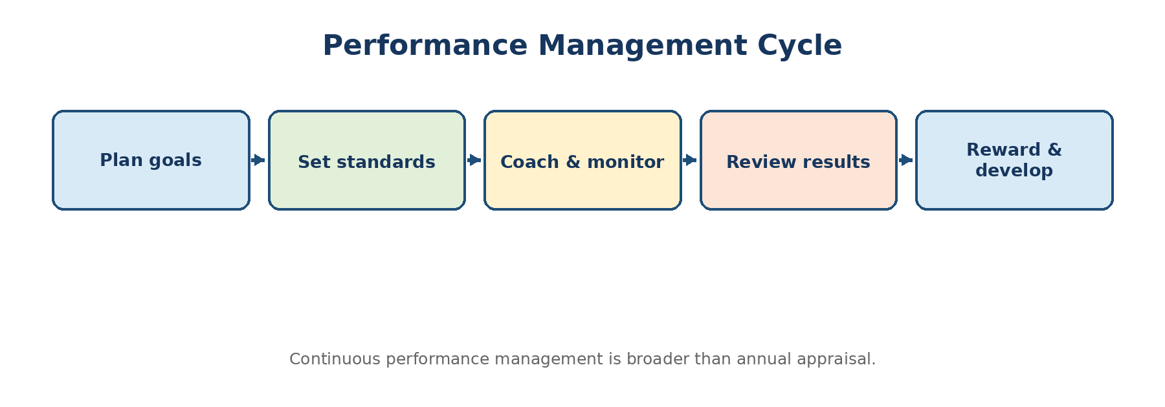
Diagram 3.1: Continuous performance management cycle
Basis | Performance Appraisal | Performance Management
Nature | Periodic evaluation event. | Continuous management process.
Main focus | Past performance and rating. | Past results, present coaching and future improvement.
Ownership | Often HR-driven form and annual meeting. | Manager-employee partnership supported by HR.
Coverage | Individual performance, commonly job results/traits. | Goals, behaviour, feedback, development, recognition and alignment.
Outcome | Rating, increment/promotion input and feedback. | Improved performance, capability and goal alignment.
Risk | Ritual, recency bias and rating anxiety. | Requires manager capability and regular discipline.

2. Objectives and Uses of Appraisal
Clarify standards and communicate performance expectations.
Provide feedback and identify strengths and performance gaps.
Support training, coaching and individual development plans.
Provide evidence for increments, incentives, promotion, transfer and confirmation.
Identify high potential and succession candidates.
Improve communication and documentation.
Evaluate recruitment, training and job-design effectiveness.

3. Performance Appraisal Process
1. Establish purpose and policy: Clarify whether the system supports development, rewards, succession or all of these.
2. Define performance criteria: Translate job responsibilities into measurable results and behaviours.
3. Communicate standards: Ensure employee understanding and opportunity to clarify.
4. Observe and record evidence: Use ongoing data, incidents, customer feedback and work outputs.
5. Evaluate performance: Compare evidence with standards using an appropriate method.
6. Conduct appraisal discussion: Recognise contribution, diagnose gaps and listen to context.
7. Agree action plan: Set future goals, support, learning and follow-up dates.
8. Review system quality: Check rating distribution, bias, appeals, goal quality and business relevance.

4. Traditional and Modern Appraisal Methods
Method | Core Idea | Strength | Limitation / Best Use
Ranking | Order employees from best to worst. | Simple for small groups. | No absolute standard; difficult with similar performance.
Paired comparison | Compare each employee with every other employee. | Systematic ranking. | Becomes complex as group size grows.
Graphic rating scale | Rate factors on a defined scale. | Economical and easy to standardise. | Traits may be vague; central tendency/halo risk.
Checklist / forced choice | Select statements describing performance. | Reduces some evaluator discretion. | Can feel mechanical; scoring may be opaque.
Critical incident | Record especially effective/ineffective behaviour. | Specific feedback. | Requires continuous recording; may overfocus extremes.
MBO | Jointly set measurable objectives and review achievement. | Strong result alignment. | May ignore context, collaboration and qualitative work.
BARS | Behaviour examples anchor each rating level. | Clear and job-specific. | Costly to develop and update.
360-degree feedback | Feedback from manager, peers, reports, self and sometimes customers. | Broad behavioural insight. | Needs confidentiality and development focus.
Assessment centre | Simulations, exercises and multiple assessors. | Rich evidence for potential/managerial roles. | Expensive and time-intensive.
Balanced scorecard / KPI | Results across financial, customer, process and learning dimensions. | Prevents single-metric focus. | Requires carefully chosen measures.

Topper Tip
For “best method for managers”, recommend a combination: agreed KPIs/MBO for results + BARS or competency ratings for behaviour + 360-degree feedback for development. Explain why one method alone is insufficient.

5. Common Rating Errors and Controls
Error | Meaning | Control
Halo / horn | One strong or weak feature influences all ratings. | Separate criteria, evidence and calibration.
Recency | Recent events dominate the whole period. | Maintain periodic records and check-ins.
Leniency / severity | Rater gives consistently high or low ratings. | Rater training, behavioural anchors and calibration.
Central tendency | Avoiding high and low ratings. | Require evidence and differentiate standards.
Similarity bias | Favouring employees similar to the manager. | Multiple inputs, structured criteria and bias review.
Contrast | Rating relative to another employee rather than standards. | Use absolute job-related criteria.
Attribution error | Ignoring situational causes of performance. | Discuss resources, workload and interdependencies.

6. Potential Appraisal and Performance Coaching
Definition: Potential Appraisal
A systematic assessment of an employee’s capacity to handle higher, broader or more complex responsibilities in the future.

Performance Appraisal | Potential Appraisal
Measures effectiveness in the current role. | Estimates capability for future roles.
Uses current results and behaviour. | Uses learning agility, leadership, problem solving, values, mobility and assessment evidence.
Answers “How well is the job being done?” | Answers “What greater responsibility may this person handle?”
Supports pay and performance improvement. | Supports succession and development decisions.

Performance Coaching Phases
Contract: agree purpose, trust, confidentiality and desired result.
Diagnose: examine evidence, causes, strengths and obstacles.
Explore: generate alternatives and build employee ownership.
Action: agree specific behaviour, support and timeline.
Follow-up: review progress, reinforce gains and adjust.

7. Training and Development
Definition: Training
A planned effort to improve the knowledge, skills and behaviour required for effective performance in a current job.

Definition: Development
A broader and longer-term process that prepares individuals for future roles, greater responsibility and personal growth.

Basis | Training | Development
Focus | Current job performance. | Future roles and overall capability.
Time horizon | Short to medium. | Medium to long.
Typical audience | Workers, staff and managers. | Often managers/high potential, but relevant to all.
Content | Specific knowledge, skill and procedure. | Leadership, judgement, perspective and adaptability.
Evaluation | Job behaviour, quality, speed, errors. | Readiness, capability growth and career movement.

8. Training Need Analysis (TNA)
TNA identifies whether a performance or future capability gap should be addressed through learning. Training is not the correct solution when the cause is poor tools, unclear goals, workload, weak incentives or lack of authority.
Level | Key Question | Evidence
Organisation | Where is training needed to support strategy? | Business goals, quality, customer, technology and risk data.
Task / job | What must people know or do? | Job analysis, standards, process and competency gaps.
Person | Who needs training and at what level? | Appraisal, tests, observation, errors, feedback and self-assessment.

9. Training and Development Process
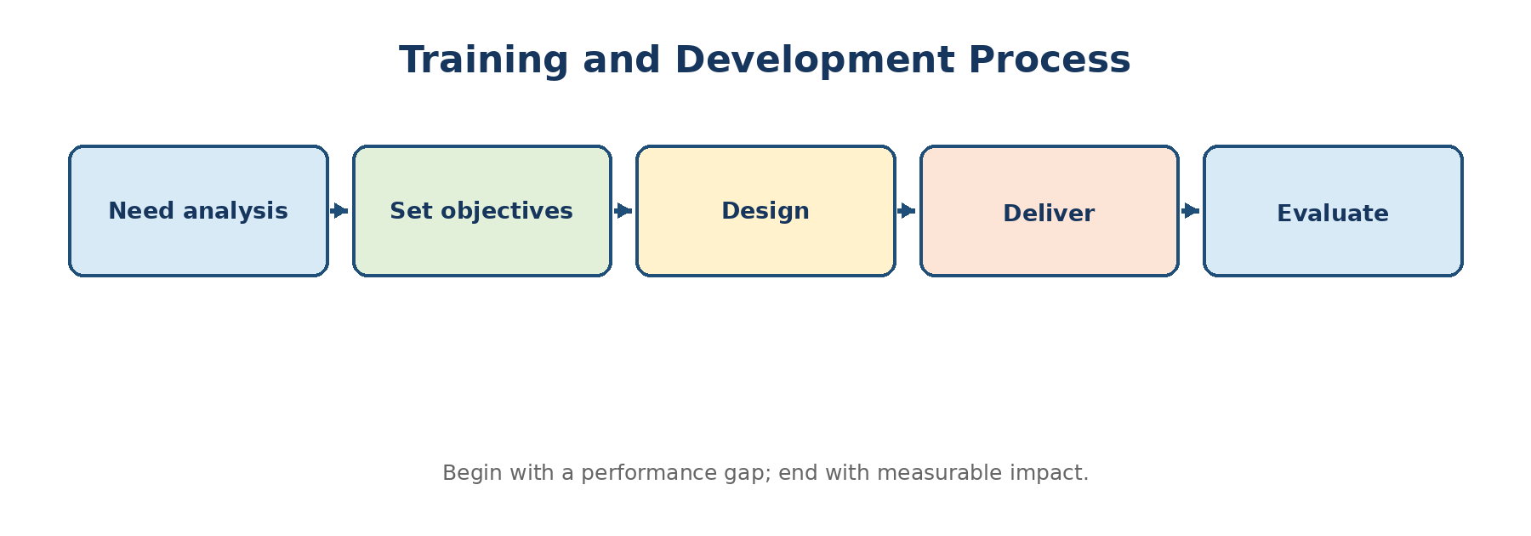
Diagram 3.2: Systematic training cycle
1. Need analysis: Identify performance or capability gap and its true cause.
2. Learning objectives: State observable outcomes, conditions and expected standard.
3. Programme design: Choose content, sequence, trainer, method, duration, materials and transfer support.
4. Delivery: Create participation, practice, feedback and accessibility.
5. Transfer to job: Ensure manager support, opportunities to apply, job aids and reinforcement.
6. Evaluation: Measure reaction, learning, behaviour and organisational results; improve future programmes.

10. Training Methods
On-the-Job Methods | Off-the-Job / Development Methods
Coaching and instruction | Lecture and facilitated discussion
Job rotation | Case study
Apprenticeship | Role play and simulation
Understudy / assistant-to position | Vestibule training
Committee and project assignment | Management games
Demonstration and practice | Assessment centre
Stretch assignment | E-learning / virtual classroom

E-learning offers flexibility, standardisation, scale, tracking and repeated access. Its limitations include digital access, lower engagement, weak transfer for hands-on skills and learner self-discipline. A blended approach often combines digital theory with coached practice.

11. Kirkpatrick Model of Training Evaluation
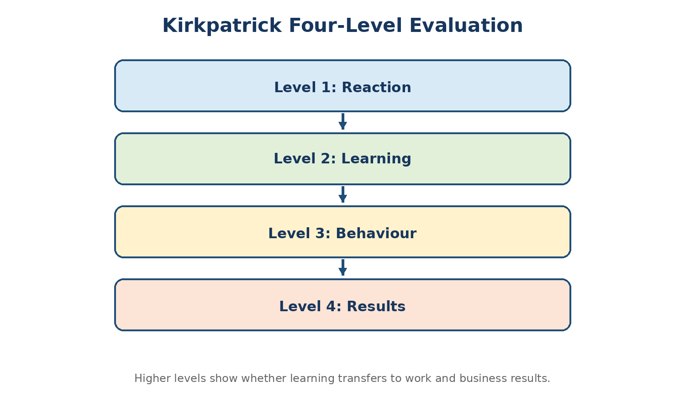
Diagram 3.3: Kirkpatrick four-level evaluation
Level | Question | Illustrative Measures
1. Reaction | Did participants find the programme relevant and engaging? | Feedback, relevance, confidence and intent to apply.
2. Learning | What knowledge, skill or attitude changed? | Pre/post test, demonstration, simulation and assessment.
3. Behaviour | Did learning transfer to the job? | Observation, manager review, work samples and behavioural indicators.
4. Results | What organisational outcome improved? | Quality, productivity, cycle time, safety, sales, complaints or cost.

Topper Tip
Do not claim that Level 1 satisfaction proves training success. A topper answer explains that evaluation should progress from reaction to measurable learning, job behaviour and business results, while considering other factors that may influence results.

PYQ-Focused Question Bank
Year | Question / Theme | Likely Marks | Priority
2022 | Training needs/objectives/methods; appraisal vs performance management; appraisal methods. | 2/10 | Very High
2023 | Performance appraisal process; performance coaching; training case; appraisal vs potential appraisal and modern methods. | 2/5/10 | Very High
2024 | Training and development; Kirkpatrick model; training process; performance appraisal process. | 2/5/10 | Very High
2025 | Worker training vs executive development; management development evaluation case; traditional/modern appraisal and best method for managers. | 5/10 | Very High

Model Answer (10 Marks - PYQ 2025 Theme): Explain traditional and modern performance appraisal methods, their advantages and limitations, and recommend a suitable approach for managers.

Performance appraisal methods differ in whether they compare people, rate traits/behaviours, evaluate objectives or collect multi-source evidence. Method choice must match the job and decision purpose.
Traditional methods
Ranking and paired comparison are simple but provide weak developmental detail.
Graphic rating scales are economical but vulnerable to vague criteria and rating errors.
Checklist/forced choice improves standardisation but can be mechanical.
Critical incident provides specific examples but requires continuous recording.
Modern methods
MBO/KPI links performance to agreed results but may ignore behaviour and changing context.
BARS gives clear behavioural anchors but is costly to develop.
360-degree feedback broadens insight but requires confidentiality and should not be used carelessly for pay.
Assessment centres provide strong evidence of managerial potential but are resource-intensive.
Balanced scorecards combine multiple result dimensions but require disciplined metric selection.
Recommended approach for managers
Use a hybrid system: 50-60% agreed business/team KPIs, 20-30% leadership and values using BARS/competency anchors, and developmental multi-source feedback. Add quarterly coaching, evidence logs and cross-manager calibration.
Applied Example
A branch manager should not be rated only on revenue. Customer retention, contribution margin, compliance, team development and collaboration should also be considered.

Conclusion: A blended, evidence-based and continuous system is more valid for managers than any single traditional or modern method.
Model Answer (10 Marks - PYQ 2024 Theme): Explain the training and development process with suitable example.

A systematic process ensures that learning addresses a genuine need, is delivered appropriately and creates job-level improvement.
1. Analyse need: At organisation, task and person level; distinguish skill gap from non-training causes.
2. Set objectives: For example, “After training, operators will complete the safety checklist with 100% accuracy.”
3. Design programme: Select content, trainer, method, sequence, duration, practice and transfer support.
4. Develop materials: Cases, job aids, demonstrations, assessment and facilitator guide.
5. Deliver: Use participation, practice, feedback and realistic work situations.
6. Enable transfer: Manager expectations, time to practise, coaching and reinforcement.
7. Evaluate: Measure reaction, learning, behaviour and results.
8. Improve: Revise content or work conditions based on evidence.
Applied Example
For repeated dispatch errors, first check whether the cause is lack of knowledge, confusing software or workload. If skill is the gap, use demonstration, guided practice, job aid and supervisor follow-up; evaluate error rate after training.

Conclusion: Training creates value only when learning transfers to work and improves an outcome relevant to the organisation.
Model Answer (5 Marks - PYQ 2024 Theme): Explain the Kirkpatrick model of training evaluation.

Level | Meaning | Example
Reaction | Participants’ response to the programme. | Relevance and facilitator feedback.
Learning | Change in knowledge, skill or attitude. | Pre/post test or demonstration.
Behaviour | Application at work. | Supervisor observes new sales questioning technique.
Results | Organisational impact. | Higher conversion, fewer errors or better safety.

Conclusion: The model moves evaluation beyond satisfaction toward application and organisational impact.
Model Answer (5 Marks): Distinguish performance appraisal and potential appraisal.

Basis | Performance Appraisal | Potential Appraisal
Time focus | Current/past performance. | Future capability.
Question | How well is the present role performed? | What higher or different role may be handled?
Evidence | Results, behaviour and standards. | Assessment, learning agility, leadership and complexity handling.
Use | Feedback, rewards and improvement. | Succession, development and career planning.
Risk | Bias in rating current results. | Overprediction and labelling without development evidence.

Rapid 2-Mark Answers
Q. Define performance appraisal. A formal periodic evaluation of employee performance against predetermined standards.
Q. Define performance management. A continuous cycle of planning, monitoring, coaching, reviewing, rewarding and developing performance.
Q. What is BARS? Behaviourally Anchored Rating Scale: each rating level is illustrated by observable job behaviour.
Q. What is 360-degree feedback? Feedback collected from multiple sources such as manager, peers, subordinates, self and customers.
Q. What is TNA? Training Need Analysis identifies where, what and who requires learning to close a performance or capability gap.
Q. What is e-learning? Learning delivered through digital platforms, allowing flexible, scalable and trackable access.

UNIT 4 - Compensation Management
Unit Scope
Compensation concept, objectives, process, trends and factors; wage and salary differentials; compensation components; financial and non-financial incentives; fringe benefits; separation; grievance procedure.

1. Meaning and Objectives of Compensation
Definition: Compensation
The total financial and non-financial return provided to employees in exchange for their work, contribution, capability and continued membership in the organisation.

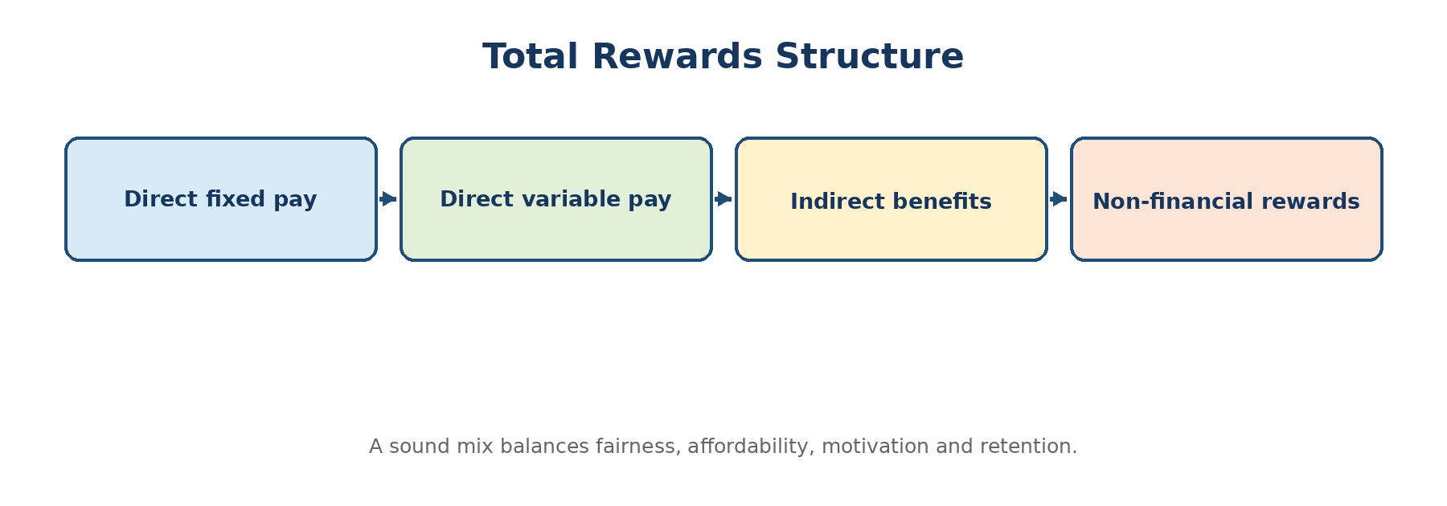
Diagram 4.1: Total rewards structure
Attract suitable employees and support recruitment.
Retain valued and scarce talent.
Motivate required performance and behaviour.
Ensure internal equity and external competitiveness.
Comply with applicable law and employment commitments.
Control labour cost and maintain affordability.
Communicate the value of the total employment relationship.

2. Compensation Management Process
1. Define compensation philosophy: Decide market position, pay mix, fairness and performance linkage.
2. Analyse jobs: Use job analysis and job evaluation to understand relative worth.
3. Study market: Use credible salary surveys and competitor/labour-market data.
4. Design structure: Create grades, bands, ranges and progression rules.
5. Design pay components: Fixed, variable, benefits and non-financial rewards.
6. Administer decisions: Starting pay, increment, promotion, incentive and exceptions.
7. Communicate: Explain total rewards and decision criteria.
8. Review and control: Monitor cost, equity, competitiveness, performance impact and employee understanding.

3. Factors Affecting Compensation
Internal Factors | External Factors
Job value and responsibility | Labour-market rates and skill scarcity
Employee performance, capability and experience | Cost of living and economic conditions
Organisation’s ability to pay and strategy | Industry practice and competitor pay
Internal equity and existing structure | Legal and regulatory requirements
Union/employee relations and culture | Location and local labour supply
Productivity and affordability | Technology and changing nature of work

4. Internal Equity and External Competitiveness
Definition: Internal Equity
Perceived fairness of pay relationships among jobs and employees within the same organisation, usually supported by job evaluation and consistent pay rules.

Definition: External Competitiveness
The organisation’s pay position compared with relevant labour-market employers, commonly described as lag, match or lead the market.

Pay Position | Meaning | Likely Use | Risk
Lag | Pay below market midpoint. | Cost-sensitive roles with strong non-pay advantages. | Attraction/retention difficulty.
Match | Pay near relevant market. | Balanced strategy for most roles. | May not differentiate scarce skills.
Lead | Pay above market. | Critical talent, rapid growth or premium employer strategy. | High fixed cost and internal compression.

A sound system balances internal equity and external competitiveness. Overemphasis on external pay can create internal inequity; overemphasis on internal hierarchy can make scarce roles uncompetitive.

5. Wage and Salary Differentials
Differentials are variations in pay caused by job value, skill, performance, location, shift, risk, industry, organisation size, scarcity or employment conditions. Differentials are acceptable when based on relevant, transparent and consistently applied factors.
Occupational and skill differential.
Inter-industry and inter-firm differential.
Geographical or city differential.
Shift, hazard and working-condition differential.
Performance and merit differential.
Seniority/experience differential.
Gender or other unrelated differences are inequitable and should be identified and corrected.

6. Components of Compensation
Component | Meaning / Examples | Main Purpose
Basic pay | Core fixed salary linked to grade/job. | Stability and job value.
Allowances | House rent, location, shift, travel or special allowance as per policy. | Recognise costs or conditions.
Variable pay | Individual, team or organisational incentive, commission and bonus. | Link reward with results/behaviour.
Benefits | Retirement contribution, insurance, leave, medical and welfare benefits. | Security, retention and employee value.
Long-term incentives | Equity, stock-linked or deferred performance rewards where applicable. | Long-term alignment and retention.
Non-financial rewards | Recognition, autonomy, career, learning, flexibility and meaningful work. | Intrinsic motivation and experience.

Applied Example
For an IT project manager, total compensation may include basic pay, allowances, project/annual variable pay, insurance, retirement benefits, learning support, flexible work and recognition. The answer should explain the purpose of each component, not merely list salary-slip labels.

7. Incentives
Financial Incentives | Non-Financial Incentives
Piece rate, commission, individual bonus | Recognition and appreciation
Team/group incentive and gainsharing | Career growth and challenging work
Profit sharing and productivity bonus | Autonomy and participation
Skill-based or competency pay | Flexible work and status
Long-term incentive / stock-linked reward | Learning, job security and quality supervision

Principles of an Effective Incentive Plan
Measures must be controllable, understandable and verifiable.
Performance standard should be challenging but achievable.
Quality, safety, ethics and customer outcomes should not be sacrificed for quantity.
Individual and team measures should reflect interdependence.
Payout formula and timing should be communicated in advance.
Plan should be affordable and reviewed for unintended behaviour.

8. Fringe Benefits
Definition: Fringe Benefits
Indirect rewards provided in addition to direct wages or salary, such as insurance, leave, retirement benefits, employee assistance, meals, transport, education support or welfare facilities.

Benefits protect employees against risk, improve well-being and support retention. However, employees may undervalue benefits if the organisation does not communicate total reward clearly.

9. Employee Separation
Form | Meaning | Key HR Requirement
Retirement | Exit on reaching prescribed age or service condition. | Succession, benefits, knowledge transfer and respectful transition.
Resignation | Voluntary exit initiated by employee. | Notice, handover, exit interview and final settlement.
Termination / dismissal | Employer-initiated end of employment for performance, conduct or other reason. | Due process, evidence, consistency, authority and documentation.
Layoff / retrenchment | Separation or work discontinuity due to business/economic reasons, subject to law. | Objective criteria, communication, legal review and support.
VRS | Voluntary retirement under an offered scheme. | Clear eligibility, informed choice, cost and knowledge-risk analysis.
Golden handshake | Attractive separation package, often for voluntary exit or senior transition. | Fair terms, confidentiality and governance.
Suspension | Temporary removal from duty, commonly during inquiry; not always final separation. | Policy, pay/status rules, timely investigation and natural justice.

Positive separation means managing exit with dignity, fairness, communication, accurate settlement, knowledge transfer and, where feasible, assistance such as counselling or outplacement. It protects both human dignity and employer reputation.

10. Grievance Handling
Definition: Grievance
A feeling of dissatisfaction or perceived injustice related to employment that is formally or informally expressed by an employee.

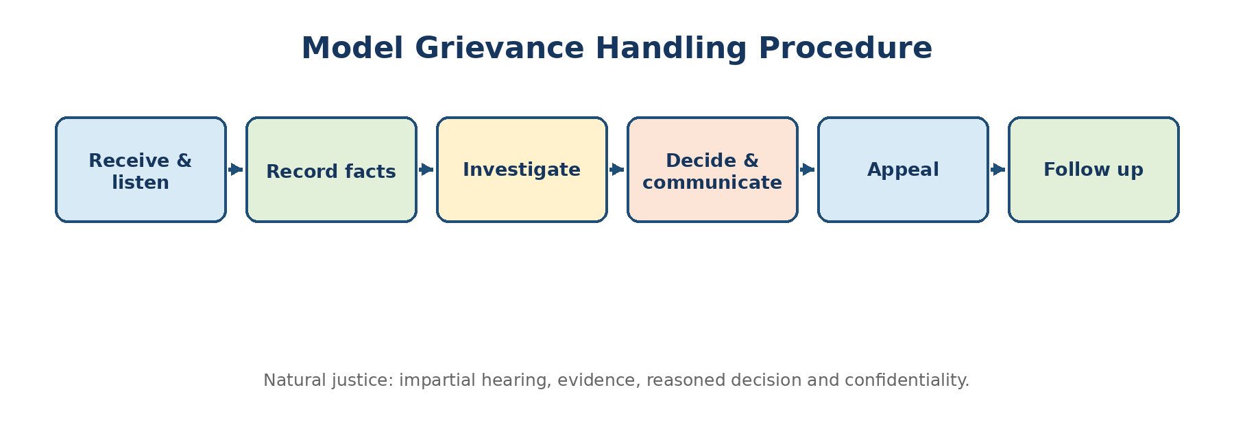
Diagram 4.2: Model grievance procedure
Listen without interruption and acknowledge the issue.
Record facts, requested remedy and relevant dates.
Maintain confidentiality and protect against retaliation.
Investigate impartially using documents and witnesses.
Apply policy consistently while considering individual facts.
Give a reasoned decision within a defined time.
Provide appeal or higher review.
Follow up to ensure resolution and prevent recurrence.

PYQ-Focused Question Bank
Year | Question / Theme | Likely Marks | Priority
2022 | Job evaluation methods; positive separation; internal equity and external competitiveness. | 2/5 | High
2023 | Internal mobility; executive compensation; team and individual incentive case. | 2/5/10 | High
2024 | Salary components; salary components in IT; grievance handling. | 2/10 | Very High
2025 | Compensation; incentive types; compensation components; promotion types. | 2/5 | High

Model Answer (10 Marks - PYQ 2024 Theme): Explain the components of compensation with reference to an IT organisation.

Compensation is the total return from employment. In an IT organisation, the design should attract scarce skills, maintain internal fairness, support performance and avoid excessive fixed cost.
1. Basic pay: Core fixed salary based on role, grade, skill and market value.
2. Allowances: Location, shift, travel or other policy-based components.
3. Short-term variable pay: Annual or quarterly incentive linked to individual, project/team and company results.
4. Sales/consulting incentives: Commission or utilisation/margin-linked payout for eligible roles.
5. Benefits: Medical insurance, leave, retirement contributions, wellness and employee assistance.
6. Long-term rewards: Deferred bonus or equity-linked plans for eligible leadership/critical talent.
7. Skill and learning support: Certification, tuition, learning platforms and conference support.
8. Non-financial rewards: Career opportunities, flexible work, recognition, autonomy and meaningful projects.
Design principles
Use job architecture and market data; protect pay equity; define performance metrics; communicate total rewards; review compression between new and existing employees; and maintain affordability.
Applied Example
A cybersecurity specialist may require a market premium, but the organisation should document the scarce-skill rationale and review impact on adjacent roles.

Conclusion: An effective IT compensation mix is competitive, skill-sensitive and performance-linked while remaining transparent and internally defensible.
Model Answer (10 Marks - PYQ 2023 Case Theme): Design a fair incentive system for employees working in teams and individually.

Where work is interdependent, purely individual incentives can create rivalry and knowledge withholding, while purely team incentives can create free-riding. A balanced plan is therefore required.
1. Clarify objectives: Productivity, quality, delivery, safety, cost, customer or innovation.
2. Map controllability: Identify which results depend on the individual, team and organisation.
3. Create balanced weights: For example, 40% individual, 40% team and 20% organisation, adjusted to job context.
4. Choose quality safeguards: No payout or reduced payout if safety, quality or conduct thresholds fail.
5. Set transparent standards: Baseline, target, stretch and maximum payout should be known in advance.
6. Use reliable data: Automated records, validation and audit trail.
7. Address new joiners and absence: Define eligibility and pro-rating rules.
8. Review unintended effects: Check collaboration, gaming, free-riding, workload and customer impact.
9. Communicate and appeal: Provide examples, periodic scorecards and a correction mechanism.
Applied Example
A customer-service team can use individual quality and attendance, team resolution time and customer satisfaction, plus an organisation-level profitability gate.

Conclusion: The most equitable system rewards personal contribution without weakening teamwork, quality, ethics or long-term performance.
Model Answer (5 Marks): Explain the grievance handling procedure.

1. Receive and acknowledge: Listen respectfully and identify the exact grievance.
2. Record: Document facts, policy area and remedy requested.
3. Investigate: Gather records and hear relevant persons impartially.
4. Decide: Apply policy and natural justice; communicate reasons.
5. Appeal: Allow review by a higher authority or committee.
6. Follow up: Confirm implementation and prevent recurrence.
Model Answer (5 Marks): Differentiate internal equity and external competitiveness.

Basis | Internal Equity | External Competitiveness
Comparison | Jobs/employees inside the organisation. | Relevant labour market outside the organisation.
Main tool | Job evaluation, grade structure and pay rules. | Salary surveys and market benchmarking.
Question | Is relative pay fair internally? | Can the organisation attract and retain externally?
Risk if ignored | Dissatisfaction, grievances and perceived unfairness. | Vacancy difficulty and turnover.
Balance | Both must be considered together. | Lead, match or lag policy should be deliberate.

Rapid 2-Mark Answers
Q. Define compensation. The total financial and non-financial return provided in exchange for employee contribution.
Q. What is an incentive? A reward linked to a defined level of performance, behaviour or result.
Q. What is a fringe benefit? An indirect reward provided in addition to direct pay, such as insurance or paid leave.
Q. What is VRS? A scheme under which eligible employees voluntarily retire in return for specified benefits.
Q. What is golden handshake? An attractive separation package offered to encourage or support voluntary exit.
Q. Define grievance. An employee’s expressed dissatisfaction or perceived injustice concerning employment.

UNIT 5 - Emerging Trends in HRM
Unit Scope
Human Resource Information System (HRIS); Human Resource Accounting; Human Resource Audit; HR Shared Services - concepts, objectives, process, benefits, limitations and issues.

1. Human Resource Information System (HRIS)
Definition: HRIS
An integrated system of people, processes, data and technology used to collect, store, process, report and support decisions about an organisation’s human resources.

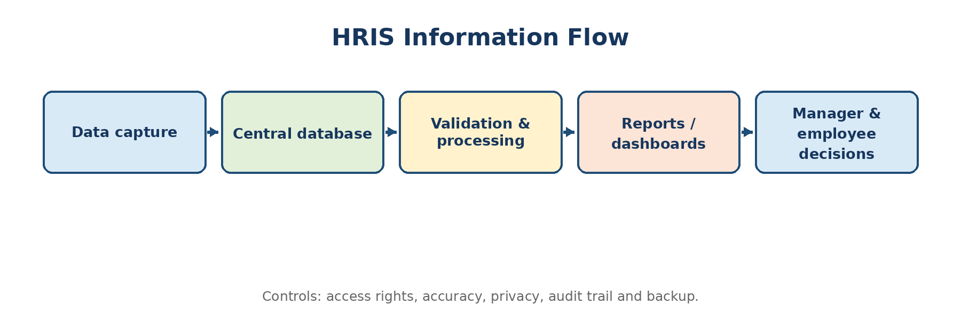
Diagram 5.1: HRIS information flow

Need and Uses of HRIS
Operational Uses | Managerial / Strategic Uses
Employee master data and organisation records | Workforce dashboards and headcount trends
Attendance, leave and payroll inputs | Turnover, skill and succession analysis
Recruitment and applicant tracking | Source effectiveness and time-to-fill analysis
Learning and certification records | Capability-gap planning
Performance workflow and documents | Performance distribution and talent review
Employee / manager self-service | Scenario planning and workforce decisions
Compliance and audit trail | HR scorecards and business reporting

Advantages
Single source of reliable employee data.
Faster transactions and lower repetitive administrative work.
Employee and manager self-service.
Timely reports and evidence-based decisions.
Standardised processes across locations.
Better controls, audit trail and compliance monitoring.
Integration across recruitment, performance, learning, payroll inputs and analytics.

Limitations / Risks
Poor data quality can automate errors.
High implementation and change-management effort.
Privacy, cybersecurity and unauthorised access risk.
Overcustomisation and dependence on vendor/system specialists.
Low adoption when workflows are difficult or managers are not trained.
Algorithmic or reporting bias if data and definitions are weak.

2. HRIS Implementation / Design Process
1. Business case and governance: Define outcomes, sponsor, project team, budget and decision rights.
2. Requirement analysis: Map current processes, users, pain points, legal needs, reports and integrations.
3. Process simplification: Remove unnecessary steps before automating.
4. Solution selection/design: Evaluate fit, usability, security, scalability, support and total cost.
5. Data preparation: Clean, standardise, validate and assign ownership.
6. Configuration and integration: Set workflows, roles, fields, interfaces and controls.
7. Testing: Functional, security, integration, user acceptance and payroll reconciliation where relevant.
8. Change and training: Communicate role changes, train users and provide support.
9. Go-live and stabilisation: Phase rollout, monitor errors and maintain contingency plans.
10. Review benefits: Measure adoption, cycle time, data quality, cost and decision usefulness.
Applied Example
An HRIS project that copies a slow paper approval process into software will create a digital bottleneck. Topper answers should state: simplify first, automate second.

3. Human Resource Accounting (HRA)
Definition: Human Resource Accounting
The process of identifying, measuring and reporting investments in and the value or cost of human resources to assist managerial decisions.

Objectives and Advantages
Make investment in recruitment, training and development visible.
Support decisions on hiring, development, retention and replacement.
Encourage management to view employees as value-creating resources.
Provide information for human-capital planning and control.
Compare cost of turnover with retention or development alternatives.

Major Methods
Method | Core Idea | Main Limitation
Historical cost | Capitalise or track actual acquisition and development cost, often amortised over expected service. | Cost does not necessarily equal value.
Replacement cost | Estimate current cost of replacing existing human resources with equivalent capability. | Replacement is difficult to define and estimate.
Opportunity cost | Value employees based on internal bids or benefit from alternative use. | Applicable mainly to scarce resources; subjective.
Present value of future earnings (Lev & Schwartz) | Estimate present value of expected future earnings over remaining service. | Earnings are not the same as organisational value; assumptions are sensitive.
Economic value / future benefits | Estimate future contribution attributable to human resources. | Difficult attribution and high uncertainty.

Limitations of HRA
No universally accepted valuation method.
Employees are not owned assets and can leave.
Future service and contribution are uncertain.
Monetary values may ignore teamwork, culture and ethical concerns.
Results depend heavily on assumptions and may not be comparable.
Financial reporting acceptance may be limited; therefore HRA is mainly a managerial information tool.

4. Human Resource Audit
Definition: Human Resource Audit
A systematic, objective and comprehensive examination of HR policies, practices, records, results and capabilities to assess compliance, effectiveness, efficiency and strategic alignment.

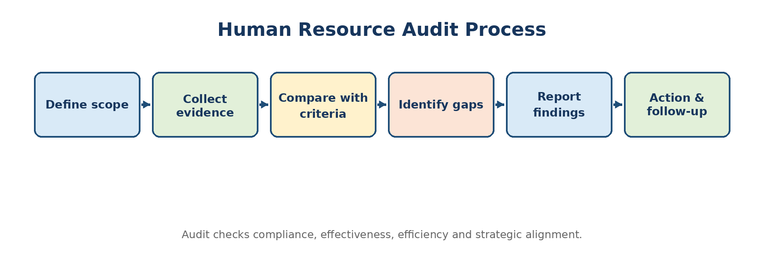
Diagram 5.2: Human Resource audit process

Objectives and Scope
Objective | Illustrative Audit Area
Compliance | Employment records, required policies, working conditions and procedural adherence.
Effectiveness | Whether staffing, training, appraisal and retention achieve intended results.
Efficiency | Cost, cycle time, duplication, HR service levels and system usage.
Strategic alignment | Whether workforce capability and HR priorities support business strategy.
Risk control | Critical vacancies, succession gaps, data privacy, conduct and employee relations.
Continuous improvement | Benchmarking, root causes, recommendations and follow-up.

Contents of an HR Audit Report
Executive summary and audit objective.
Scope, period, units covered and criteria used.
Methodology and evidence sources.
Strengths and good practices.
Findings with evidence and risk rating.
Root-cause analysis.
Prioritised recommendations, owner and target date.
Management response and follow-up plan.

5. HR Shared Services
Definition: HR Shared Services
A service-delivery model in which common and repeatable HR transactions are consolidated and standardised to serve multiple business units through a shared centre, often supported by self-service and technology.

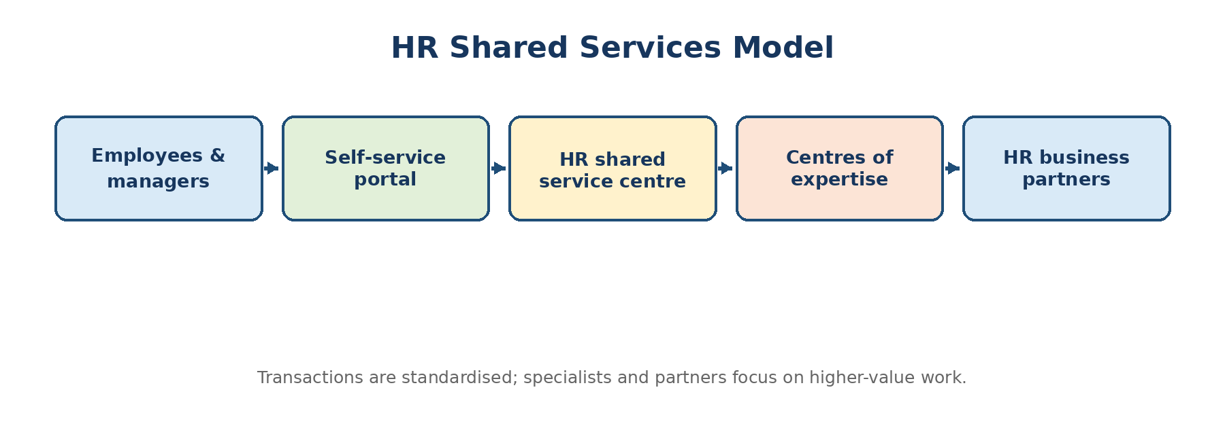
Diagram 5.3: HR shared-services operating model
Benefits | Issues / Risks
Standard processes and consistent employee service. | Loss of local flexibility or personal contact.
Economies of scale and lower transaction cost. | Poor service if roles and service levels are unclear.
Better data quality and control. | Transition resistance and job-role changes.
Specialisation and measurable service levels. | Fragmentation between shared services, experts and business partners.
Frees HR business partners for strategic work. | Dependence on HRIS, knowledge base and case-management quality.

Good Design Principles
Define service catalogue and service-level agreements.
Create clear tiered support: self-service, service centre, specialist escalation.
Use a searchable knowledge base and case tracking.
Clarify accountability between shared services, centres of expertise, HR business partners and line managers.
Measure resolution time, first-contact resolution, accuracy, satisfaction and cost.
Retain channels for sensitive issues that require human judgement.

6. Related Emerging Trends - Extra Value Points
These points extend the unit and can strengthen introductions/conclusions, but the four prescribed topics above should remain the core of an exam answer.
People analytics and predictive workforce decisions.
AI-assisted recruitment and learning with human oversight and bias controls.
Employee self-service and mobile HR.
Skill-based talent systems and internal talent marketplaces.
Digital employee experience and hybrid-work systems.
Continuous listening, pulse surveys and experience analytics.
Data privacy, cybersecurity and ethical use of employee information.

PYQ-Focused Question Bank
Year | Question / Theme | Likely Marks | Priority
2022 | HR audit objectives; HRIS significance and implementation; human resource cost measurement. | 2/5/10 | Very High
2023 | HR audit report and uses of HRIS. | 10 | High
2024 | HRIS definition/use. | 2 | Medium
2025 | Design and manage an HRIS. | 10 | Very High

Model Answer (10 Marks - PYQ 2025 Theme): Explain how an organisation should design and manage an HRIS.

An HRIS should be treated as a business-transformation project, not merely a software purchase. Its design must connect people processes, reliable data, controls and decision needs.
1. Define objectives: Examples: accurate employee data, faster transactions, self-service, compliance and workforce insights.
2. Governance: Appoint sponsor, process owners, data owners, project manager and security responsibility.
3. Requirement and process mapping: Capture users, pain points, reports, approvals and integrations; remove waste.
4. Architecture and module design: Employee core, recruitment, onboarding, time/leave, performance, learning, compensation support and analytics as required.
5. Data governance: Common definitions, mandatory fields, validation, ownership, retention and correction workflow.
6. Security and privacy: Role-based access, least privilege, consent/purpose, encryption, audit trail, backup and incident response.
7. Configuration and integration: Connect identity, finance/payroll or other systems with controlled interfaces.
8. Testing and migration: Clean legacy data; perform functional, integration, security and user-acceptance tests.
9. Change management: Communicate benefits and role changes; train users; support managers and employees.
10. Operation and improvement: Service levels, release management, data-quality dashboards, user feedback, vendor management and benefits review.
Applied Example
A dashboard showing turnover is useful only when “turnover,” employee status, organisational unit and dates are consistently defined. Data governance is therefore as important as the software interface.

Conclusion: A successful HRIS combines simplified processes, trustworthy data, secure access and active adoption to improve both employee service and managerial decisions.
Model Answer (10 Marks): Explain the objectives, scope and process of Human Resource Audit, and outline an audit report.

An HR audit provides assurance and improvement by examining whether HR systems are compliant, efficient, effective and aligned with organisational needs.
Objectives
Verify compliance and policy consistency.
Assess effectiveness of HR programmes.
Identify risk, duplication, gaps and cost opportunities.
Evaluate strategic workforce and capability alignment.
Promote accountability and continuous improvement.
Scope
HR planning, job analysis, recruitment, selection and onboarding.
Training, performance, career and succession.
Compensation, benefits, records and HRIS.
Employee relations, grievance, discipline, welfare, safety and separation.
HR structure, capability, service quality and metrics.
Process
1. Plan scope and criteria: Risk-based priorities and audit questions.
2. Collect evidence: Policies, records, interviews, surveys, samples and metrics.
3. Test and compare: Compare practice with criteria and intended results.
4. Analyse findings: Evidence, impact, root cause and risk rating.
5. Report: Strengths, findings, recommendations, owners and deadlines.
6. Follow up: Verify corrective action and sustained improvement.
Report structure
Executive summary; objectives/scope; methodology; strengths; findings with evidence and risk; recommendations; management response; action owner and due date; follow-up status.
Conclusion: The value of an HR audit lies not in finding faults, but in prioritising practical actions that strengthen workforce governance and organisational performance.
Model Answer (10 Marks): Explain Human Resource Accounting methods, advantages and limitations.

Human Resource Accounting seeks to make the cost and economic significance of people-related investment visible for management decisions.
Method | Explanation
Historical cost | Records acquisition, training and development expenditure associated with employees.
Replacement cost | Estimates what it would cost now to replace equivalent people/capability.
Opportunity cost | Values scarce employees by the benefit of their best alternative internal use.
Present value of future earnings | Discounts estimated future earnings over expected service.
Economic value | Estimates future benefits attributable to human resources.

Advantages
Improves visibility of people investment; supports build-versus-buy decisions; highlights turnover/replacement cost; encourages long-term development; supports workforce planning and control.
Limitations
No accepted universal method; uncertain service life and contribution; people are not owned; assumptions can dominate results; ethical concern in reducing persons to money; limited comparability and external reporting use.
Conclusion: HRA is most useful as a supplementary managerial information system, not as a precise statement of an employee’s human worth.
Model Answer (5 Marks): State the uses and advantages of HRIS.

1. Data accuracy: Central employee records and standard definitions.
2. Efficiency: Automated workflows and self-service reduce repetitive work.
3. Reporting: Timely headcount, turnover, staffing and learning reports.
4. Integration: Connects employee life-cycle processes.
5. Control: Role-based access, approvals and audit trail.
6. Decision support: Workforce trends, skills and succession insights.

Rapid 2-Mark Answers
Q. Define HRIS. An integrated people-process-data-technology system for HR transactions, records, reporting and decisions.
Q. Define Human Resource Accounting. Identification, measurement and reporting of human-resource costs or value for managerial use.
Q. Define HR audit. A systematic review of HR policies, practices, records and outcomes for compliance, effectiveness, efficiency and alignment.
Q. What is HR shared service? A consolidated service model for common HR transactions across multiple units.
Q. What is employee self-service? A facility enabling employees to view or update permitted information and initiate HR transactions directly.
Q. What is an audit trail? A chronological record showing who performed or changed a transaction, what changed and when.

Case Study Answer Templates

Template A - Recruitment and Selection Case
Step | What to Write
1. Diagnose | Critical role, business context, risks and success outcomes.
2. Job profile | JD, competencies, experience and values.
3. Sourcing | Internal/external channels with reasons.
4. Assessment | Work sample, structured interview, tests and multiple assessors.
5. Due diligence | References, background, conflict and realistic job preview.
6. Decision | Scoring matrix, governance and documentation.
7. Integration | Offer, induction, 30-60-90 plan and success measures.

Template B - Training Case
Step | What to Write
1. Performance gap | Expected versus actual result.
2. Cause diagnosis | Knowledge/skill versus process, tools, motivation or workload.
3. TNA | Organisation, task and person.
4. Objectives | Observable learning and job outcome.
5. Method | Match method to learner and skill; include practice.
6. Transfer | Manager support, job aids and follow-up.
7. Evaluation | Kirkpatrick Levels 1-4 and improvement.

Template C - Performance or Incentive Case
Step | What to Write
1. Define desired outcomes | Results and behaviours.
2. Choose balanced measures | Individual, team, quality, customer and organisation.
3. Set standards | Baseline, target, stretch and evidence source.
4. Discuss fairness | Controllability, opportunity, transparency and appeal.
5. Prevent gaming | Quality/safety gates and metric review.
6. Coach and communicate | Regular feedback and scorecards.
7. Evaluate | Performance, motivation, collaboration and unintended effects.

Universal Case Conclusion
Ready-to-use conclusion
The recommended HR solution should be job-related, evidence-based, transparent and aligned with organisational objectives. Its success must be monitored through clear ownership, measurable outcomes, employee communication and periodic review.

Case Study Scoring Checklist
Use at least three specific facts from the case.
Name the relevant HR concept or model before applying it.
Separate diagnosis, alternatives and final recommendation.
Explain implementation responsibility, timeline and controls.
Include fairness, ethics, data or employee-impact considerations where relevant.
End with measurable success indicators rather than a general statement.

Common Mistakes to Avoid
Repeating the case without analysing it.
Writing an unrelated textbook answer.
Giving only one solution without justification.
Ignoring practical constraints, stakeholders or unintended consequences.
Using vague recommendations such as “give training” without TNA, method and evaluation.

One-Day Revision Sheet

Must-Draw Diagrams
Unit | Diagram to Practise | One-Line Recall
1 | HRM cycle; Harvard Model; Matching Model | Align people systems with strategy while considering stakeholders.
2 | HRP process; job analysis outputs; selection funnel | Plan → define job → attract → assess → integrate → retain.
3 | Performance cycle; training cycle; Kirkpatrick | Continuous coaching and transfer from learning to results.
4 | Total rewards; grievance process | Balance fairness, competitiveness, motivation and due process.
5 | HRIS flow; HR audit; shared services | Reliable data + standard process + governance + decisions.

Most Probable Long-Answer Preparation
Strategic transformation / HRM challenges.
HRP process and barriers.
Job analysis + JD/JS applied case.
Recruitment and selection process / CEO or manager case.
Career and succession planning.
Performance appraisal methods and best approach for managers.
Training process and Kirkpatrick evaluation.
Compensation components / incentive design.
Grievance procedure.
HRIS design and management.
HR audit or HR accounting as alternate Unit 5 answer.

Last 30-Minute Definition Drill
Term | Core Phrase
HRM | Acquire, develop, motivate, maintain and utilise people.
SHRM | Align HR deployment and practices with long-term strategy.
HRP | Forecast demand and supply; close workforce gap.
Job analysis | Systematic study of job duties and requirements.
JD | Written statement about the job.
JS | Required profile of the job holder.
Recruitment | Attract suitable applicants.
Selection | Choose the best-suited applicant.
Performance management | Continuous planning, coaching, review, reward and development.
Training | Improve current-job knowledge, skill and behaviour.
Compensation | Total financial and non-financial return.
Grievance | Expressed employment-related dissatisfaction.
HRIS | Integrated HR data and process system.
HR audit | Systematic review for compliance, effectiveness, efficiency and alignment.
HRA | Measurement/reporting of human-resource cost or value.
Shared services | Consolidated delivery of common HR transactions.

Topper Tip
In the examination, select internal options only after mapping which answer can be presented with the clearest diagram, the most headings and a relevant example. A well-structured known answer generally scores better than an ambitious but incomplete one.

Source Base and Paper Mapping
The unit structure follows the SPPU MBA 2019-pattern syllabus for 203 GC-09 Human Resource Management, Semester II. PYQ mapping was prepared from the annual papers for May 2022, May 2023, May 2024 and April/May 2025.
Source | Use in These Notes
SPPU MBA Revised Curriculum 2019 - course 203 GC-09 HRM, syllabus pages for Units 1-5. | Official unit titles, scope and prescribed models/topics.
SPPU HRM question paper - May 2022. | Question themes on SHRM, HRP, training, appraisal, compensation, HRIS, audit and case application.
SPPU HRM question paper - May 2023. | Question themes on job analysis, recruitment, HRP, induction, coaching, compensation, training and HR audit/HRIS.
SPPU HRM question paper - May 2024. | Question themes on recruitment, succession, Kirkpatrick, HRP, appraisal, salary components, JD/JS and grievance.
SPPU HRM question paper - April/May 2025, paper code [6430]-203. | Question themes on job analysis, recruitment, career planning, development evaluation, appraisal methods and HRIS design.

Note: Model answers are original study material prepared by synthesising standard HRM concepts with the wording and application style of the above papers. They are not official answer keys.

