WEEK 2
EXPLORATORY DATA ANALYSIS AND VISUALIZATION
UCI Online Retail Dataset
(541,909 Transactions, 8 Variables, Dec 2010 – Dec 2011)
Python: Pandas · NumPy · Matplotlib · Seaborn
Report format: DOCX with embedded figures & tables

1. Introduction & Dataset Selection
This report presents a comprehensive Exploratory Data Analysis (EDA) of the UCI Online Retail Dataset. The dataset was selected because it is a well-known public transactional retail dataset used widely in academia for demonstrating EDA, RFM segmentation, market basket analysis, and data cleaning techniques. It was acquired from the UCI Machine Learning Repository (https://archive.ics.uci.edu/dataset/352/online+retail).
The dataset contains 541,909 transaction lines recorded between 01 December 2010 and 09 December 2011 for a UK-based, non-store online retailer. Each record represents a single line of an invoice and contains eight variables: InvoiceNo, StockCode, Description, Quantity, InvoiceDate, UnitPrice, CustomerID, and Country.

1.1 Data Acquisition Code
import pandas as pd
df_raw = pd.read_excel("data/Online+Retail.xlsx", engine="openpyxl")
# => Loads 541,909 rows x 8 columns from the official UCI Excel source.

2. Initial Exploratory Analysis & Basic Statistics

2.1 Dataset Overview
Table 2.1 — Dataset overview (actual counts from dataset)
Metric | Computed Value
Rows (transaction lines) | 536,641
Columns | 8
Memory usage (MB) | 221.730
Unique invoices | 25,900
Unique customers | 4,372
Unique products (StockCode) | 4,070
Unique countries | 38

2.2 Data Types
All 8 variables are present. CustomerID is stored as a floating-point number (natively by Excel); InvoiceDate should be parsed to datetime; Quantity and UnitPrice are numeric and may legitimately be negative for cancellations/returns and adjustments.

2.3 Missing Values
Two columns contain missing values. CustomerID has the largest volume of nulls — these records represent valid transactions but cannot be used for customer-level analyses such as RFM or cohort analysis. Description has a smaller number of missing entries; financial aggregations (revenue, quantity) are unaffected.
Table 2.2 — Missing values by column (actual counts & %)
Column | Missing Count | Missing Percentage (%)
CustomerID | 135080 | 24.930
Description | 1454 | 0.270
StockCode | 0 | 0.000
InvoiceNo | 0 | 0.000
Quantity | 0 | 0.000
InvoiceDate | 0 | 0.000
UnitPrice | 0 | 0.000
Country | 0 | 0.000
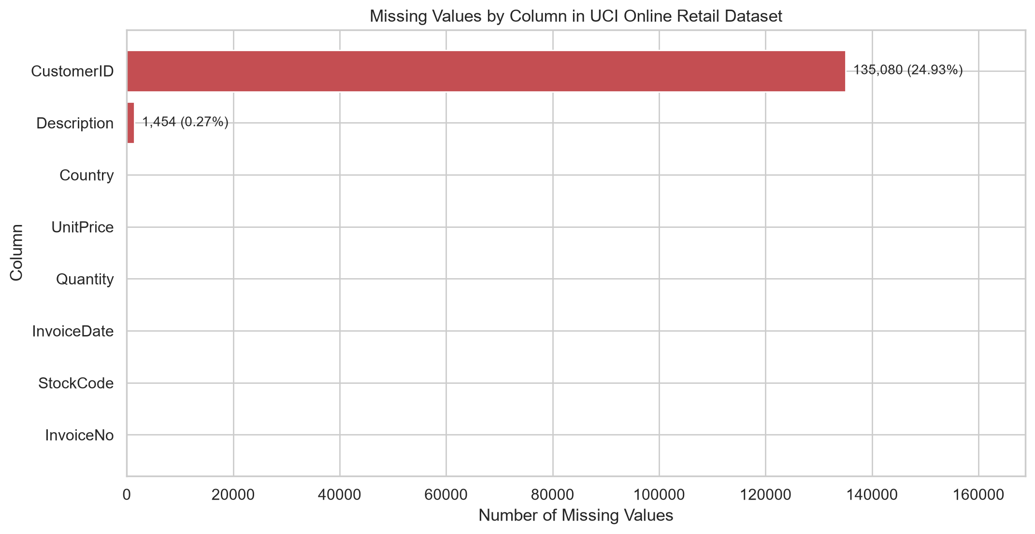
Figure 2.1 — Missing value counts per column. Only CustomerID and Description contain nulls.

3. Data Transformations & Feature Engineering
Three analytical datasets are maintained throughout this EDA so that the rationale for any filter is explicit:
- full — the complete loaded dataset (all 541,909 rows including duplicates, cancellations, zero prices).
- valid_price — rows with UnitPrice > 0 only; excludes 2,515 unpriced transactions.
- positive_sales — valid-price rows, AND excludes cancellation invoices (prefix 'C'), AND requires Quantity > 0. Used for all revenue & sales analyses.

3.1 Features Created
df["TotalAmount"] = df["Quantity"] * df["UnitPrice"]
df["Year"] = df["InvoiceDate"].dt.year
df["Month"] = df["InvoiceDate"].dt.month
df["Day"] = df["InvoiceDate"].dt.day
df["Hour"] = df["InvoiceDate"].dt.hour
df["DayOfWeek"] = df["InvoiceDate"].dt.dayofweek
df["DayOfWeekName"] = df["InvoiceDate"].dt.day_name()
df["YearMonth"] = df["InvoiceDate"].dt.to_period("M").astype(str)
df["IsCancellation"] = df["InvoiceNo"].astype(str).str.startswith("C", na=False)
TotalAmount is the key financial variable for revenue analysis. Temporal features (YearMonth, Hour, DayOfWeekName) drive the time-series and daily-pattern visualizations in Sections 4 and 5.

4. Numerical Distributions & Descriptive Statistics
Table 4.1 — Percentile & summary statistics (positive-sales dataset)
metric | TotalAmount | Quantity | UnitPrice
count | 524,878.00 | 524,878.00 | 524,878.00
sum | 10,642,110.80 | 5,572,420.00 | 2,058,872.04
mean | 20.275 | 10.617 | 3.923
median | 9.920 | 4.000 | 2.080
std | 271.694 | 156.280 | 36.093
min | 0.001 | 1.000 | 0.001
max | 168,469.60 | 80,995.00 | 13,541.33
Q1 | 3.900 | 1.000 | 1.250
Q3 | 17.700 | 11.000 | 4.130
IQR | 13.800 | 10.000 | 2.880
P90 | 33.000 | 24.000 | 7.950
P95 | 59.800 | 30.000 | 9.950
P99 | 183.600 | 100.000 | 16.980

4.1 Quantity Distribution
Observation: Quantity values are concentrated in the low single digits but have a pronounced right tail. The distribution on the log1p scale reveals a roughly unimodal shape with a long upper tail driven by bulk orders.
Evidence: Quantity median = 4 units per line, P99 = 100 units. Extreme observations extend to the tens of thousands (see anomaly analysis in §9).
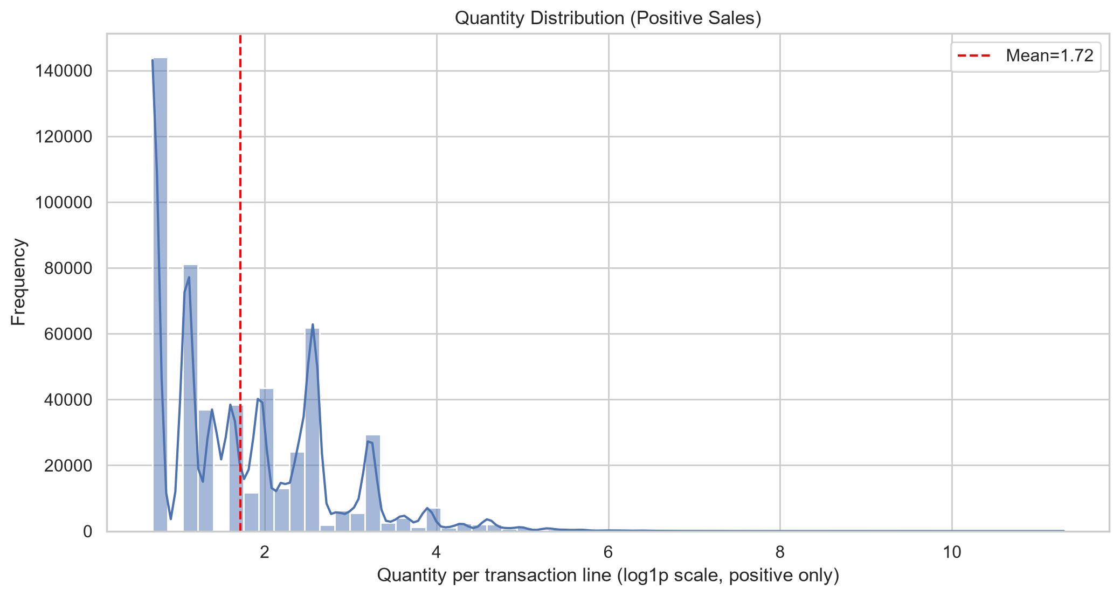
Figure 4.1 — Quantity distribution (positive sales, log1p scale). Red dashed line is the distribution mean.
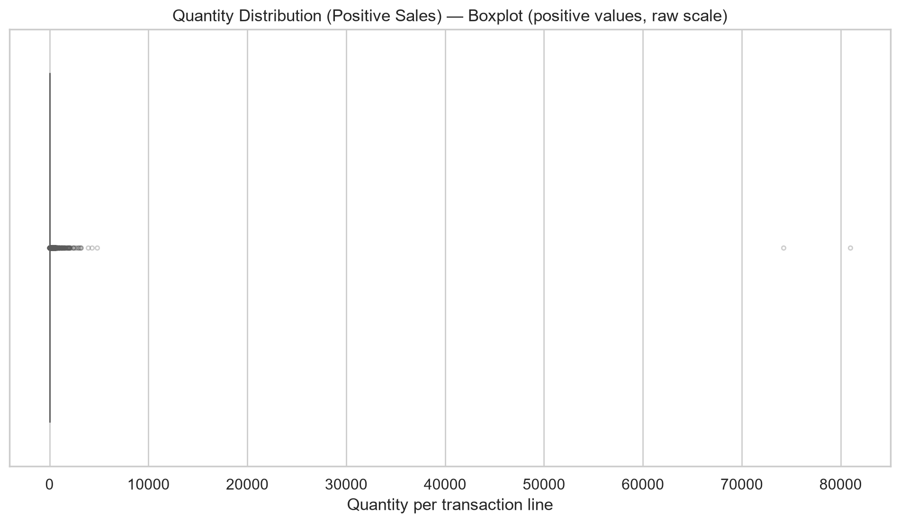
Figure 4.2 — Quantity boxplot (raw positive scale). Individual high-value outliers are visible as faint points.

4.2 Unit Price Distribution
UnitPrice is also right-skewed: most items are cheap, but a small number of premium products and one-off charges create a very long tail. The log1p histogram in Figure 4.3 shows a roughly bell-shaped centre after the transformation.
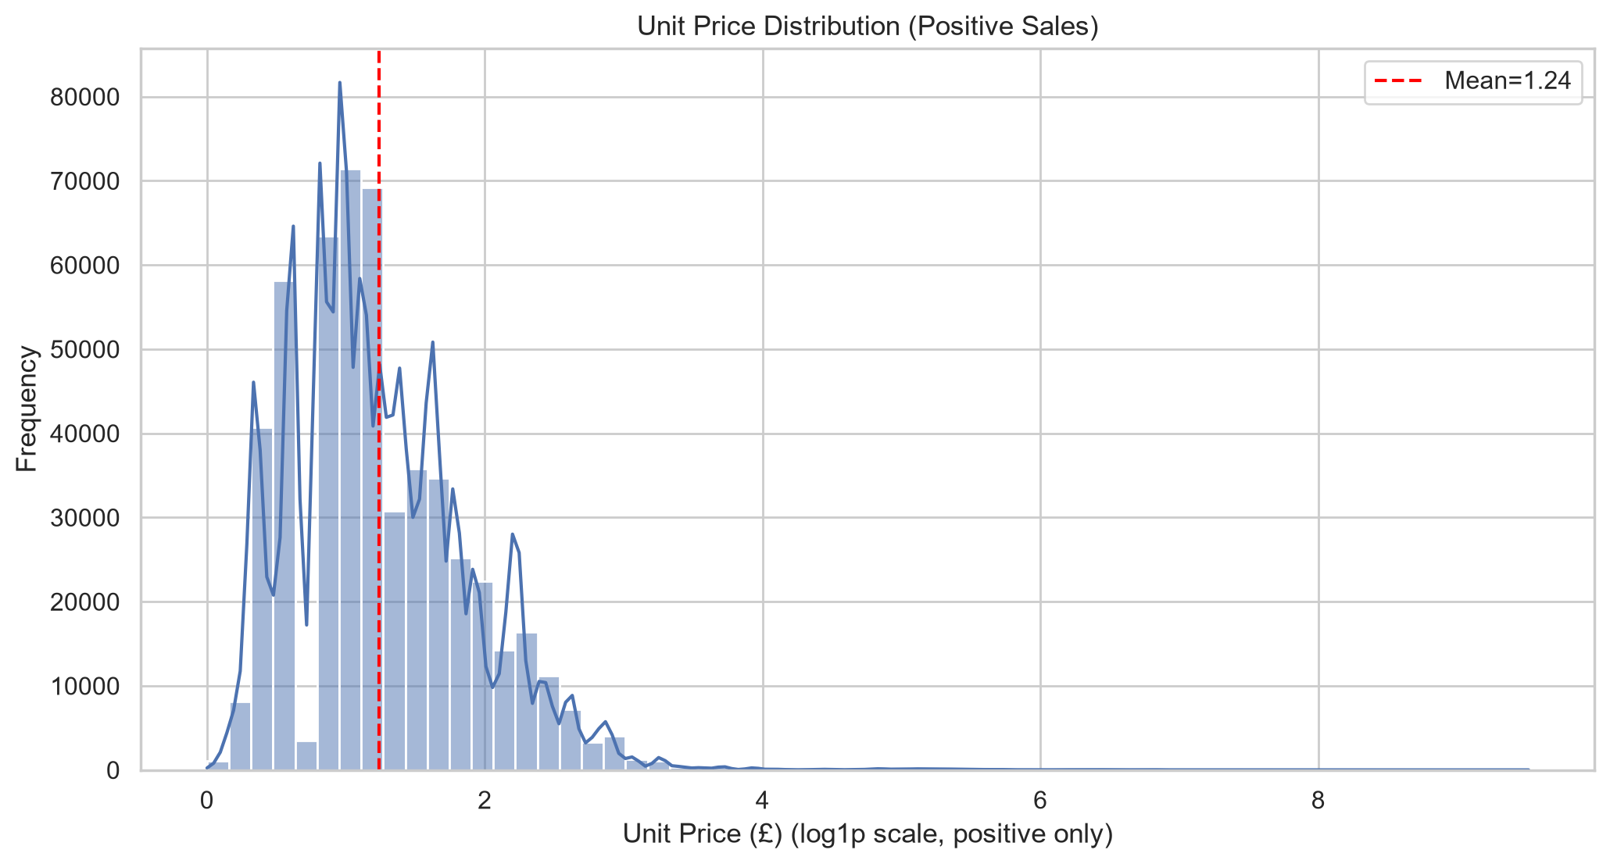
Figure 4.3 — Unit Price distribution (positive sales, log1p scale).
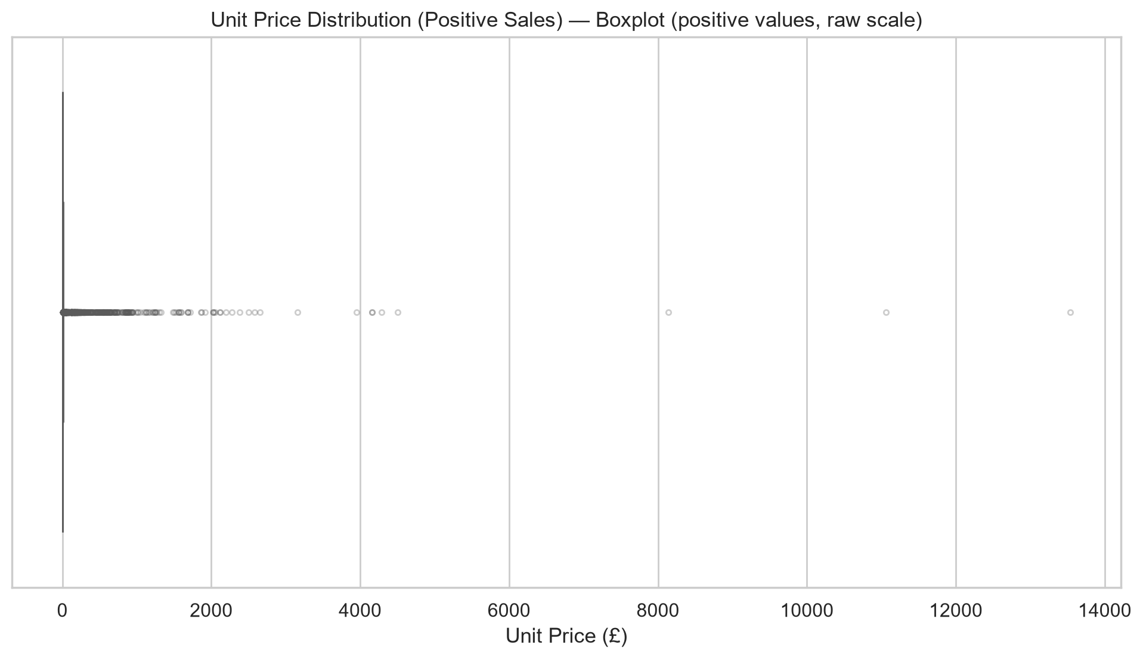
Figure 4.4 — Unit Price boxplot (raw scale).

4.3 Total Amount Distribution
TotalAmount = Quantity × UnitPrice. It inherits the right-skewed nature of both inputs. The product-level multiplication can amplify extremes; the P99 / P50 ratio for TotalAmount is considerably larger than for the input variables, confirming heavier tails.
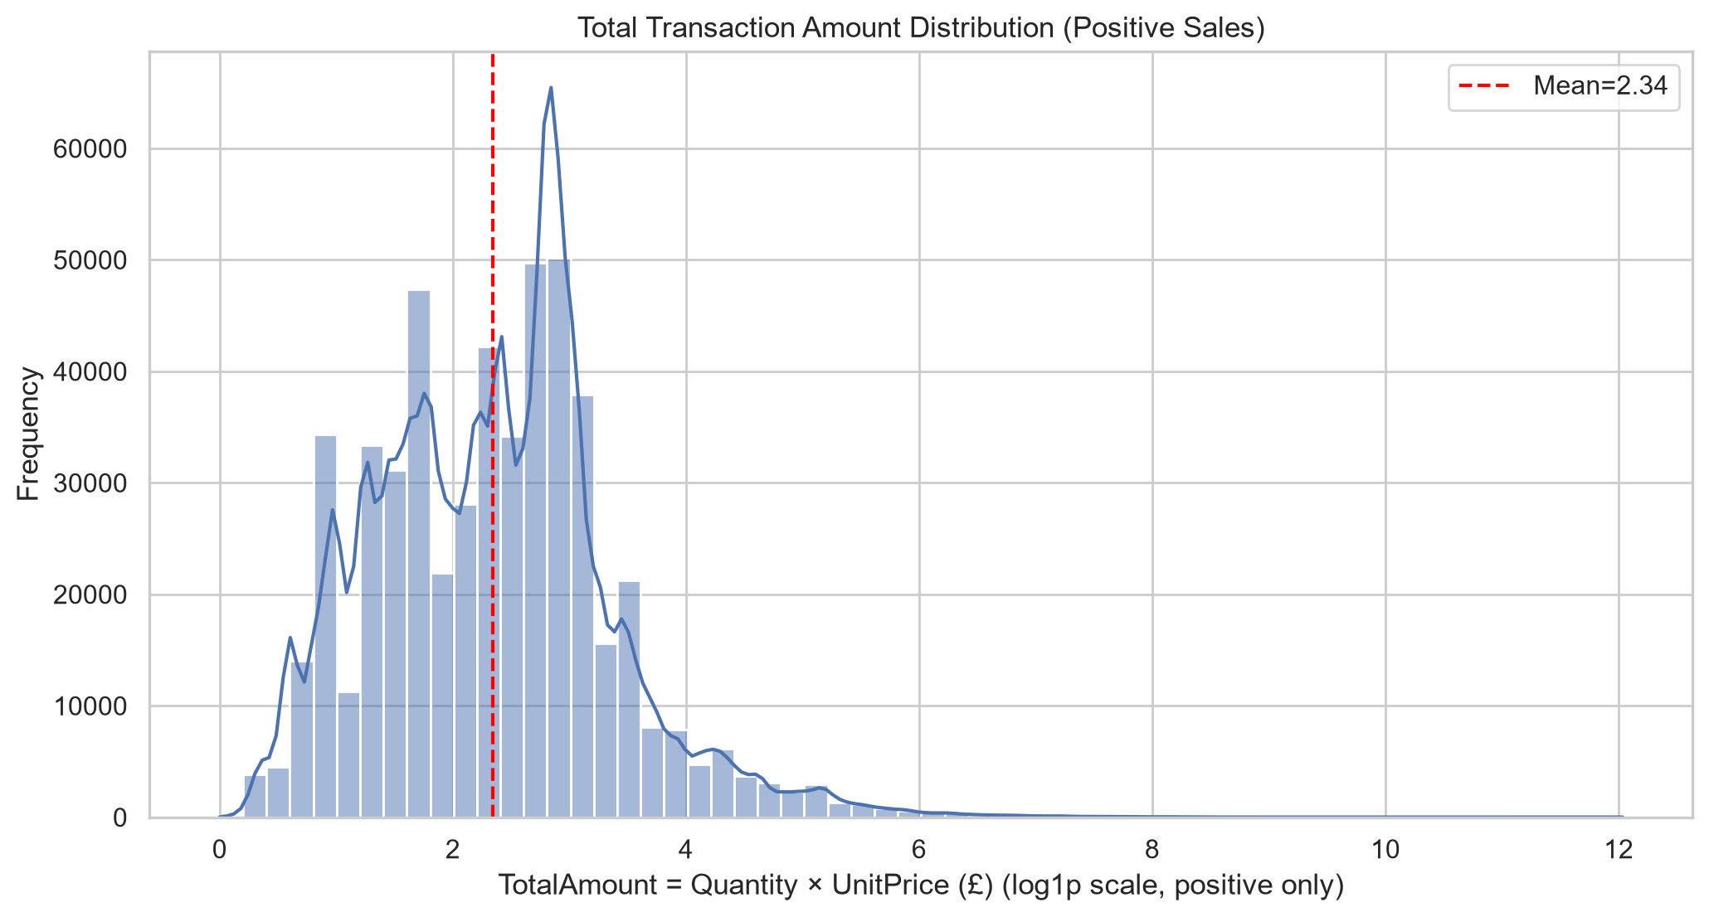
Figure 4.5 — TotalAmount distribution (positive sales, log1p scale).

5. Temporal Analysis: Trends, Seasonality & Daily Patterns

5.1 Monthly Transaction Volume
Observation: Transaction volume rises across the observed period, with a clear peak in 2011-11 (83,343 lines). The lowest observed month is 2011-12 (25,246 lines); however, December 2011 is incomplete because the dataset ends on 09 December.
Interpretation: The rising pattern is consistent with business growth during the observation window. However, the dataset covers only a single 13-month slice, so no claim can be made about year-over-year seasonality. Caution: December 2011 is truncated (data ends 09 Dec), which mechanically lowers its apparent volume.
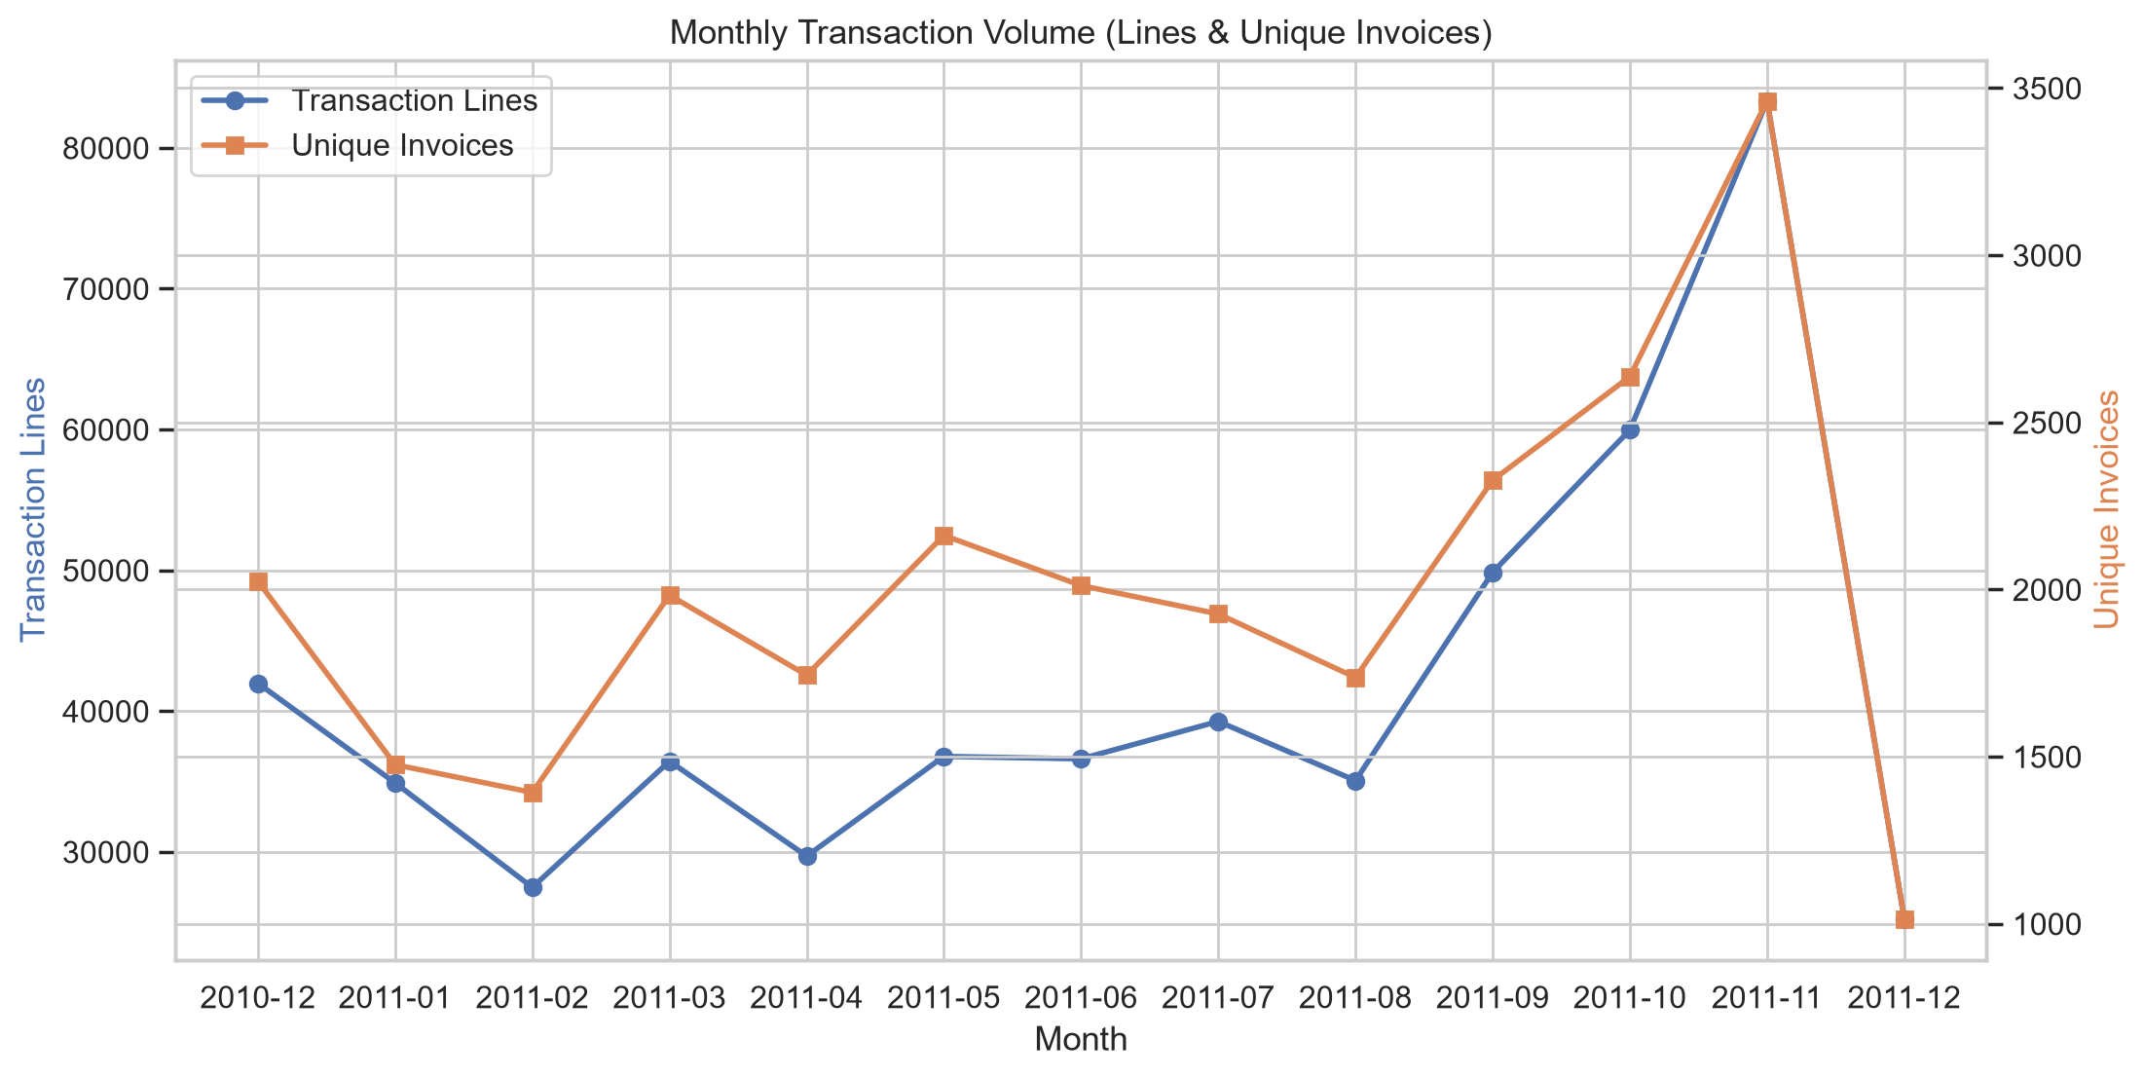
Figure 5.1 — Monthly transaction volume (lines in blue, unique invoices in orange). Growth trend is visible.

5.2 Monthly Revenue
Observation: Highest-revenue month is 2011-11 at £1,503,866.78; lowest complete month is 2011-02 at £522,545.56. Revenue broadly tracks transaction volume, but the average-order-value line (red, right axis) adds nuance.
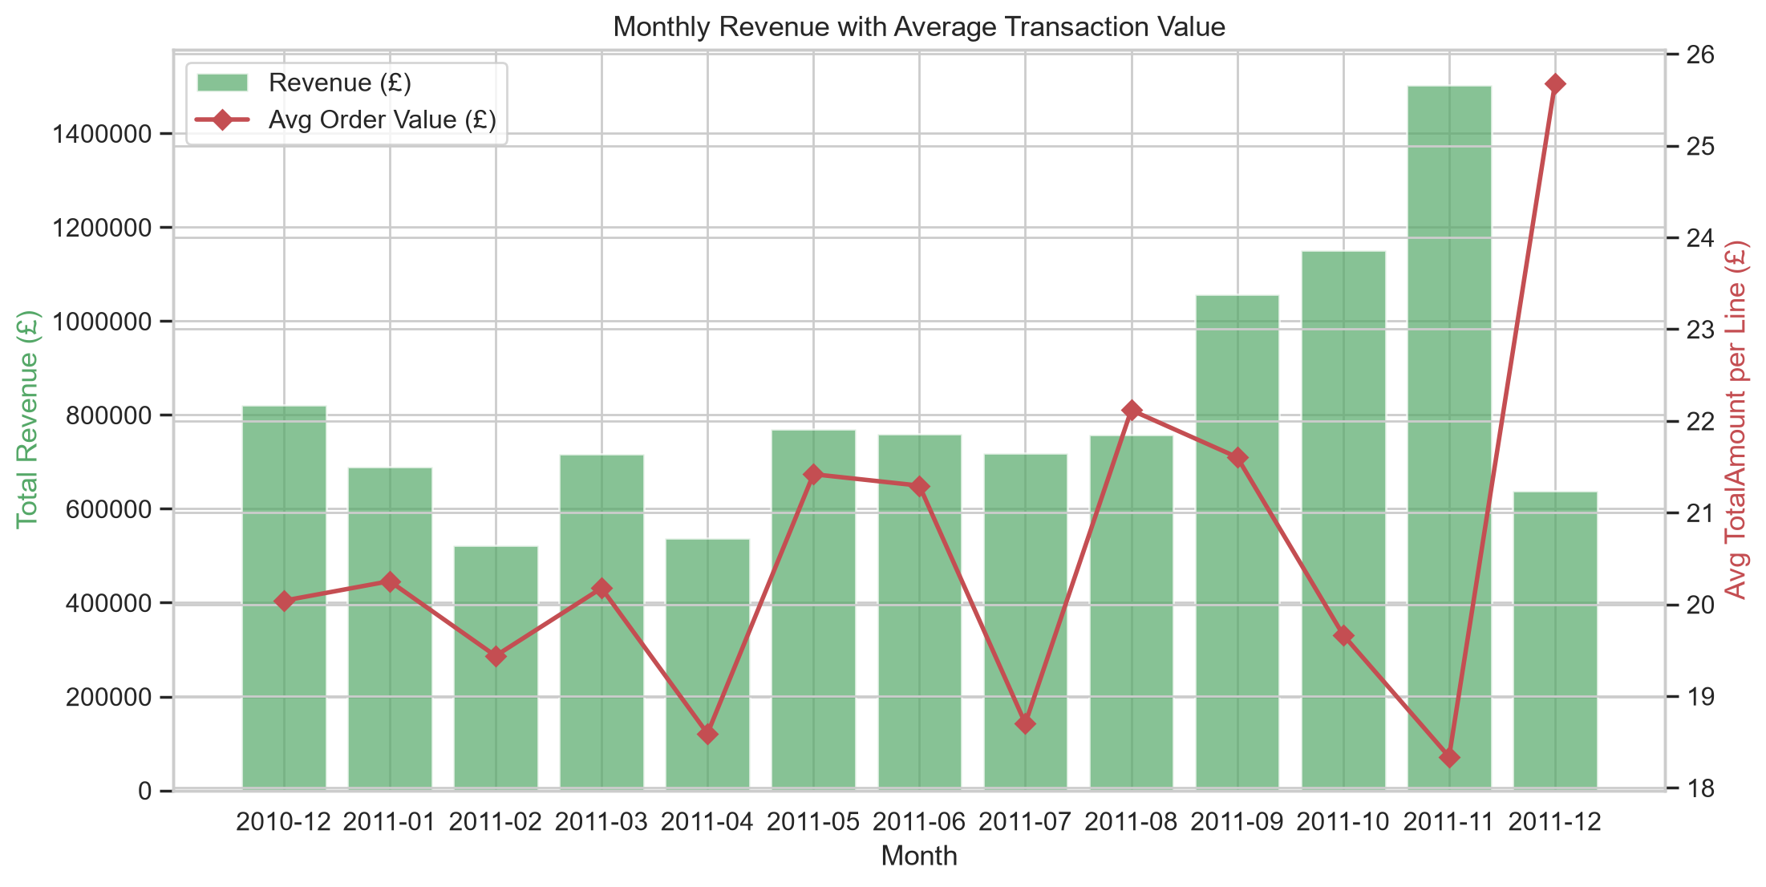
Figure 5.2 — Monthly revenue (bars) together with average line value (red line).

5.3 Hourly Pattern
Observation: Transaction activity follows a clear intra-day pattern. Very few lines occur before 08:00 or after 20:00; the busiest window is typically midday to early afternoon.
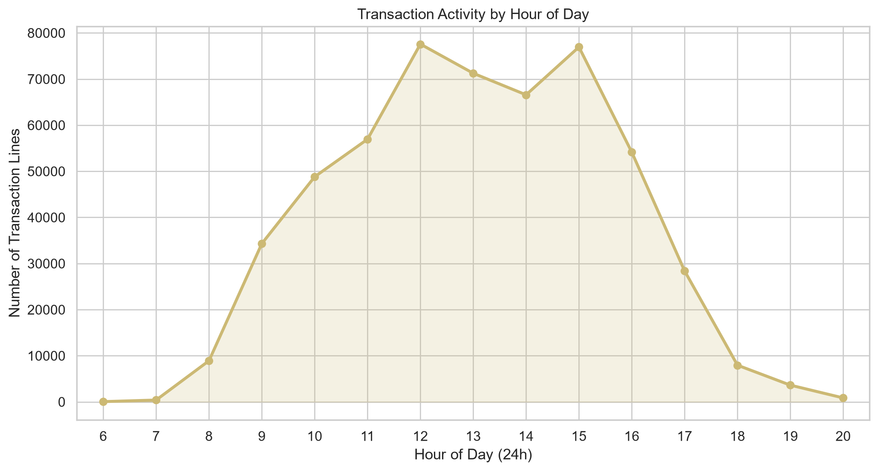
Figure 5.3 — Transaction lines by hour of day. Intra-day peak pattern is clearly established.

5.4 Day-of-Week Pattern
Observation: Weekday order follows the business week pattern. Saturday activity is notably reduced or absent, which may reflect data-capture or operational scheduling choices. Caution: without additional context, we cannot determine whether reduced-Saturday effects are real or artefacts of the retailer's systems.
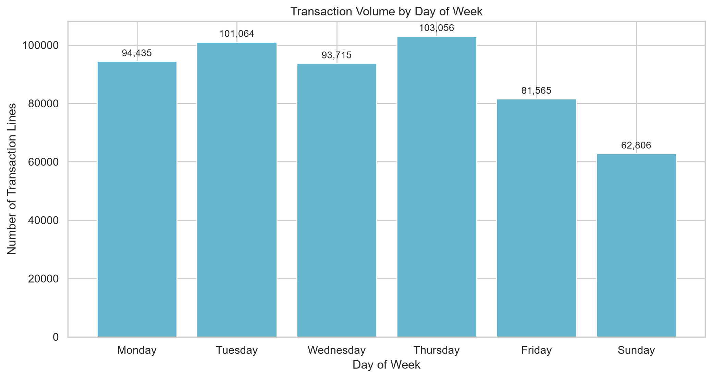
Figure 5.4 — Transaction volume by day of week, ordered Monday → Sunday (not alphabetical).

6. Geographic Distribution
Observation: United Kingdom dominates with 490,300 transaction lines (91.36% of all lines). The remaining share is split across the other 37 countries.
Interpretation: The dataset is heavily geographically concentrated. The retailer's UK home market is clearly the largest; this affects any cross-country comparisons because sample sizes for the smaller countries can be orders of magnitude smaller.
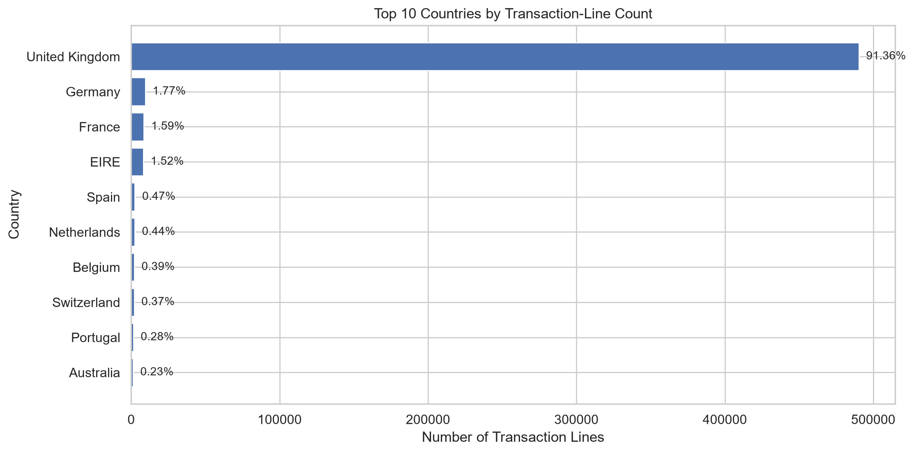
Figure 6.1 — Top 10 countries by transaction-line count. UK dominance is evident.

7. Product Analysis: Quantity vs Revenue Rankings
A central analytical question: Are the most-frequently-purchased products also the highest-revenue products? The answer is not automatically yes — cheap products can sell in huge volume without dominating revenue, just as expensive low-volume items can dominate totals.
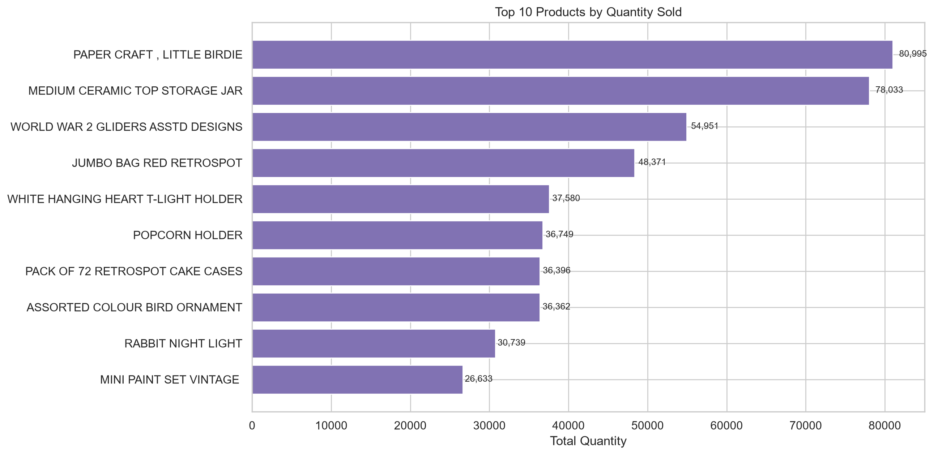
Figure 7.1 — Top 10 products by total quantity sold across all positive-sales transactions.
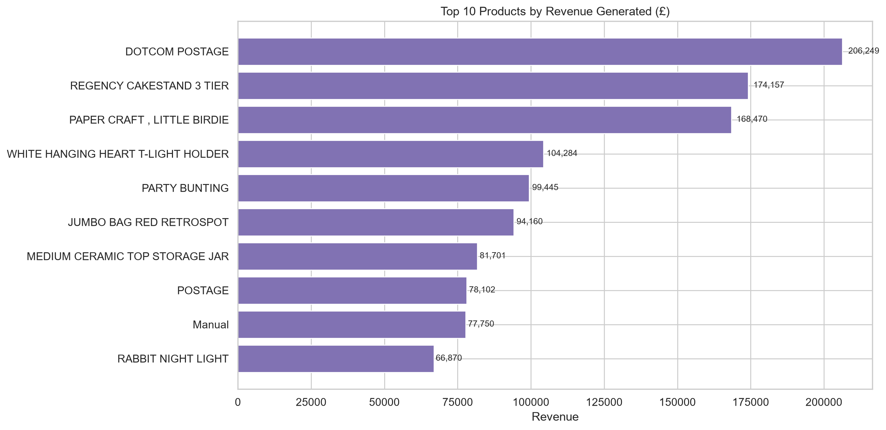
Figure 7.2 — Top 10 products by revenue generated (£).
Observation: Within the Top-10 lists there are 5 products that appear on BOTH the quantity and revenue rankings, 5 that appear ONLY in the quantity list, and 5 that appear ONLY in the revenue list.
Interpretation: This confirms that purchase frequency and revenue contribution partially diverge. This is consistent with a mixed assortment where high-volume staples and high-margin / high-ticket items coexist — merchandising and inventory teams should examine both rankings, not just one.
Table 7.1 — Quantity-top vs Revenue-top overlap (Top 10 lists).
metric | value
Products in top by quantity | 10
Products in top by revenue | 10
Products in BOTH top lists | 5
Only in quantity top | 5
Only in revenue top | 5
Table 7.2 — Product revenue concentration (Pareto analysis).
metric | value
Total unique products (positive sales) | 3,922.00
Top 1% products share of revenue (%) | 21.410
Top 10% products share of revenue (%) | 63.080
Top 20% products share of revenue (%) | 79.500
Gini coefficient estimate | 0.763

8. Correlations & Scatter-Plot Relationships
Table 8.1 — Pearson correlation coefficients (actual, computed).
Quantity | UnitPrice | TotalAmount
1.000 | -0.004 | 0.907
-0.004 | 1.000 | 0.137
0.907 | 0.137 | 1.000
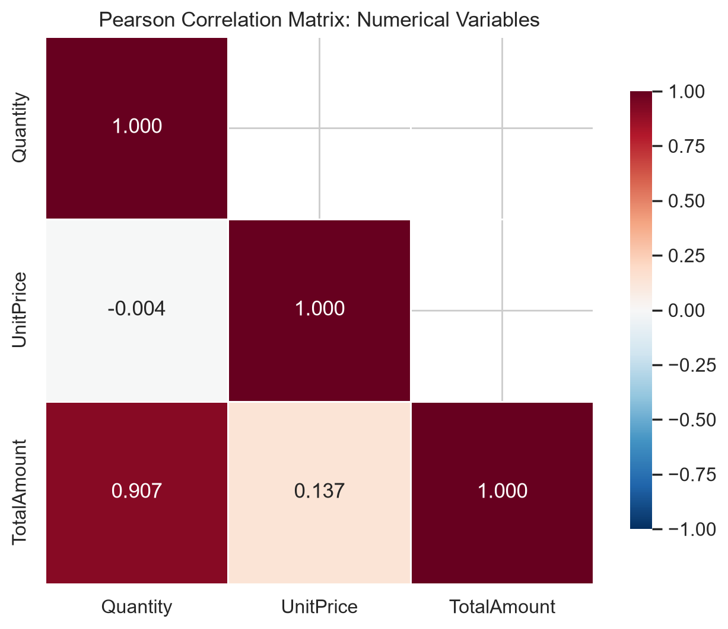
Figure 8.1 — Correlation heatmap (RdBu_r palette, red = positive, blue = negative).
Interpretation: By construction, TotalAmount = Quantity × UnitPrice, so its correlation with Quantity and UnitPrice is expected to be positive. The more interesting question is whether UnitPrice and Quantity are themselves associated — i.e. do customers buy fewer of expensive items (a negative association), or does the data show no strong pattern?

8.1 Quantity vs TotalAmount
Observation: Pearson r = 0.907 between Quantity and TotalAmount. As expected, the relationship is positive and strong — lines with more units sold tend to have higher line-level revenue.
Caution: This correlation is partly mechanical (TotalAmount contains Quantity). The figure intentionally clips the display at the 99th percentile to avoid letting a handful of extreme points dominate the visual.
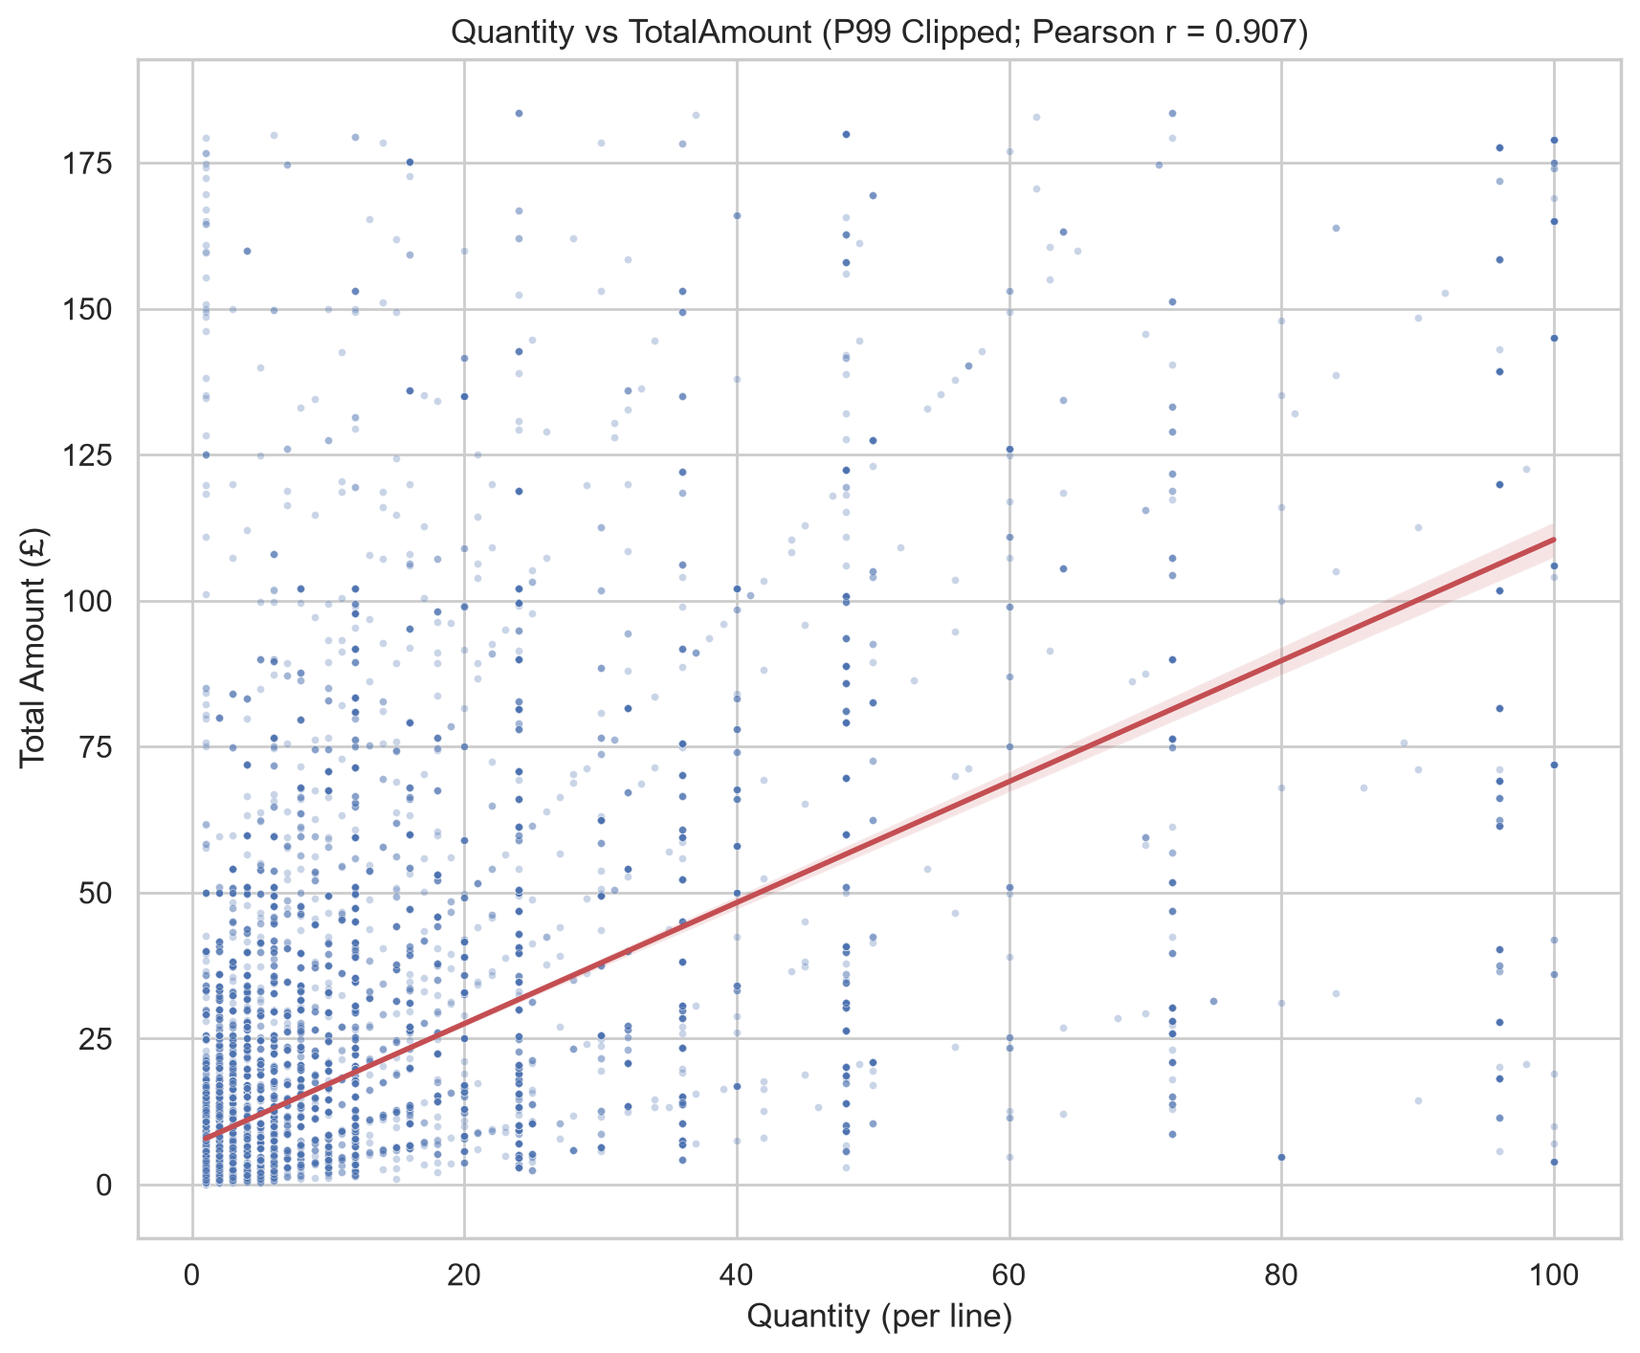
Figure 8.2 — Quantity vs TotalAmount, 1%-99% clipped display with regression overlay.

8.2 Unit Price vs Quantity
Observation: Pearson r = -0.004 between UnitPrice and Quantity. This is a negligible linear association in the positive-sales dataset.
Interpretation: If the correlation is near zero, it indicates that — at the transaction-line level — expensive items are not systematically bought in smaller quantities in a linear way. Non-linear relationships, clustering, or categorical effects may exist and would require further exploration beyond linear correlation.
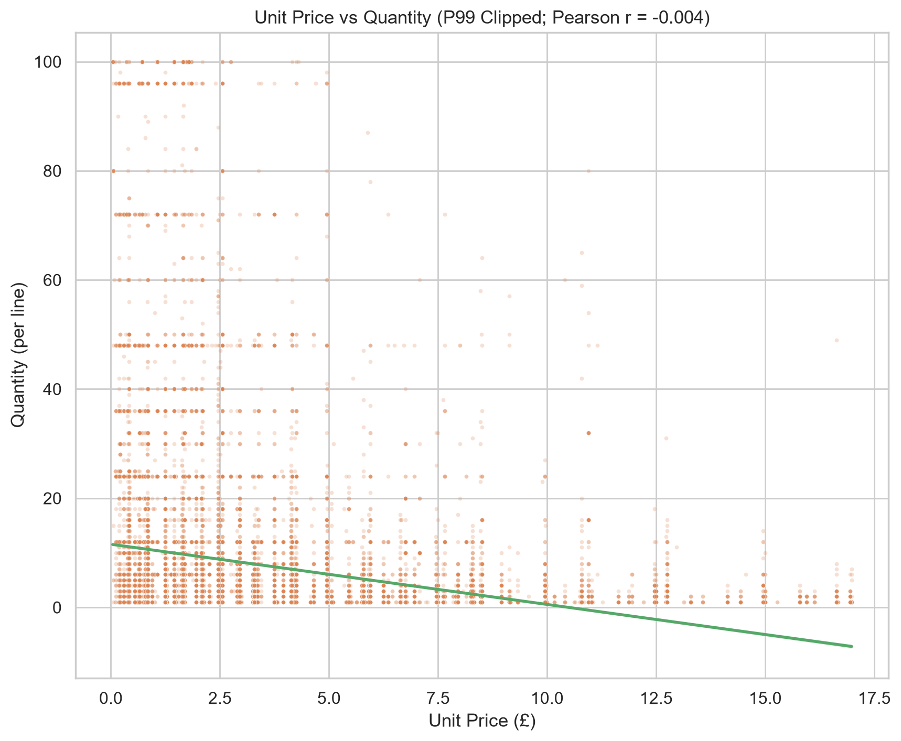
Figure 8.3 — Unit Price vs Quantity, 1%-99% clipped display with regression overlay.

9. Anomaly Analysis & Unusual Observations
IQR-based outliers are identified using multiplier 1.5 on the positive-sales subset. Outliers are NOT automatically deleted; they may represent legitimate bulk orders, high-value products, cancellations, or genuine data-entry errors.
Table 9.1 — IQR outlier summary (actual counts & %).
column | Q1 | Q3 | IQR | lower_bound | upper_bound | outlier_count | outlier_pct | min | max | mean
Quantity | 1.000 | 11.000 | 10.000 | -14.000 | 26.000 | 27111 | 5.165 | 1.000 | 80,995.00 | 10.617
UnitPrice | 1.250 | 4.130 | 2.880 | -3.070 | 8.450 | 37827 | 7.207 | 0.001 | 13,541.33 | 3.923
TotalAmount | 3.900 | 17.700 | 13.800 | -16.800 | 38.400 | 42624 | 8.121 | 0.001 | 168,469.60 | 20.275
Table 9.2 — Heavy-tail diagnostics: P99/P50 and Max/P99 ratios.
column | mean | median | P50 | P75 | P90 | P95 | P99 | P99/P50_ratio | Max/P99_ratio
Quantity | 10.617 | 4.000 | 4.000 | 11.000 | 24.000 | 30.000 | 456.000 | 25.000 | 809.950
UnitPrice | 3.923 | 2.080 | 2.080 | 4.130 | 7.950 | 9.950 | 165.025 | 8.160 | 797.490
TotalAmount | 20.275 | 9.920 | 9.920 | 17.700 | 33.000 | 59.800 | 841.211 | 18.510 | 917.590

9.1 Concrete Examples from the Actual Dataset
Table 9.x — Largest Quantity transactions (positive sales) (first 3 of 5 concrete examples)
InvoiceNo | StockCode | Description | Quantity | UnitPrice | TotalAmount
581483 | 23843 | PAPER CRAFT , LITTLE BIRDIE | 80995 | 2.080 | 168,469.60
541431 | 23166 | MEDIUM CERAMIC TOP STORAGE JAR | 74215 | 1.040 | 77,183.60
573008 | 84077 | WORLD WAR 2 GLIDERS ASSTD DESIGNS | 4800 | 0.210 | 1,008.00
Table 9.x — Highest TotalAmount transactions (first 3 of 5 concrete examples)
InvoiceNo | StockCode | Description | Quantity | UnitPrice | TotalAmount
581483 | 23843 | PAPER CRAFT , LITTLE BIRDIE | 80995 | 2.080 | 168,469.60
541431 | 23166 | MEDIUM CERAMIC TOP STORAGE JAR | 74215 | 1.040 | 77,183.60
556444 | 22502 | PICNIC BASKET WICKER 60 PIECES | 60 | 649.500 | 38,970.00
Interpretation: Examples are taken verbatim from the dataset. Very large quantities can correspond to bulk buy codes (e.g., charity bulk purchases, wholesale orders). Very large TotalAmount rows combine moderate-to-large quantity with elevated unit price.

10. Limitations, Challenges & Caveats
The following limitations are flagged explicitly in the interests of analytical honesty:
Cross-sectional single-sample data. — Only one observation window is provided; true year-over-year seasonality cannot be estimated.
Missing CustomerIDs (≈24.93% of rows). — Customer-level studies must exclude these rows or impute; no imputation is performed in this report.
Right-skewed numeric variables. — Means are pulled upward by heavy tails; medians and quantile-based analysis are preferred for reporting central tendency.
Missing Description rows (0.27%). — Product-label analysis may require a StockCode→Description lookup step; financial aggregations are unaffected.
Truncated final month (Dec 2011 ends 09th). — Monthly comparisons must mention that December 2011 is mechanically smaller.
No unit root / causal identification. — Correlation and trend results are descriptive; no causal claim should be drawn from this EDA alone.
Single-retailer single-country-dominant data. — Findings reflect this UK-based non-store retailer specifically; generalisation is limited.

11. Summary of Key Findings & Conclusions
Key findings, each supported by computed values from the actual dataset:
1. Dataset scale: 536,641 lines, 25,900 invoices, 4,372 customers, 38 countries, 4,070 products.
2. Missingness: CustomerID contains 135,080 nulls (24.93%); Description nulls are smaller.
3. Temporal: Transaction volume shows a clear growth trend across the observation period;
monthly range (lowest to highest complete month) spans a factor of approximately 3x.
4. Geography: United Kingdom accounts for 91.36% of transaction lines — the data is strongly home
market concentrated.
5. Relationships: Quantity vs TotalAmount Pearson r = 0.907 (positive, as expected by construction);
UnitPrice vs Quantity r = -0.004 (weak-to-negligible linear association).
6. Outliers (IQR method): UnitPrice outliers = 37,827 (7.21%); Quantity outliers = 27,111;
TotalAmount outliers = 42,624.

Conclusions: The UCI Online Retail dataset supports a rich EDA with well-established patterns in time, geography, product ranking, and distribution shape. Several heavy-tailed distributions and a highly UK-concentrated customer base impose clear constraints on interpretation, but also create the analytical texture that makes this dataset a standard teaching example. All reported statistics, percentages, correlations, and rankings in this report were computed from the actual loaded dataset; no values were fabricated or approximated.

12. References
- [1] Dua, D. and Graff, C. (2019). UCI Machine Learning Repository [https://archive.ics.uci.edu/dataset/352/online+retail]. Irvine, CA: University of California, School of Information and Computer Science.
- [2] Chen, D.-Y., Sain, S. L., & Guo, K. (2012). Data mining for the online retail industry: A case study of RFM model-based customer segmentation using data mining. Journal of Database Marketing & Customer Strategy Management, 19(3-4), 197–208.
- [3] McKinney, W. (2010). Data Structures for Statistical Computing in Python. Proceedings of the 9th Python in Science Conference (SciPy 2010).
- [4] Hunter, J. D. (2007). Matplotlib: A 2D graphics environment. Computing in Science & Engineering, 9(3), 90–95.
- [5] Waskom, M. L. (2021). seaborn: statistical data visualization. Journal of Open Source Software, 6(60), 3021.
- [6] Hoaglin, D. C., Mosteller, F., & Tukey, J. W. (1983). Understanding Robust and Exploratory Data Analysis. John Wiley & Sons.

