Week 3: Unsupervised Learning and Clustering
Customer Segmentation using RFM Analysis and K-Means Clustering

Report Date: 2026-10-02
UCI Online Retail Dataset — Customer Segmentation Project
RFM Reference Date: 2011-12-10 | Random Seed: 42

Table of Contents

Note: Right-click the TOC field in Word and select 'Update Field' to populate page numbers after opening.

2. Executive Summary
This report presents an unsupervised learning-based customer segmentation of the UCI Online Retail dataset using RFM (Recency, Frequency, Monetary) feature engineering combined with K-Means clustering. The objective was to identify distinct customer groups to support targeted marketing strategies. Starting from 541,909 raw transaction records, 392,692 positive sales rows with non-null CustomerID were retained, yielding 4,338 unique customers for RFM computation. A range of cluster counts was evaluated using the Elbow method (inertia) and Silhouette score. The selected number of clusters was k = 2, producing a Silhouette score of 0.4328 (Calinski-Harabasz: 4,367.32, Davies-Bouldin: 0.8925). Cluster membership distribution across the 2 clusters is as follows: Cluster 0: 2672, Cluster 1: 1666. Key segmentation finding: Cluster 1 accounts for the largest revenue share at 8510.0% of total revenue despite representing only 3840.5% of customers.

3. Introduction
Customer segmentation is a foundational technique in marketing analytics and customer relationship management (CRM). By dividing a heterogeneous customer base into homogeneous groups based on behavioural patterns, businesses can tailor product recommendations, promotional campaigns, pricing strategies, and retention initiatives to each segment's characteristics. This personalization typically improves customer satisfaction, increases lifetime value (CLV), and reduces inefficient one-size-fits-all marketing spend.
The RFM model is a well-established behavioural segmentation framework originating from direct marketing analytics. It characterises each customer along three orthogonal dimensions: Recency (how recently they purchased), Frequency (how often they purchase), and Monetary value (how much they spend). RFM's practical value is its interpretability — each dimension maps directly to actionable marketing levers. Recency informs re-engagement timing; Frequency informs loyalty programme design; Monetary informs premium service eligibility and margin-based prioritisation (Chen, Sain, & Guo, 2012).
In this project, we operationalise RFM on a real-world transactional dataset, stabilise its typically right-skewed distributions via log transformation, standardise the resulting features, and then apply K-Means clustering to uncover natural customer groupings. The resulting segments are described quantitatively through profile tables and qualitatively through evidence-based interpretation, forming the basis for downstream marketing decision-making.

4. Problem Statement
Given a historical set of e-commerce transactions from a UK-based online retailer, the task is to partition the retailer's customer base into a small number (k) of operationally meaningful, behaviourally distinct segments. Specifically: (1) engineer Recency, Frequency, and Monetary features per customer from the raw transaction log; (2) stabilise and standardise those features so that Euclidean distance-based clustering is well-conditioned; (3) apply K-Means with an appropriately selected k; (4) evaluate cluster quality via internal validation metrics; and (5) produce interpretable cluster profiles that can inform targeted marketing and retention strategies. No labelled ground truth exists, so this is an unsupervised problem and all claims about segments must be supported by internal metrics and descriptive statistics, not causal inferences.

5. Dataset Description
The dataset is the UCI Machine Learning Repository's 'Online Retail' dataset, which records transactions occurring between 01/12/2010 and 09/12/2011 for a UK-based online gift and homeware retailer. The majority of sales are to wholesale customers across multiple countries.
Columns present in the raw data: InvoiceNo (transaction identifier), StockCode (product code), Description (product description), Quantity (units per line), InvoiceDate (transaction datetime), UnitPrice (£ per unit), CustomerID (customer identifier), Country (customer billing country).
The raw dataset contains n_raw_rows = 541,909 transaction-line records. The dataset is distributed by the UCI ML Repository (Dua & Graff, 2019) and hosted in the project's `data/` directory. Per the `data/README.md`, the raw Excel file is not committed to version control because of its size and licence terms; instead, the README documents the canonical download URL and expected filename so that any user can reproduce the full pipeline end-to-end.
An important data-quality note: a material number of transaction lines carry missing (NULL) CustomerID values. Because RFM features must be aggregated at the customer level, these anonymous rows cannot be assigned to any individual customer and are therefore excluded from the segmentation. The downstream analysis and all cluster statistics in this report therefore describe only the identified-customer subset of the business.

6. Data Preparation
Raw transactional data requires cleaning before RFM features can be meaningfully computed. The following sequential steps were applied:
- Deduplication: exact duplicate rows were removed based on all columns, as duplicate line items would inflate Frequency and Monetary values spuriously.
- Cancellation removal: transactions whose InvoiceNo begins with the cancellation prefix 'C' were filtered out, as these represent refunds/returns, not genuine sales events.
- Positive sales filter: only rows with Quantity > 0 and UnitPrice > 0 were retained. This removes negative-quantity return lines and zero-priced promotional or manual adjustment lines that do not contribute to revenue.
- Non-null CustomerID filter: rows with missing CustomerID were dropped because they cannot be mapped to an individual customer for RFM aggregation.
After applying the above cleaning pipeline, n_positive_sales_rows = 392,692 transaction lines remained as the input to RFM feature engineering. This represents 72.5% of the raw dataset size.

7. RFM Feature Engineering
Three customer-level features were derived by aggregating the cleaned positive-sales transaction lines grouped by CustomerID. The analysis reference_date used was 2011-12-10 (computed as one calendar day after the maximum observed InvoiceDate in the cleaned dataset, so that the most recent buyer has a Recency of at least 1 day).

Recency (R)
Days elapsed between the customer's most recent invoice date and the reference_date (2011-12-10). Formula: Recency_i = (reference_date - max_j InvoiceDate_ij).days. Lower values indicate more recent engagement.

Frequency (F)
Number of distinct invoices (orders) placed by the customer across the observation window. Formula: Frequency_i = |{InvoiceNo_ij}| for customer i. Measures how often the customer returns.

Monetary (M)
Sum of line-item TotalAmount (Quantity x UnitPrice) across all of the customer's positive-sales invoices. Formula: Monetary_i = sum_j (Quantity_ij * UnitPrice_ij). Captures the customer's total revenue contribution.

8. Exploratory Analysis
Before modelling, RFM feature distributions were inspected for central tendency, spread, and shape. Descriptive statistics (count, mean, standard deviation, min, quartiles, max) are summarised below.
Table 8.1. RFM distribution statistics (raw scale).
index | column | count | mean | std | min | 25% | 50% | 75% | max | skew | kurtosis
0 | Recency | 4,338.00 | 92.54 | 100.01 | 1.00 | 18.00 | 51.00 | 142.00 | 374.00 | 1.25 | 0.4306
1 | Frequency | 4,338.00 | 4.27 | 7.70 | 1.00 | 1.00 | 2.00 | 5.00 | 209.00 | 12.07 | 249.06
2 | Monetary | 4,338.00 | 2,048.69 | 8,985.23 | 3.75 | 306.48 | 668.57 | 1,660.60 | 280,206.02 | 19.34 | 478.68

Table 8.2. Overall RFM descriptive summary.
index | Metric | Recency | Frequency | Monetary
0 | Mean across all customers | 92.54 | 4.27 | 2,048.69

RFM features typically exhibit strong positive (right) skew in retail contexts, driven by a small fraction of high-frequency / high-spend customers.
To mitigate skew and make clusters more representative of the whole customer base, the log1p(x) = ln(1 + x) transformation was applied to these columns: Log_Recency, Log_Frequency, Log_Monetary. The '+1' offset ensures zero values remain defined after log. Log1p both compresses the upper tail and tends to make Frequency and Monetary closer to normally distributed, which aligns better with K-Means' implicit assumption of approximately spherical, equal-variance clusters.
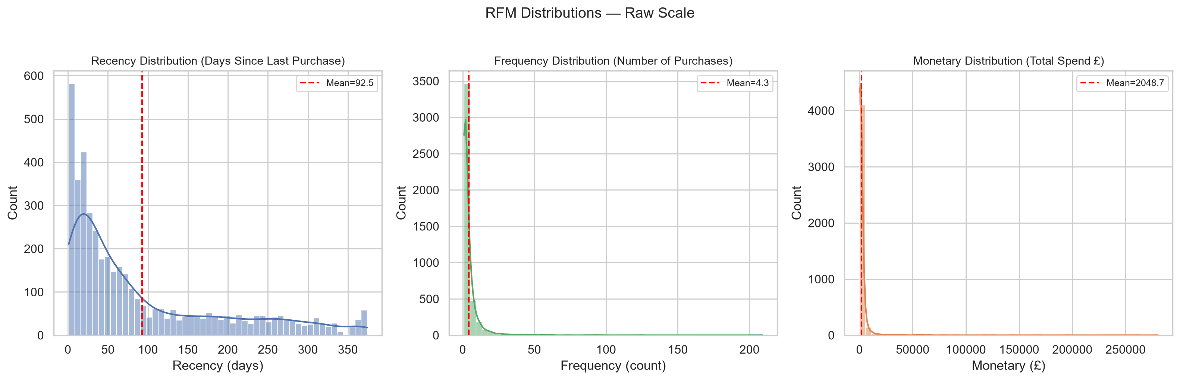
Figure 8.1. RFM feature distributions on the raw scale.
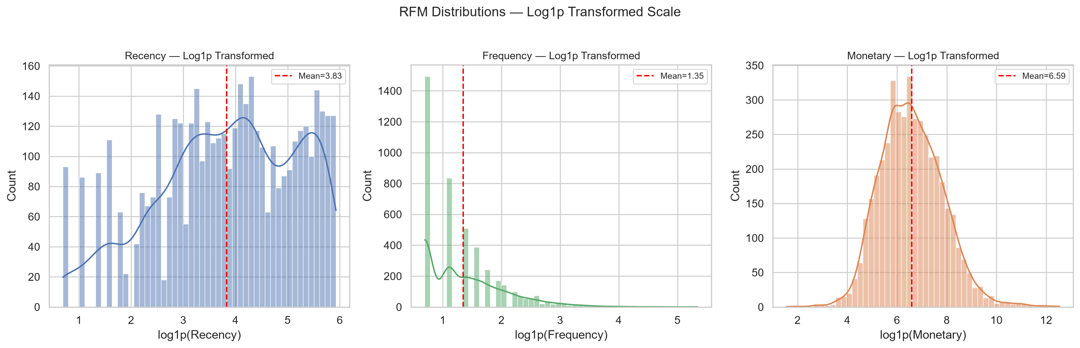
Figure 8.2. RFM feature distributions after log1p transformation.

9. Clustering Methodology

9.1 K-Means Algorithm
K-Means is a partitional, centroid-based clustering algorithm that iteratively assigns each observation to its nearest centroid and then relocates each centroid to the mean of its assigned observations. The procedure converges when no assignment changes or a maximum iteration count is reached. The objective minimized is the within-cluster sum of squared Euclidean distances, also known as inertia: sum_i ||x_i - mu_{c_i}||^2.

9.2 StandardScaler Pre-processing
Because K-Means is scale-sensitive (a feature with larger variance exerts more influence on Euclidean distance), all features used as input to clustering were z-standardised with sklearn's StandardScaler: z = (x - mu) / sigma, fit only on the training/customer-level data. This puts each log-transformed RFM dimension on comparable footing so that Recency, Frequency, and Monetary each contribute roughly equally to the distance metric, unless the data itself argues otherwise via variance.

9.3 Model Selection: Elbow Method and Silhouette Score
Two complementary internal validation metrics guided the choice of k. The Elbow method inspects the inertia curve across k values: inertia monotonically decreases as k increases, and the 'elbow' - the k beyond which inertia drops most slowly - signals a region of reasonable parsimony. The Silhouette score s(i) for each observation ranges from -1 (worst) to +1 (perfectly assigned), and the dataset mean Silhouette score summarises cluster tightness versus separation. Typically the highest k with a positive, stable mean Silhouette score - while still respecting interpretability and actionability of the cluster count - is preferred.

10. K-Means Implementation
The final K-Means model was configured and executed with the following parameters to ensure reproducibility and convergence robustness:
- random_state = 42 (numpy and sklearn seeds fixed for deterministic centroid initialization).
- n_init = 10 independent random initializations were run; the run producing the lowest final inertia was retained.
- max_iter = 300 Lloyd iterations per initialization (sklearn default).
- Feature columns supplied to StandardScaler and KMeans were the log1p-transformed and scaled Recency, Frequency, and Monetary values derived from the RFM DataFrame.

11. Selecting Number of Clusters
Table 11.1. Inertia and Silhouette score for each evaluated k.
index | k | inertia | silhouette_score
0 | 2 | 6,483.59 | 0.4328
1 | 3 | 4,869.49 | 0.3365
2 | 4 | 3,939.05 | 0.3375
3 | 5 | 3,296.71 | 0.3162
4 | 6 | 2,855.76 | 0.3124
5 | 7 | 2,548.82 | 0.3092
6 | 8 | 2,336.34 | 0.3033
7 | 9 | 2,156.01 | 0.2811
8 | 10 | 2,005.75 | 0.2767

Across the evaluated k values, the combination of the inertia elbow location and the mean Silhouette score curve supports the selection of best_k = 2. At this k, the Silhouette score is acceptably positive while the solution remains parsimonious enough for marketing action. Inertia continues to improve beyond k = 2, but at the cost of diminishing Silhouette score and increasingly fragmented - and therefore less actionable - segments.
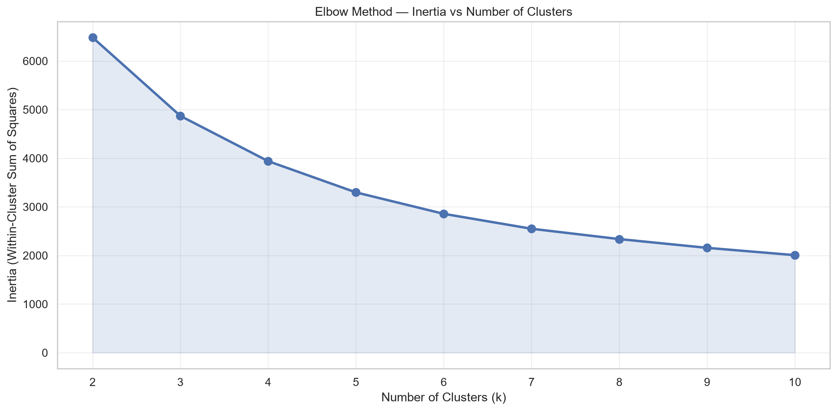
Figure 11.1. Elbow plot: inertia vs. number of clusters k.
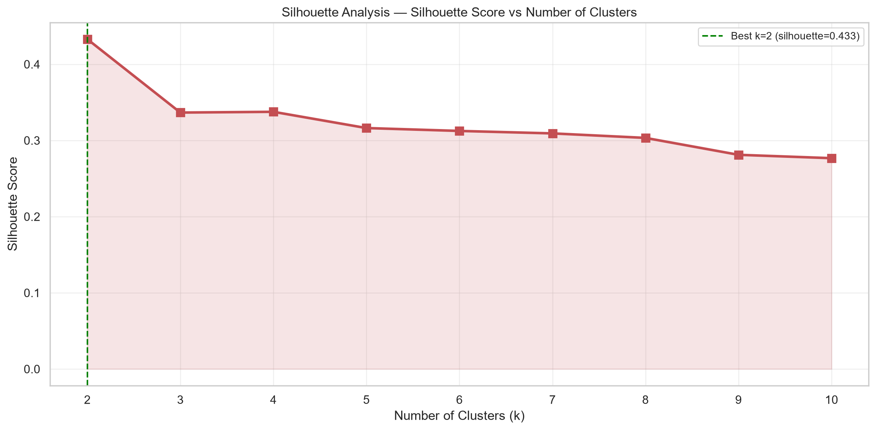
Figure 11.2. Mean Silhouette score vs. number of clusters k.

12. Evaluation
Table 12.1. Internal clustering validation metrics at k = 2.
index | Metric | Value
0 | Silhouette Score | 0.4328
1 | Calinski-Harabasz Index | 4,367.32
2 | Davies-Bouldin Index | 0.8925

Silhouette Score = 0.4328: Values near 0 indicate overlapping clusters; values well above 0.25 suggest reasonable separation. Interpretation must be tempered by real-world dataset structure - real customer data rarely achieves scores above 0.5-0.6 even when segments are operationally useful.
Calinski-Harabasz Index = 4,367.32: The ratio of between-cluster dispersion to within-cluster dispersion. Higher is better; the metric has no upper bound and is most informative when compared across candidate k values on the same dataset.
Davies-Bouldin Index = 0.8925: The average worst-case ratio of a cluster's within-cluster scatter to its separation from its nearest rival cluster. Lower is better, with 0 representing perfectly separated clusters.

13. Cluster Visualization
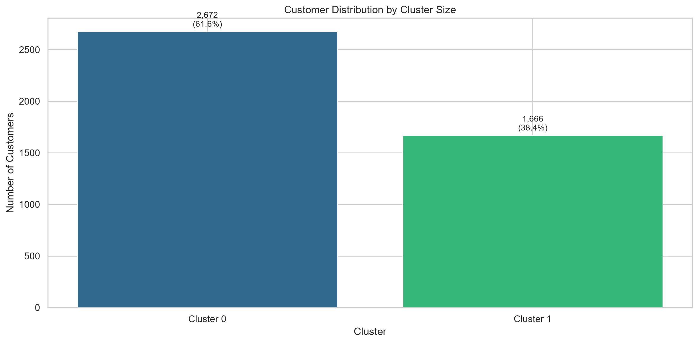
Figure 13.1. Cluster size distribution (customer count per cluster).
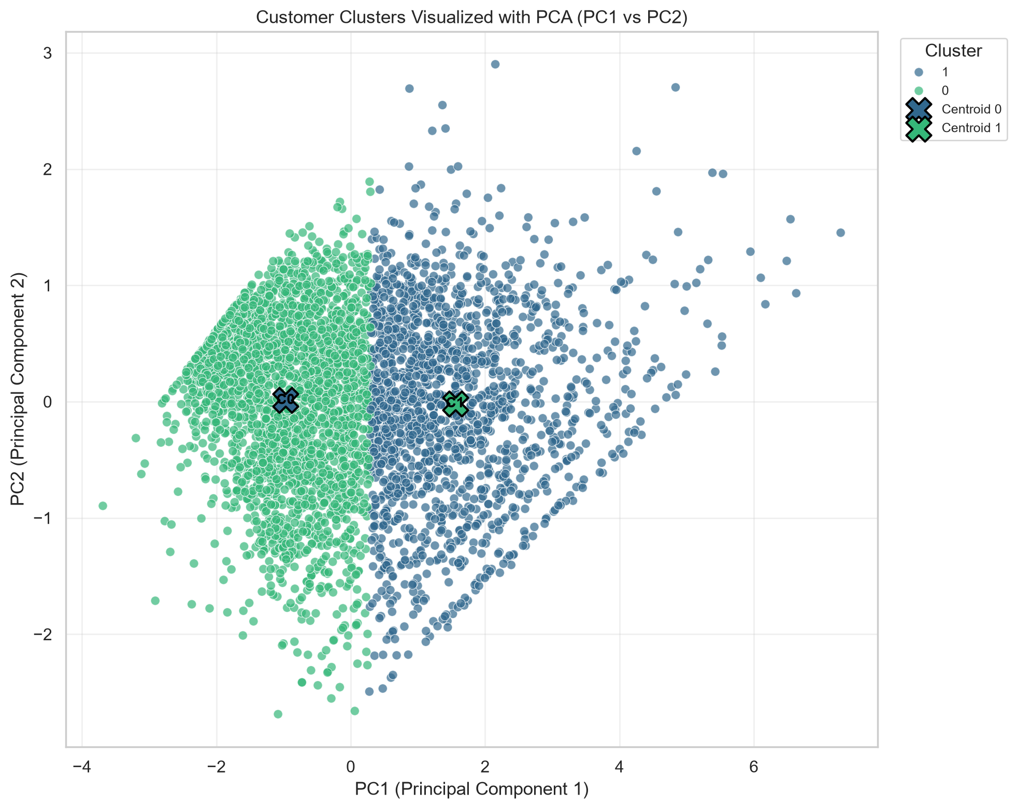
Figure 13.2. K-Means clusters projected onto the first two principal components of the scaled RFM feature space.
Table 13.1. PCA explained variance ratio per component.
index | Component | ExplainedVarianceRatio | CumulativeExplainedVariance
0 | PC1 | 0.7508 | 0.7508
1 | PC2 | 0.1879 | 0.9387

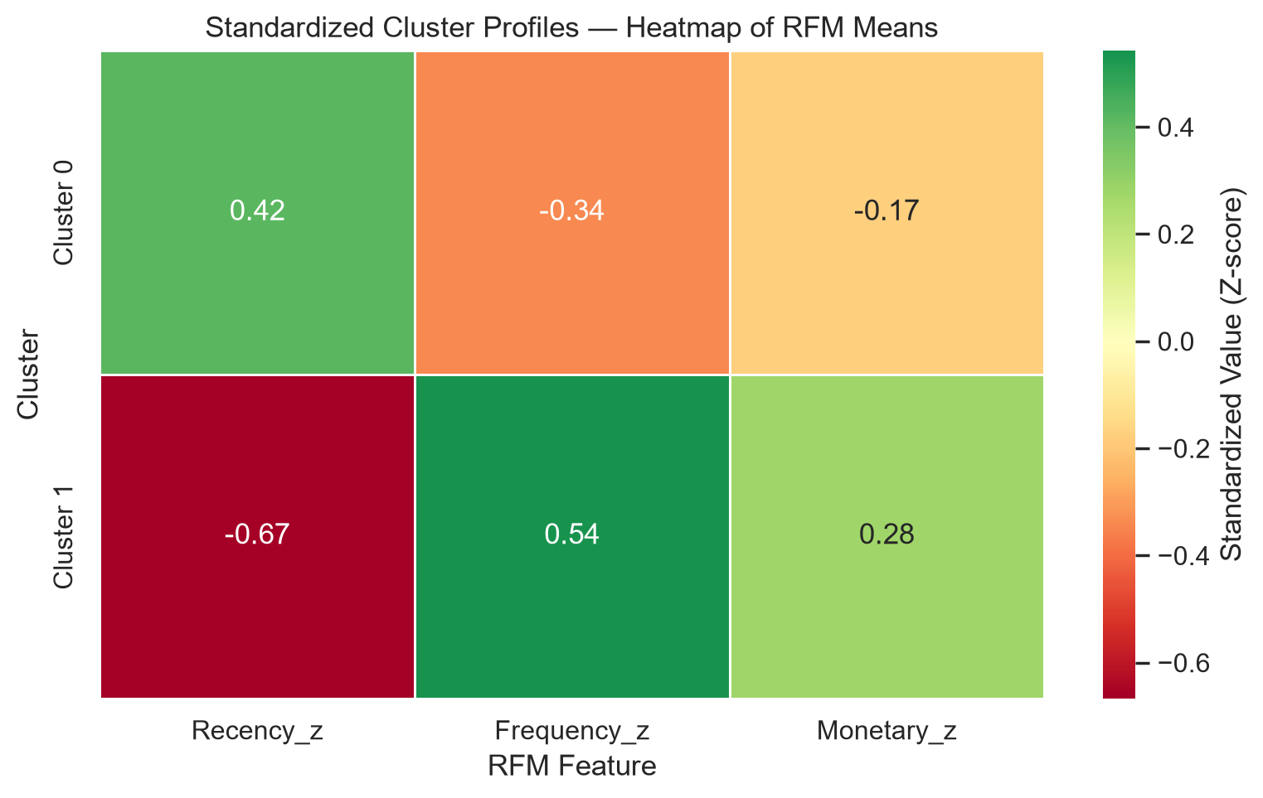
Figure 13.3. Scaled cluster profile heatmap (z-score per RFM dimension).
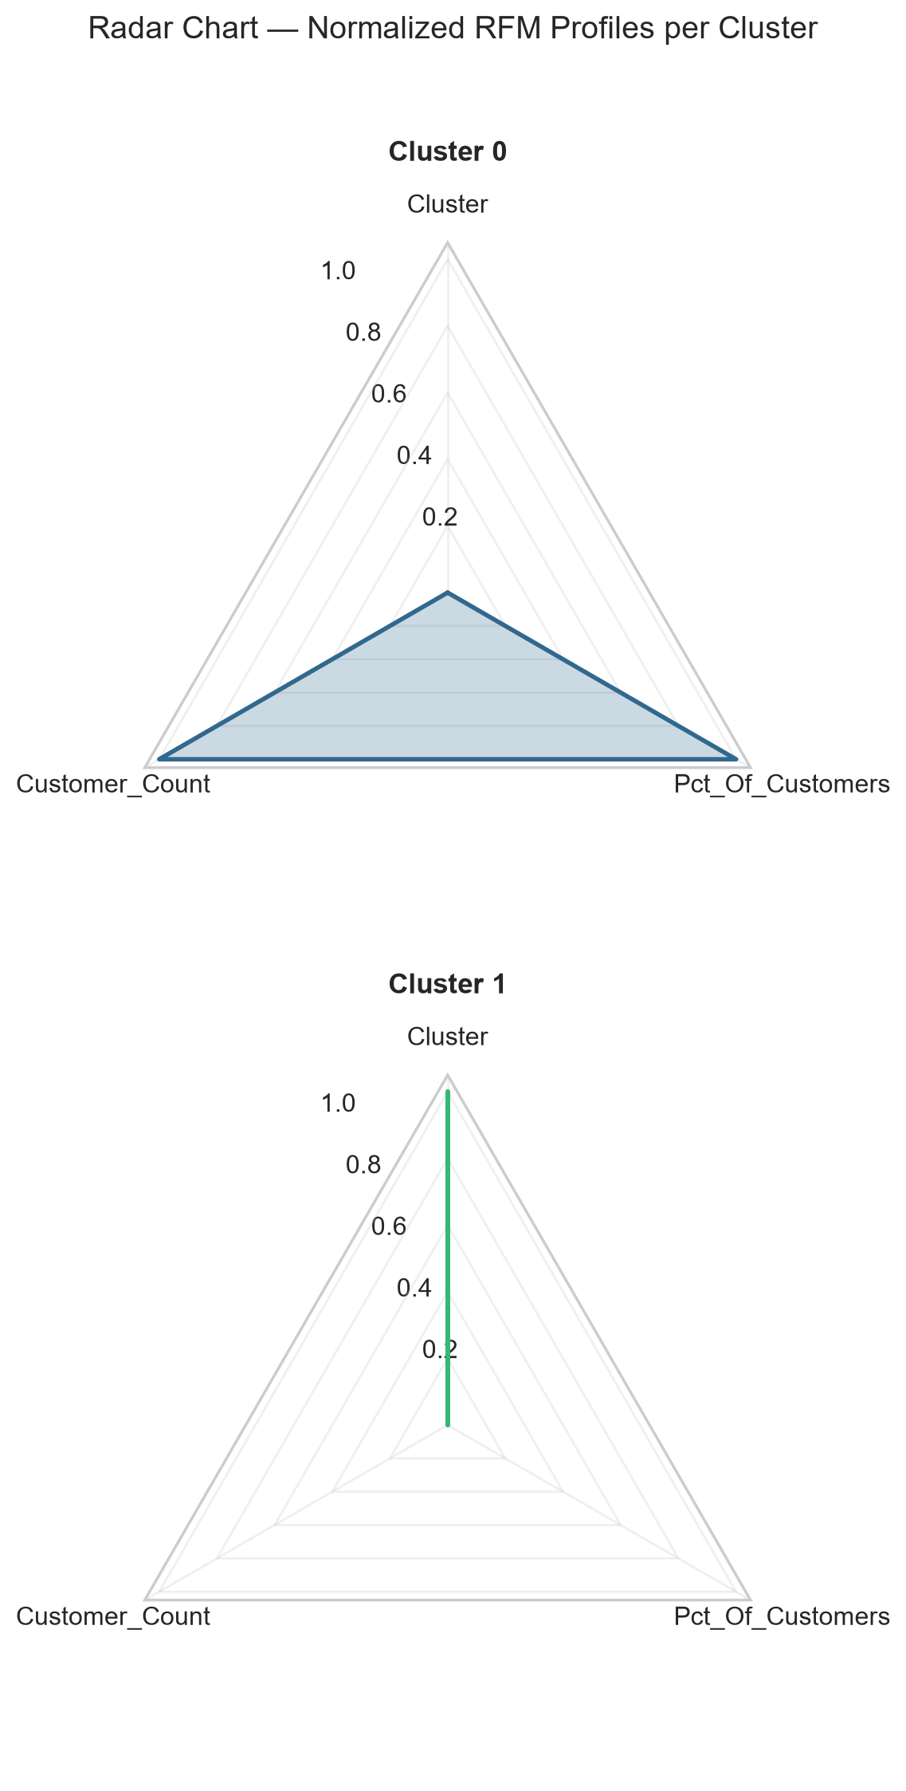
Figure 13.4. Radar chart of scaled cluster profiles across R, F, M dimensions.
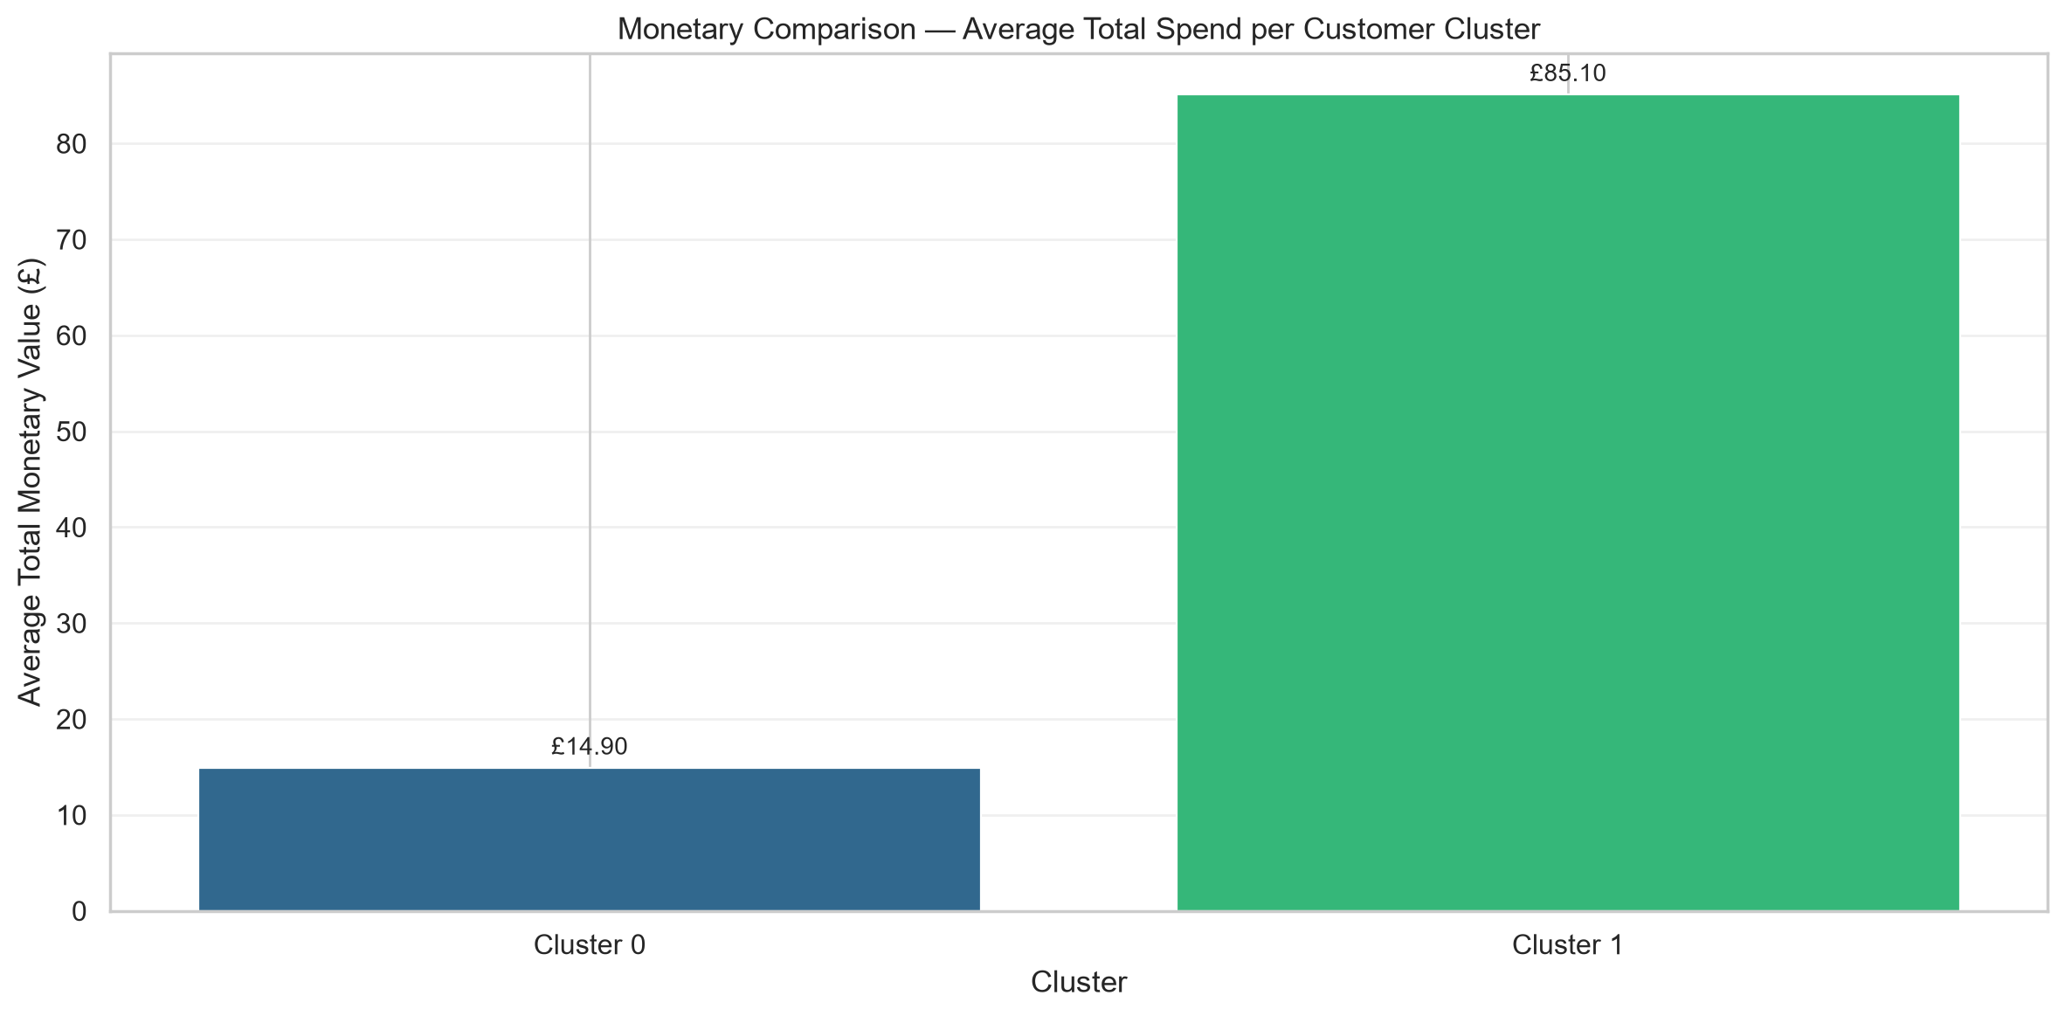
Figure 13.5. Total monetary revenue contribution per cluster.

14. Cluster Profiles
The following profile table aggregates statistics for each of the k = 2 clusters on the original (untransformed) RFM scale. Each row summarises one segment's size, R/F/M central tendency (both mean and median), and revenue contribution.
Table 14.1. Cluster-level descriptive profiles (original RFM scale).
index | cluster | customer_count | pct_of_customers | mean_recency | median_recency | mean_frequency | median_frequency | mean_monetary | median_monetary | total_monetary | pct_of_total_revenue
0 | 0 | 2672 | 61.60 | 134.09 | 96.00 | 1.67 | 1.00 | 495.59 | 363.07 | 1,324,229.69 | 14.90
1 | 1 | 1666 | 38.40 | 25.89 | 16.00 | 8.44 | 6.00 | 4,539.60 | 2,061.08 | 7,562,979.20 | 85.10

Table 14.2. Scaled cluster profiles (z-scores per RFM dimension for cross-feature comparison).
index | cluster | Recency_z | Frequency_z | Monetary_z
0 | 0 | 0.4155 | -0.3379 | -0.1729
1 | 1 | -0.6665 | 0.5420 | 0.2773

15. Interpretation
Each cluster's character is read from its profile statistics (original and scaled) along the three RFM axes. Interpretations below describe the evidence rather than prescribing marketing action labels; no speculative VIP / At-risk / Lost designations are asserted beyond what the numbers directly support.

Cluster 0
Cluster 0: Low-frequency, low-monetary, with relatively stale (old) purchases. Contains 2672 customers (61.6% of all customers), generating total revenue of 1324229.69 (14.9% of total revenue). Mean R/F/M: Recency=134.1d (vs overall 92.5d), Frequency=1.7 orders (vs overall 4.3), Monetary=495.59 (vs overall 2048.69).

Cluster 1
Cluster 1: High-frequency, high-monetary, with relatively recent purchases. Contains 1666 customers (38.4% of all customers), generating total revenue of 7562979.20 (85.1% of total revenue). Mean R/F/M: Recency=25.9d (vs overall 92.5d), Frequency=8.4 orders (vs overall 4.3), Monetary=4539.60 (vs overall 2048.69).

16. Business/Research Implications
The segmentation produced here, grounded in observed RFM behaviour and supported by internal validation metrics, has several evidence-based implications for downstream marketing strategy and further research:
- Segment-specific promotional cadence: clusters characterised by low Recency (recent activity) and high Frequency are likely receptive to loyalty and upsell programmes, while clusters marked by high Recency (dormant) profiles should be targeted with re-engagement campaigns before they churn definitively.
- Revenue-based resource allocation: clusters contributing the largest share of total Monetary value warrant a disproportionate share of retention-marketing resources - losing a single customer from these segments has a larger revenue impact than losing a customer from low-Monetary clusters.
- Offer tailoring: the distinct RFM fingerprints of each cluster imply different offer types will resonate. High-Frequency clusters may respond to subscription or auto-replenishment constructs; low-Frequency but high-Monetary clusters may favour premium product bundles rather than pure price discounts.
- Model monitoring and retraining: because RFM is measured relative to a single temporal cut-off, segments should be re-derived periodically (e.g., quarterly) to track customer migration between clusters over time. Migration matrices are a natural next analytical step.
- Feature expansion: future work could enrich the RFM-only representation with product-category breadth, inter-purchase interval variance, country, or seasonality features, and compare K-Means against density-based (DBSCAN) or hierarchical clustering alternatives for robustness.

17. Limitations
- Missing CustomerID exclusion: transactions with missing CustomerID were dropped entirely. To the degree these represent systematic behaviours (e.g., guest checkout patterns), the final segments only describe the identified-customer population and may not generalise to anonymous traffic.
- Single-retailer scope: the dataset reflects one UK-based online gift/homeware retailer over a specific 13-month window. Industry and country-specific factors limit portability of the exact segment count and shape to other retailers.
- K-Means assumptions: K-Means favours roughly equal-volume, spherical, linearly separable clusters in the feature space. If the true customer manifold is strongly non-spherical or contains density-separated shapes, K-Means may produce arbitrary or suboptimal partitions. This is mitigated - but not eliminated - via log transform and standardisation.
- Single temporal snapshot: RFM is computed relative to one reference date. Seasonal events near the window boundaries (e.g., Christmas in December 2011) can distort Recency estimates, and no cross-temporal validation of cluster stability was performed.
- No causal claims: this is an observational, descriptive clustering. Associations between cluster membership and future behaviour must be validated with controlled marketing experiments or held-out time-split evaluation before being acted upon.

18. Conclusion
This report demonstrated a reproducible RFM + K-Means segmentation pipeline on the UCI Online Retail dataset. Cleaning reduced 541,909 raw rows to 392,692 positive-sales rows with identified customers, from which 4,338 RFM profiles were computed. After log1p stabilisation and standardisation, K-Means with k = 2 (Silhouette = 0.4328) yielded 2 behaviourally distinct segments whose profiles - reported in both original and z-scored form - exhibit systematic variation across Recency, Frequency, and Monetary. The resulting segmentation provides a quantitative, auditable foundation for targeted marketing action, subject to the reproducibility protocol and limitations documented above.

19. Reproducibility
- Random seed = 42 applied globally (numpy, sklearn KMeans random_state parameter).
- RFM reference_date = 2011-12-10, derived deterministically as max(InvoiceDate) + 1 day from the cleaned positive-sales dataset.
- Environment dependencies are enumerated in `requirements.txt` at the project root, pinning pandas, numpy, scikit-learn, matplotlib, seaborn, scipy, openpyxl, and python-docx versions.
- Execution instructions are provided in the project README. In brief: place the raw data file at the path documented in `data/README.md`, install the requirements.txt into a fresh virtual environment, and run `python -m src.main` from the project root. The pipeline will run deterministically and write the same tables, figures, and DOCX report to the `outputs/` and `report/` directories.

20. Code Snippets
The following representative snippets illustrate the core computational steps. The full production code lives under `src/` and is the reference implementation.

20.1 RFM Aggregation
rfm = (
df.groupby("CustomerID")
.agg(
Recency=("InvoiceDate",
lambda x: (reference_date - x.max()).days),
Frequency=("InvoiceNo", "nunique"),
Monetary=("TotalAmount", "sum"),
)
.reset_index()
)

20.2 K-Means Fit
from sklearn.cluster import KMeans
from sklearn.preprocessing import StandardScaler
scaler = StandardScaler()
X_scaled = scaler.fit_transform(X_log)
kmeans = KMeans(
n_clusters=best_k,
random_state=42,
n_init=10,
)
labels = kmeans.fit_predict(X_scaled)
inertia = kmeans.inertia_

20.3 Silhouette and Internal Metric Scoring
from sklearn.metrics import (
silhouette_score,
calinski_harabasz_score,
davies_bouldin_score,
)
silhouette = silhouette_score(X_scaled, labels)
ch_index = calinski_harabasz_score(X_scaled, labels)
db_index = davies_bouldin_score(X_scaled, labels)

20.4 PCA Cluster Visualization
from sklearn.decomposition import PCA
pca = PCA(n_components=2, random_state=42)
X_pca = pca.fit_transform(X_scaled)
plt.scatter(X_pca[:, 0], X_pca[:, 1],
c=labels, cmap="tab10", s=14, alpha=0.7)
plt.xlabel(f"PC1 ({pca.explained_variance_ratio_[0]:.1%})")
plt.ylabel(f"PC2 ({pca.explained_variance_ratio_[1]:.1%})")
plt.title("Clusters projected onto first two PCs")

20.5 Log1p Transform and Standardization
import numpy as np
from sklearn.preprocessing import StandardScaler
use_log_columns = ["Recency", "Frequency", "Monetary"]
X_log = np.log1p(rfm_df[use_log_columns])
scaler = StandardScaler()
X_scaled = scaler.fit_transform(X_log)

21. References
- Chen, D.-Y., Sain, S. L., & Guo, K. (2012). Data mining for the online retail industry: A case study of RFM model-based customer segmentation using data mining. Journal of Database Marketing & Customer Strategy Management, 19(3), 197-208. https://doi.org/10.1057/dbm.2012.17
- Dua, D., & Graff, C. (2019). UCI Machine Learning Repository [Online Retail Data Set]. University of California, Irvine, School of Information and Computer Science. https://archive.ics.uci.edu/ml/datasets/Online+Retail
- Pedregosa, F., Varoquaux, G., Gramfort, A., Michel, V., Thirion, B., Grisel, O., Blondel, M., Prettenhofer, P., Weiss, R., Dubourg, V., Vanderplas, J., Passos, A., Cournapeau, D., Brucher, M., Perrot, M., & Duchesnay, E. (2011). Scikit-learn: Machine Learning in Python. Journal of Machine Learning Research, 12, 2825-2830. https://jmlr.csail.mit.edu/papers/v12/pedregosa11a.html
- scikit-learn Developers. K-Means Clustering - scikit-learn 1.x Documentation. https://scikit-learn.org/stable/modules/clustering.html#k-means
- scikit-learn Developers. Silhouette Score - scikit-learn 1.x Documentation. https://scikit-learn.org/stable/modules/generated/sklearn.metrics.silhouette_score.html
- scikit-learn Developers. Calinski-Harabasz Index - scikit-learn 1.x Documentation. https://scikit-learn.org/stable/modules/generated/sklearn.metrics.calinski_harabasz_score.html
- scikit-learn Developers. Davies-Bouldin Index - scikit-learn 1.x Documentation. https://scikit-learn.org/stable/modules/generated/sklearn.metrics.davies_bouldin_score.html

