Oz’s InstaBot: Readme

First of all, I’d like to say thank you for buying my InstaBot. I hope it will help you with your Instagram marketing skills. If ever you face any bugs/issues, I’ll gladly fix it for you. Just drop me an email at: [ozeuthgatum@gmail.com](mailto:ozeuthgatum@gmail.com) I will get back to you in 3 working days.

Features

1. Auto-Liking  
The InstaBot allows you to like up to 500 photos a day. This is done in real-time on a Google driver, so you can watch the photos being viewed and liked as if it was a slideshow!  
  
2. Auto-Commenting  
The InstaBot allows you to comment on 100 photos a day. You can choose what comments you want to write, and even craft your own list of comments for specific scenarios. This will be elaborated on later.  
  
3. Auto-Following  
The InstaBot allows you to follow up to 100 people a day.  
  
4. Works for Multiple Accounts  
You can of course, use this with as many accounts as you want. Each account will have the same daily limits.  
  
5. Low Risk of Detection  
I have made this Bot as undetectable as possible. For example, while the daily like limit is 500, I have liked up to 1200 photos for a test before getting temporarily banned.   
  
6. Private  
Your account is yours and yours alone: All your data is stored locally on your computer, and your passwords are not saved.

Setting Up

Simply unzip the file and put it in any location. You should have the following files:

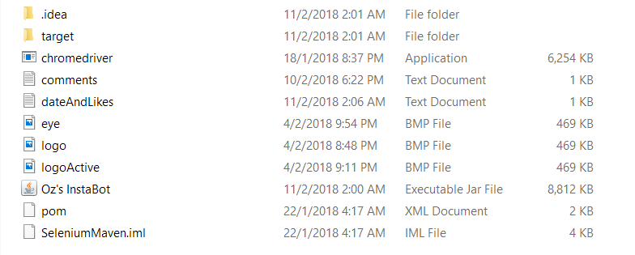

How to Use

Liking

1. Click the executable file called “Oz’s InstaBot”.
2. Enter your Instagram username and password.
3. Enter the tags for images you want the bot to like. If there is more than one tag, separate them with commas.
4. Tick the LIKE box.

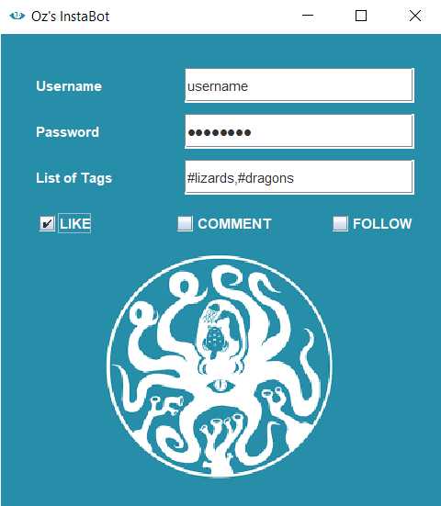

Commenting

First you need to set up what kind of comments you wish your bots to post.

1. Click the text file called “comments”. It will look as such on NotePad:
2. 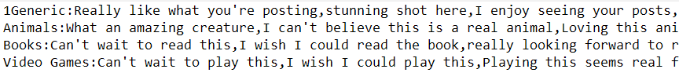Several premade lists have been added for you. To select the one you want, delete the ‘1’ in front of “Generic: ….” And put the 1 in front of that list.
3. You can add/edit that list’s comments. Separate the comments using commas.  
   NOTE: Do not create a new line by hitting Enter, instead add onto existing lines.

NOTE: Instagram will stop you from commenting if the bot repeats the same comment too many times. To avoid this, have at least 15 comments your list

1. You can add your own custom lists. Create a new list at the bottom. Below is an example of an added Movies list. It has been selected via the “1” in front.

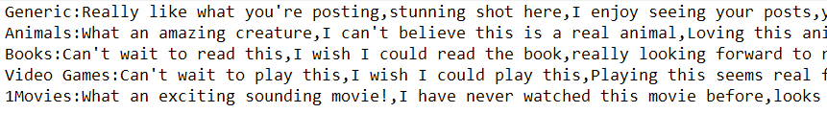

Then we can start commenting.

1. Click the executable file called “Oz’s InstaBot”.
2. Enter your Instagram username and password.
3. Enter the tags for images you want the bot to comment on. If there is more than one tag, separate them with commas.
4. Tick the COMMENT box.

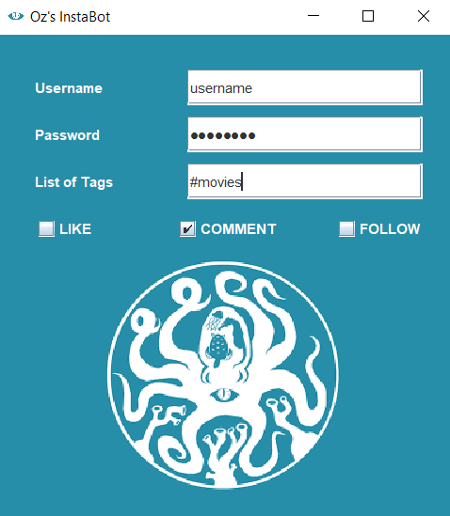

Following

1. Click the executable file called “Oz’s InstaBot”.
2. Enter your Instagram username and password.
3. Enter the tags for images for which the users you want the bot to follow. If there is more than one tag, separate them with commas.
4. Tick the FOLLOW box.

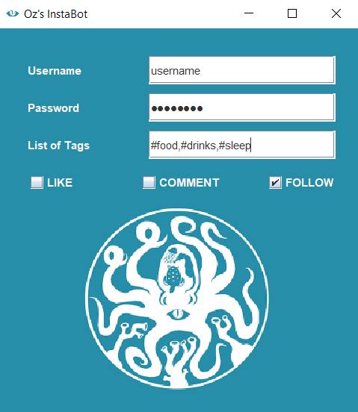

FAQ

* My bot gets stuck on “Get the Instagram App” page

This is intentional as not everyone gets this webpage. Simply click “Not Now” and the automation will resume.

* My bot tells me “File not found”/ “Comment File not found”

You have deleted/renamed crucial text files. Simply drop me an email and I will send you the original files again.

* My bot tells me that a daily limit is reached

You have liked/commented/followed the maximum amount that I believe is safe a day. Come back tomorrow and these limits will have reset.

* My bot crashes when it tries to comment

It is likely you have tweaked the files in such a way that, (A) you did not put “1” in front of your selected list in the comment file (B) you did not put a “:” behind the list’s title. Remember, the exact template for a list you want should be:  
1NAME_OF_FILE:comment1,comment2,comment3…

* How do I further reduce the risk of getting banned?  
  While I try and make the InstaBot one of the safest on the market, there is no foolproof solution to avoid detection by Instagram. Here are some methods.  
  1. A good way would be to not leave the InstaBot on for more than half hr at a go.  
  2. Have at least a couple of posts of your own before botting. This makes you seem less like a bot.  
  3. Do not like/comment/follow excessively outside of running the InstaBot.

4. Monitor your bots activities. Before any actual banning occurs, Instagram will warn you that it is uncomfortable with your level of activity by unliking/ uncomenting/ unfollowing your last few actions. If you see this, stop the bot and you will avoid incurring penalities  
  
NOTE: new accounts are under more stringent checks that older accounts, and accounts that normally post less will be under more stringent checks than those that regularly post more. Tweak the tips accordingly.

* What to do in the event I get banned  
  If you have not tweaked the base code and have followed the tips provided, it is unlikely you will be detected by Instagram. However, in the slim chance that you do:  
  1. Don’t panic! Chances are it is just a temporary bans. Temporary bans are usually lifted between 2 hours to 2 days.  
  2. Avoid using the InstaBot for the next few weeks. Post like a regular user til then.
* I am still having issues/ I would like to give feedback  
  Drop me an email and I will come sort it out for you. My email is: [ozeuthgatum@gmail.com](mailto:ozeuthgatum@gmail.com)

Happy Botting!