OSTIM TECHNICAL UNIVERSITY FACULTY OF ENGINEERING CAPSTONE PROJECT REPORT

Prolance: A Cross-Platform Freelance Marketplace with Escrow-Backed Contracts, Supabase-Backed Data Plane, and Dual Web Surfaces (Flutter · Android / iOS / Web · Next.js)
Design and Implementation of a Demo-Ready Monorepo Linking a Flutter Client, a Next.js Marketing and Employer Portal, and Managed PostgreSQL with Row-Level Security

Project Team
[Student Name Surname] ([Student Number])
[Student Name Surname] ([Student Number])
[Student Name Surname] ([Student Number])

Project Advisor
Prof. Dr. [Advisor Name Surname]

Undergraduate Project — Department of Computer Engineering — MFBP 402(1) Graduation Project II
February 2026

APPROVAL

This undergraduate capstone project, entitled “Prolance: A Cross-Platform Freelance Marketplace with Escrow-Backed Contracts, Supabase-Backed Data Plane, and Dual Web Surfaces”, prepared by the project team listed on the title page, has been examined and is accepted as a capstone project report in partial fulfilment of the requirements for the Bachelor of Science degree in Computer Engineering.

Supervisor
[Name Surname]

Member
[Name Surname]

Member
[Name Surname]

Head of Department
[Name Surname]

ACKNOWLEDGEMENTS

This report documents the analysis, design, implementation, and verification of the Prolance platform: a monorepository that couples a Flutter client for job discovery, proposals, messaging, and escrow-aware contract progression with a Supabase project (PostgreSQL, Auth, Storage, RPC) and a Next.js surface for marketing, authentication, and an employer-facing portal including dispute review for administrators.
The implementation extends an initial UI-centric prototype into a working vertical slice: authenticated profiles, job postings, proposal lifecycles, private deliverable storage, signed download links, and server-side transitions that keep financial state consistent with row-level security policies.
We thank the project advisor for structured feedback on architecture and risk management, and peers who participated in exploratory testing on web builds and mobile emulators.

Prolance Team — February 2026
Ankara

ÖZET
Serbest çalışan pazar yerlerinde güven eksikliği, ödeme anlaşmazlıkları ve dağınık iletişim kanalları işveren ile freelancer arasında sürtünme yaratır. Bu çalışma, Prolance adlı çapraz platform uygulamasını tasarlayarak bu sürtünmeyi azaltmayı hedefler: Flutter istemcisi iş ilanlarını keşfetme, teklif verme, mesajlaşma ve teslimat dosyalarını güvenli depoda toplama akışlarını sunar; Supabase tarafında Postgres üzerinde satır düzeyi güvenlik, RPC ile yaşam döngüsü geçişleri ve özel depolama ile teslim dosyalarının yalnızca taraflarca okunması sağlanır. Next.js ile pazarlama ve portal yüzeyleri birleştirilir; yönetici paneli anlaşmazlık incelemeleri için ek ekranlar içerir. Çalışma, Agile sprint düzeni, risk kaydı ve otomatikleştirilmiş testlerle desteklenen bir mühendislik sürecini belgeler.
Anahtar kelimeler: serbest çalışma platformu, Flutter, Supabase, satır düzeyi güvenlik, emanet ödeme, Next.js, portal, teslimat yaşam döngüsü.

ABSTRACT

Freelance marketplaces must combine discoverability, negotiation, and post-award execution with trust mechanisms that survive partial failures and malicious clients. Prolance implements a pragmatic slice of this problem space: employers publish jobs, freelancers submit proposals, employers accept proposals to create escrow-backed records, freelancers upload deliverables to a private bucket, and employers review downloads before releasing funds into a timed payout window with an explicit dispute path for administrators.
Keywords: freelance marketplace, Flutter, Supabase, row-level security, escrow, Next.js, employer portal, deliverable lifecycle.

TABLE OF CONTENTS

Introduction ......................................................... 3
Problem Definition ................................................... 5
Project Planning and Management ...................................... 7
System Analysis ...................................................... 9
System Design ......................................................... 12
Implementation ...................................................... 15
Testing ............................................................. 18
Working Product and MVP .............................................. 20
Conclusion and Future Work ........................................... 22
References ........................................................... 23
Appendices ........................................................... 24

LIST OF FIGURES

Figure 1 — System context (high level)
Figure 2 — Layered architecture
Figure 3 — Contract / escrow lifecycle (simplified)

LIST OF TABLES

Table 2.1 — Limitations of informal hiring channels (comparative)
Table 2.2 — Target personas (client, freelancer, admin)
Table 4.1 — Functional requirements (summary)
Table 4.2 — Non-functional requirements (summary)
Table 5.1 — Core relational tables (summary)
Table 8.1 — Working product capability matrix

ABBREVIATIONS

Abbreviation | Meaning
RLS | Row-Level Security (PostgreSQL)
RPC | Remote procedure call exposed via Supabase
JWT | JSON Web Token used by Supabase Auth
MVP | Minimum viable product / demo-ready slice
FR / NFR | Functional / non-functional requirement

Introduction

Purpose and Scope
The purpose of this document is to present the engineering rationale, architecture, and verification evidence for Prolance, following the reporting conventions and section ordering of the faculty capstone template. Scope is intentionally bounded to the shipped monorepo: `client/` Flutter application, `web/` Next.js application, and `supabase/` schema, policies, and migrations that power the hosted demo project.

Motivation
Informal freelance hiring fragments negotiation across chat applications, e-mail, and generic file sharing. Payment disputes are difficult to adjudicate without an auditable state machine and consistent access control to deliverables. Prolance concentrates post-award execution inside a database-backed lifecycle with explicit phases and server-side transitions, reducing ambiguity for both parties.

Structure of the Report
Section 2 defines the problem and personas. Section 3 summarises planning, tooling, and risks. Section 4 captures analysis artefacts (requirements and context). Section 5 presents design views including data modelling. Section 6 details implementation surfaces. Section 7 outlines testing. Section 8 demonstrates the working product path. Section 9 concludes with lessons and future work.

Problem Definition

Sectoral Background
Digital talent marketplaces span general-purpose gig platforms and vertical specialist networks. Employers seek predictable delivery checkpoints; freelancers seek payment assurance and dispute visibility. Regulatory and tax treatment varies by jurisdiction; this project adopts a demonstrative escrow model suitable for academic evaluation rather than production financial compliance.

Deficiencies of Existing Systems
Table 2.1 — Limitations of informal hiring channels (comparative)
Channel / pattern | Typical limitation
Chat-only coordination | No authoritative lifecycle; ambiguous “done” state.
Ad-hoc file links | No least-privilege read model; revocable access is manual.
Informal milestone payments | Disagreements lack structured dispute metadata.

Target User Profiles
Table 2.2 — Target personas (client, freelancer, admin)
Persona | Goals | Pain points
Employer (client) | Publish jobs, compare bids, fund escrow, review files | Trust, clarity on acceptance criteria, payout timing
Freelancer | Discover work, submit proposals, upload deliverables | Payment assurance, scope creep, fragmented tooling
Administrator | Resolve disputes, audit escalations | Needs structured case notes and reproducible actions

Project Goals and Success Criteria
Success is defined as a reproducible demo: two authenticated roles can progress a single job from proposal acceptance through deliverable review and timed payout simulation, with storage access enforced by policy rather than client-side checks alone.

Project Planning and Management

Method: Agile and Sprint Planning
Work was organised in short iterations with a prioritised backlog: schema and RLS foundations first, followed by Flutter repository integration, then portal routes for employers, and finally admin dispute UX.

Team Structure and Roles
Table 3.1 — Team members and areas of responsibility (fill names)
Role | Responsibilities (illustrative)
Mobile / Flutter | Routing, state, repositories, PDF and media UX
Backend / Supabase | Migrations, RPC, policies, storage buckets
Web / Next.js | Portal contracts, admin disputes, server actions

Version Control and Workflow
The repository is hosted on GitHub (`OzgurBuyukikiz01/Prolance_Freelance_App`). Feature branches and pull requests keep migrations reviewable; Supabase changes are applied with versioned SQL files under `supabase/migrations/`.

Risk Management
Table 3.3 — Risk register (abridged)
Risk | Mitigation
RLS misconfiguration leaks rows | Policy tests in SQL; least privilege by default
Large binary assets in Git | Deliverables only in Supabase Storage
Web / mobile skew | Shared Supabase contract as single source of truth

System Analysis

Actors and System Boundaries
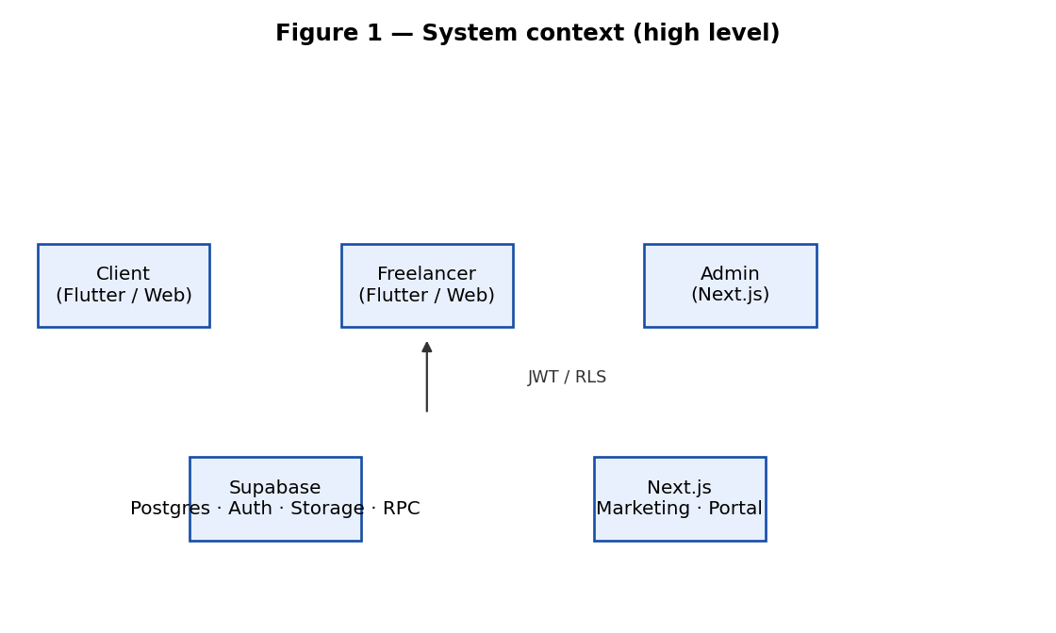
Figure 1 — System context (high level)

Functional Requirements
Table 4.1 — Functional requirements (summary)
ID | Requirement (summary)
FR-1 | Users authenticate via Supabase Auth to access protected views.
FR-2 | Employers create and list jobs; freelancers browse and apply.
FR-3 | Employers accept proposals; system creates escrow transaction rows.
FR-4 | Freelancers register deliverables; employers download via signed URLs.
FR-5 | Employers accept or decline delivery; lifecycle advances server-side.
FR-6 | Administrators review disputes with auditable notes (portal).

Non-Functional Requirements
Table 4.2 — Non-functional requirements (summary)
ID | Requirement (summary)
NFR-1 | Security: RLS on proposals, jobs, messages, and storage policies.
NFR-2 | Maintainability: typed Next.js server actions; Dart repositories.
NFR-3 | Operability: Makefile targets for local dev and deploy docs.

Context Diagram
Figure 1 situates the Flutter client and Next.js surfaces against Supabase-managed persistence. External actors are end users; the database enforces participation constraints on reads and writes.

System Design

High-Level Architecture
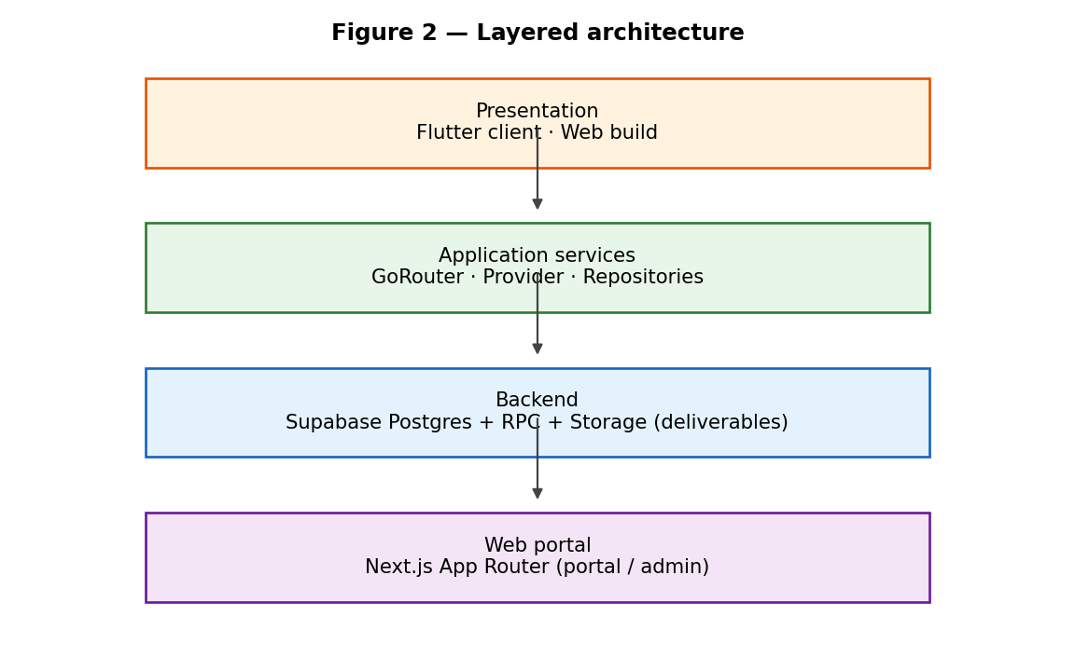
Figure 2 — Layered architecture

Database Design
Table 5.1 — Core relational tables (summary)
Table / area | Role
profiles | User attributes, balances, admin flag
jobs | Listings with client ownership
proposals | Bid, status, lifecycle_phase, escrow-related fields
proposal_deliveries | File metadata and storage paths
escrow_transactions | Held / released / disputed states
messages / conversations | Threaded chat between participants

Authentication and Authorization
Authentication is delegated to Supabase. Authorisation combines Postgres RLS policies with RPC entry points that validate actor roles (freelancer vs job owner) before mutating lifecycle columns.

API Design
The mobile client primarily uses Supabase client libraries for CRUD and `rpc(...)` for guarded transitions (for example client delivery review and freelancer submission confirmation). The portal uses Next.js server actions with the service role only where strictly necessary, documented in repository guidelines.

User Interface Design
Flutter uses a shared theme with component-level spacing; the portal adopts a shell layout with contextual navigation for contracts and disputes. Screenshots can be pasted in a later revision without altering logo assets embedded from the original template cover.

Implementation

Technology Stack
Table 6.1 — Technology stack
Layer | Technologies
Client | Flutter 3.x, Provider, go_router, Supabase Flutter SDK
Web | Next.js App Router, TypeScript, Tailwind patterns as in repo
Backend | Supabase Postgres, Auth, Storage, SQL migrations, RPC
Tooling | GitHub Actions (if enabled), Makefile, Vercel deploy docs

Mobile Application Modules
Key modules include `ProposalRepository` (remote sync, deliverable upload, signed URLs), messaging repositories, jobs provider, onboarding and profile flows, and escrow-related UI on proposal detail and delivery review routes.

Cloud Functions and Notification Pipeline
Server-side logic is expressed as SQL functions where possible, keeping orchestration close to data. Push notification hooks may be extended; the current MVP emphasises data integrity and portal workflows.

Escrow and Delivery Lifecycle
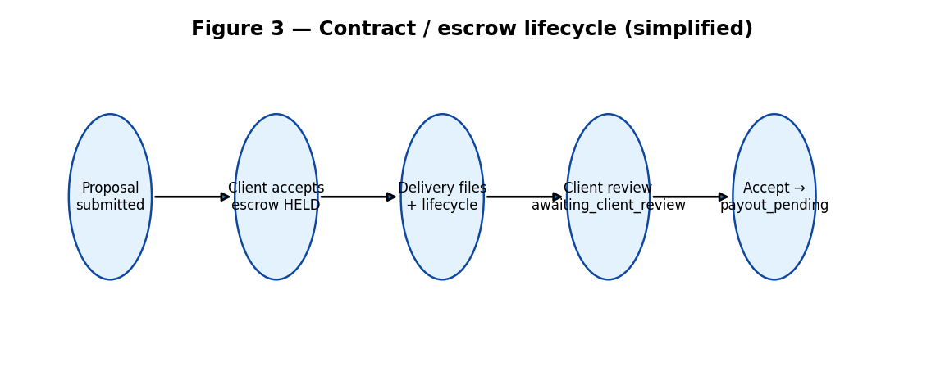
Figure 3 — Contract / escrow lifecycle (simplified)

DevOps, Build and Distribution
The README documents `make` targets; Flutter web builds integrate with deployment documentation under `DEPLOY.md`. Environment variables for Supabase keys are excluded from version control per `.gitignore`.

Testing

Test Strategy
Testing mixes automated unit coverage for repository logic with manual two-device demo passes documented in `DEMO_NOTES.md`, including timed payout simulation controls.

Unit and Integration Tests
Dart tests under `client/test/` validate selected repository behaviours; additional integration tests can target Supabase with ephemeral databases in CI when secrets are available.

User Acceptance Tests
Acceptance scenarios mirror employer and freelancer journeys on web and mobile, verifying that lifecycle labels, Turkish UI strings where applicable, and download links behave consistently after refresh.

Working Product and MVP

Demo Scenario — End-to-End Flow
The repository ships `DEMO_NOTES.md` with credential tables and a two-device walkthrough: client accepts a proposal to fund escrow, freelancer submits delivery, client accepts delivery to enter payout window, and demo controls advance the clock for presentation purposes.

Working Product Capabilities
Table 8.1 — Working product capability matrix
Capability | Status (MVP)
Job posting and discovery | Implemented
Proposal submit / accept | Implemented
Private deliverable storage + signed download | Implemented
Lifecycle RPCs for delivery review | Implemented
Admin dispute resolution UI | Implemented (portal)

Conclusion and Future Work

Overall Evaluation
The project demonstrates that a small team can converge a credible marketplace slice by anchoring trust mechanisms in the database and keeping clients thin. The remaining gap is production hardening: payments compliance, observability, and richer notification channels.

Lessons Learned
Early investment in migrations and RLS reduces rework; keeping demo credentials and repair SQL documented accelerates onboarding for evaluators.

Future Work
Planned extensions include real payment provider integration, automated CI against a disposable Supabase branch, mobile push parity, and deeper analytics on proposal quality.

References
Flutter documentation — https://docs.flutter.dev/
Supabase documentation — https://supabase.com/docs
Next.js documentation — https://nextjs.org/docs
OWASP ASVS (overview) — https://owasp.org/www-project-application-security-verification-standard/
PostgreSQL Row Security Policies — https://www.postgresql.org/docs/current/ddl-rowsecurity.html

Appendix A — GitHub and Project Management Links
Repository: https://github.com/OzgurBuyukikiz01/Prolance_Freelance_App

Appendix B — Installation and Run Instructions
See repository `README.md`: `cd client && flutter pub get && flutter run`; `cd web && npm install && npm run dev`; Supabase project ref documented in README for hosted demo alignment.

Appendix C — Development Tools Used
Visual Studio Code / Cursor, Flutter SDK, Node.js LTS, Supabase CLI (optional), Git, GitHub, Chrome device emulation for Flutter web.

