

**CS 319 - Object-Oriented Software Engineering**

**Final Report**

**Punch For Glory**

**Group 1-C**

Taner Baygün

Özgür Can Erdoğan

Saba Betigül Şahinkaya

Ömer Berk Uçar

INTRODUCTION

“Punch for Glory” is a turn based strategy (TBS) game which concept is boxing. More

generally, TBS games’ concepts are war and players should develop different strategies to win

these games. Another striking point about these games is that main purpose of TBS games is

beat all opponents and face with BOOS at the last(final) stage and beat it too.

In some cases, “Punch for Glory” is differ than other TBS games. As it was mentioned above,

although most of TBS games’ concepts are war, this TBS game focus on boxing.

“Punch for Glory” aims to amuse users while playing with user-friendly graphical user interface

which reduce the complexity of the game. Additionally, it also aims to entertain players with

different difficult levels and some power-ups. Opponent boxers’ levels are low at the beginning

of the game. These levels increase with player’s position in the league.

GUI and Functionality

Our graphical user interface functionality does not change much which we mentioned design

report. In some cases, appearance is changed in the development process. We provided

functionalities with some private methods. As it was mentioned design report, there are several

places in the game and these are seen on the map. Player work and earn money in his/her work

place and spend money to buy new items. He/she buy these item from shop. However, there is

a restriction about buying new items. Player has no more than 3 item while playing. Player can

sell items if he/she want to buy new one. Items can be used arena or street fight according to

their usability. Player also use home to maximize his energy and gym to earn new skills.

How to Play

Game starts with the main menu window. Players can enter the game, may get info about the game, create their own preferences about the game from settings button or see who created it.

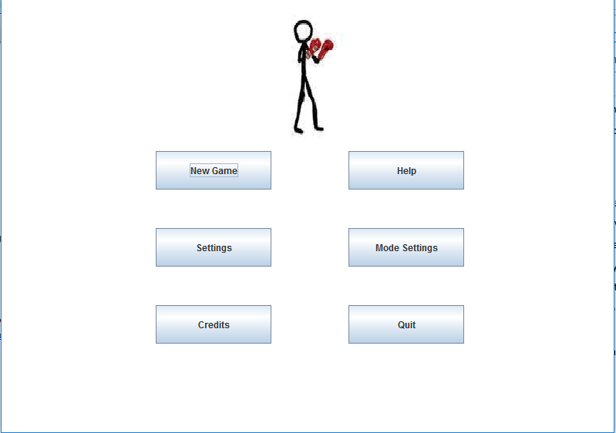

If the player prefers to start the game, the “New Game” button takes player to the main map of our game, which there are several marked-up locations like “Gym”, “Street Arena” (for illegal fights), an “Arena”( for legal matches), a “Shop”, where you can buy fighting items or players own “Home”. Players only need to click on the icon of the location they want to visit.

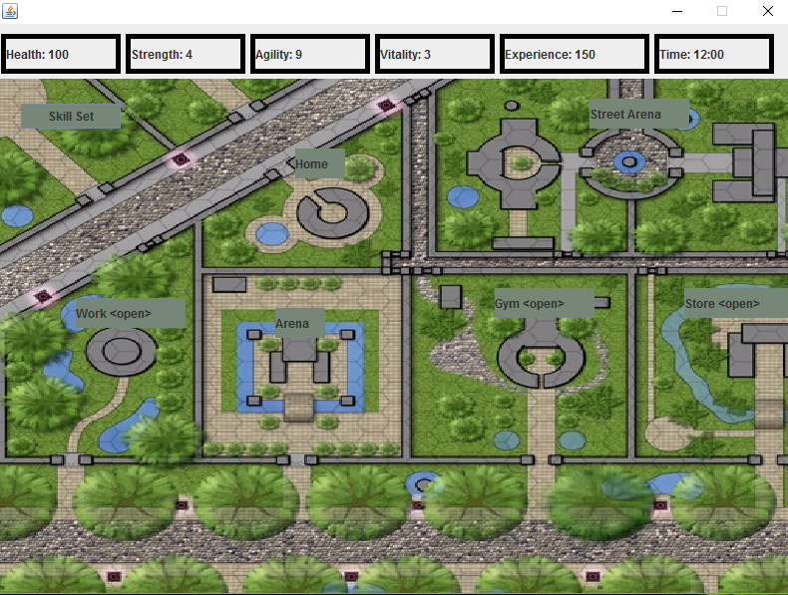

**Home**: This location is for he replenish of players energy. The visit of this place uses up a few hours of game-time to store the needed energy.

**Gym:** Every fighter needs to train to get better, so our boxer needs to train in a gym as well. In the gym, our boxer can pump up is Strength, Vitality and Agility along with the experience points.

**Work**: Our boxer should earn money to pay for rents and the gym. The money earned from fights will not be enough for all expenses, so this option is necessary.

**Arena**: Legal fights are organized here and they have fixed dates for fights. Our boxer should attend these fight in order to win the game by becoming the champion.

**Street Arena**: Unlike the Arena, Street Arena is for earning extra money end experience from illegal fights. Player will not be affected from the consequences of these fights. (Like “Game Over”)

**Store:** Player can buy fighting items from the store that can increase boxer’s attributes (i.e. knife, stick, knuckle)

**Skill Set:** Player can control skill set in this place.

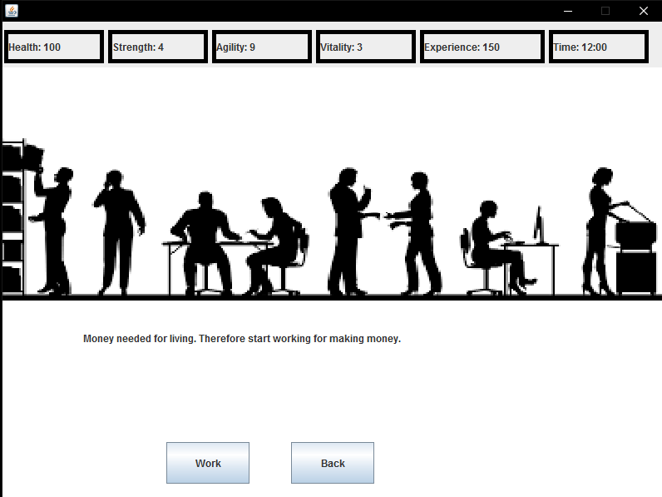

First of all, player can go to “Work”. In this place, if player selects “work” button boxer earns money and spends money on fighting items and rent. After work time, the game automatically returns player from “work” to main map. There is a second option, which is “back” button. Clicking back button also returns player to main map. Additionally, outside official working hours, (like at 4 am) boxer cannot work.

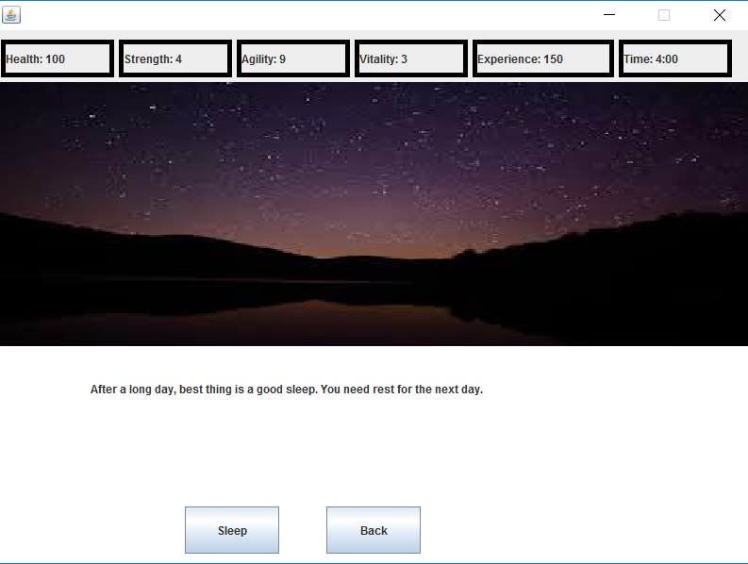

Secondly, player should select home to rest and replenish health. As same as “work, there are two buttons. If player clicks “sleep” button, character’s health replenishes and returns to main map. If player clicks “back” button game returns him to main map to select another location.

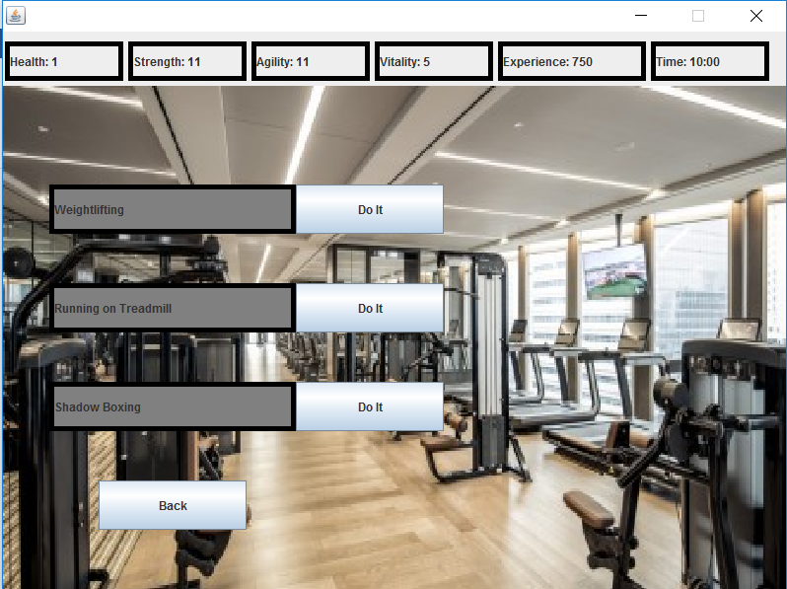

Third place is gym. In this location, player can increase boxer’s strength, agility and vitality. These features are necessary while fighting. As it can be seen above, there are three buttons. Weightlifting increases the Strength while Treadmill increases the Vitality and Shadow Boxing increases Agility.

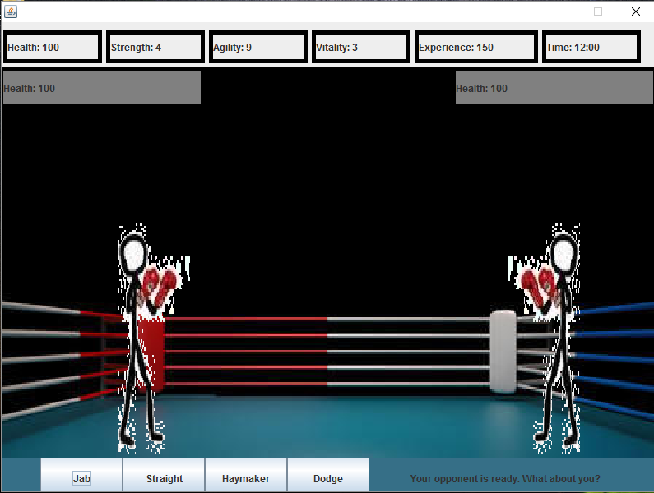

When player clicks Arena, this frame appears as fighting scene. In Arena, our boxer fights with all fighting items available in inventory. Boxer’s health may decrease while this activity.

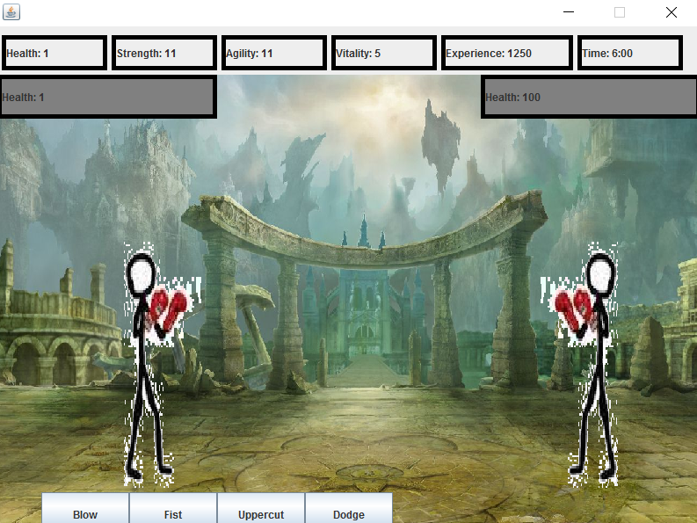

Street is also a fighting place, however it is different than Arena. Boxer fights here illegally and items are changed according to illegal fighting. Fighting Dynamics does not change at all.

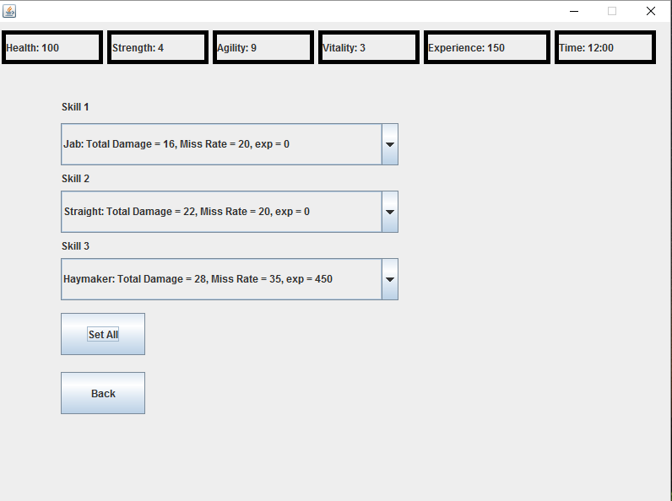

Player can set boxer’s skill in this place. There are three types of skill and that can be controlled by players. If player click “Set All” button, skills are set by player. “Back” button returns player to the main map.

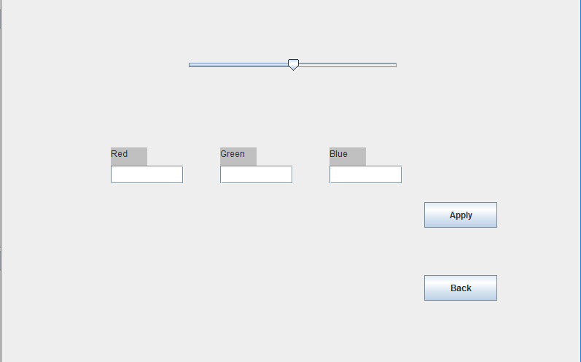

Player can change color theme in the settings. For selecting color, there are three textboxes which are red, green and blue. Player can enter an integer from 0 up to 255 to select color scheme. Apply button is to finalize the selection.

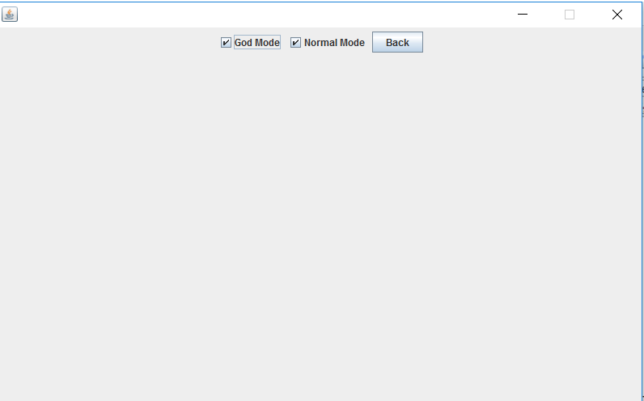

Another button is mode which provides player to select mode before playing the game. There are two modes which are “god mode” and “normal mode”. In god mode, player has only one chance to fight a round. On loose, player returns to main map to continue game. In normal mode, player have two chances for a round in arena. Like the god mode, if player loose the fight, the main map appears.

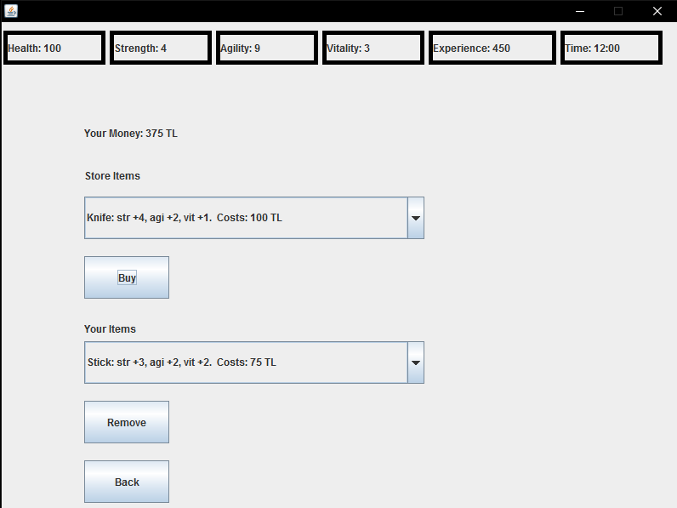

In the store, player can buy fighting items for the boxer to use in Arena. In order to buy items, boxer needs to earn money through work and fights. There are many different items but the boxer can only hold three items at a time. If player wants to add the fourth, one item should be dropped.

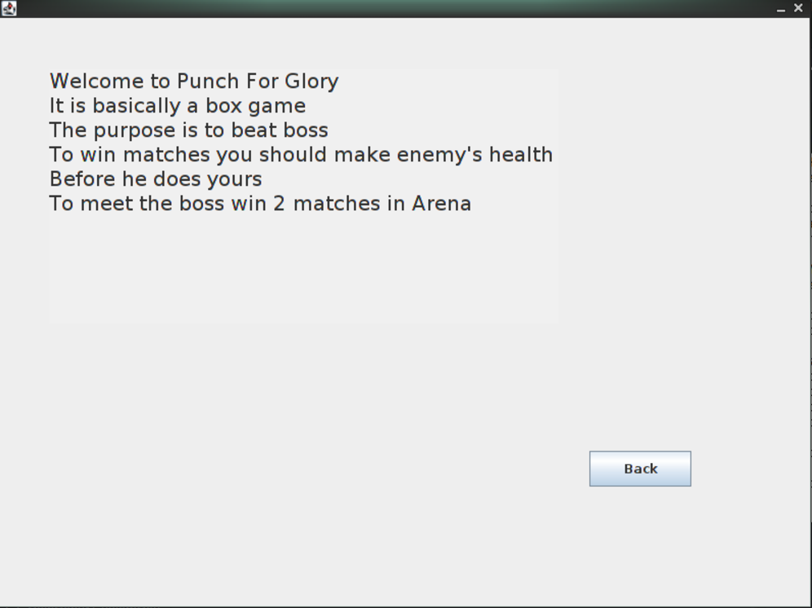

Player can go help page from main menu with click “Help” button. This page shows how the game can play and what are the rules of the game. If player clicks “Back” button game returns player to main page and player can also choose other buttons to go other pages.

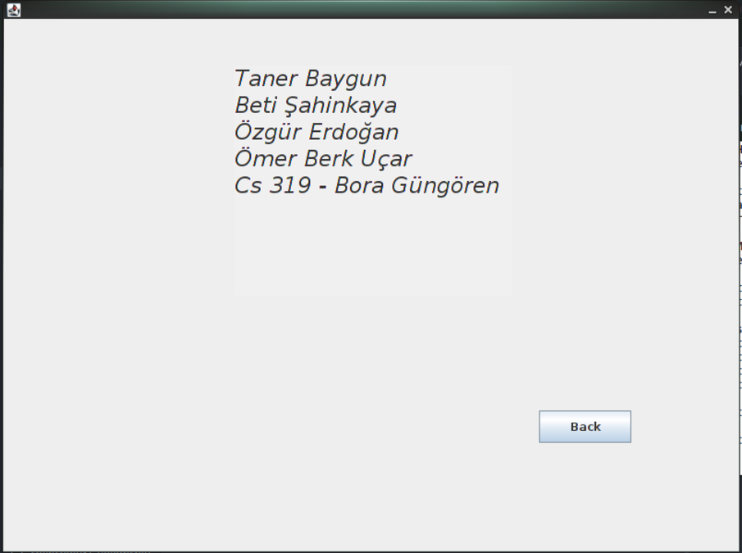

In credits page, player can see the information about developers. Additionally, like as other pages if player clicks “Back” button main page will come up.

Unimplemented Part

We were planning to add music which was related to our game. However, we have not enough time to add this attribute. Secondly, boxer’s color does not change. We mentioned it our past reports bur we could not implement it. Thirdly, we planned to change inventory colors according to skill of boxer. This implementation also cannot be achieved.

**References:**

* <https://www.oracle.com/tr/index.html>

**Internet sites that we use for graphics:**

* <http://www.fourseasons.com/seoul/services_and_amenities/fitness_facilities/gym/>
* <https://www.123rf.com/stock-photo/boxing_ring.html>
* <http://dreamatico.com/night.html>
* <http://www.floridamedicareexperts.com/blog/working-and-turning-65.aspx>
* <https://www.iapps4you.com/iphone_ipad_apps/580551_stickman_boxer.html>