SYSTEM BLUEPRINT
MEMBRANE.AI
End-to-End Flow · Software Architecture & Design
the whole system at a glance
Real-time security and architectural guardrails for AI coding agents

The Story — Life of an AI-Assisted Code Change
Follow a single change as it travels through MEMBRANE.AI — from the moment a developer prompts an AI agent, through proactive interception and layered analysis, to the enforced merge gate and a tamper-proof audit trail. Governance happens at the point of generation and again before merge, so insecure or off-pattern code is prevented early and verified again at the gate.
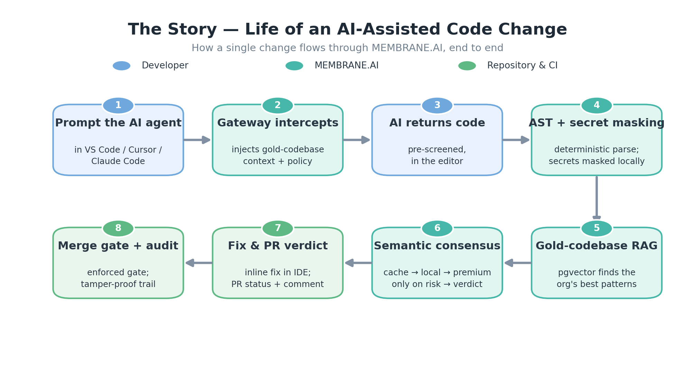
The Story — life of an AI-assisted code change.

Software Architecture — Layered Component View
A decoupled, event-driven design: a proactive gateway and post-commit hooks feed a durable event backbone; a Go analysis pipeline coordinates deterministic and semantic checks; Redis and Aurora hold hot and durable state; and a remediation daemon returns verdicts to the developer and the pipeline.
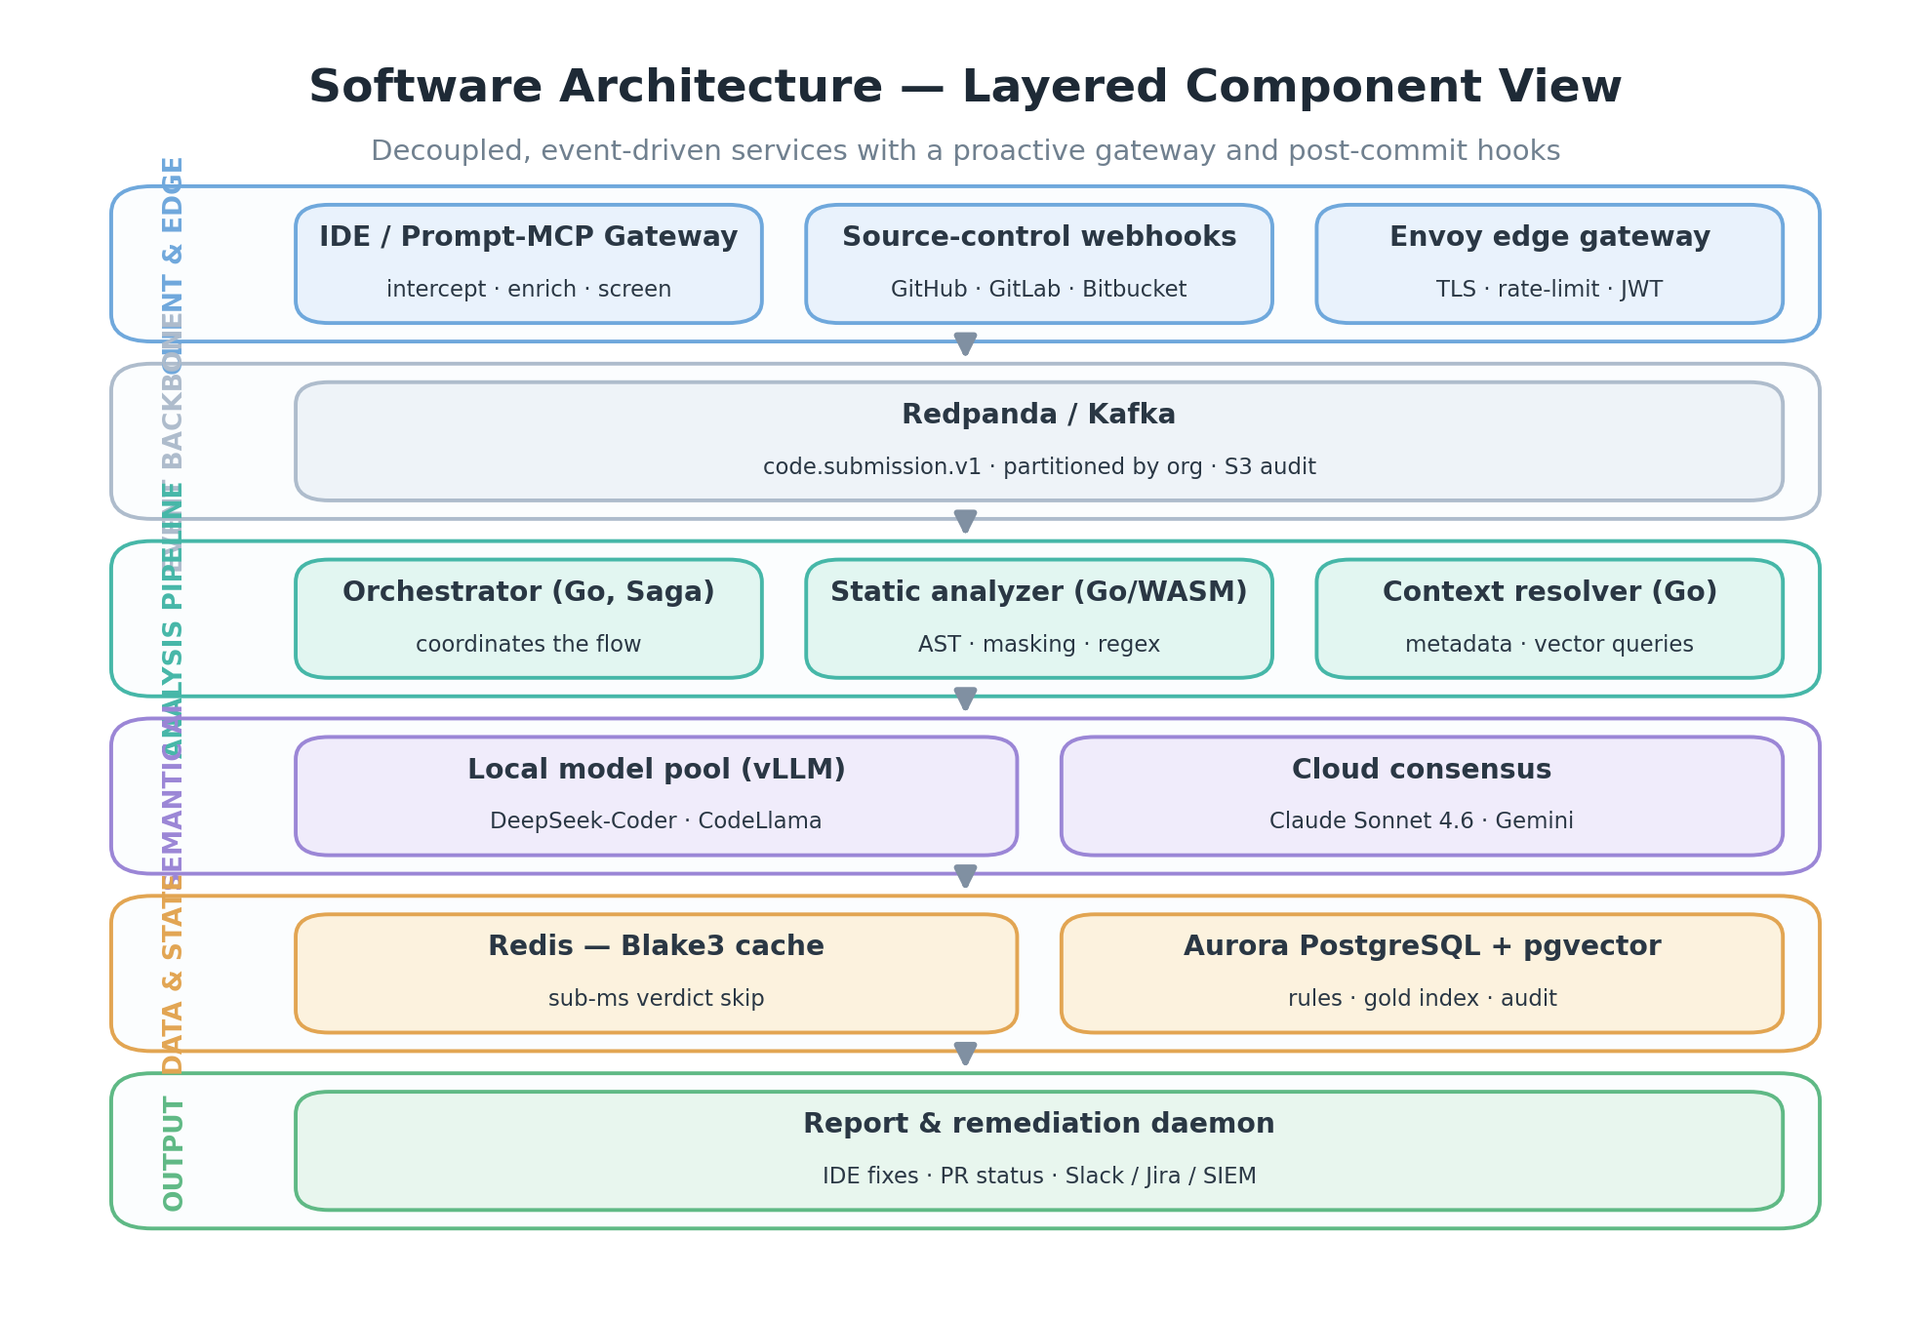
Software architecture — layered component view.

Component Responsibilities
Layer | Components | Responsibility
Client & Edge | Prompt / MCP Gateway · Source-control webhooks · Envoy | Intercept AI requests at the point of generation and inject gold-codebase context; stream every diff; terminate TLS with rate-limiting and JWT auth
Event backbone | Redpanda / Kafka | Durable, per-organization-partitioned event stream with long-term S3 audit
Analysis | Orchestrator (Go, Saga) · Static analyzer (Go/WASM) · Context resolver | Drive the cache → AST → vector → semantic → consensus flow within a 1200 ms deadline; deterministic parse + secret masking; gold-codebase vector queries
Semantic AI | Local model pool (vLLM) · Cloud consensus | Cheap first-pass triage inside the trust boundary; premium dual-model review only on flagged risk
Data & State | Redis · Aurora + pgvector | Blake3 verdict cache for sub-millisecond skips; rulesets, gold-code vectors and tamper-proof audit
Output | Report & remediation daemon | Inline IDE fixes, PR status / comments, and Slack / Jira / SIEM dispatch

Software Design — Request Lifecycle
The runtime is cache-first: a Blake3 hash can return a stored verdict in under a millisecond. On a miss, deterministic analysis and gold-codebase retrieval run first, and the premium semantic consensus is invoked only when cheaper stages flag genuine risk.
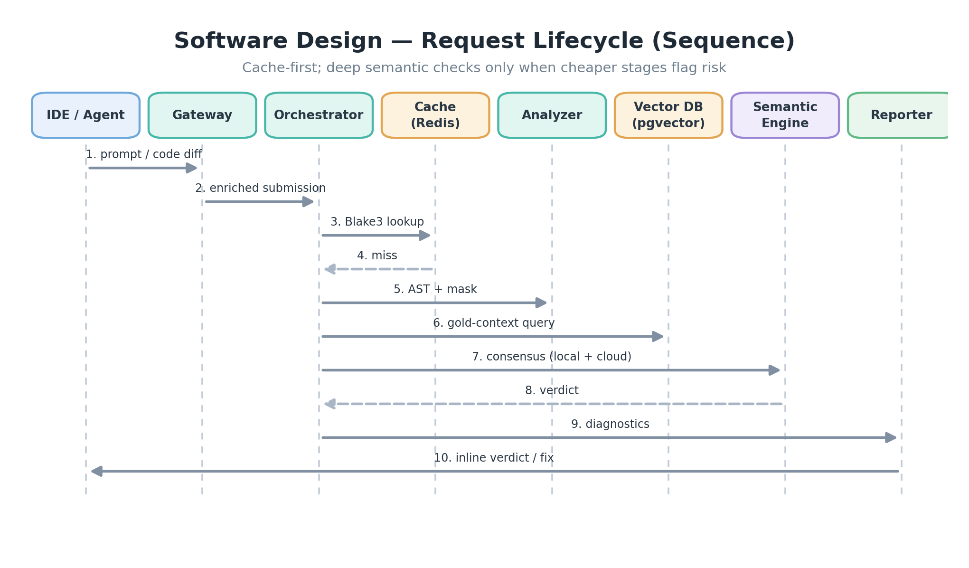
Software design — request lifecycle sequence.

Data & State Design
Hot state lives in Redis for instant skips; durable state — organizational rulesets, the gold-codebase vector index, and the compliance audit trail — lives in Aurora PostgreSQL with pgvector. Retrieval-augmented analysis grounds every model judgment in the organization's own best implementations.
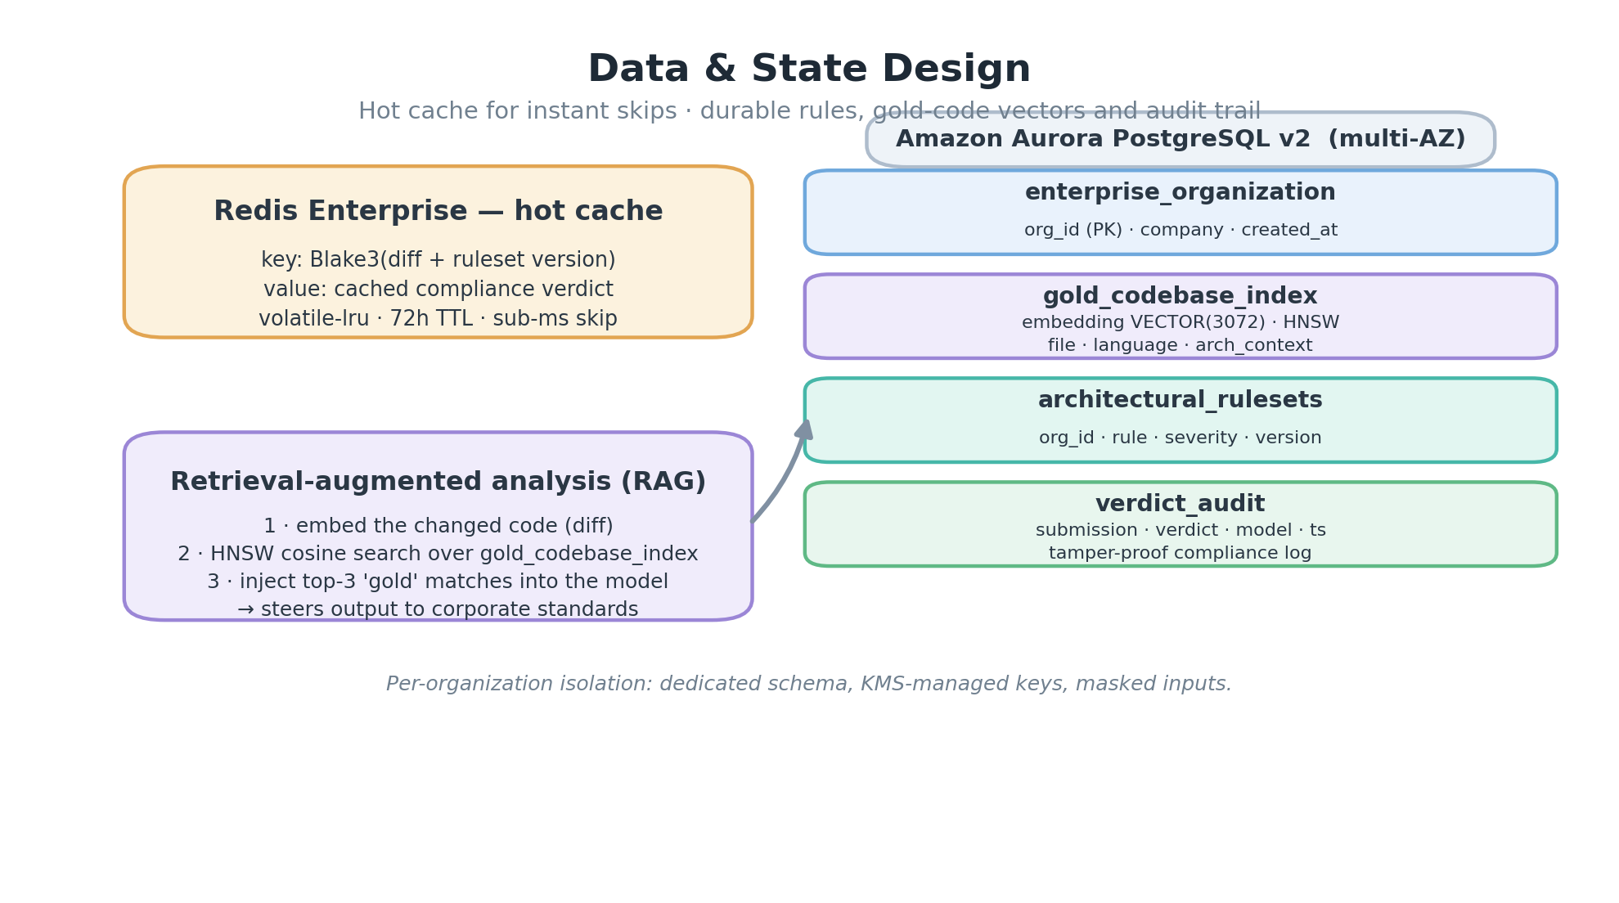
Data and state design.

Deployment & Portability
One product, three isolation postures — masked SaaS, private VPC, and fully air-gapped — running on any operating system, any Linux distribution, and any architecture. Static Go binaries cover the clients; multi-architecture distroless containers cover the services.
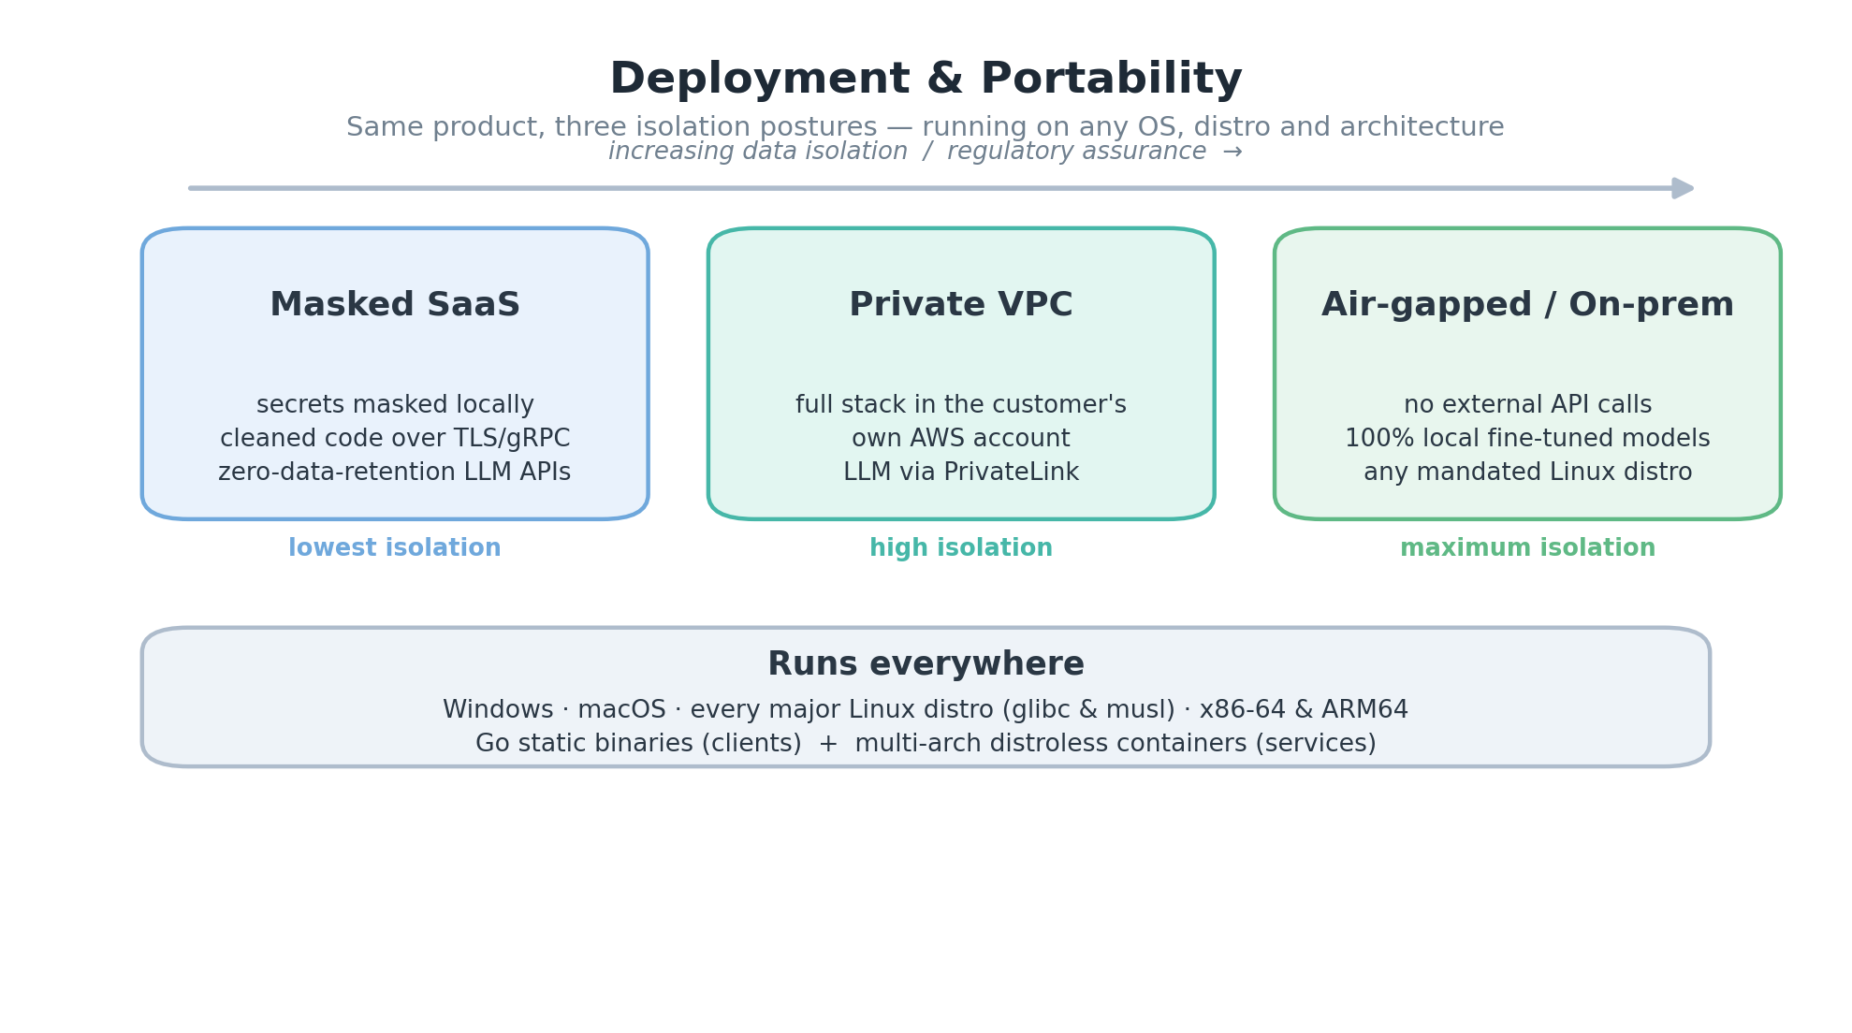
Deployment and portability.

Tech Stack at a Glance
Concern | Technology
Core services | Go — single static binaries (CGO_ENABLED=0)
Semantic interface | Python 3.12+ / FastAPI
Edge gateway | Envoy Proxy
Event bus | Redpanda / Apache Kafka
Cache | Redis Enterprise (Blake3 keys)
Database + vectors | Amazon Aurora PostgreSQL + pgvector (HNSW)
Local inference | vLLM — DeepSeek-Coder / CodeLlama
Cloud models | Claude Sonnet 4.6 · Gemini
Orchestration | Kubernetes — EKS and any distribution
Infrastructure as code | Terraform + Helm
Platforms | Windows · macOS · all Linux (glibc / musl) · x86-64 / ARM64

