1. Problem and Users
People who use the YTÜ campus cannot know how crowded a café, the dining hall or the gym is before they go. They have to walk there and turn back, wait in long lines, or message friend groups asking "is it full?" and wait for a reply. The time lost looking for a place becomes valuable especially when time is limited: for example, students who want to do a final review with friends before an exam lose time they could spend studying while walking from place to place looking for a seat.
Who experiences it: Students on campus; especially those looking for a seat at Hokka Cafe, Kayıntı Cafe, Yıldız Cafe and Büyük Ev between classes, those using the dining hall for lunch and dinner, those going to the gym, and those joining the line in front of Yirmibirco.
How often: Four out of five students said that in the last one to two weeks they went to a place 2 to 5 times and had to turn back or move somewhere else because it was full.
Evidence: Written interviews (7 questions) were conducted on 09-10.11.2026 with students who use the campus.
- Turning back and searching for a seat: Most of the turning back happens at Hokka Cafe and Büyük Ev. Four out of five students said they lose between 15 minutes and 1 hour each time they search for a seat; in the end they move to another place, an empty classroom in a faculty building, or a group study room in the library. User 4: "Walking around all the faculties and campus venues looking for a free spot costs at least an hour, and in the end we go back to the dorm."
- Weather: Two students said that on rainy days the number of available seats at Büyük Ev drops noticeably and that they turned back on those days.
- Lines and peak hours: According to students' estimates, the line at Yirmibirco reaches 20 to 50 people at peak hours and the wait takes 10-20 minutes; all of the students said they have given up after seeing the line. The dining hall is most crowded at lunchtime, roughly between 12:00 and 13:30; students said that after the long line they end up eating late or go to another place instead. The two students who use the gym said the mixed sessions are very crowded in the afternoon and even reach the capacity limit; as a result they either cut time from their classes to go at quieter hours or give up using the gym.
- Current method: Four out of five students have no reliable way to find out how crowded a place is before going; they either go and check or ask through WhatsApp groups and friends. User 1: "We keep in touch with friends in our WhatsApp group, but it doesn't really work because we all check at the same time." One student said that asking friends usually works.
- Demand: All of the students said they would use such an app; four said they would report the crowd level while at a venue, and one said they would only check it.

2. Why It Matters: Why Existing Solutions Fall Short
None of the existing channels show the current crowd level of campus venues in one place and in real time; as a result, users only find out once they arrive.
Existing solution | What it does | Why it falls short
YTÜ Mobil | Dining hall menu, campus shuttle times, announcements | No real-time crowd or line information
Google Maps "Popular times" | General crowd estimate based on historical data | Often does not distinguish small campus venues; data is either missing or not live
WhatsApp / Telegram groups | Students ask "is the dining hall full?" | Replies may not come or come late, messages are not searchable, each department has its own group
Cafés' social media accounts | Campaigns, opening and closing announcements | One-way; gives no information about the current crowd
Gym website | Opening hours and announcements | Static information; does not show how crowded the gym is right now
Going and checking | Accurate information | Wastes time; if it's full, you have to walk to another place

What makes us different: Campus cafés, the dining hall, the gym and the line at Yirmibirco on one screen; crowd levels are calculated live from users' current reports, and the number and time of reports are visible. The app also suggests the nearest available venue, offers an hourly crowd forecast, and shows the last known status when offline.
Screenshots
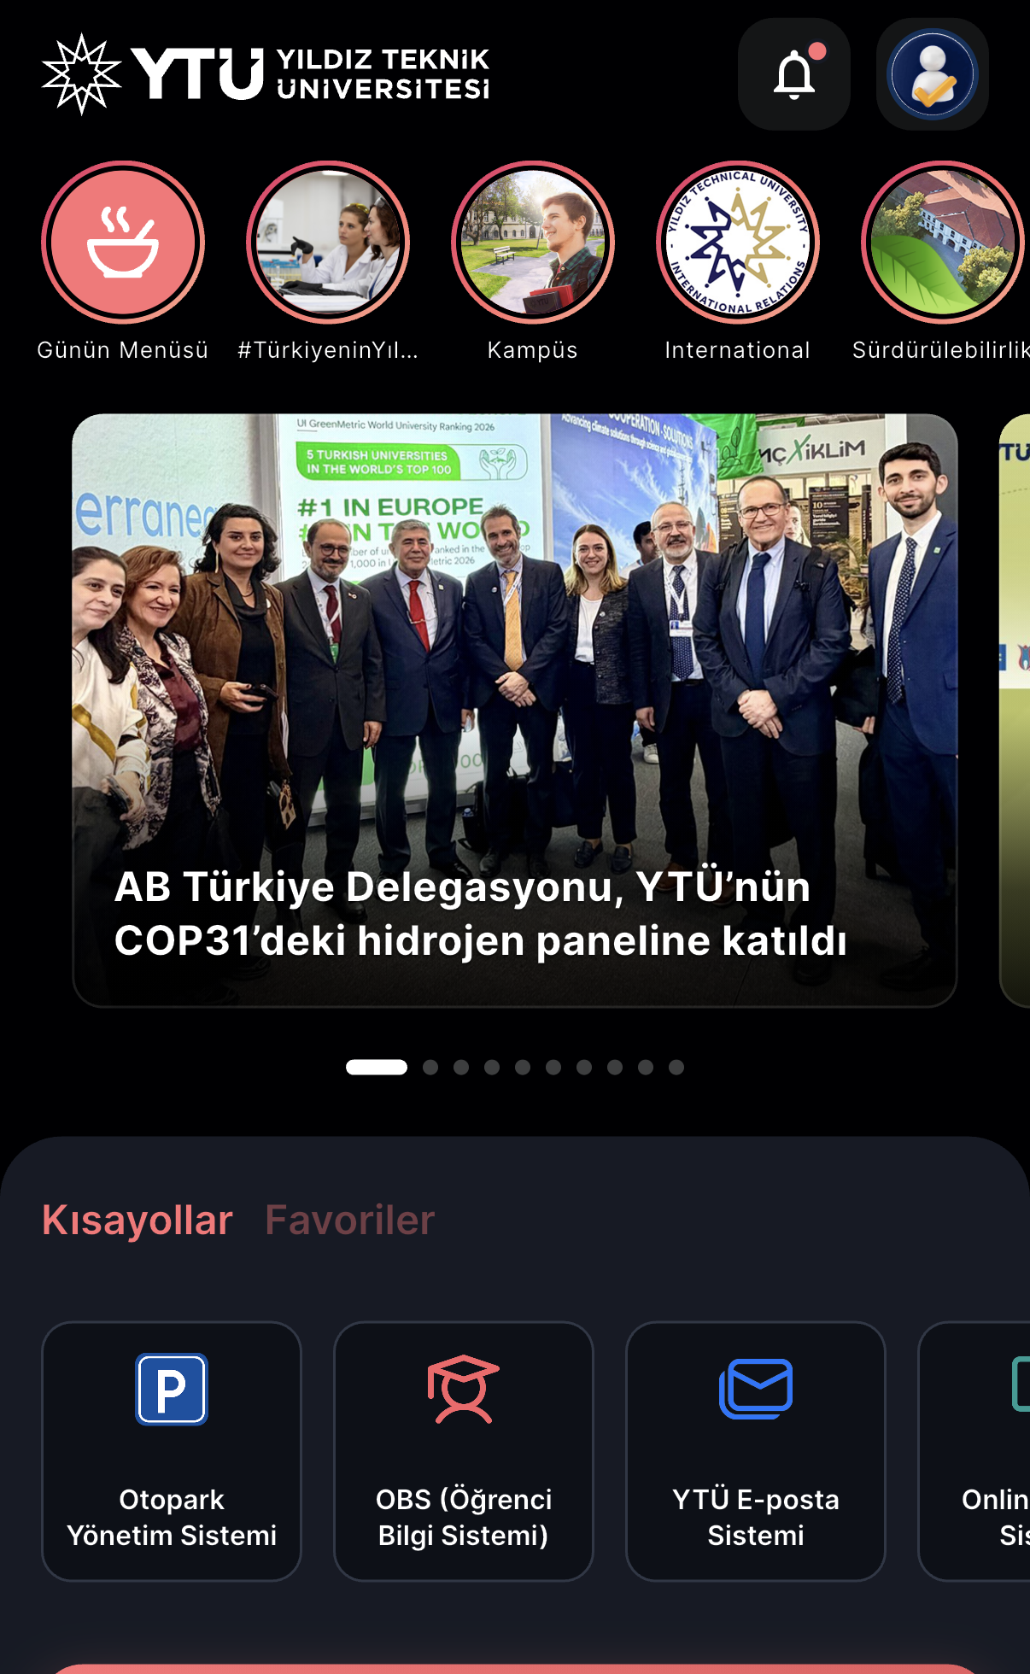  Figure 1. YTÜ Mobil – Home: news, daily menu and shortcuts | 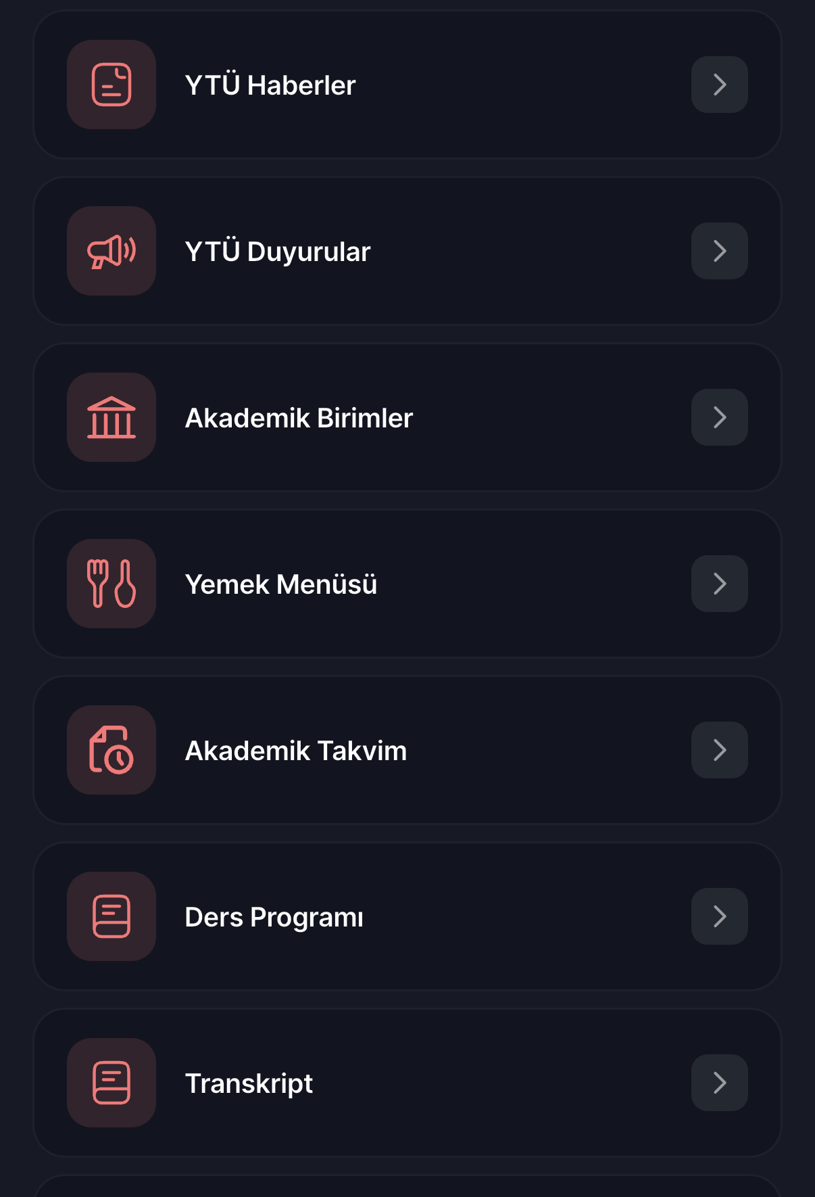  Figure 2. YTÜ Mobil – Menu: news, announcements, meal menu, calendar, timetable | 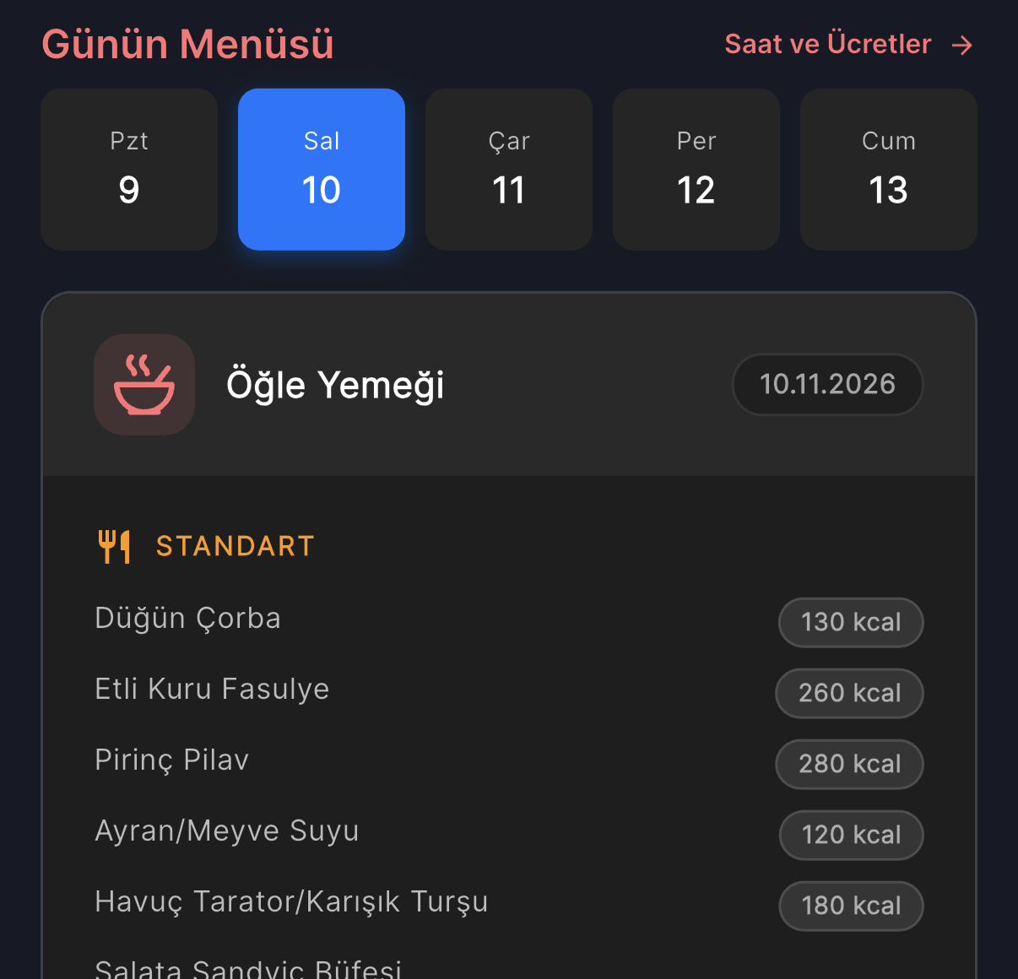  Figure 3. YTÜ Mobil – Daily menu: dining hall menu, no crowd information
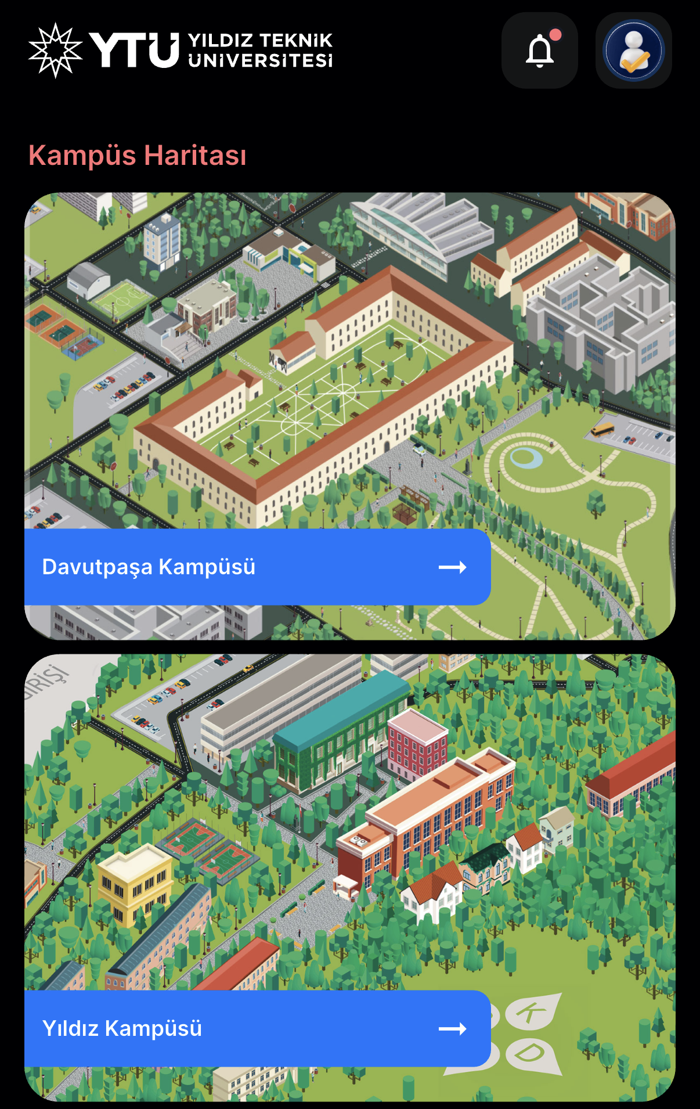  Figure 4. YTÜ Mobil – Campus map | 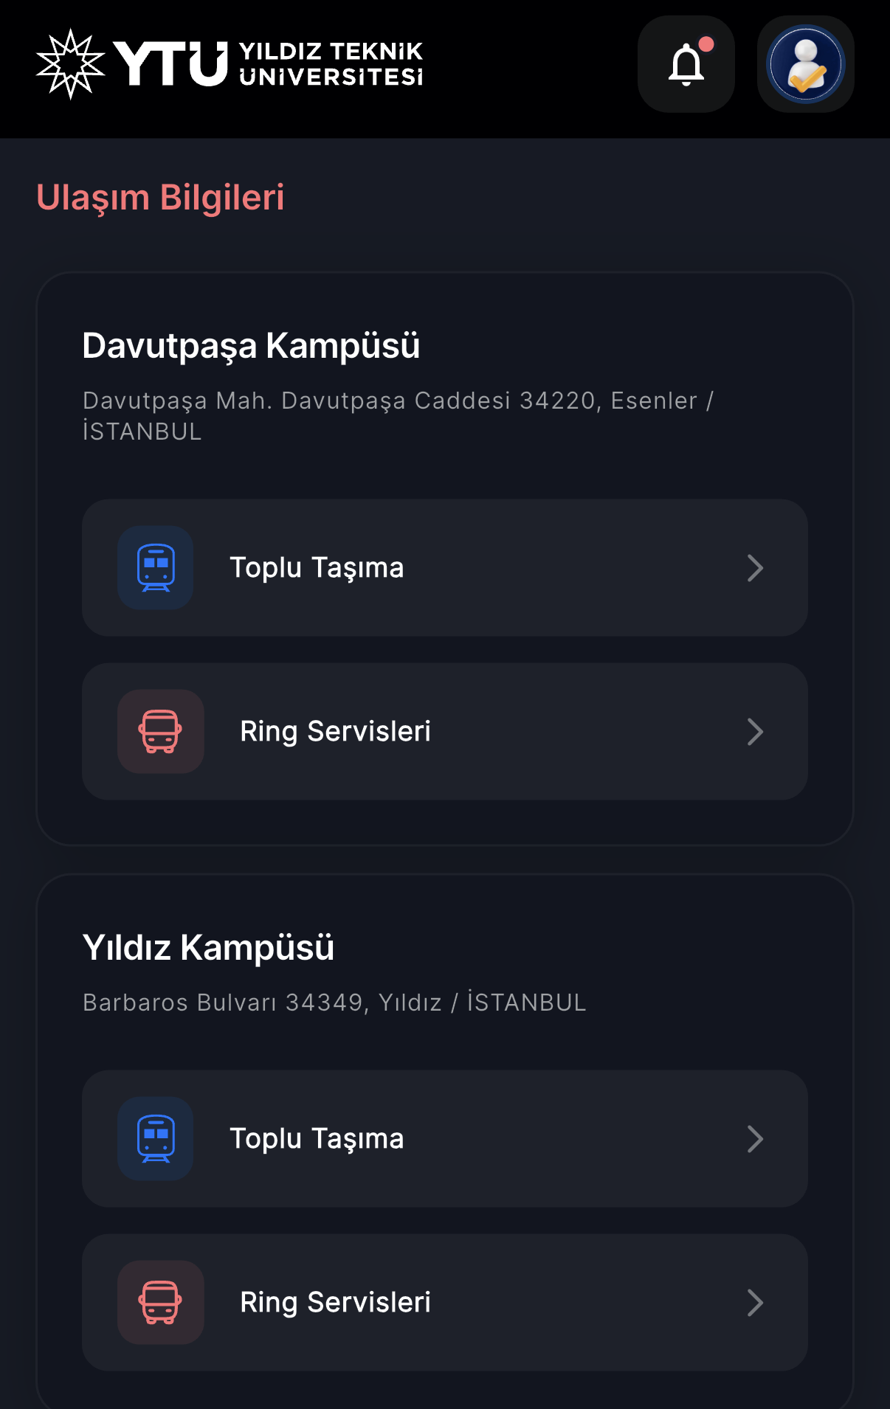  Figure 5. YTÜ Mobil – Transportation and campus shuttles
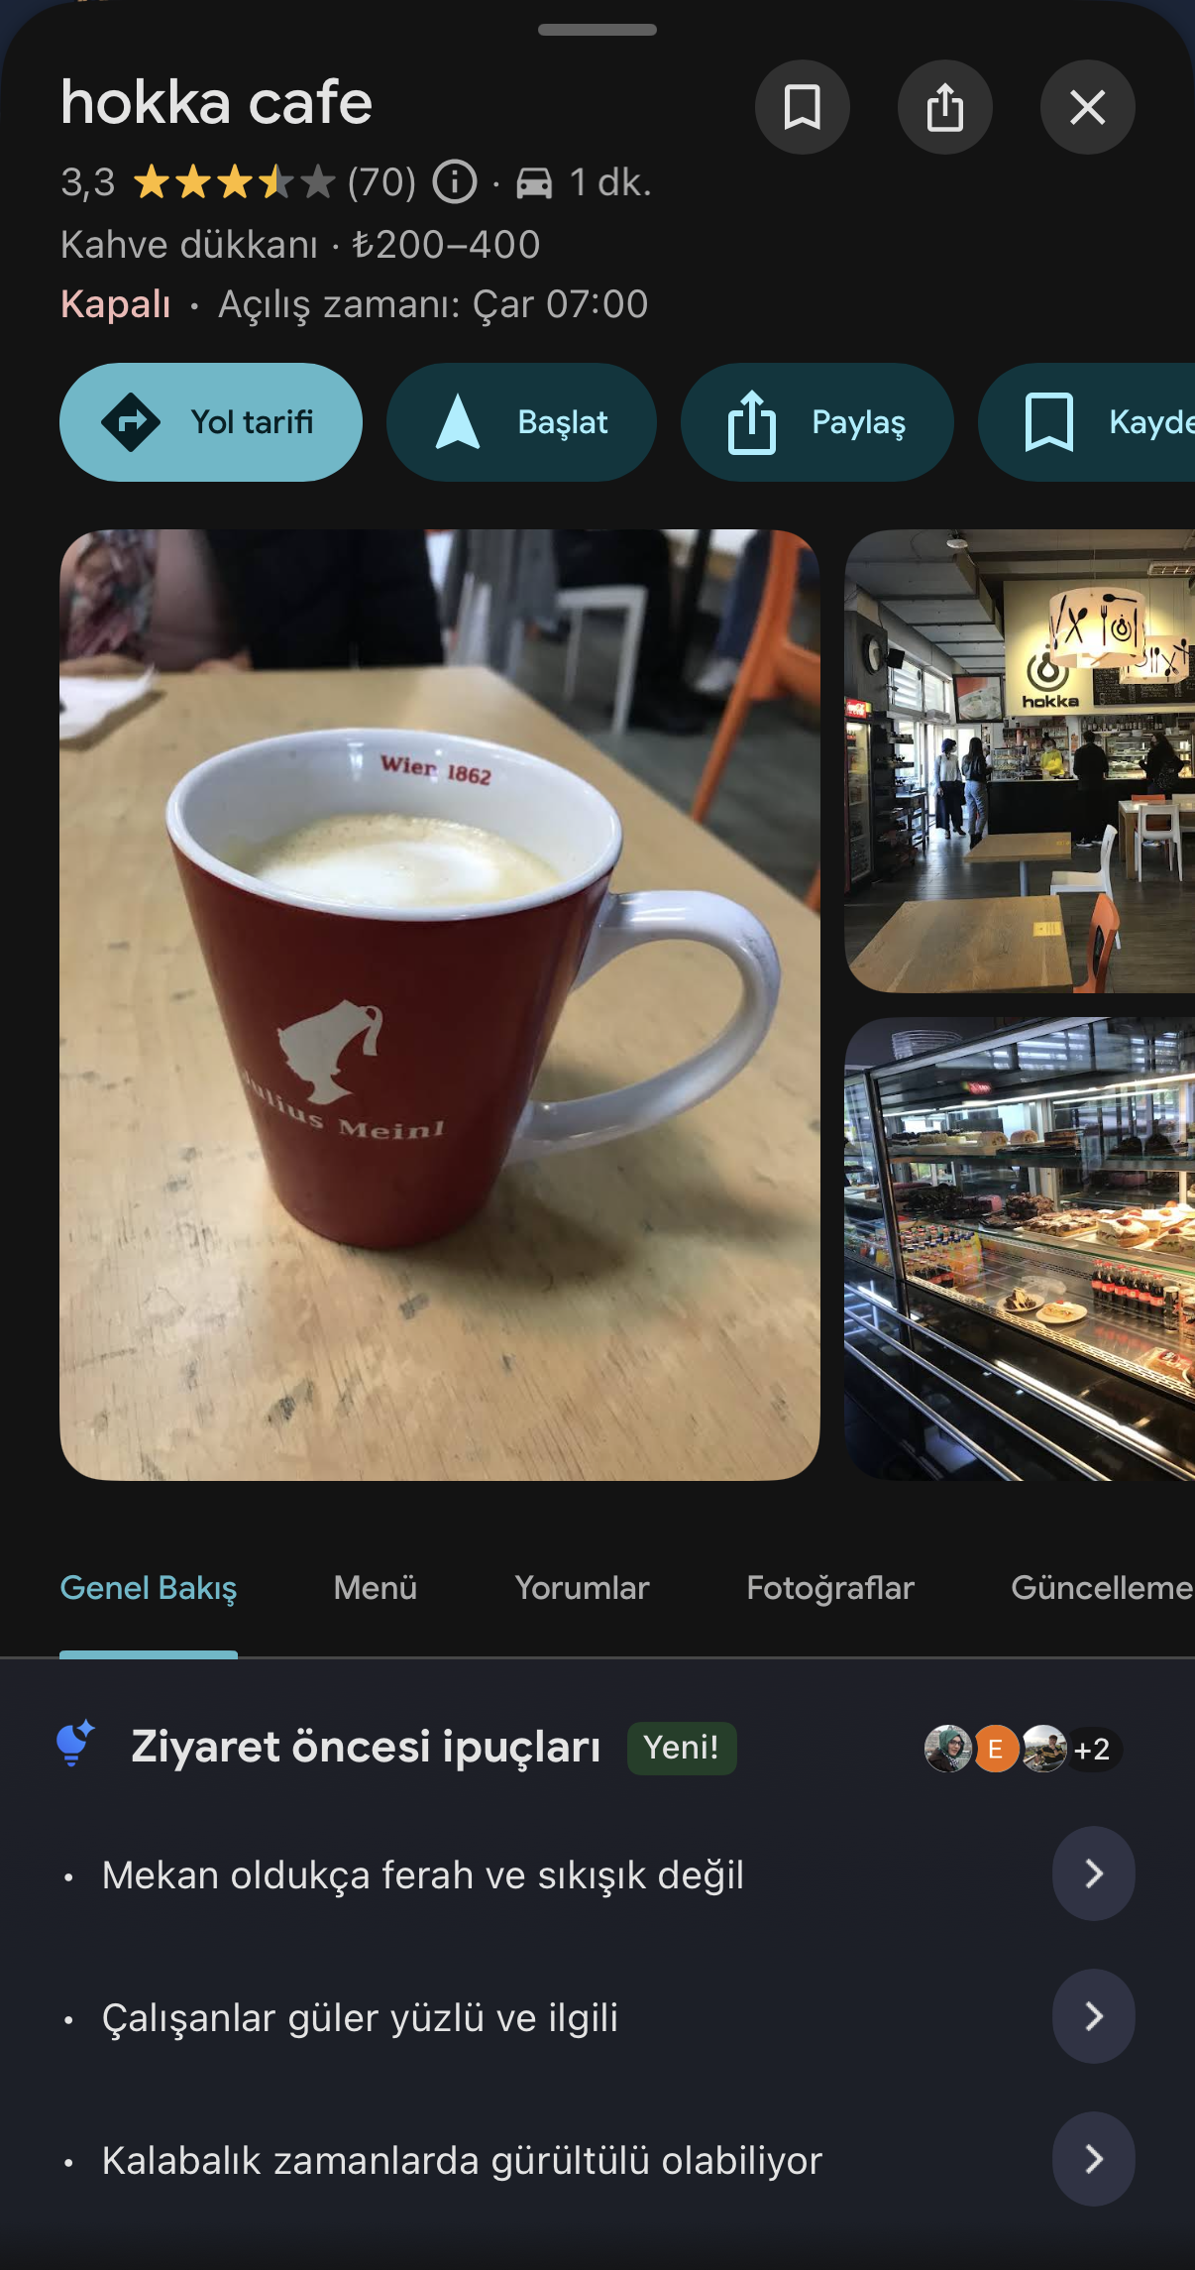  Figure 6. Google Maps – Hokka Cafe: rating, opening hours and review-based tips; no live crowd information | 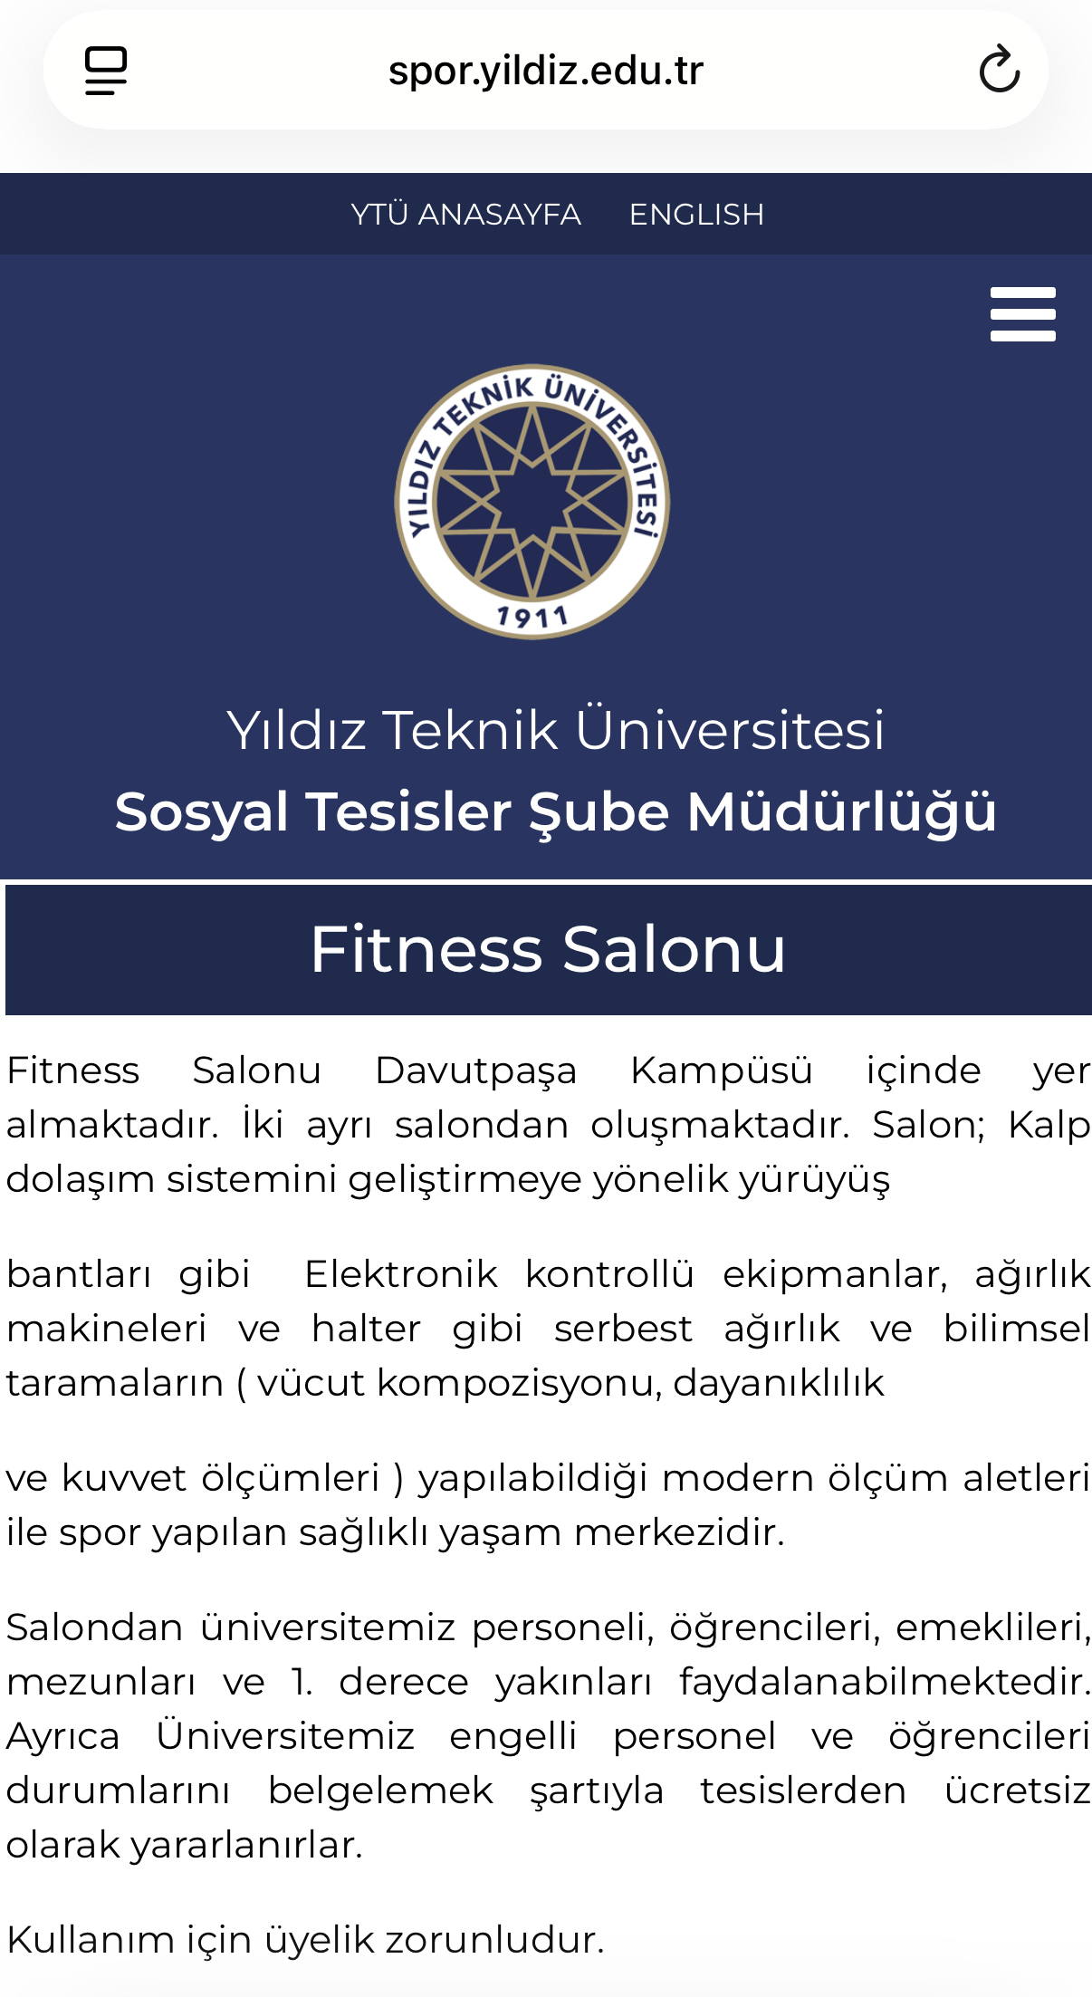  Figure 7. Gym website (spor.yildiz.edu.tr): facility description and membership info; no real-time crowd information

