CONFIDENTIAL — FOR INTERNAL USE ONLY
Enterprise Threat Intelligence Assessment
Open Source Exposure & Security Intelligence

Prepared for
NIIT Port Harcourt
Prepared by
Ozi Emmanuel Azibaolonari — Group 5
emmanuelozi2017@gmail.com | 07067589222
Date: Wednesday, 22nd April

Table of Contents
1. Introduction 3
2. Executive Summary 3
3. Objectives 4
4. Methodology 4
5. Tools Used 5
6. Threat Analysis 5
7. Intelligence Correlation 7
8. Recommendations 8
9. Conclusion 9
Appendix A: OSINT Assignment — Target Profile 9

1. Introduction
This report presents a Cyber Threat Intelligence (CTI) evaluation conducted to examine the external exposure and potential security concerns of NIIT Port Harcourt. The primary objective is to identify publicly available data relating to the organization and to assess its overall digital footprint.
The scope of the assessment is restricted to information accessible through Open Source Intelligence (OSINT) techniques; no illegal or intrusive access was carried out against any system. The key areas of investigation include infrastructure visibility, exposure of employee information, and indicators of potential phishing risk.
The report is organized to present the methodology, findings, risk assessment, and recommendations, with the overall aim of highlighting external security vulnerabilities facing the organization.

2. Executive Summary
This report presents the results of a threat intelligence assessment carried out for NIIT Port Harcourt in response to reports of increasing digital exposure, targeted communication directed at employees, and suspicious login attempts. The indicators identified collectively point to a high likelihood of an attempted compromise by external threat actors.
The assessment applied a structured intelligence approach, combining the intelligence cycle and the MITRE ATT&CK framework alongside OSINT techniques, in order to evaluate the organization's exposure and identify potential attack vectors.
Findings indicate that publicly accessible mail addresses associated with the organization are limited, suggesting a relatively low level of direct OSINT exposure in this area. However, this does not eliminate the underlying risk. Indicators of Compromise (IOCs) suggest that threat actors may be leveraging inferred email patterns, previously compromised credential datasets, or alternative communication channels to conduct social engineering (phishing) and credential-based attacks.
It is recommended that NIIT Port Harcourt strengthen its authentication mechanisms through the implementation of multi-factor authentication (MFA), and that the organization adopt advanced email and endpoint protection measures. It is further recommended that NIIT introduce a form of identification, such as student ID cards, to reduce the risk of threat actors entering the premises to conduct social engineering.

3. Objectives
- Identify publicly available information relating to the organization.
- Assess employee and organizational exposure.
- Discover digital access points and online footprint.
- Investigate publicly available information in further detail.
- Correlate intelligence findings into meaningful relationships.
- Assess security risks based on the collected intelligence.
- Produce a professional intelligence report.

4. Methodology
The investigation was carried out using a structured Cyber Threat Intelligence (CTI) approach, combining network reconnaissance with adversary behavior classification.
OSINT techniques were used to gather background information such as domain names, subdomains, and contact details. This helped provide context around the organization's infrastructure and its potential real-world use.
The findings were then analyzed using the MITRE ATT&CK framework in order to classify potential adversary behavior. The suspicious communication identified during the assessment was judged to align with Phishing (T1566) under the Initial Access tactic. This structured approach ensures that the observed risks are mapped to real-world attack techniques.

5. Tools Used
The following tools were used to conduct the OSINT collection and analysis phases of this assessment:
Tool | Purpose
Google Dorking | Advanced search of publicly indexed information
Whois | Domain registration information
theHarvester | Email address and subdomain discovery
Wayback Machine | Historical website analysis
Maltego | Relationship mapping and infrastructure link analysis
HTTrack | Offline website analysis
Shodan | Discovery of internet-facing assets and services
OSINT Framework | Domain registration research

6. Threat Analysis
Using the OSINT tool Maltego, the target infrastructure was mapped, revealing associated subdomains (ftp.niitph.com, mail.niitph.com, and webmail.niitph.com) resolving to the IP address 176.123.0.55, as shown in Figure 1.
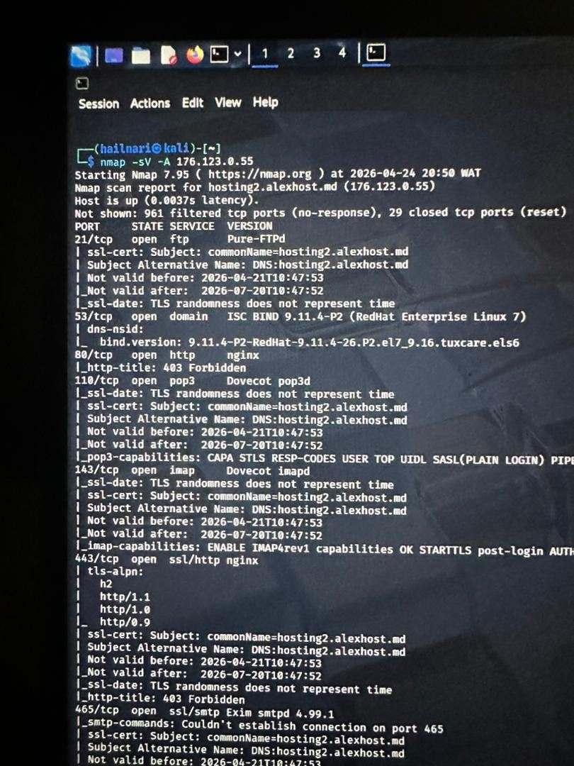
Figure 1: Maltego infrastructure and relationship mapping of niitph.com
An active scan was subsequently conducted against the target IP address (176.123.0.55) with service and version detection enabled. The results are shown in Figure 2.
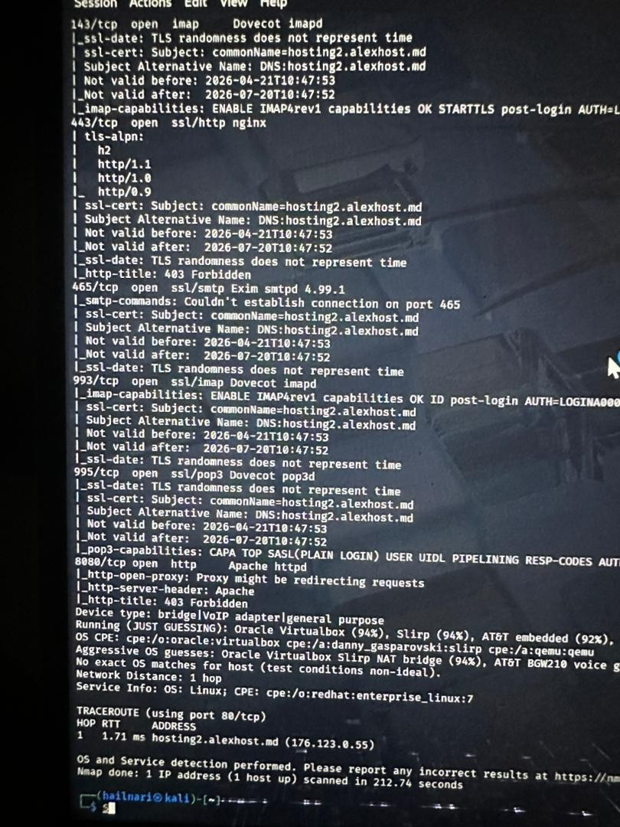
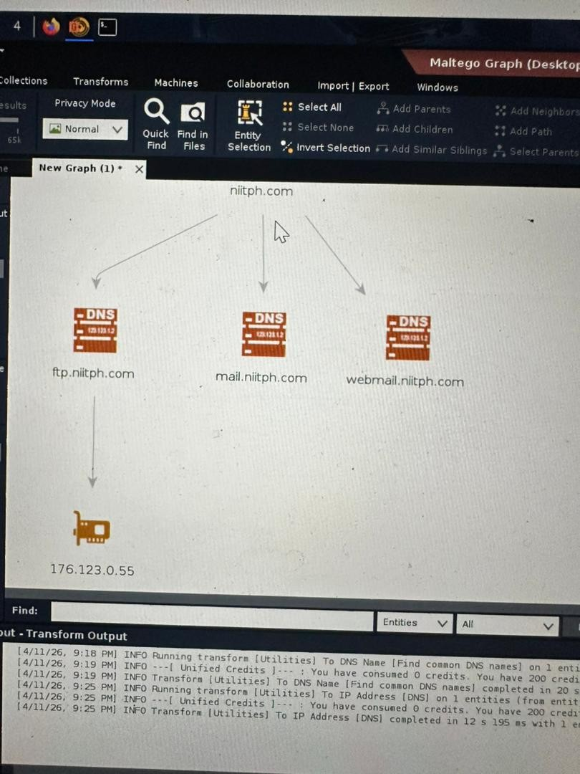
Figure 2: Nmap service and version detection scan against 176.123.0.55
The scan revealed several exposed services and their respective versions, which increases the overall attack surface of the target infrastructure. For example, the FTP service running on port 21 is open and could be targeted for unauthorized access, particularly if weak credentials or misconfigurations exist.
The presence of mail services on ports 110 and 143, together with SMTP on port 465, introduces a strong risk of phishing-related attacks.
The following table summarizes the exposed services identified during the scan and their associated risks:
Exposed Service | Port | Observed Risk
Pure-FTPd (FTP) | 21/tcp | Potential target for unauthorized access if weak credentials or misconfigurations exist
ISC BIND (DNS) | 53/tcp | DNS service exposure increases infrastructure visibility to external parties
Dovecot (POP3 / IMAP) | 110/tcp, 143/tcp, 993/tcp, 995/tcp | Mail retrieval services increase exposure to credential-based and phishing-related attacks
Exim (SMTP) | 465/tcp | Introduces risk of phishing-related and email-borne attacks
nginx / Apache httpd (HTTP/HTTPS) | 80/tcp, 443/tcp, 8080/tcp | Web-facing services expand the external attack surface

The presence of multiple exposed services across different ports suggests a multi-service architecture. This also introduces risk through:
- Service misconfiguration
- Outdated software versions
- Credential-based attacks
- Web and email exploitation vectors

7. Intelligence Correlation
The combination of exposed web and email services, together with publicly available domain and contact information, creates a realistic attack path. An attacker could use OSINT data to craft targeted phishing emails, distribute them via the exposed SMTP service, and host malicious content on the identified web servers.
This correlation of findings — infrastructure exposure, mail service availability, and the classification of observed suspicious communication under MITRE ATT&CK technique T1566 (Phishing) — supports the assessment that NIIT Port Harcourt faces a credible risk of social engineering and credential-based compromise from external threat actors.

8. Recommendations
Based on the findings of this assessment, the following measures are recommended:
- Implement multi-factor authentication (MFA) across all authentication mechanisms to strengthen access control.
- Deploy advanced email and endpoint protection measures to reduce the risk of phishing and credential-based attacks.
- Introduce a form of identification, such as student ID cards, to reduce the ability of threat actors to gain physical access to the premises for social engineering purposes.
- Review and harden the configuration of exposed services (FTP, mail, and web servers) identified during the scan, including patching outdated software versions.
- Continue to monitor for suspicious login attempts and targeted communications directed at employees.

9. Conclusion
The assessment confirms that the current system presents a moderate security risk, primarily due to insecure communication channels, outdated software, and weak monitoring mechanisms. If left unaddressed, these vulnerabilities could lead to unauthorized access to administrative accounts, exposure of sensitive user data, and increased susceptibility to cyberattacks.
Although some suspicious login attempts were observed, it remains unclear whether these activities are benign or indicative of malicious intent. Regardless, they highlight the urgent need for improved monitoring and response capabilities.
Immediate action is required to secure communication channels through HTTPS implementation, update and patch vulnerable systems, and strengthen authentication and monitoring controls. By implementing the recommendations outlined above, the organization can significantly reduce its attack surface and improve its resilience against potential cyber threats.

Appendix A: OSINT Assignment — Target Profile
As a supplementary OSINT exercise, an open-source profile was compiled on a named individual associated with the organization, using only publicly accessible and archived web sources.
Target: Dr. Martha Ozohu Musa
Using the Wayback Machine (web.archive.org), an archived snapshot of the target institution's staff directory page was retrieved. The archived record identifies the individual as a Senior Lecturer and Acting Head of Department, Cybersecurity, holding a PhD in Computer Science, with research interests spanning Cybersecurity, the Internet of Things, and Artificial Intelligence, along with published papers and conference speaking engagements.
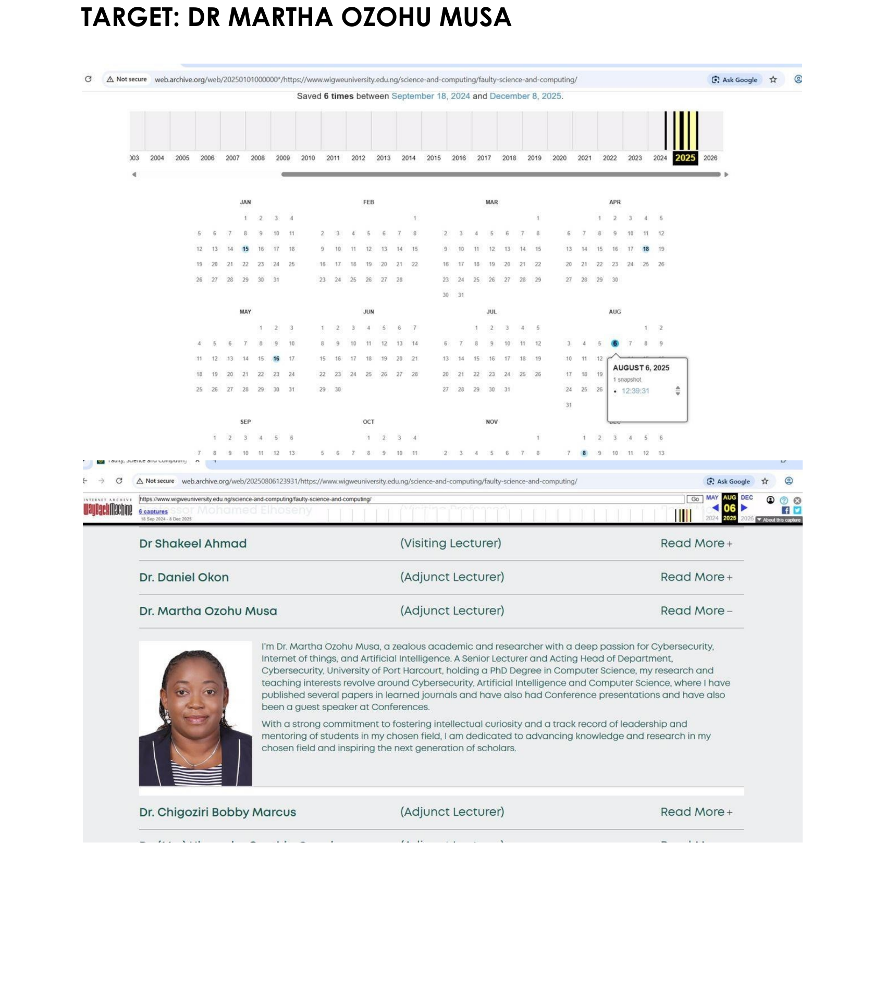
Figure 3: Archived staff-directory snapshot (Wayback Machine) referencing the target individual
This exercise illustrates how historical, publicly cached web content can surface detailed personal and professional information even after a source page has been altered or removed, underscoring the value of archive-aware reconnaissance in OSINT investigations.

