Team 1 : NBA Playoffs

Team Members : Eniola Webster-Esho,Alexius Fly & Ozioma Aguegboh

Deliverable 3: Simple Data Analysis and Visualization in Tableau

3.

Country Symbol Map

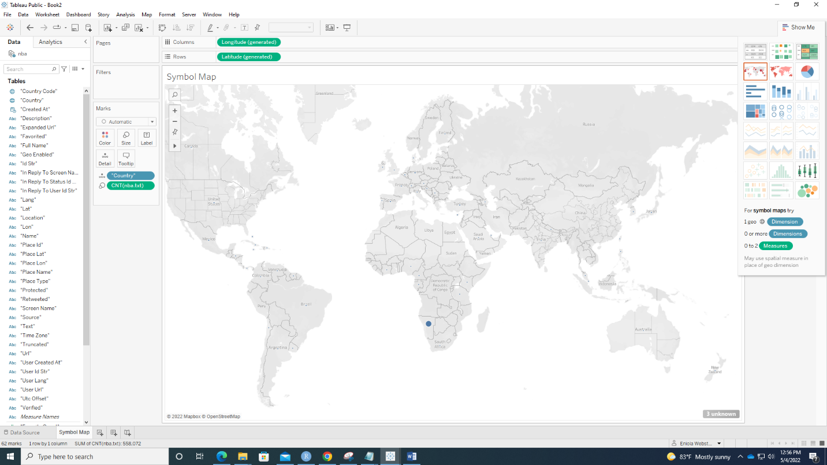

Country Symbol Map with CNT(nba.txt) as color. 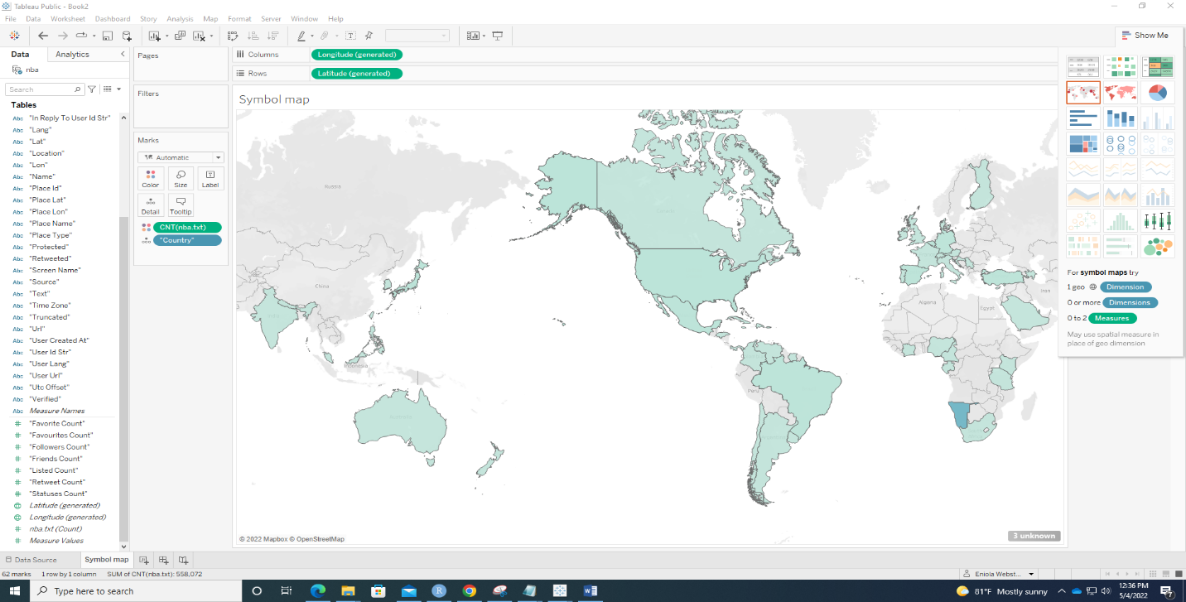

4.

Country Map

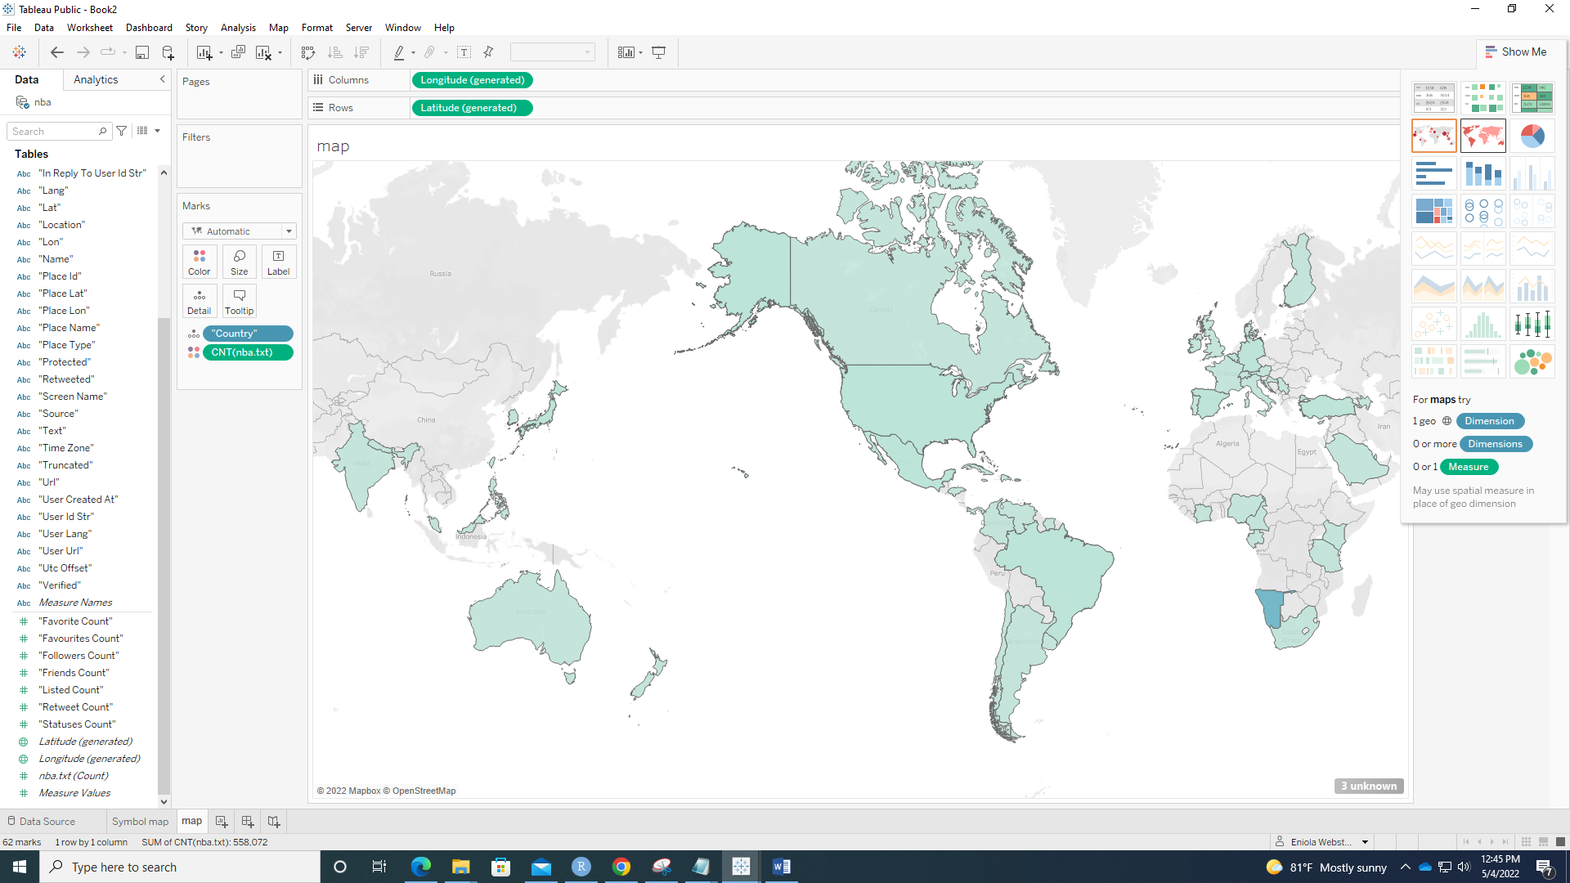

5. Area Chart (Discrete) - Weekday

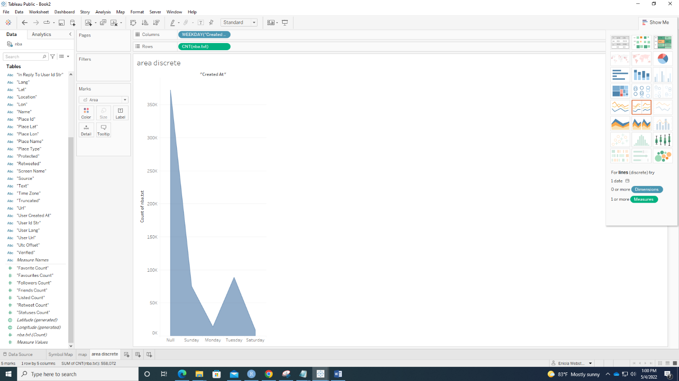

Area Chart (Discrete) – Hour

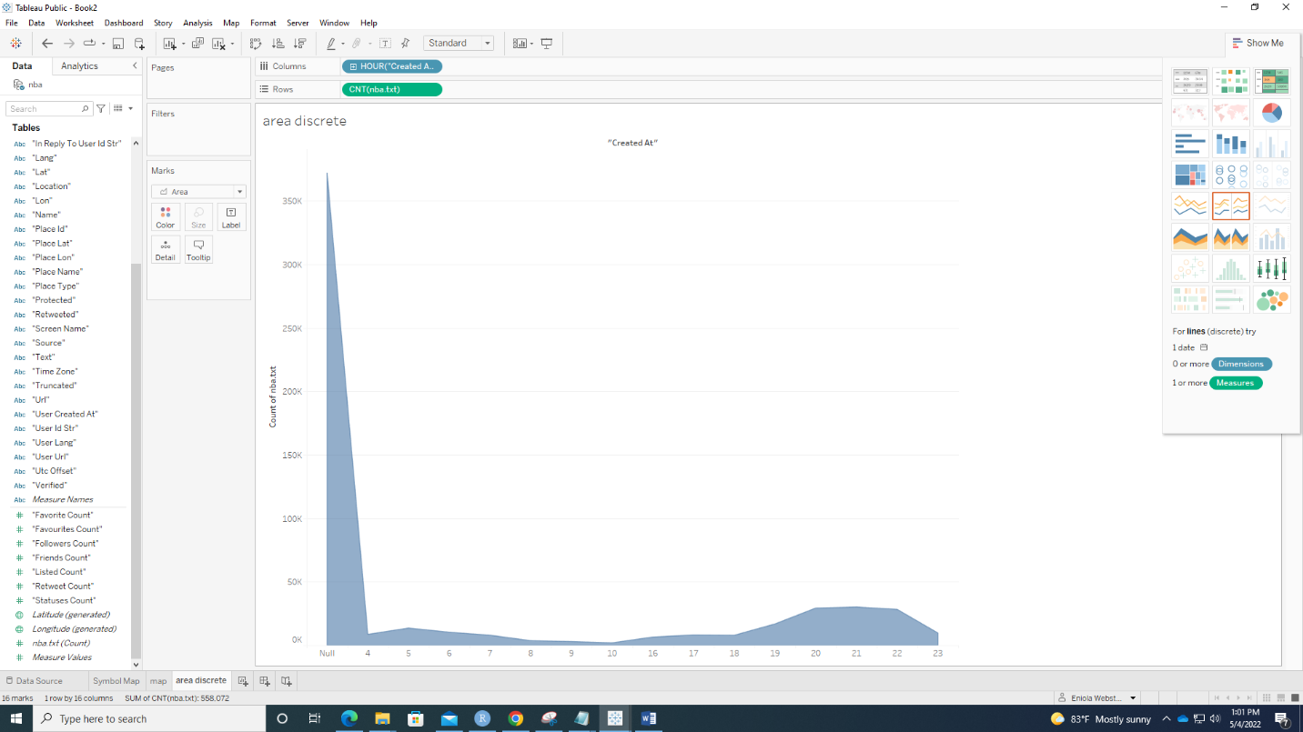

Excluded Null, NA, and other values that are not considered countries.

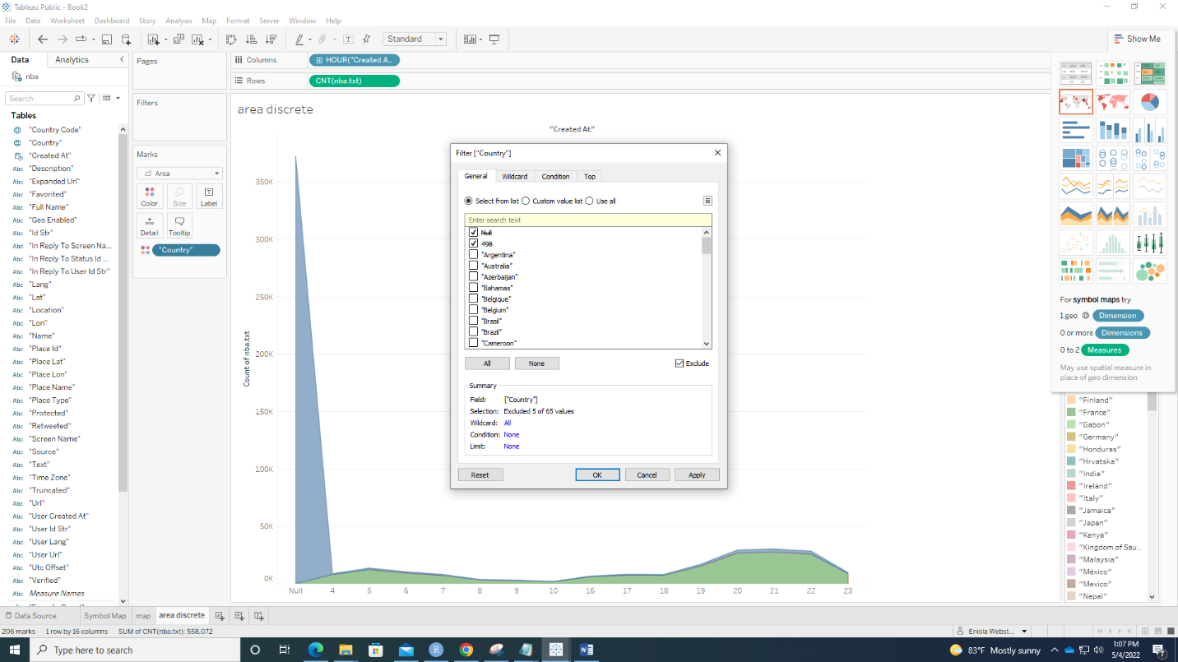

New Area Chart (Discrete) – Hour

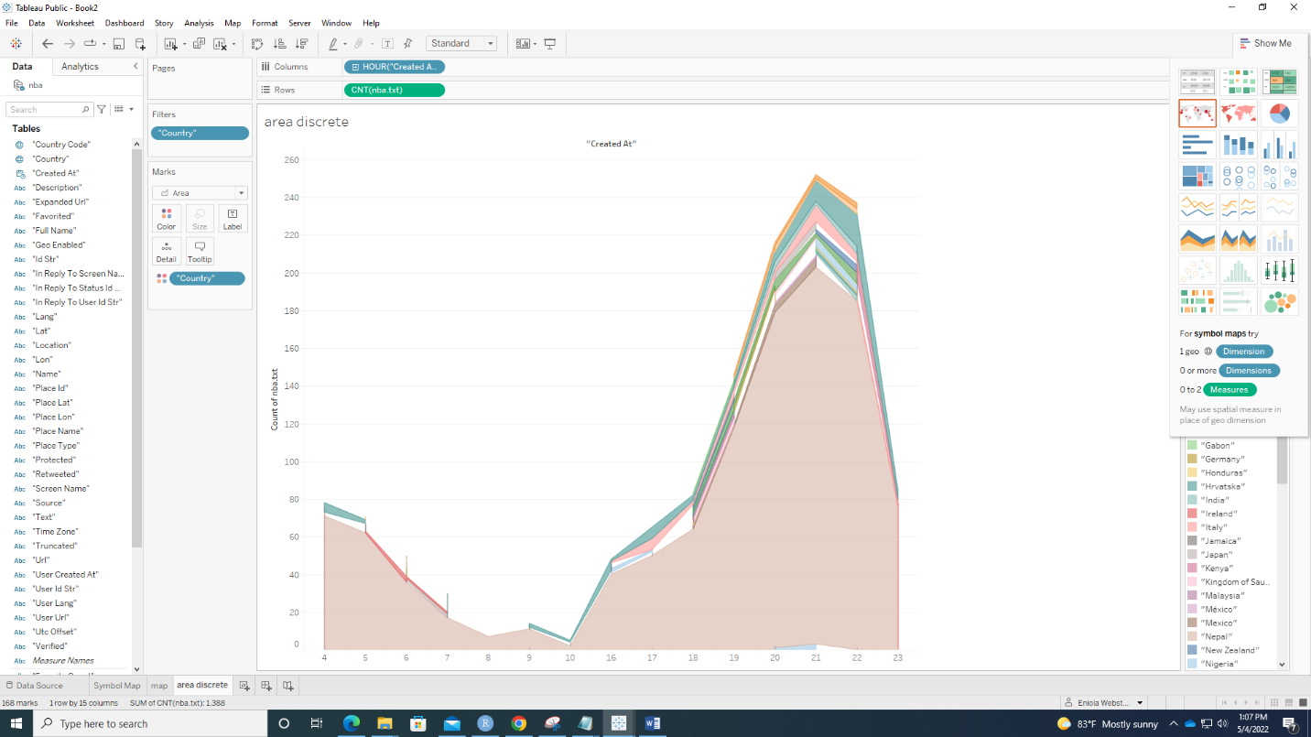

6. Distribution of Number of Tweets based on Usernames.

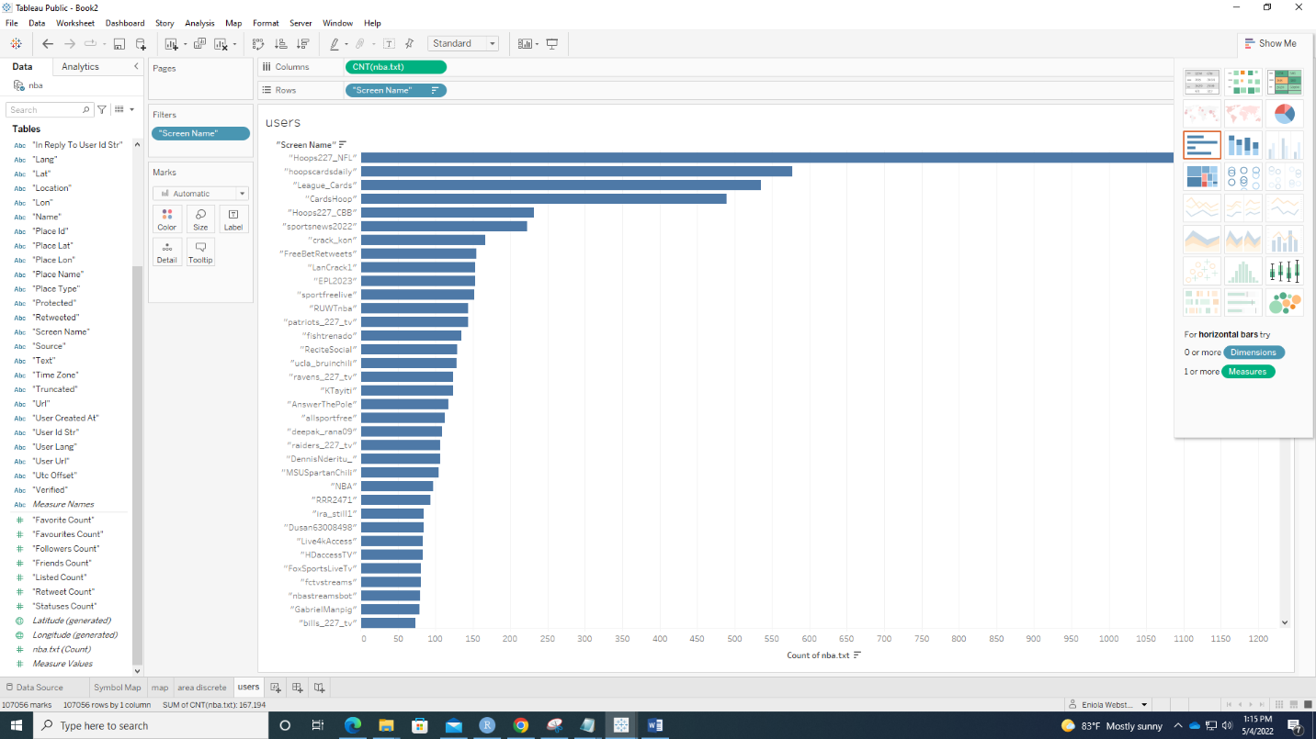

7. Tweet by Language.

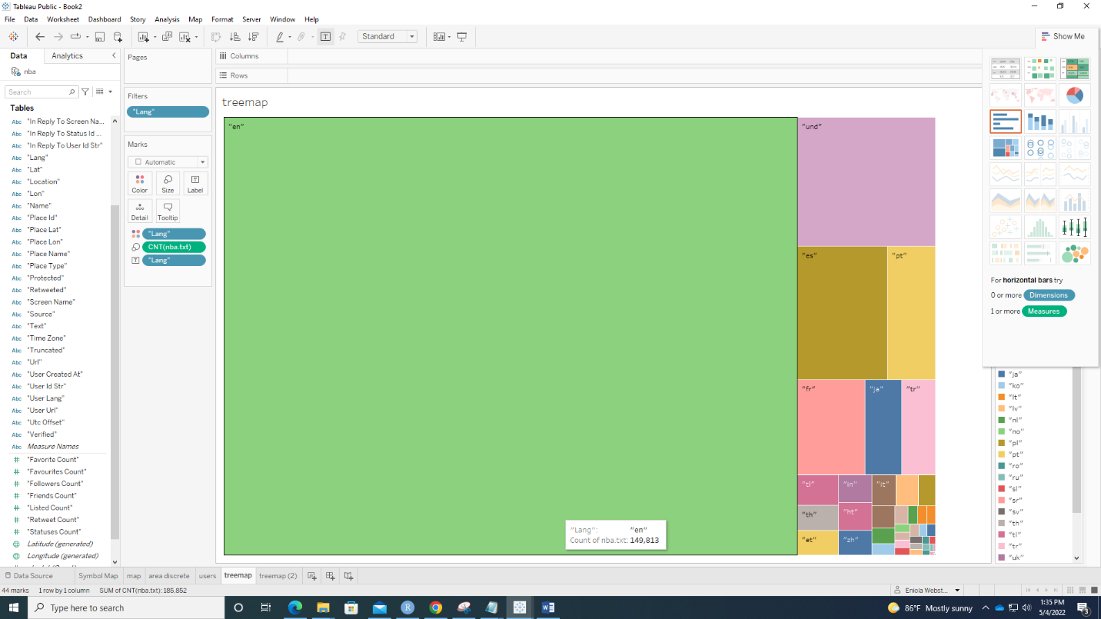

8. Followers Count.

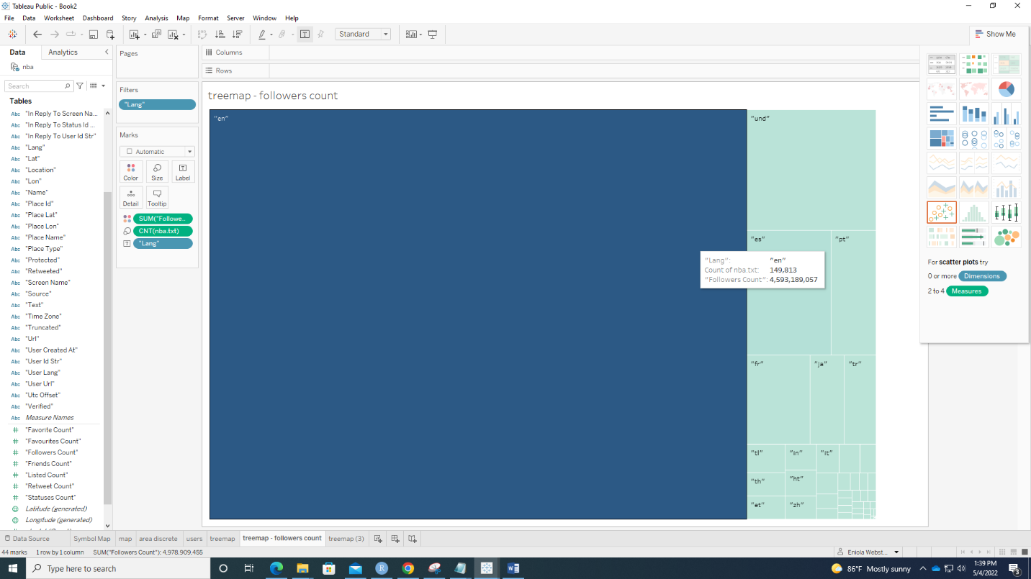

9. Favorite Count.

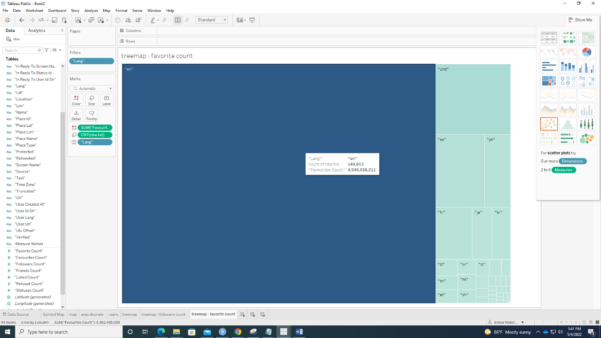

10. Barchart

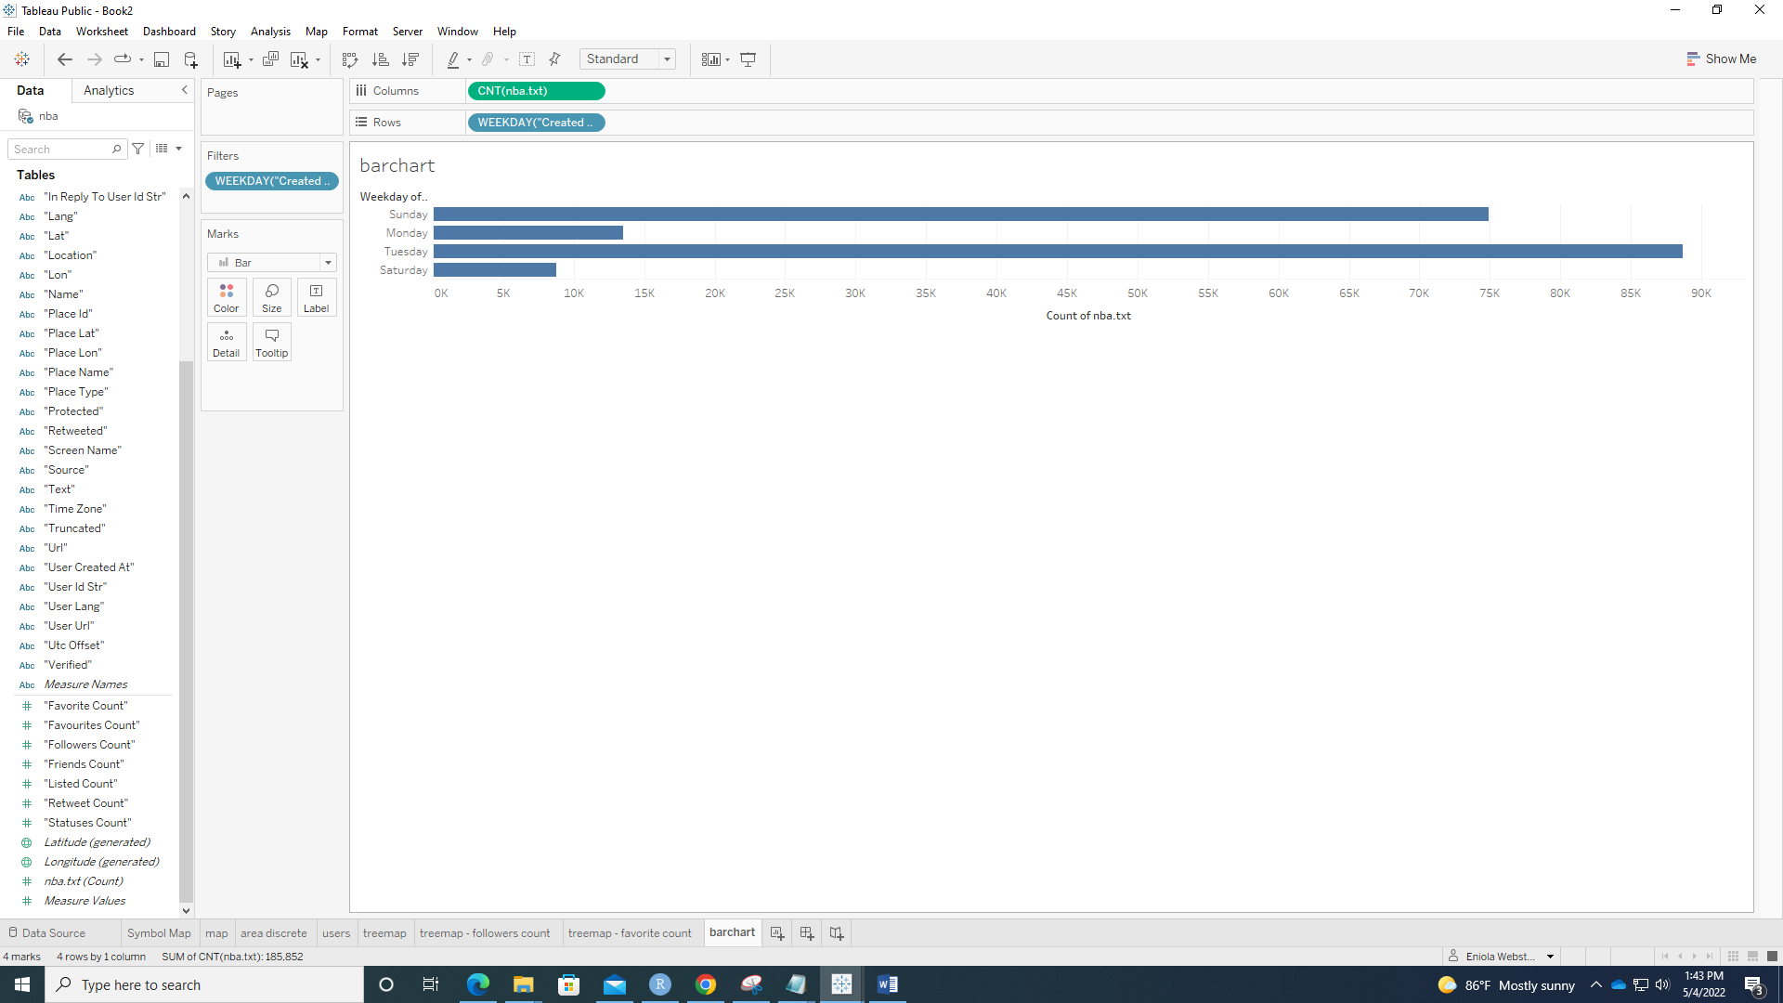

11. Barchart – Weekday.

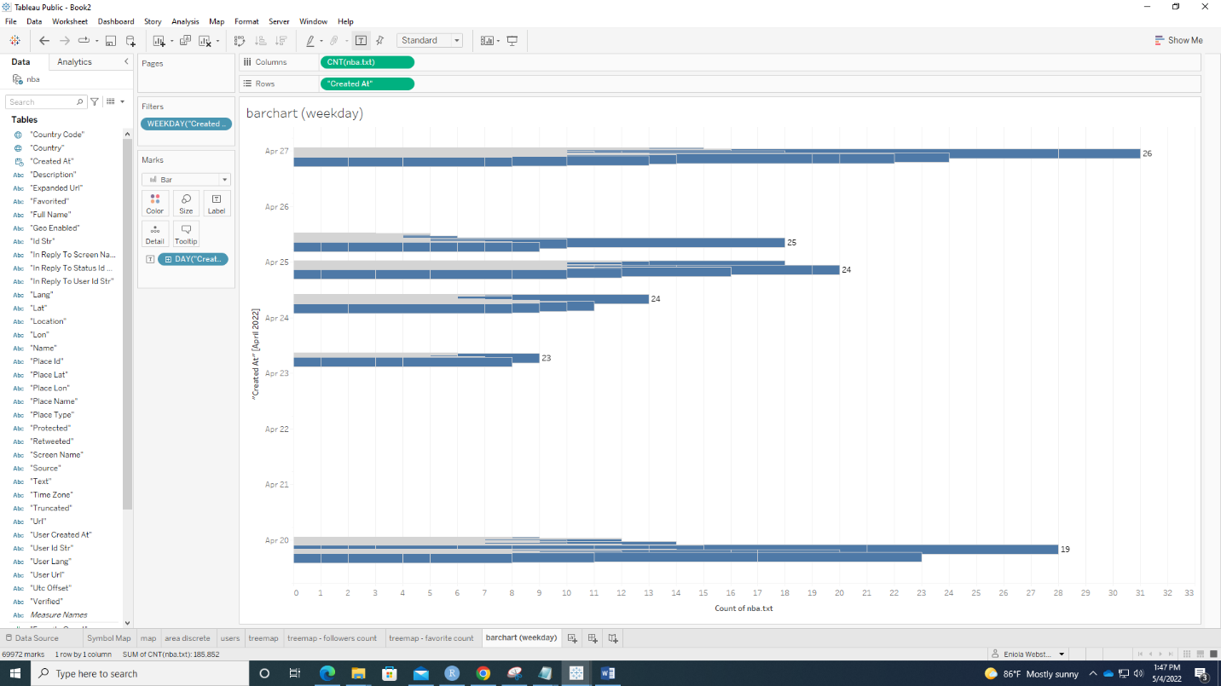

12.Fixed Total Tweets Calculated Field.

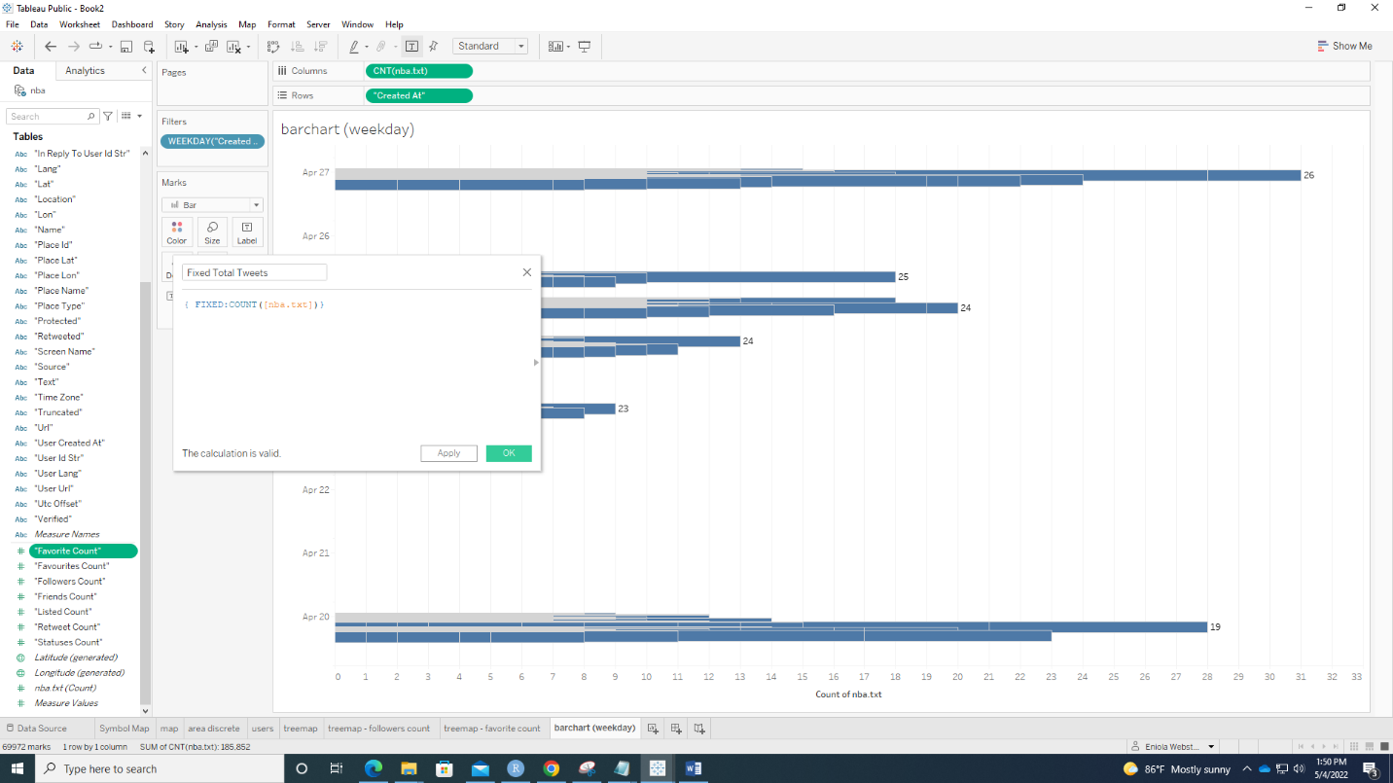

Edit Title Window

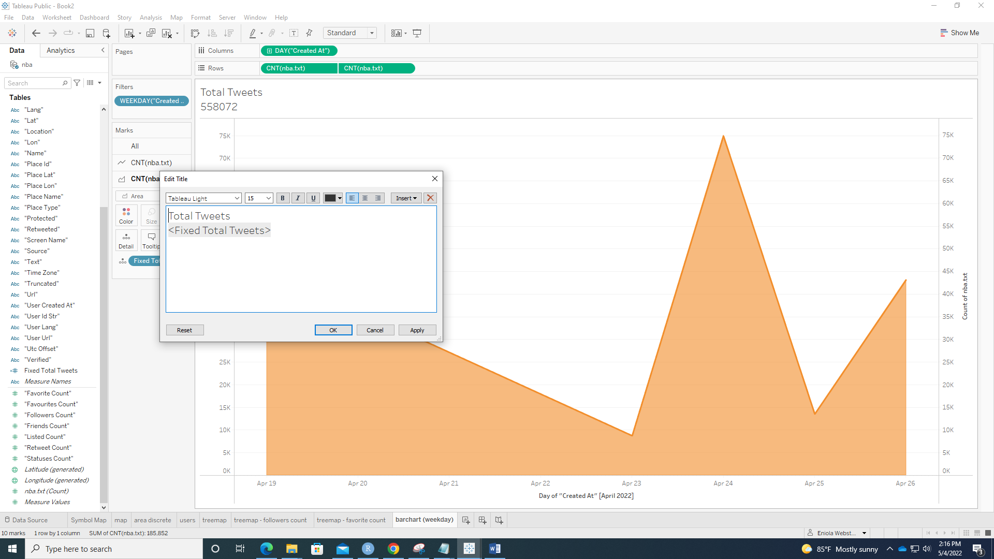

Total Tweets

