Case-Based Intelligent Tutoring System for Personalized Mathematics Learning

1. Case Study Description
This project implements a Case-Based Reasoning (CBR) Intelligent Tutoring System that assists students with mathematics learning difficulties (inspired by my thesis). The system stores previous student problems and their corresponding learning interventions in a case base. When a new student problem is entered, the system compares it with previous cases and retrieves the most similar one. The previous solution is then adapted according to the new student's error type and difficulty level before being stored as a new case.

2. Case Base
The case base contains five previous student cases involving Fractions, Algebra, and Geometry. Each case contains three problem attributes: mathematics topic, error type, and difficulty level. Each case also contains a recommended learning intervention.
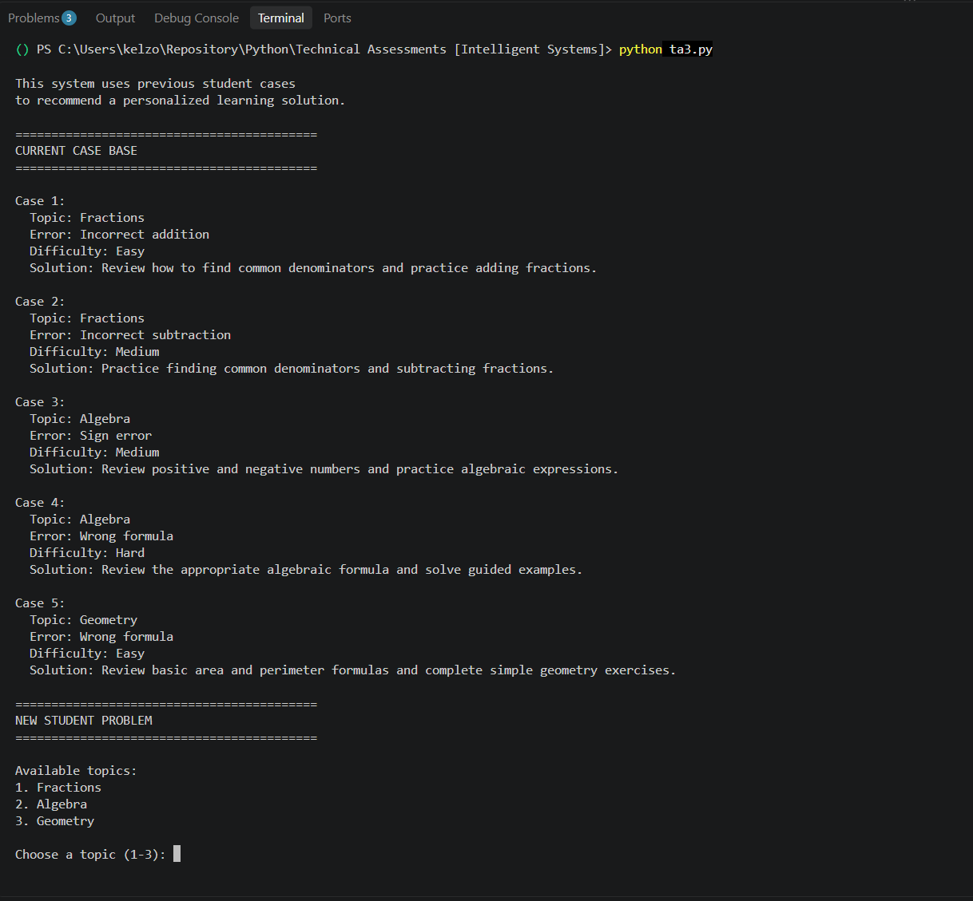

3. Similarity Method
The system uses a simple attribute-matching method. The new problem is compared with each previous case using three attributes: topic, error type, and difficulty. Each matching attribute receives one point. The maximum score is three points, which represents 100% similarity. The cases are then ranked from the highest similarity score to the lowest score, and the highest-ranking case is retrieved.
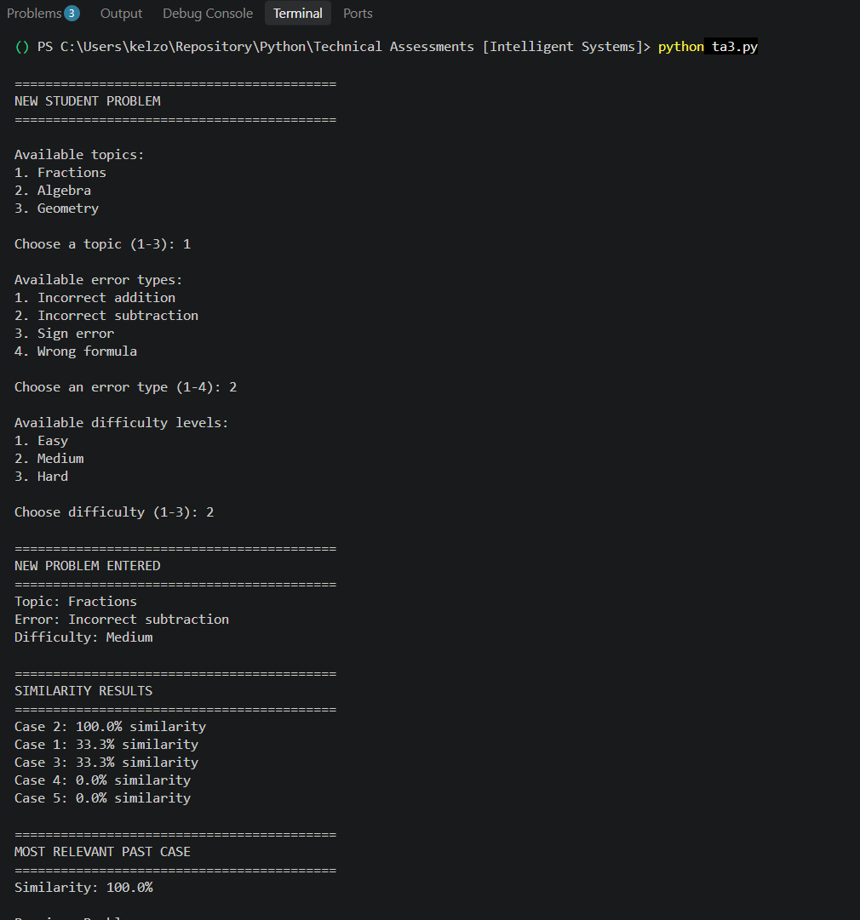
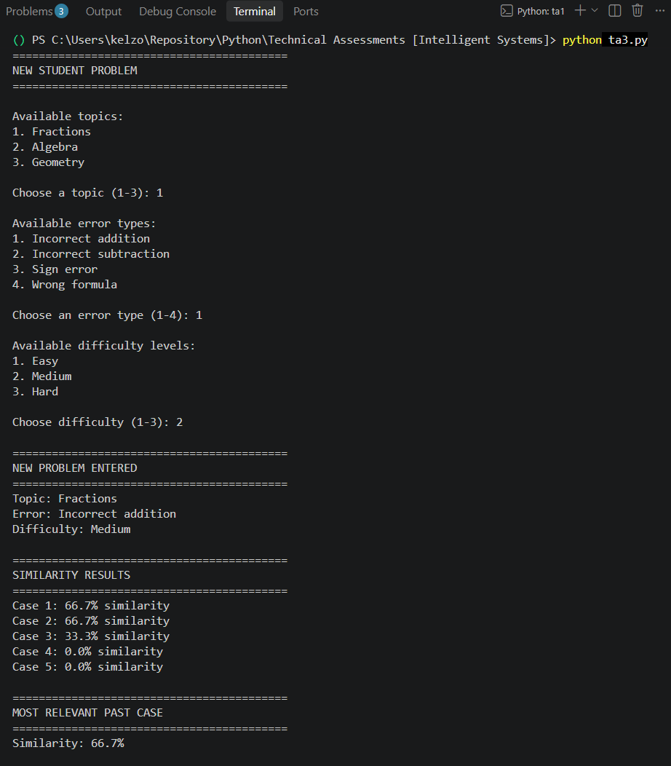

4. Adaptation Logic
After retrieving the most similar case, the system reuses its previous solution and adapts it to the new student's situation. The adaptation considers the student's difficulty level and error type. For example, a student with a hard problem receives more challenging exercises and step-by-step review, while a student with a sign error receives additional reminders to check positive and negative signs.
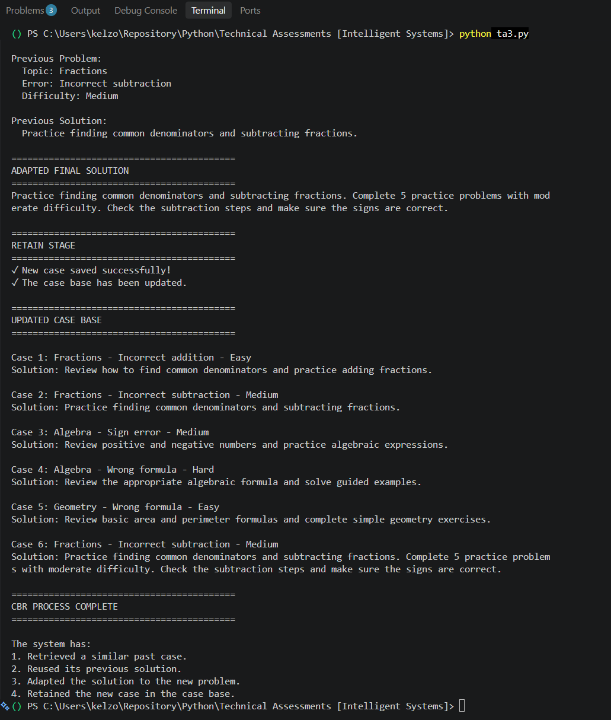

5. Retention
After the final recommendation is generated, the new problem and adapted solution are added to the case base. This demonstrates the Retain stage of the CBR cycle and allows the system to use the newly solved case in future reasoning.

Full Code:
# ============================================================
# INTELLIGENT TUTORING SYSTEM
# CASE-BASED REASONING (CBR)
#
# Case Study 3: Intelligent Tutoring System
# ============================================================

# ============================================================
# PART 1 - CASE BASE
# ============================================================

# The case base contains previous student problems.
#
# Each case has:
# - topic
# - error
# - difficulty
# - solution

case_base = [

{
"problem": {
"topic": "Fractions",
"error": "Incorrect addition",
"difficulty": "Easy"
},
"solution": "Review how to find common denominators and practice adding fractions."
},

{
"problem": {
"topic": "Fractions",
"error": "Incorrect subtraction",
"difficulty": "Medium"
},
"solution": "Practice finding common denominators and subtracting fractions."
},

{
"problem": {
"topic": "Algebra",
"error": "Sign error",
"difficulty": "Medium"
},
"solution": "Review positive and negative numbers and practice algebraic expressions."
},

{
"problem": {
"topic": "Algebra",
"error": "Wrong formula",
"difficulty": "Hard"
},
"solution": "Review the appropriate algebraic formula and solve guided examples."
},

{
"problem": {
"topic": "Geometry",
"error": "Wrong formula",
"difficulty": "Easy"
},
"solution": "Review basic area and perimeter formulas and complete simple geometry exercises."
}

]

# ============================================================
# PART 2 - DISPLAY THE CASE BASE
# ============================================================

def display_case_base():

print("\n==========================================")
print("CURRENT CASE BASE")
print("==========================================")

for i, case in enumerate(case_base, start=1):

problem = case["problem"]

print(f"\nCase {i}:")
print(f" Topic: {problem['topic']}")
print(f" Error: {problem['error']}")
print(f" Difficulty: {problem['difficulty']}")
print(f" Solution: {case['solution']}")

# ============================================================
# PART 3 - GET NEW STUDENT PROBLEM
# ============================================================

def get_new_problem():

print("\n==========================================")
print("NEW STUDENT PROBLEM")
print("==========================================")

print("\nAvailable topics:")
print("1. Fractions")
print("2. Algebra")
print("3. Geometry")

topic_choice = input("\nChoose a topic (1-3): ")

if topic_choice == "1":
topic = "Fractions"

elif topic_choice == "2":
topic = "Algebra"

elif topic_choice == "3":
topic = "Geometry"

else:
print("Invalid choice. Using Fractions.")
topic = "Fractions"

print("\nAvailable error types:")
print("1. Incorrect addition")
print("2. Incorrect subtraction")
print("3. Sign error")
print("4. Wrong formula")

error_choice = input("\nChoose an error type (1-4): ")

if error_choice == "1":
error = "Incorrect addition"

elif error_choice == "2":
error = "Incorrect subtraction"

elif error_choice == "3":
error = "Sign error"

elif error_choice == "4":
error = "Wrong formula"

else:
print("Invalid choice. Using Incorrect addition.")
error = "Incorrect addition"

print("\nAvailable difficulty levels:")
print("1. Easy")
print("2. Medium")
print("3. Hard")

difficulty_choice = input("\nChoose difficulty (1-3): ")

if difficulty_choice == "1":
difficulty = "Easy"

elif difficulty_choice == "2":
difficulty = "Medium"

elif difficulty_choice == "3":
difficulty = "Hard"

else:
print("Invalid choice. Using Medium.")
difficulty = "Medium"

# Create the new problem dictionary
new_problem = {
"topic": topic,
"error": error,
"difficulty": difficulty
}

return new_problem

# ============================================================
# PART 4 - SIMILARITY ASSESSMENT
# ============================================================

def calculate_similarity(new_problem, old_problem):

# Start with zero matching attributes
score = 0

# Check topic
if new_problem["topic"] == old_problem["topic"]:
score += 1

# Check error type
if new_problem["error"] == old_problem["error"]:
score += 1

# Check difficulty
if new_problem["difficulty"] == old_problem["difficulty"]:
score += 1

# There are 3 attributes.
# Convert the score into a percentage.
similarity = (score / 3) * 100

return similarity

# ============================================================
# PART 5 - RETRIEVE SIMILAR CASES
# ============================================================

def retrieve_cases(new_problem):

results = []

# Compare the new problem with every case
for i, case in enumerate(case_base):

similarity = calculate_similarity(
new_problem,
case["problem"]
)

results.append({
"case_number": i + 1,
"case": case,
"similarity": similarity
})

# Sort from highest similarity to lowest similarity
results.sort(
key=lambda result: result["similarity"],
reverse=True
)

return results

# ============================================================
# PART 6 - DISPLAY SIMILARITY RESULTS
# ============================================================

def display_similarity_results(results):

print("\n==========================================")
print("SIMILARITY RESULTS")
print("==========================================")

for result in results:

print(
f"Case {result['case_number']}: "
f"{result['similarity']:.1f}% similarity"
)

# ============================================================
# PART 7 - DISPLAY RETRIEVED CASE
# ============================================================

def display_retrieved_case(best_result):

case = best_result["case"]
problem = case["problem"]

print("\n==========================================")
print("MOST RELEVANT PAST CASE")
print("==========================================")

print(f"Similarity: {best_result['similarity']:.1f}%")

print("\nPrevious Problem:")
print(f" Topic: {problem['topic']}")
print(f" Error: {problem['error']}")
print(f" Difficulty: {problem['difficulty']}")

print("\nPrevious Solution:")
print(f" {case['solution']}")

# ============================================================
# PART 8 - ADAPT THE SOLUTION
# ============================================================

def adapt_solution(best_case, new_problem):

# Get the previous solution
original_solution = best_case["solution"]

# Start with the previous solution
adapted_solution = original_solution

# Add personalized instructions based on difficulty
if new_problem["difficulty"] == "Easy":

adapted_solution += (
" Start with simple guided examples "
"before moving to harder exercises."
)

elif new_problem["difficulty"] == "Medium":

adapted_solution += (
" Complete 5 practice problems "
"with moderate difficulty."
)

elif new_problem["difficulty"] == "Hard":

adapted_solution += (
" Complete challenging practice problems "
"and review the solution step-by-step."
)

# Add feedback based on the type of error
if new_problem["error"] == "Sign error":

adapted_solution += (
" Pay special attention to positive "
"and negative signs."
)

elif new_problem["error"] == "Wrong formula":

adapted_solution += (
" Review how to identify the correct "
"formula before solving."
)

elif new_problem["error"] == "Incorrect addition":

adapted_solution += (
" Check each addition step carefully."
)

elif new_problem["error"] == "Incorrect subtraction":

adapted_solution += (
" Check the subtraction steps and "
"make sure the signs are correct."
)

return adapted_solution

# ============================================================
# PART 9 - DISPLAY ADAPTED SOLUTION
# ============================================================

def display_adapted_solution(solution):

print("\n==========================================")
print("ADAPTED FINAL SOLUTION")
print("==========================================")

print(solution)

# ============================================================
# PART 10 - RETAIN NEW CASE
# ============================================================

def retain_case(new_problem, final_solution):

new_case = {
"problem": new_problem.copy(),
"solution": final_solution
}

# Add the new case to the case base
case_base.append(new_case)

print("\n==========================================")
print("RETAIN STAGE")
print("==========================================")

print("✓ New case saved successfully!")
print("✓ The case base has been updated.")

# ============================================================
# PART 11 - DISPLAY NEW CASE BASE
# ============================================================

def display_updated_case_base():

print("\n==========================================")
print("UPDATED CASE BASE")
print("==========================================")

for i, case in enumerate(case_base, start=1):

problem = case["problem"]

print(
f"\nCase {i}: "
f"{problem['topic']} - "
f"{problem['error']} - "
f"{problem['difficulty']}"
)

print(f"Solution: {case['solution']}")

# ============================================================
# MAIN PROGRAM
# ============================================================

print("==========================================")
print("INTELLIGENT TUTORING SYSTEM")
print("CASE-BASED REASONING")
print("==========================================")

print("\nThis system uses previous student cases")
print("to recommend a personalized learning solution.")

# Show original case base
display_case_base()

# ------------------------------------------------------------
# STEP 1: Get new problem
# ------------------------------------------------------------

new_problem = get_new_problem()

print("\n==========================================")
print("NEW PROBLEM ENTERED")
print("==========================================")

print(f"Topic: {new_problem['topic']}")
print(f"Error: {new_problem['error']}")
print(f"Difficulty: {new_problem['difficulty']}")

# ------------------------------------------------------------
# STEP 2: RETRIEVE
# ------------------------------------------------------------

results = retrieve_cases(new_problem)

display_similarity_results(results)

# ------------------------------------------------------------
# STEP 3: Get most similar case
# ------------------------------------------------------------

best_result = results[0]

display_retrieved_case(best_result)

# ------------------------------------------------------------
# STEP 4: REUSE + ADAPT
# ------------------------------------------------------------

final_solution = adapt_solution(
best_result["case"],
new_problem
)

display_adapted_solution(final_solution)

# ------------------------------------------------------------
# STEP 5: RETAIN
# ------------------------------------------------------------

retain_case(
new_problem,
final_solution
)

# ------------------------------------------------------------
# STEP 6: Display updated case base
# ------------------------------------------------------------

display_updated_case_base()

print("\n==========================================")
print("CBR PROCESS COMPLETE")
print("==========================================")

print("\nThe system has:")
print("1. Retrieved a similar past case.")
print("2. Reused its previous solution.")
print("3. Adapted the solution to the new problem.")
print("4. Retained the new case in the case base.")

