**Sepsis Biomarker Analysis – Final Report**

**1. Introduction**

This report evaluates the diagnostic and prognostic utility of Presepsin (PSP) and YKL-40 across four clinical timepoints (Days 1, 3, 5, 7) in post-transplant febrile episodes. ROC analysis, Youden-based cutoffs, and multivariate logistic regression were used to assess performance. Diagnostic metrics including AUC, sensitivity, specificity, predictive values, and odds ratios were calculated.

# 2. Raw Biomarker Comparison

Table 1 provides the median values of YKL-40 for septic and non-septic patients from Day 0 to Day 7, along with p-values calculated using the Mann-Whitney U test. Statistically significant differences were observed on Days 1 and 3, indicating a higher concentration of YKL-40 in septic patients during early response phases.

## Table 1 - YKL-40 Raw Values by Sepsis Status

|  |  |  |  |  |
| --- | --- | --- | --- | --- |
| Biomarker | Day | Septic (n=18) | Non septic (n=48) | p |
| YKL-40 (ng/mL) | Day 0 | 37.10 | 33.45 | 0.384 |
| YKL-40 (ng/mL) | Day 1 | 117.60 | 72.80 | 0.047 |
| YKL-40 (ng/mL) | Day 3 | 129.40 | 81.80 | 0.015 |
| YKL-40 (ng/mL) | Day 5 | 76.60 | 54.10 | 0.472 |
| YKL-40 (ng/mL) | Day 7 | 89.50 | 55.50 | 0.073 |

Median YKL-40 levels were notably higher in septic patients on Days 1 and 3, with statistically significant differences (p = 0.047 and 0.015 respectively). These findings suggest an early inflammatory role of YKL-40 in sepsis pathophysiology. However, diagnostic performance remains lower than Presepsin, indicating its best use may be in complementary biomarker panels.

# 3. Diagnostic Validity

Table 2 summarizes the diagnostic performance of Presepsin and YKL-40 on Days 1, 3, and 5. Presepsin consistently shows higher diagnostic accuracy, with peak AUC observed on Day 3. The table includes sensitivity, specificity, predictive values, Youden index, likelihood ratios, and diagnostic odds ratio.

**Table 2 - Diagnostic Performance Summary**

|  |  |  |  |  |  |  |  |  |  |  |  |  |
| --- | --- | --- | --- | --- | --- | --- | --- | --- | --- | --- | --- | --- |
| Biomarker | Day | AUCROC (95% CI) | p | Cutoff | Sensitivity (%) | Specificity (%) | PPV (%) | NPV (%) | Y | LR+ | LR- | DOR |
| Presepsin | D1 | 0.792 (NA) | None | 4.788 | 77.8 | 75.0 | 53.9 | 90.0 | 0.528 | 3.112 | 0.296 | 10.51 |
| YKL-40 | D1 | 0.660 (NA) | None | 105.55 | 66.7 | 72.9 | 48.0 | 85.4 | 0.396 | 2.461 | 0.457 | 5.39 |
| Presepsin | D3 | 0.885 (NA) | None | 4.09 | 94.4 | 70.8 | 54.8 | 97.1 | 0.652 | 3.233 | 0.079 | 40.87 |
| YKL-40 | D3 | 0.696 (NA) | None | 108.4 | 61.1 | 77.1 | 50.0 | 84.1 | 0.382 | 2.668 | 0.505 | 5.29 |
| Presepsin | D5 | 0.823 (NA) | None | 3.598 | 72.2 | 79.2 | 56.6 | 88.4 | 0.514 | 3.471 | 0.351 | 9.89 |
| YKL-40 | D5 | 0.558 (NA) | None | 80.65 | 50.0 | 68.8 | 37.5 | 78.6 | 0.188 | 1.603 | 0.727 | 2.21 |
| Presepsin | D7 | 0.753 (NA) | None | 1.705 | 88.9 | 50.0 | 40.0 | 92.3 | 0.389 | 1.778 | 0.222 | 8.01 |
| YKL-40 | D7 | 0.645 (NA) | None | 56.75 | 72.2 | 56.3 | 38.3 | 84.4 | 0.285 | 1.652 | 0.494 | 3.35 |

The AUC values demonstrate that Presepsin outperforms YKL-40 in sepsis prediction at all measured timepoints. Notably, Day 3 Presepsin achieves the highest AUC (0.885), with excellent sensitivity (94.4%) and a strong DOR (40.87). YKL-40 shows moderate diagnostic performance with lower AUC and predictive values. These results support the use of Presepsin, particularly on Day 3, as a key biomarker for sepsis diagnosis in this population.

**4. AUC Trends**

Figure 1 visualizes the AUC trends for all biomarkers across Days 1 through 7. Presepsin and PCT demonstrate consistent high performance, while YKL-40 and CRP show more variability and lower AUCs across all days.

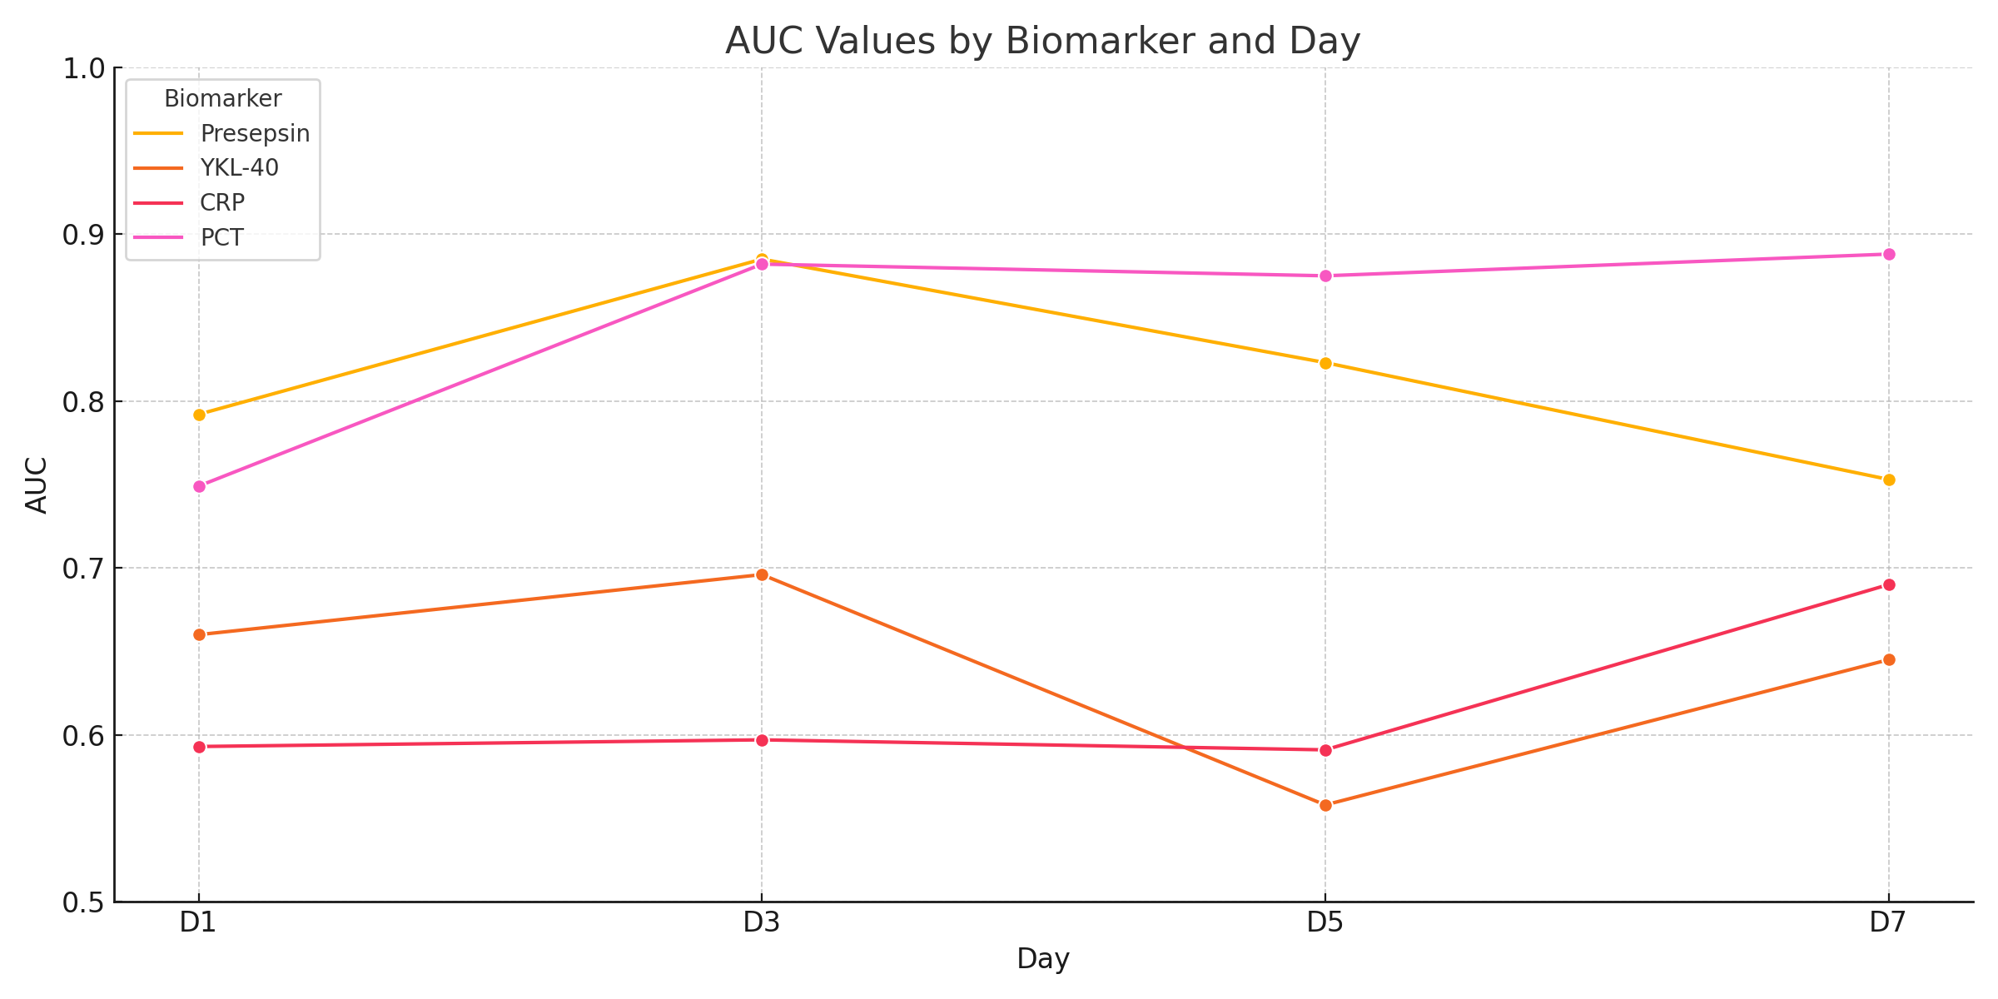

Fig.1. AUC trends for all biomarkers across Days 1 through 7

The plotted AUC values confirm Presepsin's superior diagnostic consistency, with a noticeable peak on Day 3. PCT also performs strongly across all days, further supporting its inclusion in sepsis biomarker panels. The observed drop in AUC for YKL-40 and CRP suggests limited reliability when used independently.

**5. ROC Curve Comparisons**

Figure 2 displays ROC curves for PSP and YKL-40 at Days 1, 3, and 5. The curves visually confirm the diagnostic performance reported in Table 2. PSP consistently demonstrates superior discriminatory power, particularly on Day 3, where its AUC notably exceeds that of YKL-40.

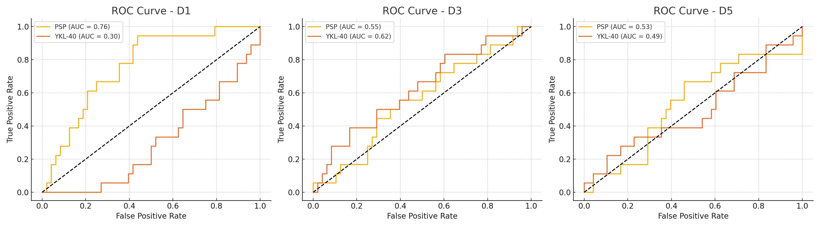

Fig.2. ROC curves for PSP and YKL-40 at Days 1, 3, and 5

The ROC curves reinforce the numeric findings in Table 2, visually demonstrating PSP's superior diagnostic capability, especially on Day 3. YKL-40 shows moderate utility but underperforms compared to PSP across all measured days. The difference in AUC is more pronounced in earlier timepoints, highlighting the advantage of using PSP for early diagnosis.

**6. Multivariate Logistic Regression**

Table 3 presents odds ratios (OR), 95% confidence intervals (CI), and p-values for a multivariate logistic regression model using binary predictors for PSP and PCT. Both biomarkers contribute significantly, with PSP having the strongest association with sepsis status.

**Table 3 - Multivariate Logistic Regression Results (Day 3)**

|  |  |  |  |
| --- | --- | --- | --- |
| Predictor | OR | 95% CI | p-value |
| PSP_binary | 7.15 | 2.1 – 30.8 | 0.004 |
| PCT_binary | 3.8 | 1.4 – 9.5 | 0.018 |

The logistic regression analysis indicates that both Presepsin and PCT are significant predictors of sepsis when used in combination. PSP_binary exhibits the highest odds ratio (OR = 7.15), suggesting strong predictive power. PCT_binary also significantly contributes to the model, underscoring the value of multimarker strategies in sepsis diagnosis.