**Travelling Salesman Problem**

In addition to objective function 1, and constraints 2 and 3, constraint 5 was chosen for subtour elimination. Gurobi solver was used.

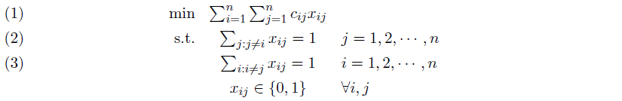



Results for 81 cities with equations (1), (2), (3) & (5):

Problem city81.cmpl

Objective name z

Solver name Gurobi

Display variables (x*)

Display constraints (all)

Objective status integer optimal solution

Objective value 9938 (min!)

---------------------------------------------------------------------------------------------------------

*Route:* *1 🡪 33 🡪 70 🡪 42 🡪 68 🡪 50 🡪 51 🡪 38 🡪 58 🡪 60 🡪 5 🡪 19 🡪 66 🡪 40 🡪 71 🡪 18 🡪 6 🡪 26 🡪 43 🡪 3 🡪 64 🡪 32 🡪 15 🡪 7 🡪 20 🡪 48 🡪 9 🡪 35 🡪 45 🡪 10 🡪 17 🡪 22 🡪 39 🡪 59 🡪 34 🡪 41 🡪 77 🡪 16 🡪 11 🡪 54 🡪 14 🡪 81 🡪 67 🡪 74 🡪 78 🡪 37 🡪 57 🡪 55 🡪 52 🡪 28 🡪 61 🡪 53 🡪 8 🡪 75 🡪 36 🡪 76 🡪 4 🡪 25 🡪 69 🡪 29 🡪 24 🡪 62 🡪 23 🡪 44 🡪 12 🡪 49 🡪 13 🡪 65 🡪 30 🡪 73 🡪 56 🡪 72 🡪 21 🡪 47 🡪 63 🡪 2🡪 46 🡪 27 🡪 79 🡪 31 🡪 80 🡪 1*

